

Programme:
BA (Hons) Business Management

LCBB5014
Data Handling and Business Intelligence
Component 2 Coursework: Individual Report

Student ID: 2437295
Student Name: Nicoleta Samson

Table of Contents
1. Introduction 3
2. Data Cleaning and Preparation 3
2.1 Data Quality Assessment 3
2.2 Data Cleaning Procedures 4
2.3 Importance of Clean Data in BI 4
3. Descriptive Statistics and Summary 4
3.1 Numerical Variables Summary 4
3.2 Distribution Analysis 5
3.3 Categorical Analysis 7
4. Trend Analysis and Visualisation 8
4.1 Genre vs Average Rating 8
4.2 Language vs Audience Engagement 9
4.3 Runtime vs Popularity 10
4.4 Likes and Fans Trend Analysis 11
5. Statistical Analysis Using SPSS 11
5.1 Hypothesis Testing (Independent Samples T-Test) 11
5.2 Correlation Analysis 13
5.3 Multiple Regression Analysis 14
6. Insights and Recommendations 15
6.1 Key Findings 15
6.2 Business Recommendations 15
6.3 Limitations and Future Research 15
Reference list 16
Appendices 18
Appendix 1: SPSS Tables 18

1. Introduction
Digital platforms have been growing and producing enormous amounts of user-generated content that can help companies understand consumer habits so they can make better decisions for their business. The film and entertainment industry can collect data that reflects how audiences are engaging with their content through measurements of ratings, engagement (watches), likes and fan counts. In turn, companies can use Business Intelligence (BI) tools to convert this data into meaningful information to support their goals of operating more efficiently, satisfying audiences, and gaining competitive advantage (Mohammad et al., 2022). This report includes an analysis of a dataset of 10,000 films (Letterbox Movie Classification Dataset) with information including film title, director, genre, runtime, language, audience rating, watches, likes and fan counts. The analysis was completed using Microsoft Excel to clean and prepare the data and conduct descriptive statistics and trend analysis. Then statistical data was conducted using SPSS for the inferential statistics. This analysis aimed to evaluate the data quality, describe the key characteristics of the database, find trends across genres and languages, examine the relationship between audience engagement variables and determine if there is a statistically different relationship between English and non-English films.

2. Data Cleaning and Preparation

2.1 Data Quality Assessment
The data quality is essential for producing dependable business intelligence, enabling sound decisions analytically or via analysis to be reliable. Poor-quality data can be biased, reduce the accuracy of an analysis and produce incorrect conclusions (Ji et al, 2021). Thus, an initial assessment was done to see if there were any missing values.
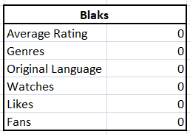
Table 1: Missing Value Summary Table
Table 1 indicates that there are no missing values for any of the selected variable(s). This elevated level of completeness will result in a lesser chance of data being distorted due to the absence of data.

2.2 Data Cleaning Procedures
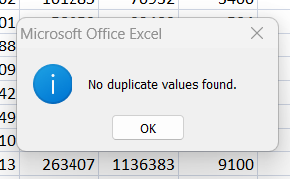
In the original data set, there were ten thousand records of data; all records are unique and contain no duplicates. In addition, Variables containing text such as Genres and Original Language were reviewed for consistent format and category. A summary variable for grouping languages as English or Non-English for follow-up statistical analysis was created.

2.3 Importance of Clean Data in BI
Data Cleaning increases the reliability and validity of analytical results by decreasing error rates and enhancing the consistency of variable data (Borrohou et al., 2023). Accurate datasets within business intelligence environments provide businesses with the ability to recognise significant patterns, understand and anticipate customer behaviours, and assist in strategic decisions (Hurbean et al., 2024).

3. Descriptive Statistics and Summary

3.1 Numerical Variables Summary
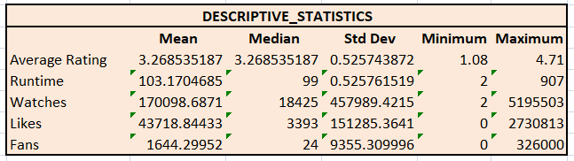
Table 2: Descriptive Statistics
The average film rating of the dataset was 3.27 (somewhat positive rating) with low standard deviation (0.53). The mean film length was about 103 minutes (median of 99 minutes); the highest length was also 907 minutes, indicating that there were really long films compared to the majority of the productions. The mean number of viewings (170,099), is also much greater than the median number of viewings (18,425) which shows that there are very high numbers of viewership of some of the films than the average number of viewings of most of the productions.
Similar patterns exist for "likes" (average = 43,036; median = 3,393) and "fans" (average = 1,644; median = 24). Thus, audience engagement metrics are highly skewed, with a small number of films resulting in large amounts of audience engagement. These concentration patterns are commonly found in digital entertainment platforms where a limited number of productions generate very high levels of popularity (Mei, 2025).

3.2 Distribution Analysis
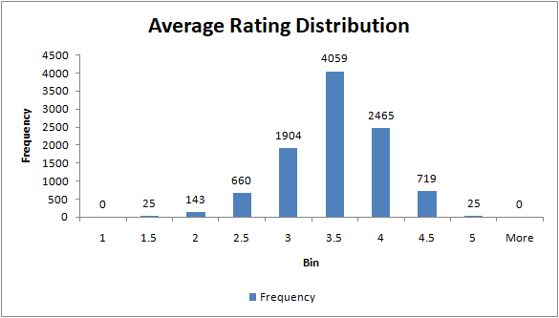
Figure 1: Histogram Average rating distribution
The distribution of film ratings is shown in the illustration below, where the largest proportion of ratings were at or around 3.5, with a small portion rated either lower (less than 2.0) or higher (greater than 5.0). The majority of ratings appear to be nearly symmetrical since they appear to be fairly equal in number from the two extremes and relatively close together. The distribution of ratings was confirmed by the quartile measures shown in Table 3, especially that the median rating was just slightly lower than the centre of the interquartile range (IQR) measure.
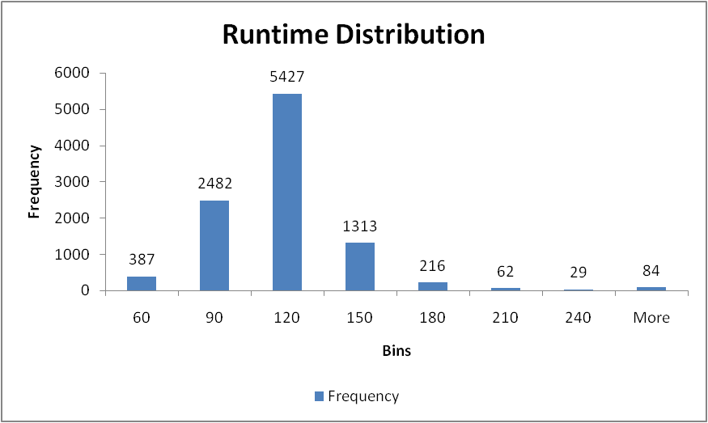
Figure 2: Runtime Distribution Histogram
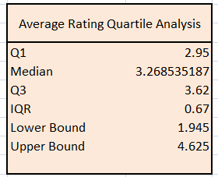
Table 3: Average Rating Quartile Analysis
The distribution of run times was shown in the figure below. The majority of films had run times between about 90 and 120 minutes. Thus, it can be assumed that most audiences view feature-length movies that follow a typical feature-length (commercially produced) film structure. There were only a few movies located between 181 and 360 minutes, and these movies represent rare occurrences. The maximum run time of 907 minutes reflected the presence of several outliers, supporting this view.

3.3 Categorical Analysis
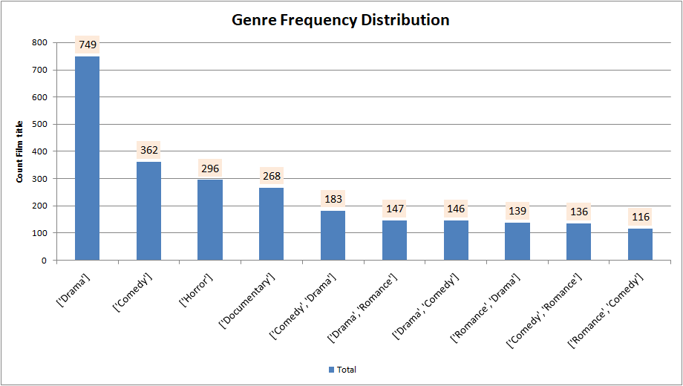
Figure 3: Genre Frequency Distribution
In figure three, it is shown that Drama is the genre most produced each year, followed by Comedy, Horror and Documentary. The large proportion of drama-based programming reflects an ongoing interest from audiences in narrative-driven storytelling.
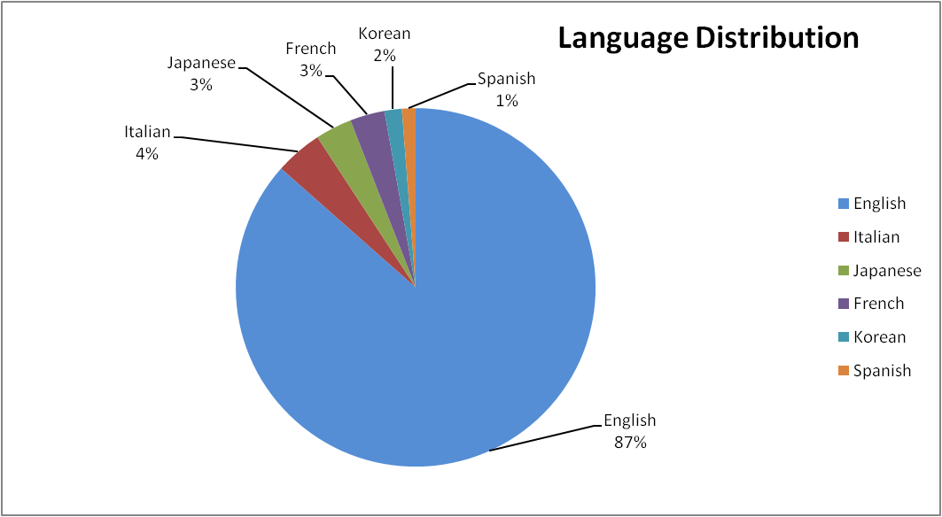
Figure 4: Language Distribution
Figure 4 shows English language films account for about 86.5% of all films produced. The next largest categories (not including English) are Italian, Japanese, and French. The popularity of English-language films reflects how much impact English-language-based film industries have globally and their reach to many audiences (Widiyaningtyas and Ariyanto, 2024).

4. Trend Analysis and Visualisation

4.1 Genre vs Average Rating
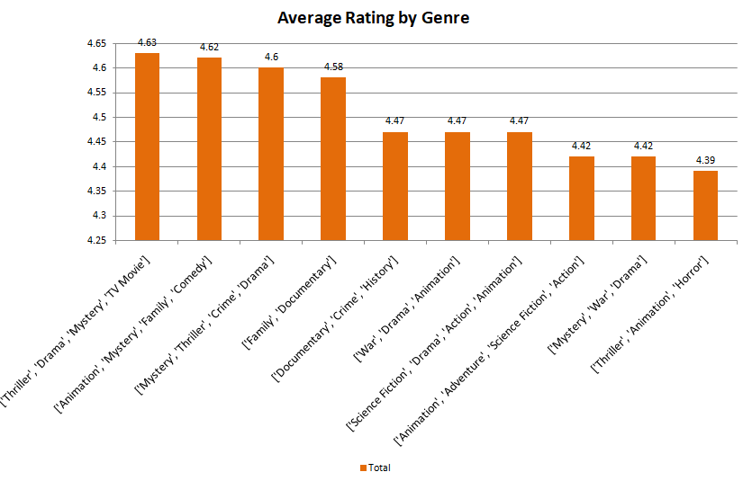
Figure 5: Average Rating by Genre
The link between genre and average viewer scores is shown by Figure 5, which displays the many combinations of niche genres that received high scores (e.g., 'Thriller/Drama/Mystery/TV Movie' at 4.63 and 'Animation/Mystery/Family/Comedy' at 4.62). Rated in the top genre categories of documentary and historical also appears to further support this interpretation of a growing appreciation among viewers for informative and real-world-based content.
The analysis of the data indicates that viewers' scores for films are determined by both the type of genre as well as the uniqueness and complexity of their genre combination. Therefore, if film companies invest in cross-genre film projects that are strong in number or the largest category of films being produced today, they will continue to have the opportunity to distinguish themselves in an increasingly competitive entertainment marketplace (Malik, 2022).

4.2 Language vs Audience Engagement
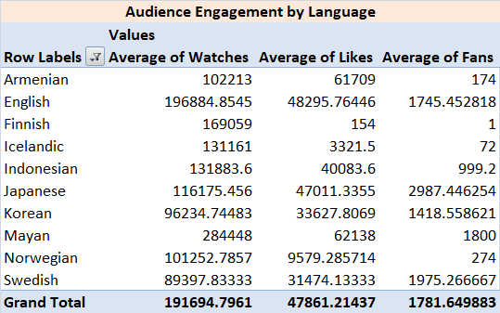
Table 4: Audience Engagement by Language (Top 10 watched languages)
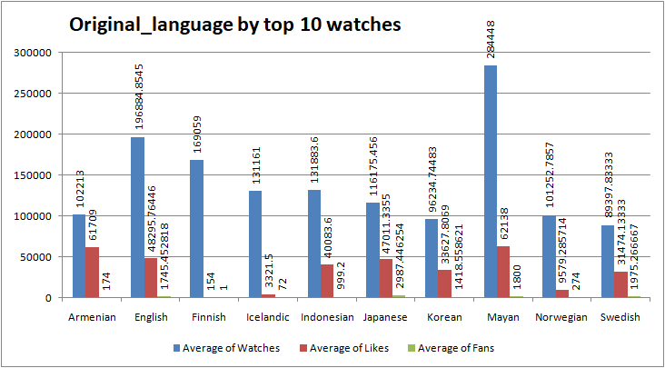
Figure 6: Original_language by top 10 watched
The average watch number for English films was by far the highest of all languages - 196,885 watches - therefore showing that the potential of reach globally is substantial with this type of film. However, the number of likes and fans that Japanese films have is relatively high for the number of watches they received. Therefore, this allows streaming providers as well as distributors to diversify their content offerings and to reach international audiences by identifying the different language groups in a more effective manner (Arshad et al, 2025).

4.3 Runtime vs Popularity
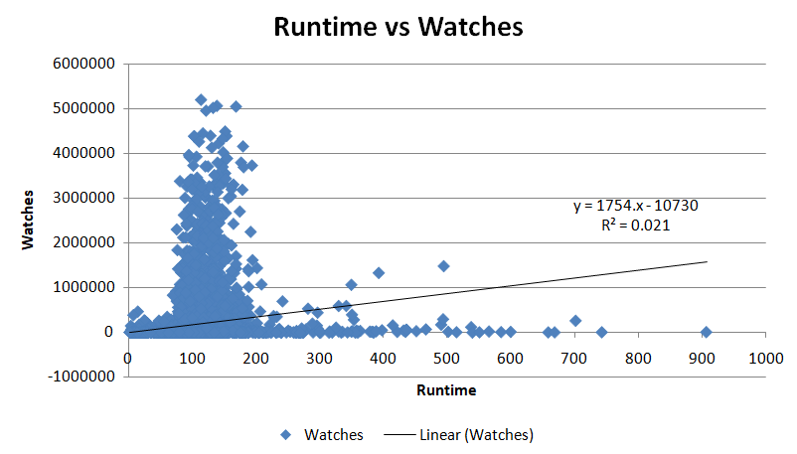
Figure 7: Runtime and Popularity Trends
Based on the data provided in Figure 7, there is a positive relationship between the runtime of a movie (hours and minutes) and the number of watches, according to the regression trendline. However, the coefficient of determination (R² = 0.021) indicates that runtime is responsible for only 2.1% of the variation in the number of watches. While runtime does appear to slightly influence whether a film receives more (or fewer) watches, the actual association between these variables is incredibly weak.

4.4 Likes and Fans Trend Analysis
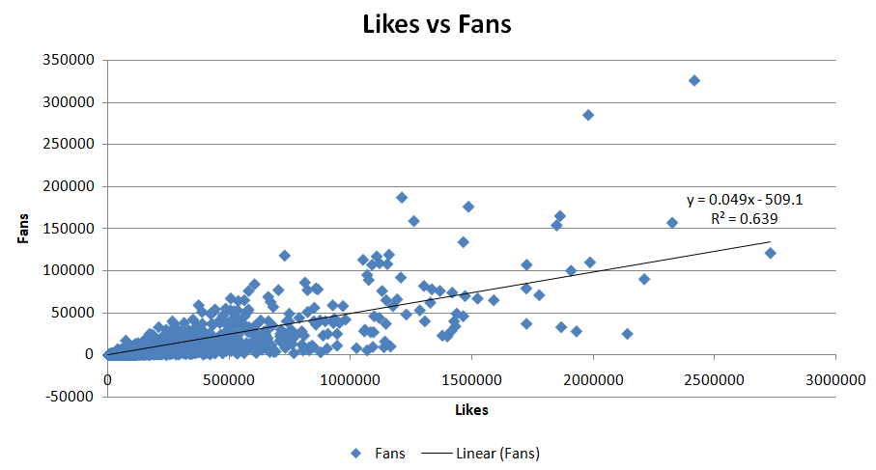
Figure 8: Viewer Engagement Trends
The regression model returned an R² value of 0.639, meaning that like counts account for approximately 63.9% of the variation in fan counts. The strong and positive correlation indicates that audience engagement is an important predictor of long-term loyalty to a film. Therefore, films with high levels of appreciation will tend to build strong fan communities. In terms of business intelligence, likes on social media platforms can provide early indications of how likely an audience will continue to engage with a film over time (Tariq et al., 2021).

5. Statistical Analysis Using SPSS

5.1 Hypothesis Testing (Independent Samples T-Test)
H0: There is no significant difference in average ratings between English and non-English films.
H1: There is a significant difference in average ratings between English and non-English films.
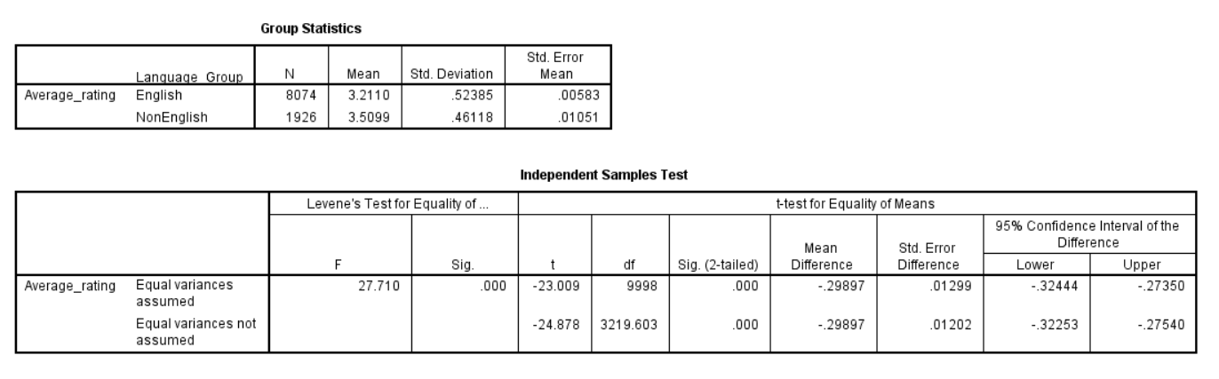
Table 5: SPSS T-Test Output
The Group Statistics found in Table 5 show that, on average, English Films received a M = 3.211 out of a maximum possible score of 5, whereas Non-English Films received a substantially higher rating of M = 3.510. Therefore, it appears that non-English films had a higher average rating than English films by the audience. The t-test shows that there was a statistically significant result (t = -24.878, p < 0.001), which indicates a difference in, on average, the way English and Non-English films are rated. The null hypothesis has been rejected due to the p-value being less than the standard significance threshold of 0.05, as shown by the results.

5.2 Correlation Analysis
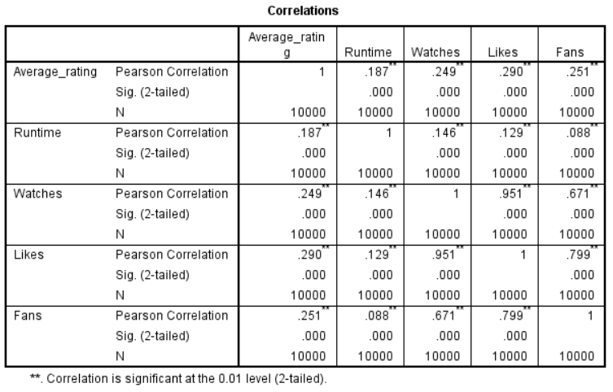
Table 6: Correlation Matrix
The relationship analysis between Average Rating, Runtime, Watches, Likes, and Fans through Pearson correlation was statistically significant at the 0.01 level for all relationships shown in Table 6. The highest correlation coefficient of (r = 0.951, p < 0.001) was found between Watches and Likes, indicating that as films have a larger audience, there tends to be a greater level of positive interaction with them (Ranjan and Kumar, 2021). Additionally, a strong relationship was found between Likes and Fans (r = 0.799, p < 0.001), indicating that when an audience enjoys a film, they also tend to help create a fan base for the film. Watches and Fans also showed a positive (r = 0.671, p < 0.001), strong relationship. In contrast, Runtime had no strong associations with Watches (r = 0.146) or Likes (r = 0.129). Similarly, Average Rating showed only weak to moderate relationships with Likes (r = 0.290), Fans (r = 0.251), and Watches (r = 0.249).

5.3 Multiple Regression Analysis
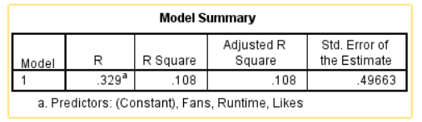
Table 7: Model Summary
From the results presented in the model summary (Table 7), yielding an R-value of 0.329 and an R² of 0.108, it can be inferred that together the three predictor variables account for about 10.8% of the variation in average ratings.
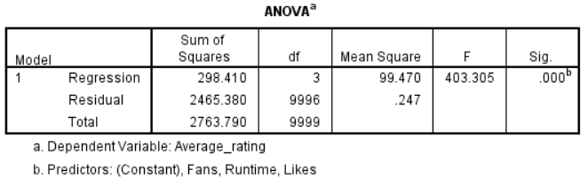
Table 8: Regression Analysis
The ANOVA results in Table 8 support the overall statistical significance of the overall regression model (F = 403.305, p < 0.001); therefore, the combined predictors of Runtime, Likes and Fans contribute to the prediction of average ratings.
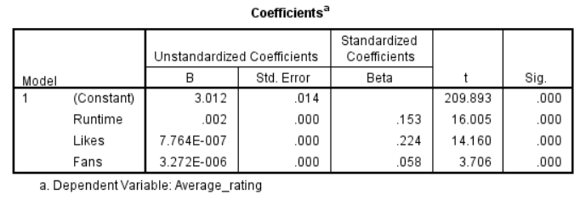
Table 9: Regression Coefficient
Likes has the highest standardised coefficient (β = 0.224, p < 0.001) followed closely by Runtime (β = 0.153, p < 0.001), and Fans (β = 0.058, p < 0.001). Thus, among the predictor variables studied, audience appreciation of a film, as indicated through likes, has the most significant influence on film ratings.

6. Insights and Recommendations

6.1 Key Findings
Descriptive statistics showed substantial variation in audiences' interactions with films, so that only a small number of films accounted for a large share of total views, likes, and fans. The most common film type was drama, while several combinations of different film types were among the films with the highest average scores. The Independent Samples T-Test found that non-English movies had higher average scores than English-language films, showing that audiences appreciate more non-English material as time goes on. Additionally, correlation analysis showed that the audience interaction metrics (views and likes) are related to one another by strong correlations; and that audience interaction (likes) was the strongest predictor of average score due to how much users engage with material (Ranjan and Kumar, 2021).

6.2 Business Recommendations
Investment should be targeted at high-rated combination films with drama and mystery, documentary and animation elements. Non-English film genres achieved significantly higher ratings so there may be potential to expand international content libraries as well as providing subtitled and/or localised content to increase accessibility. Viewer engagement metrics, such as likes and fandom counts, could be included within business intelligence dashboards since they will provide advance indicators of viewer satisfaction and potential future loyalty. By using predictive analytics tools, organisations can identify new trends in content and optimise the development of recommendation systems to enhance both audience retention and overall performance of their platforms (Hurbean et al., 2024).

6.3 Limitations and Future Research
While this research contributes significantly to our understanding of film popularity and audience engagement, the current study is limited to one dataset and only a select number of variables.

Reference list
Arshad, M., Onn, C.W., Ahmad, A. and Mogwe, G. (2025). Big data analytics and AI as success factors for online video streaming platforms. Frontiers in Big Data, 8, pp.1–12.
Borrohou, S., Fissoune, R. and Badir, H. (2023). Data cleaning survey and challenges – improving outlier detection algorithm in machine learning. Journal of Smart Cities and Society, 2(3), pp.125–140.
Hurbean, L., Militaru, F., Munteanu, V.P., Danaiata, D., Fotache, D. and Muntean, M. (2024). Assessing the Influence of Business Intelligence and Analytics and Data-Driven Culture on Managerial Performance: Evidence from Romania. Systems, 13(1), pp.1–20.
Ji, C.-B., Duan, G.-J., Zhou, J.-Y. and Xuan, W.-J. (2021). Equipment Quality Data Integration and Cleaning Based on Multiterminal Collaboration. Complexity, 2021, pp.1–16.
Malik, S. (2022). Movie Recommender System using Machine Learning. EAI Endorsed Transactions on Creative Technologies, 9(3), pp.1–6.
Mei, Z. (2025). Research on the Impact of Live Streaming Platform Recommendation Algorithms on User Engagement and Stickiness. Proceedings of the 2025 International Symposium on Artificial Intelligence and Computational Social Sciences, pp.346–350.
Mohammad, A.B., Al-Okaily, M., Al-Majali, M. and Masa’deh, R. (2022). Business Intelligence and Analytics (BIA) Usage in the Banking Industry Sector: An Application of the TOE Framework. Journal of Open Innovation: Technology, Market, and Complexity, [online] 8(4), pp.1–16.
Ranjan, R. and Kumar, S.S. (2021). User Behaviour Analysis using Data Analytics and Machine Learning to Predict Malicious User versus Legitimate User. High-Confidence Computing, 2(1), pp.1–10.
Tariq, M.U., Babar, M., Poulin, M., Khattak, A.S., Alshehri, M.D. and Kaleem, S. (2021). Human Behavior Analysis Using Intelligent Big Data Analytics. Frontiers in Psychology, 12, pp.1–8.
Widiyaningtyas, T. and Ariyanto, Y. (2024). A systematic review of movie recommender systems. ITEGAM- Journal of Engineering and Technology for Industrial Applications (ITEGAM-JETIA), 10(47), pp.1–8.

Appendices

Appendix 1: SPSS Tables

Descriptives
Descriptive Statistics
 | N | Minimum | Maximum | Mean | Std. Deviation
Average_rating | 10000 | 1.08 | 4.71 | 3.2685 | .52574
Runtime | 10000 | 2.0000 | 907.0000 | 103.169352 | 38.0707353
Watches | 10000 | 2 | 5195503 | 170314.82 | 458532.917
Likes | 10000 | 0 | 2730813 | 43734.79 | 151531.431
Fans | 10000 | 0 | 326000 | 1652.55 | 9368.258
Valid N (listwise) | 10000

T-Test

Group Statistics
 | Language_Group | N | Mean | Std. Deviation | Std. Error Mean
Average_rating | English | 8074 | 3.2110 | .52385 | .00583
Average_rating | NonEnglish | 1926 | 3.5099 | .46118 | .01051

Independent Samples Test
 |  | Levene's Test for Equality of Variances |  | t-test for Equality of Means
 |  | F | Sig. | t | df | Sig. (2-tailed) | Mean Difference | Std. Error Difference | 95% Confidence Interval of the Difference
 |  |  |  |  |  |  |  |  | Lower | Upper
Average_rating | Equal variances assumed | 27.710 | .000 | -23.009 | 9998 | .000 | -.29897 | .01299 | -.32444 | -.27350
Average_rating | Equal variances not assumed |  |  | -24.878 | 3219.603 | .000 | -.29897 | .01202 | -.32253 | -.27540

Correlations

Correlations
 |  | Average_rating | Runtime | Watches | Likes | Fans
Average_rating | Pearson Correlation | 1 | .187** | .249** | .290** | .251**
Average_rating | Sig. (2-tailed) |  | .000 | .000 | .000 | .000
Average_rating | N | 10000 | 10000 | 10000 | 10000 | 10000
Runtime | Pearson Correlation | .187** | 1 | .146** | .129** | .088**
Runtime | Sig. (2-tailed) | .000 |  | .000 | .000 | .000
Runtime | N | 10000 | 10000 | 10000 | 10000 | 10000
Watches | Pearson Correlation | .249** | .146** | 1 | .951** | .671**
Watches | Sig. (2-tailed) | .000 | .000 |  | .000 | .000
Watches | N | 10000 | 10000 | 10000 | 10000 | 10000
Likes | Pearson Correlation | .290** | .129** | .951** | 1 | .799**
Likes | Sig. (2-tailed) | .000 | .000 | .000 |  | .000
Likes | N | 10000 | 10000 | 10000 | 10000 | 10000
Fans | Pearson Correlation | .251** | .088** | .671** | .799** | 1
Fans | Sig. (2-tailed) | .000 | .000 | .000 | .000
Fans | N | 10000 | 10000 | 10000 | 10000 | 10000
**. Correlation is significant at the 0.01 level (2-tailed).

Regression

Model Summary
Model | R | R Square | Adjusted R Square | Std. Error of the Estimate
1 | .329ª | .108 | .108 | .49663
a. Predictors: (Constant), Fans, Runtime, Likes

ANOVAª
Model |  | Sum of Squares | df | Mean Square | F | Sig.
1 | Regression | 298.410 | 3 | 99.470 | 403.305 | .000^{b}
1 | Residual | 2465.380 | 9996 | .247
1 | Total | 2763.790 | 9999
a. Dependent Variable: Average_rating
b. Predictors: (Constant), Fans, Runtime, Likes

Coefficientsª
Model |  | Unstandardised Coefficients |  | Standardised Coefficients | t | Sig.
 |  | B | Std. Error | Beta | t | Sig.
1 | (Constant) | 3.012 | .014 |  | 209.893 | .000
1 | Runtime | .002 | .000 | .153 | 16.005 | .000
1 | Likes | 7.764E-007 | .000 | .224 | 14.160 | .000
1 | Fans | 3.272E-006 | .000 | .058 | 3.706 | .000
a. Dependent Variable: Average_rating

