

Name: Shamaila Sakhawat

Student ID: 2309140

Lecture: Junaid Shaikh

Module: Health, Wellbeing and Sustainable Development

Module Code: BMPH6030

Assignment Tittle: Component 2: Written Assignment (Report)

Contents Page
- Cover page…………………………………1.
- Contents page…………………………………………...2
- Introduction …………………………………………………………………3
- SDG 3: Good Health and Wellbeing …………………………………3
  - Global Policy Context
  - United Kingdom Policy Context
  - Local Implementation
  - Critical Evaluation and Recommendations
- SDG 13: Climate Action ……………………………………………….7
  - Global Policy Context
  - United Kingdom Policy Context
  - Local Level Action: Birmingham
  - Critical Evaluation and Recommendations
- Integrating SDG 3 and SDG 13 ………………………………………12
- Conclusion ………………………………………………………………….12
- References …………………………………………………………………...16

A Critical Examination of SDG 3 (Good Health and Wellbeing) and SDG 13 (Climate Action): Global, National and Local Analysis
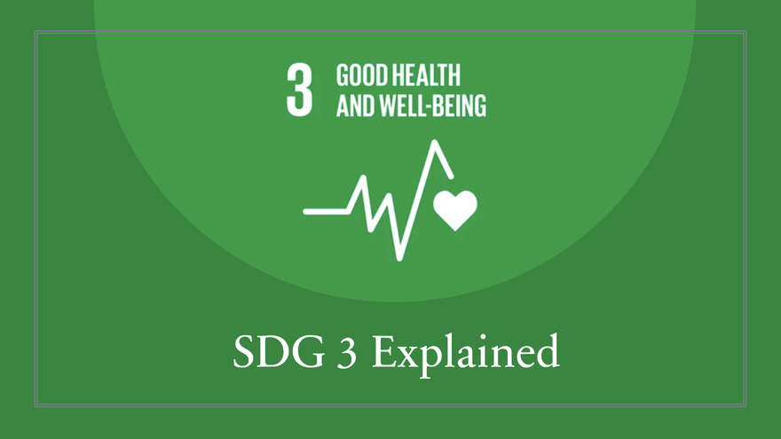

Figure1: United Nations (n.d.) states that SDG 3 focuses on ensuring healthy lives and promoting well-being for all.

Introduction
The Sustainable Development Goals (SDGs), proved by the United Nations in 2015, provide a comprehensive global framework for addressing interconnected challenges such as health inequalities, environmental degradation, and social injustice (United Nations, 2015). Among these, SDG 3: Good Health and Wellbeing is central to improving population health outcomes and reducing global disparities. However, health is increasingly understood as being shaped by structural determinants beyond healthcare systems, including environmental sustainability, income distribution, and climate stability (Marmot, 2020; WHO, 2021).
SDG 13: Climate Action is therefore critically relevant, as climate change is now recognised as one of the most significant global health threats of the 21st century (Watts et al., 2018; IPCC, 2022). Rising temperatures, air pollution, and extreme weather events directly and indirectly influence morbidity, mortality, and wellbeing.
This report critically evaluates SDG 3 and SDG 13 at global, national (United Kingdom), and local (Birmingham) levels. It applies theoretical perspectives including the Social Determinants of Health model (Dahlgren and Whitehead, 1991), Health Belief Model (Rosenstock, 1974), and Social Cognitive Theory (Bandura, 1986) to examine policy effectiveness, inequalities, and barriers affecting sustainable development.

Section 1: SDG 3 – Good Health and Wellbeing
SDG 3 aims to ensure healthy lives and promote wellbeing for people of all ages, including improving maternal health, reducing communicable and non-communicable diseases, supporting mental health, and achieving universal health coverage (United Nations, 2015). Although global health improvements have increased life expectancy and reduced some diseases, significant inequalities remain between and within countries (Marmot, 2020; Beaglehole et al., 2019).

Digital healthcare approaches such as telehealth can improve access to healthcare, particularly for people living in rural or underserved communities. Remote consultations reduce travel barriers and allow individuals to receive prompt support. Remote monitoring technologies also support people with long-term conditions, including diabetes and hypertension, by enabling early intervention, improving health outcomes, and reducing avoidable hospital admissions (World Health Organisation, 2023).

However, digital exclusion and data privacy concerns may limit the effectiveness of telehealth (United Nations Inter-Agency Task Team on Science, Technology, and Innovation for the SDGs and UNIDO, 2022).

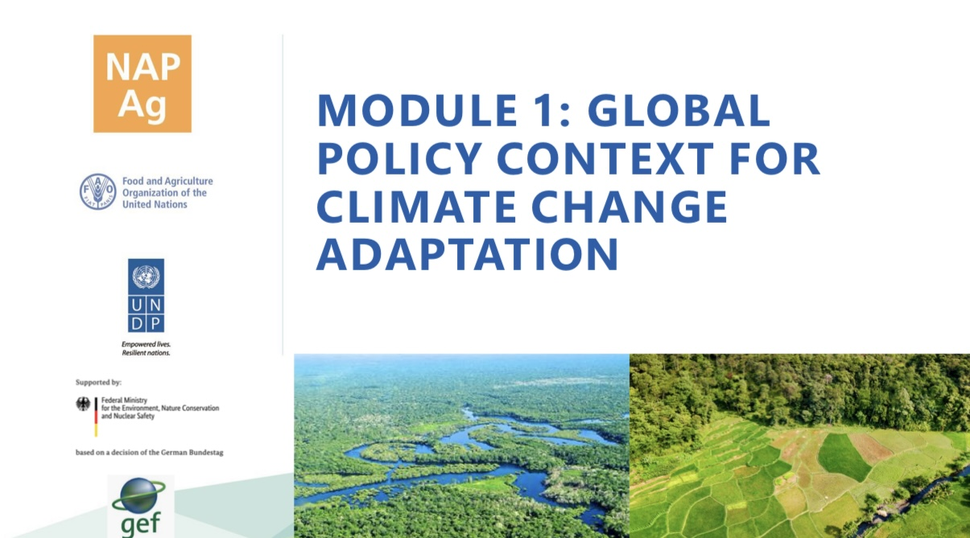
Global Policy Context

Figure2: Climate adaptation should address gender inequalities affecting vulnerable groups (United Nations Development Programme, n.d.)

At a global level, the World Health Organisation (WHO) supports international health governance through initiatives such as the Global Action Plan for Healthy Lives and Well-being for All, which promotes collaboration between organisations and improved health system efficiency (WHO, 2019). However, global health governance remains affected by political and economic inequalities, limiting equal participation among countries (Kickbusch and Lister, 2016; Yamey et al., 2020).
The COVID-19 pandemic exposed weaknesses within global health systems, particularly through unequal vaccine distribution. High-income countries secured greater vaccine access, highlighting continuing inequalities and limitations in achieving global health equity (Yamey et al., 2020).
The Social Determinants of Health model (Dahlgren and Whitehead, 1991) demonstrates that health outcomes are shaped by wider social, economic, and environmental conditions rather than healthcare services alone. Therefore, improving health requires addressing poverty, education, housing, and employment inequalities alongside medical interventions (Marmot, 2020).

United Kingdom Policy Context

In the UK, SDG 3 is supported through the National Health Service (NHS) and public health strategies such as Prevention is Better than Cure, which focus on prevention, early intervention, and reducing long-term health conditions (Department of Health and Social Care, 2018). Integrated care approaches aim to improve collaboration between healthcare and social care services (NHS England, 2021).
However, significant health inequalities remain. Marmot (2020) identified widening differences in life expectancy between affluent and deprived communities, demonstrating the continuing impact of social determinants such as income, housing, education, and employment. Wilkinson and Pickett (2018) argue that greater income inequality contributes to poorer population health outcomes.
Behavioural theories help explain challenges in improving health behaviours. The Health Belief Model suggests that individuals are more likely to adopt healthier behaviours when they recognise health risks and believe that change will provide benefits (Rosenstock, 1974). However, social, and economic barriers can limit people’s ability to make healthy choices. Social Cognitive Theory also highlights that behaviour is influenced by social environments and available resources rather than individual decisions alone (Bandura, 1986).

Local Implementation
At the local level, Integrated Care Systems (ICSs) aim to coordinate healthcare, social care, and community services (NHS England, 2021). Local authority public health programmes focus on smoking cessation, obesity reduction, and mental health support.
However, austerity policies have significantly reduced local public health budgets, weakening preventive capacity (Bambra, 2019). This has resulted in uneven service provision and increased regional health inequalities. The Ottawa Charter for Health Promotion (WHO, 1986) emphasises enabling environments and community empowerment, yet local implementation often remains service-driven rather than structural.

Critical Evaluation and Recommendations
Overall, SDG 3 demonstrates partial success but persistent structural limitations. A key issue is over reliance on individual behaviour change models, which insufficiently address socioeconomic determinants (Marmot, 2020). A shift toward Health in All Policies (HiAP) is required to embed health considerations across housing, education, and employment policy (Kickbusch and Buckett, 2010).
Increased investment in prevention, stronger integration of services, and community-led interventions is also essential to reduce inequalities and improve long-term outcomes (WHO, 2019).

Section 2: SDG 13 – Climate Action
SDG 13 focuses on urgent action to combat climate change and its impacts (United Nations, 2015). Climate change is increasingly recognised as a major determinant of global health, affecting mortality, disease patterns, mental health, food security, and health inequalities (Watts et al., 2018; IPCC, 2022).

Global Policy Context

The Paris Agreement (2015) represents the main international climate governance framework, aiming to limit global temperature increases to well below 2°C while pursuing efforts to restrict warming to 1.5°C (UNFCCC, 2015). The World Health Organisation (2023) highlights that climate mitigation actions can provide important health benefits, including improved air quality, reduced respiratory illness, and increased opportunities for physical activity.
However, global climate action remains insufficient. The IPCC (2022) reports that current national commitments are not consistent with achieving global temperature targets. In addition, climate finance inequalities continue, with lower-income countries experiencing severe climate impacts despite contributing less to global emissions (UNDP, 2022).
Climate change also raises ethical concerns regarding climate justice. Vulnerable populations often experience the greatest consequences of climate change due to limited resources, weaker infrastructure, and reduced adaptation capacity. The United Nations Development Programme (n.d.) highlights the importance of climate adaptation strategies that consider inequalities and protect vulnerable communities.
From a behavioural perspective, the Health Belief Model suggests that individuals and policymakers may underestimate climate risks when they perceive them as distant or unlikely to affect them directly. This reduced perception of vulnerability can delay climate action despite scientific evidence (Rogers, 1974).

Critical Debate: Global Health Governance

Although international agreements such as the Paris Agreement have strengthened global cooperation, debates remain regarding their effectiveness. Supporters argue that international climate commitments encourage governments to invest in renewable energy and prove long-term sustainability goals (UNFCCC, 2015). However, critics highlight that limited enforcement mechanisms allow countries to create ambitious targets without sufficient implementation (IPCC, 2022).
Climate finance remains another major concern. Although wealthier countries have greater responsibility due to historical emissions, many developing countries continue to experience difficulties accessing sufficient resources for climate adaptation (UNDP, 2022). Therefore, achieving SDG 13 requires stronger accountability, financial support, and international cooperation.

United Kingdom Policy Context

The UK has proven climate commitments through the Climate Change Act (2008, amended 2019), which legally requires achieving net-zero greenhouse gas emissions by 2050 (HM Government, 2019). Supporting policies include the Net Zero Strategy, which focuses on renewable energy, transport improvements, and reducing emissions across different sectors (BEIS, 2021).
Despite these commitments, significant challenges remain. The Climate Change Committee (2023) identified gaps in areas including transport, housing, and industrial decarbonisation. Climate policies also need to address environmental inequalities, as deprived communities are often exposed to higher levels of pollution and greater climate-related risks (Fecht et al., 2015; Marmot et al., 2020).
Climate action can create important health benefits. For example, cleaner transport systems can reduce air pollution and encourage active travel, improving cardiovascular and respiratory health. However, policies must consider fairness and ensure that vulnerable groups are not disadvantaged during the transition towards sustainability.

Critical Debate: Individual Responsibility versus Structural Determinants

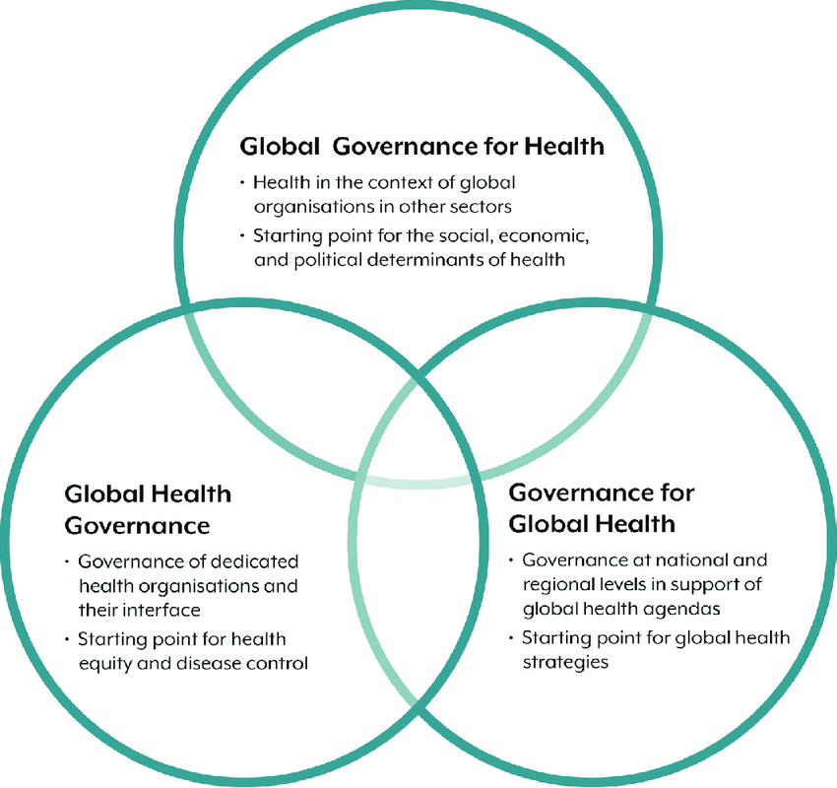

Figure 3: Global Health Governance along three political spaces (van de Pas, 2020).

A continuing debate in public health concerns whether improving health and environmental outcomes should focus on individual behaviour or wider structural change. Government strategies often encourage personal responsibility through lifestyle changes such as healthier diets, increased physical activity, and reduced smoking (Department of Health and Social Care, 2018).
However, Marmot (2020) argues that focusing on individual choices ignores wider factors such as poverty, housing conditions, employment insecurity, and unequal access to resources. Individuals living in disadvantaged communities may face greater barriers to making healthy and environmentally sustainable choices.
Behavioural approaches remain valuable because lifestyle changes can reduce the risk of preventable diseases (Beaglehole et al., 2019). However, effective progress requires combining individual interventions with policies that address wider social and economic inequalities.

Critical Debate: Climate Commitments versus Policy Implementation

Although international agreements such as the Paris Agreement represent significant political progress, there is considerable debate regarding their practical effectiveness. Supporters argue that legally recognised climate targets encourage long-term investment in renewable technologies and strengthen international cooperation (UNFCCC, 2015). Nevertheless, critics note that the Agreement lacks robust enforcement mechanisms, allowing governments to set ambitious targets without implementing sufficient domestic action (IPCC, 2022).
This “implementation gap” has become increasingly evident as current national commitments remain inconsistent with limiting global warming to 1.5°C (Climate Action Tracker, 2023). Furthermore, wealthier nations have frequently failed to meet promised climate finance commitments to developing countries, raising concerns regarding climate justice and international accountability (UNDP, 2022). Consequently, while global agreements establish an important policy framework, their success depends upon effective national implementation, transparent monitoring, and equitable international cooperation.

Local Level Action Birmingham
At a local level, Birmingham City Council has developed climate action strategies focusing on reducing emissions, improving green spaces, and encouraging sustainable transport (Birmingham City Council, 2023). These approaches can improve health by increasing physical activity, reducing air pollution, and supporting healthier environments.
However, challenges remain due to differences in local authority resources, funding pressures, and technical capacity. Limited resources can affect the ability of communities to implement effective climate adaptation strategies and may increase inequalities in climate resilience.

Critical Debate: Economic Growth and Climate Policy
A significant debate concerns whether ambitious climate policies can be achieved alongside economic growth. Supporters of green economic development argue that investment in renewable energy, sustainable transport, and green infrastructure can create employment opportunities while improving environmental and health outcomes (Mastini, Kallis, and Hickel, 2021)
Conversely, critics argue that rapid decarbonisation may create short-term economic challenges for industries and workers dependent on carbon-intensive sectors (Climate Change Committee, 2023). However, evidence suggests that the long-term costs of climate inaction, including increased healthcare costs and environmental damage, are likely to exceed the costs of prompt action (Stern, 2008; IPCC, 2022).
Therefore, climate policies should support a just transition by protecting vulnerable workers, reducing inequalities, and promoting sustainable economic development.

Critical Evaluation and Recommendations

Achieving SDG 3 requires stronger accountability, as policy effectiveness depends on transparent monitoring, adequate funding, and collaboration between healthcare providers, governments, and communities (World Health Organisation, 2023).
However, workforce shortages, unequal resource distribution, and wider social determinants continue to reinforce health inequalities (Dahlgren and Whitehead, 1991; Marmot et al., 2020). Ethical concerns regarding unequal access and digital exclusion remain significant (Nutbeam, 2018).
Similarly, SDG 13 demonstrates strong policy ambition but weak implementation consistency due to the separation of climate and health policies (Watts et al., 2018). A planetary health approach is needed to integrate sustainability, health impact assessments, adaptation funding, and climate justice to address unequal vulnerability and exposure (Whitmee et al., 2015; IPCC, 2022).

Integrating SDG 3 and SDG 13

Although SDG 3 and SDG 13 are separate goals, they are strongly interconnected. Climate change affects health through increased temperatures, air pollution, food insecurity, infectious diseases, and mental health impacts (Watts et al., 2018). At the same time, climate mitigation strategies such as renewable energy, active transport, and improved urban environments can create direct health benefits (WHO, 2021).
A systems-thinking approach is therefore required, where health and environmental policies are developed together rather than separately. Integrating these goals can improve efficiency, reduce inequalities, and support sustainable development.

Conclusion

This report has critically examined SDG 3 and SDG 13 across global, national, and local contexts, demonstrating that health and climate challenges are deeply connected. Although SDG 3 has improved healthcare access and disease prevention, progress remains limited by social, economic, and environmental inequalities. The Social Determinants of Health model demonstrates that improving health requires action beyond healthcare services alone.
Similarly, SDG 13 has encouraged important climate commitments, but implementation remains challenged by political, economic, and governance barriers. Climate change is not only an environmental issue but also a major public health and ethical concern that disproportionately affects vulnerable populations.
The relationship between SDG 3 and SDG 13 highlights the need for integrated approaches based on equity, accountability, and planetary health principles. Future progress requires stronger implementation, transparent monitoring, community involvement, and fair distribution of resources to protect both current and future generations.

References
Bandura, A., 1986. Social foundations of thought and action. Englewood Cliffs, NJ, 1986(23-28), p.2.
Bambra, C., 2019. Introduction: Local health inequalities in an age of austerity. In Health in hard times (pp. 1-34). Policy Press.
Beaglehole, R., Bonita, R., Horton, R., Adams, C., Alleyne, G., Asaria, P., Baugh, V., Bekedam, H., Billo, N., Casswell, S. and Cecchini, M., 2011. Priority actions for the non-communicable disease crisis. The lancet, 377(9775), pp.1438-1447.
Birmingham City Council (2023) Route to net zero: Birmingham’s climate action journey. Birmingham: Birmingham City Council. Available at: https://www.birmingham.gov.uk/climatechange (Accessed: 13 July 2026).
Climate Change Committee (2023) Progress in reducing emissions: 2023 report to Parliament. London: Climate Change Committee.
Department for Business, Energy, and Industrial Strategy (BEIS) (2021) Net Zero Strategy: Build Back Greener. London: HM Government. Available at: https://www.gov.uk/government/publications/net-zero-strategy (Accessed: 13 July 2026).
UK, G., 2018. Prevention is better than cure: our vision to help you live well for longer. Department of Health and Social Care.
Fecht, D., Fischer, P., Fortunato, L., Hoek, G., De Hoogh, K., Marra, M., Kruize, H., Vienneau, D., Beelen, R. and Hansell, A., 2015. Associations between air pollution and socioeconomic characteristics, ethnicity, and age profile of neighbourhoods in England and the Netherlands. Environmental pollution, 198, pp.201-210.
HM Government (2019) The Climate Change Act 2008 (2050 Target Amendment) Order 2019. London: The Stationery Office. Available at: https://www.legislation.gov.uk (Accessed: 13 July 2026).
Change, I.C., 2022. impacts, adaptation, and vulnerability. Contribution of Working Group II to the Sixth Assessment Report of the Intergovernmental Panel on Climate Change. O., Roberts, DC, Tignor, M., Poloczanska, ES, Mintenbeck, K., Alegría, A., Craig, M., Langsdorf, S., Löschke, S., Möller, V., et al., Eds, 3056.
Kickbusch, I. and Buckett, K., 2010. Implementing health in all policies: Adelaide 2010.
Kickbusch, I., and Lister, G. (2016) Global health diplomacy. London: Chatham House.
Marmot, M., 2020. Health equity in England: The Marmot review 10 years on. Bmj, 368.
England, N.H.S. and Improvement, N.H.S., 2021. Integrated care systems: design framework. Version, 1, p.13.
Nutbeam, D., 2000. Health literacy as a public health goal: a challenge for contemporary health education and communication strategies into the 21st century. Health promotion international, 15(3), pp.259-267
Rogers, R.W., 1975. A protection motivation theory of fear appeals and attitude change1. The journal of psychology, 91(1), pp.93-114.
Mastini, R., Kallis, G. and Hickel, J., 2021. A new green deal without growth? Ecological economics, 179, p.106832.
Stern, N., 2008. The economics of climate change. American economic review, 98(2), pp.1-37.
United Nations (2015) Transforming our world: The 2030 Agenda for Sustainable Development. New York: United Nations. Available at: https://sdgs.un.org/2030agenda (Accessed: 13 July 2026).
United Nations (n.d.) Goal 3: Ensure healthy lives and promote well-being for all at all ages. Available at: https://sdgs.un.org/goals/goal3 (Accessed: 13 July 2026).
United Nations Development Programme (UNDP) (n.d.) Module 1: Global Policy Context for Climate Change Adaptation. Available at: https://www.adaptation-undp.org/sites/default/files/uploaded-images/module_1_global_policy_context_for_me_of_adaptation.pdf (Accessed: 13 July 2026).
United Nations Development Programme (UNDP) (2022) Human Development Report 2021/2022: Uncertain times, unsettled lives. New York: UNDP. Available at: https://hdr.undp.org (Accessed: 13 July 2026).
United Nations Framework Convention on Climate Change (UNFCCC) (2015) The Paris Agreement. Bonn: UNFCCC. Available at: https://unfccc.int (Accessed: 13 July 2026).
Van de Pas, R.A.M., 2020. A cosmopolitan outlook on health workforce development.
Watts, N., Amann, M., Arnell, N., Ayeb-Karlsson, S., Belesova, K., Berry, H., Bouley, T., Boykoff, M., Byass, P., Cai, W. and Campbell-Lendrum, D., 2018. The 2018 report of the Lancet Countdown on health and climate change: shaping the health of nations for centuries to come. The Lancet, 392(10163), pp.2479-2514.
Whitmee, S., Haines, A., Beyrer, C., Boltz, F., Capon, A.G., de Souza Dias, B.F., Ezeh, A., Frumkin, H., Gong, P., Head, P. and Horton, R., 2015. Safeguarding human health in the Anthropocene epoch: report of The Rockefeller Foundation–Lancet Commission on planetary health. The lancet, 386(10007), pp.1973-2028.
Wilkinson, R. and Pickett, K., 2020. The inner level: How more equal societies reduce stress, restore sanity, and improve everyone's well-being. Penguin.
World Health Organisation, 1986. Ottawa charter for health promotion. In First International Health Promotion Conference, Ottawa, Canada, 1986.
World Health Organisation (WHO) (2019) Global action plan for healthy lives and wellbeing for all. Geneva: World Health Organisation.
World Health Organisation, 2023. Climate change, health, and environment: a regional framework for action, 2023-2029 (No. EM/RC70/6). World Health Organisation. Regional Office for the Eastern Mediterranean.

Yamey, G., Schäferhoff, M., Hatchett, R., Pate, M., Zhao, F. and McDade, K.K., 2020. Ensuring global access to COVID-19 vaccines. The Lancet, 395(10234), pp.1405-1406.

