

ASSESSMENT COMPONENT 1: INDIVIDUAL REPORT – CHOSEN COMPANY AIRBNB
NAMES AND SURNAME: SANDRA JULITA KUBIS
STUDENT ID: 2327907
MODULE CODE: LCBB5010_LON
MODULE NAME: MANAGEMENT ACCOUNTING FOR MANAGERS
LECTURER: ANDRY RAKOTOVOLOLONA

Table of Contents
1. INTRODUCTION 2
1.1 Brief Background 2
1.2 Importance of Management Accounting in Decision-Making 2
2. COST ANALYSIS AND BUSINESS MODEL OF AIRBNB 2
2.1 Revenue Model 2
2.2 Key Cost Structures 3
3. BUDGETING AND FINANCIAL PLANNING 4
3.1 The Role of Budgeting in Airbnb’s Operations 4
3.2 Year-on-Year Change 5
3.2.1 Operating Expense Change 5
3.2.2 Management Decisions 6
3.2.3 Macroeconomic Influences 6
4. PERFORMANCE MEASUREMENT AND DECISION-MAKING 6
4.1 Financial KPIs 7
4.2 Non-Financial KPIs 9
4.3 Application of KPI’s 10
4.4 Strategic Decisions Informed by KPI’s 10
5. SUSTAINABILITY AND ETHICAL CONSIDERATIONTS 11
5.1 Sustainability and Ethical Considerations 11
5.2 Ethical Cost Management and Pricing 11
5.2.1 Pricing Strategies 11
6. CONCLUSION 12
7. RECOMMENDATIONS 12
8. REFERENCES 13

1. INTRODUCTION

1.1 Brief Background
Founded in 2008, Airbnb, Inc. is a global online marketplace connecting hosts offering accommodation with travellers seeking short-term stays. Operating in more than 2020 countries and regions, Airbnb has transformed the hospitality industry by enabling peer-to-peer lodging through its digital platform. Its core services include home rentals, Airbnb Experiences, and increasingly, long-term stays positioning it as a leading player in the sharing economy (Airbnb, 2024).

1.2 Importance of Management Accounting in Decision-Making
In today’s dynamic business environment, management accounting plays a vital role in supporting Airbnb’s strategic and operational decisions. It provides managers with relevant financial and non-financial information to plan, control, and evaluate performance, ensuring resource optimization and competitiveness. By applying tools such as budgeting, cost analysis, and performance metrics, management accounting enables data-driven decision-making that enhances profitability, improves customer experience, and sustains long-term growth. This essay will examine these roles in detail, linking them to Airbnb’s cost structure, budgeting practices, performance measurement and ethical considerations.

2. COST ANALYSIS AND BUSINESS MODEL OF AIRBNB

2.1 Revenue Model
Airbnb operates a platform-based peer-to-peer (P2P) business model that connects hosts who list properties with guests looking for short-term accommodation. Unlike traditional hotel chains, Airbnb does not own the rental properties listed on its platform, allowing for scalability without major capital investment in real estate (Guttentag, 2019). The company’s primary revenue stream comes from services fees charged to both costs and guests. Hosts are typically charged around 3% per booking, while guests may pay between 5-15% depending on the duration, property type, and location (Airbnb, 2023). This fee structure ensures that revenue is tied directly to booking volume and platform usage.
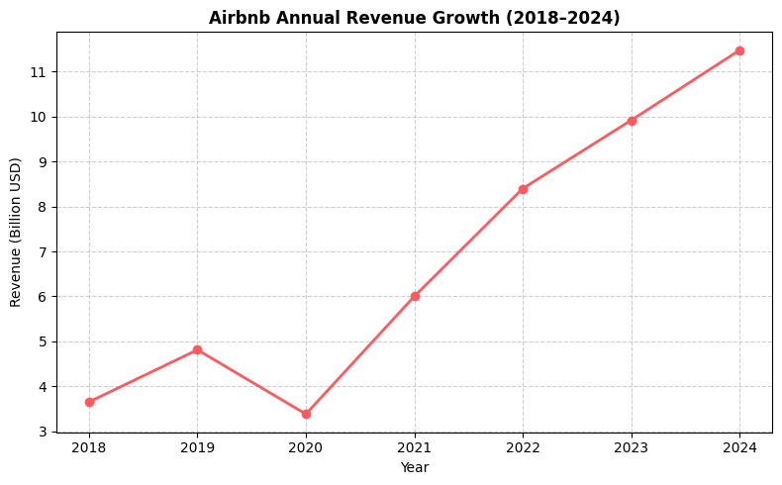
Figure 1: Created by the learner based on Airbnb Annual Reports (2018-2024).
Figure 1, derived from Airbnb Annual Reports (2018-2024), demonstrates a clear increase in revenue over time, rising from around USD 3.7 billion in 2018 to more than USD 11.5 billion in 2024. The noticeable drop in 2020 corresponds with the global decline in travel caused by COVIID-19 restrictions, which significantly affected the tourism and hospitality industry (OECD, 2021). However, revenue sharply recovered from 2021 onwards due to the rise of remote work, longer stays, and travellers seeking flexible, home-based accommodation instead of traditional hotel stays (Burbank, 2022). This recovery reflects Airbnb’s ability to adapt its platform to evolving lifestyle and travel trends, demonstrating effective management decision-making and strategic resilience.

2.2 Key Cost Structures
Airbnb’s cost structure includes both fixed and variable operational expenses. A significant fixed cost relates to technology development, cybersecurity, and continuous platform maintenance to ensure efficient global operations (Airbnb, 2023). Other fixed expenses include salaries for corporate staff, regulatory compliance, and extensive marketing campaigns aimed at strengthening brand visibility worldwide (Li, Liu and Zhang, 2023).

Variable costs, however, fluctuate based on platform usage and include customer service operations, host support programmes, insurance guarantees, and promotional incentives. Importantly, Airbnb does not incur costs associated with property ownership, maintenance, or staffing, as these responsibilities are carried by individual hosts (Dolnicar, 2019). This enables Airbnb to benefit from high operational leverage, where increases in booking volume lead to greater profitability (Kumar, 2021).

3. BUDGETING AND FINANCIAL PLANNING

3.1 The Role of Budgeting in Airbnb’s Operations
Budgeting plays a central role in Airbnb’s financial planning and strategic decision-making. As Atrill and McLaney (2023) explain, budgeting helps organisations align financial resources with strategic objectives, coordinate operational activities, and evaluate performance through planned vs. actual outcomes. This is highly relevant for Airbnb, which operates in a dynamic travel market influenced by seasonality, global economic trends, and regulatory changes.
Budgeting at Airbnb involves forecasting revenue from bookings, estimating spending on technology infrastructure, marketing, and host acquisition, and planning resource allocation across global markets. During periods of strong demand, Airbnb increases budgets for platform development and market expansion, while during downturns, the company focuses on cost efficiency and core service quality (Deloitte, 2024). Budgeting also supports performance control, enabling management to compare financial outcomes with targets and respond to deviations (Atrill and McLaney, 2023).
Moreover, Airbnb increasingly uses rolling forecasts, updated frequently using real-time platform analytics and predictive models (Accenture, 2024). This allows rapid adjustment to changing travel patterns, strengthening resilience in uncertain economic environments. Overall, budgeting in Airbnb functions as an integrated management accounting tool, linking operational metrics to financial performance and long-term strategic planning.

3.2 Year-on-Year Change
Airbnb’s financial statements provide evidence of budgeting outcomes, revealing how cost structures and spending priorities shift over time in response to market conditions and organisational strategy.

3.2.1 Operating Expense Change
According to Airbnb’s 2024 Annual Report, operating expenses increased year-on-year due to higher investments in product development and marketing.

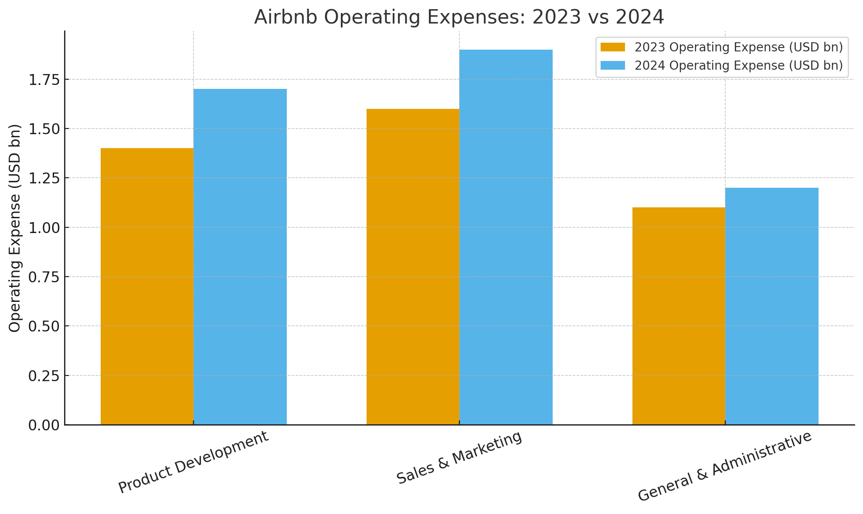
+9%
+19%
+21%
Figure 2: Created by the learner based on source Airbnb (2024).

This increase reflects strategic spending rather than inefficiency, showing planned reinvestment driven by expected future growth.

3.2.2 Management Decisions
The increase in operating expenses reflects management’s strategic decision to invest in technology enhancements that improve search accuracy, pricing tools, and host onboarding, as well as to expand brand and performance marketing to attract new users and grow in emerging markets. Additionally, resources were directed towards trust and safety initiatives, including stronger identity verification and insurance protections, to enhance reliability sustainable growth and align budgeting with long-term strategic objectives (Horngren, Datar and Rajan, 2023).

3.2.3 Macroeconomic Influences
The year-on-year increase in Airbnb’s operating expenses was also shaped by wider macroeconomic conditions. The global recovery in travel following the pandemic led to stronger consumer demand, which encouraged greater investment in platform capacity and host acquisition (Deloitte, 2024). At the same time inflationary pressures contributed to rising labour and marketing costs, particularly in technology development and digital advertising, Currency fluctuations further influenced reported expenses, as Airbnb operates across multiple international markets where exchange rate movements affect the conversion of global operating costs (OECD, 2021). These factors indicate that Airbnb’s budgeting decisions are influenced not only by internal strategic priorities, but also by external economic conditions that shape cost structures and revenue expectations.

4. PERFORMANCE MEASUREMENT AND DECISION-MAKING
Effective performance measurement is central to Airbnb’s management accounting and strategic decision-making processes. By integrating financial and non-financial Key Performance Indicatiors (PKIs), Airbnb is able to evaluate operational efficiency, market competitiveness, and long-term sustainability (Camilleri, 2024). KPIs translate organisational activities into measurable outcomes, allowing managers to monitor profitability, assess strategic progress, and optimise resource allocation.
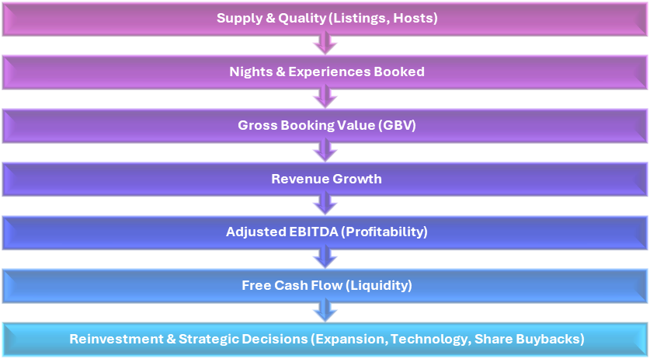
Figure 3: Created by the learner.
Figure 3, visualises how Airbnb’s performance indicators flow from operational inputs (such as listings and nights booked) to financial outcomes (including EBITDA and Free Cash Flow), ultimately informing reinvestment priorities and strategic planning. This demonstrated how operational activity directly influences financial results and long-term growth decisions – a core principle of management accounting and strategic analysis.

4.1 Financial KPIs
One of the key financial performance indicators used by Airbnb is Gross Booking Value (GBV), which represents the total value of all reservations made through the platform. In 2024, Airbnb reported GBV of approximately USD 82 billion, reflecting the scale of its global operations and the extend of its market penetration (Airbnb, 2024a). GBV is particularly useful as a leading indicator because it signals future revenue potential before deductions for service fees and operational costs, thereby informing decisions related to market expansion and pricing strategies.
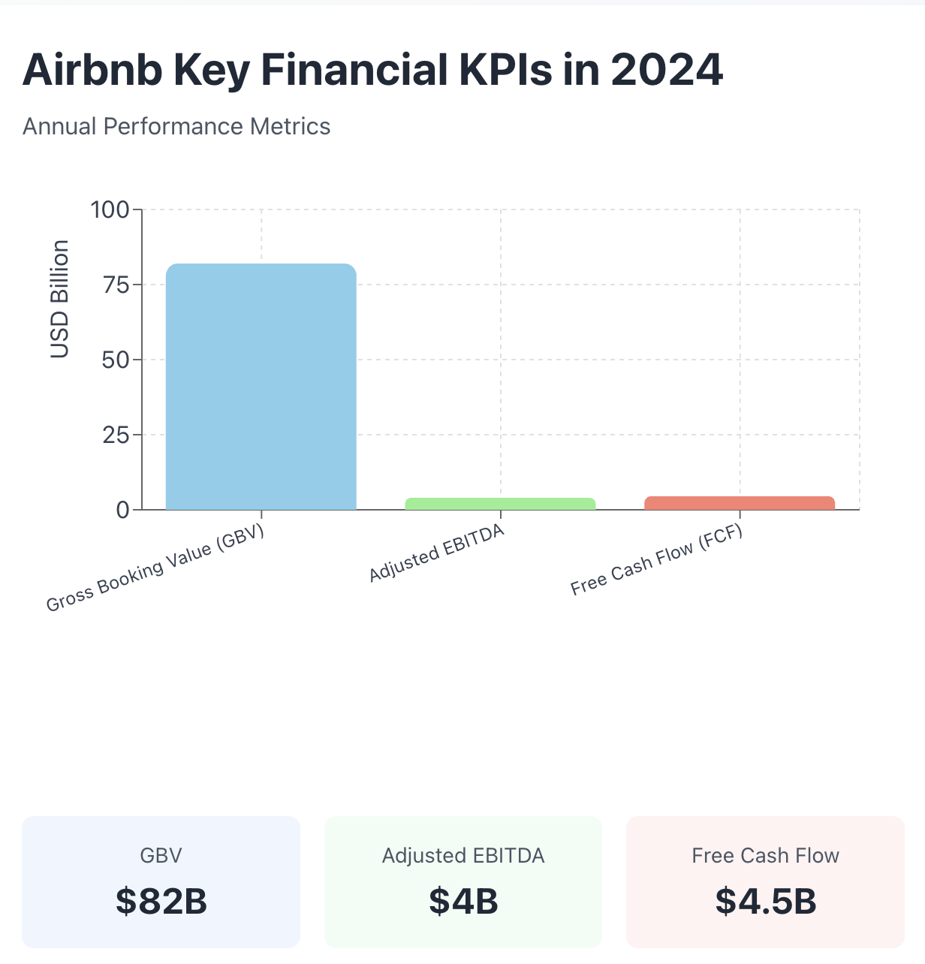
Figure 4: Created by the learner based on source Airbnb (2024a).
Another important financial KPI is Adjusted EBITDA, which reached USD 4.0 billion in 2024, corresponding to a 36% margin (Airbnb, 2024a). This measure excludes one-off and non-cash expenses, allowing managers to assess underlying profitability and operational efficiency more accurately, supporting strategic decisions about cost allocation and resource planning (Camilleri, 2024).
In addition, Airbnb generated USD 4.5 billion in Free Cash Flow (FCF) in 2024, demonstrating strong liquidity and internal financing capacity (Airbnb, 2024a). FCF plays a central role in evaluating financial resilience, particularly in relation to decisions concerning share repurchases, technology investment, and international expansion. Collectively, these financial KPIs enable Airbnb to assess profitability, sustainability, and long-term value creation, aligning performance evaluation with strategic decision-making (Camilleri, 2024).

4.2 Non-Financial KPIs
In addition to financial indicators, Airbnb relies on non-financial KPIs to assess operational performance and long-term growth potential. One of the most significant of these is the number of Nights and Experiences Booked, which reached 122.8 million in Q3 2024, representing an 8% year-on-year increase (Airbnb, 2024c). This KPI provides insight into consumer demand and platform engagement across diverse global markets.
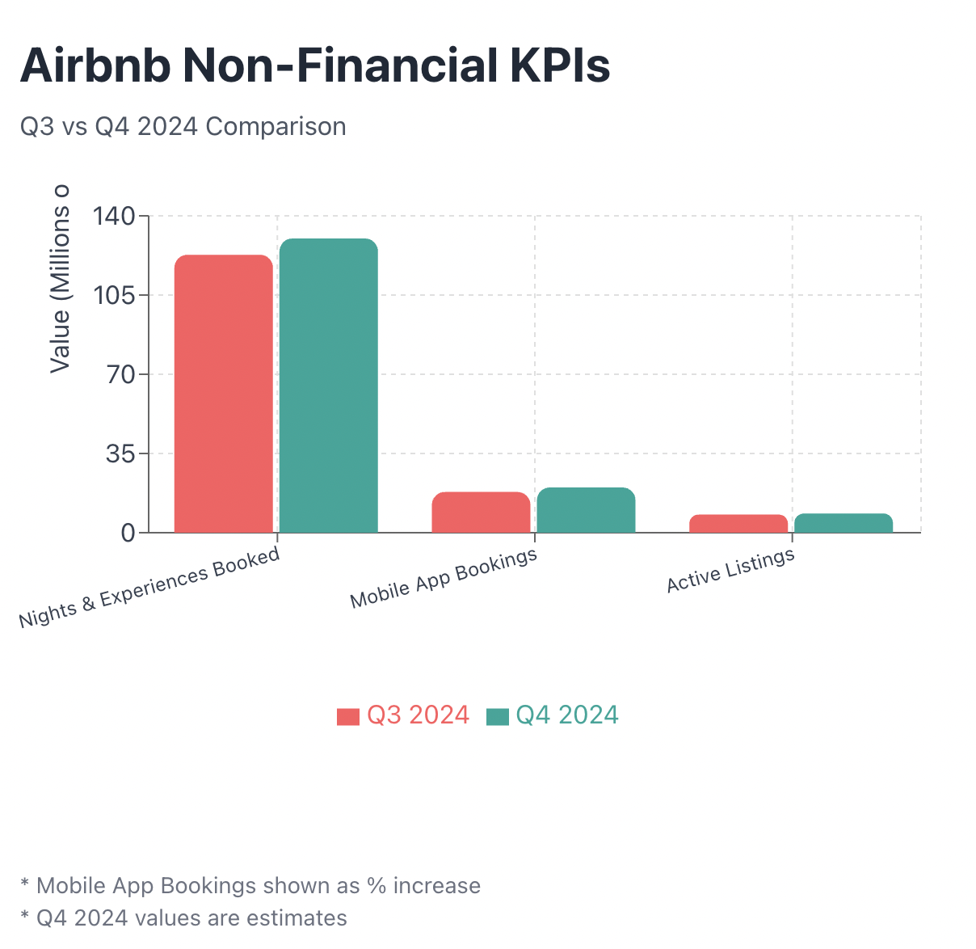
Figure 5: Created by the learner based on sources Airbnb (2024c), Rental Scale-Up (2024) and Zarzycka (2022).
Similarly, the organisation tracks the volume of Mobile App Bookings and the number of Active Listings, both of which indicate platform accessibility and supply network strength. In Q3 2024, mobile bookings rose by 18%, while active listings surpassed 8 million worldwide, reflecting successful host acquisition and user interface optimisation (Rental Scale-Up, 2024).
These non-financial indicators help managers identify operational strengths and service delivery challenges, informing investment in technology development, user experience improvements, and host support programmes. In Q4 2024, Airbnb continued this trend, reporting further growth in nights booked and strong demand across key regions (Airbnb, 2024b). Overall, non-financial KPIs offer a broader understanding of performance by linking customer behaviour and service quality to future revenue potential, thereby complementing traditional financial measures (Zarzycka, 2022).

4.3 Application of KPI’s
Together, financial and non-financial KPIs form an integrated performance framework, where:
Operational activity -> Drives Revenue -> Enhances Profitability -> Generates Cash Flow -> Funds Reinvestment
For example, increased nights booked raise GBV, which boosts revenue and EBITDA, leading to stronger free cash flow that can be reinvested into platform innovation and strategic expansion (Airbnb, 2024c). This alignment demonstrates analytical reasoning and strategic competence, reflecting transferable professional skills.

4.4 Strategic Decisions Informed by KPI’s
Airbnb’s financial and non-financial KPIs guide strategic decisions including expansion, investment, and pricing. Growth in ‘’Nights and Experiences Booked’’ and ‘’Active Listing’’ signalled rising demand, supporting expansion into long-term stays and remote-worker accommodations (Airbnb, 2024c). Internal analytics showed that 20% of 2023 bookings were for stays longer that 28 days, highlighting changing travel behaviour (Deloitte, 2024). Strong Free Cash Flow and Adjusted EBITDA enabled share repurchases and reinvestment in platform development (Airbnb, 2024a). Non-financial metrics, such as host satisfaction and review ratings, informed pricing and service improvements, including the ‘’Airbnb Categories’’ and ‘’Guest Favourites’’ systems (Rental Scale-Up, 2024).
Overall, Airbnb’s data-driven approach links KPI insights to strategic growth, profitability, and service differentiation (Horngren, Datar and Rajan, 2023),

5. SUSTAINABILITY AND ETHICAL CONSIDERATIONTS

5.1 Sustainability and Ethical Considerations
Sustainability has become an integral consideration in Airbnb’s financial decision-making, particularly as consumers and regulators increasingly expect responsible business practices. Airbnb incorporates sustainability into its strategy through initiatives that promote resource efficiency, local community engagement, and reduction of environmental impact. For example, the company encourages hosts to adopt energy-saving measures and eco-friendly amenities, while providing guidance on sustainable home operations (Airbnb, 2024).
Additionally, Airbnb supports dispersed tourism, which aims to reduce overcrowding in major cities by promoting less-visited destinations, thus reducing pressure on local infrastructure and improving community well-being (OECD, 2021). These sustainability efforts are reflected in Airbnb’s investment decisions, where funds are allocated to platform enhancements that improve host support, encourage sustainable travel, experiences, and strengthen trust and safety mechanisms, linking sustainability directly with long-term financial performance.

5.2 Ethical Cost Management and Pricing
Ethical considerations also play a crucial role in Airbnb’s cost management. The company must balance profitability with fairness to both hosts and guests. For instance, while Airbnb benefits from low capital expenditure due to its asset-light model, it has ethical responsibility to ensure that cost efficiencies do not negatively impact host income or customer experience (Dolnicar, 2019). Airbnb provides host guarantees, liability protection, and transparent fee structure to support ethical cost allocation (Airbnb, 2023).

5.2.1 Pricing Strategies
Airbnb employs dynamic pricing tools that adjust listing prices based on demand patterns, seasonality, and booking behaviour. While this enhances revenue optimisation, ethical concerns may arise where pricing contributes to affordability issues or housing market pressures in certain cities. In response, Airbnb has introduced regulations compliance support, pricing transparency features, and local partnership programmes to mitigate negative social impacts (Rental Scale-Up, 2024). Therefore, Airbnb’s pricing strategy reflects an ongoing balance between value creation, market competitiveness, and ethical responsibility.

6. CONCLUSION
This report demonstrated how Airbnb applies management accounting tools – including budgeting, cost analysis, and KPI performance measurement - to support strategic planning, operational efficiency, and financial decision-making. Airbnb’s asset-light platform model and data-driven budgeting processes enhance adaptability in a dynamic market environment, while integrated financial and non-financial KPIs inform strategic decision such as technology investment and market expansion. However, sustainability and ethical consideration require continued attention, particularly in cost management and pricing practices.

7. RECOMMENDATIONS
To strengthen its long-term strategic position, Airbnb should enhance sustainability reporting by including measurable environmental performance indicators into its financial and operational dashboards, allowing for greater transparency and accountability towards stakeholders.
Additionally, the organisation could benefit from strengthening ethical pricing governance, particularly in regions where short-term rental activity contributes to housing affordability pressures. Establishing clearer pricing guidelines and collaborating with local authorities would support fair market outcomes while maintaining platform competitiveness.
Finally, expanding host training and development programmes would improve service consistency and encourage sustainable property management practices. Together, these recommendations align with management accounting principles by ensuring informed decision-making, responsible resource allocation, and value creation over time.

8. REFERENCES
- Accenture (2024) AI-Powered Forecasting and Digital Operating Models in Travel Platforms. Dublin: Accenture Global Research. Available at: https://www.accenture.com (Accessed: 06 November 2025).
- Airbnb (2023) Form 10-K Annual Report. San Francisco: Airbnb, Inc. Available at: https://investors.airbnb.com/financials (Accessed: 06 November 2025).
- Airbnb (2024) Airbnb Annual Report 2024. Available at: https://www.airbnb.com (Accessed: 5 November 2025).
- Airbnb (2024a) Form 10-K Annual Report 2024. San Francisco: Airbnb Inc. Available at: https://investors.airbnb.com/financials (Accessed: 06 November 2025).
- Airbnb (2024b) Q4 2024 Shareholder Letter. Available at: https://s26.q4cdn.com/656283129/files/doc_financials/2024/q4/Airbnb_Q4-2024-Shareholder-Letter_Final.pdf (Accessed: 5 November 2025).
- Airbnb (2024c) Q3 2024 Shareholder Letter. Available at: https://s26.q4cdn.com/656283129/files/doc_financials/2024/q3/Airbnb_Q3-2024-Shareholder-Letter_Final.pdf (Accessed: 5 November 2025).
- Atrill, P. and McLaney, E. (2023) Management Accounting for Decision Makers. 11th edn. Harlow: Pearson Education.
- Burbank, J. (2022) ‘Remote Work and the Transformation of Travel Patterns’, Journal of Tourism Futures, 8(3), pp. 245–259. Emerald Publishing.
- Camilleri, E. (2024) Key Performance Indicators: The Complete Guide to KPIs for Business Success. Abingdon: Routledge.
- Deloitte (2024) Global Travel Industry Outlook 2024. London: Deloitte Insights. Available at: https://www2.deloitte.com (Accessed: 06 November 2025).
- Dolnicar, S. (2019) Airbnb and the Hospitality Industry. Cham: Springer International Publishing.
- Drury, C. (2022) Management and Cost Accounting. 11th edn. Andover: Cengage Learning.
- Guttentag, D. (2019) ‘Progress on Airbnb: A Literature Review’, Journal of Hospitality and Tourism Technology, 10(4), pp. 814–844. Emerald Publishing.
- Horngren, C.T., Datar, S.M. and Rajan, M. (2023) Cost Accounting: A Managerial Emphasis. 17th edn. Harlow: Pearson Education.
- Kaplan Publishing (2020) Performance Measurement Techniques. London: Kaplan Publishing.
- Kumar, V. (2021) ‘Platform Business Models and Profit Scaling’, Management Science Review, 67(6), pp. 1212–1228. INFORMS.
- Li, Y., Liu, H. and Zhang, L. (2023) ‘Marketing Expenditure and Global Platform Competition’, International Journal of Digital Marketing, 11(1), pp. 33–50. Taylor & Francis.
- OECD (2021) Tourism Policy Responses to COVID-19. Paris: OECD Publishing. Available at: https://www.oecd.org/coronavirus/policy-responses (Accessed: 06 November 2025).
- Rental Scale-Up (2024) ‘Airbnb Q3 2024 Financials Analysis.’ Available at: https://www.rentalscaleup.com/airbnb-q3-2024-financials/ (Accessed: 5 November 2025).
- Zarzycka, E. (2022) ‘Non-financial key performance indicators: what determines their use?’, Journal of Accounting & Organizational Change, 18(1), pp. 139–163.

