University of Wales Trinity Saint David
Wales Institute of Science and Art


Electronic Circuits Testing and Applications

Electrical Control Systems ACHA4010
Word Count:713
Jason Taberner
2404389
6/4/25
Contents
1 Task 3 1
1.1 Scope Time Division Calculations (3) 1
1.2 Function Generator output square wave (3) 2
1.3 Capacitor charge and discharge wave marked at correct points. (3) 2
1.4 Basic Capacitor Calculations (3) 2
1.5 Capacitor discharge table (2) 3
1.6 Plot log(V) Gradient (2) 3
1.7 Gradient Calculations and Compare (4) 3
1.7.1 Gradient Calculations 3
1.7.2 Comparison table 4
1.8 Capacitor Uses (5) 4
1.9 Inaccuracies Question (4) 5
2 References 6

Task 3
Equation 2

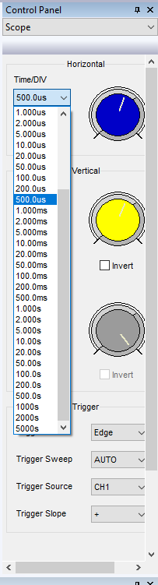
Scope Time Division Calculations (3)
Equation 1
Figure 1 Time/Div available in Hantek
$$τ=\frac{1}{f}=\frac{1}{250}=4*{10}^{-3}s$$
$$Time per Div=\frac{4*{10}^{-3}}{10}=\frac{1}{2500}=400µs$$

Figure 1 shows the Time/Div options available in the Hantek oscilloscope software. Equation 1 shows how to calculate the period of the waveform which is 1/frequency. Equation 2 shows how to calculate the time/div, there are 10 time divisions and so the equation is period/number of time div.

Function Generator output square wave (3)
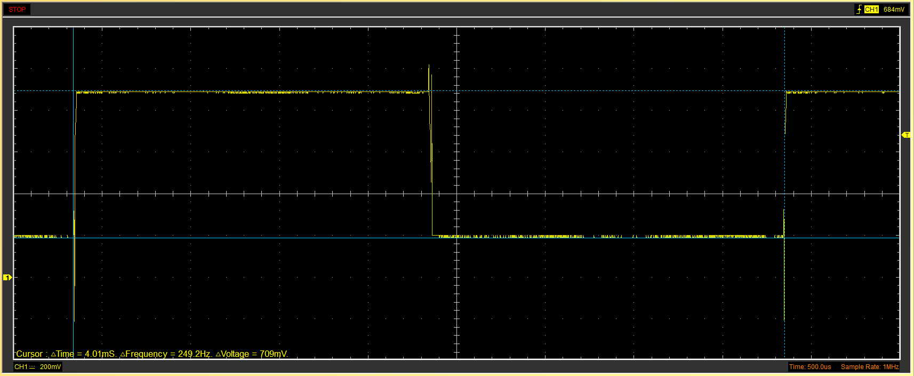
Figure 2 Square wave

Capacitor charge and discharge wave marked at correct points. (3)
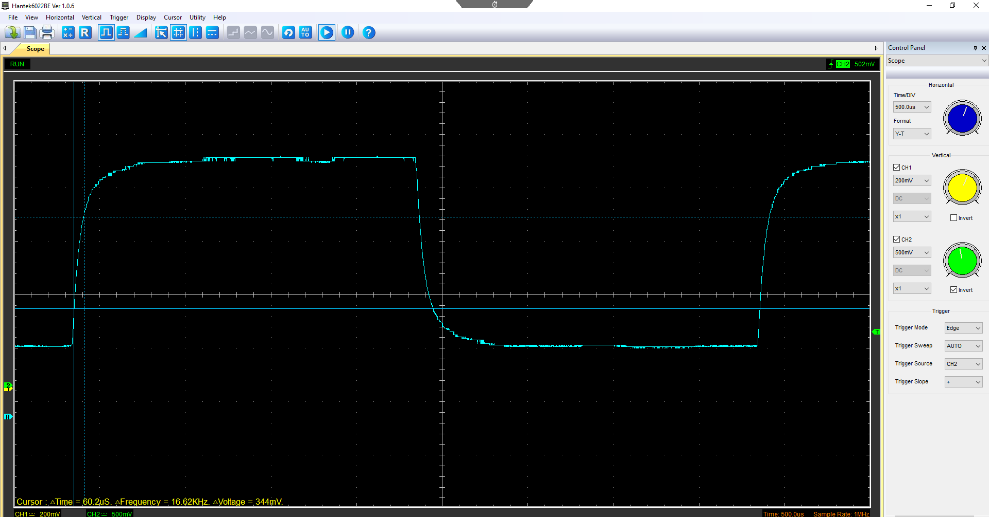
Figure 3 Capacitor wave form
Figure 4 Cursor Values
$$ΔV*63.2\%+Start\left(V\right)=V of the top cursor$$
$$V of top cursor=0.542*63.2\%=0.343V$$
The +start(V) isn’t needed as the start cursor stays in the same place automatically. The time constant is the ∆Time=60.2µs.

Basic Capacitor Calculations (3)
The resistor used had a resistance of 100Ω.
$$τ=R*C C=\frac{τ}{R}$$
$$C=\frac{60.2{*10}^{-6}}{100}=0.602μF$$

Capacitor discharge table (2)
Table 1 Capacitor discharge table
Time (s) | Voltage (V) | ln (V) | dy = y2 – y1  dy = ln(V)2-ln(V)1 | dx = x2- x1  dx = Time2 – Time1 | dy/dx
0.002394 | 0.9725 | -0.027885203 | x | x | x
0.002412 | 0.9161 | -0.08762975 | -0.059744546 | 1.8E-05 | -3319.141471
0.00243 | 0.7216 | -0.32628431 | -0.23865456 | 1.8E-05 | -13258.58668
0.002448 | 0.5961 | -0.517346841 | -0.191062531 | 1.8E-05 | -10614.58503
0.002466 | 0.5082 | -0.676880208 | -0.159533367 | 1.8E-05 | -8862.964852
0.002485 | 0.458 | -0.780886095 | -0.104005887 | 1.9E-05 | -5473.994041
0.002503 | 0.4141 | -0.881647788 | -0.100761694 | 1.8E-05 | -5597.871865
0.002521 | 0.389 | -0.944175935 | -0.062528147 | 1.8E-05 | -3473.785941
0.002539 | 0.3639 | -1.010876174 | -0.066700239 | 1.8E-05 | -3705.568833
0.002558 | 0.3514 | -1.045830103 | -0.034953929 | 1.9E-05 | -1839.680467

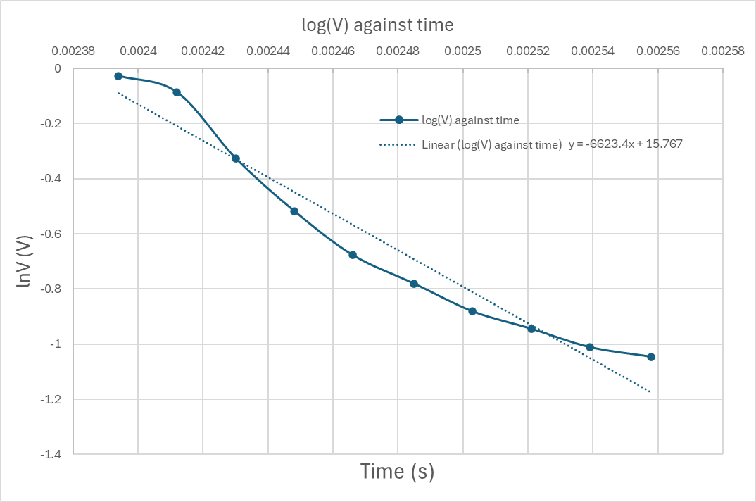
Plot log(V) Gradient (2)
Figure 5 log(V) graph

Gradient Calculations and Compare (4)

Gradient Calculations
$$τ=\frac{1}{-gradient}=\frac{1}{-(-6623.4)}=150.98{*10}^{-6}$$
$$C=\frac{τ}{R}=\frac{150.98{*10}^{-6}}{100}=1.51μF$$

Comparison table
Table 2 Comparison table
 | Capacitance | Delta | Percentage difference
Actual | 1 µF | x | X
Marker Calculation | 0.602µF | 0.398 µF | 39.8%
Gradient Calculation | 1.51 µF | 0.51 µF | 51%

Capacitor Uses (5)
Capacitors are used in many things that we interact with every day. Things like electronic appliances, cars, motorcycles, and even phones. Below is a list of some of these applications.
- Capacitors are used in microwave ovens to generate high voltages by being a crucial part of the voltage doubler. The capacitor accumulates, stores, and discharges the electrical energy, and without it the microwave wouldn’t be able to reach the required voltage to produce microwaves (Anypcba, 2024).
- In a refrigerator, capacitors are used to supply the compressor motor with enough energy to get up to speed quickly. A capacitor is used to do this because it can discharge its stored energy very quickly (Weishi Innovation, 2024).
- Capacitors are used in touchscreens like the ones in phones. They are laid out in an array behind the screen and are designed to have their electrical field reach just past the screen. Because fingers are conductive, when a finger touches the screen, it will interact with the electrical field lines and change the capacitance. This change is dependant on the distance to the capacitor and so the location of the touch can be identified (Isaac Physics, 2025).
- Capacitor discharge ignition boxes are used on motorcycles to start the engine. These use a capacitor to charge up and store the electric energy before quickly discharging, creating a spark at the sparkplug. (Universal Technical Institute, 2025)
- Supercapacitor modules can be used as storage devices in the regenerative braking system of electric and hybrid vehicles. The kinetic energy produced when the car brakes can be converted into electrical energy and stored in the supercapacitors and used later (Guruvareddiyar and Ramaraj, 2019).
- Most modern car audio systems use capacitors to regulate the voltage in the system. They do this by storing energy and only releasing the amount required by the system. The regulated voltage helps remove noise from the system which provides better audio quality (Recoil Audio, 2021).
- Capacitors are used on computer motherboards to regulate the flow of electrical energy that is supplied to the motherboard and provide the components on the board with constant power (Logistics Technology, 2025).
- Capacitors are used in car airbag systems so that in the event of the battery being disconnected or destroyed in a crash before the airbag went off, the airbag would have a backup power supply and be able to deploy (MCFRS Driver Certification Program, 2014).
- Defibrillators take advantage of a capacitor’s ability to discharge very quickly. The defibrillator charges up a capacitor and then after pads have been put on the patient’s chest, discharges very quickly which can cause the heart to start beating again (How Equipment Works, 2025).
- Capacitors can be used to extend signals from a motion detector. This is done by charging the capacitor and when motion is detected a relay is held closed and the discharge of the capacitor holds it for the discharge time. Thus, extending the signal time and ensuring it is received (V. Ryan, 2022).

Inaccuracies Question (4)
The measured values could be different from the specified value because of the measuring equipment used. Over time equipment loses some accuracy, this can be due to regular use or the environmental conditions it is used and stored in. If the equipment is sensitive, the damage can be permanent. Incorrect use is also a possible cause for inaccuracy, if the test equipment has been dropped or connected incorrectly it could lose its accuracy. This is likely as the test equipment is used in an educational environment and not by professionals (DM Systems Group Ltd, 2023). For the same reason, the results could be different if the test has been performed, or the results recorded wrong. Electrical components like capacitors degrade over time from use. This degradation can cause it to lose capacitance and so cause a difference to the specified value (PUHANE, 2021).

References
Anypcba (2024) Understanding Microwave Capacitors: Safety, Function, and Replacement. Available at: https://www.anypcba.com/blogs/electronic-component-knowledge/understanding-microwave-capacitors-safety-function-and-replacement.html (Accessed: 5 April 2025).
DM Systems Group Ltd (2023) What compromises electrical test equipment accuracy? Available at: https://blog.dmsystemsgroup.co.uk/electrical-test-equipment-accuracy (Accessed: 6 April 2025).
Guruvareddiyar, G. and Ramaraj, R. (2019) ‘Super Capacitor Based Energy Recovery System from Regenerative Braking used for Electric Vehicle Application’, 2019 International Conference on Clean Energy and Energy Efficient Electronics Circuit for Sustainable Development, INCCES 2019 [Preprint]. Available at: https://doi.org/10.1109/INCCES47820.2019.9167714.
How Equipment Works (2025) How defibrillators work explained simply. Available at: https://www.howequipmentworks.com/defibrillator/ (Accessed: 5 April 2025).
Isaac Physics (2025) Capacitive Touchscreen. Available at: https://isaacphysics.org/questions/capacitive_touchscreen (Accessed: 5 April 2025).
Logistics Technology (2025) Enhancing Your PC: Capacitor Stability on Motherboards – Logics Technology Solutions Inc. Available at: https://logicstechnology.com/blogs/news/enhancing-your-pc-capacitor-stability-on-motherboards (Accessed: 5 April 2025).
MCFRS Driver Certification Program (2014) VEHICLE SAFETY. Available at: https://montgomerycountymd.gov/mcfrs-psta/Resources/Files/Driver/Aerial_Units/Module%2014%20-%20Vehicle%20Safety.pdf (Accessed: 5 April 2025).
PUHANE, F. (2021) Afraid of aging? The effects of time on electrolytic capacitor. Available at: https://www.we-online.com/catalog/media/o467325v410%20SN019_EN_d.pdf (Accessed: 6 April 2025).
Recoil Audio (2021) The Science Behind Car Audio Capacitors and How They Improve Your Sound System – Recoil Audio. Available at: https://recoilaudio.com/the-science-behind-car-audio-capacitors-and-how-they-improve-your-sound-system/ (Accessed: 5 April 2025).
V. Ryan (2022) The Design and Technology Site. Available at: https://technologystudent.com/elec1/capac2.htm (Accessed: 5 April 2025).
Universal Technical Institute (2025) What Are Motorcycle Ignition Systems? How They Work | UTI. Available at: https://www.uti.edu/blog/motorcycle/motorcycle-ignition-systems (Accessed: 5 April 2025).
Weishi Innovation (2024) Buy Refrigerator Capacitor from Leading Electronic Component Manufacturer China. Available at: https://weishielectronics.com/refrigerator-capacitor/ (Accessed: 5 April 2025).

