

Module Title: Changemakers: Creativity and Value Creation
Module Code: BMHP5014
Student Name: Bianca Muntean
Student ID: 2323244

Task 1 – Concept Map
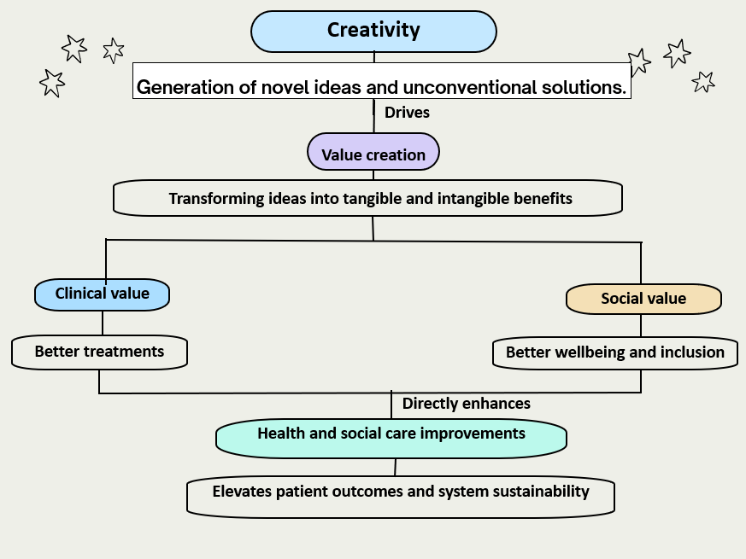
(Source: Self-created)
Creativity allows for the generation of novel solutions in the health and social care setting, directly allowing for driving value creation (Brewster et al., 2022). Healthcare systems are transformed through making improvements in patient outcomes, operational efficiency, and the overall well-being of the patients. Creativity acts as the catalyst in this regard, involving thinking outside of the traditional clinical frameworks for designing new care models. Value creation can be observed through the facilitation of creativity, and solving specific problems in the clinical setting becomes possible. This may involve reducing the rates of readmission and cutting administrative costs. In this specific setting, this aspect of value is broken down into clinical and social value. Clinical value involves superior medical outcomes, and social value involves enhancing patient experiences, equity, and quality of life.
Clinical value focuses on the attainment of evidence-based and measurable healthcare outcomes (Kehyayan et al., 2025). Lowering the rate of mortality and preventive management of chronic conditions are included in this aspect. Social value involves putting emphasis on holistic patient wellbeing, accessibility, and equity. Incorporation of person-centred models allows for empowering the patients, offering emotional support through community inclusion. Value, if it is continuously created, allows for evolving the system of service delivery in the clinical setting. Improvements in health and social care settings are attained as creative and value-driven solutions are integrated into daily practices in this industry. This results in the observance of safer, personalised and highly accessible services for the population (Tringale et al., 2022).

Task 2 - Self-Reflection of Group Activity
Gibbs reflective cycle is a framework that is used to evaluate learning in a structured process (Galli and New, 2022). Application of this framework in reflecting the paperclip activity is as follows.
Description
During the creative workshop, I worked in a group of four for brainstorming the use of a paperclip within ten minutes. This was a very innovative activity that was given to us and allowed us to address the area of convergent and divergent thinking.
Feelings
Initially, I blamed it on the ideas, but my group actively stated all the kinds of ideas that they had in their mind. As they started to shout out the ideas, I came up with some too, and finally, we ended up outlining 26 other uses of paperclips.
Evolution
I played a crucial role during the divergent thinking phase as I proposed uses such as conductive wire for a low-voltage circuit. On the other hand, during the final minutes, my thought process shifted towards convergent thinking. This allowed me to address the risks associated with the ideas that have been proposed.
Analysis
Selecting the most appropriate ideas allowed for the identification of differences between the convergent and divergent ideas. A lack of judgment is associated with the divergent thinking process to enhance the flexibility of the thinking process (Orzechowski et al., 2023). On the other hand, convergent thinking allows for addressing the feasibility of solutions (Wigert et al., 2024).
Conclusion
I have understood that I am more comfortable indulging in the process of idea generation.
Action plan
As I have become accustomed to learning these two aspects, in future I will separate these two phases for the identification of proper ideas.

Task 3 - Case Study of a UK innovation
Introduction
The "NHS at Home" or virtual wards initiatives permit vulnerable patients to receive hospital-level care in their own homes (NHS England, 2026). The introduction of remote monitoring technologies like wearable devices and digital platforms is crucial. It enables service users to manage their health from the comfort of their home. This addresses severe shortages of beds and avoidable hospital admissions. It is created by using remote monitoring devices. These monitoring devices help to track the important signs. The main stakeholders include healthcare providers, patients, and system administrators.
Main Body
Creativity in the NHS at Home model originated from reimagining the capacity of hospitals by embracing telehealth applications and IoT devices. This innovation permits proactive home-based care by using real-time analytics to manage vulnerable patients. It diminishes hospital admissions and heightens pressure on secondary care.
The creative approaches used for the NHS Home model combine digital health technologies and collaborative partnerships between hospital clinicians and community carers. The components of innovation were wearable devices. It tracks signs like blood pressure, heart rate and glucose levels. The home-based health monitoring system transmitted data directly to the providers of healthcare. Predictive Analytics and AI reduced the need for emergency care by giving early warning signs of deterioration (Williams, 2022). This creativity permits acute-level care to be safely administered within the residence of the patient.
This creativity transformed care by replacing reactive visits to hospitals with continuous care. It empowers staff to avoid unnecessary visits and frees up inpatient beds. This further offers a comfortable patient-centric recovery atmosphere.
The initiatives of NHS at Home used creative thinking to overcome the restriction of capacity by incorporating digital monitoring technology and virtual wards. Innovative solutions like standardised data-driven tools and non-clinical triage diminished emergency admissions. It permits care delivery outside the settings of traditional hospitals.
Impact
The tangible benefits involve optimised resources and reduced costs by remote monitoring programmes like “NHS at Home”. It overall improves outcomes of patients with early detection of deterioration. Meanwhile the intangible advantages involve peace of mind, patient empowerment and enhanced quality of life.
The innovation uses remote monitoring to offer hospital-level care in the community. It enhanced patient care with early detection of clinical deterioration. The virtual ward model diminishes emergency by permitting recovery in a familiar setting. It has enhanced patient satisfaction by reducing hospital-induced anxiety. Real-time tracking leads to better outcomes in health yet reduces hospital admissions and minimises per-patient costs.

Task 4 - Research Task
Mental health stigma as a current issue in health and social care
As written by Radez et al. (2021), a sense of embarrassment, perceived social stigma and lack of literacy regarding mental health often prevent children and adolescents from seeking professional mental health support. A majority of young individuals feel the fear of social consequences of being labelled as “crazy” or “flawed”. They suffer from a sense of embarrassment, rejection from peers and negative judgmental attitudes. The authors have highlighted this as a key reason behind the limited willingness to ask for professional help regarding mental well-being. Simultaneously, it has been stated that mental health stigma is closely connected to privacy fears. Several youth express worry about being found out by their parents about seeking therapies or counselling. They also become anxious about failing to trust completely unknown professionals, which creates a fear of not getting the proper help. Furthermore, the scholars have illustrated that poor mental health knowledge is a crucial reason for creating stigma. Young people often lack basic mental health literacy that creates hesitation and confusion among them, halting them from seeking actual support.
The research by Edwards and Kotera (2021), on the other hand, has showcased the main reasons behind mental health stigma among working professionals. The UK police force has been used as a representative population in the study. Findings from the research have summarised that the stigma surrounding mental health disorders among police professionals is mainly driven by a strong, masculine police culture. According to the authors, police professionals hold a traditional masculine coping culture that prevents them from disclosing psychological distress and expressing insecurity. Besides this, reports from police officers have highlighted that poor leadership and management within workplaces are key reasons for failed recognition and a lack of support for mental illness.

Task 5 – Podcast

Task 6 - NHS Leadership Framework Analysis
The NHS has provided some leadership frameworks that every healthcare professional needs to follow. These are based on the aspect that can be responsible for the success of an organisation. Those frameworks of the NHS describe the leadership as a shared approach in the healthcare sector. The framework includes codes of practice and standards of competencies at all levels of the healthcare sector. It highlights that not everyone can become a leader though everyone can contribute to this process of leadership. The medical leadership competency framework and the leadership qualities framework can be explained here. The leadership quality framework describes the leadership behaviours for all staff based on their roles in a healthcare organisation. The medical leadership competency framework suggests that doctors need to become more active in participating in innovative solution-providing to patients. This framework offers suggestions for all doctors and medical students throughout their careers. It states that doctors can transform the healthcare services for their patients and improve the results with shared leadership. The medical leaders can become more efficient with a regular personal development method ( NHS Leadership Academy, 2026). They can develop networks to foster a positive team and improve the healthcare services.
The medical leadership competency framework can help an individual improve healthcare and foster creativity. They need to critically evaluate the current situation of the healthcare services that can help identify problems. The problem identification can help to provide innovative solutions for each problem. The professionals can question the patterns of current services and develop new innovative solutions to fill the gap. It can help them to implement evidence-based practices and offer excellent services. Critical thinking can be used in this process to identify the results of present services and provide innovative frameworks. The healthcare professionals can identify the gap to incorporate modern technologies and fill the gap for the betterment of patients (NHS , 2025). Innovations can help to consider patient safety and improve their health through offering better services. A change management process can be followed to implement the innovative ideas for a transformation in the healthcare sector.

Task 7 - Self-Reflection Journal Entry
The module helped to learn a few things about creativity and its other aspects. It helps me to gain information on various topics in the health and social care industry. I understood that creativity can help to generate noble ideas and solutions. Social value and clinical value can be created through this. The importance of partnership in healthcare campaigns has been learned through this module. Partnership can help to expand the reach of healthcare and gain public trust. Long-term partnership in healthcare can help to ensure campaign longevity and continuous improvement (Da Silva and Minciotti, 2021). Technological application in this sector has been learned in this module. Healthcare professionals can identify and treat infections quickly with the help of modern technologies.
The creativity and value creation within the health and social care sector have helped me to improve my professional practice. It has changed my previous perspectives and helped me to build empathy. This empathy-building helped me to understand the feelings and needs of the patients. The importance of innovation in this sector has been learned through this module or project. Innovation can help to empower healthcare professionals to complete tasks quickly and accurately.

Reference List
Brewster, A.L., Lee, Y.S., Linnander, E.L. and Curry, L.A., (2022). Creativity in problem solving to improve complex health outcomes: Insights from hospitals seeking to improve cardiovascular care. Learning Health Systems, 6(2), p.e10283.
Da Silva, E.C. and Minciotti, S.A., (2021). CO-CREATING HEALTHCARE CAMPAIGNS THROUGH DESIGN AND SOCIAL MARKETING APPROACHES. British Journal of Marketing Studies, 10(1), pp.1-12.
Edwards, A.M. and Kotera, Y., (2021). Mental health in the UK police force: a qualitative investigation into the stigma with mental illness. International Journal of Mental Health and Addiction, 19(4), pp.1116-1134.
Galli, F. and New, K.J., (2022). Gibbs’ cycle review. Emotions as a part of the cycle. E-Motion: Revista de Educación, Motricidad e Investigación, (19), pp.92-101.
Kehyayan, V., Yasin, Y.M. and Al-Hamad, A., (2025). Toward a clearer understanding of value‐based healthcare: A concept analysis. Journal of Nursing Management, 2025(1), p.8186530.
NHS , (2025). Draft Management & Leadership Framework. [Online] Available at: https://www.england.nhs.uk/wp-content/uploads/2025/09/item-8i-appendix-a-mgmt-and-leadership-full-draft-standards.pdf [Accessed 22 06 2026].
NHS England, (2026). Virtual wards. [Online] Available at: https://www.england.nhs.uk/virtual-wards/ [Accessed 20 6 2026].
NHS Leadership Academy, (2026). Leadership Framework. [Online] Available at: https://mail.google.com/mail/u/0?ui=2&ik=7645765c89&attid=0.6&permmsgid=msg-f:1869035873402504319&th=19f026396a9e447f&view=att&disp=inline&realattid=f_mquhkwog3&zw&acrobatPromotionSource=gmail_chrome-card [Accessed 22 06 2026].
Orzechowski, J., Gruszka, A. and Michalik, K., (2023). The impact of working memory on divergent thinking flexibility. Thinking & Reasoning, 29(4), pp.643-662.
Radez, J., Reardon, T., Creswell, C., Lawrence, P.J., Evdoka-Burton, G. and Waite, P., (2021). Why do children and adolescents (not) seek and access professional help for their mental health problems? A systematic review of quantitative and qualitative studies. European child & adolescent psychiatry, 30(2), pp.183-211.
Tringale, M., Stephen, G., Boylan, A.M. and Heneghan, C., (2022). Integrating patient values and preferences in healthcare: a systematic review of qualitative evidence. BMJ open, 12(11), p.e067268.
Wigert, B.G., Murugavel, V.R. and Reiter-Palmon, R., (2024). The utility of divergent and convergent thinking in the problem construction processes during creative problem-solving. Psychology of Aesthetics, Creativity, and the Arts, 18(5), p.858.
Williams, B., (2022). The national early warning score: from concept to NHS implementation. Clinical Medicine, 22(6), pp.499-505.

