Module: Introducing the Modern Workplace
Module code: LCBB4003
Assignment Title: Assessment 1
Organizational Structure & Culture in airline industry
a
Student name: Valentina Stefanovska

Student ID: 2123930
Table of Contents
Introduction 3
Appropriate Organizational Structure and Culture for Outstanding Organizational Performance 4
Organizational Structure 4
Organizational Culture 5
Factors Influencing Individual behaviour in the Workplace 7
Conclusion 10
References 11
Appendix 12

List of Figure
Figure 1: EasyJet, airline Company 12
Figure 2: Hierarchy of Organizational Structure 12

Introduction
EasyJet is a public airline company that is very popular for its low-cost service. In 1995 it was established and started the journey with only 70 employees. The company expanded its business rapidly from the beginning through acquisition and taking advantage of technologies (easyJet Plc, 2022). The performance of any company highly depends on its structure, culture and people. To get the best outcome, the organizational structure and culture must be modernized over time (Pathiranage, 2019). In this report, a thorough discussion about organizational structure and culture will be presented and here the main concern is about the development of organizational performance. At the workplace, monitoring employees’ behaviour is much needed as different factors can influence their behaviour and thus change their performance in the company. The author will also provide basic knowledge about the employees who work in the airline industry and how their behaviour gets affected by different factors.

Appropriate Organizational Structure and Culture for Outstanding Organizational Performance
The basic foundation of an organization is its structure and culture which can affect organizational performance both positively and negatively (Visser, 2015). If an inappropriate structure is used, the company may perform adversely. In the beginning, organizations set the goals that they pursue to accomplish. To achieve the goals, all the activities and operations must be finished efficiently and effectively within time. In this competitive market, companies are always under pressure of improving and observing the structure and organization as they highly influence performance (Pathiranage, 2019).
EasyJet Airlines is also operating its business in a competitive airline industry that must have a perfect organizational structure and culture that can improve its performance and reach the highest position in the industry (easyJet Plc, 2022). The structure and culture should not be so complicated that prevent the employees to adjust easily rather it must be creative. To achieve specific goals, a company sets some rules and policies that are relevant to the company’s mission and vision which is called organizational structure whereas organizational culture is related to the behaviours and values of the employees in the workplace (Pathiranage, 2019). But they are interdependent in a way that structure can change the effectiveness of the culture even a perfect organizational culture.

Organizational Structure
The airline industry is one of the most challenging industries if it is compared to other businesses as it is greatly affected by the outside factors in the world (Hortaçsu et al., 2021). They must consider the safety of their customers over anything else. Companies that have made their successful position in the airline industry have balanced all the activities with an appropriate organizational structure and have modified them over time (Visser, 2015). There are different types of organizational structures that are used by the airline industry such as functional organizational structure, pyramid-shaped or hierarchy organizational structure (Hortaçsu et al., 2021).
A hierarchal organizational structure is followed by EasyJet. In this structure, multiple management levels are connected through a chain of command (Dalton, 2014). They follow a decentralized structure where employees can give their opinions. At every level, there is a team leader who manages specific work. They follow a process to complete all activities thoroughly so that tasks contradict each other. Whenever there are any changes in the airline industry, EasyJet has taken the necessary steps and adopted new technologies and other initiatives. They follow a cost-minimizing structure as they focus on keeping their prices as lower as possible (Visser, 2015). The managers who are at the top level of management are experts in that field and hardly take any wrong decisions. EasyJet Airlines is quite an expert in modernizing its organizational structure to get the best performance. Modern technologies are being used by them so that they compete with their rivals (Gaspary, Moura, and Wegner, 2020). In recent years EasyJet has developed so much as they have always focused on finding a suitable organizational structure and improving the structure (easyJet Plc, 2022). The performance has changed a lot and customers are more satisfied with their services.

Organizational Culture
The organizational culture is more independent when employees also have the chance to involve themselves in decision-making (Stone, Cox and Gavin, 2020). When employees are directly involved in the task and can take decisions on behalf of the team, they feel more prioritized in their workplace (Pathiranage, 2019). They feel more confident when they are appreciated. They can generate more new ideas when they think of themselves as a part of the organization (Sierk et al., 2018). Each employee performs better when they have freedom and thus the whole organizational performance is better with the suitable culture of the organization.
The culture of EasyJet airline is very innovative. If the employees are passionate and ready to accept challenges, they will appreciate them to grow their careers in a friendly work environment (Diamantidis and Chatzoglou, 2018). Employees are very ambitious, creative and ready to come up with new ideas to solve any problems even if they are so complicated. When the workplace becomes so friendly, employees can focus more on their assigned work and finish them more energetically. The company changes its cultures or develops them when needed because the same culture may not work forever (Sierk et al., 2018). The whole world is changing very fast as well as the technologies, values and behaviours are also changing. The organizational culture must be improved so that the best output of the organization can be achieved (Hellriegel and Slocum, 2020). Employees are a major part of an organization. If they are treated properly, they will be able to perform even better and thus the organizational performance will be outstanding.
EasyJet airline is quite different from other airlines as they provide the best service to the customers. All the employees work together to satisfy the customers. EasyJet also offers a budget-friendly ticket. The performance of EasyJet airline has developed so much because of the appropriate organizational structure and culture (Pathiranage, 2019).

Factors Influencing Individual behaviour in the Workplace
In the workplace, there are different factors that influence employee behaviour that affects organizational performance also (Diamantidis and Chatzoglou, 2018). Their behaviour also depends on the organization in which they are working. If the organizational culture is friendly, employees will learn from their colleagues and supervisors how they should behave in the organization (Pathiranage, 2019). In the airline industry, how different factors can influence the behaviours of employees are described below.
Organizational performance is defined by organizational behaviour (Hellriegel and Slocum, 2020). An employee’s behaviour within an organization is different from his personal life. He has to behave in a certain way to maintain his relationship with other employees or managers. But the behaviour may also vary from organization to organization. A suitable organizational behaviour is very essential to stimulate innovations to cope with this competitive market (Gaspary, Moura, and Wegner, 2020). Individual and group behaviour in the workplace were highlighted by the behavioural approach, research on human behaviour conducted by psychology, sociology, and anthropology. The behavioural approach was supported by Hawthorne's research in the 1920s and 1930s (Daft and Lane, 2015).
There are some specific factors that influence the behaviour of the employees in EasyJet.
Leadership: When the leader is innovative, employees who work under his can learn easily about the workplace. Employees are more encouraged to perform efficiently and thus the organizational performance gets better (Stone, Cox and Gavin, 2020). A leader must have the qualities of being a perfect leader otherwise he will not be able to support the employees to acknowledge themselves in the modern work environment (Daft and Lane, 2015). New employees always follow their team leaders and get influenced. The leader should monitor the daily activities of the employees. When the employees are quite lazy and not interested in their work, they need a strict authority that can pressurize them to finish the work. In EasyJet, there are small numbers of employees who work under a leader and the behaviours are monitored seriously.
Work Environment: The work environment can change the employee’s work performance. If the work environment is safe and secure, they will feel comfortable and will be able to concentrate on their work (Hellriegel and Slocum, 2020). Also, if the working environment is good the productivity as well as the efficiency of the employee's increases and based on that the overall profitability of the organisation increases too. EasyJet Airlines always makes sure to keep their workplace favourable and this led to the ultimate success of the organization.
Effective communication: Communication is very important in an organization. There are different levels of management in the hierarchy who accomplish their specific task but these tasks are interrelated (Stone, Cox and Gavin, 2020). One task is done after another so effective communication is a must to keep track of every task. If there is any communication problem, the ultimate goals will not be achieved. All the necessary information should reach timely where it is needed through a proper communication system (Diamantidis and Chatzoglou, 2018). EasyJet airline focuses on communication with the help of modern technology which made it easy to communicate. Supervisors strictly monitor and control the employees so that they do not miss anything unconsciously.
Self-perception: The characteristics of employees within an organization are different from each other. They can be extroverts, introverts, emotional, innovative or creative. They perform differently according to their perception (Hellriegel and Slocum, 2020). This is an important factor that changes employee behaviour. In EasyJet airline, employees are encouraged to use their creativeness which will help them to generate new ideas for the betterment of EasyJet (easyJet Plc, 2022).
Stuffing level and workload: When the stuffing level changes, it also influences organizational behaviour (Hellriegel and Slocum, 2020). The workload can affect the performance of employees adversely as it damages mental processing. They fail to perform their best and finish the task due to workload. Though in many organizations, the workload is not considered anything problematic rather they think they are getting more output by pressurizing the workers. But in reality, it affects their physical and mental health and leads to underperformance (Stone, Cox and Gavin, 2020). EasyJet airline always makes sure to recruit enough employees, so that employees do not have a workload. Managers assign limited work to each employee.
Ability: Ability refers to the capabilities one has to accomplish a task properly within time. Different people have different abilities and they should be assigned the tasks in which they are experts (Murrell and Meredith, 2017). EasyJet follows a tough recruiting process to find the best person who is fit for the job. They choose qualified candidates and train them for performing better. If employees are enough competent with their abilities, they will be encouraged and help the organization to achieve its goals (Stone, Cox and Gavin, 2020).
Personal life: Employee’s personal life can also influence their behaviour in the organization (Diamantidis and Chatzoglou, 2018). If they are facing trouble in their personal life and cannot give proper attention to the workplace, their performance will be disappointing (Murrell and Meredith, 2017). So employees should not bring their personal life into their workplace. If they are disturbed about anything, they can share it with the manager or other fellow workers with whom they have a good relationship.

Conclusion
Organizational performance somehow highly relies upon the organizational structure and organizational culture. The organizational structure and culture must be easygoing and re-constructed when any internal or external factor changes. The same structure and culture will not work forever. An appropriate structure and culture can enhance the performance of the organization. Here EasyJet, a company in the airline industry is improving its performance over time by applying suitable structure and culture. During Covid-19, airline businesses almost collapsed but somehow most of them managed to overcome the losses by focusing on the organizational structure and culture. An individual’s behaviour within an organization has a great impact on organizational performance. For improving an organization’s effectiveness, employees should behave in a systematic way. Organizational behaviour focuses on the employee’s perceptions, actions and values. EasyJet airline company make sure to provide the employees with a safe and secure workplace so that they can perform their best and thus organizational performance gets better.

References
Daft, R. and Lane, P., 2015. Leadership. Stamford: Cengage Learning.
Dalton, G., 2014. Organizational Structure and Design. Homewood, Ill.: Richard D. Irwin, Inc. and The Dorsey Press.
Diamantidis, A.D. and Chatzoglou, P., 2018. Factors affecting employee performance: an empirical approach. International Journal of Productivity and Performance Management.
easyJet Plc, 2022. https://www.easyjet.com/en/. 2022. easyJet Plc. [online] Available at: <https://www.easyjet.com/en/> [Accessed 16 August 2022].
Gaspary, E., Moura, G.L.D. and Wegner, D., 2020. How does the organisational structure influence a work environment for innovation?. International Journal of Entrepreneurship and Innovation Management, 24(2-3).
Hellriegel, D. and Slocum, J., 2020. Organizational behavior. Mason, OH: South-Western Cengage Learning.
Hortaçsu, A., Natan, O.R., Parsley, H., Schwieg, T. and Williams, K.R., 2021. Organizational structure and pricing: Evidence from a large us airline (No. w29508). National Bureau of Economic Research.
Murrell, K. and Meredith, M., 2017. Empowering employees. New York: McGraw-Hill.
Pathiranage, J., 2019. Organizational culture and business performance: an empirical study. International Journal of Economics and Management, 24(2).
Sierk, Y., Dvora Yanow, Y. and Ida, S., 2018. Organizational Culture. Cheltenham: Edward Elgar Pub.
Stone, R.J., Cox, A. and Gavin, M., 2020. Human resource management. John Wiley & Sons.
Visser, B., 2015. Organizational structure and performance. Badia Fiesolana, Italie: European University Institute.

Appendix

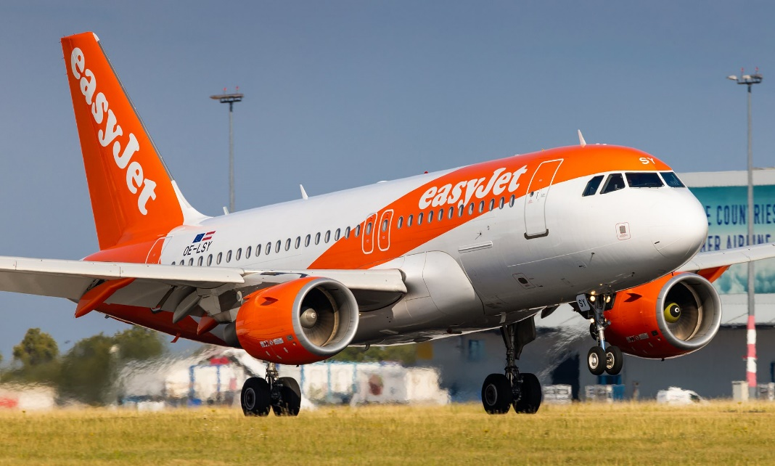
Figure 1: EasyJet, airline Company
Source: (easyJet Plc, 2022)
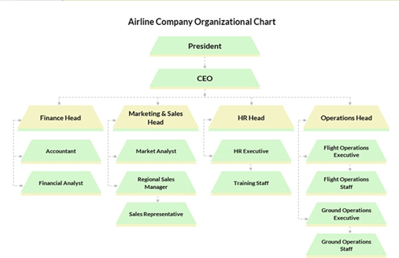
Figure 2: Hierarchy of Organizational Structure
Source: (Hortaçsu et al., 2021)

