Marketing Fundamentals- LCBB4004
The role of marketing in creating value for customers
Stakeholder engagement and their impact on the marketing activities of an organisation

Student name: Coordinator
Cornelia-Roxana Rad (2023709) Dr. Hossein Shokri

Table of Contents
Table of contents 2
Introduction 3
Customer Value and Satisfaction 3
Advantage of Marketing to Consumers 4
o Creating value 4
o Delivering Value 5
o Communicating Value 6
Definition of a Stakeholder 7
Internal and External Stakeholders 7
Stakeholder Relationship 8
Conclusion 11
References 12

Introduction

Marketing is one of the most important activities which creating value for every customer. In this essay I am providing a critical analysis and evaluation about the value for costumers, delivering value, communicating value stakeholder engagement and their impact on the marketing activities but also, I explain how work, what is the definition for stakeholders and what is the importance for the stakeholders and where is used and I explain how the relationship work in combination with stakeholders but I offered some explanation about some types used for every organisation and i give some explanation about the stakeholders engagement and their impact on the marketing activities for all organisation .

Customer Value and Satisfaction

The value of the customer can in principle mean receiving what he wants or can receive something in exchange for what is given or even obtain a reasonable cost in exchange for a product or service but can also be defined as receiving quality for what is paid. In terms of money, time, data, by chance and his knowledge can also be described as customer satisfaction in all the above aspects. Money is also a pretty important factor by which you can get what you want. Another idea for the value of a customer can be defined as, the customer himself should feel the value of the money spent and satisfied with the product or services he benefits from it.
Customer satisfaction can be defined as a measurement tool used to review how successful the business is in procuring quality services or products in the vision of customers to exceed expectations. If the great success of the service or product does not respond, then we can say that the customer is in a state of dissatisfaction. It is essential to provide full customer satisfaction because it not only maintains a loyal or existing customer, but it helps to develop and bring more customers into the business. As is self-evident, it will always be easier and cheaper to keep in touch with an existing customer than to attract new customers through the idea of ​​marketing that costs quite a lot. When a customer is satisfied with services and products, not only will he remain loyal to the company, but he will also bring kindness, friendship to the company and through deeds and words they will attract new potential customers but also different opportunities (Philip, et al.) (Peter & Philip).

Advantage of Marketing to Consumers

An advantage of customer marketing is to promote your business so that you gain public recognition and attention in a wide market. This advantage can only be achieved with the help of customers because to reach a large and wide market, you must not only capture the public's attention but also recognize the improvement of the brand and product qualities. In every business it is necessary that “to make money he must spend “. So, the most important advantage is to improve the profit of companies and more concretely or more precisely by increasing sales.

Creating value

Value creation is the basis of a business that provides us with long-term customers, helps us with the competition but also brings a distinct meaning to the brand and the solution. Definition of creatin value gives something precious or important to receive something more precious or valuable in return. This definition is quite cotton that covers both benefits and costs, in addition it can be applied to both customers, owners and employees.
For the best possible sale, you must:
- Communication: this is the basis of success for this we need customers who need to understand that for something of value you pay them what they deserve
- Create the sales process by improving people's opinion about the product but also about you. Thus, the hunts end up growing because the customers come to understand and then they notice a higher value.

Delivering Value

Delivering value to consumers is important in finding valuable positions but also in terms of valuable opportunities. They allow customers to obtain information provided by the company, business, company more precisely with the help of services and products, they become considered the moments of truth for any supplier in a company. The value delivered by the customer consists in the difference between the total value or the value that the customer puts on the product and the customer's cost consists in the effort and the money for the respective purchase. Customers usually buy from the company as much as it has a maximum delivery value (Nijssen & Frambach) (Ray). (Roeder).
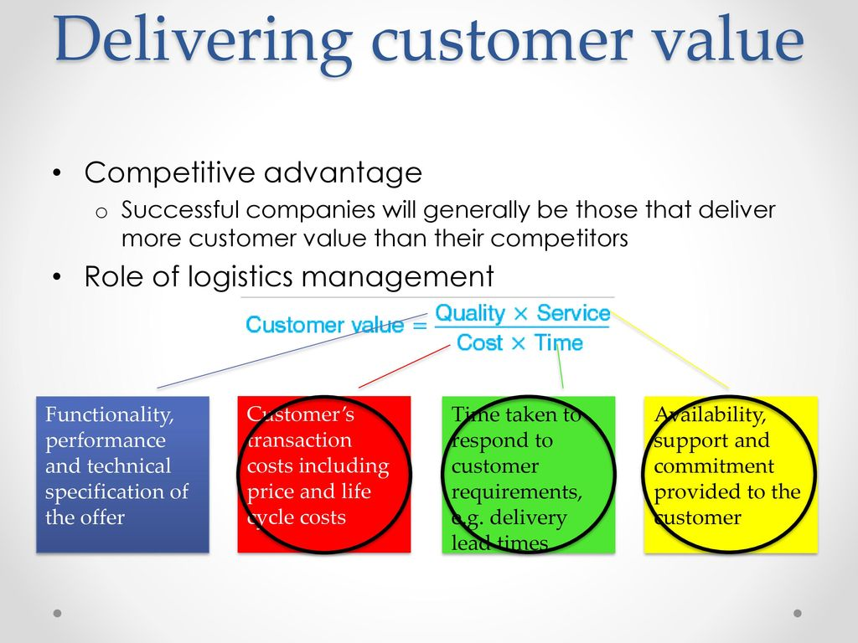
Figure 1, Delivering Value, Source: Online internet (Wang)

Communicating Value

Communicating value means guiding your audience from displaying to realizing awareness, understanding, attention, giving in, evaluation, preservation, all of which ultimately bring the action of value communications. One of the most important elements is the small marketing, namely the promotion. This refers more precisely to advertising, to the personal sales mix of direct marketing with public relations that any company tries to develop a relationship between customers and the communication of customer values. It communicates through the mix of elements but also through the promotional mix. The promotion Mix have five tools for communicating customer value, advertising, sales promotion, personal selling, public relations, direct and digital marketing. The Promotion mix are used by the company is to engage consumer and communicating value to customer.

Definition of a Stakeholder

A stakeholder is the parties who have an interest in a company. Stakeholders come to play an important role in defining the company. These parts can be both external and internal to an organization. It can be represented by a group or any person who has an attraction for the activities of a business. This group or person can affect the actions of a company but of course both the group and the person have a legitimate interest in the company (Ray) (Eskerod & Jepsen).

Internal and External Stakeholders

Stakeholders can be external or internal. Internal Stakeholders refers more precisely to individual’s parties within an organization and internal parties are those people who have a direct relationship such as employment within the company, and over time come to increase interest in the company. Over time, stakeholders are investors who end up being affected by the preoccupation and performance of the business. Stakeholders can be investors who end up playing an important role in the company. Internal stakeholders are those groups or individuals in an organization such as owners, shareholders, employees, and management who have a high interest in the good and future of the company. An example: Roxanne's employees at Book Street Bookstore are a little worried about this company, how it will cooperate in the future because employees want to know if they will still have those jobs. An employee like Roxanne will always be worried if something doesn't work because this worry can raise her or create different opportunities for her advancement or why she won't have a salary increase.

External stakeholders there are those who do not collaborate directly with the company, they can be creditors, suppliers but also public groups, these being considered external parties, but they end up being somehow affected by the actions and results of the business. External parties compared to internal parties do not have a direct relationship with the company. An external stakeholder may be affected by the company's operations, may include an organization or an individual. External stakeholders may be individuals or groups that are not directly related to the company. These are:
- creditors - are those to whom the company owes a sum of money.
- customers - are the people who purchase the services and goods.
- suppliers - where companies purchase products.
When customers purchase a product, they expect to be a product with good quality and value for the amount owed by the customer in return. Creditors are also interested in how companies pay their debts; creditors can be banks. An example: If Book street asks for a loan, then the bank wants to know if this business earns enough to pay off that loan. And the government comes to have a role in this business of Jan, by paying taxes, etc., and if Book street does not make money, then the government will not have less money to finance. (Anon.)

Stakeholder Relationship

Stakeholder relationship it is in fact the establishment of connections that end up being advantageous with people or groups that of course have a common interest. This kind of relationship is built more precisely to solve problems in an organization and this group or people are chosen based on several criteria, becoming credible and united voices, these are important for any organization. A single person, is a single voice, does not have enough credibility and its results end up being a total failure in raising issues and thus the problems end up being unresolved. While a group of voices manages to solve the problem of products, service and the public understands the message and then this group can grow harmoniously. It is created based on different criteria such as credibility which is defined as a very important factor in any organization, united voices in solving problems, service or products that are important to an organization.
Owners, shareholders are the most important because they have an important role in controlling, verifying the business. If they become dissatisfied then you can dismiss their managers, directors or even sell the business to another person or group. In none of the business should customers be ignored. (Bourne)Who are the main stakeholders in a business? Types of Stakeholders:
- Customers - they play an important role in a business by being affected by the quality of products, the quality of services or their value.
- Employees - have a direct connection in the company, they earn an income but can also benefit from other benefits.
- Investors- include both debt holders and shareholders. Investors are usually interested and busy with the concept of shareholder value.
- Suppliers and sellers - sell service or goods to a company.
- Communities - are those stakeholders of large enterprises, they can be affected by more things, health, development, safety.
- Governments end up being considered stakeholders for a business because they collect taxes on everything, corporate taxes, payroll taxes, sales taxes, income taxes.

Stakeholder engagement can be defined as a method used to understand or obtain the views of stakeholders in each association. Involvement of these stakeholders may be a habit of involving stakeholders in actions or various organizational activities. To defy and understand the answers we need several elements such as defining a project we need the parts that are of interest in the process of planning a business. Each interested party has a problem to solve as well as a strategy in solving the problem, therefore each party knows how to answer the questions strictly addressed to them. This helping to integrate them into the communication plan.
Ways to communicate with your stakeholders. The most important element is the parties that are in the public identification. Interested parties are searched in detail in the delay of a project and then the search for the person or group and the understanding if they have received any notice is applied. Formal methods of communication can be:
- Meetings - are among the most common methods of communicating with the public or not necessarily. Of course, this type of communication can vary depending on the audience or message. This type is considered the best because it avoids misinterpretation.
- Conference Calls- Nowadays they become quite used because it does not require the expense, I mean the trip. To have a dialogue this way the clarity of the voice and the intonation of the verbal message are considered. It is a rather favoured and quite convenient model because these calls can be recorded and if they cannot be recorded, they can be played back.
- Email, posters, newsletters- This is another way to communicate using various email updates, newsletters, brochures, all of which can be used as a method of communication. One of the disadvantages is the messages that sometimes cannot be understood and then this is a problem.
Informal methods - it is quite important not to put all your foundations or trust on these formal channels but to use another type of communication such as direct.
- Different types of Conversation such as those in the bathroom or in the hallway they are great for individual communication also must not set different expectations such as false and communication to be as clear as possible so as not to have a surprise result.
- Meetings either in a bar after the end of the program or at lunch this kind of meetings can be quite excellent because you can get an opinion, an impression, a feedback you can discover new ideas about different projects or even a new job.
- Different events be they sports, gala, discussion, or many others, this can be called a way to find out different opinions about different organizations or the importance of a project or how you can get good feedback or even get new business ideas.
Communication is the key to success; it will remain a very important factor in the art of business but also in that of organizations. It is not enough to have a plan and follow it, it is essential to come to understand what both the unspoken and the spoken. Every expectation must be carefully controlled and understood with horse and patience from beginning to end.

Conclusion

In conclusion the role of marketing in creating value for customers are so important for each organization, I discovered what each one actually represents customers value it’s actually what customers really want and for customer satisfaction can be defined as a measurement tool used to review how successful the business is in procuring quality services or products in the vision of customers to exceed expectations. However, I came to understand each advantage that constitutes and each factor in it, I explained it and defined what it means. This small, large activity that I had to tell and understand about stakeholder involvement made me not only understand but also can further explain the basic criteria, learn to recognize the importance of marketing in creating different values ​​for customers and consumers but to I also understand the risk or failure of a project for a business. I came to understand the importance and development of relationships within the project, not only understanding is an important factor but also communication which is the key to success. I came to understand the importance of the interna land external stakeholders but also how they work and in the end I what to same why the relation of stakeholders is important in which organization it is in fact the establishment of connections that end up being advantageous with people or groups that of course have a common interest.

References

Wang, Y., 2019. SlidePlayer. [Online]
Available at: https://slideplayer.com/slide/13125142/
[Accessed 26 04 2021].
Nijssen, E. J. & Frambach, R. T., 2001. Strategic Marketing Planning. 1 ed. Boston: Springer.
Ray, D., 2010. Delivering customers value. s.l.:Butterwort-Heineman.
Philip, K. et al., 2009. Marketing management. European ed. Harlow: Pearson.
Peter, D. & Philip, S., 2006. Marketing Management ans Stategy. 4 ed. s.l.:Person.
Roeder, T., 2013. Managing Project Stakeholderes. 1 ed. s.l.:s.n.
Eskerod, P. & Jepsen, A. L., 2016. Project Stakeholder Management. s.l.:Routledge.
Anon., n.d. CIPS KNOWLEDGE. [Online]
Available at: https://www.cips.org/PageFiles/156828/Internal%20external%20and%20connected%20stakeholders.pdf
[Accessed 28 04 2021].
Bourne, D. L., 2016. Stakeholder Relationship Management. New York: Gower routledge.

