An Evidence-Based Nutritional Strategy to Support Lean Mass Gain in a Resistance-Trained Athlete
Introduction
1.1 Athlete Background
The client is a 35-year-old male with a background in amateur rugby, primarily playing in the second-row position. Over the past year, he has transitioned towards bodybuilding-style training, with performance goals progressing towards competitive bodybuilding and the aim of completing his first competition in August 2026. His rugby background has contributed to the development of strong power and strength qualities, which align well with the demands of hypertrophy-focused training.
Anthropometrically, the client stands at 193 cm and weighs 90.4 kg. Body composition assessment indicated a high skeletal muscle mass (50.7 kg) and very low body fat levels. Although the bioelectrical impedance estimate of 3.2% body fat is likely an underestimation compared with the skinfold sum (13.87 mm), both measures indicate a lean and muscular physique. The client also has several years of resistance training experience, is comfortable training with high effort, and is capable of tolerating higher training volumes.
1.2 Training Volume and Structure
The client completes five resistance training sessions per week, each lasting approximately 90 minutes and averaging 14–16 working sets per muscle group. Training follows a push/pull/legs split, with most working sets taken to mechanical failure and rest periods kept controlled. This training style places a high demand on intramuscular glycogen stores and requires consistent nutritional support to maintain performance and recovery (Haff & Triplett, 2016).
In addition, the client performs five 20-minute cardiovascular sessions per week at an easy to moderate intensity, resulting in a total weekly training load of approximately 8–10 hours.
1.3 Lifestyle Considerations
A key lifestyle challenge for the client is limited sleep duration, averaging approximately five hours per night. Chronic sleep restriction has been shown to impair training performance, increase perceived fatigue, and negatively affect recovery processes (Fullagar et al., 2015; Watson, 2017), increasing the importance of effective nutritional support.
The client works full time as a kitchen worktop fitter, involving regular manual handling, prolonged standing, and intermittent lifting, alongside periods of long-distance driving. This combination contributes additional non-exercise activity demands, increasing daily energy expenditure and cumulative fatigue (Westerterp, 2017). Despite these constraints, the client demonstrates strong discipline and adherence, with consistent hydration, effective food preparation, and reliable achievement of daily nutritional targets. No appetite-related issues are reported, supporting the feasibility of a controlled lean mass gain phase.
1.4 Current Phase and Goals
Having recently completed a fat loss phase, the client is now entering a lean gain block. The primary aim is to increase muscle mass while minimising unnecessary fat gain. This phase is planned to last approximately 12–16 weeks and forms part of a longer-term preparation period leading toward a bodybuilding competition in August 2026.
1.5 Summary
Four key principles form the analysis and nutritional planning: high training volume combined with restricted sleep increases the need for structured carbohydrate timing and enhanced recovery support (Burke et al., 2018; Impey et al., 2018; Simpson et al., 2017); a predicted fast twitch muscle fibre profile shifts metabolism towards carbohydrate use (Burke et al., 2017; Lievens et al., 2020; Stellingwerff et al., 2011); a very lean post-diet state primes a controlled caloric surplus to support lean mass gain (Müller et al., 2015; Dulloo et al., 2015; Mountjoy et al., 2018); and strong discipline allows for advanced nutritional strategies such as nutrient timing and carbohydrate periodisation (Jeukendrup, 2017; Stellingwerff & Cox, 2014; Burke et al., 2018). These principles ensure the nutritional strategy is physiologically relevant, evidence-based, and aligned with the client’s long-term bodybuilding goals.
Methodology
This assignment used a case study approach to assess the physiological profile, training demands, and nutritional requirements of a resistance-trained male athlete preparing for competitive bodybuilding. All assessments were completed in accordance with AfN/SENr/CASES ethical guidelines, with informed consent and PAR-Q screening carried out prior to testing (see appendix E1-4). The client reported no history of cardiovascular, metabolic, or respiratory disease, no indicators of relative energy deficiency in sport (RED-S) or disordered eating, and no use of medications known to influence metabolism, confirming the suitability of the subsequent physiological testing and nutritional intervention.
Anthropometric data was collected, including body mass, height, and body composition. Body mass and stature were measured using calibrated weighing scales and stadiometer (Seca, Hamburg, Germany). Body composition was assessed using bioelectrical impedance analysis (InBody 380, InBody, Seoul, South Korea), alongside skinfold measurements obtained using Harpenden skinfold callipers (Baty International, West Sussex, UK) to provide additional context given the client’s lean and muscular physique. While bioelectrical impedance analysis has recognised limitations in athletic populations, the combination of assessment methods allowed for more informed interpretation of body composition outcomes.
Physiological assessment was performed using a cardiopulmonary exercise test (CPET) conducted on a cycle ergometer (Wattbike Atom X, Wattbike, Nottingham, UK) with expired gases analysed using a metabolic cart (Cortex Metalyzer 3B, Cortex Biophysik, Leipzig, Germany). This testing protocol was used to determine aerobic capacity, ventilatory thresholds (VT1 and VT2), and patterns of substrate utilisation across increasing exercise intensities. Neuromuscular and anaerobic characteristics were further assessed using a 30-s Wingate Anaerobic Test performed on a mechanically braked cycle ergometer (Monark Ergomedic 894E, Monark, Vansbro, Sweden), alongside lower-body strength–power profiling conducted on a pneumatic leg press (Keiser A300, Keiser, Fresno, USA). These assessments enabled inference of muscle fibre profile, power output, and fatigue characteristics relevant to hypertrophy-focused resistance training.
Training structure, weekly volume, occupational activity, and sleep patterns were assessed through structured discussion and training logs. Nutritional planning integrated physiological data, predictive energy expenditure modelling, and current evidence-based guidelines. All estimates were treated as practical starting points and adjusted based on training performance, recovery, and observed changes in body composition.

2. PHYSIOLOGICAL & NUTRITIONAL DEMANDS
2.1 Overview of Sport Demands
Bodybuilding has a specific physiological profile characterised by high-volume resistance training using moderate to high loads, low to moderate repetition ranges, and relatively short rest periods (Grgic et al., 2018; Schoenfeld et al., 2021). This training style places a substantial demand on the anaerobic glycolytic system, as repeated sets rely heavily on intramuscular glycogen stores and rapid adenosine triphosphate (ATP) turnover (Scott et al., 2018; Robergs et al., 2004). The accumulation of metabolites such as lactate, hydrogen ions, and inorganic phosphate contributes to muscular fatigue but also plays a role in the hypertrophy stimulus (Schoenfeld, 2010; Allen et al., 2008).
In addition to resistance training, the client performs five steady-state cardiovascular sessions per week, typically at an intensity of approximately 120 bpm, corresponding to the lower to middle aerobic training zones (Achten and Jeukendrup, 2003; Faude et al., 2009). This cardiovascular work is undertaken primarily for health, conditioning, and appetite regulation rather than aerobic performance development, but still contributes to overall energy expenditure and recovery demands (Mountjoy et al., 2018; Hackney et al., 2012).
Both bodybuilding training and steady-state cardiovascular exercise rely on carbohydrate availability (Burke et al., 2017; Jeukendrup, 2017). Resistance training depends on carbohydrate to support repeated high-intensity efforts, while cardiovascular exercise at this intensity utilises carbohydrates depending on workload and duration (Brooks and Mercier, 1994). Collectively, these demands indicate the need for a nutritional strategy that supports high carbohydrate turnover, frequent refuelling, and the maintenance of training performance within a limited recovery window (Impey et al., 2018; Burke et al., 2018).

2.2 Energy Systems Breakdown
An understanding of energy utilisation across different exercise intensities is important to developing an appropriate nutritional strategy. Cardiopulmonary exercise testing (CPET) provides insight into training intensity domains, substrate utilisation, and the point at which carbohydrate becomes the dominant fuel source (Jeukendrup and Wallis, 2005; Appendix D1, Figure D1)
Below VT1 (HR <114 bpm)
At intensities below VT1, fat oxidation typically contributes a greater proportion of energy production (Achten and Jeukendrup, 2004). In this client, however, fat oxidation capacity is relatively limited, with maximal fat oxidation occurring at approximately 92–103 bpm and ranging between 23–44 g·h⁻¹ (Appendix D5, Figure D5). These values are low compared with endurance-trained individuals, who commonly demonstrate substantially higher rates of fat oxidation (Jeukendrup and Achten, 2001; Venables et al., 2005).
This suggests that the client is not metabolically efficient at utilising fat, even at lower exercise intensities, and exhibits an early crossover toward carbohydrate reliance (Brooks and Mercier, 1994; Jeukendrup, 2017). As a result, carbohydrate utilisation becomes prominent even during low-intensity cardiovascular exercise. This profile is consistent with the client’s training history, as rugby and resistance-based exercise promote glycolytic adaptations while providing limited stimulus for oxidative development (MacInnis and Gibala, 2017; Bishop et al., 2019).
Between VT1 and VT2 (114–138 bpm)
The intensity range between VT1 and VT2 represents the heavy exercise domain, where carbohydrate progressively becomes the primary fuel source (Poole et al., 2016; Brooks, 2020). This zone closely aligns with the intensity used during the client’s steady-state cardiovascular sessions. CPET data demonstrate a steady rise in respiratory exchange ratio across this domain, indicating an increasing reliance on carbohydrate despite relatively moderate absolute exercise intensity (Jeukendrup and Wallis, 2005; Maunder et al., 2018; Appendix D2, Figure D2) This further reinforces the client’s limited capacity for fat oxidation and early dependence on glycogen breakdown (Romijn et al., 1993; Stellingwerff and Cox, 2014).
Above VT2 (>138 bpm)
Exercise intensities above VT2 represent the severe domain, where carbohydrate becomes the predominant fuel source and fat oxidation is effectively suppressed (Romijn et al., 1993; Brooks, 2020; Appendix D3, Figure D3). At this point, carbohydrate oxidation increases markedly to approximately 160 g·h⁻¹, while fat contribution approaches zero. Although the client does not typically perform cardiovascular exercise at this intensity, bodybuilding training frequently exceeds VT2. Sets performed close to or at failure, particularly during drop sets or under accumulated fatigue, push metabolic demand into this domain, making carbohydrate availability critical for performance (Scott et al., 2018; Haff and Triplett, 2016). This provides a clear rationale for the importance of carbohydrate timing around training sessions. VO₂max data is included to confirm maximal CPET effort but were not used to inform nutritional strategy due to the resistance-dominated training demands of the client (Appendix D4, Figure D4).

2.3 Substrate Utilisation and Data Analysis
Table 1. Summary of CPET Key Physiological Thresholds and Substrate Utilisation
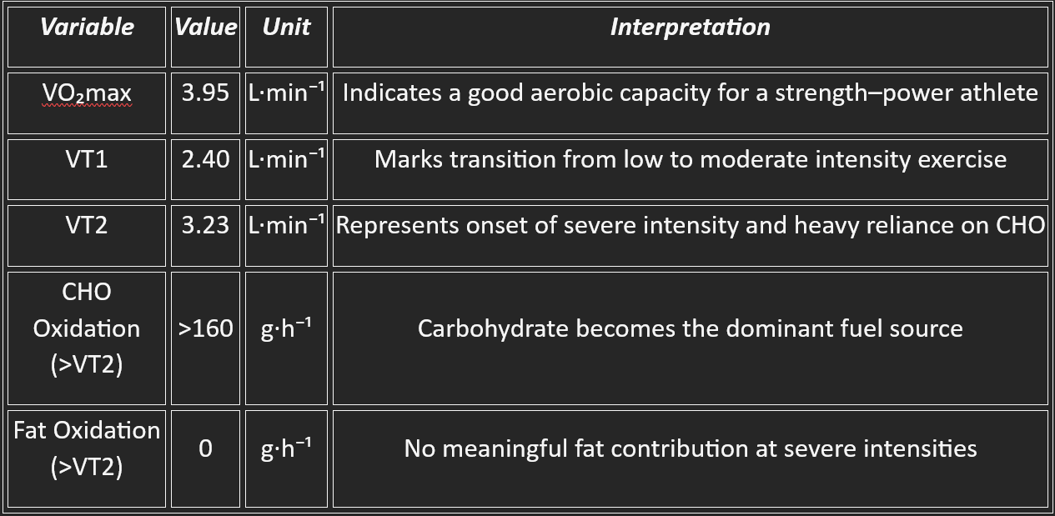
Table 1 summarises key CPET-derived physiological thresholds and substrate utilisation characteristics. Collectively, the data demonstrate an early transition toward carbohydrate reliance and a complete suppression of fat oxidation at higher intensities, highlighting the importance of adequate carbohydrate availability to support high-volume hypertrophy training and recovery. Full summary table (Appendix D1, Figure D1)
2.4 Muscle Fibre Typology and Neuromuscular Characteristics
Further insight into the client’s metabolic profile is provided by the Wingate anaerobic test and Keiser strength–power assessments (Bar-Or, 1987; Inbar et al., 2018; Cormie et al., 2011; Weakley et al., 2021). These assessments help explain force production characteristics alongside the client’s high carbohydrate demand and fatigue profile (Bishop et al., 2019; Brooks, 2020).
The Wingate test revealed a peak power output of approximately 1121 W followed by a rapid decline across the test duration, a pattern characteristic of fast twitch muscle fibre dominance. This fibre profile prioritises power output and rapid ATP turnover at the expense of fatigue resistance (Bottinelli and Reggiani, 2000; Lievens et al., 2020). Fast-twitch fibres possess high glycolytic enzyme activity but limited oxidative capacity, resulting in accelerated phosphocreatine depletion and reliance on anaerobic glycolysis during repeated high-intensity efforts (Schiaffino and Reggiani, 2011; Bogdanis et al., 1996).
These findings align with the client’s rugby background, where repeated high-force, short-duration efforts with incomplete recovery promote adaptations favouring fast-twitch fibre recruitment and glycolytic capacity (Austin et al., 2011; Cunningham et al., 2018; Bishop et al., 2019). This training history helps explain the combination of high power output, rapid fatigue, and early carbohydrate dependence observed during laboratory testing.
Keiser strength–power profiling further supports this interpretation, with high peak power values observed during early repetitions followed by a decline in output as fatigue accumulates (Cormie et al., 2011; Girard et al., 2011; Weakley et al., 2021). This decline reflects increasing metabolic stress during repeated high-intensity efforts, driven by greater anaerobic glycolytic contribution and associated intramuscular acidosis and phosphate accumulation, impairing force production and accelerating fatigue as muscle glycogen availability declines (Schoenfeld, 2010; Allen et al., 2008; Robergs et al., 2004; Ørtenblad et al., 2013).
From a nutritional perspective, this fibre typology has important implications. Fast-twitch dominant musculature is highly dependent on carbohydrate availability during hypertrophy-focused resistance training, particularly when sets are performed close to failure with limited recovery. Inadequate carbohydrate intake would be expected to increase fatigue and reduce training quality, whereas sufficient availability supports glycolytic flux, delays fatigue, and preserves force output (Haff et al., 2000; Burke et al., 2018; Schoenfeld et al., 2021).
2.5 Fatigue Mechanisms and Recovery Implications
Fatigue development in this client reflects the interaction between peripheral and central mechanisms driven by high training volume, fibre-type characteristics, and limited recovery capacity (Allen et al., 2008; Enoka and Duchateau, 2016). From a peripheral perspective, repeated high-volume resistance training progressively depletes phosphocreatine and muscle glycogen stores, particularly during sets performed close to failure, reducing the capacity for rapid ATP resynthesis and contributing to declining force output across sessions (Bogdanis et al., 1996; Ørtenblad et al., 2013; Westerblad et al., 2010).
Central fatigue also contributes meaningfully to the client’s fatigue profile. Averaging approximately five hours of sleep per night, the client is likely operating with reduced neurological recovery capacity. Sleep restriction has been shown to impair glucose regulation, increase perceived exertion, and reduce neuromuscular efficiency during high-intensity exercise (Simpson et al., 2017; Knowles et al., 2018). When combined with a weekly schedule of five resistance and five cardiovascular sessions, limited sleep increases the risk of cumulative fatigue across the training week (Halson, 2014; Enoka and Duchateau, 2016).
While nutritional support plays a key role in mitigating fatigue, periods of reduced training load, such as planned deloads or lower-volume phases, may also be required to prevent excessive fatigue accumulation over time (Meeusen et al., 2013; Grgic et al., 2021). Aligning macronutrient intake with fluctuations in training stress can further support recovery and reduce injury risk (Burke et al., 2018; Impey et al., 2018).
Overall, the interaction between high training volume, fast-twitch muscle fibre characteristics, carbohydrate dependence, and restricted sleep places the client at increased risk of performance decline if recovery is not adequately supported. This reinforces the need for a structured nutritional strategy prioritising carbohydrate timing, consistent daily fuelling, and recovery-focused nutrition, forming the basis for the applied plan presented in the following section.
3. Nutrition Strategy
3.1 Energy Intake and Surplus Rationale
The primary objective during this phase is to support lean mass gain while minimising unnecessary body fat accumulation. As the client has recently completed a fat-loss phase and is maintaining a low body fat level, a controlled and conservative caloric surplus was selected rather than pursuing rapid increases in body mass. The focus of this phase is therefore on sustaining training performance, supporting recovery, and facilitating gradual muscle tissue accretion over time.
Estimated energy requirements were calculated using the Harris–Benedict equation, with an activity multiplier applied to reflect both the client’s structured training load and physically demanding occupation. From this baseline, a modest caloric surplus of approximately 300–400 kcal·day⁻¹ was applied to support lean mass gain while limiting excessive fat accumulation. These values were treated as practical starting points rather than set indefinitely, with ongoing adjustments guided by training performance, recovery, and observed changes in body composition rather than reliance on predicted values alone.
Future Energy intake will be monitored using performance-based markers, including the ability to maintain or progress training loads, repetitions, and weekly volume. Body composition will be tracked using standardised assessment conditions, circumference measures, and progress photographs, alongside monitoring appetite and digestive tolerance to ensure the prescribed intake remains practical and sustainable.
3.2 Macronutrient Distribution Overview
Macronutrient distribution during this phase was structured to align with the client’s physiological profile, training demands, and current goal of lean mass gain. Rather than adopting a generic approach, macronutrients were prioritised based on their roles in supporting training performance, recovery, and adaptation.
Carbohydrate intake forms the foundation of the nutritional strategy, followed by adequate protein intake to support muscle repair and adaptation. Dietary fat intake is maintained at a moderate level to support hormonal function and overall energy balance without displacing carbohydrate intake. This approach reflects the client’s high-volume resistance training demands and the need to prioritise training quality and recovery within the constraints of the client’s lifestyle.

3.3 Macronutrient Targets and Periodisation
Based on the estimated total daily energy requirements and the inclusion of a modest caloric surplus, total daily energy intake was set at approximately 3,700–3,900 kcal·day⁻¹. This intake is intended to support training performance, recovery, and lean mass accretion while minimising unnecessary fat gain.
Protein intake was set at 2.0–2.4 g·kg⁻¹·day⁻¹, equating to approximately 180–215 g·day⁻¹ based on the client’s body mass of 90.4 kg. Protein intake will be distributed evenly across the day to support muscle protein synthesis and recovery between training sessions.
Carbohydrate intake accounts for the majority of total energy intake and was set at 5–7 g·kg⁻¹·day⁻¹ (approximately 450–630 g·day⁻¹). Intake will be periodised within this range based on daily training demands, with higher intakes on resistance training and combined training days and lower intakes on rest or lower-demand days.
Dietary fat intake was set at approximately 15–25% of total daily energy intake (approximately 60–105 g·day⁻¹) and adjusted inversely with carbohydrate intake. On high-volume resistance training days, fat intake is maintained toward the lower end of the range to prioritise carbohydrate availability, while intake is increased modestly on rest or lower-intensity days to support energy balance and dietary adherence.
4. Justification & Critical Evaluation
4.1 Rationale for Energy Intake and Surplus Selection
The selection of daily energy intake was informed by predictive modelling, physiological assessment data, and consideration of training load and lifestyle demands (Burke et al., 2018; Loucks, 2019). Resting energy requirements were estimated using the Harris–Benedict equation (Harris and Benedict, 1919), producing the predicted resting metabolic rate outlined previously. While predictive equations are known to carry a margin of error, their use remains common in applied sport nutrition when direct measures such as doubly labelled water, the gold standard method, are unavailable (Schoeller, 1988; Pontzer et al., 2021).
The Cunningham and Schofield equations were also considered as alternative models (Cunningham, 1980; Schofield, 1985). The Cunningham equation was initially appealing due to its reliance on lean mass, which is theoretically appropriate for a strength-trained individual with high fat-free mass (Cunningham, 1980; Müller et al., 2015). However, the client’s lean mass values from body composition assessments indicating extremely low body fat levels. Given the recognised limitations of bioelectrical impedance analysis in very lean, muscular individuals, this approach carried a risk of overestimating resting energy expenditure and was therefore was discounted (Kyle et al., 2004; Buckinx et al., 2018; see Appendix A, Figure A1).
The Schofield equation produced resting energy values comparable to those calculated using Harris–Benedict (see Appendix A, Figure A1), increasing confidence that the estimated resting requirement fell within a realistic range. On this basis, Harris–Benedict was selected as a conservative starting point, as its inclusion of height alongside body mass offers a more individualised estimate while avoiding the potential overestimation associated with fat-free-mass–based models (Frankenfield et al., 2005; Müller et al., 2015). It is acknowledged that all predictive equations provide estimates rather than exact values and should be interpreted alongside training performance, recovery capacity, and longer-term body composition trends (Compher et al., 2006; Burke et al., 2018).
To estimate total daily energy expenditure, a physical activity multiplier of 1.7 was applied to account for structured training and elevated non-exercise activity thermogenesis (Levine, 2004; Westerterp, 2017). This multiplier reflects a moderate-to-high activity profile and was considered appropriate for the client’s daily energy demands (FAO/WHO/UNU, 2004; Loucks, 2019). Using this value, estimated maintenance requirements were calculated at approximately 3,400–3,500 kcal/day (see Appendix B, Figure B). It is acknowledged that activity multipliers remain subjective and may under- or overestimate true energy expenditure (Compher et al., 2006; Pontzer et al., 2021).
From this baseline, a modest caloric surplus of approximately 300–400 kcal/day was applied, resulting in a target intake of approximately 3,700–3,900 kcal/day (see Appendix C, Figure C). This surplus was selected to support progressive lean mass accumulation while minimising excessive fat gain (Helms et al., 2014; Slater and Phillips, 2011).
Evidence from resistance-trained populations further supports the decision to adopt a conservative caloric surplus during this phase. Research indicates that increasing energy intake beyond a modest surplus does not lead to proportional increases in muscle mass and is more likely to promote unnecessary fat gain, particularly in individuals with established training adaptations (Slater and Phillips, 2011; Helms et al., 2014). This appears to reflect physiological constraints on the rate at which new muscle tissue can be synthesised, such that excess energy intake beyond this point is potentially stored as adipose tissue rather than contributing to further lean mass accretion. In the case of the client’s training status and low post-diet body fat levels, a restrained surplus was therefore prioritised to optimise the balance between lean mass gains and fat accumulation.
4.2 Justification of Carbohydrate Intake and Periodisation
Carbohydrate intake was periodised due to the client’s clear physiological reliance on carbohydrate metabolism across both resistance and cardiovascular exercise. High-volume hypertrophy training, characterised by sets performed close to failure, short rest intervals, and substantial metabolic accumulation, places a heavy demand on anaerobic glycolysis and intramuscular glycogen stores (Schoenfeld, 2010; Grgic et al., 2018; Scott et al., 2018). When glycogen availability is reduced, training performance and work capacity are commonly compromised (Haff et al., 2000; Impey et al., 2018).
The client’s fast-twitch dominant fibre profile further supports elevated carbohydrate intake. Fast-twitch fibres possess high glycolytic capacity but fatigue rapidly when substrate availability is limited, leading to reductions in power output and accelerated neuromuscular fatigue (Schiaffino and Reggiani, 2011; Ørtenblad et al., 2013; Lievens et al., 2020). Maintaining sufficient carbohydrate intake is therefore essential for preserving training intensity and promoting hypertrophic adaptation (Burke et al., 2018; Schoenfeld et al., 2021).
Carbohydrate intake was set relative to daily training demands, with higher intakes ranges allocated to resistance training and combined training days and lower intakes on rest or lower-demand days (Impey et al., 2018; Jeukendrup, 2017). This periodised approach allows training performance to be maximised on high-demand days while avoiding unnecessary excess intake on lower-demand days (Burke et al., 2018; Stellingwerff et al., 2021).
Although lower-carbohydrate or fat-adapted dietary strategies have been proposed as a means of enhancing metabolic flexibility, such approaches were not prioritised within the current nutritional strategy. While carbohydrate restriction may increase reliance on fat oxidation, evidence indicates that this often occurs alongside reductions in training intensity and total work performed during high-intensity or resistance-based exercise (Burke et al., 2018; Stellingwerff et al., 2021). Given that hypertrophic adaptation is strongly dependent on the ability to sustain high training volumes and repeatedly perform sets close to failure, any dietary approach that compromises session quality would be counterproductive in this context. Accordingly, carbohydrate intake was prioritised to support training performance and progressive overload, rather than to maximise metabolic flexibility in isolation.
Beyond performance, carbohydrate availability plays a key role in recovery. Adequate post-exercise carbohydrate intake supports muscle glycogen resynthesis, particularly when training frequency is high and recovery windows are limited (Burke et al., 2017). A larger proportion of daily carbohydrate intake was therefore prioritised around pre- and post-training periods, with the remainder distributed across meals to maintain energy availability and support recovery between sessions (Impey et al., 2018; Burke et al., 2018). Given the client’s chronically restricted sleep, maintaining sufficient carbohydrate and overall energy intake may help mitigate some of the negative effects of sleep loss on performance and recovery, although nutrition cannot fully compensate for inadequate sleep (Simpson et al., 2017; Knowles et al., 2018).
4.3 Justification of Protein and Fat Intake
Protein intake was prioritised to support training adaptation and recovery during the high-volume hypertrophy phase. A daily intake of approximately 2.0–2.4 g/kg was selected to reflect the client’s training frequency, fibre type characteristics, and elevated recovery demands. Evidence consistently demonstrates that protein intakes within this range optimise muscle protein synthesis in resistance-trained individuals, particularly when training volume is high and sessions are performed close to failure (Morton et al., 2018).
However, although higher protein intakes have been suggested as a means of further enhancing muscle protein synthesis, the prevailing evidence indicates that resistance training gain increases in lean mass are largely maximised at intakes of around 1.6 g·kg⁻¹·day⁻¹, with an upper effective range extending toward approximately 2.2–2.4 g·kg⁻¹·day⁻¹, beyond which additional benefits appear limited (Morton et al., 2018; Tagawa et al., 2022). This interpretation is reinforced by the findings of Nunes et al. (2022), whose systematic review suggests that while higher protein intakes continue to support gains in lean mass during resistance training, further increases beyond this range do not meaningfully produce hypertrophic outcomes in the majority of individuals.
In the current case, protein intake was deliberately set toward the upper end of this evidence-based range in recognition of the client’s high training volume, physically demanding occupation, and chronically restricted sleep duration, all of which are likely to impair recovery and increase daily protein requirements (Simpson et al., 2017). Due to elevated mechanical stress and compromised recovery, ensuring sufficient total protein intake, alongside an even distribution across meals, is advised to aid muscle repair and maintain daily protein balance between sessions (Moore et al., 2012; Areta et al., 2013).
Dietary fat intake was set at a moderate and periodised level (15–25% of total energy intake) to support endocrine function and overall energy balance while minimising interference with carbohydrate availability (Helms et al., 2014; Volek et al., 2006). While dietary fat plays an important role in hormonal health and the absorption of fat-soluble vitamins, excessively high fat intakes during high-volume resistance training may displace carbohydrate intake and impair training quality, particularly in athletes with a high reliance on glycolytic metabolism (Burke et al., 2018).
Conversely, overly restrictive fat intakes may negatively affect dietary adherence, satiety, and overall energy intake, which are important considerations during prolonged training phases characterised by high workloads and elevated recovery demands (Stubbs et al., 2018). Fat intake was therefore moderated on resistance training and high-demand days to prioritise carbohydrate availability, while being increased modestly on rest or lower-intensity days to support energy balance, satiety, and long-term adherence (Jeukendrup, 2017). This periodised approach allows fat intake to support health and sustainability without compromising the primary performance and hypertrophy demands of training.
Overall, the selected protein and fat targets complement the carbohydrate-focused strategy by supporting muscle repair, endocrine health, and adherence, while remaining secondary to the primary demands of training quality, recovery, and progressive overload.
4.4 Justification of Ergogenic Aids
The inclusion of ergogenic aids was intended to complement, rather than replace, the nutritional strategy. Supplements were selected as practical and interchangeable tools, guided by evidence supporting improvements in training performance, fatigue reduction, and recovery.
Caffeine was selected as the most practical ergogenic aid due to its well-established ability to reduce perceived exertion and enhance training output, which is particularly beneficial during high-volume, high-intensity resistance training (Grgic et al., 2019). Caffeine was therefore used selectively around key resistance training sessions to support performance and focus. Dosage was prescribed on a body-mass–adjusted basis in line with current evidence, with an intake of approximately 3–6 mg/kg recommended (Spriet, 2014; Grgic et al., 2019). For this 90 kg client, this equated to 270–540 mg, with a practical target of 300–400 mg consumed 45–60 minutes pre-session to maximise ergogenic benefit while minimising adverse effects (Spriet, 2014; Grgic et al., 2019).
Creatine monohydrate was included due to its established effects on high-intensity performance and phosphocreatine resynthesis (Kreider et al., 2017; Candow et al., 2021). Given the client’s fibre-type characteristics and reliance on anaerobic energy pathways, creatine supplementation is well aligned with the physiological demands of hypertrophy training (Kreider et al., 2017; Candow et al., 2021). A maintenance dose of 3–5 g/day was prescribed, which is sufficient to maximise phosphocreatine stores, with no loading phase required as supplementation had already been established (Kreider et al., 2017).
The use of essential amino acids around training was justified primarily on practical grounds. Where whole-food intake around training is not feasible, EAA supplementation provides a convenient means of maintaining amino acid availability to support performance and recovery without increasing gastrointestinal burden (Tipton, 2018). A dose of approximately 10 g was selected, which has been shown to be sufficient to stimulate muscle protein synthesis (Areta et al., 2013).
Nitrate-rich supplements and buffering agents such as sodium bicarbonate were considered optional and situational. While evidence suggests potential benefits during exercise characterised by high metabolic stress (McMahon et al., 2017) their use was not prioritised due to variability in individual gastrointestinal tolerance and limited relevance to all training sessions (Heibel et al., 2018). Where implemented, these aids would be reserved for specific high-demand sessions rather than routine use (McMahon et al., 2017; Heibel et al., 2018).
- Limitations And Critical Reflection
While this nutritional strategy was informed by a range of physiological assessments and applied evidence, several limitations must be acknowledged. Firstly, as previously touched upon, all estimate of energy expenditure were calculated from predictive equations and activity multipliers rather than direct measures from ‘gold standard’ apparatus such as doubly labelled water (Schoeller, 1988; Pontzer et al., 2021). Although equations were compared to improve confidence in the set values, true daily energy expenditure from predicted estimations. For this reason, calculations of energy requirements and macronutrient targets were treated as base points that could be adjusted depending on the clients weekly feedback spoken about previously.
Body composition assessment is another limitation. Inbody bioelectrical impedance analysis and skinfold measurements provide an easy access and practical estimate, however, are subject to error. Hydration status, time of day taken, recent training and human measurement assumptions may influence results, and therefore changes in body composition should be assessed cautiously (Kyle et al., 2004; Buckinx et al., 2018). To minimise error, body composition assessments should be measured under standardised conditions to identify trends over time.
CPET testing provided valuable insight into substrate utilisation and metabolic responses, however, results represent a snapshot of physiological function in that precise moment under laboratory conditions. Substrate oxidation patterns may different during prolonged or sport-specific training sessions (Achten and Jeukendrup, 2003). CPET data was used to inform broad nutritional principles rather than dictate accurate macronutrient requirements.
Finally, lifestyle factors such as limited sleep and occupational demands introduce a variability that cannot be controlled through nutrition alone (Simpson et al., 2017; Halson, 2014). While the strategy aims to reduce these stressors, optimal adaptations remain dependent on factors beyond nutritional strategy (Simpson et al., 2017; Halson, 2014).
From this, ongoing review and individualisation is therefore essential to ensure that this particular nutritional strategy remains aligned with the clients long term performance goals, training loads and recovery capacity.
References
Ackland, T.R., Lohman, T.G., Sundgot-Borgen, J., Maughan, R.J., Meyer, N.L., Stewart, A.D. and Müller, W. (2012) Current status of body composition assessment in sport. Sports Medicine, 42(3), pp. 227–249.
Achten, J. and Jeukendrup, A.E. (2003) Heart rate monitoring: applications and limitations. Sports Medicine, 33(7), pp. 517–538. doi: 10.2165/00007256-200333070-00004.
Achten, J. and Jeukendrup, A.E. (2004) Optimizing fat oxidation through exercise and diet. Nutrition, 20(7–8), pp. 716–727. doi: 10.1016/j.nut.2004.04.005.
Allen, D.G., Lamb, G.D. and Westerblad, H. (2008) Skeletal muscle fatigue: cellular mechanisms. Physiological Reviews, 88(1), pp. 287–332. doi: 10.1152/physrev.00015.2007.
Areta, J.L., Burke, L.M., Ross, M.L.R., Camera, D.M., West, D.W.D., Broad, E.M., Jeacocke, N.A., Moore, D.R., Stellingwerff, T., Phillips, S.M. and Hawley, J.A. (2013) Timing and distribution of protein ingestion during prolonged recovery from resistance exercise alters myofibrillar protein synthesis. Journal of Physiology, 591(9), pp. 2319–2331. doi: 10.1113/jphysiol.2012.244897.
Austin, D., Gabbett, T. and Jenkins, D. (2011) Repeated high-intensity exercise in a professional rugby league. Journal of Strength and Conditioning Research, 25(7), pp. 1898–1904. doi: 10.1519/JSC.0b013e3181e4f00b.
Bar-Or, O. (1987) The Wingate anaerobic test: an update on methodology, reliability and validity. Sports Medicine, 4(6), pp. 381–394. doi: 10.2165/00007256-198704060-00001.
Bishop, D.J., Granata, C. and Eynon, N. (2019) Can we optimise the exercise training prescription to maximise improvements in mitochondria function and content? Biochimica et Biophysica Acta – General Subjects, 1863(4), pp. 1266–1279. doi: 10.1016/j.bbagen.2018.11.017.
Bogdanis, G.C., Nevill, M.E., Boobis, L.H. and Lakomy, H.K.A. (1996) Contribution of phosphocreatine and aerobic metabolism to energy supply during repeated sprint exercise. Journal of Applied Physiology, 80(3), pp. 876–884. doi: 10.1152/jappl.1996.80.3.876.
Bottinelli, R. and Reggiani, C. (2000) Human skeletal muscle fibres: molecular and functional diversity. Progress in Biophysics and Molecular Biology, 73(2–4), pp. 195–262. doi: 10.1016/S0079-6107(00)00006-7.
Brooks, G.A. (2020) The science and translation of lactate shuttle theory. Cell Metabolism, 31(3), pp. 491–506. doi: 10.1016/j.cmet.2020.02.008.
Brooks, G.A. and Mercier, J. (1994) Balance of carbohydrate and lipid utilization during exercise: the “crossover” concept. Journal of Applied Physiology, 76(6), pp. 2253–2261. doi: 10.1152/jappl.1994.76.6.2253.
Buckinx, F., Reginster, J.Y., Dardenne, N., Croisiser, J.L., Kaux, J.F., Beaudart, C., Slomian, J. and Bruyère, O. (2018) Concordance between muscle mass assessed by bioelectrical impedance analysis and by dual-energy X-ray absorptiometry: a cross-sectional study. BMC Musculoskeletal Disorders, 19, Article 10. doi: 10.1186/s12891-017-1913-0.
Buckinx, F., Landi, F., Cesari, M., et al. (2018) Pitfalls in the measurement of muscle mass: a need for a reference standard. Journal of Cachexia, Sarcopenia and Muscle, 9(2), pp. 269–278. doi: 10.1002/jcsm.12268.
Burke, L.M. and Hawley, J.A. (2018) Swifter, higher, stronger: What’s on the menu? Science, 362(6416), pp. 781–787. doi: 10.1126/science.aau2093.
Burke, L.M., van Loon, L.J.C. and Hawley, J.A. (2017) Postexercise muscle glycogen resynthesis in humans. Journal of Applied Physiology, 122(5), pp. 1055–1067. doi: 10.1152/japplphysiol.00860.2016.
Burke, L.M., Hawley, J.A., Jeukendrup, A.E. and Morton, J.P. (2018) Nutrition for training adaptation and performance. Journal of Sports Sciences, 36(6), pp. 685–696. doi: 10.1080/02640414.2017.1340650.
Candow, D.G., Forbes, S.C., Chilibeck, P.D., et al. (2021) Effectiveness of creatine supplementation on aging muscle and performance. Nutrients, 13(6), 1915. doi: 10.3390/nu13061915.
Compher, C., Frankenfield, D., Keim, N. and Roth-Yousey, L. (2006) Best practice methods to apply to measurement of resting metabolic rate in adults: a systematic review. Journal of the American Dietetic Association, 106(6), pp. 881–903. doi: 10.1016/j.jada.2006.02.009.
Cormie, P., McGuigan, M.R. and Newton, R.U. (2011) Developing maximal neuromuscular power: part 1—biological basis of maximal power production. Sports Medicine, 41(1), pp. 17–38. doi: 10.2165/11537690-000000000-00000.
Cortex Biophysik GmbH (n.d.) METALYZER® 3B metabolic cart. Leipzig, Germany. Available at: https://cortex-medical.com/EN/METALYZER-3B-en.htm (Accessed: 9 January 2026).
Cranlea & Co. (n.d.) Calibration gas mixtures. Birmingham, UK. Available at: https://www.cranlea.co.uk/product/calibration-gas/ (Accessed: 9 January 2026).
Cunningham, J.J. (1980) A reanalysis of the factors influencing basal metabolic rate in normal adults. American Journal of Clinical Nutrition, 33(11), pp. 2372–2374. doi: 10.1093/ajcn/33.11.2372.
Cunningham, D.J., Shearer, D.A., Drawer, S., Pollard, B., Bennett, M., Eager, R., Taylor, N. and Cook, C.J. (2018) Movement demands of elite under-20s and senior international rugby union players. PLoS ONE, 13(1), e0191020. doi: 10.1371/journal.pone.0191020.
Dulloo, A.G., Jacquet, J., Montani, J.P. and Schutz, Y. (2015) Adaptive thermogenesis in human body weight regulation: more of a concept than a measurable entity? Obesity Reviews, 16(S1), pp. 5–15. doi: 10.1111/obr.12246.
Egan, B. and Zierath, J.R. (2013) Exercise metabolism and the molecular regulation of skeletal muscle adaptation. Cell Metabolism, 17(2), pp. 162–184. doi: 10.1016/j.cmet.2012.12.012.
Enoka, R.M. and Duchateau, J. (2016) Translating fatigue to human performance. Medicine & Science in Sports & Exercise, 48(11), pp. 2228–2238. doi: 10.1249/MSS.0000000000000929.
FAO/WHO/UNU (2004) Human energy requirements. Rome: Food and Agriculture Organization of the United Nations.
Faude, O., Kindermann, W. and Meyer, T. (2009) Lactate threshold concepts: how valid are they? Sports Medicine, 39(6), pp. 469–490. doi: 10.2165/00007256-200939060-00003.
Frankenfield, D., Roth-Yousey, L. and Compher, C. (2005) Comparison of predictive equations for resting metabolic rate in healthy nonobese and obese adults. Journal of the American Dietetic Association, 105(5), pp. 775–789. doi: 10.1016/j.jada.2005.02.005.
Fullagar, H.H.K., Skorski, S., Duffield, R., Hammes, D., Coutts, A.J. and Meyer, T. (2015) Sleep and athletic performance: the effects of sleep loss on exercise performance, and physiological and cognitive responses to exercise. Sports Medicine, 45(2), pp. 161–186. doi: 10.1007/s40279-014-0260-0.
Girard, O., Mendez-Villanueva, A. and Bishop, D. (2011) Repeated-sprint ability—part I: factors contributing to fatigue. Sports Medicine, 41(8), pp. 673–694. doi: 10.2165/11590550-000000000-00000.
Grgic, J., Schoenfeld, B.J., Skrepnik, M., Davies, T.B. and Mikulic, P. (2018) Effects of rest interval duration in resistance training on measures of muscular strength, hypertrophy and endurance: a systematic review. Sports Medicine, 48(1), pp. 137–151. doi: 10.1007/s40279-017-0788-x.
Grgic, J., Mikulic, P., Schoenfeld, B.J., Bishop, D.J. and Pedisic, Z. (2019) The influence of caffeine supplementation on resistance exercise: a review. Sports Medicine, 49(1), pp. 17–30. doi: 10.1007/s40279-018-0997-y.
Grgic, J., Schoenfeld, B.J., Davies, T.B., Lazinica, B., Krieger, J.W. and Pedisic, Z. (2021) Effect of resistance training frequency on gains in muscular strength: a systematic review and meta-analysis. Sports Medicine, 51(6), pp. 1207–1220. doi: 10.1007/s40279-021-01435-9.
Hackney, A.C., Kallman, A.L. and Hosick, K.P. (2012) Exercise endocrinology: the stress response to exercise and its role in exercise adaptation. International Journal of Sports Medicine, 33(6), pp. 491–496. doi: 10.1055/s-0031-1295465.
Haff, G.G. and Triplett, N.T. (2016) Essentials of Strength Training and Conditioning. 4th edn. Champaign, IL: Human Kinetics.
Haff, G.G., Stone, M.H., Warren, B.J., Keith, R., Johnson, R.L. and Nieman, D.C. (2000) The effect of carbohydrate supplementation on multiple sessions and bouts of resistance exercise. Journal of Strength and Conditioning Research, 14(4), pp. 311–317.
Halson, S.L. (2014) Monitoring training load to understand fatigue in athletes. Sports Medicine, 44(S2), pp. 139–147. doi: 10.1007/s40279-014-0253-z.
Halson, S.L. (2014) Sleep in elite athletes and nutritional interventions to enhance sleep. Sports Medicine, 44(Suppl 1), pp. S13–S23. doi: 10.1007/s40279-014-0147-0.
Harris, J.A. and Benedict, F.G. (1919) A biometric study of basal metabolism in man. Proceedings of the National Academy of Sciences, 4(12), pp. 370–373. doi: 10.1073/pnas.4.12.370.
Heibel, A.B., Perim, P.H.L., Oliveira, L.F., McNaughton, L.R. and Saunders, B. (2018) Time to optimize supplementation: modifying factors influencing the individual responses to extracellular buffering agents. Frontiers in Nutrition, 5, Article 35. doi: 10.3389/fnut.2018.00035.
Helms, E.R., Aragon, A.A. and Fitschen, P.J. (2014) Evidence-based recommendations for natural bodybuilding contest preparation: nutrition and supplementation. Journal of the International Society of Sports Nutrition, 11, Article 20. doi: 10.1186/1550-2783-11-20.
Impey, S.G., Hearris, M.A., Hammond, K.M., Bartlett, J.D., Louis, J., Close, G.L. and Morton, J.P. (2018) Fuel for the work required: a theoretical framework for carbohydrate periodization and the glycogen threshold hypothesis. Sports Medicine, 48(5), pp. 1031–1048. doi: 10.1007/s40279-018-0867-7.
Inbar, O., Bar-Or, O. and Skinner, J.S. (2018) The Wingate Anaerobic Test. Champaign, IL: Human Kinetics.
InBody Co., Ltd. (n.d.) InBody 380 body composition analyser. Seoul, South Korea. Available at: https://uk.inbody.com (Accessed: 9 January 2026).
Jeukendrup, A.E. (2017) Periodized nutrition for athletes. Sports Medicine, 47(S1), pp. 51–63. doi: 10.1007/s40279-017-0694-2.
Jeukendrup, A.E. and Achten, J. (2001) Fatmax: a new concept to optimize fat oxidation during exercise? European Journal of Sport Science, 1(5), pp. 1–12. doi: 10.1080/17461390100071501.
Jeukendrup, A.E. and Wallis, G.A. (2005) Measurement of substrate oxidation during exercise by means of gas exchange measurements. International Journal of Sports Medicine, 26(S1), pp. S28–S37. doi: 10.1055/s-2004-830512.
Keiser Corporation (n.d.) Keiser A300 pneumatic leg press. Fresno, CA, USA. Available at: https://www.keiser.com (Accessed: 9 January 2026).
Knowles, O.E., Drinkwater, E.J., Urwin, C.S., Lamon, S. and Aisbett, B. (2018) Inadequate sleep and muscle strength: implications for resistance training. Sports Medicine, 48(3), pp. 597–607. doi: 10.1007/s40279-017-0790-3.
Kreider, R.B., Kalman, D.S., Antonio, J., Ziegenfuss, T.N., Wildman, R., Collins, R., Candow, D.G., Kleiner, S.M., Almada, A.L. and Lopez, H.L. (2017) International Society of Sports Nutrition position stand: safety and efficacy of creatine supplementation in exercise, sport, and medicine. Journal of the International Society of Sports Nutrition, 14, Article 18. doi: 10.1186/s12970-017-0173-z.
Kyle, U.G., Bosaeus, I., De Lorenzo, A.D., Deurenberg, P., Elia, M., Gómez, J.M., Heitmann, B.L., Kent-Smith, L., Melchior, J.C., Pirlich, M., Scharfetter, H., Schols, A.M., Pichard, C. and ESPEN (2004) Bioelectrical impedance analysis—part I: review of principles and methods. Clinical Nutrition, 23(5), pp. 1226–1243. doi: 10.1016/j.clnu.2004.06.004.
Kyle, U.G., Bosaeus, I., De Lorenzo, A.D., et al. (2004) Bioelectrical impedance analysis—part II: utilization in clinical practice. Clinical Nutrition, 23(6), pp. 1430–1453. doi: 10.1016/j.clnu.2004.09.012.
Levine, J.A. (2004) Non-exercise activity thermogenesis (NEAT). American Journal of Physiology – Endocrinology and Metabolism, 286(5), pp. E675–E685. doi: 10.1152/ajpendo.00562.2003.
Lievens, E., Klass, M., Bex, T. and Derave, W. (2020) Muscle fiber typology substantially influences time to recover from high-intensity exercise. Journal of Applied Physiology, 128(3), pp. 648–659. doi: 10.1152/japplphysiol.00636.2019.
Loucks, A.B. (2019) Low energy availability in the marathon and other endurance sports. Sports Medicine, 49(S2), pp. 13–21. doi: 10.1007/s40279-019-01102-4.
MacInnis, M.J. and Gibala, M.J. (2017) Physiological adaptations to interval training and the role of exercise intensity. Journal of Physiology, 595(9), pp. 2915–2930. doi: 10.1113/JP273196.
Maunder, E., Plews, D.J. and Kilding, A.E. (2018) Contextualising maximal fat oxidation during exercise: determinants and normative values. Frontiers in Physiology, 9, Article 599. doi: 10.3389/fphys.2018.00599.
McMahon, N.F., Leveritt, M.D. and Pavey, T.G. (2017) The effect of sodium bicarbonate supplementation on performance in repeated sprint activities: a systematic review. Journal of Strength and Conditioning Research, 31(8), pp. 2228–2239. doi: 10.1519/JSC.0000000000001671.
Meeusen, R., Duclos, M., Foster, C., Fry, A., Gleeson, M., Nieman, D., Raglin, J., Rietjens, G., Steinacker, J. and Urhausen, A. (2013) Prevention, diagnosis and treatment of the overtraining syndrome. European Journal of Sport Science, 13(1), pp. 1–24. doi: 10.1080/17461391.2012.730061.
Monark Exercise AB (n.d.) Ergomedic 894E cycle ergometer. Vansbro, Sweden. Available at: https://monarkexercise.se (Accessed: 9 January 2026).
Moore, D.R., Areta, J.L., Coffey, V.G., Stellingwerff, T., Phillips, S.M., Burke, L.M., Cléroux, M. and Hawley, J.A. (2012) Daytime pattern of protein intake affects whole-body protein turnover in resistance-trained males. Journal of Nutrition, 142(2), pp. 285–291. doi: 10.3945/jn.111.145219.
Morton, R.W., Murphy, K.T., McKellar, S.R., Schoenfeld, B.J., Henselmans, M., Helms, E., Aragon, A.A., Devries, M.C., Banfield, L., Krieger, J.W. and Phillips, S.M. (2018) A systematic review, meta-analysis and meta-regression of the effect of protein supplementation on resistance training–induced gains in muscle mass and strength. British Journal of Sports Medicine, 52(6), pp. 376–384. doi: 10.1136/bjsports-2017-097608.
Mountjoy, M., Sundgot-Borgen, J., Burke, L., Ackerman, K.E., Blauwet, C., Constantini, N., Lebrun, C., Lundy, B., Melin, A.K., Meyer, N., Sherman, R., Tenforde, A.S., Torstveit, M.K. and Budgett, R. (2018) IOC consensus statement on relative energy deficiency in sport (RED-S). British Journal of Sports Medicine, 52(11), pp. 687–697. doi: 10.1136/bjsports-2018-099193.
Müller, M.J., Enderle, J. and Bosy-Westphal, A. (2016) Changes in energy expenditure with weight gain and weight loss in humans. Current Obesity Reports, 5(4), pp. 413–423. doi: 10.1007/s13679-016-0237-4.
Nunes, J.P., Grgic, J., Cunha, P.M., Ribeiro, A.S. and Schoenfeld, B.J. (2022) What is the effect of protein intake on muscle mass and strength in healthy adults? A systematic review and meta-analysis. Nutrients, 14(6), 1235. doi: 10.3390/nu14061235.
Ørtenblad, N., Westerblad, H. and Nielsen, J. (2013) Muscle glycogen stores and fatigue. Journal of Physiology, 591(18), pp. 4405–4413. doi: 10.1113/jphysiol.2013.251629.
Paddon-Jones, D., Sheffield-Moore, M., Zhang, X.J., Volpi, E., Wolf, S.E., Aarsland, A., Ferrando, A.A. and Wolfe, R.R. (2004) Amino acid ingestion improves muscle protein synthesis in the young and elderly. American Journal of Physiology – Endocrinology and Metabolism, 286(3), pp. E321–E328. doi: 10.1152/ajpendo.00368.2003.
Pontzer, H., Yamada, Y., Sagayama, H., Ainslie, P.N., Andersen, L.F., Anderson, L.J., Arab, L., Baddou, I., Bedu-Addo, K., Blaak, E.E., et al. (2021) Daily energy expenditure through the human life course. Science, 373(6556), pp. 808–812. doi: 10.1126/science.abe5017.
Poole, D.C., Burnley, M., Vanhatalo, A., Rossiter, H.B. and Jones, A.M. (2016) Critical power: an important fatigue threshold in exercise physiology. Medicine & Science in Sports & Exercise, 48(11), pp. 2320–2334. doi: 10.1249/MSS.0000000000000939.
Robergs, R.A., Ghiasvand, F. and Parker, D. (2004) Biochemistry of exercise-induced metabolic acidosis. American Journal of Physiology – Regulatory, Integrative and Comparative Physiology, 287(3), pp. R502–R516. doi: 10.1152/ajpregu.00114.2004.
Romijn, J.A., Coyle, E.F., Sidossis, L.S., Gastaldelli, A., Horowitz, J.F., Endert, E. and Wolfe, R.R. (1993) Regulation of endogenous fat and carbohydrate metabolism in relation to exercise intensity and duration. American Journal of Physiology – Endocrinology and Metabolism, 265(3), pp. E380–E391. doi: 10.1152/ajpendo.1993.265.3.E380.
Schoeller, D.A. (1988) Measurement of energy expenditure in free-living humans by using doubly labeled water. Journal of Nutrition, 118(11), pp. 1278–1289. doi: 10.1093/jn/118.11.1278.
Schoenfeld, B.J. (2010) The mechanisms of muscle hypertrophy and their application to resistance training. Journal of Strength and Conditioning Research, 24(10), pp. 2857–2872. doi: 10.1519/JSC.0b013e3181e840f3.
Schoenfeld, B.J., Grgic, J. and Krieger, J.W. (2021) How many sets are optimal for muscle hypertrophy? Strength and Conditioning Journal, 43(2), pp. 28–38. doi: 10.1519/SSC.0000000000000585.
Schiaffino, S. and Reggiani, C. (2011) Fiber types in mammalian skeletal muscles. Physiological Reviews, 91(4), pp. 1447–1531. doi: 10.1152/physrev.00031.2010.
Schofield, W.N. (1985) Predicting basal metabolic rate, new standards and review of previous work. Human Nutrition: Clinical Nutrition, 39(S1), pp. 5–41.
Scott, C.B., Leighton, B.H., Ahearn, K.J. and McManus, J.J. (2018) Aerobic, anaerobic, and excess postexercise oxygen consumption energy expenditure of resistance training. Journal of Strength and Conditioning Research, 32(3), pp. 749–755. doi: 10.1519/JSC.0000000000001810.
Seca GmbH & Co. KG (n.d.) Seca 875 weighing scales and Seca 213 stadiometer. Hamburg, Germany. Available at: https://www.seca.com (Accessed: 9 January 2026).
Servomex Group Ltd. (n.d.) MiniHF 5200 gas analyser. Bristol, UK. Available at: https://www.servomex.com (Accessed: 9 January 2026).
Simpson, N.S., Gibbs, E.L. and Matheson, G.O. (2017) Optimizing sleep to maximize performance: implications and recommendations for elite athletes. Scandinavian Journal of Medicine & Science in Sports, 27(3), pp. 266–274. doi: 10.1111/sms.12703.
Slater, G.J. and Phillips, S.M. (2011) Nutrition guidelines for strength sports: sprinting, weightlifting, throwing events, and bodybuilding. Journal of Sports Sciences, 29(S1), pp. S67–S77. doi: 10.1080/02640414.2011.574722.
Spriet, L.L. (2014) Exercise and sport performance with low doses of caffeine. Sports Medicine, 44(S2), pp. 175–184. doi: 10.1007/s40279-014-0257-8.
Stellingwerff, T. and Cox, G.R. (2014) Systematic review: carbohydrate supplementation on exercise performance or capacity of varying duration. Applied Physiology, Nutrition, and Metabolism, 39(9), pp. 998–1011. doi: 10.1139/apnm-2014-0027.
Stellingwerff, T., Morton, J.P. and Burke, L.M. (2021) A framework for periodized nutrition for athletics. International Journal of Sport Nutrition and Exercise Metabolism, 31(1), pp. 1–12. doi: 10.1123/ijsnem.2020-0300.
Stubbs, B.J., Cox, P.J., Evans, R.D., Santer, P., Miller, J.J., Faull, O.K., Magor-Elliott, S., Hiyama, S., Stirling, M., Clarke, K. and Bennett, A.J. (2018) On the metabolism of exogenous ketones in humans. Frontiers in Physiology, 9, Article 245. doi: 10.3389/fphys.2018.00245.
Tagawa, R., Ogasawara, R., Kobayashi, K., et al. (2022) Dose–response relationship between protein intake and muscle strength and hypertrophy: a systematic review and meta-analysis. Sports Medicine – Open, 8, Article 72. doi: 10.1186/s40798-022-00508-w.
Tipton, K.D. (2018) Nutritional support for exercise-induced injuries. Sports Medicine, 48(S1), pp. 93–104. doi: 10.1007/s40279-017-0848-2.
Venables, M.C., Achten, J. and Jeukendrup, A.E. (2005) Determinants of fat oxidation during exercise in healthy men and women: a cross-sectional study. Journal of Applied Physiology, 98(1), pp. 160–167. doi: 10.1152/japplphysiol.00662.2003.
Volek, J.S., Gómez, A.L., Love, D.M., Weyers, A.M., Hesslink, R., Wise, J.A. and Kraemer, W.J. (2006) Effects of a high-fat diet on hormonal responses to resistance exercise. Journal of Applied Physiology, 100(3), pp. 953–960. doi: 10.1152/japplphysiol.01053.2005.
Wattbike Ltd. (n.d.) Wattbike Atom X. Nottingham, UK. Available at: https://www.wattbike.com (Accessed: 9 January 2026).
Watson, N.F. (2017) Health benefits of adequate sleep: improved performance and well-being. Sleep, 40(1), zsw104. doi: 10.1093/sleep/zsw104.
Weakley, J., Morrison, M., García-Ramos, A., Johnston, R., James, L.P. and Haff, G.G. (2021) The validity and reliability of commercially available resistance training devices for measuring force, velocity and power. Sports Medicine, 51(3), pp. 443–502. doi: 10.1007/s40279-020-01373-0.
Westerblad, H., Allen, D.G. and Lännergren, J. (2002) Muscle fatigue: lactic acid or inorganic phosphate the major cause? News in Physiological Sciences, 17, pp. 17–21. doi: 10.1152/nips.01347.2002.
Westerblad, H., Bruton, J.D. and Katz, A. (2010) Skeletal muscle: energy metabolism, fibre types and fatigue. Acta Physiologica, 199(2), pp. 139–148. doi: 10.1111/j.1748-1716.2010.02142.x.
Westerterp, K.R. (2017) Control of energy expenditure in humans. European Journal of Clinical Nutrition, 71(3), pp. 340–344. doi: 10.1038/ejcn.2016.237.

Appendices
Appendix A: Comparison of Resting Metabolic Rate Prediction Equations
Table A1. Comparison of resting metabolic rate estimates derived from Harris–Benedict, Cunningham, and Schofield equations.
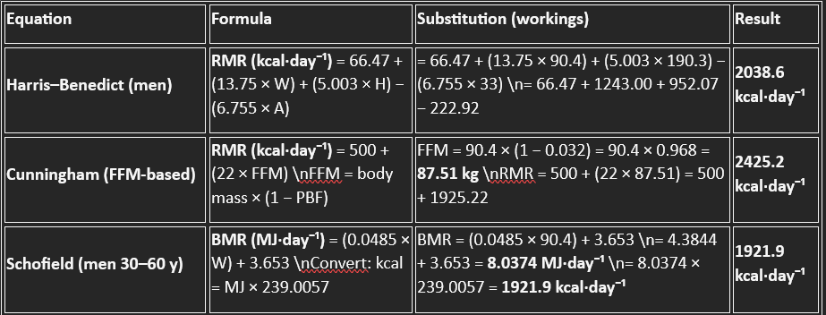

Appendix B: Estimation of Total Daily Energy Expenditure (TDEE)
Table B1. Calculation of estimated maintenance total daily energy expenditure using predicted resting metabolic rate and activity multiplier.
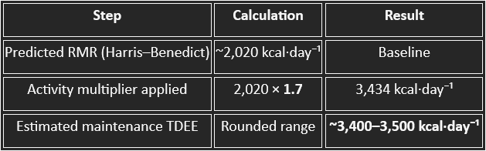

Appendix C: Estimation of Maintenance Energy Intake and Selected Surplus
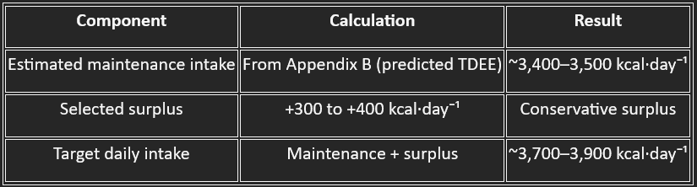
Table C1. Summary of estimated maintenance energy intake, applied caloric surplus, and resulting target daily energy intake.

Appendix D1: CPET Summary
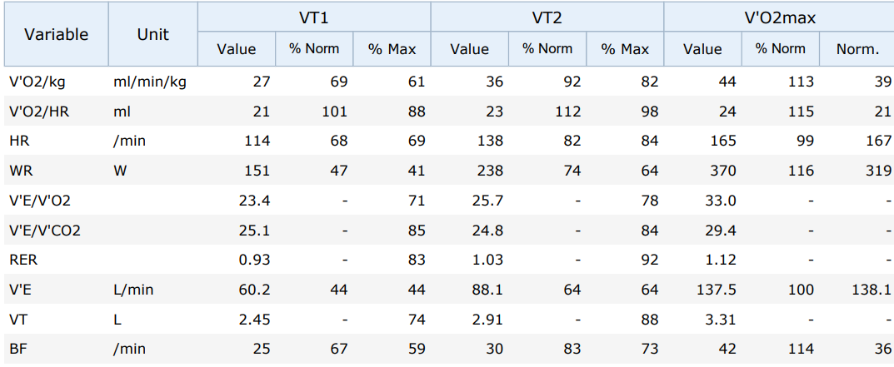
Table D1. Cardiopulmonary exercise testing variables at VT1, VT2, and VO₂max

Appendix D2: Ventilatory Threshold Identification
Figure D2. Identification of ventilatory threshold 1 (VT1) using the ventilatory equivalents method
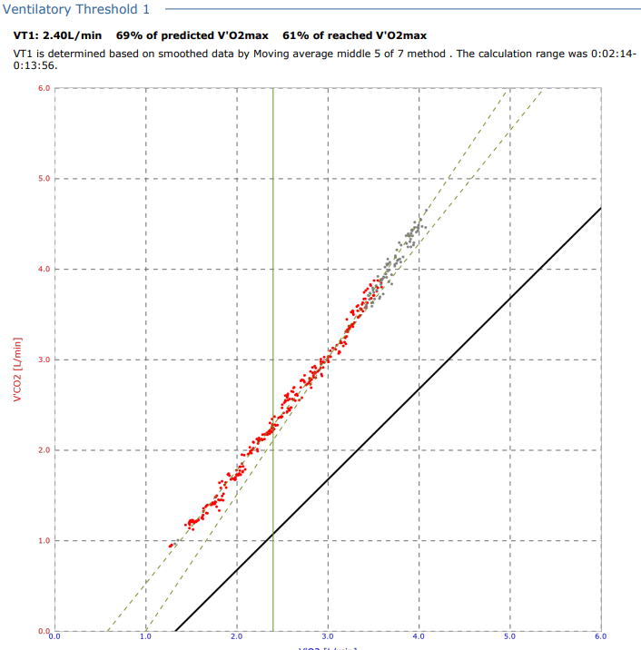

Appendix D3: Ventilatory Threshold Identification
Figure D3. Identification of ventilatory threshold 2 (VT2) using the ventilatory equivalents method
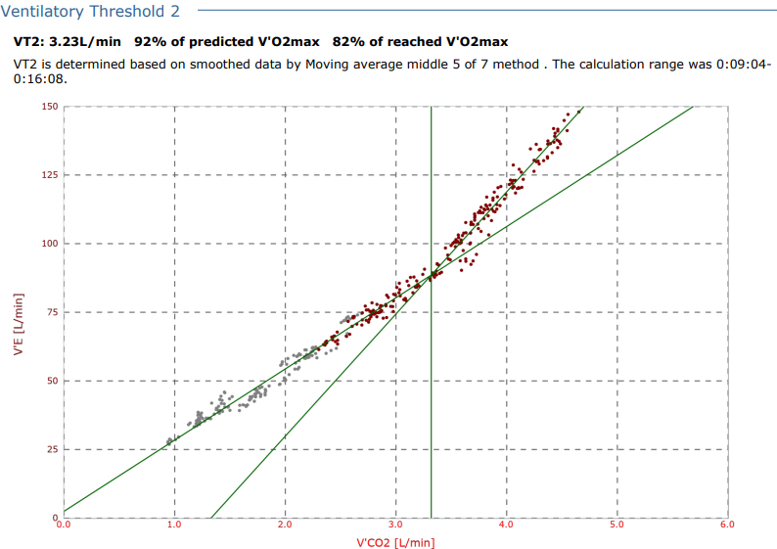

Appendix D4: VO2Max
Figure D4. Identification of ventilatory threshold Max (VO2max) using the ventilatory equivalents method
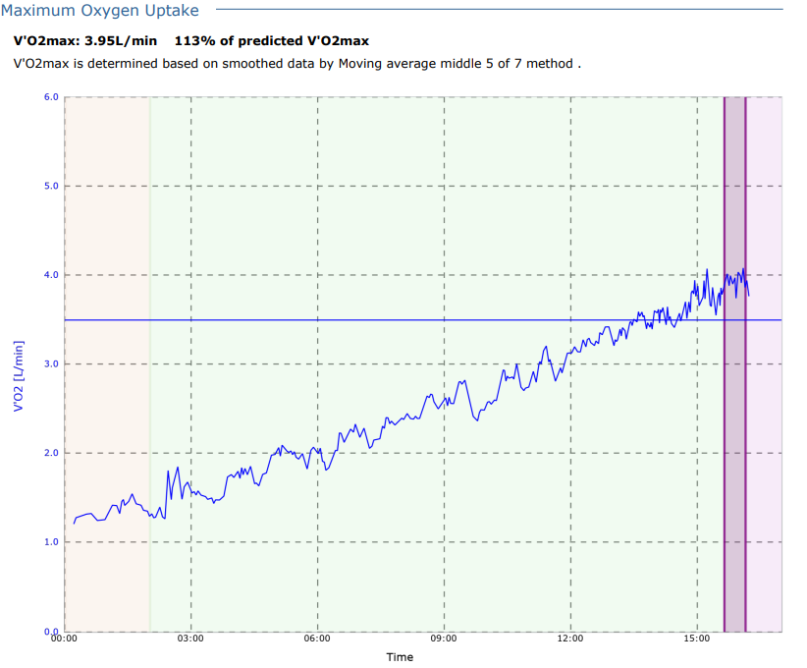

Appendix D5: Lipid Oxidation and Substrate Utilisation Across Exercise Intensity
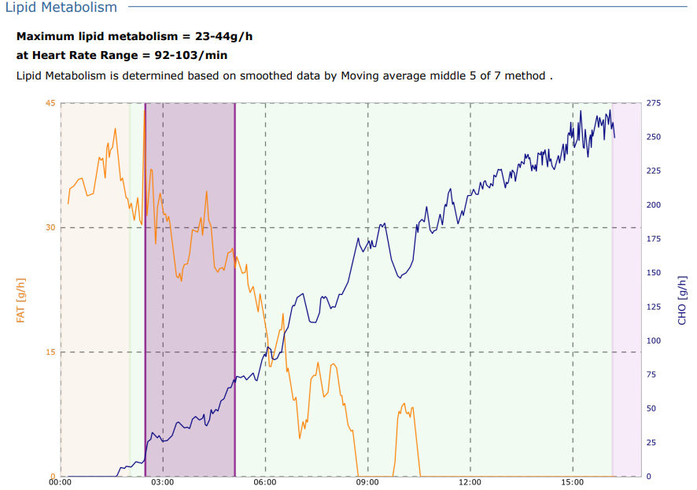
Figure D5. Substrate oxidation rates for lipid and carbohydrate

Appendix E1: Par Q & Consent
Figure E1 Complete Consent



Appendix E2: Par Q & Consent
Figure E2 Par Q Page 2


Appendix E3: Par Q & Consent

Figure E3: Par Q Page 3

Appendix E4: Par Q & Consent

Figure E4 Par Q Page 4

