

Assessment 1
Supporting Paper

Student name: RUTH SENE
Student ID: 2029258
Module name: Mental Disorders and Psychopathology
Module code: BMHP6006
Lecturer name: Bianca Sanfilippo

Contents

Introduction 2
Mental Health Disorder in the UK 2
PTSD within the ICD-10 Manual 3
Evolution of PTSD Diagnosis and Treatment 4
Current treatments (NHS) 5
Principles when working with people with PTSD 6
Recommendations for the improvement of the symptoms 6
Conclusion 7
References 8
Appendix 10

Introduction
Mental Health is of great importance and has become increasingly important in achieving sustainable development in global healthcare. Given the many factors contributing to a decline in the mental health of individuals across the world, it is essential that the existing treatment and strategies employed in addressing these health issues undergo a comprehensive review. In so doing, a greater appreciation for mental illness can be garnered the world over, with greater technical expertise on how to treat these illnesses and those affected, whether directly or indirectly. This becomes especially important given the results of research undertaken by the World Health Organisation (2022a), which highlight that of every eight (8) persons in the world, one (1) is living with a mental disorder.

Mental Health Disorder in the UK
According to the WHO (2022a), mental illness refers to a substantial disruption in an individual’s behaviour, emotional regulations, and cognition, deemed to be clinically significant. In so saying, it is typical of a person suffering from a mental health disorder to also experience some form of impairment in one or more important areas of everyday functions, and to experience emotional distress. Based on the results of research conducted by the WHO (2022a), it has also been found that of every eight (8) persons in the world, one (1) is living with a mental disorder.
More specific to the context of the UK, however, is the Survey of Mental Health and
Wellbeing in England (Baker, 2021), which found that of every six persons aged 16 years or older, one would have experienced the symptoms of a common mental health problem, with women being more susceptible. The study showed that, in England, the prevalence of mental illness, regardless of the form it takes has increased since 1993. Of the survey conducted, 4.4% of the respondents were deemed to have suffered from PTSD.

PTSD within the ICD-10 Manual
The ICD-10 manual, by its very nature, seeks to collect, process and classify the information available on the diseases and therefore seeks to provide clear and precise information on the status of technical medical expertise throughout the world. From this point, a combined effort can be employed to ascertain the best treatment methods to be meted out to those in dire need of medical intervention. Having defined what a mental health disorder is, one now looks at the classification of PTSD within the scope of the manual.
Post-Traumatic Stress Disorder is an anxiety-based mental and behavioural disorder produced by frightening, stressful or otherwise distressing incidents. Additionally, PTSD may occur in days, weeks or, in some cases, even years after the disturbing event has taken place. The WHO (2022b) has indicated that, within the ambit of the ICD-10, PTSD is covered in section F43.1 beneath the Neurotic, stress-related and somatoform disorders section, which occupies F40 through to F48. To further contextualize, it must be noted that the National Institute for Health and Care Excellence, or NICE (2018), has proffered that approximately a third of those who have been subjected to traumatic experiences have been affected, or continue to be affected, by PTSD.

Post-Traumatic Stress Disorder (PTSD)
In keeping with the definition of PTSD and based on the information of the UK’s National Health Service (NHS, 2021), a person afflicted with PTSD typically relives the traumatic event by way of nightmares and flashbacks, as well as face feelings of irritability, isolation, and guilt. These concerns tend to be taxing on the ability of the human mind and often result in the development of other medical problems including difficulty with concentrating and insomnia. Additionally, the associated symptoms are often severe and persistent, especially as it pertains to the impact on an individual’s daily life.
As it pertains to the possible causes of PTSD, however, MIND (2021) indicated that a range of distressing events could lead to a diagnosis of PTSD. These events include (i) torture, war and other conflicts; (ii) Serious vehicular accidents; (iii) Childbirth; and (iv) Violent assaults, including rape, robbery and battery. MIND is further corroborated by the NHS which further intimated that though traumatic events and experiences weigh heavily on the mind for all involved, it remains unclear why some individuals develop PTSD from the situation witnessed and others do not develop the condition.

Evolution of PTSD Diagnosis and Treatment
As time progressed and technological innovations and revolutions took place, the evolution of PTSD diagnosis and treatment could be clearly examined, thus identifying possible ways to treat the condition, or at the very least it’s most debilitating symptoms. It is against that backdrop that ancient stories, according to Crocq & Crocq (2000) revealed tales of post-battle trauma and flashback-like dreams as documented by Hippocrates between 4607 and 377BC. By the 1800s however, the term “battle exhaustion” or “soldier’s fatigue” were coined to capture the “hysterical attacks” that would have been noted to occur in military personnel years after their involvement of witnessing of a traumatic event. Moving into the time of the first World War (WWI) a new term, “shell shock”, came into being and subsequently brought into medical literature by the 1950s. At this point in time, the term as included in the medical journals describes the same symptoms of what is modern day PTSD.
It is at this juncture that treatment options for PTSD (as we know it today) were being determined. At the onset, to treat “shell shock”, a range of medical practices and procedures were deemed to provide some relief of the symptoms being experienced. These included psychoanalysis (to determine the interactions between the conscious and subconscious mind in mentally unwell patients), as well as more drastic measures including electric shock. As the years went by, treatment options became more humane in nature. There, however, presented a constraint to the successful implementation of treatment, according to Stupak & Dobrocozynski (2021), given that patients would wilfully ignore the presence of trauma so as to avoid being stigmatized as a result of suffering from a mental illness. PTSD became official in the 1980s by way of the American Psychological Association through its inclusion in the Diagnostic and Statistical Manual of Mental Disorders, or DSM.

Current treatments (NHS)
In further scrutiny of the evolution of treatment practices, one must note the drastic changes that were observed in the options chosen. Having started with invasive and torturous procedures such as trepanation, in which a hole was made in the skull, and electroshock therapy, upon receipt of greater knowledge about the condition, it is seen where treatment practices underwent a renaissance of sorts.
Modern-day treatment for PTSD primarily involves:
- Medication – antidepressant medications are the most researched means of treating PTSD, and are usually effective ate controlling, sadness, anger, sadness and other PTSD symptoms (Giller, 1990). The most frequently used type of anti-depressant are Selective serotonin reuptake inhibitors (SSRIs), as the number of side effects tend to be less. At the same time, these medications can also cause gastrointestinal bleeding. Dizziness, among other ill effects (PTSD UK, 2014).
- Complementary and alternative medicine (CAM)- this option required less disclosure of the traumatic event by the patient than psychotherapy, while avoiding the side effect risks associated with pharmaceutical treatments. Currently, however, there is no consensus on which CAM method is most suitable, but practitioners have observed positive outcomes in PTSD patients’ condition using acupuncture, meditation, yoga, deep-breathing exercises, mind-body therapy and tai chi (Song et. al., 2020).
- Psychotherapy and cognitive behavioural therapy (CBT) – this ‘talk therapy’ can be oneon-one or group based, depending on patient’s preference (National Institute of Mental Health, 2019). Studies have shown that between 60% and 82% of PTSD patients who participate in CBT improved completely, though the rate of improvement depends heavily on the degree of exposure to the traumatic event, the duration of the event, among other factors.

Principles when working with people with PTSD
In light of the historical developments of PTSD, it is also noted that certain underlying principles have been identified when interacting with PTSD patients. These, according to NICE (2018) include:
- building trusting relationships or the employment of a person-centred approach
- involving service personnel
- gaining an awareness of discrimination and stigmatization
- ensuring privacy, confidentiality and dignity
- Respecting policy and legislation, including the Mental Health Act, the Human Rights Act, and the Equality Act of 2010.

Recommendations for the improvement of the symptoms
Having carefully examined the information presented as it relates to PTSD and its evolution in treatment and diagnosis, as well as having accounted for PTSD in the context of the UK, it is recommended that adherence to the treatment guidelines, as provided by NICE (2018), are maintained. Given the issues that discrimination and stigmatization have presented, impeding the provision of effective treatment, special consideration should also be given to eliminating instances of its occurrence.

Conclusion
In conclusion, the consideration afforded to mental health in the United Kingdom has seen significant developments throughout history, as reflected in the evolution of PTSD and its treatment. These developments can be attributed to the ICD-10 Manual which laid the foundation upon which further research could be conducted with respect to the signs/symptoms, diagnosis and treatment methods that would be deemed feasible. This in turn, has proffered great benefits as UK citizens can be afforded a better chance of leading a life of “normalcy”, despite the afflictions of mental disorders such as PTSD.

References
Baker, C. (2021). Mental Health statistics: prevalence, Services and Funding in England. commonslibrary.parliament.uk. [online] Available at: https://commonslibrary.parliament.uk/research-briefings/sn06988/. [Accessed 16 August 2022]
Crocq, M.-A. & Crocq, L., 2000. From shell shock and war neurosis to posttraumatic stress disorder: a history of psychotraumatology. Dialogues in Clinical Neuroscience, March, 2(1), pp.
47-55.
Gan, K. L. Post Traumatic Stress Disorder PTSD signs and symptoms. [Online] Available at: https://www.alamy.com/post-traumatic-stress-disorder-ptsd-signs-and-symptoms-illustrationsdepict-man-with-post-traumatic-stress-disorder-facing-difficulty-in-life-and-menimage240732267.html
Gaston, L. 2017. Limitations of Trauma-Focused Therapies for Treating PTSD: A Perspective.
[Online] Available at: http://www.traumatys.com/wp-content/uploads/2017/09/Limitations-ofTrauma-Focused-Therapies-Gaston-2017.pdf [Accessed 15 August 2022].
Giller, E., 1990. Biological Assessment and Treatment of Posttraumatic Stress Disorder.
Washington DC: American Psychiatric Press, Inc..
MIND. 2021. Post-traumatic Stress Disorder (PTSD). [Online] Available at: https://www.mind.org.uk/information-support/types-of-mental-health-problems/post-traumaticstress-disorder-ptsd-and-complex-ptsd/symptoms/ [Accessed 16 August 2022].
National Institute of Mental Health, 2019. Post-Traumatic Stress Disorder. [Online] Available at: https://www.nimh.nih.gov/health/topics/post-traumatic-stress-disorder-ptsd [Accessed 15 August 2022].
NHS, 2022. Overview- Post-Traumatic Stress disorder. [Online] Available at: https://www.nhs.uk/mental-health/conditions/post-traumatic-stress-disorder-ptsd/overview/ [Accessed 16 August 2022].
NHS, 2022. Treatment - Post-traumatic stress disorder. [Online] Available at: https://www.nhs.uk/mental-health/conditions/post-traumatic-stress-disorder-ptsd/treatment/
[Accessed 16 August 2022]
NHS, 2022. Symptoms - Post-traumatic stress disorder. [Online] Available at: https://www.nhs.uk/mental-health/conditions/post-traumatic-stress-disorder-ptsd/symptoms/ [Accessed 16 August 2022].
NHS (2021). Post-traumatic stress disorder. [online] nhs.uk. Available at: https://www.nhs.uk/mental-health/conditions/post-traumatic-stress-disorder-ptsd/overview/ [Accessed 16 August 2022]
NICE, 2018. Post-traumatic stress disorder NICE guideline [NG116]. [Online] Available at: https://www.nice.org.uk/guidance/ng116 [Accessed 15 August 2022].
PTSD UK. 2014. Medication for PTSD. [online] Available at: https://www.ptsduk.org/medicationfor-ptsd/ [Accessed 11 July 2022].
PTSD UK. 2022. Cognitive behavioural therapy (CBT) [online] Available at:
https://www.ptsduk.org/treatment-help/cognitive-behavioural-therapy-cbt/ [Accessed 11 July 2022].
Song, K. et al., 2020. Complementary and alternative therapies for post-traumatic stress disorder: A protocol for systematic review and network meta-analysis.. Medicine (Baltimore), 99(28), p. e21142.
Stupak, R. & Dobroczyński, B., 2021. From Mental Health Industry to Humane Care. Suggestions for an Alternative Systemic Approach to Distress. International Journal of Environmental Research and Public Health, 20 June.18(12).
Wahbeh, H., Senders, A., Neuendorf, R. & Julien Cayton, 2014. Complementary and alternative medicine for post-traumatic stress disorder symptoms: A systematic review. Evidence-Based Complementary and Alternative Medicine, 19(3), pp. 161-175.
WHO, 2022a. Mental disorders. [Online] Available at: https://www.who.int/news-room/factsheets/detail/mental-disorders [Accessed 15 August 2022].
WHO, 2022b. Mental and Behavioural disorders. [Online] Available at: https://icd.who.int/browse10/2010/en#/F43.1[Accessed 15 August 2022].

Appendix




Post
-
traumatic
Stress Disorder
(
PTSD)
STUDENT
NAME: RUTH SENE
STUDENT ID
:
2029258

MENTAL DISORDERS AND PSYCHOPATHOLOGY
(
BMHP6006_LON
)





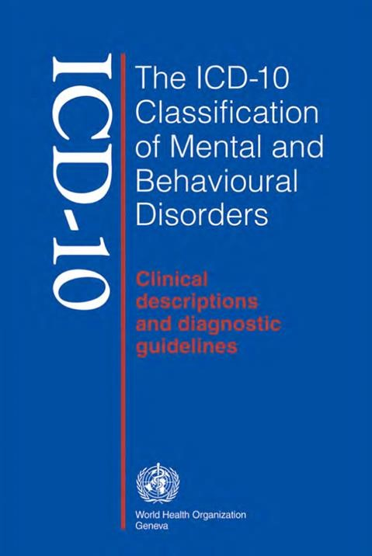
Introduction
◆
Defining Mental Illness
◆
What is PTSD?
◆
Causes of PTSD
◆
Symptoms/ Signs of PTSD
◆
Diagnosing PTSD
◆
Historical view and treatments for PTSD
◆
Current treatments
◆
Principles when working with people with PTSD
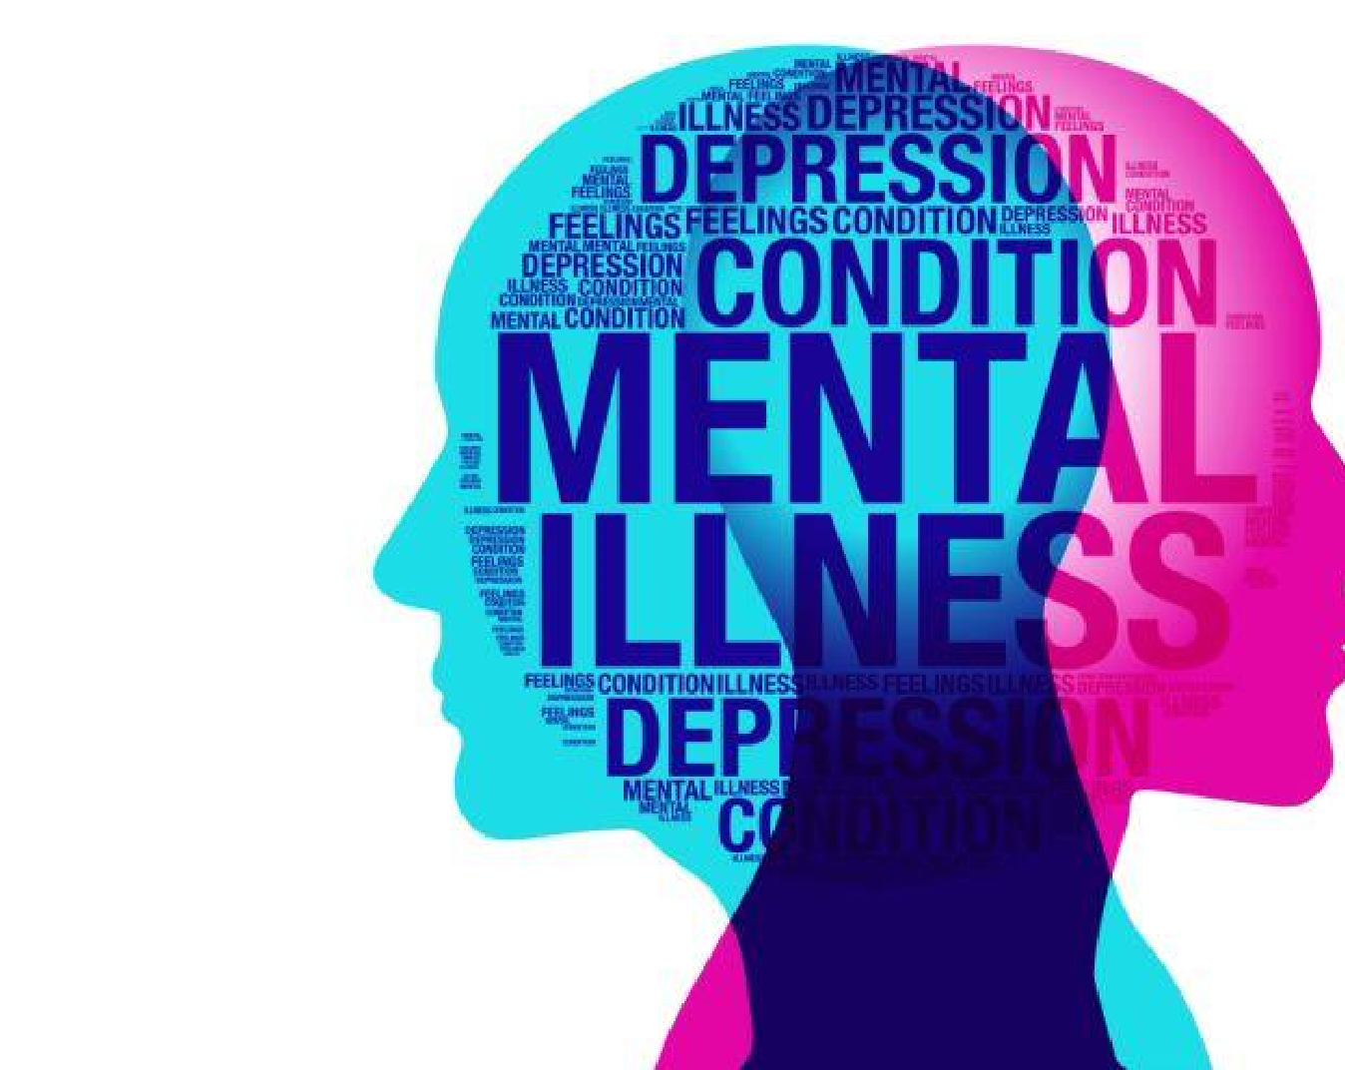
What is mental illness?
◆
A substantial disruption in of an individual’s
behaviour,
emotional regulations, and cognition that is deemed
clinically significant (WHO, 2022).
◆
Usually accompanied by an impairment of one or more
important areas of everyday functions, or emotional
distress.

What is PTSD?
◆
Post
-
traumatic
stress disorder
is an anxiety
-
based mental and behavioural
disorder produced by frightening, stressful or otherwise distressing incidents.
PTSD may occur days, weeks or even years after the disturbing event.
◆
It is
covered
in
section F43.1
of the International Classification of Disease
2010(
ICD
-
10
) manual
under the
Neurotic, stress
-
related and somatoform
disorders sections (F40
-
F48)
(
WHO, 2022b).
◆
Roughly a third of all persons who are subjected to traumatic experiences
are affected by PTSD (NICE, 2018).

Causes of PTSD
◆
A wide range of distressing events can lead to PTSD,
including but not limited to:
◆
Torture, war and other conflicts
◆
Serious vehicular accident
◆
Childbirth
◆
Violent assaults, including rape, robbery and
battery (MIND, 2021)

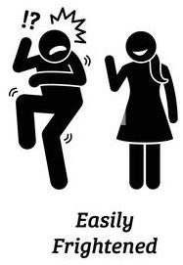

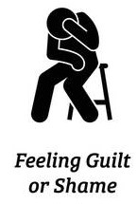
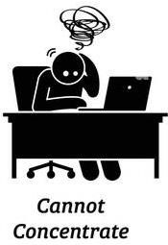
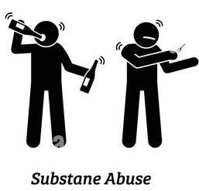
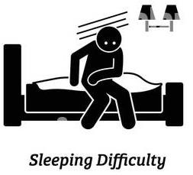
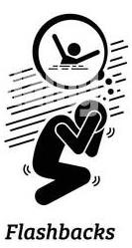
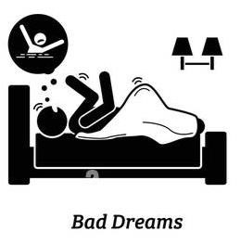
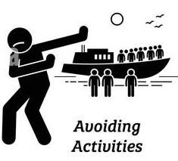
Symptoms/signs
of PTSD
(
Gan
, 2020)

Evolution of PTSD diagnosis and
treatment
◆
Ancient stories of post
-
battle trauma and flashback
-
like dreams were
documented
by Hippocrates (4607
-
377
BC
)

(
Crocq
&
Crocq
, 2000
)
◆
During the 1800s, it was known as
“
battle exhaustion” or “soldier’s fatigue
”
which is often characterized by
“hysterical attacks
” that sometimes take
place years after the traumatic event
◆
The term “shell shock” was introduced during World War 1 and was
brought into medical literature by the 1950s to describe the same
symptoms as PTSD.
◆
Treatment for shell shock ranged from psychoanalysis to drastic measures
such as electric shock
Evolution of PTSD diagnosis and
treatment (Cont’d)
◆
Treatments eventually became more humane, but patients would not
acknowledge their trauma in order to avoid the stigma associated with
mental illness during the
1950
s (Stupak &
Dobroczyński
, 2021)
◆
PTSD was officially described in
the Diagnostic and Statistical Manual of
Mental Disorders (DSM
)
by
the American Psychological
Association during
the 1980s
◆
During the 1990s, new PTSD treatments of various types emerged, including
newer medicines
, Eye
-
movement desensitization and reprocessing (
EMDR)
and new therapy approaches
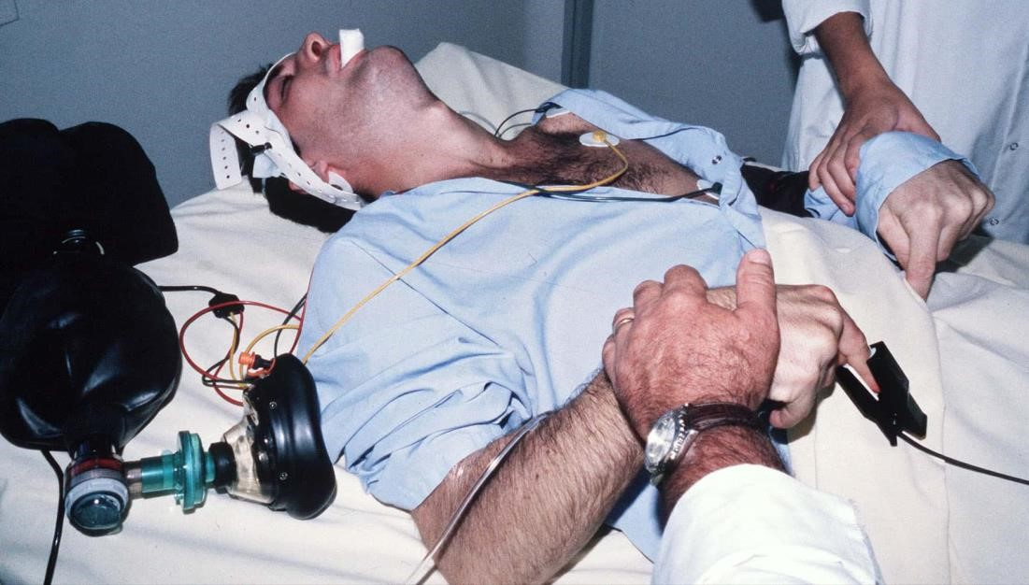

Historical Treatments
◆
Trepanation
-
surgical procedure
during which a hole is made in the skull
◆
Electroshock therapy


Historical Treatments (Cont’d)
◆
Hypnotherapy
◆
Solitary confinement
Modern Treatment
for PTSD
◆
Medications
◆
Antidepressant medication are the most researched means of treating PTSD, and are
generally effective at controlling anger, sadness, anxiety, and other symptoms of
PTSD (
Giller
, 1990
).
◆
Complementary therapy
◆
Acupuncture
,
meditation
, yoga, deep
-
breathing exercises, mind
-
body therapy, and
tai chi (Song, et al., 2020)
◆
Psychotherapy
◆
This is often referred to s talk therapy, and can be done on a one
-
on
-
one basis with a
health professional, or as part of a larger group
(
National Institute of Mental Health,
2019)
◆
Cognitive
behavioural
therapy (CBT)
◆
This method aims to treat PTSD patients by changing how they think and act (NHS
,
2022b)

Principles when working with people
with PTSD
◆
Several guiding principles have been put forward to be used in providing care
for persons with PTSD
(
NICE, 2018
):
◆
Build a trusting relationship/ person
-
centred
approach
◆
Involve service users
◆
Be aware of discrimination and stigma
◆
Ensure privacy, confidentiality and dignity
◆
Respect policy and legislation including Mental Health Act, Human Rights Act, and
Equality Act 2010
Recommendations and Conclusion
◆
In order to ensure
th
best possible outcomes for those suffering from PTSD, it is
important that health and social care practitioners:
◆
Adhere to the treatment guidelines set forth by NICE
◆
Provide care in a manner that does not stigmatise nor discriminate against those in need
of care
◆
Use complementary therapies
•
Repetitive transcranial magnetic stimulation (
rTMS
)
was found to be the most effective
complementary intervention, followed by acupuncture hypnotherapy
, meditation, and
visualization
(
Wahbeh
, et al., 2014)
.



