Table of Contents
Introduction 3
1.1 Career management
Main findings 4
2.1 Career SWOT analysis 5
2.2.Employability skills…………………………………………………………………………………………………………………………6
2.3 Personal learning style ………………………………………………………………………………………………………………….7
2.4 Personal development plan …………………………………………………………………………………………………………11
Conclusion……………………………………………………………………………………………………………………………………………13
Reference list……………………………………………………………………………………………………………………………………… 14
Appendices ………………………………………………………………………………………………………………………………………….15

Introduction

1.1. Career management

Career management is that the method by that you pursue, prepare and direct your potential towards achieving the goals and wishes set beforehand. We must always manage our career as an organization. The most effective angle is to understand your own person. Therefore, you want to perform every activity as best as attainable. At the bottom of career management could be a high level of self knowledge, you would like to understand the benefits, the disadvantages, a way to consolidate the benefits, a way to take away the disadvantages over time. Career management plans and models the progress of people among a company in accordance with the assessments of structure desires, furthermore like the performances, potential and individual preferences of its members.
Self-awareness is the capability for introspection and the capability to apprehend oneself as an man or woman separate from the surroundings and different individuals.
I think that self-awareness is important because if you know yourself you can improve your personality easier.
Self-assessment
In social brain research, self-evaluation is simply the way toward glancing so as to survey viewpoints that are imperative to one's personality. It is one of the thought processes that drive self-assessment, alongside self-confirmation and self-upgrade. Self-appraisal thought process will incite individuals to look for data to affirm their unsure self-idea as opposed to their specific self-idea and simultaneously individuals utilize self-evaluation to improve their sureness of their own self-information. In any case, the self-appraisal thought process could be viewed as very unique to the next two self-assessment intentions. (definition,2020).

Main findings

2.1. Career SWOT ANALYSIS

Career SWOT analysis it is one of the most used tool in the strategic career planning process, focusing on the internal and external reality, thus examining it the strengths and weaknesses of the career in the internal environment of the organization and identifying threats and opportunities career development according to the evolutions of the external environment .
The accomplishment by any individual, employed, of a SWOT analysis of his / her career has as starting point the current situation.
Goal-setting plays an important role in your work life. It’s about taking baby steps towards becoming the best version of yourself as a professional. While you can never expect yourself to reach the top of the pyramid overnight, you need to allow yourself to progress slowly but effectively. This involves a gradual process of developing your professional knowledge and skills, strengthening professional relationships, and building effective working practices.
Complete a professional certificate or degree
A great career development goal is earning a professional certificate or degree in your related field. Continuing education improves your current skills and can help you in the future if you want to apply for a promotion or change careers. There are a variety of programs available in different industries, and many institutions offer evening courses to accommodate work schedules.

Some employers offer professional development programs to invest in the growth of their employees. Ask your manager or human resources representative if your company has a professional development program so you can continue to learn industry-related skills.
Personal development is essential for success and as such you need to identify goals that fall under this category. These could be improving your communication or leadership skills and developing conflict management and strategic contribution skills at work. These skills are just as important as vocational competencies, and they can help professionals develop short-term goals that will lead them to achieving their longer-term ones.
As you can see, goal setting doesn’t have to be difficult; it simply needs to reflect your priorities in life, as this is the only way to ensure that you’ll be passionate about reaching them. The best way to achieve that is with self-motivation, although you can implement a few of these strategies as well.
My professional goal is to complete and achieve the Certificate of higher education skills for the workplace.
My professional goal is a SMART goal because: is specific – obtain a certificate in skills for the workplace, measurable- acquiring the skills, achievable-having opportunities and resources to complete it, relevant-the certificate will improve my skills and time-bound- one year .
A career SWOT Analysis
Strengths.
I am very determinate to learn all new skills and new useful information.
I take pride in my work and always turn it in with confidence and on time.
I am a communicative person and very committed in any task I have to accomplish.

Weaknesses

I tend to compare myself to others, even those way more experienced than me.
I am not completely confident in my skills.
I wish I was a morning person.
I let constructive criticism from others affect me emotionally, instead of hearing them out.

Opportunities
I have taught myself the skills necessary to get this certificate.
There are upcoming job fairs that I can attend.
I know how to write my own content and how to use other content in my own.
Threats
Time management, how to manage my time between university-work-family, I have to be careful to assure time for every single activity and be aware of how this will affect other activities.
Possibility of not passing degree.
Procrastination severely disturbs my work.

2.2 Employability skills
All students in any higher education want to develop their employability skills. These skills are frequently nominal by employers at intervals the work advertisements they publish to recruit new employees from colleges and universities. At the work action and selection stage, employers pay careful attention to create certain that the adolescents they recruit are prepared to: communicate orally and in writing; work as a member of a group; solve problems; manage projects; handle and manipulate data; and gather data.(Hind and Moss 2005).
Employability is regarding making connections between study, personal development and completely different activities therefore on get your hands on, gain and bring home the bacon success in your selected career, and contribute to society. Developing a strong employability profile will cause you to rather additional employable and successful in your career.
Your employability skills may be developed in many ways together with paid work, through your studies, work expertise and volunteering. This might be specific useful if you’ve had a niche in your employment history for any reason.
Employability skills relevant to achieve my goal are:

• Collaboration abilities that add to beneficial working connections and results.
• Critical thinking abilities that add to beneficial results.
• Self-administration aptitudes that add to worker fulfillment and development.
• Arranging and sorting out abilities that add to long haul and transient key arranging.
• Activity and venture abilities that add to creative result.

2.3 Personal learning style
A learning style is a student's consistent way of responding to and using stimuli in the context of learning. Keefe (1979) defines learning styles as the “composite of characteristic cognitive, affective, and physiological factors that serve as relatively stable indicators of how a learner perceives, interacts with, and responds to the learning environment.”

Personal learning style
The four learning style are (Mobbs, 2010):

Activists: Activists square measure those who learn by doing. Activists have to be compelled to get their hands filthy. They have a receptive due to manage learning, also as themselves absolutely and whereas not inclination in new encounters. The coaching activities are event, downside determination, discussion, puzzles, competitions, role-play.

Theorists: These learners get a kick out of the prospect to know the hypothesis behind the activities. They have models, ideas and truths with a specific end goal to participate inside the training procedure. They like to interrupt down and integrate. Their various of learning activities includes stories, applying ideas on paper, statistics and quotes.
Pragmatists: These individuals have the aptitude to know the way to put the coaching into apply in their gift reality. Abstract ideas associate degreed recreations are of strained utility unless they will see an approach to put the concepts abundant in their lives. Experimenting with new ideas, speculations and ways in which to check if they work is their mode of action. They learn higher through taking time to think about the way to use learning very, case studies, disadvantage determination and discussion.

Reflectors: These individuals learn by observation and considering what happened. They will abstain from jumping in and wish to observe from the sidelines. They need to remain back and see encounters from varied alternate points of browse, gathering knowledge and victimization the possibility to work towards an appropriate conclusion. They like paired discussions, self-analysis questionnaires, temperament questionnaires, time out, perceptive activities, feedback from others. coaching, interviews etc.
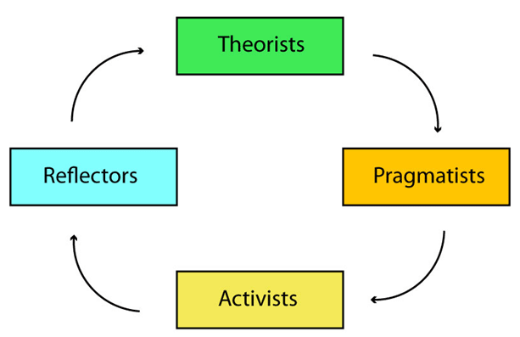
After I have completed the questionnaire designed by Peter Honey and Alan Mumford (appendix q1) the result was that I am a reflector.
Reflectors typically get pleasure from distance learning as a result of they need time to soak up data. Their main danger is obtaining too stalled with theories, looking for additional data instead of buckling all the way down to finding out or writing assignments. As a reflector, I have to set myself begin and finish times for my study periods. I am cautious, methodical, and introspective, I like to stand back and collect knowledge, before thorough thinking results in a conclusion, usually delayed for as long as attainable, which will integrate the views of others similarly as my own.

Kolb s learning style
Educators first got curious about learning styles following Kolb's description of them among the mid-1970s. His learning styles unit of measurement connected with the Kolb learning cycle. He educated that although learners got to be compelled to bear constant stages as they progress through the academic cycle, they sometimes like some aspects of the cycle to others. This semiconductor diode Kolb to identify four learning styles, that he observed as accommodative, divergent, assimilative, and convergent.

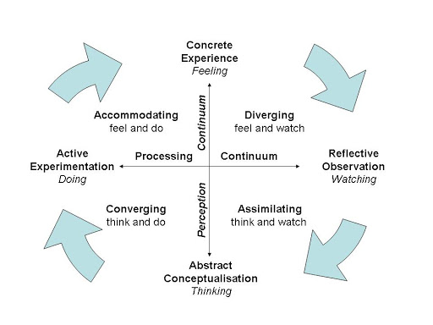

Another type of learning is VAK model, perhaps the most well-known model of learning styles. V is for visual, A is for auditory and K is for kinesthetic.
Visual learners learn best by seeing, they use pictures, charts, graphs, maps, time-lines.
Auditory learners learn best by listening, they prefer lectures, recordings,
debates, discussions, repeating words.
Kinesthetic learners learn best by moving and touching. Examples of activities that help this type of learners are projects, experiments, field trips.
As a result of completed learning styles questionnaire (appendix q2), I am a kinesthetic learner.
Like a kinesthetic learner I understand additional once learning through active expertise, become simply bored in a very ancient room.
I like to learn through movement, I enjoy sports and physical activity.
I am full of life participant instead of a passive observer once learning.
I Enjoy opportunities to travel on excursions or be outside the room.
I like to create things and work with my hands and love testing things and experimenting and making.
We are hand talkers and communicative in nature.
We like to attempt new things and consider what we will expertise or perform.
Kinesthetics learners strive things out, touch, feel and manipulate objects. Body tension is also a sensible indication of their emotions. They gesture once speaking, area unit poor listeners, stand very shut once speaking or listening, and quickly lose interest in long discourse.
They detain mind best what has been done, not what they have seen or talked regarding, they like direct involvement in what they are learning. They are distractible and know it powerful to concentrate, sometimes poor spellers, they need to jot words to envision if they “feel” right.

2.4 Personal development plan

Part 1-personal analysis
Strengths  My basic skills are good  Positive attitude to learn new things  I gained confidence from proving that I could cope with the pressure and deadlines  Having the opportunity to improve my team-leader skills | Areas for further development  It was difficult to maintain the work-life balance  I need to take more time in planning a task  To build my confidence I need more experience in team management
Opportunities | Threats
I have been exposed to a structured approach to check in to problems and finding solutions. | Balance work, university and personal life.

Part 2-seting goals

What do I want to learn? | What do I have to do? | What support and resources will I need? | How will I measure the success? | Target date for review
How to be a good leader | Attend courses and complete tasks | Good lecturers | Complete assessments | January,2021
IT skills | Attend courses and complete tasks |  | Complete assessments | January,2021
Management skills | Observe more experienced managers |  | Achieved certificate | January,2021
Finding solutions and problems solving | Attend courses and complete tasks |  | Achieved  Certificate | January,2021

Part 3- personal objectives

Short term goals (next 8 months)
Attending courses and learn as much as I can.
Medium term goals (next 2-3 years)
Be given the responsibility for leading and managing a small team
Long term goal (5 years)
Having my own business

Conclusion
In this report I have tried to expose theory about career management and how this theory applied to my personal development plan.
The personal development set up is extremely vital in the chase of biological process changes that are necessary for the action of set goals. Designing is extremely vital since it provides a medium for someone to line goals and judge, however they are going to need to be achieved.

Reference list

- Definitions.net. STANDS4 LLC, (2020) Web. 13 Feb. 2020
- Graduate employability skills prepared for the business industry and higher education collaboration council (2007) , Precition consutancy. This document is available on the Department of Education, Science and Training BIHECC:http://www.dest.gov.au/highered/bihecc.

- Hind D. and Moss S. (2005), Employability skills, Business education publishers
- Honey P. and Mumford A. (1992), The manual of Learning styles, Peter Honey.
- http://www.businessdictionary.com/definition/employability skills.html
- Maund A., Schriek M. and Tinker P.K.,(2017),Certificate in higher education skills for the workplace student yearbook, Sage publications.
- Mobbs, R. (2010). Honey and Mumford. [online] University of Leicester. Available at: http://www2.le.ac.uk/departments/gradschool/training/eresources/teaching/theories/honey-mumford
- Morgan P.,(2017),The business student s guide to study and employability, Sage publications
- Keefe, J.W. (1979) Learning style: An overview. NASSP's Student learning styles: Diagnosing and proscribing programs (pp. 1-17). Reston, VA. National Association of Secondary School Principles.

- Kolb, D.A.,(1971),Individual Learning Styles and the Learning Process, MIT Sloan School Working Paper No. 535-71.

Appendices



