Gallwch ychwanegu’ch targedau o’ch aseiniad diwethaf (Ond yn berthnasol os yr ydych wedi cwblhau aseiniad) / Please add your targets from the previous assignment (Only relevant if you have completed an assignment)
 | Targed/target | Yr hyn yr wyf wedi'i wneud yn yr aseiniad hwn  What I have done in this assignment...
Targed/Target 1 | Use less statements in brackets. | Made a conscious effort to rephrase wording in order to avoid overuse of statements in brackets.
Targed/Target 2 | Ensure you use a wide range of literature to support your writing. | Somewhat difficult in an assignment as concise as this. Effort made to use as many sources without drifting off-topic.
Targed/Target 3

How a school develops one aspect of its SDP: a report that critically reflects on the actions, impact, and evidence base.
Word count: 2,521
For this assignment the task was to identify one aspect of a school development plan (SDP) and critically reflect and evaluate how action points were generated and how impact and progress of meeting said action points was measured. For this report I have chosen to focus on how one school strive to improve literacy across all departments. The target of literacy improvement is shared by both the SDP and English department improvement plan (DIP) from which the action points discussed in this report have been taken as they play a strong role in the improvement and development of literacy skills across the whole school and curriculum. The improvement of literacy and numeracy is a target always attached to almost all SDPs. Since the Covid-19 pandemic many schools have been working towards bridging the gap created by the impact of lockdown and temporary loss of traditional education. Reading assessments that took place in Autumn 2021 revealed that some secondary school pupils were 2 months behind whereas secondary students from more disadvantaged backgrounds were 3.5 months behind reading expectations (Department for Education, 2022: 13). The school this report focuses on is an English-medium secondary school based in the Vale of Glamorgan with around 1,500 pupils aged 11 – 18.

School development plans are live documents generated based on previous targets, national priorities, for example, consideration for the introduction of CFW, improvement of literacy and numeracy and Welsh Language goals, and self-evaluation recognised targets. SDPs are a collaborative effort within the school community in which headteachers will consort with school staff and governing bodies to develop an SDP and employ agreed upon action points to meet targets set in the document (Welsh Gov, 2014: 4). School development planning allows schools to outline these priorities and test and evaluate methods of improvement and development which are “reflected in a continuous cycle” (Welsh Gov, 2014: 2). In creating the document, schools must reflect on their roles as learning organisations with links to the wider community and the professional development of their staff as well as progression and learning of the pupils. Alongside meeting targets identified within the context of the individual school, as learning organisations they must also have a shared developed vision which focuses on empowering and motivating all learners, give opportunity for professional development of staff, encourage collaboration, enquiry, and innovation (Hwb, 2018).

With all this in consideration, the school will produce a vision based on the context of the school that must be “motivational and achievable” (Welsh Gov, 2014: 7) much like designing effective success criteria for AFL. Once a shared vision is decided, the SDP will go through a cycle in its creation (Appendix B). With the changing face of education in Wales, the government has aligned a focus in which SDPs also must help learners “to progress in a way that will support them to develop towards the four purposes” (Welsh Government, 2022). In additional support for schools in Wales the government have identified ways of working in the development of SDPs being as effective and purposeful in the changing climate of education in Wales with great consideration not only for academic success, but also for well-being and the future. This includes long term planning in which students will be prepared for a “rapidly changing world” and meeting the “needs of business and the economy in the future” so that young people will leave school ready to become confident contributors to the wider community (Welsh Government, 2022). For this to work effectively all stakeholders must be aware of their roles and responsibilities within the SDP; for teachers, this may mean how the SDP filters their own DIP. In his BERA blog post, Goldstone notes the significance of gaining the support of stakeholders and “empower local actors” such as teachers, students, parents, local authority figures, etc, “to own school improvement alongside school leadership” (Goldstone, 2022). This is echoed in the Welsh Government guidance which states that “high-quality leadership at all levels is crucial in sustaining the involvement and commitment of staff” in developing and efficiently rolling out SDPs (Welsh Government, 2022: 16).

The aspect this report will focus on is the improvement of literacy outlined in one school’s SDP with a focus on the action points outlined in the DIP. In 2013 Ofsted released a report on improving literacy detailing some of the common obstacles met. The report comments on weaknesses not just in basic literacy skill being a barrier, but also readiness to learn” (Ofsted, 2013: 5). The report argues that promoting the case for literacy is “urgent and essential” as many students leave school without a good understanding of literacy, and that one in six adults have a literacy level below what is expected of an 11-year-old (2013: 6). The issue of literacy weakness however is not unique to secondary schools as nationally one in five children leave primary school achieving below the expected standard of reading and writing (Ofsted, 2011: 5) and noting that inaccurate data obtained from primary schools can impact strategic planning to combat literacy issues in pupil transition to secondary school (Ofsted, 2011: 7). Poor literacy impacts in adult life, and as such always appears as a key priority in SDPs. Negative attitudes to the constant focus on literacy improvement strategies and implementations impact the long-term success of said strategies (Ofsted, 2013: 4) which is why all stakeholders must be aware of their responsibilities and content to carry out the duties assigned to them. The significance of involving stakeholders is referenced as literacy support, training and advice provided in early years / primary education evidenced good practice not seen as frequently in secondary education (Ofsted, 2011: 5). Stakeholders employed within the school are also of great significance, as noted in the section previously, but also as in their role as teachers they must “demonstrate an understanding of and take responsibility for promoting high standards of literacy, articulacy and the correct use of standard English, whatever their specialist subject” (Department for Education, 2011: 11).

To develop targets and action points through which to achieve them, schools must first self-evaluate. In undergoing self-evaluation schools can identify what they are doing well and areas that require improvements, from which they can strategically plan how to make said improvements that are then included in the SDP. For the school this report focuses on, three key priorities were identified from performance reflection, self-evaluation, and feedback from Estyn reports. In the most recent Estyn report the school achieved an “excellent” rating with no recommendations other than the school’s own next steps which were to “draw up an action plan that shows how [the school] is going to maintain high standards and quality of provision” (Estyn, 2019: 3). This is reflected in the key priorities outlined in the SDP, the first of which being to develop a “recovery plan” to help students from disadvantaged backgrounds who are now behind due to the impact of the pandemic as referenced earlier in this report (Anonymised SDP, 2021/23). Another key priority is to improve literacy and numeracy skills for all students but especially lower attaining pupils (Anonymised SDP, 2021/23), meaning that the school would have to develop purposeful and effective strategies to accomplish this target.

The target outlined in the DIP is to “improve pupils’ skills in literacy and numeracy” and “further improve and refine pupils’ literacy and numeracy skills (where appropriate) across the curriculum.” (Anonymised DIP, 2022/23). This echoes the target included in the SDP; however, the action points differ between the two. Literacy skills have been broken up within the plan and each given their own action point to aid improvement: for reading, reading aloud is encouraged with Year 7 pupils, a book club and book swap shop have both been introduced (the former being hugely popular in its first week running on 27th – 31st March 2023), and a trip to Hay festival in May 2023 for Year 8 / 9 students has been planned. For the first time oracy skills have been included in the DIP, for which the action points of reading aloud and the inclusion of more oracy assessments have been introduced into the curriculum for KS3. Finally, to improve writing skills the department have created a synonym wheel (Appendix A) to encourage students to use advanced vocabulary in their work. The synonym wheel has been popular across all departments and was used as an example of good literacy practice in the school’s most recent inset day where some action points were reviewed.

In aid of improving writing skills the English department have also begun literacy lessons that are consistently taught to “enhance knowledge of basic skill” (Anonymous DIP, 2022/23). One recommendation for literacy improvement suggested by the EEF notes that “schools should expect and proactively plan to support students with the weakest levels of literacy, particularly in Year 7” (EEF, 2018). The literacy focused lessons take place every two weeks for KS3 students (KS4 have literacy focused starter / plenary tasks rather than full focused lessons) and focus on improving four main literacy skills on continuous rotation: comma splicing, sentence types (simple, compound, complex), improving vocabulary and spelling. The literacy focused lessons are taught by members of the English department, though ideally to meet the target of literacy and numeracy skills being improved, all stakeholders must be willing to work. All English department staff must be willing to focus on literacy skills, all other staff must be consistent in monitoring progress and identifying difficulties / inconsistencies / misconceptions even within their own work, all parents must be willing to support students in improving literacy skills (e.g.: reading at home) and all students must be resilient in learning.

The improvement of literacy and refining of basic skill across both literacy and numeracy are evaluated regularly by the literacy and numeracy leads at the school. In aid of strategic planning and to ensure focus on the most necessary action points is sustained, in these reviews action points on the SDP are RAG rated (red meaning they are a priority, amber meaning they are a working progress and green meaning they are successful and no longer require constant monitoring). Another action point outlined is to use data to “inform planning” (Anonymous DIP, 2022/23); data is accumulated during review by the literacy and numeracy leads in checking student book samples from across all subjects, from regular reading tests undertaken by students and pupil voice. From data created from these sources, misconceptions to focus upon, such as comma splicing or improvement on oracy skills, for example), have been added to the literacy improvement plans alongside standard elements such as spelling and reading.

The DIP includes intended outcomes for each action point. Each intended outcome states that “nearly all pupils” (Estyn terminology for “with very few exceptions”, Estyn, 2022:12). Interestingly the previous Estyn report noted that “many” or “a majority of” pupils have good literacy skills (Estyn, 2019: 4) meaning “70% or more” and “60%” respectively (Estyn, 2022: 13) which shows the school has made a conscious effort to improve standards and given a direct percentage they wish to achieve.

The department have taken the time to generate several action points to improve literacy skills in all pupils across the school cohort. As stated in the above section, time and consideration for collaboration has been included when developing action points in improving literacy, such as a focus on cross-curricular responsibilities of all departments as outlined in the target to improve literacy “across the curriculum” (Anonymous DIP, 2022/23). This focus was included as in previous targets to improve literacy, improvements were seen in English where students are taught specifically about spelling, punctuation, and grammar, but basic use and knowledge of literacy was not evidenced consistently in students work across all subjects. Most recently examples of good literacy and numeracy practice were shown in a school inset day where photographs of student work were included, and a review of consistent good literacy practice between English and History.

The literacy lessons in particular, aim to “focus on teaching students strategies for learning to spell” (Anonymous DIP, 2022/23) rather than using traditional spelling tests to continuously test memory. With consideration to not cause cognitive load, each spelling lesson which will be one of four literacy lessons every other week for KS3, will focus only on four commonly misspelled words, giving students a primary focus to create more purposeful learning. As stated in the action point, students will learn spelling strategies rather than being given a traditional spelling test. Some of these strategies include:
- Look, say, cover, write, check.
- Rainbow writing – e.g., highlighting or writing the most difficult part of a word in a different colour (maybe silent letters or ‘I before E’ words).
- Mnemonics – creating a rhyme or spelling pattern to help remember spelling (e.g.: ‘Betty Eats Cakes And Uses Six Eggs’ for because, or ‘a shirt has one Collar and two Sleeves’ for spelling necessary.

The literacy lessons are taught by members of the English department; however, the synonym wheel is being gradually introduced across other departments, and spelling focus on subject specific terminology has been adopted in some literacy heavy subjects, for example, RE classes are ensuring spelling of religions and terminology is correct in student work. The literacy lessons have so far proved successful and evidenced good practice and improvement in both literacy and numeracy has been commented positively on within the school. English teachers teaching literacy however holds both advantages and limitations: while it is beneficial having a subject specialist teaching literacy, there may be issues with teachers in other departments who are unknowingly making literacy errors themselves and therefore not picking up on / correcting student misconceptions. This can be said also for Maths teachers taking charge of numeracy, as these elements belong so naturally to these subjects, it may be difficult for these departments to develop effective strategies to incorporate literacy and numeracy purposefully across the curriculum. Time and budget are also frequent limitations outlined in strategic planning however, the department have taken it upon themselves to plan literacy focused lessons both imbedded in SOL and existing as independent SOL themselves. Therefore, budget is not an issue faced in this action point however only time will evidence if taking lessons out of KS3 English timetable and replacing them with by-weekly literacy focused lessons will benefit and sustain improvement of literacy skills.

The department improvement plan focused upon in this assignment, includes targets shared with other departments and the school development plan. The focus on literacy improvement and engagement in basic skill and knowledge will likely continue to be a target across all schools, particularly in aid of bridging gaps created by the Covid-19 pandemic. In researching for this assignment, attending bridging and the school inset day and reading and conversing over the SDP and DIP I have been able to learn and understand how schools develop targets and action points to meet said targets. In my further professional development, I am teaching one SOL in the Year 7 literacy lessons action point, which includes strategies I can take with me in my career journey in order to improve literacy as an ongoing target for all learners.
Appendices
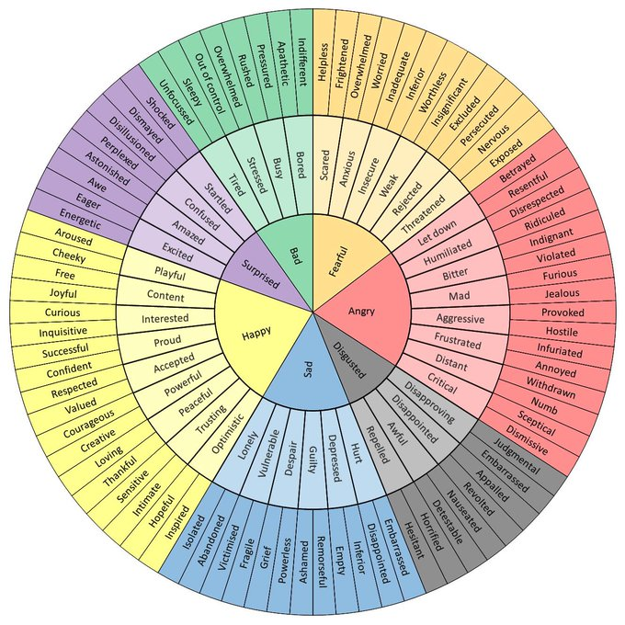
Appendix A – Example of synonym wheel

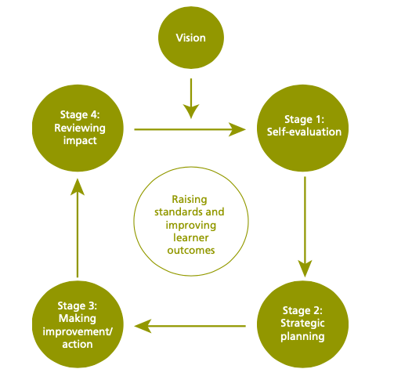
Appendix B – SDP Cycle (Welsh Gov, 2014: 7)
Reference List

[Anonymised SDP] 2021/23 [Anonymised School] School Improvement Plan. Wales: Anonymised School.

[Anonymised DIP] 2022/23 [Anonymised School] Departmental Improvement Plan. Wales: Anonymised School.

Department for Education (2011) Teachers’ Standards: Guidance for school leaders, school staff and governing bodies. Available: https://assets.publishing.service.gov.uk/government/uploads/system/uploads/attachment_data/file/1040274/Teachers__Standards_Dec_2021.pdf

Department for Education (2022) Understanding Progress in the 2020/21 Academic Year. Available: https://assets.publishing.service.gov.uk/government/uploads/system/uploads/attachment_data/file/1063488/Understanding_Progress_in_the_2020_to_2021_Academic_Year_Extension_report_covering_the_first_half_of_the_autumn_term_2021.pdf

EEF (2018) Improving Literacy in Secondary Schools. Available: https://educationendowmentfoundation.org.uk/education-evidence/guidance-reports/literacy-ks3-ks4

Estyn (2019) Cowbridge Comprehensive School Report. https://www.estyn.gov.wales/system/files/2021-08/Inspection%20report%20Cowbridge%20Comprehensive%20School%202019.pdf

Estyn (2022) Writing Guide: A Guide to Our Report Style Writing. Available: https://www.estyn.gov.wales/system/files/2022-02/Estyn%20writing%20guide%20-%202021-2022.pdf

Goldstone, R (2022) School self-evaluation for school improvement: Principles of effective practice. (BERA Blog). Available: https://www.bera.ac.uk/blog/school-self-evaluation-for-school-improvement-principles-of-effective-practice

Hwb (2018) Schools as Learning Organisations. Available: https://hwb.gov.wales/api/storage/f87e720f-8568-4a60-9383-55e20b9a1bb7/schools-in-wales-as-learning-organisations.pdf

Ofsted (2011) Removing Barriers to Literacy. Available: https://assets.publishing.service.gov.uk/government/uploads/system/uploads/attachment_data/file/413745/Removing_barriers_to_literacy.pdf

Ofsted (2013) Improving literacy in secondary schools: a shared responsibility. Available: https://assets.publishing.service.gov.uk/government/uploads/system/uploads/attachment_data/file/413182/Improving_literacy_in_secondary_schools.pdf

Welsh Gov (2014) School Development Plan Guidance, October 2014. Available: https://padlet.com/jessicaroberts4/school-improvement-e04tfqe8jmln73vb/wish/1449350519

Welsh Gov (2022) School improvement guidance: impact assessment. Available: https://www.gov.wales/sites/default/files/pdf-versions/2022/7/3/1657103361/school-improvement-guidance-impact-assessment.pdf

