Anna Misiak-Ali (2311228)

5th July 2024
Digital Skills for Personal and Professional Growth (BMSW 4008)
Philippa Fitzgerald

Table of content
Task 1 Story Telling 2
Task 2 Video 6
Task 3 Questionnaire analysis 7
Task 4 Design of the website and marketing materials 11
References 18

Task 1 Story Telling

Storytelling is the art, the process of conveying and interpreting experiences, events, or information through narration. Although storytelling has been one of the basic forms of communication since the dawn of time, it also appears in other fields, from literature to marketing, education, and media. Storytelling is as old as the world (Parkes, D. no date). In the era of the Internet and e-marketing, however, storytelling has gained a new face, it has become a key tool in business, education and the media (Zimmermann, E. and Koon-Stack, C.; no date). But what exactly is storytelling, what elements does it involve?
One of the most powerful tools for building relationships with customers is storytelling (Aime, I. 2021).Marketing campaigns are designed to create a deep, emotional connection with customers. It helps to communicate brand values and unique selling points. Brand storytelling is a technique used by businesses to tell stories related to a brand, products, or services. Storytelling is such a powerful tactic for growing business for three primary reasons: stories are relatable, memorable, and emotional (Wood, W. 2024). Words and sounds as well as language patterns are used by narrators as building materials, while voice projection, facial expressions and hand gestures are the tools to create a large human experience. A great way to bring your character to life is to use all these elements (Choo, Y.B. et.al. 2020). Moreover, consumers' purchasing responses are directly stimulated through behavioural and cognitive responses. (Crespo, C.F. et.al. 2023). The storytelling listener’s role is to actively create the lively, multi-modal approach, activity, feature. The teller is responsible to past experiences, faith, and perception. The story is completed in listener mind. There are 3 signs that a consumer is establishing a relationship with a company through identification, experiencing emotional value, and engaging behaviour. (Crespo, C.F. et al. 2023 and Mavilinda, H.F. et. al. 2023). A global and fast-paced world is facing the challenge of standing out and being relevant, a change that has occurred to build deeper connections with loyal consumers. The concept of brand love is to rely on a long-term relationship between the brand and consumers. ( Dias, P. and Cavalheiro, R. 2022). Storytelling is one of the most important forms of marketing, it is responsible for building a brand and relationships with customers. Lasting bonds with consumers and building an image are closely related to emotions and attachment. A good story contains several key elements, these elements help to build an emotional bond with the recipient (Drew, Ch. 2023 and MasterClass, 2021).
• Characters involved: The characters are central to every story. Characters should have their own motivations, goals, and weaknesses.
• Conflict: It can be a problem that needs to be solved, an internal struggle, struggles with external forces, or a conflict between characters.
• Clear message: Effective storytelling is a clear and consistent message.
• Building the background: A good story often requires a believable and compelling background.
• Narrative structure: An effective story has a well-organized structure, allowing the viewer to smoothly guide the reader through the story.
• Emotional involvement: Storytelling should evoke emotions to make the story stay in the viewer's mind for longer.
• Use of symbolism and metaphors: The use of symbolism and metaphors can enrich the story, add depth, and allow for multi-level interpretation.
• Dialogue and interaction: Dialogues between characters are essential for character development and conveying information.
• Scenic descriptions: Detailed and scenic descriptions that engage the viewer's senses can significantly enhance the storytelling experience.
Proper integration of these elements creates a story that not only conveys information, but also evokes emotions, makes the story memorable for a long time.
Luxury brands mainly communicate through emotions. Perfumes and cosmetics are quite often presented as more luxurious, high-end brands. Celebrities and models are involved in the promotion of these products. Although quite often, the brand and price are responsible for the purchase of a product that can also be seen as a cultural act. AFNAN PERFUMES brings unforgettable memories to local and international markets, giving life and key experiences to every project. The heritage and exceptional quality reflect the unique and artisanal experience that Afnan's fragrances and packaging offer to the market. According to Imran Fazlani (Afnan Perfumes; no date), Founder and Managing Director of Afnan Perfumes LLC, the inspiration and motivation for an organic love in the perfume industry, as well as great respect for the end user gives satisfaction and motivates to create more sophisticated and extraordinary perfumes. From the ingredient's design up to the bottle's feel, the aim is to attract all generations in the multicultural world. Since 2007, Afnan Perfumes ,,has created a trade that can challenge the market by building unique, detailed, crafted fragrances that inspire experiences through product quality and design’’( Afnan Perfumes; no date). Since its establishment the brand strives for high quality, original and unforgettable perfumes for men and women for every season. One of their high-quality perfumes are ,,9 pm’’ for men. This perfume has mix of different notes. From sweet and fruity to fresh and spicy. It is very loud, and it could easily stay on the skin 8 hours. Best suited for chilly days and evenings but can be used but can be used in every season. Overall Afnan 9 pm is an amazing masculine fragrance that gets the complement everywhere can be smelled and most people love the scent profile.
Storytelling is a powerful communication tool. A well-told story engages and educates the audience. Interesting stories are remembered, they evoke emotions. Storytelling is therefore used in various fields, both in online marketing and in education and training. There are many indications that the role of storytelling in culture and business will grow with each passing year.

Task 2 Video
https://youtu.be/rWvW2LM249A?si=Q8gdGWLODhaz7Aao

Task 3 Questionnaire analysis

The basis of every research conducted is a well-made survey. The ability to ask questions correctly and determine possible answers (in the case of closed questions) is a very important element of the subsequent analysis of the collected data (Taherdoost, H. 2022). For goals to be achieved, researchers must carefully choose data collection methods. Choosing wrong research method can cause false discovery followed by incorrect conclusion ( Mwita, K. 2022). There are many advantages of a questionnaire. According to Williams, K. (2024) there are four advantages: efficiency, cost-effectiveness, anonymity encourages honest responses and longitudinal studies. However, Lindemann, N. (2023) describe twelve disadvantages of a questionnaire. They are: limited measure information, reaction prejudice, not to many responses, misunderstanding of questions, lack of ability to guess non-verbal cues, finite participation, irrelevant context, difficulty to understand information, incapability to inquest for clarification, limitation in samples, possible errors, response tiredness.
New company ,,Perfect Cleaning’’ cleaning services sent questionnaire to potential customers to find out if there will be interest in hiring cleaning service and what type of cleaning clients would prefer. Questions were designed to collect information about type of cleaning, frequency and how much they are willing to pay for the service. Designed questionnaire was sent to customers who answered short question. The questionnaire can be found at: https://docs.google.com/forms/d/e/1FAIpQLSc1C-NnlA8pLqH234PPhooUUWhlxf35eGP1PA_ePCI6ut42zw/viewform?usp=pp_url

Results are discussed and described as followed:
In the question number 4 responders were asked if they ever considered hiring cleaning service? More than 87.5% of responders said ,,yes’’ to a question. It is more than ¾ of responders who can provide new customers list through suggestion and bring more clients and provide new network connections. Providing exceptional service can help to establish customer base. Recommendations will help to grow and eventually Perfect Cleaning company will expand.

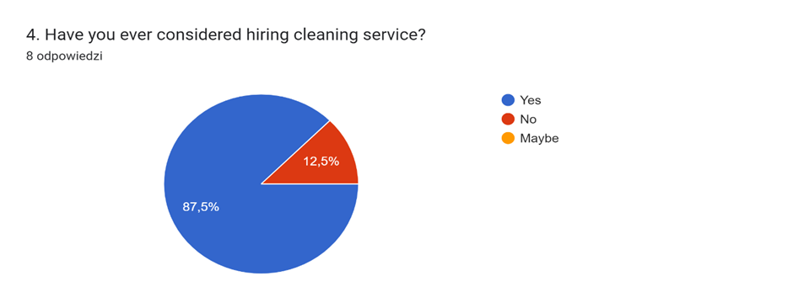

Perfect Cleaning company based in Cardiff can charge between £15-£20 per hour chose by 88.9% customers. According to answers obtained, only 11.1% were willing to pay between £20-£25 per hour for a service. Analysing those answers Perfect Cleaning company will set a price for £18 per hour for a regular cleaning. After considering all pros and cons of the price, Perfect Cleaning decided to charge average price. The reason is to draw clients but also take into consideration rising cost of living and potential drop in demands. The price is still higher than minimum wages which can help with costs of running a business.

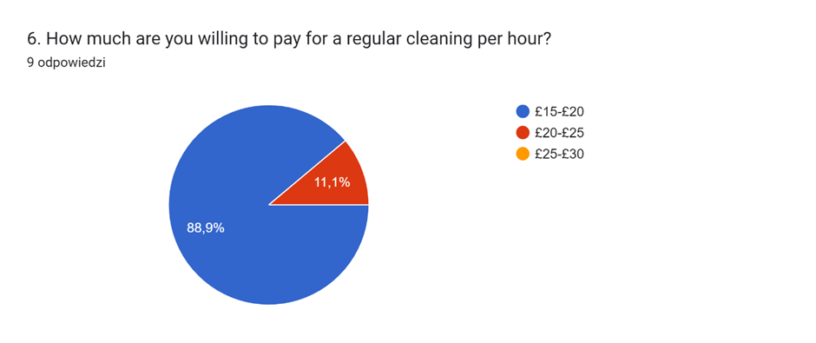

Based on answers in next question around 50% of customers wish to have a cleaning service once a week followed by 37.5% of customers to have a cleaning service once a month. Only 12.5% of customers would like to have a cleaning service every 2 weeks. More research will determine if those customers who chose cleaning services once a month consider regular cleaning or deep cleaning service.

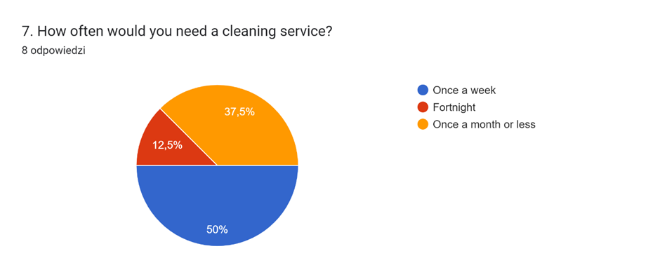

Answers in question number 8 shows that 55.6% consider deep cleaning. Surprisingly most of the answers in previous question showed that half of the responders would like to hire cleaning service once a week, further analysis will explain if responders are planning to hire cleaning service to deep clean their houses.

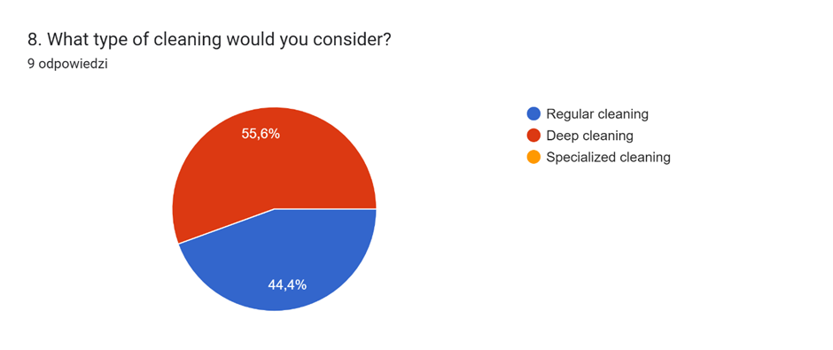

Sending questionnaire to potential clients helped to make the decision to move forward and start a business. The development of research results provides data that allows decisions to be made based on knowledge, not assumptions. A business questionnaire is designed to collect information from different people, such as customers and employees. The questions in the questionnaire are intended to provide information to the organisation. The information collected helps in decision-making (Indeed Editorial Team, 2024). This questionnaire was designed to collect information and by collecting data undertake process of improving business and take responsibility for creating and delivering products and services in a company. Product and service improvements focus primarily on improving customer value and secondarily on reducing business costs (Knotts, J. 2021). A business idea can be taken from the surrounding world. Analysing the basic needs that other companies have met for society can help to meet the goals of delivering what customers want ( Cote, C. 2020).

Task 4 Design of the website and marketing materials

When running a business, companies need to know their customers well. Knowledge about their behaviour, needs and preferences will allow to choose the right communication channels and implement effective marketing activities. However, there will be many different individuals in the audience that cannot be approached the same way as other individuals. Perfect cleaning company underwent few marketing research strategies.
Market segmentation is a strategy that involves dividing consumers into different groups. This solution makes it easier for the company to reach its customers with the right sales messages. Segmentation, targeting, and positioning are core disciplines in marketing strategy, both in a domestic and global environment (Schlegelmilch, B.B. 2022). Demographic segmentation can be considered the basic type of customer segmentation. Of course, it refers to such characteristics of the recipients as age, gender, profession, nationality, household size or education. By using such factors, it is possible to better adapt the company's offer to consumer preferences (University Lab Partners, 2021). Market segmentation helps companies reach their target audience more successfully. By recognising and understanding different customer segments, businesses can create personalized marketing campaigns that are more relevant to each group. Market segmentation allows companies to learn about the preferences, shopping habits, and needs of their customers. As a part of market research and market segmentation, questionnaire was sent to potential customers. Williams, K. (2024) states that a questionnaire is a conversation on paper, online, or in digital format. At the beginning of the market research, questionnaire had been sent to define what type of cleaning respondents prefer. Questions were designed to find information about potential customer base for another cleaning company. The answers can be found here:
https://docs.google.com/forms/d/e/1FAIpQLSc1C-NnlA8pLqH234PPhooUUWhlxf35eGP1PA_ePCI6ut42zw/viewform?usp=pp_url

According to answers in this questionnaire, first 2 questions were designed to collect information about gender and age. More than ¾ of the responders selected age between 31-42. Only 22,2% were people between 43-55 of age. Those answers indicate that the questionnaire was not sent to all group of people, in which case another questionnaire must be sent to different group of people. More information collected can improve targeting suitable customer base and rise interest in Perfect Cleaning, cleaning services offer. When responders asked about their gender, almost 90% were females. This information can help with potential customer base as mostly females are responsible for daily chores.
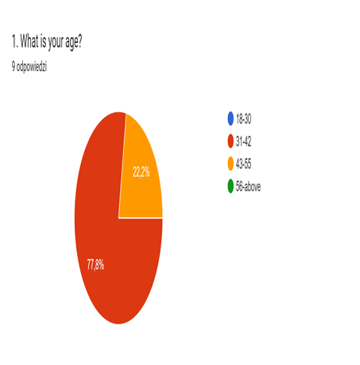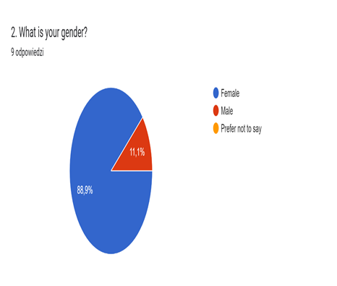

Geographic segmentation is responsible for dividing the listeners into dissimilar category using geographic variables. This type of segmentation helps identify and use location-based characteristics to create more personalised marketing campaigns (Burt, S.J. 2024). Perfect Cleaning company will be based in Cardiff. Following question can help to determine if there is enough interested people from Cardiff to hire cleaning services. More than 77% of responders are based in Cardiff which can help to build network connections and potentially increase customers base through suggestions.
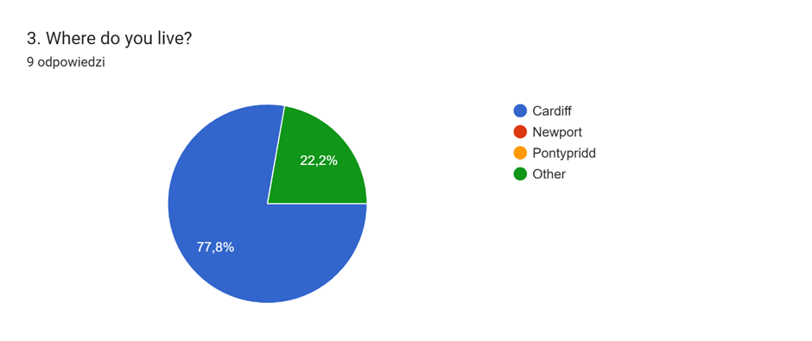

Psychographic segmentation is another form of market segmentation in which consumers are grouped based on criteria such as consumers' personalities, interests, and social status (Nicole, D. 2024).
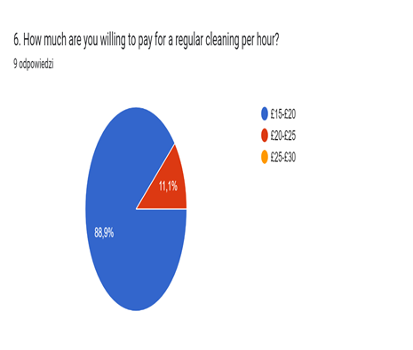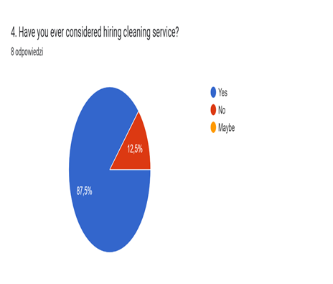

Behavioural segmentation is responsible for dividing the target market into distinct groups based on their behaviours, preferences, and actions. Behavioural segmentation focuses on dynamic factors such as purchasing behaviour, brand loyalty, and product usage (Appinio Research, 2024).

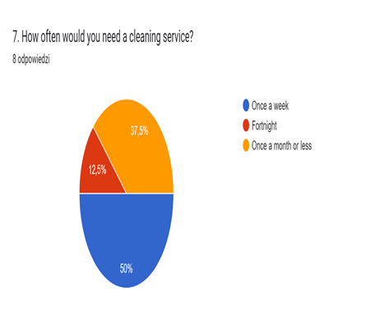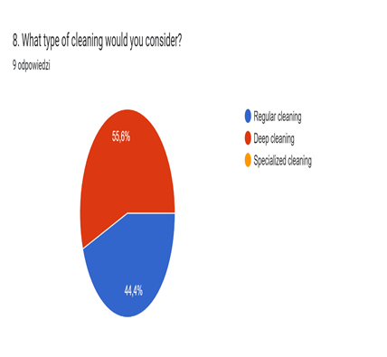

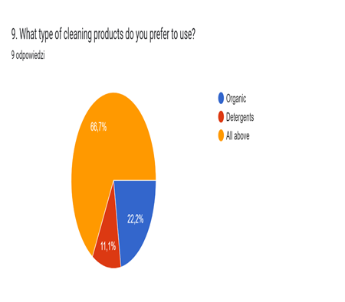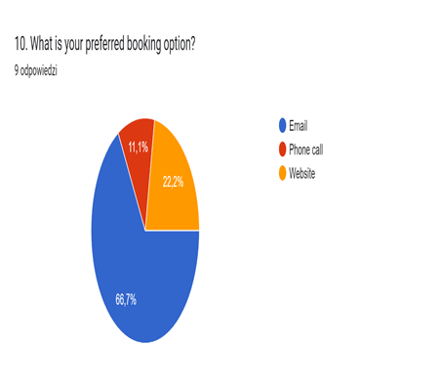

Search engine optimization (SEO) is the procedure by which a website or web page is improved to maximize the periodicity and amount of organic traffic from search engines. Effective SEO means that the web page will appear higher on the results page of a search engine (SERP) (Almukhtar, F. et.al. 2021). A huge scores of websites causes the search engine to have a key task in providing the right pages to the user. Search Engine Optimization is a process which increasing the chance of a website appearing on the first page of search results (Sharma, D. et. al. 2019). A very important aspect of the company's development is its presence on the Internet. Nowadays, some businesses still do not understand how big impact on their presence in internet customers can have shopping behaviour (Melinn, C. 2024). Companies need to realize that most of their customers will visit their website before making a purchase (Kaplan, K. 2022). High-quality content on a website will reflect the number of visitors who will find solutions to their needs, establishing your brand as an authority (Jolaoso, Ch. 2024). Perfect Cleaning, cleaning services as a new company on the market using questionnaire looked for information about customers and their preferences. Website had been built to promote company and draw customers attention. According to answers in questionnaire most of the responders were quite young. Website information was designed to inform them about responsibilities and what service company can provide. First page informs about pricing for the cleaning service. Customers can choose between regular cleaning, deep cleaning and customise cleaning. Most of the clients chose contacting with company through email. Last page of the website informs how they can contact company. It is easier way as they can express their needs.

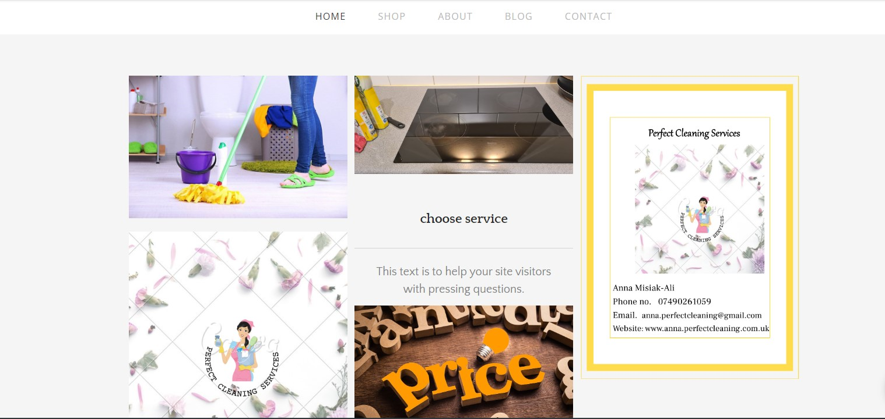

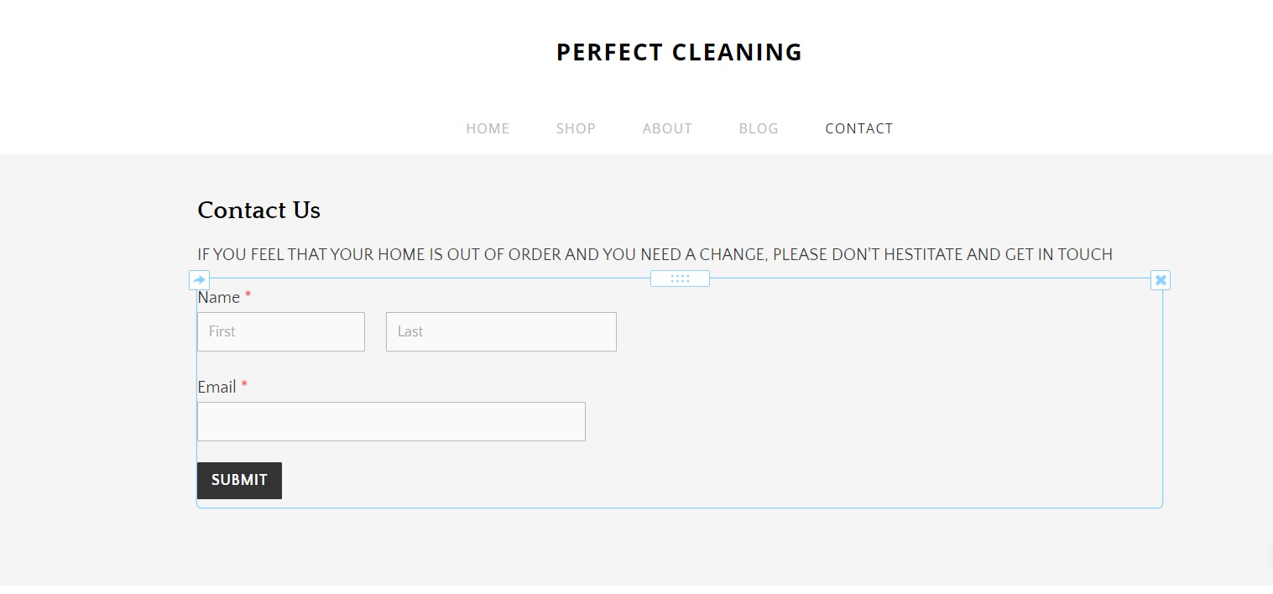

There will be also available leaflets for elder generation who do not use internet or are not familiar with online shopping. Those leaflets will be sent through post to inform customers about the service. The leaflet includes phone number and duties company can overtake.
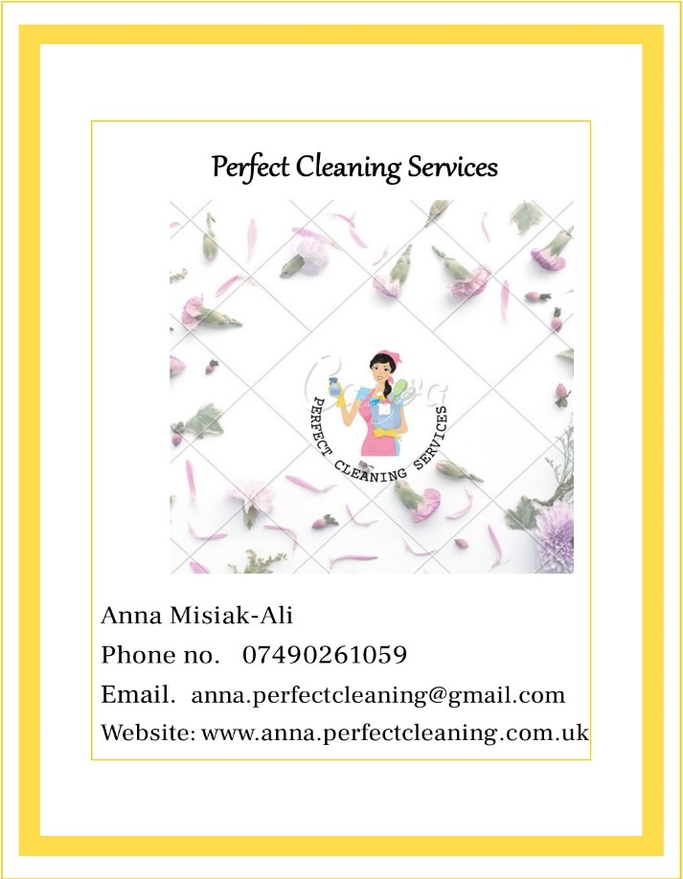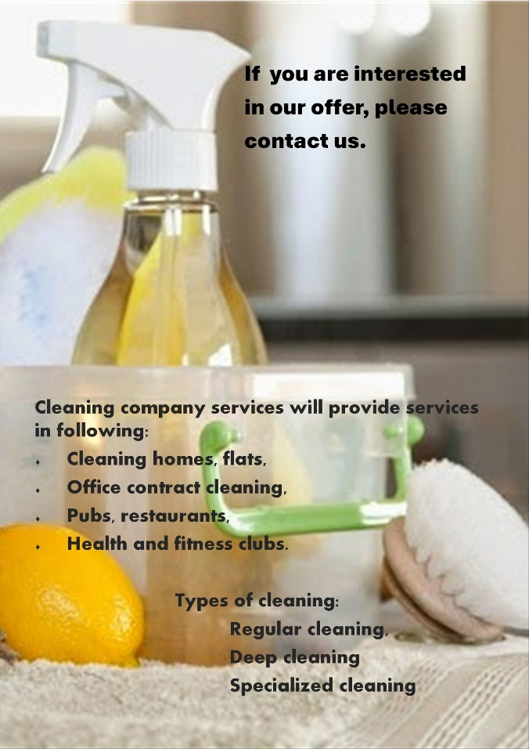

Perfect Cleaning, cleaning services have logo which can help people to recognise company. This logo looks fresh and hopefully will help to promote cleanliness.



All those materials are new and throughout growing and expanding business will change but company’s mission will not change ,,Our mission is to strive to ensure that highest standard of visual and hygienic cleanliness and order are met, while paying attention to detail and aesthetic values.’’

References
Afnan Perfumes. (2023). Afnan Perfumes Marks a Momentous Morning at the UK Launch Event, Unveiling Highness Collection. [Online]. Afnan Perfumes. Last Updated: 3 August 2023. Available at: https://www.afnan.com/pages/videos [Accessed 3 July 2024].
Afnan Perfumes. (no date). Since Its Inception In 2007, Afnan Perfumes LLC Has Perfected Its Product Portfolio As a Perfume House. [Online]. Afnan Perfumes. Last Updated: no date. Available at: https://www.afnan.com/pages/about-us [Accessed 3 July 2024].
Aime, I. (2021). The dynamic construction of brand storytelling. Journal of Strategic Marketing. 31(7), pp.1243-1262. [Online]. Available at: https://www.tandfonline.com/doi/citedby/10.1080/0965254X.2021.1908404?scroll=top&needAccess=true [Accessed 2 July 2024].
Almukhtar, F. et.al. ( 2021). SEARCH ENGINE OPTIMIZATION: A REVIEW. Applied Computer Science. 17(1), pp.70-80. [Online]. Available at: file:///C:/Users/Saeed%20Ali/Downloads/Search_engine_optimization_a_review%20(2).pdf [Accessed 4 July 2024].
Appinio Research. (2024). What is Behavioural Segmentation? Definition, Types, Examples. [Online]. Appinio Research. Last Updated: 8 March 2024. Available at: https://www.appinio.com/en/blog/market-research/behavioral-segmentation [Accessed 4 July 2024].
Burt, S.J. (2024). What is Geographic Segmentation? How to Use It + 7 Examples that Work. [Online]. Hawksem Digital Marketing Agency. Last Updated: 27 February 2024. Available at: https://hawksem.com/blog/geographic-segmentation/ [Accessed 4 July 2024].
Choo, Y.B., Abdullah, T. and Nawi, A.M., (2020). Digital storytelling vs. oral storytelling: An analysis of the art of telling stories now and then. Universal Journal of Educational Research, 8(5A), pp.46-50.
Cote, C. (2020). HOW TO COME UP WITH AN INNOVATIVE BUSINESS IDEA. [Online]. Harvard Business School online. Last Updated: 21 July 2020. Available at: https://online.hbs.edu/blog/post/how-to-come-up-with-a-business-idea [Accessed 5 July 2024].
Crespo, C.F., el. at. (2023). The influence of storytelling on the consumer- brand relationship experience. Journal of Marketing Analytics. 11(1), pp.41-56. [Online]. Available at: https://link.springer.com/article/10.1057/s41270-021-00149-0#citeas [Accessed 2 July 2024].
Dias, P. and Cavalheiro, R. (2022). The role of storytelling in the creation of brand love: the PANDORA case. Journal of Brand Management. 29(1), pp.58-71. [Online]. Available at: https://www.ncbi.nlm.nih.gov/pmc/articles/PMC8494506/ [Accessed 2 July 2024].
Drew, Ch. (2023). The 8 Elements of A Story – Explained for Students!. [Online]. HelpfulProfessor.com. Last Updated: 16 July 2023. Available at: https://helpfulprofessor.com/story-elements/ [Accessed 3 July 2024].
Indeed Editorial Team. (2024). What is a business questionnaire? (With example questions). [Online]. Indeed carrier guide. Last Updated: 27 June 2024. Available at: https://uk.indeed.com/career-advice/career-development/business-questionnaire [Accessed 5 July 2024].
Jolaoso, Ch. (2024). 19 Website Optimization Tips For 2024. [Online]. Forbes. Last Updated: 23 May 2024. Available at: https://www.forbes.com/advisor/business/software/website-optimization-tips/ [Accessed 4 July 2024].
Kaplan, K. (2022). Why Every Business Needs a Website. [Online]. Forbes. Last Updated: 3 February 2020. Available at: https://www.forbes.com/sites/theyec/2020/02/03/why-every-business-needs-a-website/ [Accessed 4 July 2024].
Knotts, J. (2021). How To Improve Your Business In Six Ways. [Online]. Forbes. Last Updated: 27 September 2021. Available at: https://www.forbes.com/sites/forbescoachescouncil/2021/09/27/how-to-improve-your-business-in-six-way [Accessed 5 July 2024].
Lindemann, N. (2023). 12 advantages and disadvantages of questionnaires. [Online]. pointerpro. Last Updated: 7 June 2023. Available at: https://pointerpro.com/blog/questionnaire-pros-and-cons/ [Accessed 30 June 2024].
Melinn, C. (2024). What is SEO and how does it work?. [Online]. Digital Marketing Institute. Last Updated: 27 February 2024. Available at: https://digitalmarketinginstitute.com/blog/what-is-seo [Accessed 4 July 2024].
MasterClass. (2021). The 5 Essential Elements of a Good Story. [Online]. MasterClass. Last Updated: 7 September 2021. Available at: https://www.masterclass.com/articles/the-essential-elements-of-a-good-story [Accessed 3 July 2024].
Mavilinda, H.F. et. al. (2023). Is Storytelling Marketing Effective in Building Customer Engagement and Driving Purchase Decisions?. Journal Manajemen Bisnis. 14(2), p.2023. [Online]. Available at: https://journal.umy.ac.id/index.php/mb/article/view/17830/8566 [Accessed 2 July 2024].
Mwita, K. (2022). Factors to consider when choosing data collection methods. INTERNATIONAL JOURNAL OF RESEARCH IN BUSINESS AND SOCIAL SCIENCE (2147- 4478). 11(5), pp.532-538. [Online]. Available at: https://www.ssbfnet.com/ojs/index.php/ijrbs/article/view/1842 [Accessed 30 June 2024].
Nicole, D. (2024). Psychographic Segmentation: Definition, Examples, and Steps. [Online]. Semrush Blog. Last Updated: 27 February 2024. Available at: https://www.semrush.com/blog/psychographic-segmentation/ [Accessed 4 July 2024].
Parkes, D. (no date). A BRIEF HISTORY OF STORYTELLING: HOW LONG HAS IT EXISTED?. [Online]. Daniela Parkes. Last Updated: 29 April. Available at: https://danielaparkes.com/blog/brief-history-of-storytelling/ [Accessed 3 July 2024].
Sharma, D. et. al. (2019). A Brief Review on Search Engine Optimization. 2019 9th International Conference on Cloud Computing, Data Science & Engineering (Confluence) . 29 July 2019, pp.687-692.
Schlegelmilch, B.B. (2022). Segmenting Targeting and Positioning in Global Markets. In: Global Marketing Strategy. Switzerland: Springer, Cham.
Taherdoost, H. (2022). Designing a Questionnaire for a Research Paper: A Comprehensive Guide to Design and Develop an Effective Questionnaire. Asian Journal of Managerial Science. 11(1), pp.8-16. [Online]. Available at: https://ajmsjournal.org/index.php/ajms/article/view/3087 [Accessed 30 June 2024].
University Lab Partners. (2021). 4 Key Types of Market Segmentation: Everything You Need to Know. [Online]. University Lab Partners. Last Updated: 11 December 2021. Available at: https://www.universitylabpartners.org/blog/key-types-market-segmentation-everything-you-need-to-know [Accessed 4 July 2024].
Williams, K. (2024). What Are Questionnaires? Benefits, Importance and Examples. [Online]. Survey Sparrow. Last Updated: 29 May 2024. Available at: https://surveysparrow.com/blog/questionnaires/ [Accessed 10June 2024].
Wood, W. (2024). Brand Storytelling: What It Is, Best Practices, & Examples. [Online]. mirasee. Last Updated: 3 June 2024. Available at: https://mirasee.com/blog/brand-storytelling/ [Accessed 3 July 2024].
Zimmermann, E. and Koon-Stack, C. (no date). How to Incorporate Multimedia into Your Storytelling. [Online]. Storytelling. Last Updated: no date. Available at: https://storytelling.comnetwork.org/explore/172/how-to-incorporate-multimedia-into-your-storytelling [Accessed 3 July 2024].

