GARETH WILLIAMS
1302811

Stress Analysis and Dynamics
ACMA5010
23/04/2021


Contents Page | Page No
Introduction | 3
Question 1 | 4 - 8
Question 2 | 9
Question 3 | 10 - 16
Question 4 | 17
Conclusion | 18
References | 19

Table of Figures | Page No
Figure 1 - Under Running Single Girder Component Diagram | 3
Figure 2 - 3D Model of 686 x 254 x 170 Universal Beam | 6
Figure 3 - 2D Inventor drawing of beam dimensions | 6
Figure 4 - CAD Stress Analysis of beam with centre load | 6
Figure 5 - Free body diagram of beam | 7
Figure 6 - Bending Diagram | 8
Figure 7 - Linear Strain Gage | 11
Figure 8 - Shear Strain Gage | 12
Figure 9 - Membrane Rosette Strain Gage | 12
Figure 10 - Basic Rosette types classified by grid orientation | 13
Figure 11 - Full Bridge Strain Gage | 15
Figure 12 - Half Bridge Strain Gage | 16
Figure 13 - Strain Gauge on lower web of steel beam | 17

Introduction

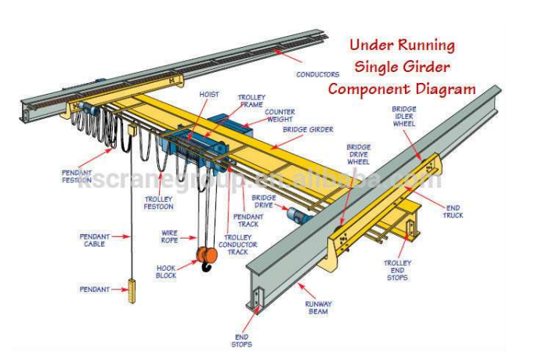Figure 1- Under Running Single Girder Component Diagram

The aim of this assignment is to design a cost effective under running gantry crane which is similar to the diagram shown above in ‘Figure 1’. The crane will be manufactured from steel and will need to have capability to lift 5000kg while also keeping the deflection of the chosen sections to a maximum of 10mm, to ensure the crane’s movements are safe while being operated.
Using slope and deflection of beams theory, the minimum second moment of area can be calculated which will then be used to select the most appropriate section.
For the operator to monitor the safety of the crane during its use, it is proposed that suitable strain gauges are fitted.

Question 1

Calculate the minimum second moment of area required for the bridge girder and hence recommend a suitable section using ‘slope and deflections of beams’ theory.
Data given.
Material of the crane is steel, Elastic Modulus (E) = 210GPa
Load (L) = 5000kg
Maximum amount of deflection allowed = 10mm

The standard formula for finding deflection in the y-axis at any point x from one end of the beam is given by:

$$y= \frac{wx(L-x)}{24EIL}\left[L^{2}+x(L-x)\right]$$

Where
E = Young’s modulus of elasticity of the steel beam, which has units (N/m²)
I = Area Moment of Inertia which has units (m⁴)
L = Total length of the beam which has units (m)
x = A distance from one side of the beam which has units (m)
w = Load (N or kN). The deflection will be at its maximum in the centre of the beam as the load is uniformly distributed along the span length (L).
The flexural equation of a beam is given by:
$$\frac{M}{I}= \frac{δ}{y}= \frac{E}{R}$$
Where
M = Moment/ Torque
I = Second moment of inertia
Δ = Maximum stress generated
Y = Distance from LHS or RHS
E = Young’s Modulus
R = Radius of curvature after bending
The bridge girder can be assumed to be a simply supported beam as the ends are not rigidly fixed. The free body diagram of this beam is show below in Figure 5.
Hence, using the slope and deflection of beams theory, the formula for a simply supported beam with a concentrated load (W) at the centre of the beam is given by:

$$δ= \frac{WL^{3}}{48EI}$$
E = 210000 MPa
δ = 10mm
W = 500kg = 5000 x 9.81N = 49,050N or 4.905KN

Inputting the data into the equation:

$$δ=10= \frac{49050 x ({5000)}^{3}}{48 x 210000 x I}$$

$$I=\frac{49050 x ({5000)}^{3}}{48 x 210000 x 10}$$

$$I= \frac{6.13125 x{10}^{15}}{100.8 x{10}^{6}}$$

$$I=60825892.86{mm}^{4}$$

Minimum second moment of inertia using a 5m length steel section = 6082cms⁴
Based on the calculations above, a suitable I section steel beam would need to be 686 x 254 x 170 according to the British steel sections datasheet. (Steel, 2018)
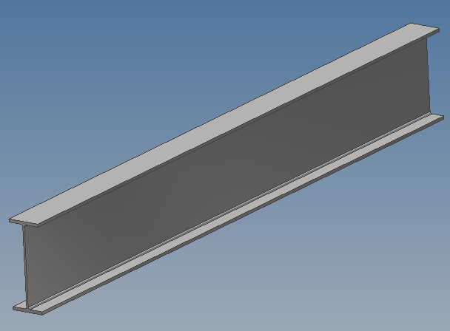
Figure 2- 3D Model of 686 x 254 x 170 Universal Beam

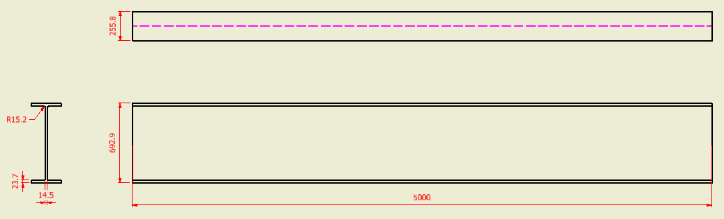
Figure 3- 2D Inventor drawing of beam dimensions

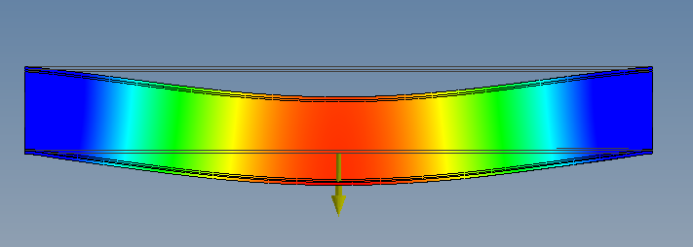
Figure 4- CAD Stress Analysis of beam with centre load
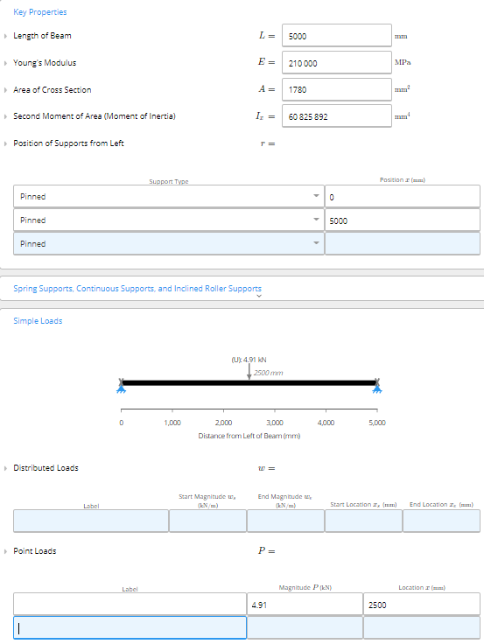
Figure 5- Free body diagram of beam
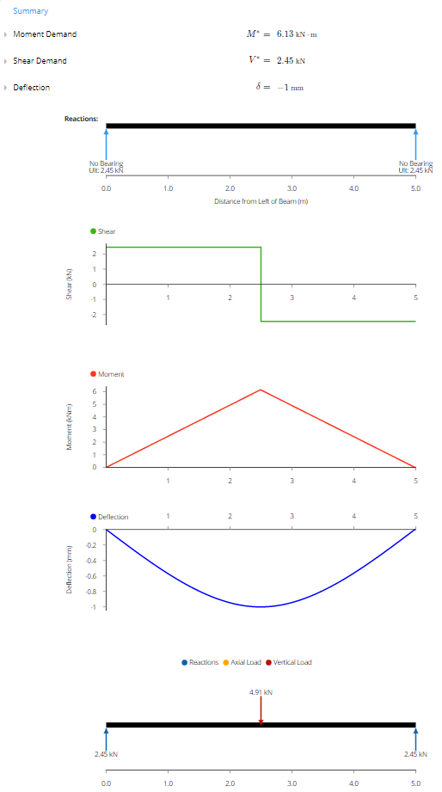
Figure 6- Bending Diagram

(Pty, 2020)
Question 2

Assumptions made from task 1.

- The length of the bridge girder is assumed to be 5m (5000mm), though this could be changed to any length that is required, the second moment of inertia would need to be re-calculated based on the new beam length.

- The crane will be lifting a 5000kg mass when the hoist is positioned in the center of the bridge girder, hence this will be where the maximum deflection will occur.

- The bridge girder travels along the longest axis of the runway beam, guided by the conductors, which is driven by the bridge drive wheel and the bridge idler wheel shown in figure 1 above. It is therefore assumed that the bridge girder is a simply supported beam.

- Any frictional force created from the wheels are ignored, meaning that the crane translation in all directions at either end is limited when the crane is parked.

- The dimensional manufacturing tolerances of the steel section are ignored, and it is taken that the dimensions from the datasheet are true, as this would change the calculations slightly.

- The stretching of the wire rope is ignored in the calculation. The deflection of the hook is only due to the deflection of the bridge girder.

- The mass of the counterweight, trolley frame, wire rope and hook are ignored in the calculation as they are small compared to the 5000kg of live load to be carried by the crane.

Question 3

Discuss the types of strain gauges available, how and why these have been developed historically and how these may develop in the future.
When a material or structure is subjected to a load or force, it changes the original properties and behaviors of that material. There must be a great understanding of how applying various loads or forces to a material can have as if the material is unable to cope with the change of conditions, it could result in the material becoming unstable or even catastrophic consequences such as failure. (Karuppasamy, 2019) Therefore, it is important for the engineers to calculate the stresses and strains that the material will encounter at the design stage to reduce the chances of failure. Strain gauges are also used to measure pressure and acceleration. Being able to measure strain has become a major part of research when it comes to manufacturing parts for industry sectors such as automotive, medical, aerospace, and agricultural. (Meiners, 2005).
One method of doing this is to use conventional strain gauges. A conventional strain gauge is a sensor device that can measure the electrical resistance variations when a material is strained. (Nachazel, 2020)
The history of conventional strain gauges dated back to 1938 when it was invented by professors Arthur Ruge and Edward Simmons. (Kell, 2017)
Strain gauges have developed a lot over the years since. The conventional gauges that were first designed and are still widely used today are simple flexible base, usually a plastic as it is non conducting, which then has a metallic foil stuck to it using a special type of glue such as Cyanoacrylate or Epoxy. There would also be wires soldered to the foil which sends the signal back to the receiver. As the foil is deformed by the pressure or load of an object, the resistance changes which measures the strain. (eFunda, 2018)
Over time, strain gauges have been advanced and now incorporate the latest technology and electronics available. In 1958 the load cell was created by Nils Eilersen. Load cells are much more robust than traditional strain gauges which would only be used for a short amount of time, whereas a load cell can last many years due to its ability to sustain higher tolerances to overloads. (Eilersen, 2019)
Load cell strain gauges are widely used because of their high accuracy and low unit price. The technology available now allows load cell strain gauges to be fitted and monitored continuously. A great safety feature that is used is the ability for the strain gauge load cell to set off an alarm if the load or force exceeds a certain value. For example, if a strain gauge is fitted to a cable bridge and the wind is too high, a alarm will sound which the operator could act on by closing the bridge to high sided vehicles.
There are many different types of strain gauges that are suitable for many different applications. Some applications where a strain gauge is used are.
Aerospace – Strain gauges are commonly used on the wings of aircraft to measure the stresses along the load paths, and to measure wing deflection.
Civil Engineering – Strain gauges are used on bridges and high-rise buildings to monitor the strain that is subjected to the cables and beams of the structure due to wind and traffic.
Rail – Strain gauges are often used in the rail industry to monitor any changes in either the rail itself, or the ground which the rails are laid on. For example, if a railway line is laid on ground above an old mine shaft, then strain gauges can be used to monitor any change in the ground due to sagging etc.
Green Energy – The world is changing whereby energy is increasingly sourced by ‘clean’ sources such as wind turbine and solar panels. Strain gauges are used to monitor the torque of the propellers. If the wind is too high, then it can become dangerous for the propellers to spin at high speeds.
Different type of strain gauges and load cells
• Linear or one direction strain gage
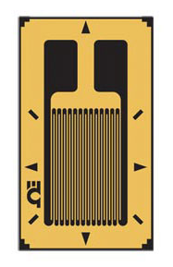
Figure 7 - Linear Strain Gage (Omega.com)
Linear strain gauges measure in straight lines only, which shows one specific strain. Linear strain gauges only have one single grid measurement, so they measure uniaxial stress such as the bending of a beam that is subjected to a load, such as a overhead crane gantry. Linear strain gauges are most used while tensile testing.

- Shear strain gauges.
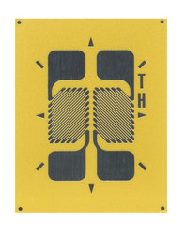
Figure 8- Shear Strain Gage (micro-measurments.com)
Since shear strain (γ) is measured by measuring strain at a 45° angle, strain gauges used in a shear strain configuration may also be used to measure vertical loads (Fv); this is also known as a shear beam load cell. (Group, 2010)

- Membrane Rosette strain gauges
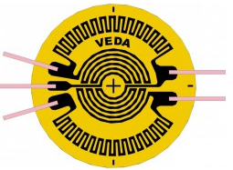
Figure 9- Membrane Rosette Strain Gage (Veda.com)
Membrane rosette strain gauges are used to measure displacement, velocity, pressure, and stress, as well as the elastic strain of engineered materials and structures subjected to dynamic and static loads. Unlike a linear strain gauge, rosette strain gauges usually have two or more gauges which are placed close together so that they can measure strain at different directions to each other. This makes them much more accurate.

- Rectangular Rosette (0°- 45°-60°)
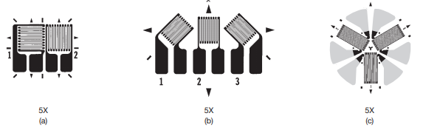
Figure 10 - Basic Rosette types classified by grid orientation (intertechnology.com)

A three-element rectangular rosette strain gauge consists of three grids. The second and third grids are angularly displaced by 45° and 90°, respectively.
• 45°-Rosette
For the most part, the wire gauge is only successful when it is applied in one direction. There are three independent linear measurements needed to locate plane strain.
To increase the accuracy of a strain rosette, large angles are used. A common rosette of three gages is where the gages are separated by 45°, or θa = 0°, or θb = 45°, or θc = 90°. The three equations can then be simplifying to
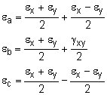
Solving for εx, εy and γxy gives,

• 60°-Rosette
Similarly, if the angles between the gages are 60°, or θa = 0o, or θb = 60°, or θc = 120°., the unknown strains, for εx, εy and γxy will be,
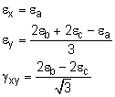

• 90°-Rosette
In electric installations, T-rosettes are installed when the prevailing flow directions are established. These devices have a Luffingle retractable coupler mounted, which allows engineers to accurately calculate stresses and strain at 90° to be included in the testing, rather than just one or exclude one of these from the calculation. compression or tension is applied, the common method for measuring patellar or pegging deflection enables both measurement of Poisson's ratio and the stiffness of the patella. T-rosette testing gives the consumer the best opportunity for test results to be precise transversely.
They were historically developed only after the discovery that the resistance of a conductor is directly proportional to the length and inversely proportional to the cross-sectional area of the conductor. They are simple and reliable means of strain measurement. They work on the principle of Wheatstone- bridge balancing which is spoken about below. The disadvantages of these types of gauges are that they are one time use only. They cannot be reused generally. Also, they are required to be bonded to the surface for the strain measurement. Thus, in future, other means of strain measurement like Digital image correlation (DIC) is likely to replace strain gauges as it is reusable as well as it does not require any bonding on the surface.

- Full bridge (Wheatstone Bridge) strain gauges.
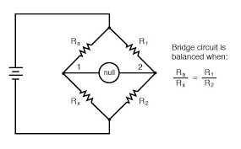
Figure 11- Full Bridge Strain Gage (allaboutcircuits.com)
Four active strain gauges are used in a full-bridge strain gauge configuration, which comes in three different forms. Bending strain is measured by types 1 and 2, while an axial strain is measured by type 3. Only types 2 and 3 accounts for the Poisson effect, but all three types reduce temperature effects.
When there is no current flowing through the Wheatstone bridge is taken to be in a balanced state where,
$$\frac{R1}{R2}= \frac{R3}{R4}$$
To take the voltage readings from the Wheatstone bride and convert them into strain, the equation is.
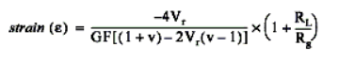
Where,
GF = The Gauge Factor which is usually specified by the manufacturer.
Vr = Voltage ratio.
R_{L} = Lead or cable resistance. The longer the cable, the less accurate the reading will be.
R_{g} = Nominal gauge resistance, which should also be specified by the manufacturer.

- Half bridge strain gauges.

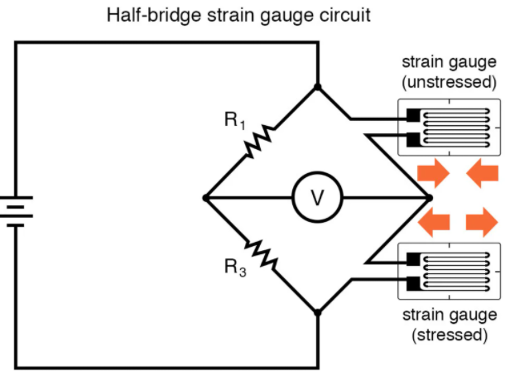
Figure 12 - Half Bridge Strain Gage (allaboutcircuits.com)
There are two types of Half bridge strain gauges, type I and type II. The half-bridge type I: has two active strain-gauge elements. One is oriented in the direction of axial strain, while the other is oriented perpendicular to the principal axis of strain and serves as a Poisson gauge. Half-bridge completion is provided by completion resistors.
The type II Half bridge strain gauge only measures bending strain. It also has two active strain-gauge elements. One is mounted in the direction of the bending strain on one side and one on the opposite side.

Question 4

Suggest which strain gauge should be used and discuss how readings from these strain gauges should be interpreted.
The main purpose of an overhead crane gantry is to lift objects from the ground in a single axis, i.e., unidirectional loading. Therefore, the most appropriate strain gauge to use for the crane would be a linear strain gauge as the mass that the crane is lifting is going to want to pull the beam towards the ground as the mass is lifted. The linear strain gauges are to be bonded on the lower webs of the bridge girder shown in the figure below. The reason for this is because the operator of the crane needs to know the strain of the beam when it is lifting a mass of 5000kg, so the maximum deflection will occur at the center of the beam.
For the readings to be as accurate as possible, then it is important that the strain gauges are calibrated before every lifting operation. This is because different factors can affect the ‘zero’ home position of the strain gauge. For example, if the operator had used the crane and left the lifting chains attached to the hook, then the weight of the chains would be adding strain to the beam. This could give a false deflection reading to the operator. Temperature could also play a small part in false readings of the strain gauge as if it were a hot day then the heat would cause the material to expand whereas if it were a cold day then the material could contract.

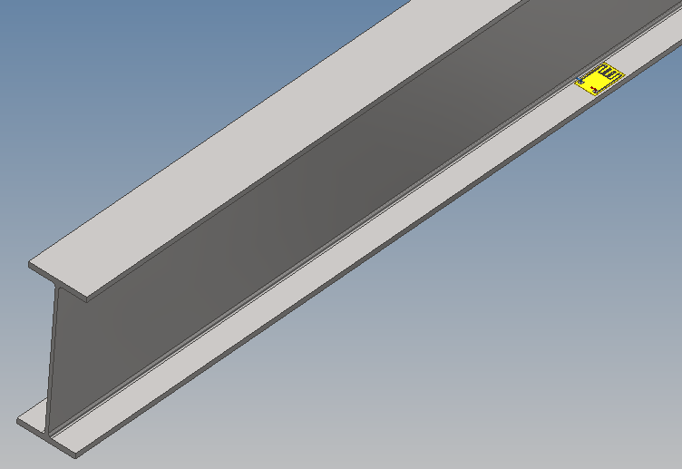
Figure 13 - Strain Gauge on lower web of steel beam
Conclusion

This report has proven how important it is to use calculations such as slope and deflection of beams theory to work out the maximum amount a piece of material will deflect safely whilst under a certain load. From that the design engineers can make sure they choose a suitable size section based on the second moment of inertia. Stress analysis software can also be used in 3D CAD to visualise how a piece of material will react, so that the design engineer can see on a screen whether a material is likely to fail in real world situations. They can also apply a suitable factor of safety at the design stage.
Strain gauges also play a vital role in the safety of material and structures. They allow operators to constantly monitor how the material is coping in different situations and point out any maintenance that needs to be carried out because of a material being overloaded that would not be easy to spot with the eye such as internal fracture or hairline cracking of the material, which left untreated could result in catastrophic consequences.

References

References
eFunda, 2018. Engineering Fundamentals. [Online]
Available at: https://www.efunda.com/designstandards/sensors/strain_gages/strain_gage_selection_matl.cfm
[Zugriff am 17 04 2021].
Eilersen, N., 2019. The weighing experts. [Online]
Available at: https://www.eilersen.com/history/
[Zugriff am 19 04 2021].
Group, V. P., 2010. Strain Guages & Instruments. s.l.:Micro-Measurements.
Karuppasamy, K. S. K., 2019. Applications and Techniques for Experimental Stress Analysis. 1st Hrsg. Guwahati: IGI Global.
Kell, S., 2017. Technology and Practical Use of Strain Gages: With Particular Consideration of Stress Analysis Using. In: 1st, Hrsg. s.l.:y Ernst & Sohn GmbH & Co.
Meiners, H. F., 2005. Advances in Chemical and Materials Engineering. American Journal of Physics , Band 33, p. 165.
Nachazel, T., 2020. What is a strain guage and how does it work?. [Online]
Available at: https://www.michsci.com/what-is-a-strain-gauge/
[Zugriff am 18 04 2021].
Omega, kein Datum Linear Strain Guage. [Online]
Available at: https://www.omega.co.uk/pptst/SGD_LINEAR1-AXIS.html
[Zugriff am 17 04 2021].
Pty, C., 2020. Clear Calcs. [Online]
Available at: https://clearcalcs.com/freetools/beam-analysis/au
[Zugriff am 09 04 2021].
Steel, B., 2018. British steel sections datasheet, Lincolnshire: British Steel Limited.

