7/20/2026
AI Acknowledgment
I used Microsoft Copilot to assist with brainstorming ideas, improving sentence structure, and checking grammar while preparing this assessment. All final content, analysis, and conclusions are my own work. The AI-generated suggestions were reviewed and edited before inclusion.

Villarose V. Reginaldo
Student no. 2527563
Module code: LCHS4003
Module Title: Introduction To Health and Social Care
Module Lecturer: Muhammad Aliyu
Submission: 20th July 2026
INTRODUCTION TO HEALTH & SOCIAL CARE
LCHS4003
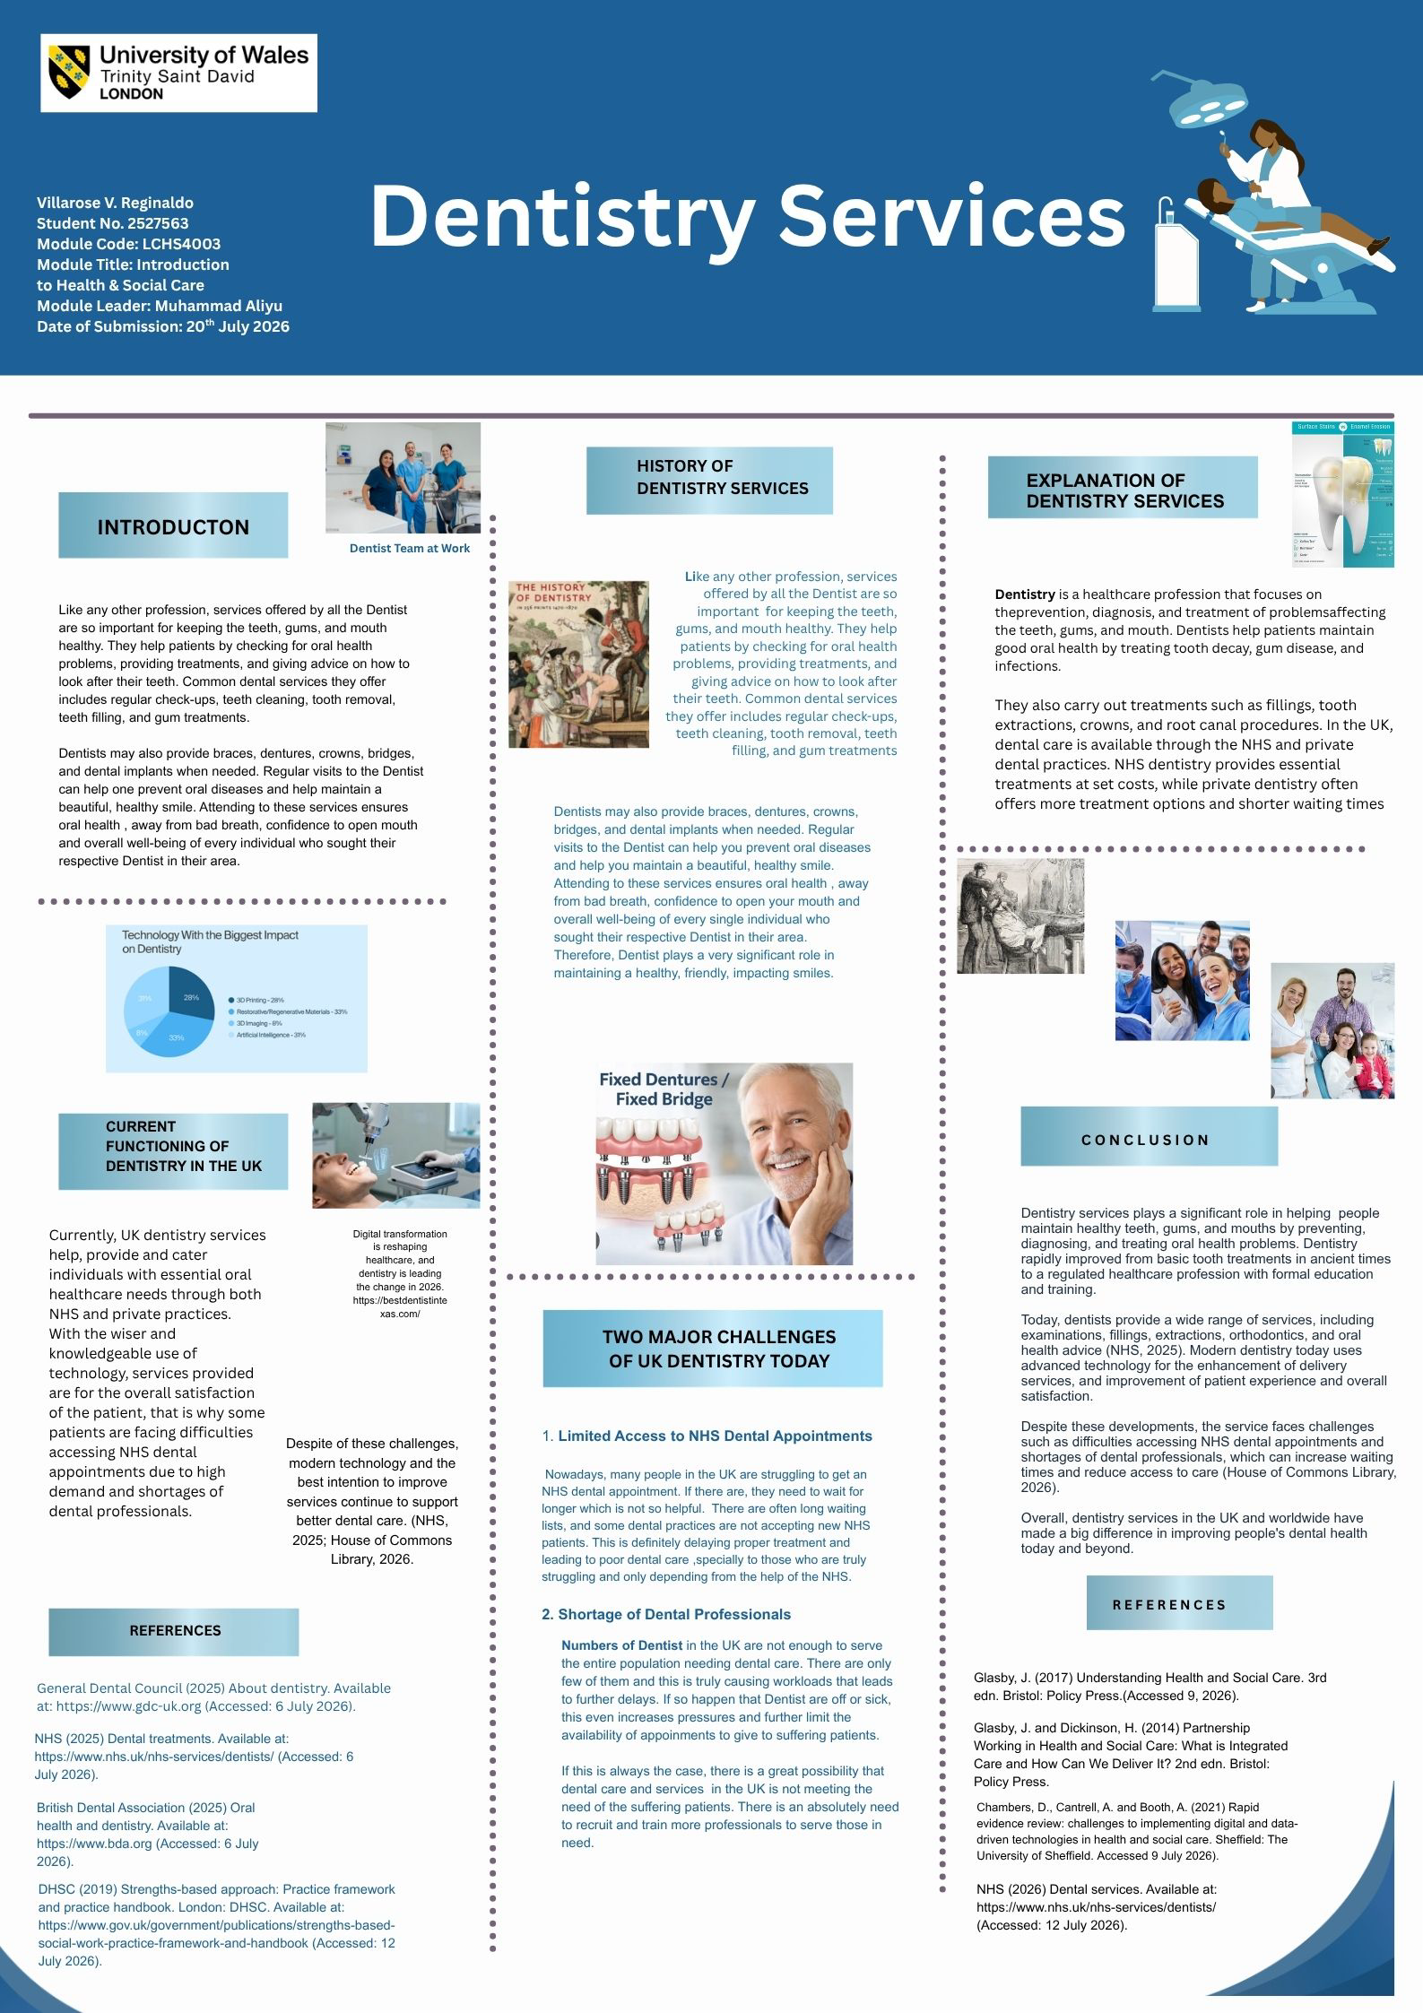

RESIDENTIAL CARE HOME

INTRODUCTION

Residential care homes provide essential support for people who cannot live independently, including older adults and individuals with illnesses or disabilities. They offer safe accommodation, personal care, companionship, emotional support, and safeguarding. Residents are treated with kindness, dignity, fairness, and respect, helping them feel valued and part of a family. Care homes support all aspects of well-being, including physical, mental, emotional, social, intellectual, and spiritual needs. They also ensure residents receive appropriate healthcare and regular monitoring. Planned social activities encourage interaction, friendship, shared experiences, and enjoyment, helping residents stay engaged, reduce loneliness, and improve their overall quality of life.

HISTORY: FIRST CARE HOME IN BRITAIN

In 936, Alms house was built in York under King Athelstan who was the present King of the English at that time. He provided funding to care for the elderly. They have the so-called virtue and compassion: Alms - means- to give to others. Bede houses- Prayer-from Anglo Saxon word. These houses were funded by generous and wealthy people with the hope that by doing so their chances to go to heaven is more possible. Almshouses were aimed to nurture the soul as well as the body of every resident.

Residents were known as Bedesmen and Bedeswomen and were expected to follow a strict routine of prayer and worship as part of their care. In medieval times, monasteries provided accommodation for people who were elderly, ill, or disabled. Later, hospitals emerged, including St John’s Hospital in Canterbury, founded around 1087, which is considered one of the first institutions to provide long-term care and temporary treatment for people with leprosy. As leprosy declined, many almshouses replaced smaller hospitals, while larger hospitals cared for the sick and wounded.

The Poor Relief Act of 1601 (Old Poor Law) provided food, shelter, and housing for people unable to work due to illness, disability, or old age. However, it did little to improve their overall quality of life. Over time, society recognised that vulnerable individuals needed dignity, privacy, and personalised support. During the 20th century, modern residential care homes developed to better meet individuals’ need and improve well-being (Carehome.co.uk, 2025).
HOW DOES RESIDENTIAL CARE HOMES FUNCTION TODAY

Today, residential care homes provide much more than accommodation. Care workers help residents with everyday tasks such as washing, dressing, eating meals, taking medication, and maintaining personal hygiene. Residents usually have individual care plans that are designed around their specific needs. Many care homes also organise activities such as crafts, games, gardening, and social events to encourage residents to stay active and build relationships with others (Care Quality Commission, 2026).
In my opinion, one of the main advantages of residential care homes is the sense of security they provide. Many residents need regular support because of their age, illness, or disability. Knowing that trained staff are always available and can make residents feel safe and supported. It also gives family members reassurance that their loved ones are receiving the care they needed.

THE GROWING CHALLENGES OF RESIDENTIAL CARE HOME

Residential care homes are facing increasing pressure as residents increase in numbers. The demand for care continues to grow. Difficulties recruiting and retaining skilled staff also a challenge, so with financial funds to operate fully and regularly. Furthermore, looking after those with dementia even through person centred care support, remain a challenge within the sector. (Skills for Care, 2024; CQC, 2024).

SIGNIFICANCE
Residential care homes are important because they can have a positive impact on both physical and mental well-being. Living in a care home can provide a strong sense of belonging. Residents have opportunities to socialise with friends, be part of a supportive community, and receive care from people who are genuinely concerned about their well-being. This helps to promote a high quality of life that is comfortable, fulfilling, and sustainable.

CONCLUSION
Residential care homes have changed significantly over time. They have developed from basic institutions into services that focus on providing care, dignity, and respect. Although there are still challenges within the sector, care homes continue to play a valuable role in supporting people who can no longer live independently. By offering safety, companionship, and personalised care, they help improve the wellbeing of many individuals.

REFERENCES
In-text Citations
(Carehome.co.uk, 2025)
(Care Quality Commission, 2026)
Carehome.co.uk (2025) A history of care homes. Available at: https://www.carehome.co.uk/advice/a-history-of-care-homes (Accessed: 8 July 2026).

Care Quality Commission (2026) Care Quality Commission. Available at: https://www.cqc.org.uk/ (Accessed: 8 July 2026).

Care Quality Commission (2026) Guidance on Residential Care Services. Available at: https://www.cqc.org.uk/about-us/fundamental-standards (Accessed:13 July 2026

Munson, S. (2025) A history of care homes. Carehome.co.uk. Available at: https://www.carehome.co.uk/advice/a-history-of-care-homes (Accessed: 15 July 2026). [carehome.co.uk]

Johnson, J., Rolph, S. and Smith, R. (2010) ‘Uncovering history: private sector care homes for older people in England’, Journal of Social Policy, 39(2), pp. 235-253. [cambridge.org], [oro.open.ac.uk](Accessed: 13 July 2026)

Andrews, G.J. and Phillips, D.R. (eds.) (2004) Ageing and Place: Perspectives, Policy, Practice. 1st edn. London: Routledge. https://doi.org/10.4324/9780203694510. (Accessed 12 July 2026)

