Adele Murphy (P150554)

research methods and communication
MDes Surface Pattern Design
M7X02233

Introduction Page 2

Response to colour Page 2

Health benefits of Nature Page 3

The need to paint by hand Page 4

Context and future trends Page 6

Bibliography Page 9

Introduction

Throughout my practice I have struggled to find who I am as a designer. From exploring different avenues in my thought experiment and in research for this assignment, I discovered that to find who I am as a designer I first need to discover who I am as a person. I need more tranquillity in my life and that led to me to discover methods such as yoga and meditation to bring calm when I begin to feel overwhelmed. From there I decided I wanted to implement these elements into my practice and therefore create a healthy working environment for myself, as well as producing work that may also help someone else. I researched into what it is in our surroundings that can affect the way we think and feel, that is when I discovered that the use of colour in my everyday life may have an influence on my emotions. For example, being around a certain tone of green may enable me to feel more at ease.

When I create a collection, I like there to be an underlining narrative, as my work becomes much stronger when I combine my conceptual ideas along with my technical ability. When producing a piece of artwork for a fashion garment I aspire for it to hopefully bring some positivity and enlightenment towards members of society, even if that may only be a select few who just needed something to make them smile.

Response to colour

Our environments may have an influence towards affecting our emotions. It has been discovered that being around elements of nature can have positive effects such as lowering “physiological stress, increas[ing] attention span and improv[ing] well-being” (Exeter.ac.uk,2014). During an experiment that took place using ninety-eight college students, each student indicated their emotional responses after being exposed to various colours and hues. These included; five principle hues (red, yellow, green, blue and purple), five intermediate hues (yellow-red, green-yellow, blue-green, purple-blue, and red-purple) and three achromatic colours (white, grey and black). The information gathered showed that certain colours had common responses, for example, the hue green-yellow had reported connotations of sickness and disgust, as opposed to other colours which had more positive reactions (Kaya, N. and Epps, H. H., 2004).

The most positive result from the experiment with the students was the responses to the colour green, the colour green evoked the sense of nature and therefore made them feel more comfortable and relaxed (Kaya, N. and Epps, H. H., 2004). There is an “innate human need to affiliate with nature” (McGee, B. and Marshall-Baker, A. (2015) and Edward Wilson described this phenomena, as being part of our being, he stated that “the living world is the natural domain of the most restless and paradoxical part of the human spirit” (Wilson, 1984). The word that is used to express this is ‘biophilia’, combining the words “bio or life and philia a platonic love” (McGee, B. and Marshall-Baker, A. (2015). It essentially means that due to the way nature can affect our emotions we tend to favour it over being around inanimate objects like being indoors surrounded by technology. However, has humanity taken it too far? Have we “accelerated toward the machine antipode, heedless of the natural desire of the mind to keep the opposite as well” (Wilson, 1984). Humanity has almost been consumed by technology and lost sight of the benefits the natural world can have for us and our environment. It has resulted in humans being stuck between two ideals, “nature and machine, forest and city, the natural and the artifactual” (Wilson, 1984).

I do believe that our use of technology has distorted our perceptions of the world around us and by bringing the outside inside and onto our bodies, I aspire to introduce nature back into our everyday lives, where we are so caught up in our jobs and our work that we lose sight of what is important. I intend to produce my own colour charts to help myself understand the differences between the cooler hues versus the warmer hues and how I feel when I am exposed to each one. That will help me build an archive of information to refer to once I begin inserting imagery into my designs to evoke emotional responses.

Health benefits of nature

Being around the natural world can have many beneficial attributes which can affect one’s well-being, in a physical and psychological way (McGee, B. and Marshall-Baker, A. (2015). In an experiment by Park and Mattson it was proven that being around plants and nature can actually reduce your heart rate and blood pressure, as well as significantly decreasing your levels of “pain, anxiety, and fatigue” (Park and Mattson, 2008). During this experiment patients in a hospital were split into two groups, one group was given plants and flowers in their rooms whilst the other group was not. The feedback that returned was that the patients in the rooms with flowers showed significantly more positive physiological responses such as, lowered blood pressure and heart rate compared to the group with no plants in their rooms (Park and Mattson, 2008).

While this experiment took place in a hospital, it can be applied into the field of textiles through the means of floral imagery and specific colour choices being used to create designs. I intend on using this information and putting it forth within my practice as a way to try and physically and psychologically help those who may engage with my work. I will be combining the information that I have gathered through both experiments, as well as future experiments I propose to carry out in my creative venture, where is expose myself to a selection of warm and cool colours and document my emotional responses. This then allows me to make informed decisions on how my designs are created through their composition and even through their non-visible attributes.
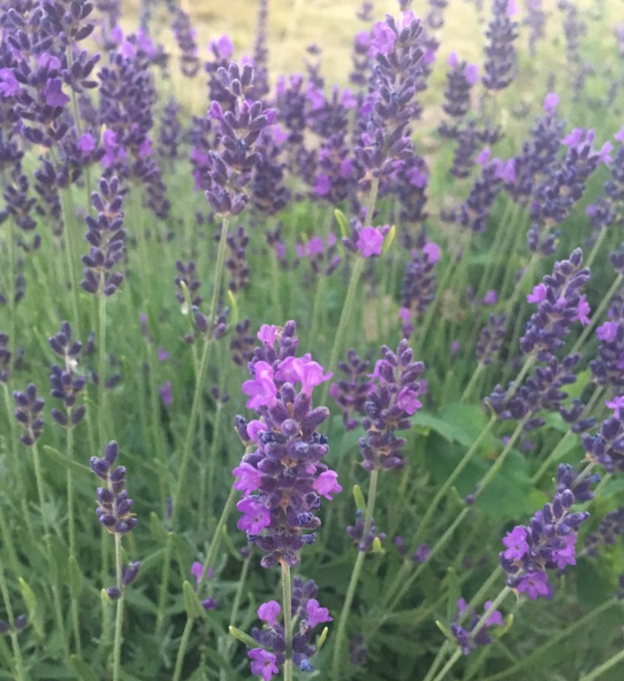
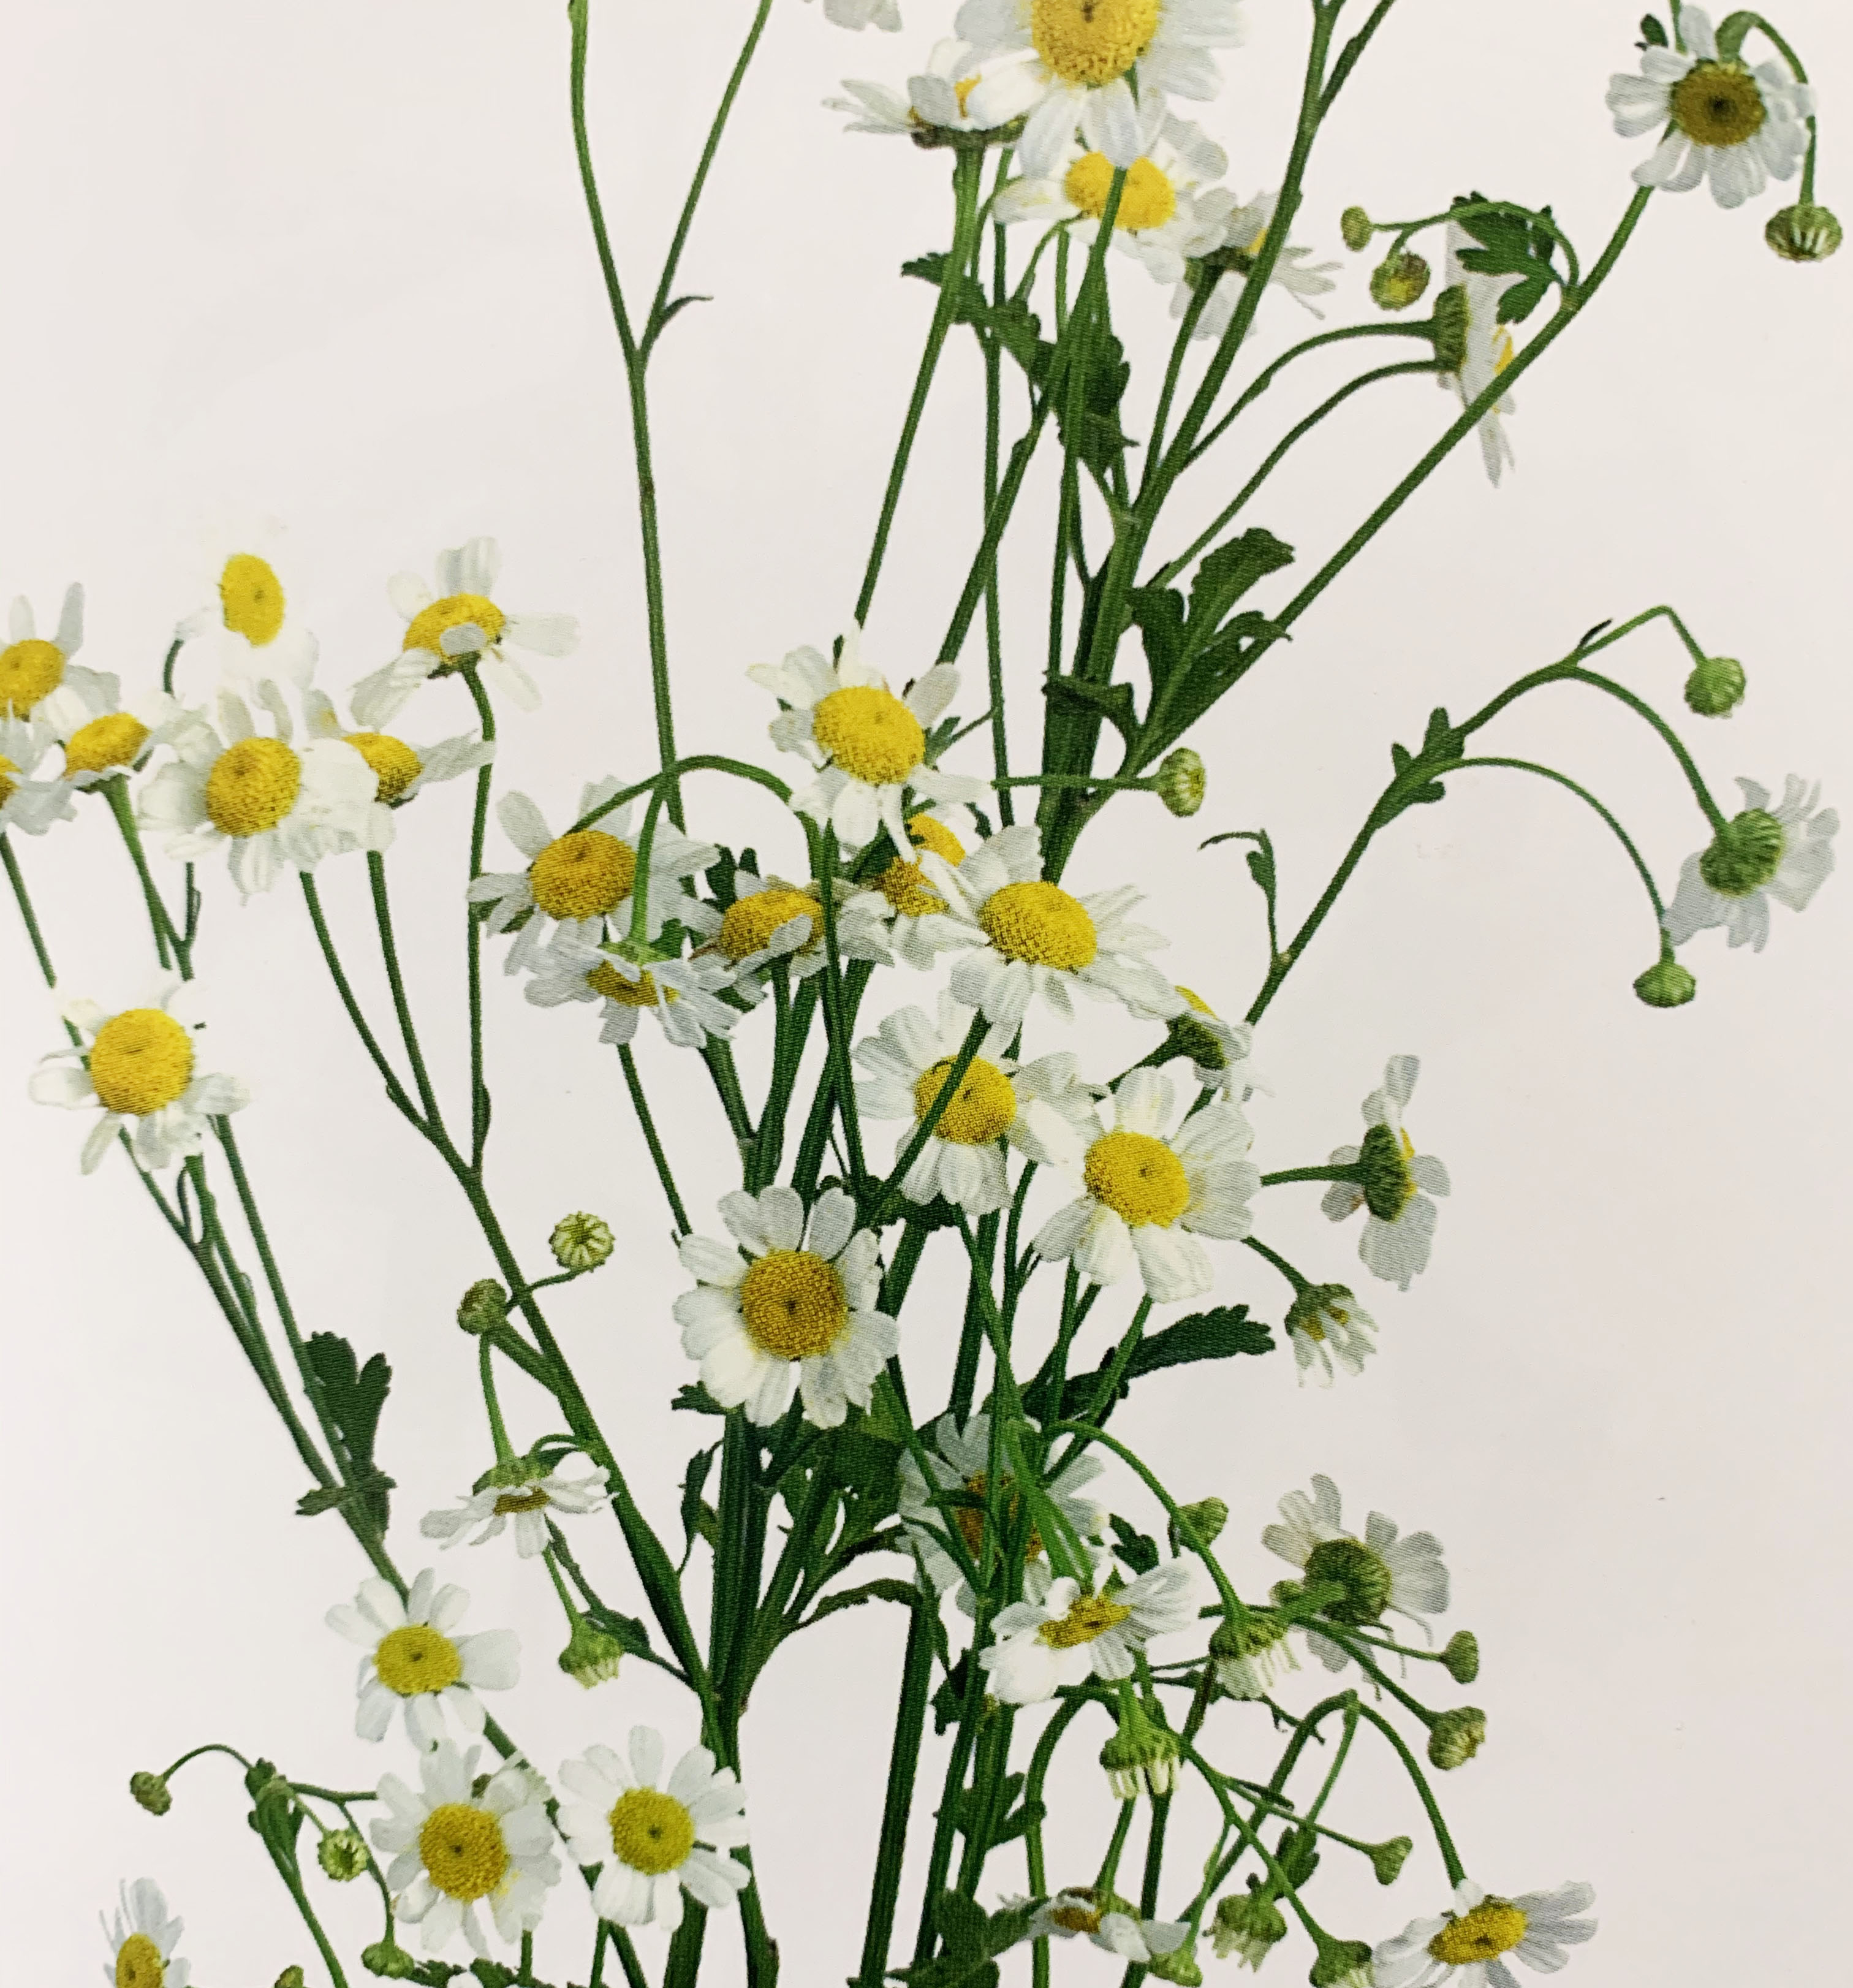
Image 2
Image 1
By introducing plants that have health beneficial properties such as lavender and chamomile, I can begin to introduce the feeling of relaxation and tranquillity to the consumer. Lavender in particular can help “you calm down when you’re overworked and stressed out over a particularly challenging task.” (Productivity-Boosting Blooms for your workplace, 2018) This is a result of the aroma along with the colours, the soft purple colour is easy to look at and along with other cool colours such as blue and green, “they are generally considered to be restful and quiet” (Kaya, N. and Epps, H. H., 2004). Warmer colours such as red, yellow and orange can be seen as “active and stimulating” (Kaya, N. and Epps, H. H., 2004), which can be a lot to handle for someone with an already over-active and stressed mind. However, I can use this to take on different emotional strands within my final collection. I will do this by including sub-collections, which will include prints that emulate emotions such as, calm and relaxation as well as excitement and joy. Using colours which are very active and stimulating in the excitement collection, and colours which are more restful and quieter in the calm collection.

The need to paint by hand

I am pulled towards drawing and painting flowers, as it takes me to another place. When I am painting that is all my mind is focused on, it is peaceful and quiet. I almost feel lost when I am not working with florals, as if something is missing. Using watercolour to paint flora can be very time consuming and can sometimes create a lot of pressure within the fast pace environment of my studies, therefore I often use computer aided design to help speed up the process of creating imagery. Richard Sennett explains the importance of the hand and that modern technology’s capacity to “compute [is] superior to those of anyone working out a drawing by hand” (Sennett, 2009). Correspondingly, many designers lean towards CAD due to “its speed [and] the fact it never tires” (Sennett, 2009), however it has so many more positive properties other than just speed. Programmes such as photoshop allow me to take my hand painted artworks and transform them into complex repeats whilst adding layers of texture and other elements. It pushes my concepts further and gives me the opportunity to translate my work onto cloth through; digital printing, digital embroidery and producing images to expose onto screens. Technology therefore can aid the development of artisan techniques such as screen printing, by creating imagery that is reusable and affective, as oppose to using hand cut stencils. In my creative venture I intend to use photoshop to my advantage but attempt to retain an artisan essence within my final pieces, possibly through processes such as mono printing, hand dying or stitch. In combining the substantial opportunities technology can offer me with the skills I hold in my own hand, I anticipate it will positively uplift my final collection.

Intrinsic satisfaction is something lots of people rarely receive in their day to day lives as it is normally found whilst carrying out leisure activities or hobbies (Crawford, 2010). I find this when hand painting as I find the process of it just as satisfying as the end result, activities that evoke this feeling are ones that “we pursue…without anyone having to pay us to do so” (Crawford, 2010, p.181). It is very common to find this within creative jobs, if you give someone the opportunity to do what they enjoy doing then they are more likely to receive intrinsic satisfaction. If I feel happy within my practice, then I am more likely to produce more exciting work that reflects myself as a designer.

Throughout my previous thought experiment, I took influence from my environment and how it is so important to take care of your own self mentally and physically, without feeling guilty. I focused on the human interactions we have every day, as well as the relationships we have with each other and with our technology. We are constantly surrounded by technology and it is consuming our lives without us really noticing it. The message I wanted to convey in my work was to highlight the need of taking breaks from our everyday use of machines and having moments to simply focus on our own personal well-being. A part of my experiment was retaining the notion of ‘I am here now’. To be in the moment and to take a breather. To know that everything is okay in that moment in time.

An obstacle that I face is distractions, either from my own head, reaching for my phone for some interaction, or other things that may seem so small. Musicologist Alfred Einstein would wear the same clothes every day, his reasoning for this was so that he could cut down “on the daily effort involved in deciding what clothes to wear, so that his mind could focus on matters that to him were more important” (Csikszentmihalyi, 2013, p.351). It may seem like nothing, but a couple minutes a day to decide what to wear equates to a lot of time over a year. It essentially means that his mind had more space to think and reduced the interruptions to his train of thought. The concept of uncluttering the mind is extremely important and a main motivation for my work. I feel happiest when I am sat down drawing and painting with no pressure, as when I am in that moment my mind is focused on the task in hand rather than everything that is going on around me. However, I have a huge reliance on technology, and it is something that has come to light this year whilst researching the connections and relationships we have with each other and our surroundings.

Being at university so far away from home has caused my dependence of technology to grow. The reason for this is that it is my way of staying connected, without it I am alone with no one to talk to, it is my comfort blanket for when I am feeling down. On the other hand, it has resulted in me disconnecting from nature and the space around me, as if I am in my own bubble, causing me to find it hard to settle into my environment. I am surrounded by a plethora of people, yet I feel lonely. For that reason, it is vital that I begin to introduce more of the natural world into my daily life, going for a walk to the beach or having a conversation with someone new. I hope that through introducing emotionally stimulating imagery and colours within my practice, it will help me outside of my practice also.

Context and future trends

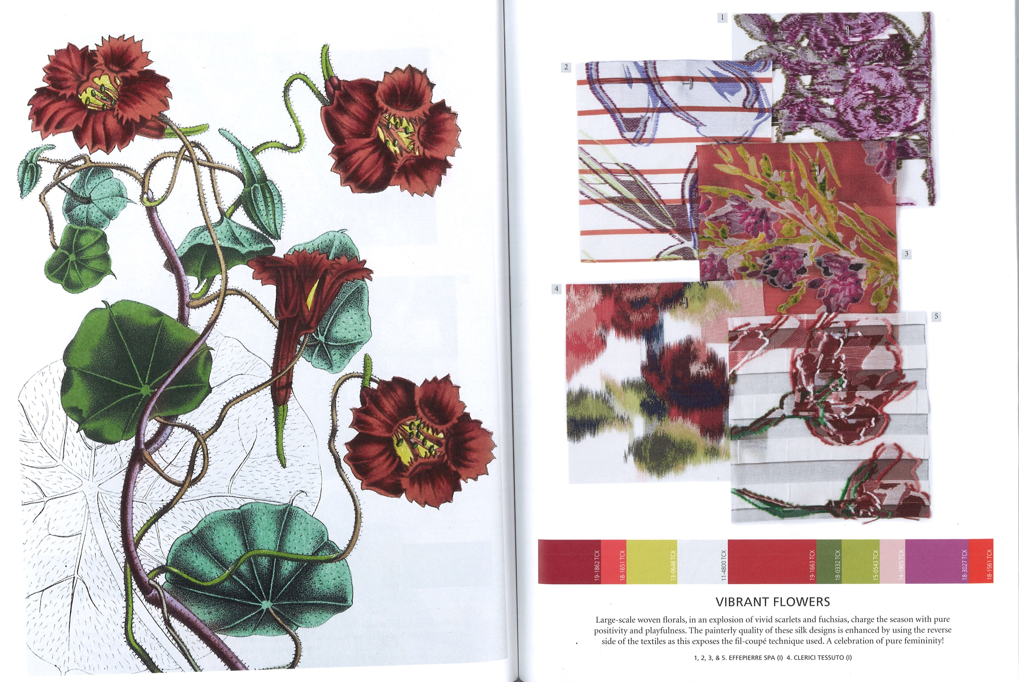
I am planning to produce a collection of fabric samples which hold carefully selected imagery from natural environments, to encourage a sense of relaxation and with the potential to boost the well-being and decrease stress and anxiety levels within myself and potentially others who may observe my work. They may subsequently be produced into fashion items at a later date to be worn day to day, therefore allowing the opportunity for more people to have access to my work. The trend forecasts for spring summer 2021 show considered palettes, ranging from very neutered barely present colours in the lacy weaves collection in image 3, to a vibrant and playful collaboration with the vibrant flowers collection in image 4. I intend to take influence from both of these forecasts within the various emotional strands within my collection. The lacy weaves collection is quiet, understated and almost fragile looking, relating to the feelings of loneliness. The feeling of being both there and not there is reflected in the faintness of the colours. In contrast, the vibrancy and boldness of the colours in the vibrant flowers collection is packed full of energy and stimulation. When we are excited, we tend to show it with big and loud expressions, equally the bold use of colour within this forecast emulates that passion.
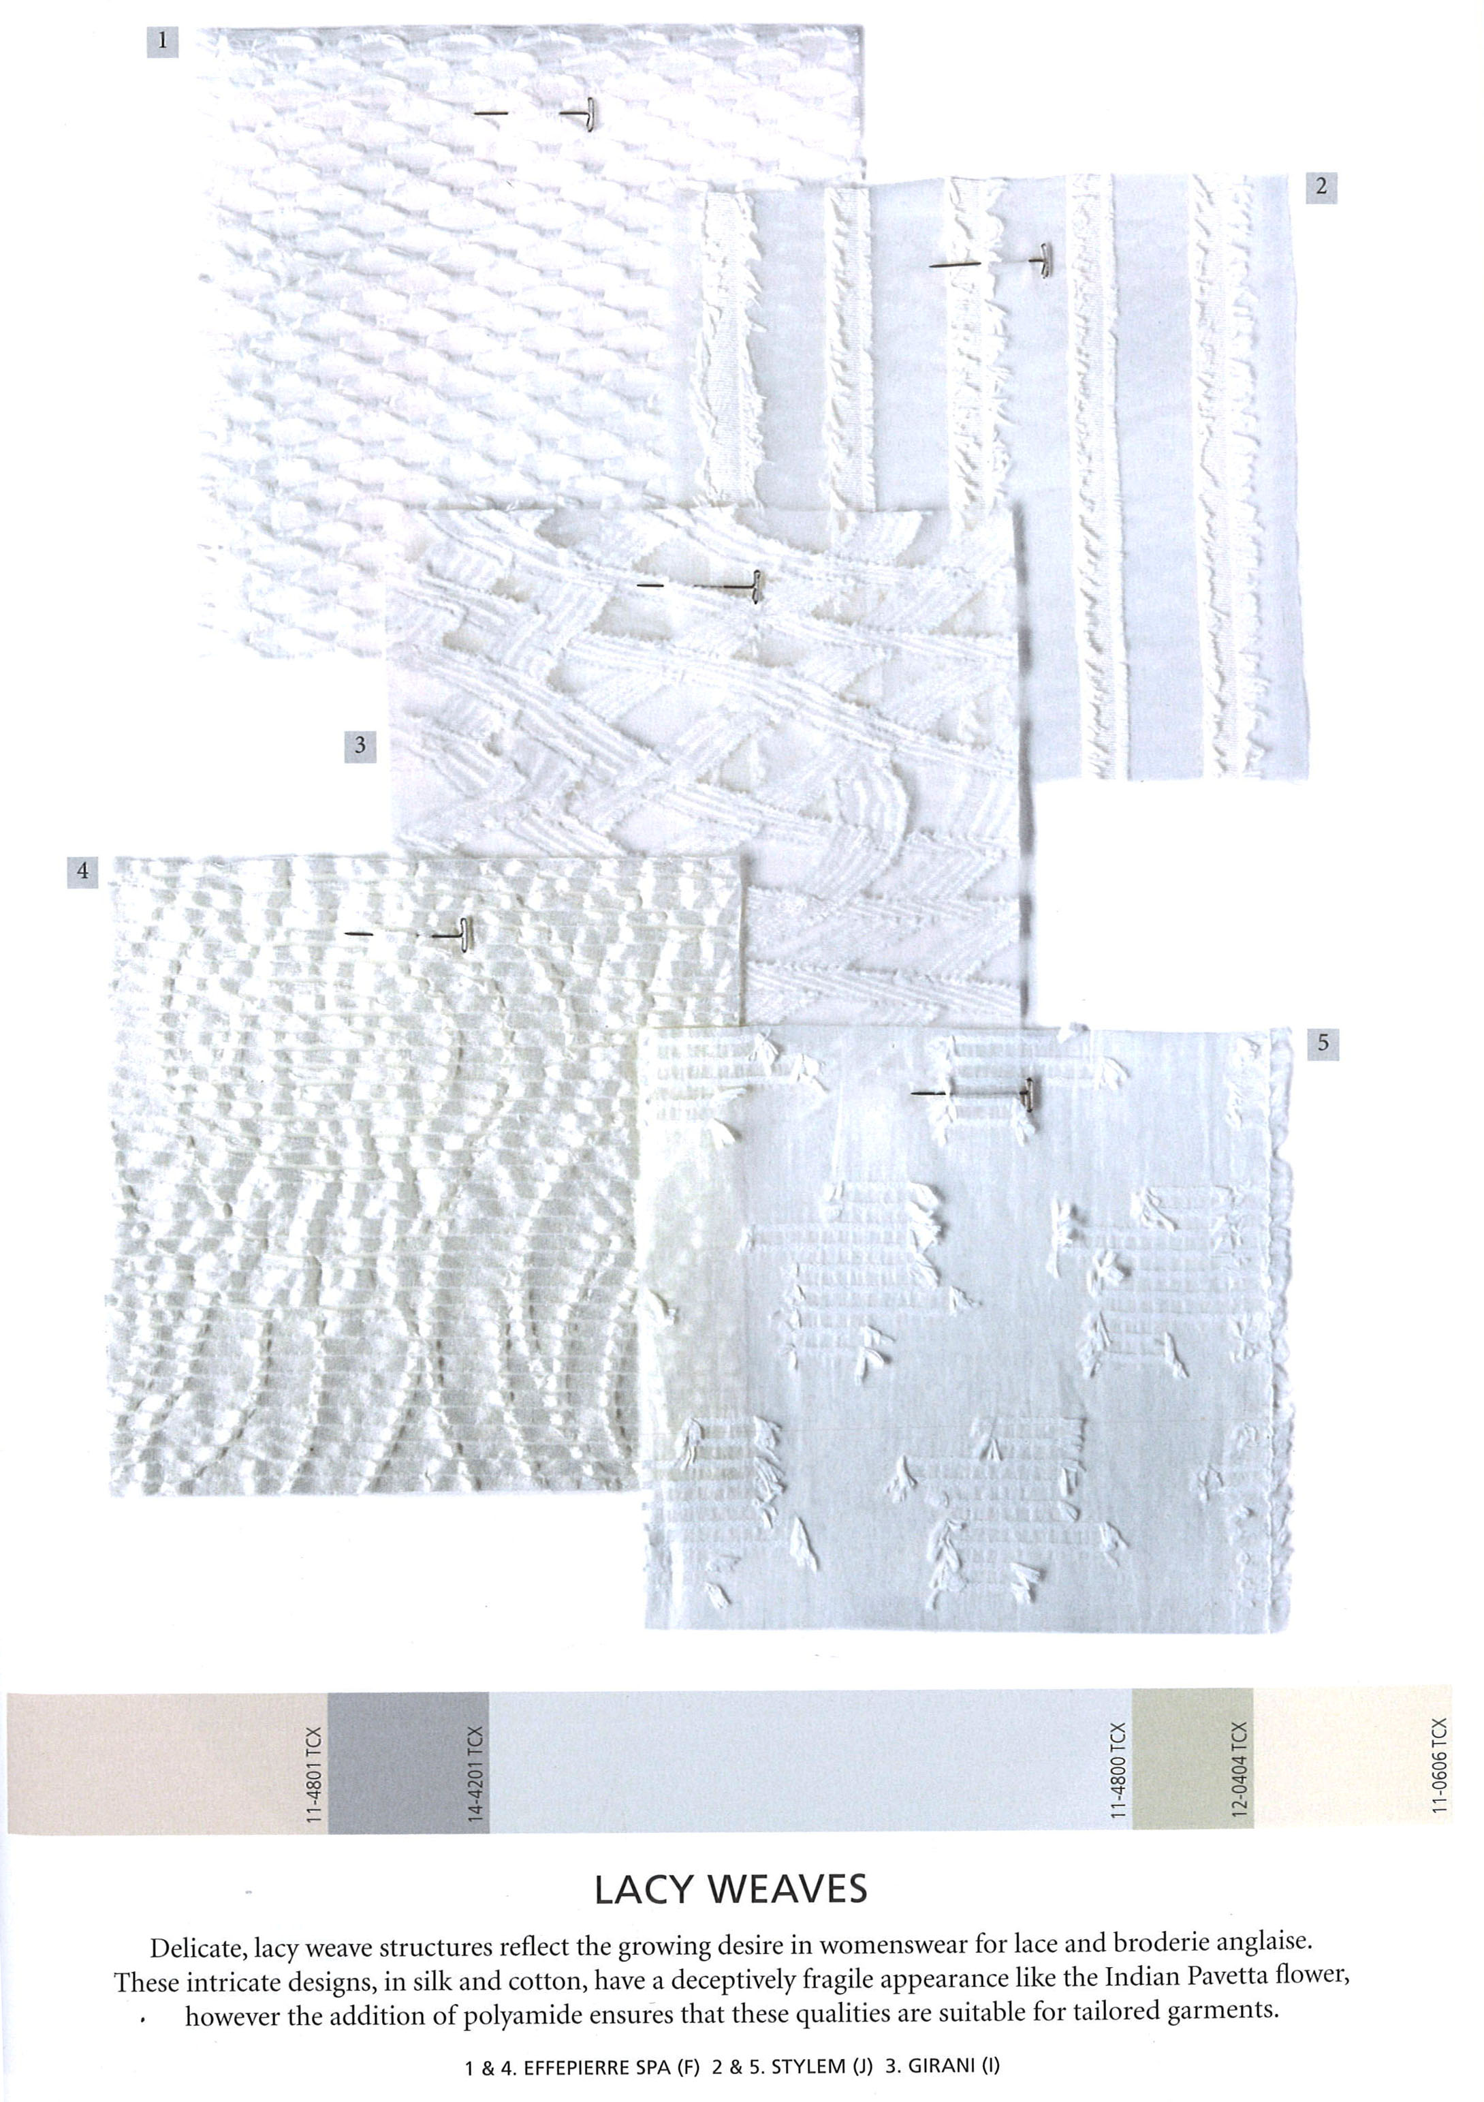
Image 4
Image 3

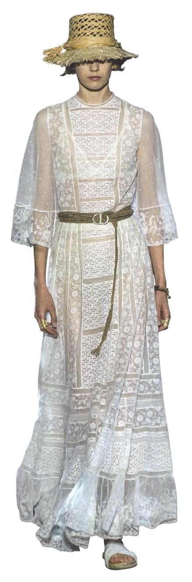
Image 7
Image 6
Image 5
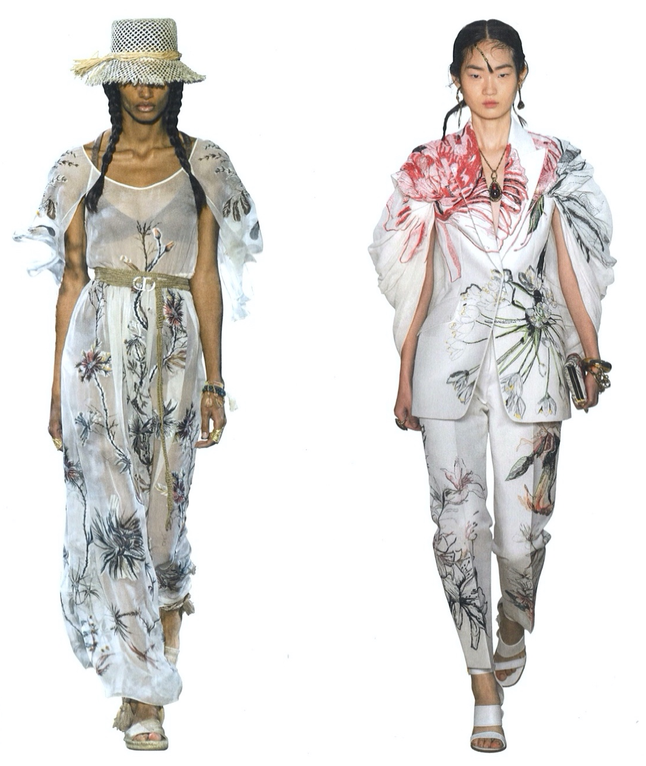
The transparency in these fabrics allow for movement of the print, when the model walks the fabric will float and overlap creating new and interesting compositions. The choice of fabric is almost as important and the imagery that is applied, I am planning to use natural materials that drape across the body to give a luxury allure. Sheers have a great ability to move with the body, they drape and float as if they were weightless. However, you can see straight through, so if it was to be worn on bare skin, adding elements such as embroidery is almost like the print is situated directly on the body. Adding layers of sheer fabric results in the final piece become more opaque, however as they move within the light, elements of colour from each layer would peek through and begin to show. I hope to experiment more with this technique with translucent fabrics in my creative venture.

Conclusion

My aim going forward into my creative venture is to create a textiles collection that can help reduce stress through the use of colour and florals. However, without knowing how each person will react to each colour it is unlikely that I will be able to achieve this result for everyone. I will begin by carrying out my own colour experiments and testing how different tones and hues of colour affect my emotions, so that I can ensure the research I have taken out correlates with my own concepts of colour. My main goal for this creative venture is to find happiness within my practice and to hopefully create a space for myself where I can feel well and comfortable. I always put other people’s emotions before my own and it is time that I focused on my own well-being as that is vital for my own health. Through making personal connections in this collection it will support the growth of my unique handwriting, I also hope it may also help anyone who might interact with my work. It is not my aim to make everyone feel relaxed as that would be nearly impossible, but if I can make one person look at my work and get one small moment of joy then I have been successful, because having a positive impact on someone’s life is worth so much to me.

I will be using information from the experiments within this report and the future experiments I carry out to help focus my colour usage, as well as experimenting with a variety of fabrics holding varying opacities. My collection will consist of textile samples to be worn on the body, we tend to hide our emotions on the inside as we may be too afraid to express them to others around us. However, my collection goes about protruding those feelings and wearing them proudly on our bodies. Using the saying ‘wearing my heart on my sleeve’ in a literal sense. I will do this by observing which emotions relate to which colours and natural plants the most. Taking into consideration all the research I have gathered about the effect of nature on ourselves as humans and combine that with how various colour and hue combinations can physically and physiologically affect our health.

Bibliography:

Image 1: Putnam, D. and Putnam, M. (2018). Flower Colour Guide. London: Phaidon Press Limited.

Image 2: Murphy, A. (2018). Lavender. [image].

Image 3-7: Shah, D. (2019). Textile View, (128).

Crawford, M. (2010). The case for working with your hands, or, Why office work is bad for us and fixing things feels good. London: Penguin.

Csikszentmihalyi, M. (2013). Creativity: the psychology of discovery and invention. New York, NY: Harper Perennial Modern Classics.

Dael, N., Perseguers, M., Marchand, C., Antonietti, J. and Mohr, C. (2016). Put on that colour, it fits your emotion: Colour appropriateness as a function of expressed emotion. Quarterly Journal of Experimental Psychology, 69(8). Available at: https://journals-sagepub-com.ezproxy.uwtsd.ac.uk/doi/10.1080/17470218.2015.1090462#articleCitationDownloadContainer [Accessed on 15th November 2019]

Davis, S., Kauneckis, D., Kruse, N., Miller, K., Zimmer, M. and Dabelko, G. (2016). Closing the loop: integrative systems management of waste in food, energy, and water systems. Journal of Environmental Studies and Sciences, [online] 6(1), pp.11-24. Available at: https://link.springer.com/article/10.1007/s13412-016-0370-0#citeas [Accessed 19th November 2019].

Esn-network.com. (2009). Flowers make you feel good. [online] Available at: https://www.esn-network.com/new-sensory-finding/product-quality/flowers/ [Accessed 14 Nov. 2019].

Exeter.ac.uk. (2014). Why plants in the office make us more productive. [online] Available at: https://www.exeter.ac.uk/news/featurednews/title_409094_en.html [Accessed 14 Nov. 2019].

Huttunen, M. (2018). Beneath the Surface of Colours. Books on Demand. Available at: https://books.google.co.uk/books?id=OXuADwAAQBAJ&pg=PA199&dq=Huttunen,+M.+(2018).+Beneath+the+Surface+of+Colours.+Books+on+Demand.&hl=en&sa=X&ved=0ahUKEwis3rDU9_TmAhWCi1wKHQxYAJIQ6AEIKDAA#v=onepage&q=Huttunen%2C%20M.%20(2018).%20Beneath%20the%20Surface%20of%20Colours.%20Books%20on%20Demand.&f=false [Accessed on 3rd January]

Kaya, N. and Epps, H. H. (2004) ‘Relationship between Color and Emotion: A Study of College Students’, College Student Journal, 38(3), pp. 396–405. Available at: https://search-ebscohost-com.ezproxy.uwtsd.ac.uk/login.aspx?direct=true&db=s3h&AN=14669489&site=ehost-live (Accessed: 15 November 2019).
McGee, B. and Marshall-Baker, A. (2015) ‘Loving Nature From the Inside Out: A Biophilia Matrix Identification Strategy for Designers’, HERD: Health Environments Research & Design Journal, 8(4), pp. 115–130. doi: 10.1177/1937586715578644.
Available at: https://journals-sagepub-com.ezproxy.uwtsd.ac.uk/doi/full/10.1177/1937586715578644#articleCitationDownloadContainer [Accesses on 19th November 2019]

Park, S. and Mattson, R. (2008). Effects of Flowering and Foliage Plants in Hospital Rooms on Patients Recovering from Abdominal Surgery. Available from: https://journals.ashs.org/horttech/view/journals/horttech/18/4/article-p563.xml [Accessed on 14th November 2019]

Productivity-Boosting Blooms for Your Workplace. (2018). [Blog] Her Flowers. Available at: https://www.herflowers.sg/blog/productivity-boosting-blooms-for-your-workplace/ [Accessed 14 Nov. 2019].

Putnam, D. and Putnam, M. (2018). Flower Colour Guide. London: Phaidon Press Limited.

Sennett, R. (2009). The Craftsman. London: Penguin Books.

Shah, D. (2019). Textile View, (128).

