Digital Disruption in the Postal Services Industry

Royal Mail Group – June 2021
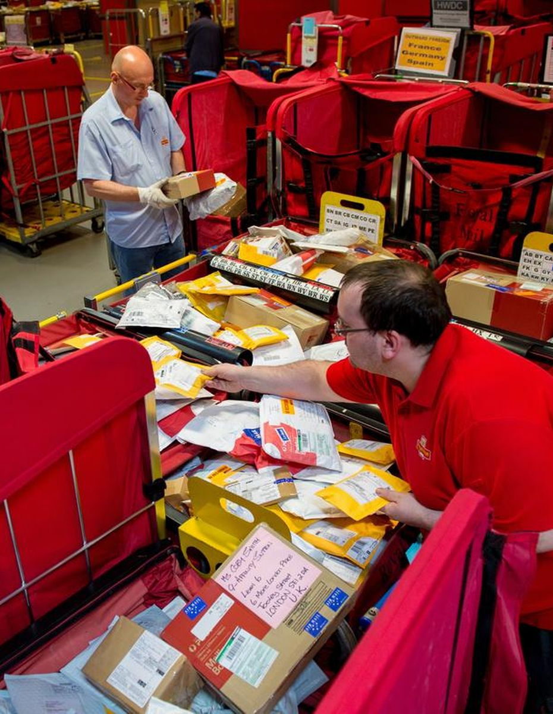

Adam Fetherstonhaugh
Digital Entrepreneurship - BMMB7002D
Word Count: 1543
Contents

Executive Summary 3
Introduction 3
Digital Disruption 4
Internal Environment Analysis 6
Porters Value Chain 6
SWOT Analysis 9
Strengths 10
Weaknesses 11
Conclusion 12
Recommendations 13
References 14

Executive Summary

Royal Mail Group is a multinational corporation operating with 3 strategic business until across the UK, Europe, and North America. The postal service market worldwide is undergoing substantial change at a rapid pace due to digital disruption as communication, business, and commerce change. With the growth of the digital economy Royal Mail must modernise and adapt to service growing sectors and consumer demand. The accompanying presentation has analysed the external environment and industry. This report will look at the internal structure of Royal Mail UK using Porter’s Value chain before looking at the Strengths and Weakness components of the SWOT analysis. This will support the opportunities and threats identified in the presentation and show how competitive advantage for Royal Mail can be attained utilising differentiation strategy.

Introduction

Royal Mail Group Plc. is a UK multinational corporation that was originally founded in 1516, before being expanded to consolidate the various postal providers in England, Scotland, Wales and eventually Ireland into a single publicly owned venture (Campbell-Smith, 2012). The group consists of Royal Mail (Letters and Packets), Parcelforce Worldwide (Courier) and Global Logistics Systems (GLS).
As was explained in the accompanying presentation, Royal Mail and Parcelforce operate within the UK, with GLS operating on a multinational platform across the European Union and North America. Due to the broad operating base of GLS requiring an extremely in-depth reporting, this scope of this report will only include the UK operations. References to Royal Mail from this point on refer to Royal Mail and Parcelforce unless otherwise individually stated.
Royal Mail in 2020-21 delivered approximately 14.6 billion items of mail to over 31 million addresses throughout the UK (Royal Mail Group, 2021).

Digital Disruption

Digital disruption has been impacting and changing businesses at an increasing rate, with new technologies changing and unseating established industry leaders. The postal industry was one of the first to be impacted, beginning with email and continuing through the social media evolution (Moeller, Hodson and Sangin, 2017). As the market leading postal and courier company in the UK (Figure 1), Royal Mail needs to be aware of developing tends and to be prepared to move and thrive (Bradley and O’Toole, 2016). While disruption to traditional letter delivery has been ongoing, it has been at a lower rate than other industries however has been accelerating and currently stands at 16% YoY (2020-21) compared with 8% YoY (2019-20) (Royal Mail Group, 2020, 2021). Operating with different product types across the range, Royal Mail is subject to a variety of different disruptions at the same time (Skog, Wimelius and Sandberg, 2018).

Figure 1.
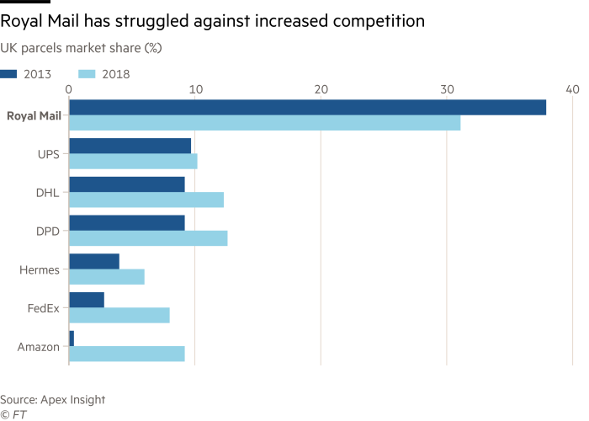
(Pooler, 2020)
As demonstrated in the presentation on the external environment digital disruption within the industry has placed pressure on Royal Mail. New entries into the industry utilising and capitalising on new technologies and shifting customer expectations further threaten the company’s existing services and require adaption if Royal Mail is to retain its position (Matzler et al., 2018). Throughout Royal Mail’s 500-year history, there have been multiple disruptions and changes that have had to be met; however, companies already fighting new competition and industry changes are more vulnerable to the additional pace and change of technology developments presenting further challenges to established incumbent businesses (Herzog, Puthiyamadam and Naujok, 2017).

Internal Environment Analysis

In order to see how Royal Mail is positioned and moving to combat digital disruption and move to benefit from it; we need to analyse the internal company environment and its current strength and weaknesses.

Porters Value Chain

At the core of any for-profit business is the ability generate value, and how the organisation does this forms its competitive advantage. Porter, (1985) introduced the value chain to analyse how a company changes its inputs to the outputs purchased by customers, and the supporting activities that support this (Figure 2).
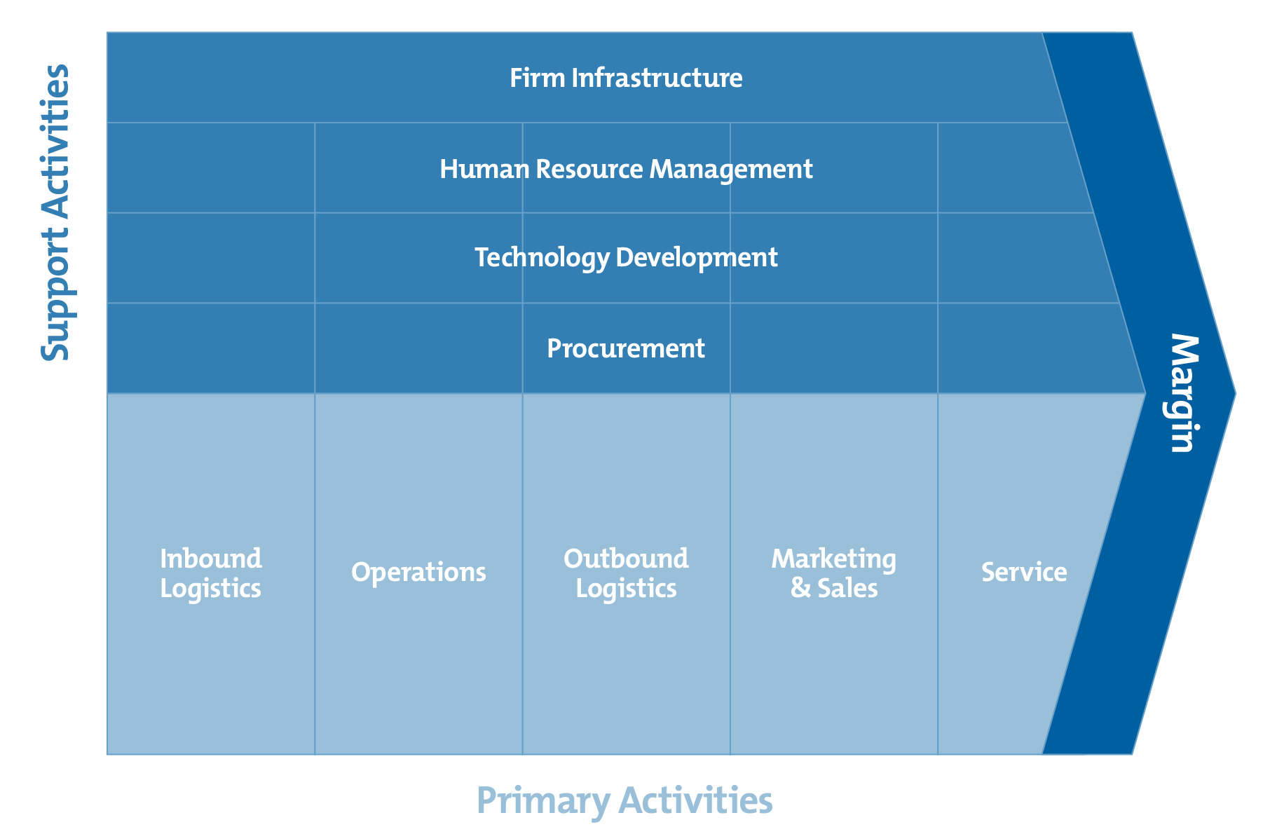
Figure 2.
(Mind Tools, no date)
The primary activities in the chain are those that directly concerned with the production/provision of the services provided.

Inbound Logistics | - Incoming Flow of Parcels and Mail  - Royal Mail Post Boxes  - Post Office Branches  - Business Collections  - 3rd Part Mail Shops (e.g. Mailbox Etc)  - Competitor USO Input Mail  - Depot and Sorting Office Counter Service  - Digital Postage Options (Pre-Paid and Dropped off/Collected)
Operations | - Divided operations – Royal Mail (Letters/Parcels) and Parcelforce  - Parcel and Mail delivery works on hub and spoke systems of hubs and delivery offices  - Royal Mail Logistics operates one of the largest bulk logistics services in the UK  - Partnerships with DHL and Fedex to carry airmail/express worldwide/24hr delivery parcels  - Central processing hubs throughout the UK  - HMRC default customs processor for international mail  - Postcode system to easily identify over 30 million addresses for sorting
Outbound Logistics | - International mail departure through 2 airports  - Ground network for road transport to Europe  - Over 1450 delivery offices across the UK for last mile sort and delivery  - User selectable delivery options  - Optimised delivery schedules based on customer and route information, and customer needs
Marketing & Sales | - Royal Mail is a highly regarded brand with a strong reputation  - High visibility of the community postman/woman  - The Royal Mail logo, branding and commercial colouring is well known, highly distinctive and holds a Royal Charter  - Professional drivers and well-trained personal communication/relations  - Multi-channel entry points for service purchase  - Pricing offers for business customers  - Annual event (e.g. holiday and university moving) promotion offers  - Collectable and limited-edition stamps  - Enterprise Resource Planning (ERP) system to integrate into customer’s business systems to provide advance information and identify trends and needs
Service | - Wide range of products to suit customer needs  - Internal sub-brands to distinguish ‘premium’ courier services  - Partnerships with worldwide national postal operators  - Commercial Partnerships with premium international parcel carriers  - SME e-commerce targeting and dedicated accounts management  - Supply chain provision for big businesses  - Only ‘human’ phone support in UK industry  - Online parcel updates, options and information systems updated in real time.

The supporting activities run alongside the primary activities in creating competitive advantage.
Technology | - Increasing use throughout the group  - CRM management and billing  - Purchase portals – business and retail  - Real-time delivery tracking  - In-flight delivery options  - Route optimisation and planning  - Customer support systems  - End-to-end mail tracking ability  - Selectable automatic alerts and updates
Infrastructure | - Well established company structure  - Separate strategic business units to ensure adaptability under common goals  - Siloed company structure  - Established support operations, IT, HRM, Legal, Marketing, Financial  - In-house support companies – ROMAC (Facilities management), Logistics (Bulk transportation) and Fleet (Vehicle maintenance)  - Automated sorting and handling systems
Human Resource Management | - Over 133,000 direct employees  - High employee engagement scores  - Industrial relations management team  - Union interaction at all levels  - Graduate and skilled worker programs  - Industry leading compensation and benefit packages  - Privatisation brought employee ownership/input through Share Incentive Package  - Established training and upskilling courses  - Detailed costing and budgeting systems
Procurement | - Long term relationships with suppliers  - High buying power for new contracts  - Properties held long term and owned outright  - Centralised procurement to ensure best pricing across the group  - Internal maintenance of fleet to reduce costs  - Bulk vehicle purchasing (>30,000 strong fleet)
(Royal Mail Group, 2018, 2019a, 2019b, 2021; Accenture, 2020; Bellis, 2020; OFCOM, 2020; Harper, 2021; Moran, 2021)

SWOT Analysis

The Value chain analysis has mapped the structure and process within Royal Mail that are used in its normal operation, based on this we need to look at the strengths and weaknesses of the company in light of digital disruption to these. Within the external analysis presentation, the opportunities and threats of a SWOT analysis have already been discussed.

Strengths

- Strong presence in B2B and B2C sectors – B2C Growing YoY
- Market share growth growing in new international markets
- Royal Mail handles 99% of letter mail – even through this is a declining market
- Largest drop-off/collection point network in the UK – 11,000 locations
- Large selection of differentiated products to suit individual customer needs
- Multiple IT infrastructure and modernisation projects completed over the past 4 years. Including all new PDA hardware and software systems
- Full End to End tracking with customer visibility
- Ability for customers (sender and receiver) to choose a range of delivery options e.g. Safe place, neighbour, alternative day
- Real-time live parcel tracking – full visibility of driver location
- ‘In-flight’ delivery alterations – customers can change preferences while item is on delivery if circumstances change
- Big Data and AI being used to optimise workflow and identify problem areas
- Strong customer service provision
  - Integrated system so any person on any customer service team can see previous enquires, investigations and answers given to customers
  - Multi-channel communication options, expanding into social media platforms
- Nationally ‘treasured’ service and staff presence
.

Weaknesses

- Outdated legacy technology systems – Billing system is over 30 years old
- Slow technology adoption and optimisation – Union objections to efficiency processes that may cost jobs
- Scale and breadth of company
- Parcel sorting process in Royal Mail (Letters and parcels) needs modernisation and automation
- Parcel tracking only available on certain services – lower cost options do not have this advantage
- Company is not innovating in digital services
- Organisational silos create difficulties
- Historic reliance on letters – decline has been accelerating faster than projected
- Historic infrastructure and working methods designed for letter priority
(Royal Mail Group, 2018, 2019a; Schaar et al., 2020; Royal Mail Group, 2021; Schwed, 2021)

SWOT analysis does have limitations, as with Royal Mail’s case, there are weaknesses and strengths that closely align with each other and appear to be contradictory. It is essential to view Royal Mail Group from its current position – an incumbent company that has identified a need to pivot and adapt to industry and market change. In a company the size and breadth of Royal Mail, change takes time, meaning that as new technologies resulting from digital disruption come online; others remain a company weakness (Helms and Nixon, 2010; Furr and Shipilov, 2019).

Companies may pursue two fundamental strategies to attain competitive advantage, the results of Porters Value chain analysis suggest that Royal Mail’s internal structure and processes are best placed to compete on differentiation – supported by the industry analysis in the accompanying presentation (Porter, 1985; Ormanidhi and Stringa, 2008).
New start-up entrants into the market have focused on providing lower cost products, often with inferior quality provision. Royal Mail has historically prided itself and is frequently congratulated on the personal, and high level of customer service that its staff and service is able to provide (Apex Insight, 2020; Bellis, 2020; Schwed, 2021). This, along with the embracing of new technology positions the company in the ideal place to respond to digital disruption and market changes by focusing on high quality services and high levels of customer service to maintain a market leading position with a higher price point (Wood and Walker, 1994; Gibbons, 2018; Amar et al., 2020).

Conclusion

Royal Mail Group is changing investing in changing its focus and operations to respond to ongoing digital disruption which has been accelerating in pace. This report needs to be considered along with the accompanying presentation, in order to gain a full picture of both the internal environment of Royal Mail Group, and trends in the industry and environment it operates in.
Over years of digital disruption that began with the mass uptake of email, Royal Mail has been competing against increased competition and declining traditional business. Yet as digital disruption has accelerated into wider markets causing a rise in e-commerce, it has presented the opportunity for growth and for Royal Mail to itself become a disruptor within the parcel delivery industry.
The use of the very technologies such as social media communication that have been disrupting the company’s marketplace, have the scope to transform the operations of the company to create competitive advantage over its competition. In order to do so, Royal Mail needs to remain outward looking, let go of past markets, innovate in products, services and add-ons while leveraging its strong market leading position.

Recommendations

- Continuing development and integration of Digital Customer service options including social media use.
- Utilise ‘big data’ analysis in real time:
  - To predict customer service issues and pre-emptively communicate issues with customers.
  - Drive efficiency improvements in resource management – Royal Mail’s higher cost base than competition means any improvement here is beneficial.
- Further integrate delivery options and live updates – inflight chances advised to drivers in real time to prevent wasted delivery attempts etc.
- Work with digital media marketing companies to fulfil targeted mixed media promotions.
- Capitalise on growing e-commerce trends – e.g. business returns are increasing, post boxes need adapted to handle parcels.

References

Accenture (2020) Reiventing the Last Mile: Win the race to the top. Accenture, p. 16. Available at: https://www.accenture.com/_acnmedia/PDF-116/Accenture-Postal-Research-Story-POV.pdf#zoom=50 (Accessed: 10 June 2021).
Amar, J. et al. (2020) The vision for 2025: Hyperpersonalized care and ‘care of one’. McKinsey & Company, p. 32. Available at: https://www.mckinsey.com/business-functions/operations/our-insights/the-vision-for-2025-hyperpersonalized-care-and-care-of-one (Accessed: 16 December 2020).
Apex Insight (2020) Global Parcel Delivery Market Insight Report 2020. Apex Insights, p. 143. Available at: //apex-insight.com/product/global-parcel-delivery-market/ (Accessed: 16 December 2020).
Bellis, R. (2020) Postman thanked for over 40 years of service with The Royal Mail, The Northern Echo. Available at: https://www.thenorthernecho.co.uk/news/18870765.postman-thanked-hard-work-delivering-rural-villages/ (Accessed: 20 June 2021).
Bradley, C. and O’Toole, C. (2016) ‘An incumbent’s guide to digital disruption’, McKinsey Quarterly, 18 May. Available at: https://www.mckinsey.com/business-functions/strategy-and-corporate-finance/our-insights/an-incumbents-guide-to-digital-disruption (Accessed: 19 June 2021).
Campbell-Smith, D. (2012) Masters of the Post: The Authorized History of the Royal Mail.
Furr, N. and Shipilov, A. (2019) ‘Digital Doesn’t Have to Be Disruptive’, Harvard Business Review, 97(4), pp. 94–103.
Gibbons, S. (2018) ‘How To Develop A Competitive Edge In Customer Service’, Forbes, 23 October. Available at: https://www.forbes.com/sites/serenitygibbons/2018/10/23/how-to-develop-a-competitive-edge-in-customer-service/ (Accessed: 16 December 2020).
Harper, C. (2021) ‘Royal Mail to offer customers chance to set delivery times’, BirminghamLive, 9 June. Available at: https://www.birminghammail.co.uk/news/midlands-news/royal-mail-offer-customers-chance-20774646 (Accessed: 20 June 2021).
Helms, M. M. and Nixon, J. (2010) ‘Exploring SWOT analysis - where are we now?: A review of academic research from the last decade’, Journal of Strategy and Management, 3(3), pp. 215–251. doi: http://dx.doi.org.ezproxy.uwtsd.ac.uk/10.1108/17554251011064837.
Herzog, M., Puthiyamadam, T. and Naujok, N. (2017) ‘10 Principles for Winning the Game of Digital Disruption’, strategy+business, 30 November. Available at: https://www.strategy-business.com/article/10-Principles-for-Winning-the-Game-of-Digital-Disruption (Accessed: 19 June 2021).
Matzler, K. et al. (2018) ‘The crusade of digital disruption’, The Journal of Business Strategy, 39(6), pp. 13–20. doi: http://dx.doi.org.ezproxy.uwtsd.ac.uk/10.1108/JBS-12-2017-0187.
Mind Tools (no date) Porter’s Value Chain: Understanding How Value is Created Within Organizations, MindTools. Available at: http://www.mindtools.com/pages/article/newSTR_66.htm (Accessed: 19 June 2021).
Moeller, L. H., Hodson, N. and Sangin, M. (2017) ‘The Coming Wave of Digital Disruption’, strategy+business, 20 November. Available at: https://www.strategy-business.com/article/The-Coming-Wave-of-Digital-Disruption (Accessed: 18 June 2021).
Moran, G. (2021) ‘Unrivalled reliability and convenience with Royal Mail’, Drapers, 2 June. Available at: https://www.drapersonline.com/insight/the-industry-view/unrivalled-reliability-and-convenience-with-royal-mail (Accessed: 20 June 2021).
OFCOM (2020) Annual Monitoring Update on Postal Services: Financial Year 2019-2020. Office for Communications, p. 81. Available at: https://www.ofcom.org.uk/__data/assets/pdf_file/0022/208219/2019-20-annual-monitoring-update-postal-market.pdf.
Ormanidhi, O. and Stringa, O. (2008) ‘Porter’s Model of Generic Competitive Strategies’, Business Economics, 43(3), pp. 55–64.
Pooler, M. (2020) ‘Royal Mail pushed to its limits to deliver through coronavirus’, Financial Times, 28 June. Available at: https://www.ft.com/content/7289be77-dac7-48a9-9bd6-8dcd6c618398 (Accessed: 19 June 2021).
Porter, M. E. (1985) Competitive advantage: creating and sustaining superior performance. New York: Free Press : Collier Macmillan.
Royal Mail Group (2018) Annual Report and Financial Statements 2017-18. Annual Report. Royal Mail Group, p. 167.
Royal Mail Group (2019a) Annual Report and Financial Statements 2018-19. Annual Report. Royal Mail Group, p. 236. Available at: https://www.royalmailgroup.com/media/10924/royal_mail_ar19_190918.pdf (Accessed: 20 June 2021).
Royal Mail Group (2019b) Journey 2024. Growing, Efficient, Diversified. Presentation. Available at: https://www.royalmailgroup.com/media/10705/fy-2018-19-results-and-strategy-presentation.pdf (Accessed: 1 December 2020).
Royal Mail Group (2020) Annual Report and Accounts 2019-20, p. 256. Available at: https://www.royalmailgroup.com/media/11212/royal-mail-plc-annual-report-and-accounts-2019-20.pdf (Accessed: 5 December 2020).
Royal Mail Group (2021) Annual Report and Financial Statements 2020-21 - Connecting Customers, Companies and Countries. Royal Mail Group, p. 224. Available at: https://www.royalmailgroup.com/media/11465/rmg_ar2020-21.pdf (Accessed: 19 June 2021).
Schaar, D. et al. (2020) ‘Why Parcel Companies Need to Make Every Delivery Special’, BCG Global, 20 July. Available at: https://www.bcg.com/publications/2020/why-parcel-companies-need-to-make-every-delivery-special (Accessed: 16 December 2020).
Schwed, J. (2021) ‘A Royal Thank You for Royal Mail’, AssetWorks, 26 February. Available at: https://www.assetworks.com/fleet-uk-royal-thank-you-royal-mail/ (Accessed: 20 June 2021).
Skog, D. A., Wimelius, H. and Sandberg, J. (2018) ‘Digital Disruption’, Business & information systems engineering, 60(5), pp. 431–437. doi: 10.1007/s12599-018-0550-4.
Wood, C. and Walker, P. (1994) ‘Putting the Customer First: Royal Mail’s Strategy for Service Excellence’, The TQM Magazine, 6(2), pp. 17–24. doi: 10.1108/09544789410053975.

