Indie Game Development
  - Lecture 5b Lab Tutorial Exercise

Game 2

Objectives
In this exercise, you will create a game world for a third person character scene.

Getting Started
- Create a new 3D project. I leave the name up to you
- Import the Robots vs Aliens Terrain package available on Moodle into your project. I will see if I can find a better game world later.

Creating the Game World
Please feel free to create your own game world.
- From the Resources Prefabs folder, drag the Terrain prefab to the scene.
- Also drag the Level Prefab to the scene
- Right-click in the Assets window and select Import Package Environment and select the options shown below.
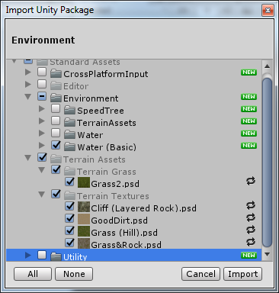
- Go to the Standard Assets Environment Water (Basic) Prefabs folder and drag the Water Basic Daytime prefab to the scene and position and scale as follows:
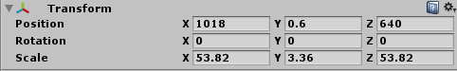

Adding a Third Person Character
As before, you will initially make use of the Standard character provided by the Asset Store, but will later extend the functionality.
- Right-click in the Asset window and select Import Package Characters.
  - In the window that opens, deselect the RollerBall and FirstPerson character as you do not need this.
  - See screenshot below.
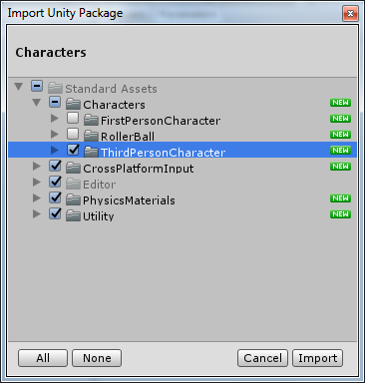
- Start by dragging a third person character prefab to the hierarchy window.
  - Rename the game object to Player or whatever you like
  - Position and rotate the player as follows:
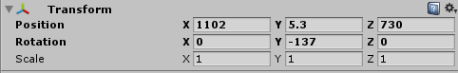

- Select the Main Camera from the hierarchy window
  - Position and rotate as follows:
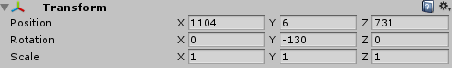
  - Attach the Smooth Follow script to it and set the target to follow to the Player character in your scene.
- You should be able to test your scene. You may want to reduce the distance at which the Camera follows the player on the Smooth Follow script.

Changing the TPC Game Object
In this exercise, you will change the standard assets TPC game object Ethan to something else.
- Go to Moodle and download and import the Battle Droids package into your game.
- Once it is done importing
  - Expand the BattleDroids Models folder
  - Locate a Droid of your choice
- Go back to your scene and expand the Third Person Player character and delete all its child objects (Ethan )
Note: Do not delete the root TPC Player game object.
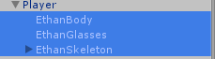
- Now, drag your chosen Droid model and make it a child of the Third Person Player character to replace Ethan
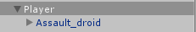
- Select the Third Person Player game object from the hierarchy window and in the Inspector window:
  - Locate the Animator component
  - Set the Avatar to your chosen Droid’s Avatar – see example below.
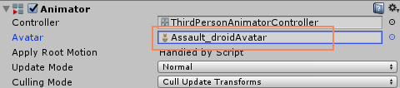
- Save your changes and test.
- Hmmm, you probably notice that the player character has a funny gait.
- You need to replace Ethan’s animations with the Droid’s animations. In a later lecture, you will learn how to create an animator controller with the different motion states and how to control them using scripting.

Environment models imported from Mastering Unity 5.x Packt (2017) By Alan Thorn. Publisher Websites

