Name: MD SOHEL KHAN
Business Plan for: Babaji Restaurant

Word Count: 2057
Lecturer: | Ben Chong
Date: | 04-Mar-2024
Team members: | MD SOHEL KHAN (2211256)  Shahd Ali Hammad Omer (2130010)  Vasile Alexandru Vasile (2207749)
Business plan contents

Executive summary 4
1 Executive summary 4
2 Business details 5
3 Key personnel 6
Vision 8
4 The business idea 8
5 Business goals 9
6 What the business does 9
7 What makes the business different (Value Proposition) 10
8 Legal requirements (including regulations and licences particular to your business) 11
Marketing 12
9 Market research 12
10 Profiling customers 12
11 Profiling competitors 13
12 Managing market risks 15
13 Pricing 15
14 Promotion and advertising 16
Running the business 18
15 Staff 18
16 Premises 18
17 Suppliers 19
18 Equipment 19
19 Managing operational risks 20
Finance 21
20 Start-up costs 21
21 Profit and loss forecast 22
22 Sourcing finance 23
23 Managing financial risks (such as, sales are less than forecasted or start-up finance takes three months longer to obtain) 23
24 Cash flow forecast 25
26 Reference list 28
Appendix: 31

Executive summary

1 Executive summary
Babaji restaurant is a new business idea. The startup aims to provide authentic Indian cuisine in the UK. There are many competitors of the restaurant who offer similar items. They also offer Indian cuisine. But Babaji Restaurant is different from them. It will ensure that the Indian cuisine remains authentic using the traditional processes for their preparations. The business idea can be explained using the business model canvas framework. Babaji restaurant has employed different roles for the key personnel such as the management. The business wants to create a strong position in the target market within a year. In the long term, the business will become a leading authentic Indian cuisine restaurant in the UK. The business requires taking necessary permits and licenses to start its operations. It is very difficult to offer the right products in the market. Babaji's market research has helped the business to identify the customer needs and preferences. Using the website and the digital marketing, it will promote its value propositions. It may encounter supply chain disruption and high employee turnover challenges while performing the business activities. By taking proper approaches, those challenges can be overcome. The business requires £115,000 for startup and it will generate £78,000 in net profit at the end of the first year. The fluctuations in the forecast are the financial risk for the business.

2 Business details
Company name:
Babaji Restaurant
Address:
Sunderland City Centre, the UK
Primary contact method
Website: www.babajirestaurant.com
Email: info@babaji.restaurant
The business will: (Provide a brief description of what your business will do)
Babaji Restaurant will be a culinary hub that specialises in the preparation of authentic Indian cuisine. The primary location to serve the people who have an interest in authentic Indian cuisine is the Sunderland city centre. The menu offered by the restaurant will be diverse with traditional dishes. These dishes are meticulously prepared with high-quality ingredients. Hence, Indian flavour and traditional essence will be preserved. The guests will be welcomed with Indian hospitality and culture. They will receive exceptional experience and memorable dining in Babaji Restaurant. They will feel the rich cultural heritage of Indian cuisine. The business will also offer catering services to various events and festivals where authentic Indian cuisine is demanded.

3 Key personnel
Details of owner(s): Name: MD SOHEL KHAN
Position/main responsibilities: Operation Manager
Experience and knowledge of our industry: OWNER BABAJI SUNDERLAND LTD
Previous employment: OWNER BAR DA SOLE SRLS
Key skills brought to the business: Culinary expertise, menu development, kitchen management
Business experience and any training undertaken: Certified in food safety and hygiene, attended management training workshops.
Academic/professional qualifications: BA (Hons) DIPLOMA IN HOTEL MANAGEMENT.
Salary expectations £ £40,000 per annum
Name: Shahd Ali Hammad Omer
Position/main responsibilities: Financial Advisor
Experience and knowledge of our industry: 3 years of experience in restaurant management, with a focus on customer service and operations, Banking Office Manager.
Previous employment: Bank of Khartoum
Key skills brought to the business: Customer relationship management, staff supervision, inventory control
Business experience and any training undertaken: Completed courses in hospitality management and leadership development.
Academic/professional qualifications: BSc Mass Communications and French language.
Salary expectations £ £35,000 per annum
Name: Vasile Alexandru Vasile
Position/main responsibilities: Marketing Manager
Experience and knowledge of our industry: Co-owner Romanian restaurant Allegria, Oldham, Greater Manchester.
Previous employment: kitchen porter at Friends Restaurant, Oldham, Greater Manchester.
Key skills brought to the business: Marketing campaigns, social media management, customer engagement
Business experience and any training undertaken: Attended workshops on digital marketing and branding
Academic/professional qualifications: BA (Hons) DIPLOMA IN HOTEL MANAGEMENT.
Salary expectations £ £38,000 per annum

Vision

4 The business idea
Sum up your business idea:
The business's vision is to become the leading restaurant that offers authentic Indian cuisine in the target market. The vision and business activities are aligned with the goals and objectives of the business (Barringer and Ireland, 2019).
The entire business idea has been explained below using the business model canvas:
Key Partnership: At first, the partnership will be created with the local vendors and suppliers to get fresh and quality ingredients at fair prices (Williams, 2021). Then, the partnership will be created with the apps such as UberEATS, Yelp, and TripAdvisor. Moreover, other local businesses can be considered for the partnership.
Key Activities: The key activities include cooking, serving, managing employees, marketing, and operating business operations.
Value Proposition: The restaurant will provide authentic Indian cuisine using high-quality ingredients and ensure exceptional dining experience (Barringer and Ireland, 2019).
Customer Relationship: The customer relationship will be managed by offering personalised services, quick response, continuous engagement, and incentives.
Customer Segments: The target customer segments of Babaji Restaurant are customers having an interest in authentic Indian cuisine, tourists and visitors, and local residents.
Key Resources: The key resources of the business are kitchen equipment and supplies, chef, staff, management team, website, and social media platforms. These are essential to get a competitive advantage (Burns, 2022).
Channels: Website, social media, and word-of-mouth are the primary channels of communication with the target customers.
Cost structure: The restaurant has different types of costs such as fixed, variable, and semi-variable costs. The various costs are utilities, rent, ingredients, supplies, employee salaries, and other operating costs.
Revenue Streams: Revenue streams should be diversified to achieve higher growth in future (Sparviero, 2019). Revenue will be generated from the sale of Indian dishes and beverages. It will also generate revenue from the catering services.

5 Business goals
- What do you want to achieve in your first year of business?
- The short-term goal of the business is to create a position in Sunderland city centre and attract enough customers to reach the break-even point.

- Where do you see your business in 3-5 years’ time?
- The long-term goal of the business is to become the destination for Indian cuisine in the UK.
- The restaurant will expand in three more strategic locations in the UK (Davidsson and Klofsten, 2003).

6 What the business does

Product/service | Features | Benefits
- Authentic Indian Cuisine | - Diverse menu of traditional Indian dishes | - Provide the unique and vibrant flavours of Indian cuisine that are prepared with high quality ingredients
- Catering Services | - Customised catering packages | - Ensure hassle-free catering services aiming to fill the market gap and meet the demand
- Delivery Services | - Convenient delivery of Indian meals | - Save time and effort
- Dining Experience | - Ambiance and warm hospitality | - Immerse guests in the vibrant atmosphere that can not be found in other restaurants in the UK

7 What makes the business different (Value Proposition)
Your product/service is unique or different compared with the competition because:
- Babaji restaurant differentiates itself from other restaurants in the target market by providing a unique customer dining experience. The dining experience is deeply rooted in the authenticity and quality of Indian cuisine. The value proposition of the restaurant covers the following aspects: authenticity, quality ingredients, warm hospitality, unique dining experience, and personalised services. The restaurant provides undiluted Indian cuisine using high-quality ingredients. It celebrates Indian hospitality with unparalleled experience (Burns, 2022).

8 Legal requirements (including regulations and licences particular to your business)
The legal and insurance requirements that apply in your business are:
Legal aspects are essential to make sure that the venture can operate smoothly and effectively (Burns, 2022). Babaji Restaurant requires the following legal aspects in its operations:
- Business License: A license for starting the business operations needs to be acquired from the local authority.
- Employment Legislation: The workplace practices and organisational policies should comply with the employment legislation such as minimum pay, diversity and inclusion (Young, 2024).
- Environmental health regulations: The disposal of waste, cleanliness, and sanitation should not violate environmental health regulations.
- Insurance Coverage: The restaurant should include all its properties within the insurance coverage such as fire insurance.
You will meet your legal and insurance requirements by:
The legal requirements will be met by taking the following steps:
- Monitoring: The business will assign a monitoring team who are responsible for monitoring the legal compliance regularly.
- Legal and Insurance Expert: To avoid legal challenges, expert guidance will be received (Sutherland, 2023).
- Documentation: All the necessary licenses, permits, and insurance policies should be documented and preserved.
- Industry Standard: Babaji will ensure that it adheres to the industry standards.

Marketing

9 Market research
Trends in your chosen market are:
- Increasing demand for Traditional Indian cuisine
- Increasing interest in exploring new dishes
- Growing demand for quality and healthy food
How you know this: (Provide examples with references)
- The market trends are identified from the research articles and news media. Statista's research findings have shown that the UK people have increased their consumption for Indian dishes over the years (Statista, 2024). The news article focused the shifts in customer preferences toward authentic and traditional Indian cuisine (Shackle, 2023).

10 Profiling customers
The customer groups you will be selling to are: (4 x Customer profiles minimum)
- Families and groups who are looking for experiencing unique dining experience.
- Health-conscious people who want quality foods
- People who have an interest in tasting authentic Indian cuisine
- Young professionals and students who are looking for the convenient and quick dining experience.
Your customer research has shown what your customers want is:
The survey research has been performed to understand the customer expectations. The research result shows that they want quality products prepared from fresh ingredients. The academic research paper findings identified that customers are satisfied when they get personalised services and exceptional customer services (Buhalis and Amaranggana, 2015). The online reviews show that they also want friendly environment and comfortable dining space (The Guardian, 2023). (What research did you undertake and what were the results?)
How you know this:
- The research findings are appropriate because 50 samples have been collected from the target market that include target customer's responses. They have confirmed all these aspects by agreeing with these requirements. (What evidence can you offer)
Number of customers you expect to win in each group and what they might pay:
Group | Number of customers | Price they might pay per unit
Families and groups who are looking for experiencing unique dining experience | 100 per week | £ 15 per person
Health-conscious people who want quality foods | 50 per week | £ 12 per person
People who have an interest in tasting authentic Indian cuisine | 75 per week | £ 10 per person
Young professionals and students who are looking for the convenient and quick dining experience | 150 per week | £

11 Profiling competitors

Competitor name | Strengths | Weaknesses
- Spice Empire | - Having good ratings  - Popular place for dining and takeaways  - Diverse Indian menu | - Lack of online delivery system  - Small place that is crowded most of the time (Spice Empire, 2024)  - Poor and limited options for vegans (Motiraj Restaurant, 2024)
- Motiraj Tandoori Restaurant | - Received various prestigious awards such as Pat Chapman's good curry guide award  - A well-established restaurant | - High price  - No online delivery
- Yuvraaj Restaurant | - Good ratings  - Innovative dishes (Yuvraj Restaurant, 2015) | - Limited sea food options  - No online delivery
- Mumbai Silk | - Competitive price  - Online delivery options | - Average rating  - No vegan options (Mumbai Silk, 2024)

How you can improve on their offer and/or price(s) unique offerings:
- Babaji restaurant will make sure that it is consistent in providing high quality products. It should differentiate itself from other restaurants by sticking to the authentic Indian cuisine (Walker, 2017). The restaurant will provide an exceptional guest experience.

12 Managing market risks
Write down the risks you have identified:
- Food safety and hygiene risk (Walker, 2017)
- Competition risk
- Regulatory risk
- Supply risk (Barringer and Ireland, 2019)

How will you manage these risks so that they become less of a threat:
- Establishing strong food safety and hygiene standards can eliminate food safety and hygiene risk
- By conducting thorough market analysis and analysing the competitors, Babaji Restaurant can address the competition risk (Walker, 2017).
- Strict compliance with the legal aspects and keeping continuous updates of the changes in legislation can minimise the regulatory risk.
- The supply chain risk can be reduced and minimised by ensuring diversified sources for suppliers (Barringer and Ireland, 2019).

13 Pricing
How you can calculate your prices:
- The prices of the products will be calculated using value-based pricing method. The method considers the perceived value of the products while determining their prices rather than the consideration of the costs.

How your prices compare with the competition:
Product/service | Your price(s) | Range of competitor prices (per unit)
Chicken Tikka Masala | £ 8.95 | £ 7.95 - £9.95
Lamb Rogan Josh | £ 9.95 | £ 8.95 - £10.95
Vegetable Biryani | £ 7.95 | £ 6.95 - £8.95
Garlic Naan | £ 2.50 | £ 2.00 - £3.00
Mango Lassi | £ 3.50 | £ 2.50 - £4.00
Goan Fish Curry | £ 10.95 | £ 9.95 - £11.95
Malabar Coastal Curry | £ 10.95 | £ 9.95 - £11.95

Reasons for the difference between your price(s) and your competitors’ price(s):
- Babaji's products have higher prices compared to the other businesses because the restaurant ensures quality products and exceptional services.

14 Promotion and advertising
How and where will you promote your product/service?
- Website: The website of the restaurant will be optimised and made user-friendly (Kuester, Konya-Baumbach and Schuhmacher, 2018). It can be used for promoting the restaurant's market offerings.
- Digital Marketing: The business will use digital channels such as social media for communicating with the target audience and keeping continuous engagement. The business will create pages in Facebook and Instagram. Through these pages, the restaurant will make promotional activities such as sharing the pictures of the authentic Indian dishes. Digital marketing is more effective in getting higher reach for customers (Kannan and Li, 2017).

Running the business

15 Staff

Role | Total cost | Necessary experience | Specialist skills and/or qualifications
- Head Chef | £ 4500 | - 5+ years in high-end restaurants | - Culinary degree, Michelin star experience
- Sous Chef | £ 3500 | - 3+ years in fine dining kitchens | - Culinary degree, knife skills, food safety certification
- Restaurant Manager | £ 3800 | - 5+ years in restaurant management | - Leadership skills, customer service expertise (Walker, 2017)
- Waitstaff (x4) | £ 2400 | - 1+ years in hospitality industry | - Food and beverage knowledge, customer service
- Kitchen Porter (x2) | £ 1800 | - Previous kitchen experience | - Physical stamina, attention to detail

16 Premises

 | Cost £
Premises required at start-up: | £ 40,000
Premises required in the future (if different): | £ 30,000

17 Suppliers
Your key suppliers and their credit terms
Supplier | What you’ll buy from them | Number of days’ credit
- Fresh Produce Ltd | - Vegetables and fruits | - 30
- Spice World Ltd | - Spices and seasonings | - 60
- Meat Master Inc | - Meat and poultry | - 45
- Dairy Delights Ltd | - Dairy products | - 30
- Baker's Paradise Ltd | - Baked goods | - 60
- Beverage Solutions Inc | - Beverages | - 45

18 Equipment
Resource | When | How funded | Cost £ per unit
Cooking Stove | Startup | Self-funded | £ 1200
Oven | Startup | Self-funded | £ 1500
Refrigerator | Startup | Self-funded | £ 800
Freezer | Startup | Self-funded | £ 900
Mixers | Startup | Self-funded | £ 300
Blenders | Startup | Self-funded | £ 150
Utensils | Startup | Self-funded | £ 200
Serving Dishes | Startup | Self-funded | £ 100
POS System | Startup | Self-funded | £ 2000

19 Managing operational risks

Risk | Solution
Staff  - High staff turnover | - Recruit highly experienced and qualified employees (Bufquin et al., 2021).  - Provide them with adequate training and development opportunities (Longart, 2019)  - Make the compensation competitive (Chen and Qi, 2022)  - Provide incentives
Suppliers  - Supply chain disruption | - Diversify the supply chain (Moosavi, Fard and Dulebenets, 2022)  - Keep continuous contacts with the suppliers

Finance
Please double click in the table below to access the embedded Microsoft Excel sheets to input your figures, Microsoft Excel will automatically update the total for you.

20 Start-up costs
Calculate how much money you need before you start trading

21 Profit and loss forecast

22 Sourcing finance

Total borrowing requirement for the business

23 Managing financial risks (such as, sales are less than forecasted or start-up finance takes three months longer to obtain)
The risks that you have identified for your financial forecast are:
- Uncertainties and fluctuations in the forecast. The income statement and cash flow statement have been prepared with forecasted data (Barringer and Ireland, 2019). The financial risk involves in the data usage. The real outcome can vary greatly from the forecasts.

How you will minimise their impact:
The impacts of the deviation in the forecasts can be mininised by making alternative options. The business can change its decisions to get the desired result. The data used in the business should be ensured that they are reliable and accurate (Burns, 2022). Moreover, the market research should be more comprehensive and accurate. It will ensure that the financial risks are minimised.

24 Cash flow forecast
(Click on the tabs within the Microsoft Excel sheet to view the second 6 months and summary)

25 Conclusion
Starting an Indian restaurant in the UK is quite a challenging task. The entrepreneur has to monitor the market trends continuously to make adjustments in the strategies. Babaji Restaurant can be a successful startup if the business gets the opportunities. The business is profitable for the investors as it offers a positive return in the first three years of the forecast. Since the market is highly competitive, Babaji Restaurant should focus on the quality and authenticity aspects to stand out from the competition and gain a competitive advantage. The business should keep consistency in its quality cuisine and services so that it can develop a strong loyal customer base.

26 Reference list
Barringer, B.R. and Ireland, R.D. (2019) Entrepreneurship : Successfully Launching New Ventures. New York, Ny: Pearson.
Bufquin, D., Park, J.-Y., Back, R.M., de Souza Meira, J.V. and Hight, S.K. (2021) Employee Work status, Mental health, Substance use, and Career Turnover intentions: an Examination of Restaurant Employees during COVID-19. International Journal of Hospitality Management, 93(1), p.102764. doi:https://doi.org/10.1016/j.ijhm.2020.102764.
Buhalis, D. and Amaranggana, A. (2015) Smart Tourism Destinations Enhancing Tourism Experience through Personalisation of Services. Information and Communication Technologies in Tourism 2015, pp.377–389. doi:https://doi.org/10.1007/978-3-319-14343-9_28.
Burns, P. (2022) Entrepreneurship and Small Business : Start-up, Growth and Maturity. 5th ed. Basingstoke (Gb): Palgrave Macmillan Education, Cop.
Chen, H. and Qi, R. (2022) Restaurant Frontline Employees’ Turnover intentions: three-way Interactions between Job stress, Fear of COVID-19, and Resilience. International Journal of Contemporary Hospitality Management, 34(7). doi:https://doi.org/10.1108/ijchm-08-2021-1016.
Davidsson, P. and Klofsten, M. (2003) The Business Platform: Developing an Instrument to Gauge and to Assist the Development of Young Firms. Journal of Small Business Management, 41(1), pp.1–26. doi:https://doi.org/10.1111/1540-627x.00064.
Kannan, P.K. and Li, H.A. (2017) Digital marketing: a framework, Review and Research Agenda. International Journal of Research in Marketing, 34(1), pp.22–45. doi:https://doi.org/10.1016/j.ijresmar.2016.11.006.
Kuester, S., Konya-Baumbach, E. and Schuhmacher, M.C. (2018) Get the Show on the road: Go-to-market Strategies for e-innovations of start-ups. Journal of Business Research, 83, pp.65–81. doi:https://doi.org/10.1016/j.jbusres.2017.09.037.
Longart, P. (2019) Understanding Hotel Maintenance Management. Journal of Quality Assurance in Hospitality & Tourism, pp.1–30. doi:https://doi.org/10.1080/1528008x.2019.1658148.
Moosavi, J., Fard, A.M.F. and Dulebenets, M.A. (2022) Supply Chain Disruption during the COVID-19 pandemic: Recognizing Potential Disruption Management Strategies. International Journal of Disaster Risk Reduction, [online] 75(102983), p.102983. doi:https://doi.org/10.1016/j.ijdrr.2022.102983.
Motiraj Restaurant (2024) Home Page : Motiraj. [online] motirajsunderland.com. Available at: https://motirajsunderland.com/restaurants/restaurant_menu_details/motiraj-restaurant [Accessed 25 Feb. 2024].
Mumbai Silk (2024) Home Page : Mumbai Silk. [online] mumbaisilk.co.uk. Available at: http://mumbaisilk.co.uk/ [Accessed 25 Feb. 2024].
Shackle, S. (2023) British Taste for Curry Has changed, but Appetite Remains Strong. [online] Al Jazeera. Available at: https://www.google.com/amp/s/www.aljazeera.com/amp/features/2019/10/7/british-taste-for-curry-has-changed-but-appetite-remains-strong [Accessed 25 Feb. 2024].
Sparviero, S. (2019) The Case for a Socially Oriented Business Model Canvas: the Social Enterprise Model Canvas. Journal of Social Entrepreneurship, 10(2), pp.1–20. doi:https://doi.org/10.1080/19420676.2018.1541011.
Spice Empire (2024) Home Page : SPICE EMPIRE. [online] spiceempire.co.uk. Available at: https://spiceempire.co.uk/ [Accessed 25 Feb. 2024].
Statista (2024) Eating out: Indian Food Consumption in the UK-2018. [online] Statista. Available at: https://www.statista.com/statistics/284566/weekly-consumption-of-indian-food-eaten-out-in-the-united-kingdom-uk/ [Accessed 25 Feb. 2024].
Sutherland, T. (2023) Legal Considerations for Your Restaurant | LegalVision UK. [online] legalvision.co.uk. Available at: https://legalvision.co.uk/business-structures/legal-restaurant/ [Accessed 25 Feb. 2024].
The Guardian (2023) Restaurants + Reviews | Food | the Guardian. [online] The Guardian. Available at: https://www.theguardian.com/food/restaurants+tone/reviews [Accessed 25 Feb. 2024].
Walker, J.R. (2017) Introduction to Hospitality Management. Boston: Pearson.
Williams, S. (2021) The Financial Times Guide to Business Start up 2021/2023 : the Most Comprehensive Guide for Entrepreneurs. Harlow, England ; London ; New York: Pearson.
Young, J. (2024) Restaurant Licence and Regulation Laws. [online] Startups.co.uk. Available at: https://startups.co.uk/setting-up/restaurant-regulations/ [Accessed 25 Feb. 2024].
Yuvraj Restaurant (2015) Yuvraaj Restaurant | Indian Cuisine in Ashbrooke, Sunderland. [online] Yuvraj Restaurant . Available at: https://yuvraajrestaurant.co.uk/ [Accessed 25 Feb. 2024].

Appendix:
Slide 1
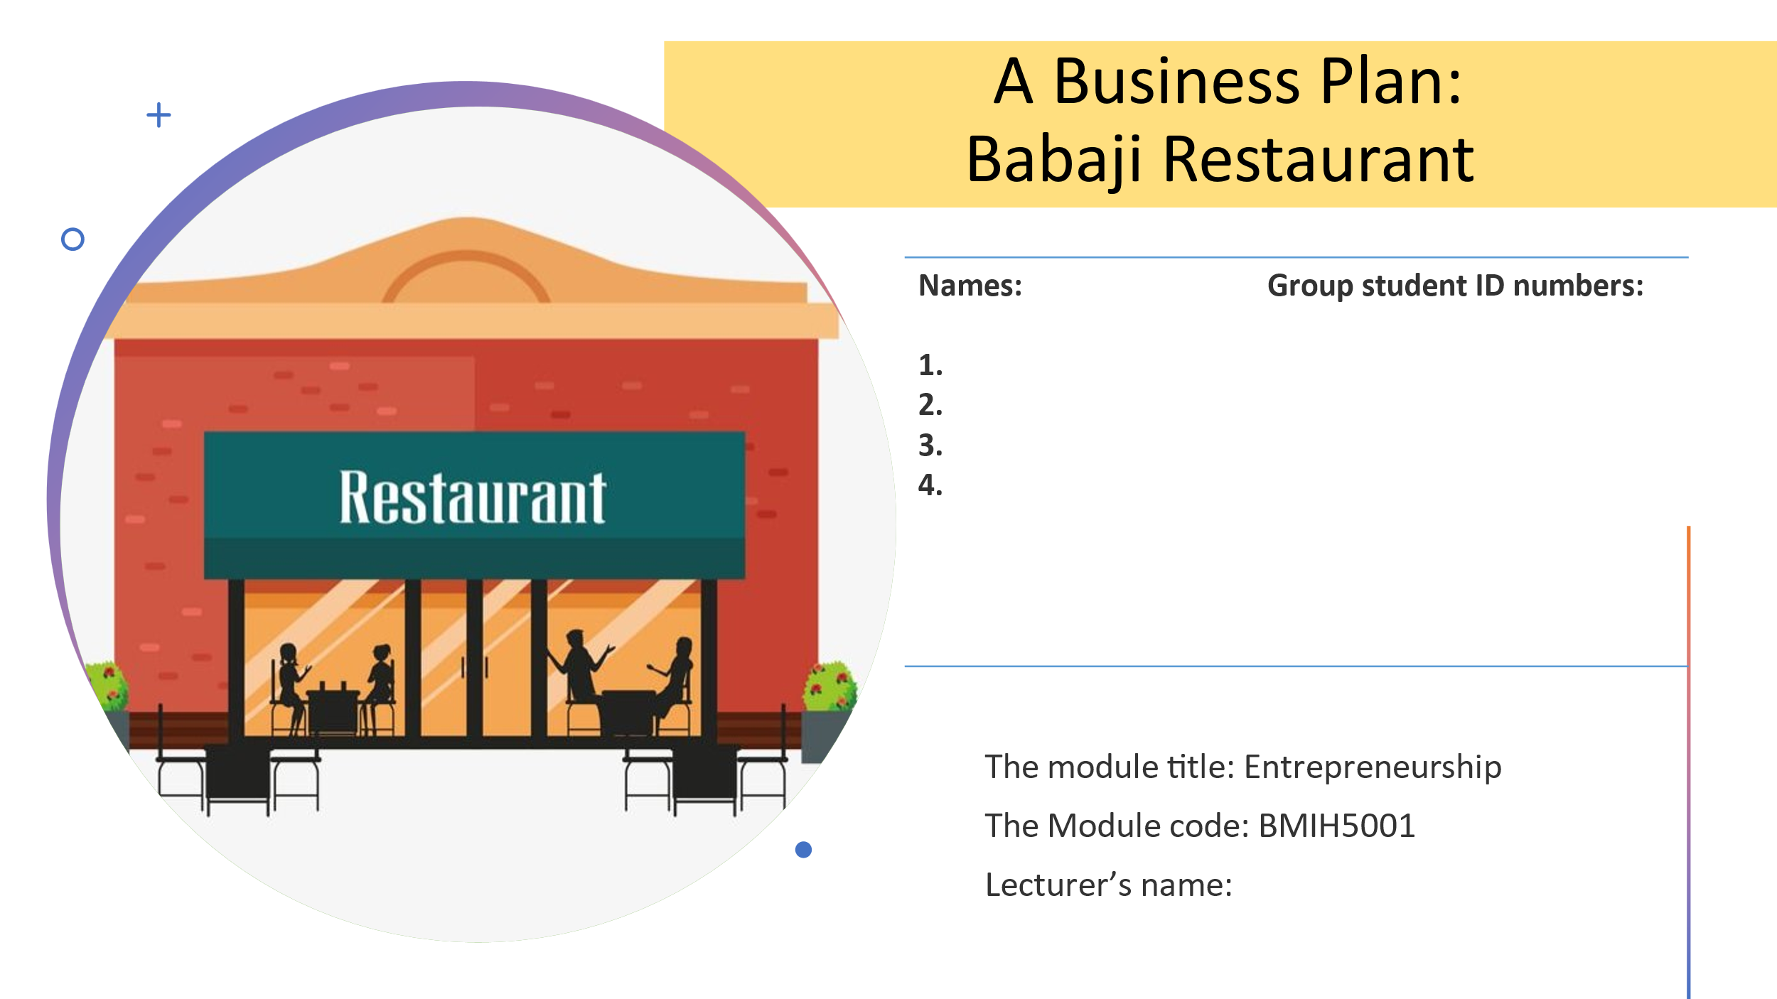
Slide 2
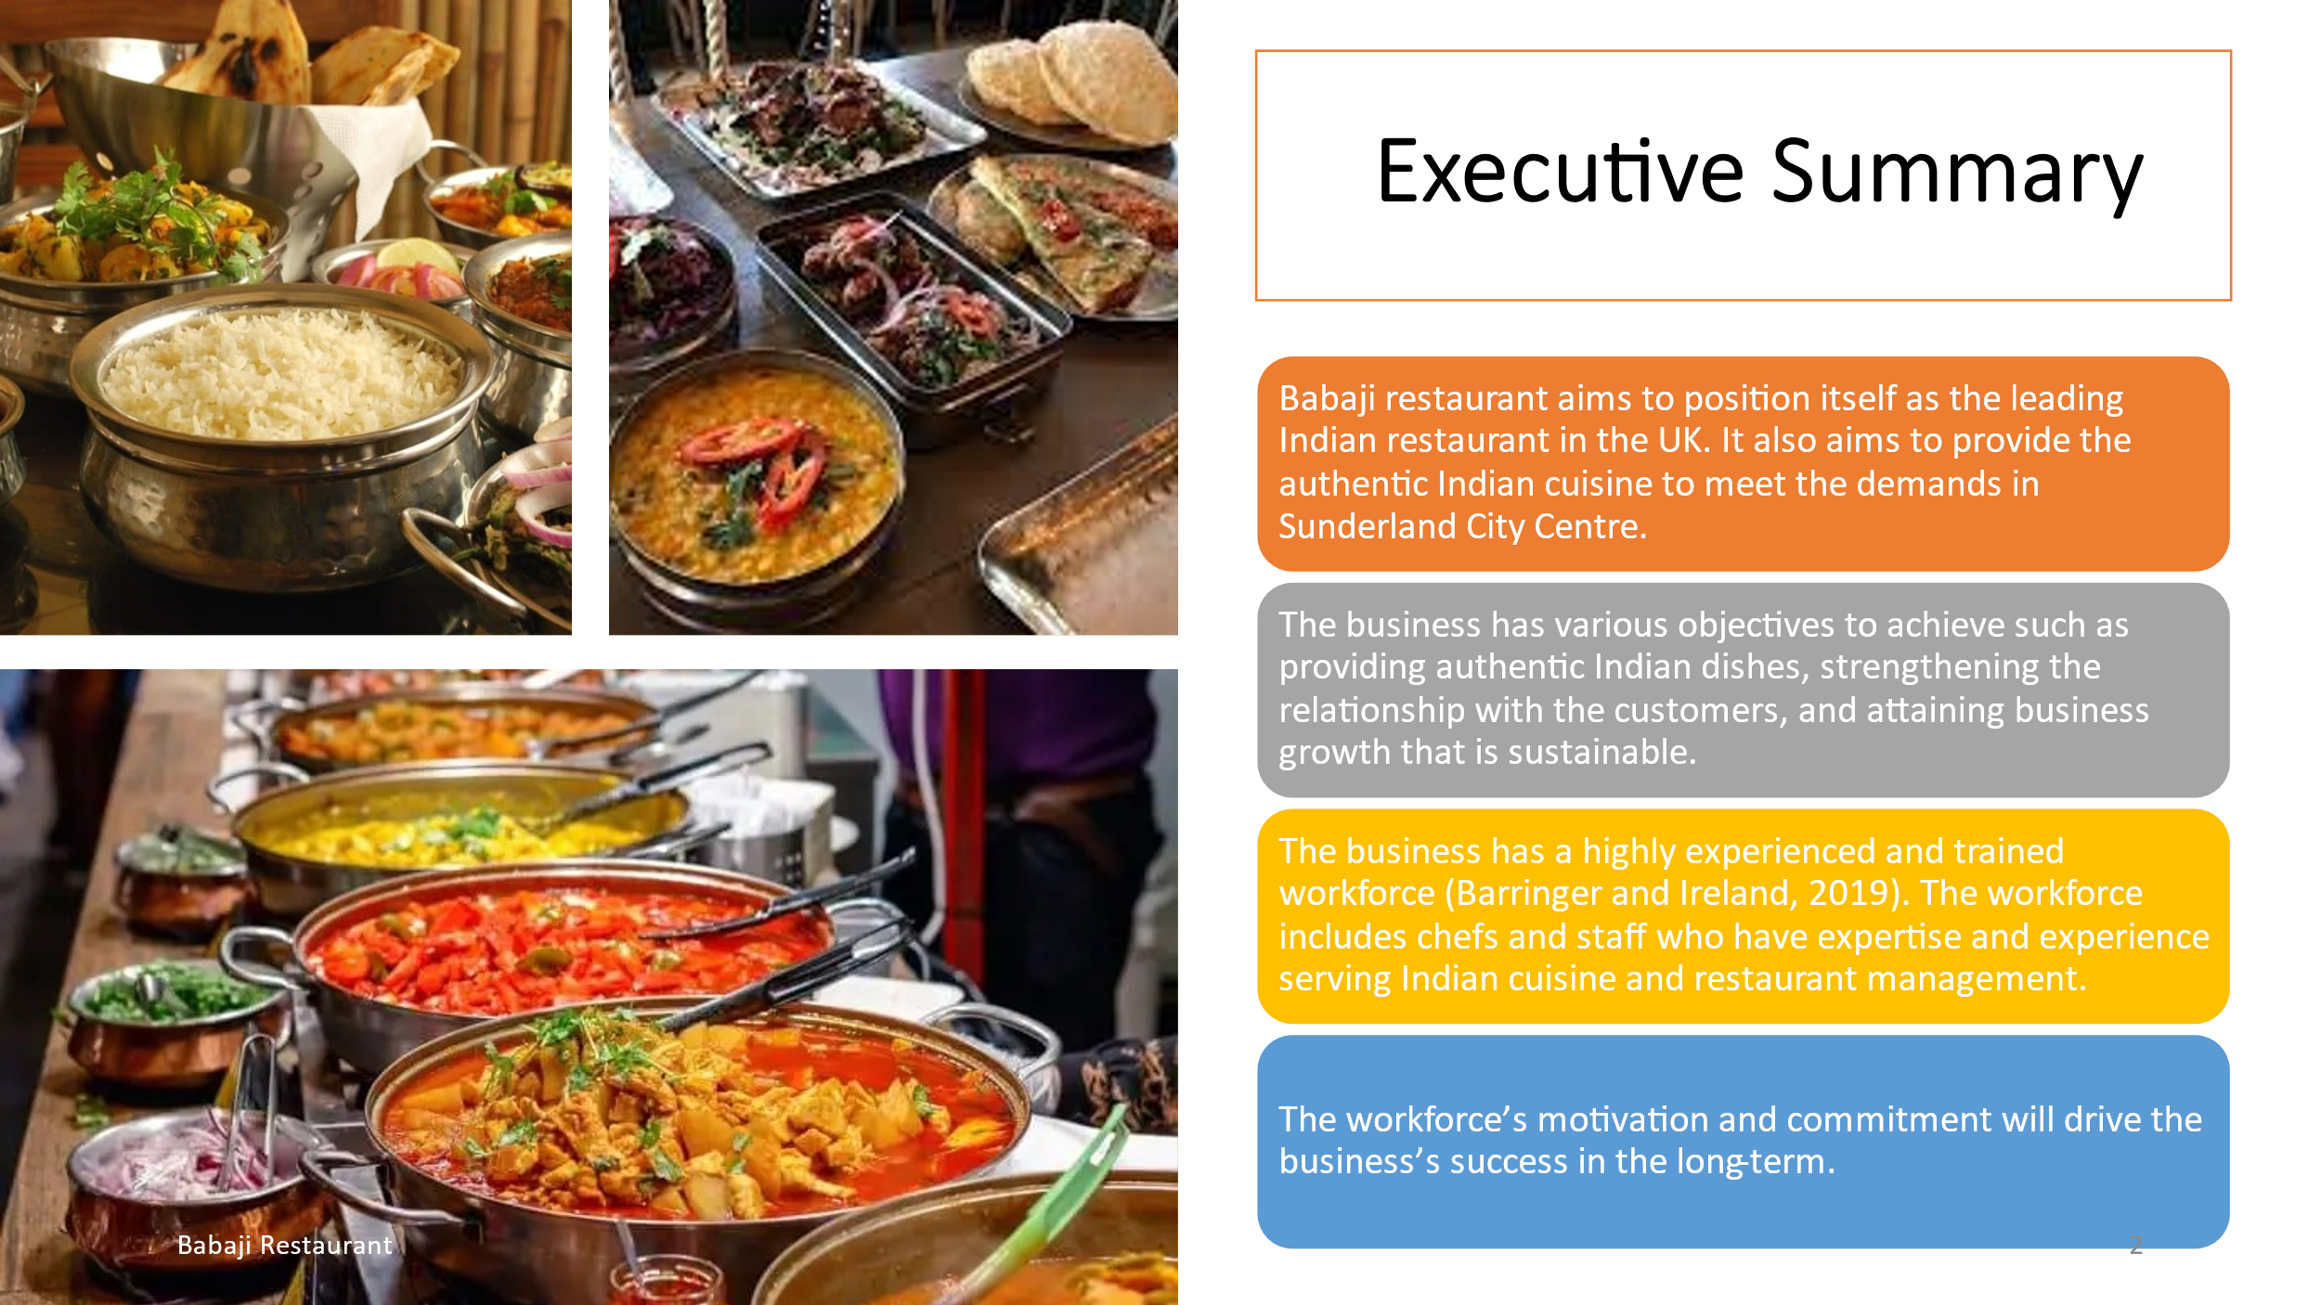
Slide 3
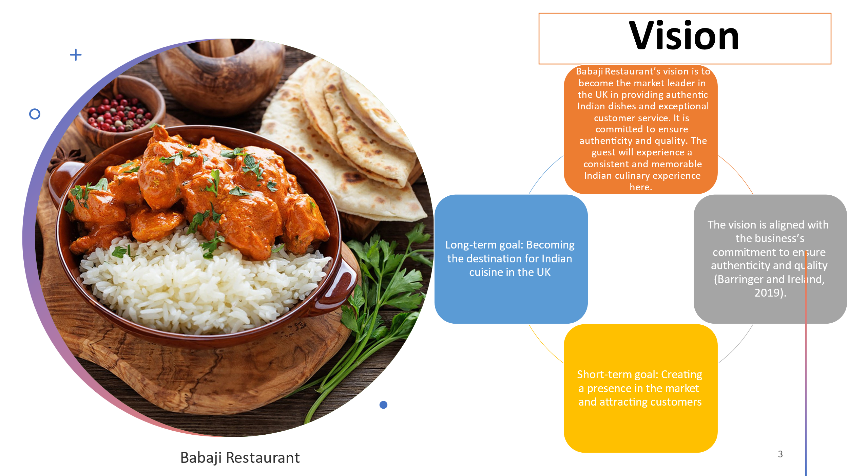
Slide 4
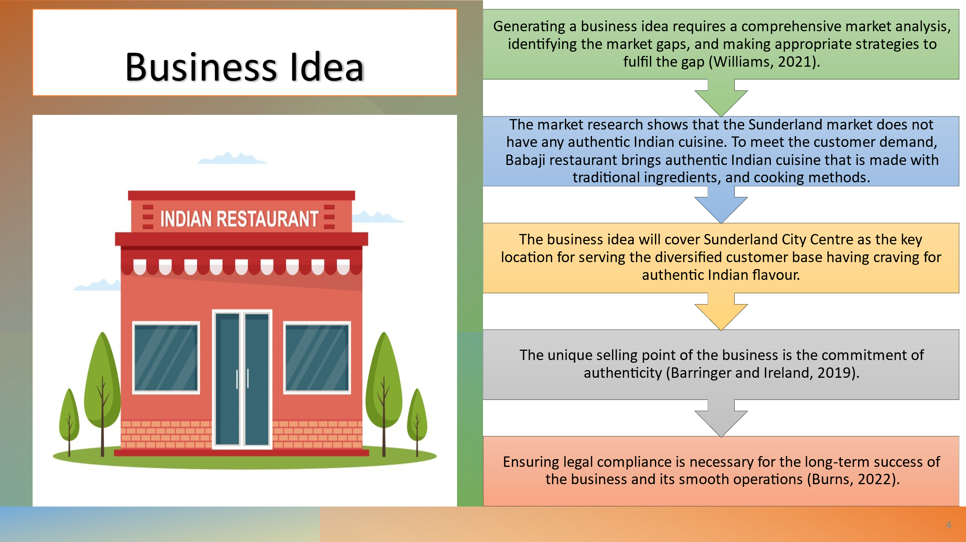
Slide 5
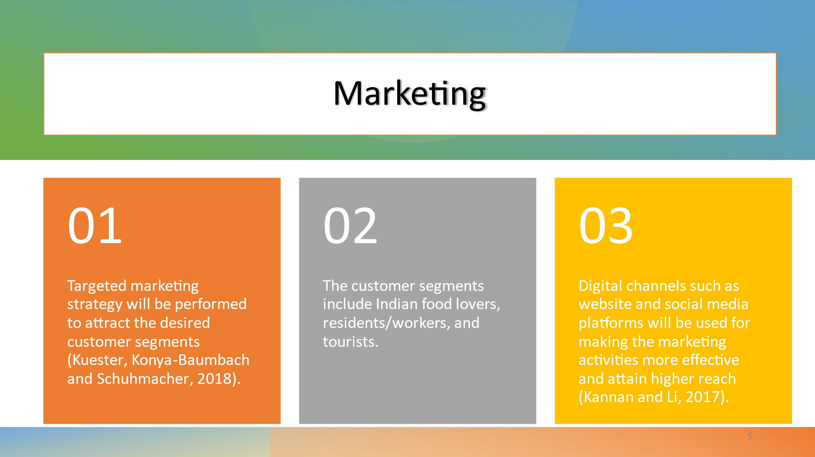
Slide 6
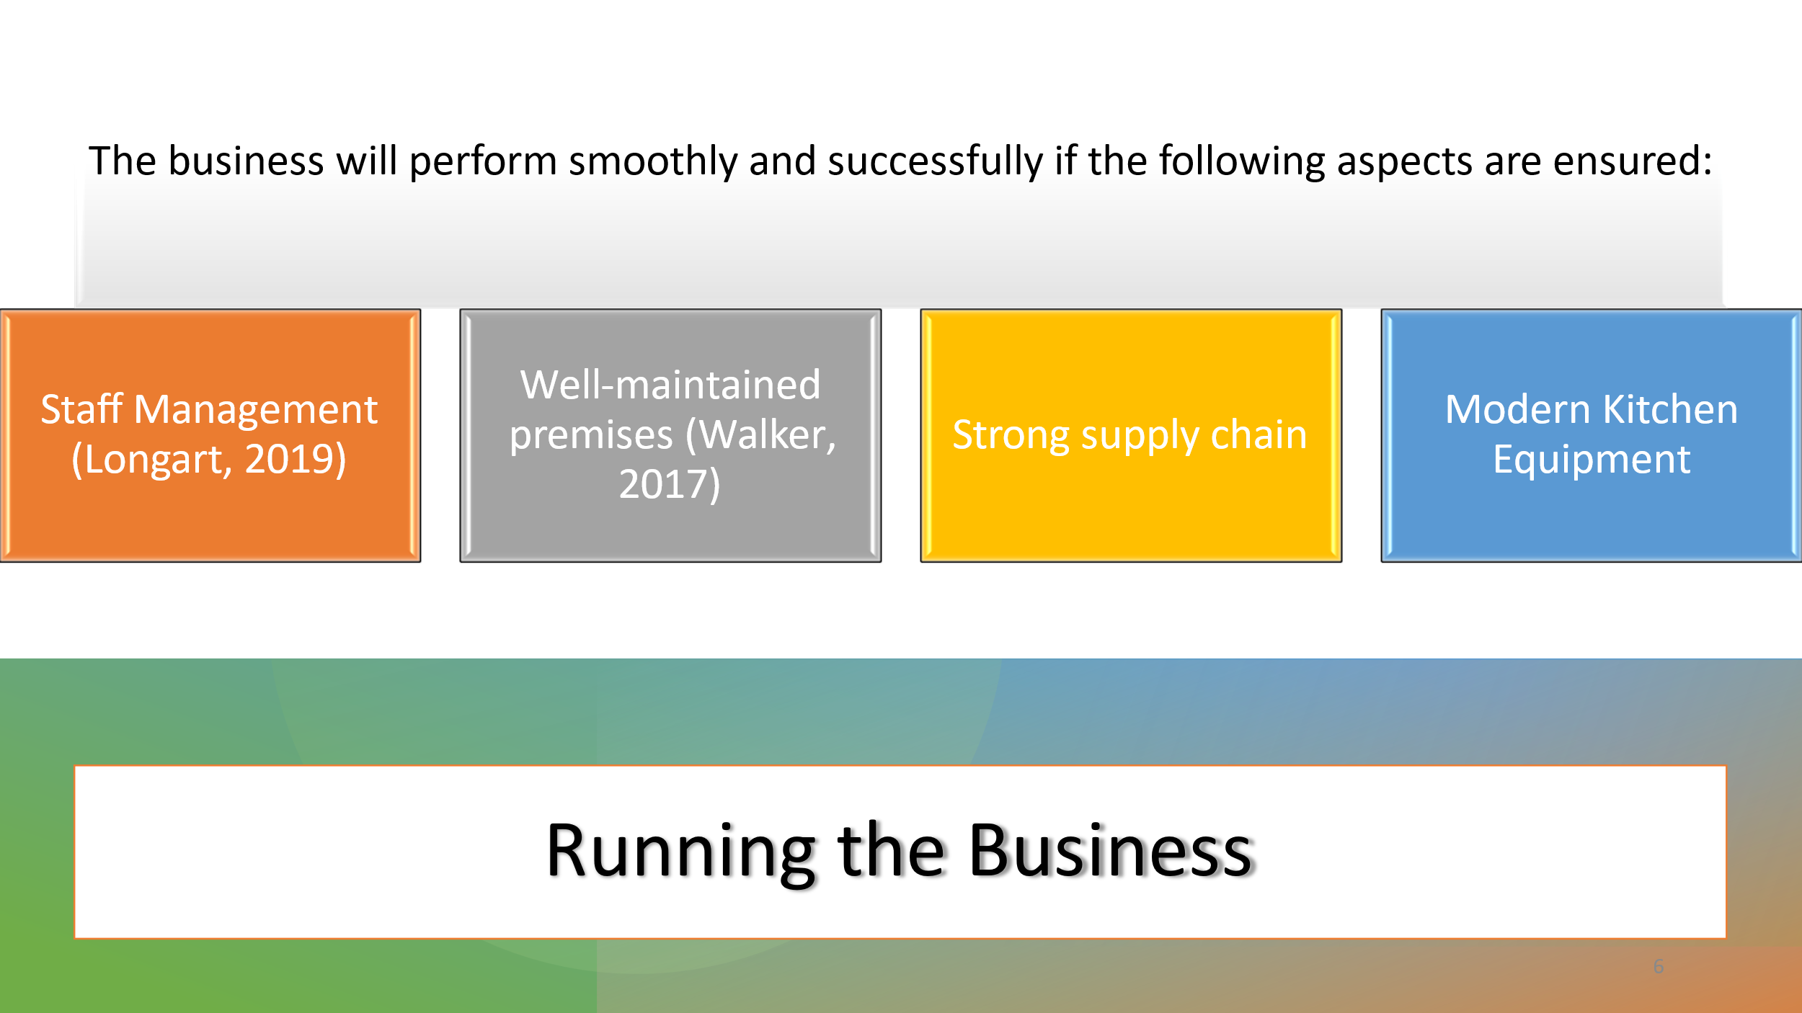
Slide 7
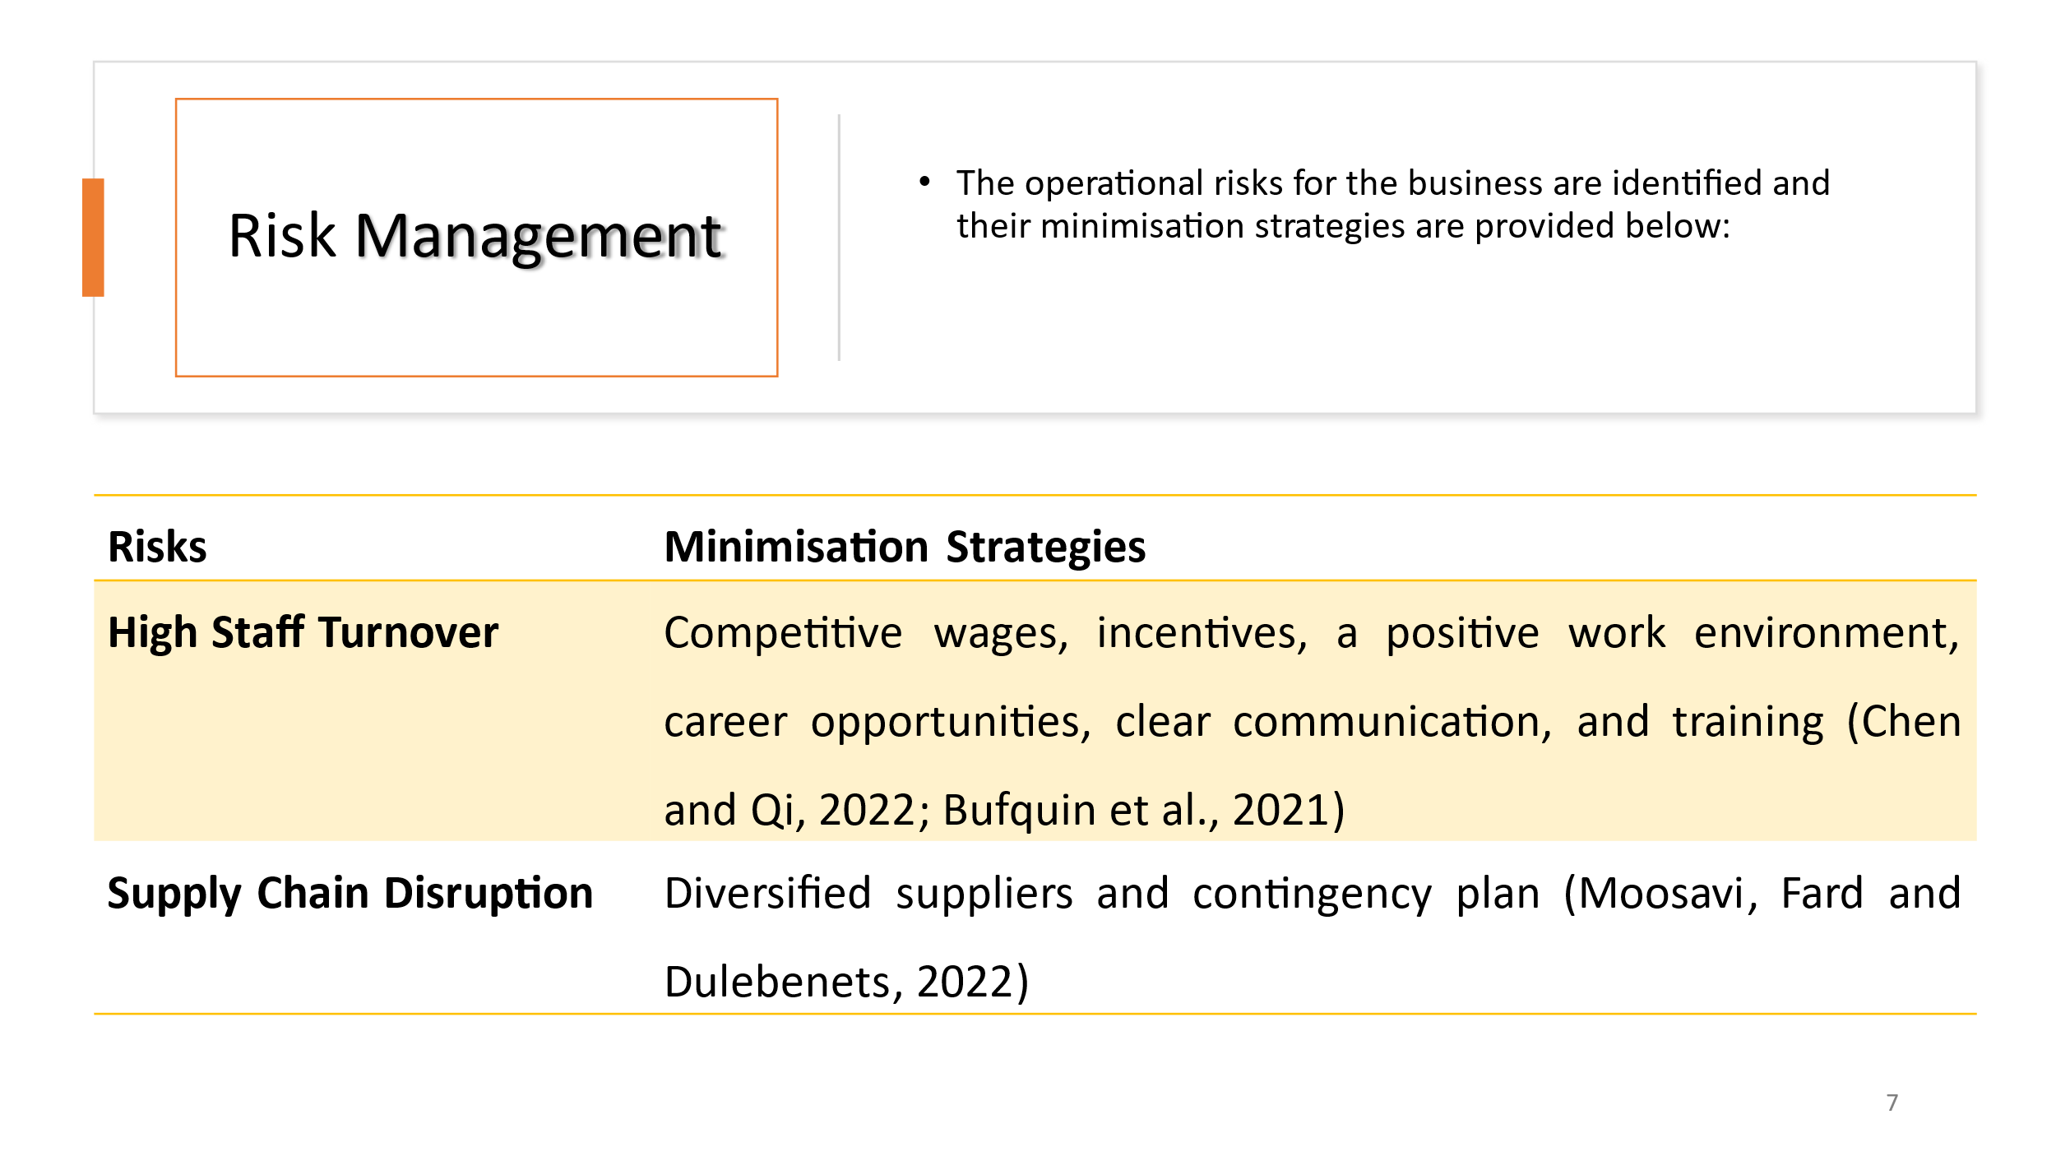
Slide 8
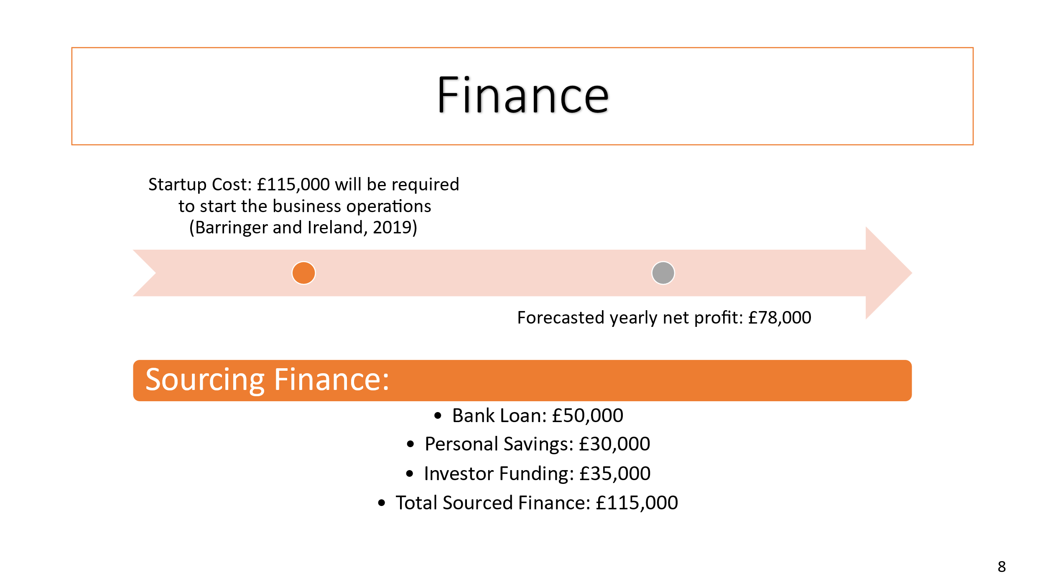
Slide 9
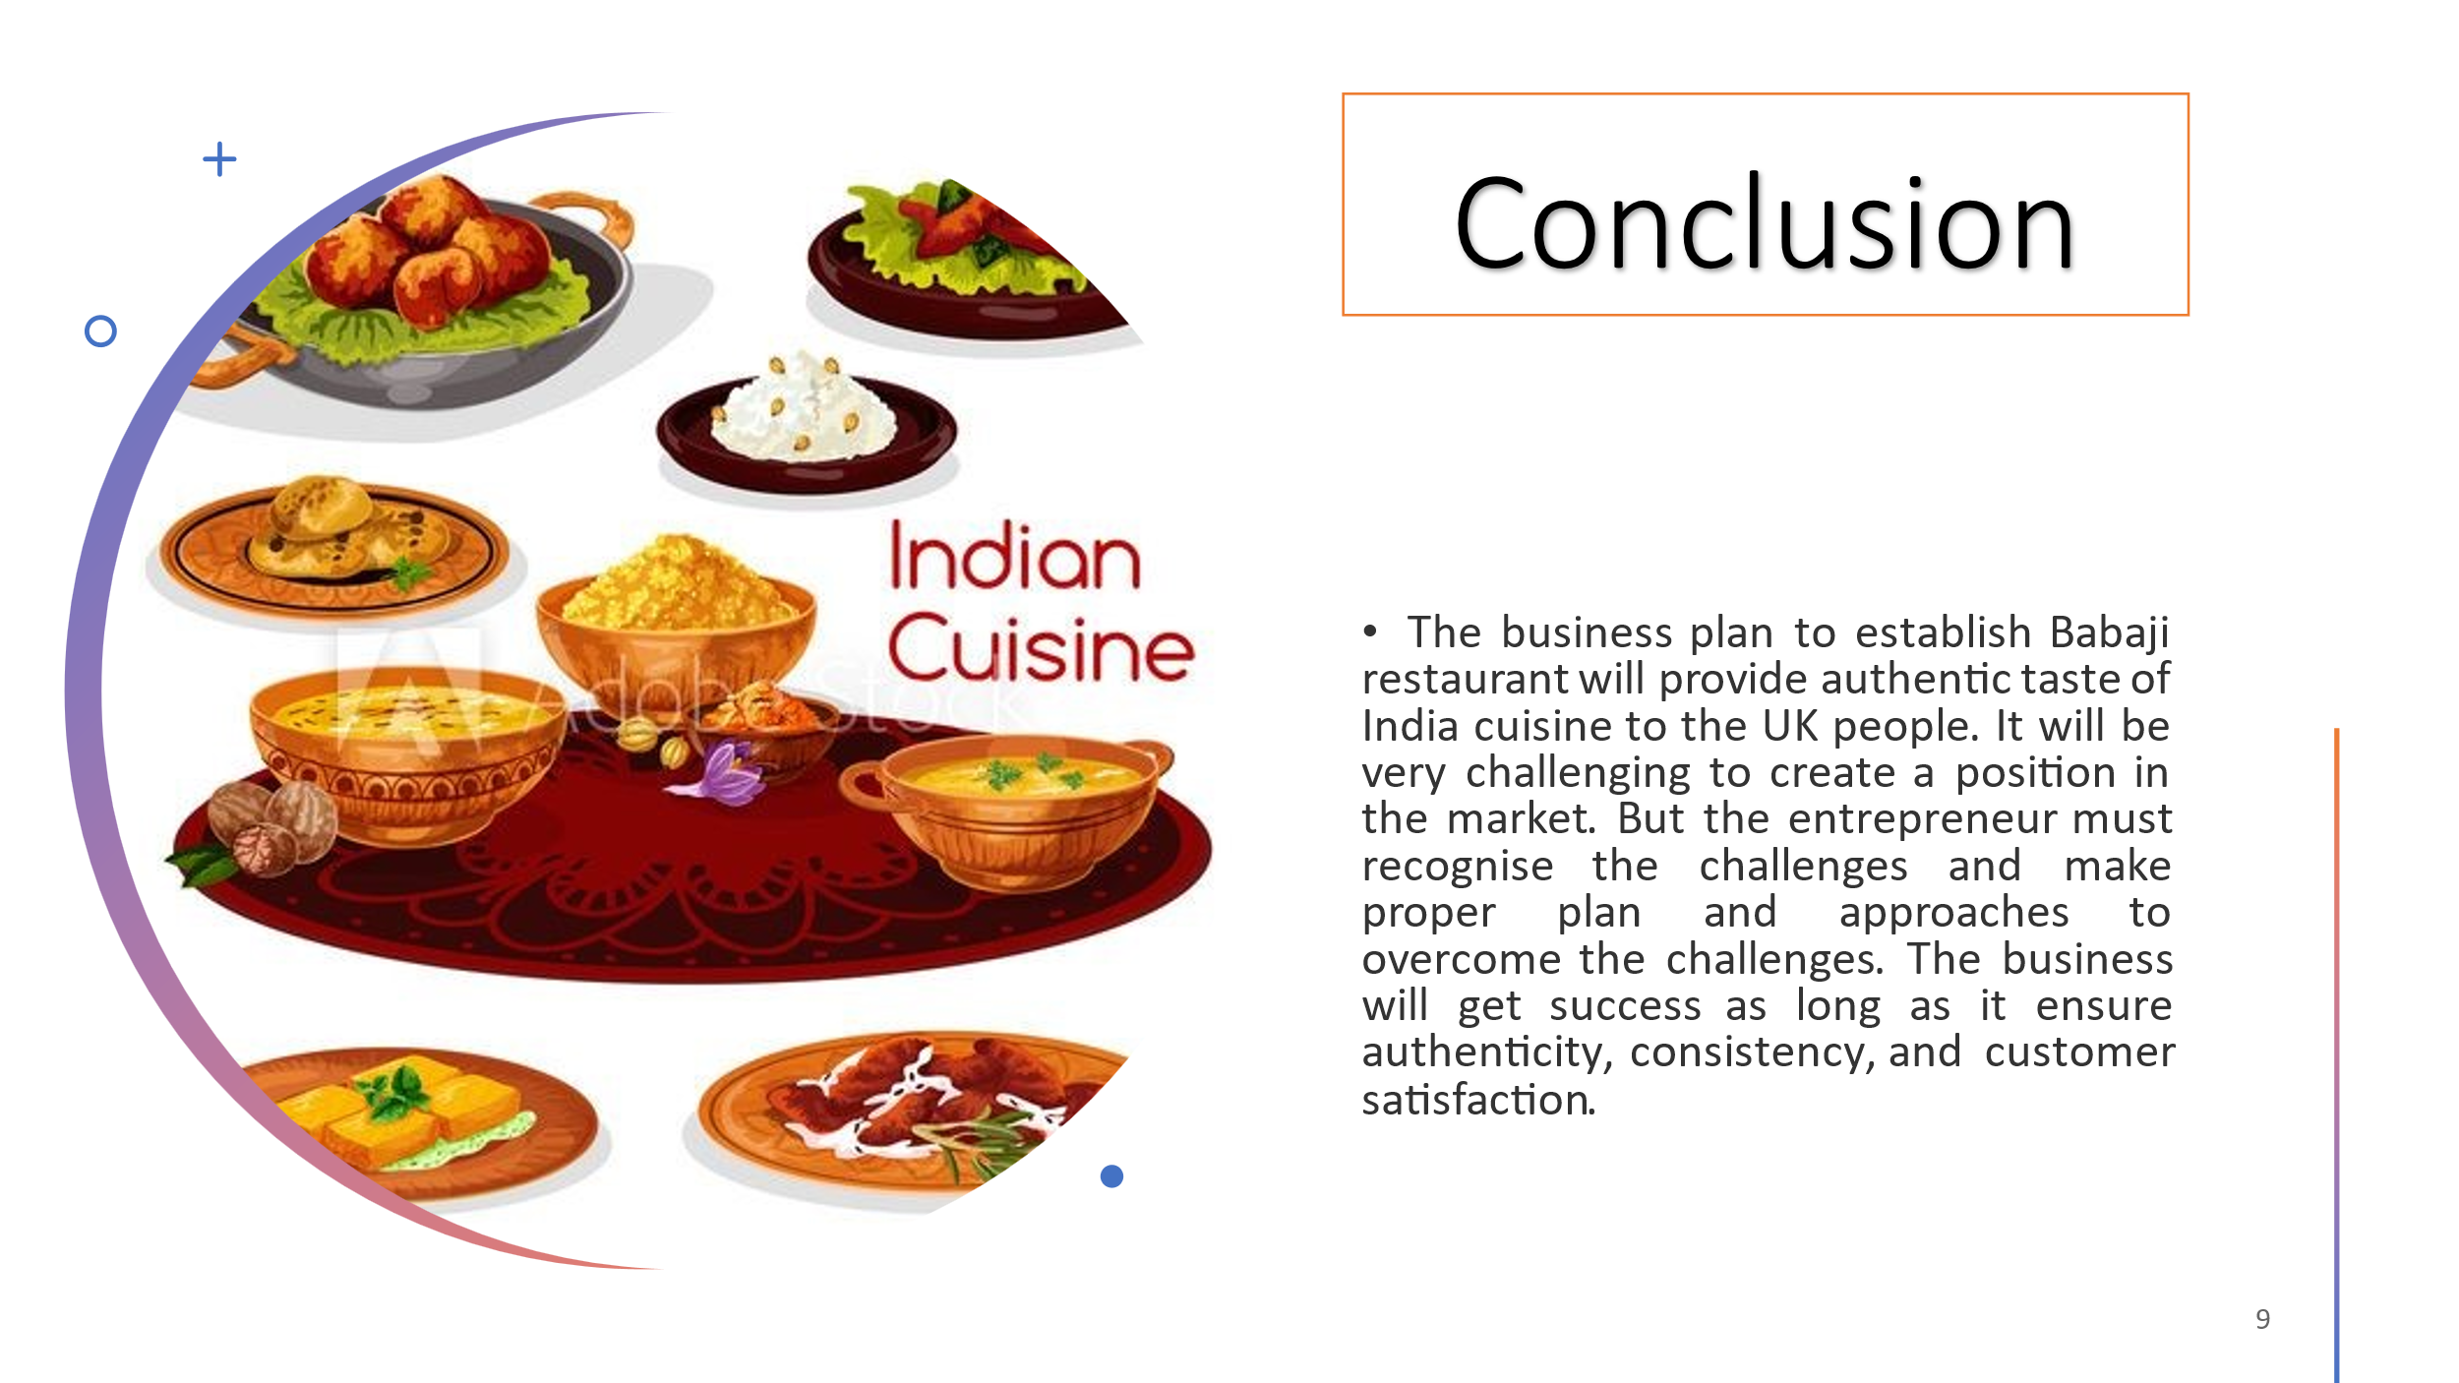
Slide 10


