

Assessment 1 – Reading Task Template
PART 1: Upload your photo of your A3 in-class notes here:
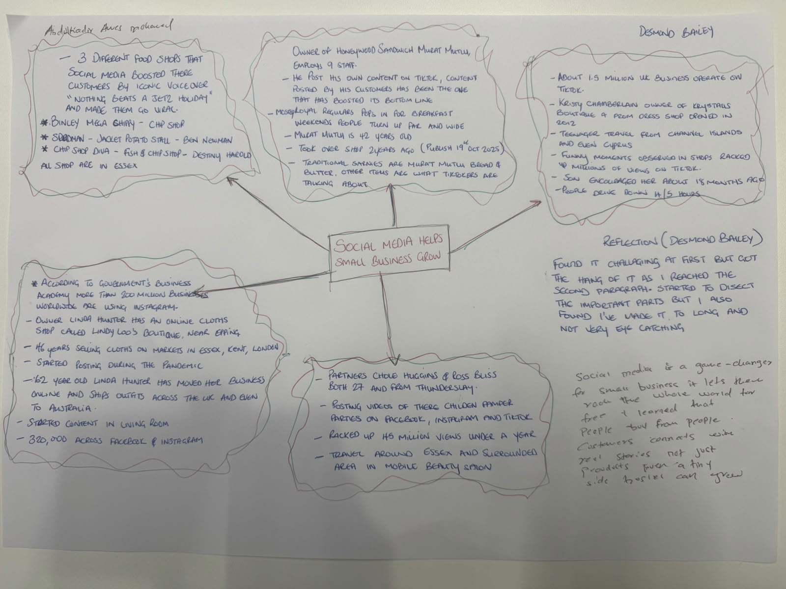

- What is the main idea of the whole text?
The main idea is that business academic skills help students learn and succeed in their studies. These skills can also prepare students for the workplace.

- What is one key point that supports the main idea, and which specific example from the text shows this
One key point is that good communication is important in business. For example, writing professional emails and giving presentations help students communicate their ideas clearly.

- What is a different key point that supports the main idea, and which specific example from the text shows this?
Another key point is that time management and organisation help students complete their work successfully. For example, planning assignments and meeting deadlines can help students manage their studies.

- Which part of the text do you think is most important, and why?
I think the part about communication skills is the most important because communication is useful in education and the workplace. It helps people share ideas and work well with others.

Reflection:
- What did you find difficult in this task (including in-class components), and why was it difficult?
I found it difficult to understand the main idea and choose important information from the text. This was difficult because I needed to understand the reading and find the most relevant examples.

- What helped you with this difficulty, and how did it help you?
Reading the text carefully and taking notes helped me understand the main points. My notes helped me organise my ideas and answer the questions more clearly.

