

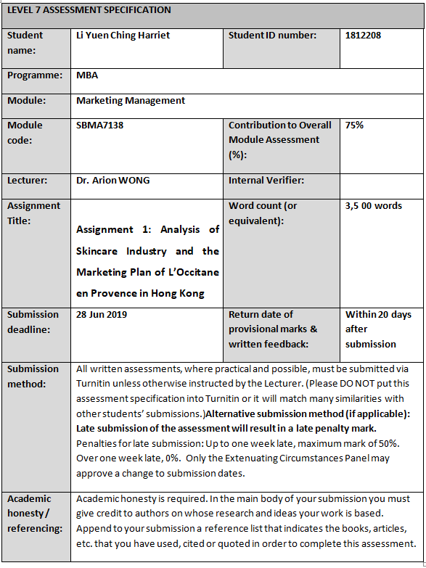
Executive Summary
L'Occitane International S.A is a manufacturer and retailer of skincare, body and home products. Its products are natural and organic ingredient-based. With analysis the skincare and cosmetics industry by using PEST and investigate L’Occitane’s present marketing strategies, L’Occitane is suggested to shift its target group to millennial and leverage the advanced technology and social platforms to launch its marketing plan so that to sustain its competitive advantage to the future.
Key Words: Skincare industry, AR, 4P, STP, PEST

Analysis of Skincare Industry and the Marketing Plan of L’Occitane en Provence in Hong Kong
Contents
Executive Summary
1. Introduction 1
2. Situation Analysis 2
2.1. Macro Environment 2
2.1.1. Political Factors 2
2.1.2. Economic Factors 3
2.1.3. Socio-cultural Factors 5
2.1.4. Technological Factors 7
2.2. Micro Environment 8
2.3. What is the industrial trend in the coming three years in Hong Kong? 10
3. Market Strategy 12
3.1. 4P 12
3.1.1. Product 12
3.1.2. Price 12
3.1.3. Place 13
3.1.4. Promotion 14
3.2. L’Occitane’s STP 14
3.2.1. Segment 14
3.2.2. Positioning 14
3.2.3. Targeting 15
3.3. Critical Success Factors for L’Occitane 15
4. Recommendation and Conclusion 16
4.1. Recommendations 16
4.1.1. AR helps luxury brands compete with large groups 16
4.1.2. Instagram to boost the brand awareness among young customers 16
4.2. Conclusion 18
Works Cited i

List of Figure

Figure 1: Hong Kong GDP Trend 3
Figure 2: The Revenue Growth In The Skincare And Cosmetic Industry In Hong Kong 3
Figure 3: Top 5 Countries Of The Most Revenue Generated In Skincare & Cosmetics Industry 4
Figure 4: Hong Kong Female Spend More On Skincare 6
Figure 5: Age 35-44 Have The Highest Spending 6
Figure 6: Total Spending - Skincare VS Cosmetics 7
Figure 7: Instagram KOL 17
Figure 8: Online Retail Penetrating Rate In Hong Kong Is Far Lagged Behind. (Source: Consumer Council, 2016) Ii

List of Table
Table 1: The Top Beauty Companies And Their Skincare Brands In Hong Kong 9
Table 2: Current L'Occitane STP In Hong Kong Market 15

- Introduction
L'Occitane International S.A. (the group) is a listed company in Hong Kong (SEHK:973). It also known as L'Occitane en Provence (L’Occitane) originated in France in 1976. The group is a manufacturer and retailer of skincare, body and home products. It is a global, natural and organic ingredient-based company with 5 natural brands including L'Occitane en Provence, L'Occitane Eau bresil, Erborian, Melvita and LimeLife by Alcone. (L'occitane International S.A., 2018a)
The L’Occitane’s founder, Mr. Olivier Baussan created its first line of products in 1976 by and opened the first L’Occitane store in 1978 in Provence. After forty years’ development, as at 31 March 2018, L’Occitane products are in presence over 88 countries through more 3,285 store locations which sell its products exclusively with standardized L’Occitane decoration and design. (L'occitane International S.A., 2018a)
Geographically, the US, China, Hong Kong and Brazil are the key markets to contribute the group’s overall financial growth. (L'Occitance International S.A., 2018b) Net sales in Hong Kong for FY2018 were HK$ 11.5 billion that was an increase of 0.2% as compared the year before. It was contributing 17.0% to overall growth. (L'occitane International S.A., 2018a)
Nowadays, Hong Kong people are more concerned about their health as the sake of increasingly better educated and thus are paying more attention on the products that is put on their face and body. In this tiny city, skincare market is a small sector, and it imported $474 million of skincare and cosmetics from the US in 2014. Brands claimed on “made in Hong Kong” are less, instead, global luxury brands are dominating the beauty industry. (Federico, 2016) L'Occitane en Provence is one of the international luxury brands in Hong Kong.
In this paper, we would prepare a comprehensive marketing plan for L'Occitane en Provence in Hong Kong and the focus is on its skincare products. With currently a solid financial performance and good organic image, under the technology is keep evolving, how it sustain its competitive advantage in the future.

- Situation Analysis
  - Macro Environment
To formulate the marketing strategies, L’Occitane’s marketer must understand the industrial environmental trends and the changes are expected to happen in Hong Kong. Keller & Kotler (2009) depiected that the marketing environment affects marketing management’s capabilities to establish and maintain long-term relationships between the Company and targeted customers. Macro and micro environment have very important roles to marketing successful. Thus, L’Occitane has to analyze the global and Hong Kong environment that surrounding them.
    - Political Factors
Some political factors may impinge the business operations unconsciously. Business leaders should always be aware such kind of factors, for example international campaigns, local trading practices, legislations on merging and acquisitions, controls and guidelines on advertising, etc.
Risks Relating to the Global Cosmetics Industry
Laws and regulations sometimes will be changed and adjusted. If imposition of a new law and / or amending the existing laws and regulation, the company is always required pay extra costs to comply with the more rigorous rules and regulations. (L'Occitance International S.A., 2009) It is not difficult to understand that once a new law and regulation launch, the company operation might be effected or slow down at the initial phase, product development or growth rate may also have an adverse impact. Adjustment should be made so that to avoid serious financial impact.
Regulations in Local Cosmetics Industry
To operate skincare retailing business in Hong Kong region, the general beauty and cosmetic products are not required to do registration and local labelling, unless there are medical or therapeutic claims on the products. Animal testing is not required on any product. This is no tariff on imported skincare and cosmetics products. (Bollati, 2017) Thus, lower administration and time costs to do the business in the region. It is easy and quick to launch new products into the market. This depicts the reason why Hong Kong has a wide range of variety of beauty brands.
Skincare and cosmetics products produced in Hong Kong can enter China market tariff free because of the implementation of Chinese mainland and Hong Kong Closer Economic Partnership Arrangement (CEPA) in Jaru7 edSAAnuary 2006. (Bollati, 2017) Taxation cost incurred here is much lower than the company operates the business in other countries.
    - Economic Factors
L’Occitane has to keep track on economic factors at both domestic and international levels so that the company could be aware of the coming threats and take corresponding remedial measurements to keep itself at a better position in the market.
In 2017, Hong Kong’s Gross Domestic Product (GDP) was worth US$341.45 billion. (Trade Economics, 2019) From figure 1, the Hong Kong GDP curve is going up, it depicts the economic is growing. Aged between 30-49 Hong Kong consumers is the largest age group (31.3%) and having the highest disposable income while they are also the larger group of buyer of skincare and cosmetics products. (The International Trade, 2016)
Figure 1: Hong Kong GDP trend
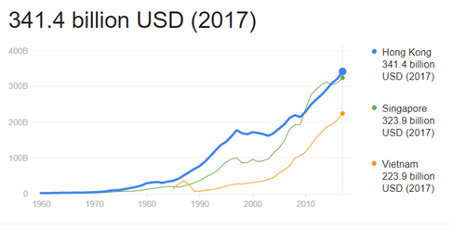
Source: World Bank, 2018
Figure 2: The Revenue Growth in the Skincare and Cosmetic Industry in Hong Kong
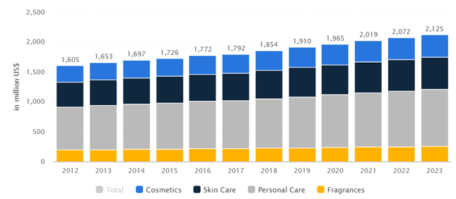
Source: Statista, 2019
According to Statista (2019), revenue in the skincare and cosmetics market in Hong Kong amounts to US$1,910 million in 2019 (figure 2). It is expected that the market is gradually grow by 2.7% annually (CAGR 2019-2023). From figure 2, it shows the top 5 countries that generate the most revenue in globe is United States (US$82,885M in 2019) and followed by China, Japan, India and Brazil. And the largest segment is “personal care” with the market volume of US$853 million this year. In relation to total population figures, every person generates revenues of US$255.03 in 2019.
Compared with the top 5 countries, Hong Kong’s revenue in the market is only US$1,910 M that shows skincare and cosmetics market in the region is very small. Nonetheless, huge number of international brands in presence Hong Kong, again, proves that they treat Hong Kong is a step stone to China’s giant skincare and cosmetics market.
Figure 3: Top 5 Countries of the Most Revenue Generated in Skincare & Cosmetics Industry
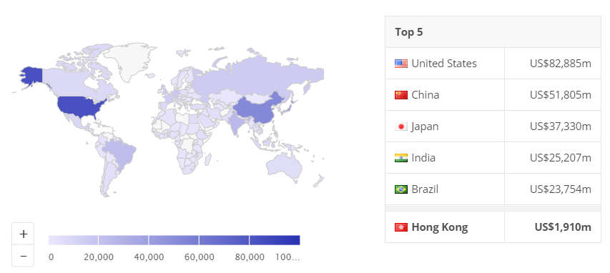
Source: Statista, 2019
In Hong Kong, under the individual visitor scheme, the number of the mainland Chinese tourists came to shop in the region increased and with the concomitant surge in Hong Kong’s cosmetics sales, international brands are eying Hong Kong’s local skincare and cosmetics market. (Hong Kong Trade Development Council, 2018) This caused continuous attracting new skincare and cosmetics brands to establish a presence in this small region.
    - Socio-cultural Factors
Numbers of studies proved that the demographic factor is one of the most influencing elements in predicting consumer behavior towards organic and natural products (D'Souza et al., 2007). In this decade, people in Hong Kong is better educated compared with those in 1990s’ and they put more focus on the quality and the ingredients of the skincare and cosmetics when they are shopping. (Federico, 2016).
The Consumer Council (2016) stated that 35% of consumer aged 35-44 would shop online, but with elderly, like aged 55 or above, least of them would like to do online shopping. 51% of post-secondary educated people are online consumers. In general, Hong Kong people who do online shopping mainly are highly educated and they aged young and middle.
Reference to Yu’s (2017) survey report (figure 4&5), 96% of Hong Kong female consumers were spending average HK$4,021 on skincare or cosmetic products per year. While, in terms of the amount spent on such products, the aged 35-44 female consumers are the biggest spenders spent around HK$5,000 in 2016. Followed by group aged 25-34, they were spending approximately HK$4,700 at the same period of time.
Figure 4: Hong Kong Female Spend More on Skincare
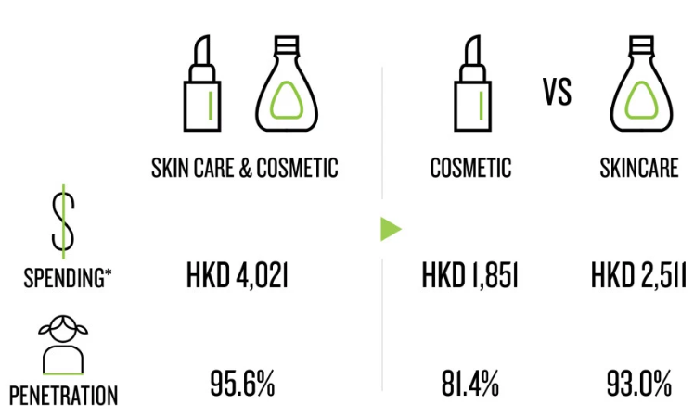
Source: Yu (2017)
Figure 5: Age 35-44 Have the Highest Spending
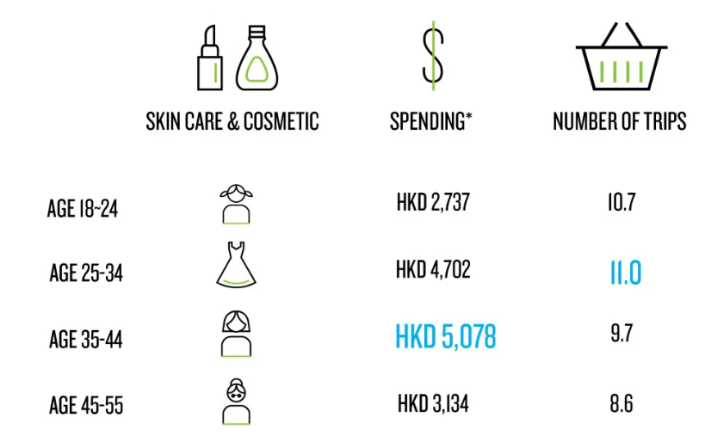
Source: Yu (2017)
In general, figure 5 showed between both on cosmetic and skincare products, more than half the spending (57%) is on skincare products. Among all age groups, the groups’ ladies aged 35-44 & 45-55 spend more on skincare products (64% of total spending) whereas younger groups spend 53% of the total spend on cosmetics. To define the target age group, L’Occitane should consider such figures.
Figure 6: Total Spending - Skincare VS Cosmetics
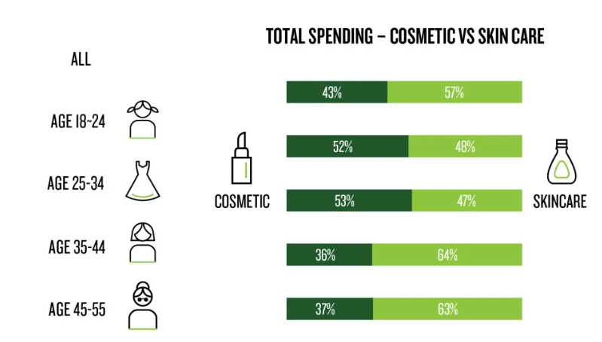
Source: Yu (2017)
The above figures showed that consumers aged 35 to 44 are generally the biggest spenders. Meanwhile, the different age groups vary in their preferences of purchase channel. So, it is essentially for L’Occitane to formulate the strategies to gain the bigger market share with using appropriate sales channels to get connected with its relevant age groups customers.
    - Technological Factors
In Hong Kong, the rate of mobile phone penetration is the highest in the world. Also, here has the solid telecommunications infrastructure and a giant consumer base. (Arienti, et al., 2018)With a staggering 232% penetration rate of smartphones and 176% for internet subscriptions in 2017, (Leung, 2018) and 98% of smart phone users are online at least once a day, (Retail News Asia, 2018) Hong Kong definitely is a technologically advanced city in the world.
Assersohn, et al. (2018) emphasized that online retail is optimism and it also reflected that the retailers (72% of the market participants) and the landlords (90%) agreed that the sale volume in online shopping market would expand significantly over the next five years in Hong Kong.
Currently, luxury brands’ sales growth is driven by the millennials (aged 20-39) and the Generation Z. With different purchasing habits, these younger group seek a seamless personalized shopping experience by omni-channels (both online and offline) digital platforms. The new technology such as Augmented Reality (AR) and Artificial Intelligence (AI) may fulfill their expectation. Also, voice commerce technology is also reshaping the whole luxury brand industry. (Arienti, et al., 2018)
Further, some luxury brands in globe start using AR combined with their brick-and-mortar stores to uplift the customers’ shopping experience. AR technologies helps consumers visualise new products and let them “feel” or “try” the products at home before making purchases. For instance, in mid of 2017 Estée Lauder launched a conversational AR lipstick advisor which assists the potential customers determine an ideal lip shade for themselves. L’Oréal is increasingly focusing on AR from March. (Arienti, et al., 2018)
  - Micro Environment
L’Occitane is a beauty product manufacturer and retailer. Its manufacturing plants are in Manosque and Lagorce where manufacture major portion of its products. If there are any major disruptions of destruction caused by fire or explosion, the manufacturing operation will be ceased. And it would directly impact the financial result.
To manufacture organic skincare product, it totally rely on suppliers’ raw materials, such as essential oil, shea butter and even the packaging materials so that to maintain the production processes. In case the harvest and thus the supply of such natural and organic ingredients are affected by adverse weather conditions, natural disasters, pest infestations, diseases, etc. L’Occitane may not be able to locate alternative resources in sufficient quantities, at acceptable prices and of suitable quality, finally affect the financial performance.
Competitors
L’Occitane operates in Hong Kong, definitely, in which it has to face a fierce business competition among wide variety of international luxury skincare competitors. To prevent losing market share to the competitors, L’Occitane have to retain its competitive advantage by formulate appropriate and comprehensive market strategies. Otherwise, it may suffer from adversely financial loss.
Hong Kong has a small local manufacturing, such as Choi Fung Hong’s cosmetic brands – Joseristine, majority of the skincare product needs in Hong Kong are overwhelmingly met by imports. Recently, there are a number of Hong Kong skincare brands, such as JaneClare, iSUM, highlighted their products are “made in Hong Kong. (Hong Kong Trade Development Council, 2018)
Generally, international brand names are playing the dominant place in beauty industry in Hong Kong. A number of international companies (Table 1), including Unilever, L’Oreal, Estée Lauder, Shiseido and P&G have been dominating the skincare and cosmetics markets. (Hong Kong Trade Development Council, 2018) Other popular brands like Shu Uemura, Chanel, Laneige, Clinique can also be easily found in big shopping malls and the major department stores, e.g. Sogo. All these global brands naturally form a very strong barrier that the new skincare brands hard to enter the local beauty industry.
Table 1: The Top Beauty Companies and their Skincare Brands in Hong Kong
Companies/Groups | Brands
Unilever | 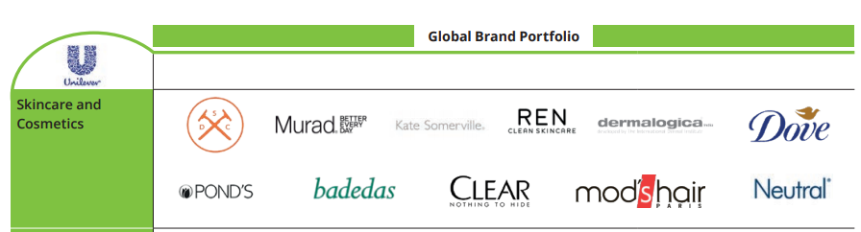
L’Oréal | 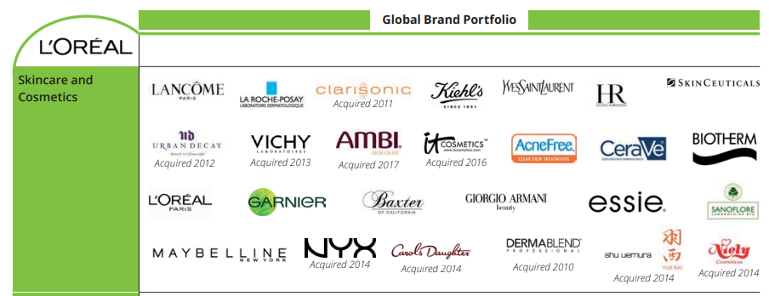
Estée Lauder | 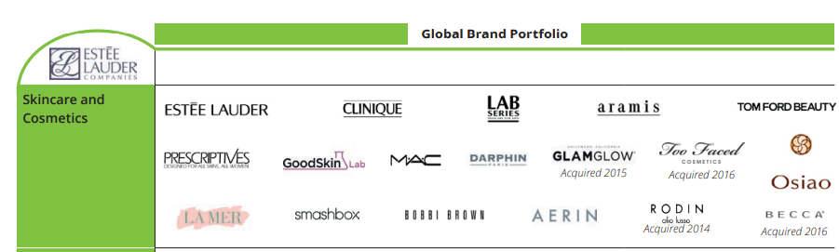
Shiseido | 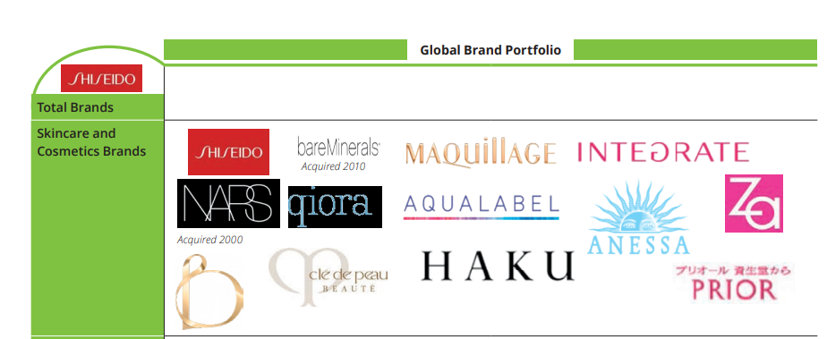
Source: Deloitte (2017)
These competitors may have stronger financial power that allow them to formulate much better marketing, technological or even customer services strategies to attract same target customers as L’Occitane. They may able to devote greater resources to promote, develop, sale and support their products than what L’Occitane can do. As a result, L’Occitane may not be able to compete effectively in certain of their target group and competitive pressures could finally affect L’Occitane’s financial status and business.
  - What is the industrial trend in the coming three years in Hong Kong?
Sales driver: Convenience
Cheap and fast delivery and ease of access became increasingly important to the luxury brands in the skincare industry. 81% of beauty shoppers use digital prior to or during their shopping journey, the majority reason for this change is “ease”. (Deloitte, 2017)
To become convenience to L’Occitane’s consumers, the company can establish easy-to-navigate stores in shopping malls, and setup an intuitive website layout, allow their customers ease of getting the precise beauty advices so that assisting them quickly making decision, etc.
Alternative distribution
Consumer Council (2016) (Appendix) showed the penetrating rate of online shopping, currently, in Hong Kong was only 23%. Compared to the rate of China, 67%, the rate here is extremely low. However, Assersohn et al. (2018) emphasized that online retail is optimism and it also reflected that the retailers (72% of the market participants) and the landlords (90%) agreed that the sale volume in online shopping market would expand significantly in Hong Kong over the next three years.
Systemic shifts
According to the report of Nielsen Holdings plc (2018), natural, personal and conncted are three giant systemic shifts that will definitely redefine the future trend of the beauty industry.
- Natural - As with organic food and household supplies, more Hong Kong people are interested in natural skincare products.
- Personal - The same shoppers who are redefining what healthier, natural beauty products look like are themselves younger, more racially, culturally and ethnically diverse and cosmopolitan consumers.
- Connected - The playbook for building and retaining brand loyalty has been changed. As the ease of access to online channels for purchasing, the opportunity for connecting between the consumers and retailers is increasing as well.
- Market Strategy
The key elements that a company can manage to its advantage for marketing purposes comprise the ‘marketing mix’. The four Ps in the marketing mix are:
- Product, Price, Place & Promotion (4P)
The other main elements associated with marketing mix concept are :
- Segmentation, Target, Positioning (STP)
  - 4P
    - Product
L'Occitane en Provence is providing wide range of products from skincare, fragrances, hair care and body series to bath ranges with a high standard on qualitative, natural and organic ingredients.
For skincare category, moisturizer is the most frequently purchased category while face mask is the highest spending items. Face serum is not in the top five in terms of penetration, however, because of high price and higher than average purchase frequency, in terms of spending, face serum is the second largest category. (L'occitane International S.A., 2018a)
    - Price
L’Occitane’s products in Hong Kong are ranged from HK$295 for a 50ml moisturizing cream up to HK$1,500 for a 30ml serum. (L'Occitane (Far East) Limited, 2019) It has a wide variety of products and thus has products in different ranges with each segment priced differently. L’Occitane is charging a premium pricing for their products. And it also offers festival discounts and sale on special occasions. (L'Occitance International S.A., 2018b) Since it is a differentiated brand and because with always loyal customers in the beauty market and L’Occitane is a differentiated brand, it seldom follows a competitive pricing model.
It is using psychological pricing strategy in skincare and beauty market in Hong Kong. Many Hong Kong or Chinese consumers use price as a products’ quality indicator. Prestige pricing uses higher prices to promote the idea of value and status – that is L’Occitane is the global brand with luxury, natural and organic ingredient-based cosmetics and well-being.
    - Place
Retail sector for the sale and distribution for skincare and cosmetics products here in Hong Kong is very sophisticated. (Haydon & Chan, 2017) The channels include department stores, beauty specialty stores, pharmacy stores, supermarket chains, multi-brand stores, B2C e-Commerce platforms.
L’Occitane in Hong Kong is operating total 25 stores - 6 of them are located in Hong Kong side, 9 stores are at New Territories and 10 out of 25 are set up on Kowloon Island. (L'Occitane (Far East) Limited, 2019) Besides, brick-and-mortar store, customers can purchase its products via L’Occitane’s websites. All those products from these said medium would be sold to end customers directly which the group state that is “sell-out” category. (L'Occitance International S.A., 2018b)
L’Occitane also sells its products to intermediates which mainly wholesalers, distributors and travel retailers, in which that is “sell-in” category. (L'Occitance International S.A., 2018b)
Intensive distribution is usually used by fast-moving consumer goods (FMCG) manufacturers and convenience goods manufacturers. (Keller & Kotler, 2009) L’Occitane in Hong Kong is using intensive distribution strategy. In this small region, 1,106 square kilometers, it is operating 25 stores within 1,106 square kilometers, i.e. around 44 square kilometers would have one L’Occitane store. Whereas, there is around 48,715square kilometers would have on stores in China that have 197 stores in 9.5 million square kilometers. (Statista, 2019)
Intensive distribution helps L’Occitane stocking their products in the maximum number of outlets and that maximum exposure at point of sale. This will boost revenue for the company, enrich the product awareness and pushing for impulse buying.
    - Promotion
In the marketing mix, promotion is a key element because products do not sell themselves instead they have to be promoted. (Keller & Kotler, 2009)
L'Occitane focuses on a wide range of media coverage includes magazine advertisement in fashion magazines, e.g. Marie Claire. L’Occitane started using mobile marketing strategy to promote its brand in Hong Kong in order to drive brand awareness and customer interaction. The company has its Facebook website, Instagram, and YouTube site. From there, a lot of up-to-date products and promotional programs are posted on the sites. However, L’Occitane does not have its own company Apps.
Sales promotion means offering customers with an incentive after purchasing and expressed in cash or in other format. L’Occitane in Hong Kong has customer program, customers gain points after their purchases and the points would be used as money for their next visit.
  - L’Occitane’s STP
    - Segmentation
A market segment is referring a group of customers that they are sharing certain wants or needs. Segmentation divides the existing entire market into segments that can be targeted with particular marketed and designed products and that can form the basis for positioning the product in the market. Segmentation brings the company’s benefits that directing the marketing policies and plans to retain the focus on particular marketing opportunities and to develop an appropriate marketing mix and allocate the company’s resources that fit in assigned market segments’ requirements. (Matić & Puh, 2016)
    - Positioning
Positioning is the process of reaching market segments. It differentiates their products (or service) from its competitors in order that the brand becomes the preferred choice in defined market segments. Positioning can focus on new brands but some companies encounter repositioning existing brands. (Matić & Puh, 2016) Positioning is a means to ensure the company is achieving marketing objectives by evolving its right product at the right price in the right market segment.
    - Targeting
Target marketing is the process of determine which segments of the market will provide the best opportunities for the company. It helps the company to identify the marketing direction in accordance with its understanding of market segmentation. (Matić & Puh, 2016)
Table 2: Current L'Occitane STP in Hong Kong market
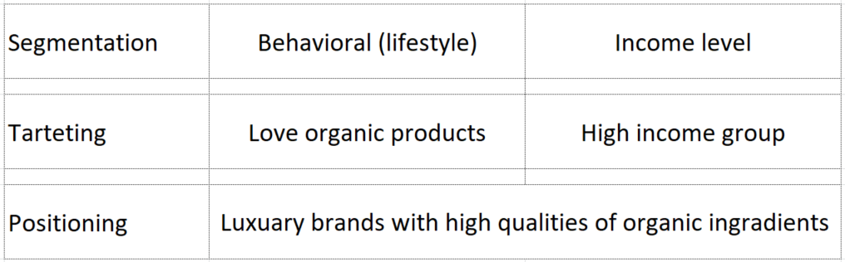
Source: Created by author
L'Occitane uses lifestyle and income level to segment the skincare market. It targets for upper-class or high income women who are fond of luxury and natural products.
  - Critical Success Factors for L’Occitane
The key attractions of brand are their quality and the use of natural and organic ingredients with traceable origins. (L'occitane International S.A, 2018a)

- Recommendation and Conclusion

Recommendations
    - AR helps luxury brands compete with large groups
The internet has already an integral part of the buying habits of among different groups of consumers globally. However nowadays, luxury sales revenue is being driven by millennials and Generation Z. (Arienti, et al., 2018) With the changed expectations, these younger Hong Kong consumers seek a personalized consumers experience that seamlessly integrates with both online and offline platforms. L’Occitane should shift is target customers as millennial and Gen Z. It should leverage the Augmented Reality (AR) technology in combination with their physical retail stores to enhance the shopping experience of their customers.
Currently, AR is used in cosmetic brand, but not in skincare market. L’Occitane should use AR allows the customers to see what will her face’s texture or appearance like look after few years at home, such as fine lines on face, by analysis her skincare habits. And make a personal advices for her and suggesting a suitable skincare product for her specifically and reveal her appearance after few years again if she accepts the advice and uses the L’Occitane products.
    - Instagram to boost the brand awareness among young customers
As marketers in Hong Kong know, social-media influence may work better in some niches than in others. “One particularity that remains in Hong Kong is forums. After Instagram, they are the most active platform through which people ask for advice and find resellers, discounts and good deals,” says Koh. (Ko , 2018)
Social media, especially Instagram, definitely acts as a catalyst to boost brand awareness. (Ko , 2018) L’Occitane should use key opinion leaders (KOL) to promote its products on Instagram instead of posting advertisement on magazines. Below (Figure 7) are two KOL suggesting for L’Occitane. Mssmlle and justavari are recently very popular skincare KOL.
Figure 7: Instagram KOL
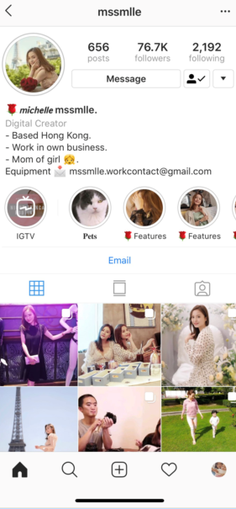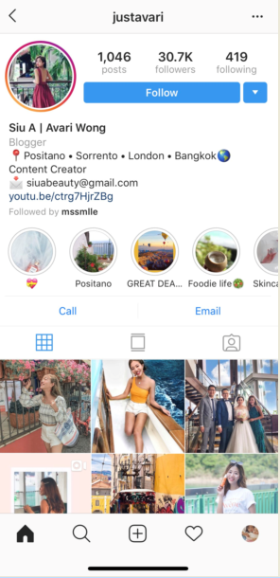

Conclusion
Although the majority of prestige beauty sales are still taking place in department stores, multi-branded stores and pharmacies, digital channels become the critical medium for our consumer decision-making. (Deloitte, 2017)
Technology enables new buying behaviors, but the fundamentals of marketing and brand building doesn’t never really be changed. The fact that consumers in Hong Kong, nowadays, are more health and wellness conscious, more diverse and more technologically empowered shouldn’t change the fundamental purpose as a brand, retailer or company. However, these shifts will require us to change the way how we reach those consumers. (Nielsen Holdings plc, 2018)
To sustain our competitive advantages, the company needs to throw out old playbook. Our customers are as focused on the transparency of the company and their practices as they are on what goes into the products they make. The skincare market – actually is real to apply on all markets - that will be successful, will be true and authentic, and harness the digital platforms or technology to achieve their marketing objectives.

Bibliography
Keller, . K.-L. & Kotler, P., 2009. Marketing Management. 13th ed. PrenticeHall, New Jersey: Upper Saddle River.
Adobe Systems Incorporated , 2015. L’Occitane: beauty in marketing, USA: Adobe Systems Incorporated.
Arienti, P. et al., 2018. Global Powers of Luxury Goods 2018 - Shaping the future of the luxury industry, Italy: Deloitte.
Assersohn, J. et al., 2018. Reimagining Retail-Bricks, mortar, and the evolution of e-commerce in Hong Kong. [Online]
Available at: https://access.jll.com/omni-channel-retail-paper-hk/?utm_medium=corporate_website&utm_source=social&utm_content=report_research&utm_campaign=AP-HK-RES-Retail-Omni-Channel-Paper-2018
[Accessed 2 6 2019].
Bollati, D., 2017. Cosmetics. [Online]
Available at: https://www.investhk.gov.hk/sites/default/files/2017.10-Cosmetics-en-1.pdf
[Accessed 2 6 2019].
Deloitte, 2017. Shades for success - Influence in the beauty market, London: Deloitte.
Federico, 2016. Skincare in Hong Kong: Overview. [Online]
Available at: http://www.daxueconsulting.com.hk/skincare-in-hong-kong/
[Accessed 2 6 2019].
GovHK, 2018. Hong Kong: The Facts. Tourism. [Online]
Available at: https://www.gov.hk/en/about/abouthk/factsheets/docs/tourism.pdf
[Accessed 22 1 2019].
Hales , C., 2017. China’s beauty trends: KOLs, organics, more make-up, and men. [Online]
Available at: https://www.scmp.com/lifestyle/fashion-luxury/article/2109267/chinas-beauty-trends-organics-live-streaming-influencers
[Accessed 2 6 2019].
Hansen, D. R. & Mowen, M. M., 2006. Management Accounting Edisi 7. s.l.:Jakarta: Salemba Empat.
Haydon, W. & Chan, V., 2017. Guide to Hong kong health and Beauty Retail Stores. [Online]
[Accessed 2 6 2019].
Hong Kong Trade Development Council, 2018. Cosmetics and Toiletries Industry in Hong Kong. [Online]
Available at: https://hkmb.hktdc.com/en/1X006S6I/hktdc-research/Cosmetics-and-Toiletries-Industry-in-Hong-Kong
[Accessed 2 6 2019].
Jeune , O., 2015. 10 Trends of Chinese consumers in Cosmetics. [Online]
Available at: http://cosmeticschinaagency.com/10-trends-chinese-consumers-cosmetics/
[Accessed 3 6 2019].
Knudson, J., 2018. L’Occitane updates engagement and streamlines its digital presence. [Online]
Available at: https://stores.org/2018/01/09/five-keys-to-a-better-online-user-experience/
[Accessed 2 6 2019].
Ko , C., 2018. Instagram hits: eight beauty brands that owe their start to social media site. [Online]
Available at: https://www.scmp.com/lifestyle/fashion-beauty/article/2167611/instagram-hits-eight-beauty-brands-owe-their-start-social
[Accessed 2 6 2019].
Kotler, P. & Armstrong, G., 2008. Principle of Marketing. New Jersey: Printice Hall International, Inc.
KPMG International, 2016. How much more convenient. [Online]
Available at: https://assets.kpmg/content/dam/kpmg/cn/pdf/en/2016/11/outlook-for-e-commerce-in-hong-kong.pdf
[Accessed 2 6 2019].
Leung, D., 2018. E-commerce in Hong Kong: Ready for Take-Off. [Online]
Available at: https://blog.euromonitor.com/e-commerce-in-hong-kong-ready-for-take-off/
[Accessed 22 12 2018].
L'Occitance International S.A. (B), 2018. Annual Results Announcement For The Year Ended 31 March 2018. [Online]
Available at: https://group.loccitane.com/sites/default/files/2018-06/Annual%20Results%20Announcement%20for%20the%20Year%20Ended%2031%20March%202018_Eng_0.PDF
[Accessed 2 6 2019].
L'Occitance International S.A., 2009. Prospectus. [Online]
Available at: https://www1.hkexnews.hk/listedco/listconews/sehk/2010/0426/ltn20100426175.pdf
[Accessed 2 6 2019].
L'Occitane (Far East) Limited, 2019. L'Occitane en Provence. [Online]
Available at: https://hk.loccitane.com/new-territories-district,39,1,4369,52571.htm
[Accessed 2 6 2019].
L'occitane International S.A. (A), 2018. Annual Report 2018. [Online]
Available at: https://group.loccitane.com/sites/default/files/2018-07/20180717_FY2018%20Annual%20Report_E.pdf
[Accessed 2 6 2019].
Matić, M. & Puh, B., 2016. Consumers' Purchase Intentions Towards Natural Cosmetics. Econviews, 29(1), pp. 53-64.
Mose, A. & Syaifuddin, 2016. Aanlysis of Macro and Micro Environment. Academy of Strategic Management Journal , Volume 15, pp. 35-41.
Nielsen Holdings plc, 2018. The Future of Beauty. [Online]
Available at: https://www.nielsen.com/nielsen_2018_the-future-of-beauty-report-pdf/
[Accessed 2 6 2019].
Retail News Asia, 2018. Google explains Hong Kong’s E-commerce chanllenge. [Online]
Available at: https://www.retailnews.asia/google-explains-hong-kongs-e-commerce-challenges/
[Accessed 2 6 2019].
Statista, 2019. Beauty & Personal Care. [Online]
Available at: https://www.statista.com/outlook/70000000/118/beauty-personal-care/hong-kong
[Accessed 2 6 2019].
Statista, 2019. Number of L'Occitane en Provence stores worldwide from 2016 to 2018, by country. [Online]
Available at: https://www.statista.com/statistics/753823/l-occitane-retail-stores-by-country/
[Accessed 2 6 2019].
The Consumer Council, 2016. Online retail: A Study on Hong Kong Consumer Attitudes, Business Practices and Legal Protection. [Online]
Available at: https://www.consumer.org.hk/sites/consumer/files/competition_issues/online-retail/full%20report_e.pdf
[Accessed 2 6 2019].
The International Trade, 2016. Asia Personal Care & Cosmetics Market Guide 2016, Washington: The International Trade;.
Trade Economics, 2019. Hong Kong GDP. [Online]
Available at: https://tradingeconomics.com/hong-kong/gdp
[Accessed 2 6 2019].
Yu, P., 2017. HONG KONG FEMALE CONSUMERS SPEND OVER HK$4,000. [Online]
Available at: www.nielsen.com/hk/en/insights/news/2017/hong-kong-female-consumers-spendover-
[Accessed 2 6 2019].

Appendix
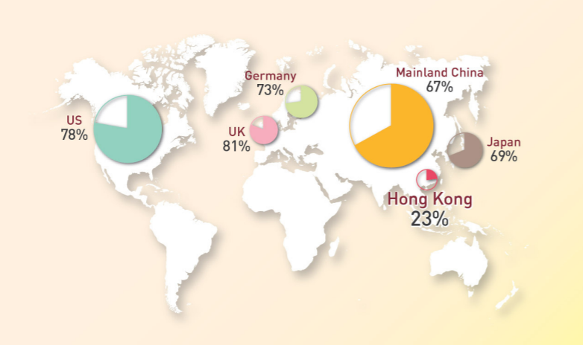
Figure 8: Online retail penetrating rate in Hong Kong is far lagged behind. (Source: Consumer Council, 2016)

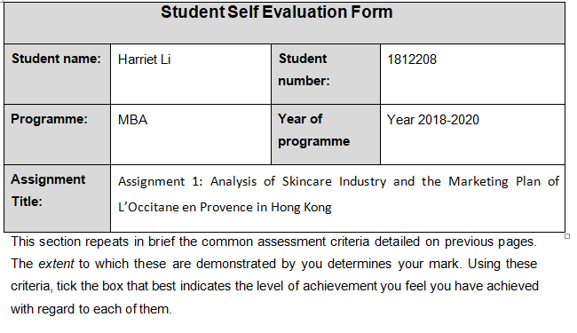
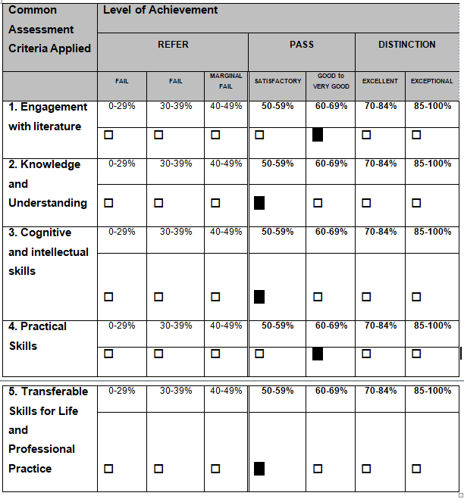

s

