Appendices
0800077

Appendix 1 = Seating Plan
Appendix 2 = Blank semi-structured interview questions used
Appendix 3 = Blank questionnaire used for pupils.
Appendix 4 = Ethics Form
Appendix 5 = Bar graph to represent quantitative data from the questionnaire.
Appendix 6 = Parent consent form for the child.
Appendix 7 = Staff consent form
Appendix 8 = Information sheet about the study for children.
Appendix 9 = Information sheet about the study for staff.
Appendix 10 = Information sheet about the study for parents.
Appendix 11 – Photograph of oracy area.

Appendix 1 = Year 3 Seating Plan in Classroom

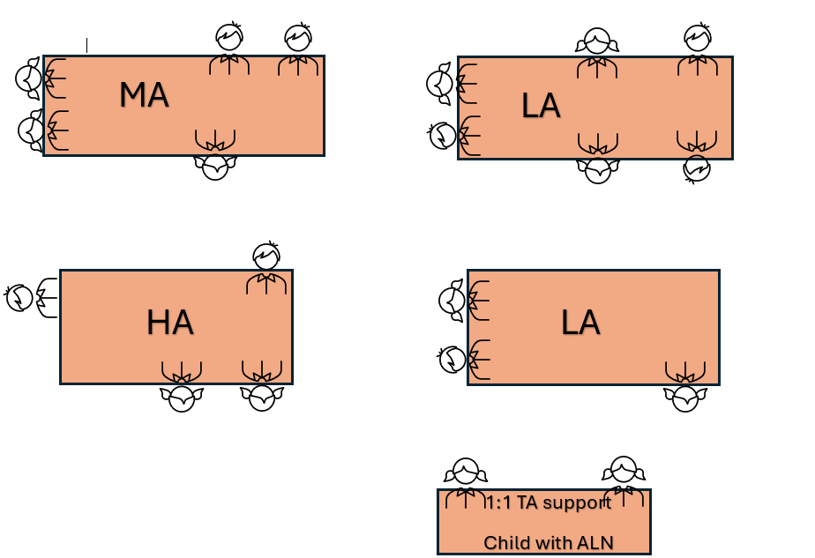

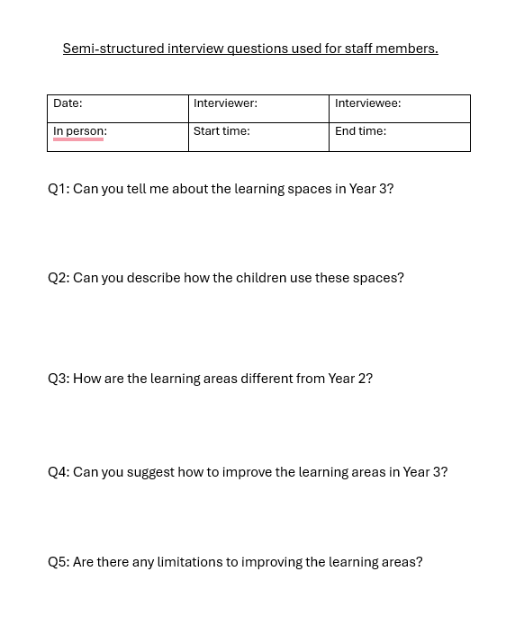
Appendix 2– Blank Semi -Structured Interview Questions for Staff Members
Appendix 3 - Blank Questionnaire used for Pupils

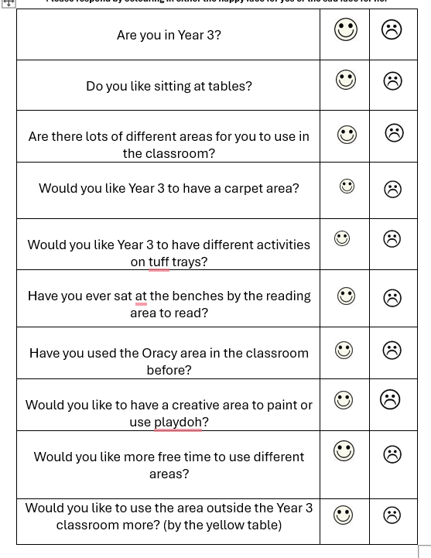
Appendix 3 - Blank questionnaire used for pupils.

Appendix 4 – Ethics Form

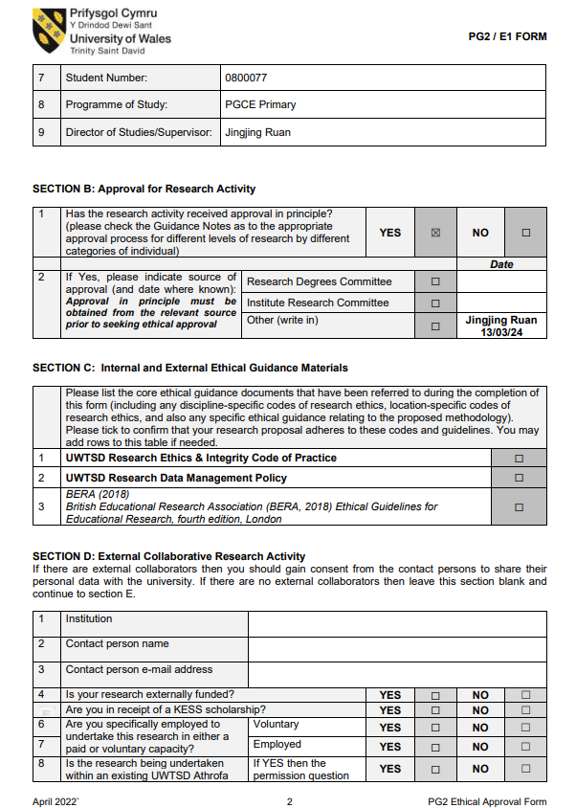
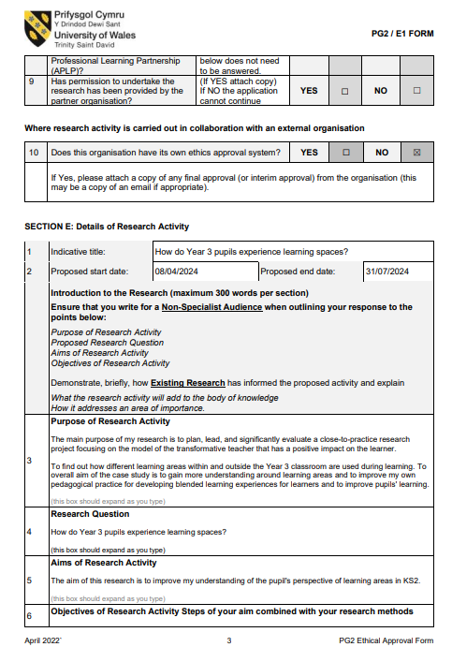
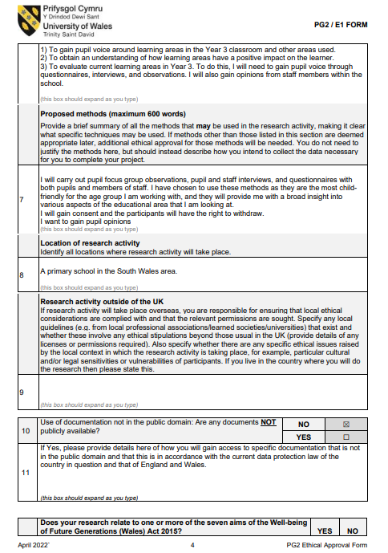
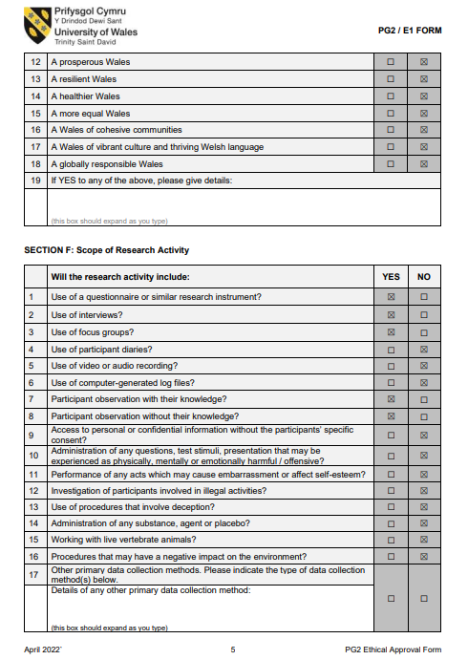
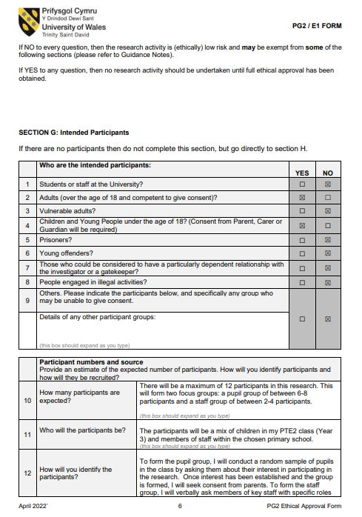
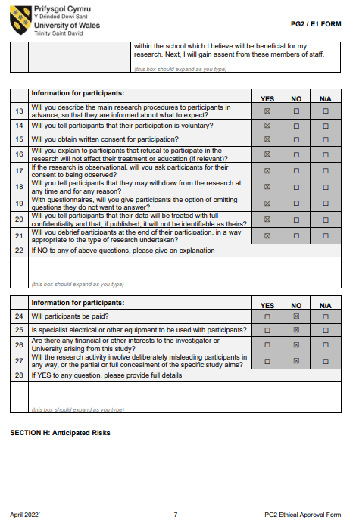
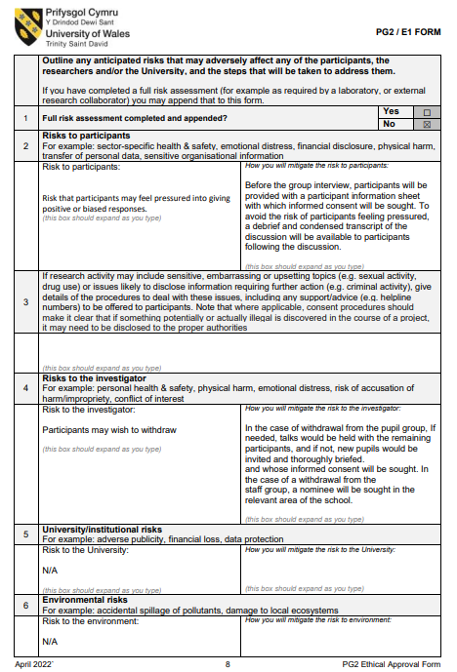
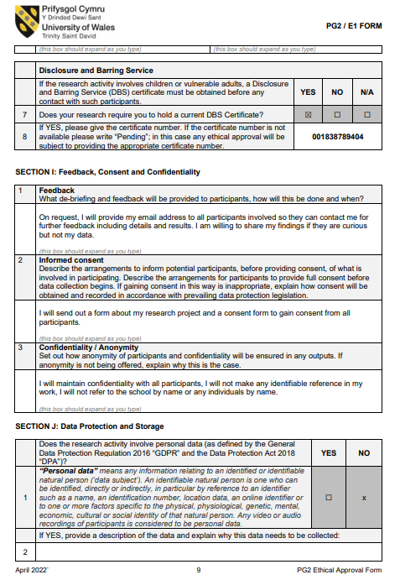
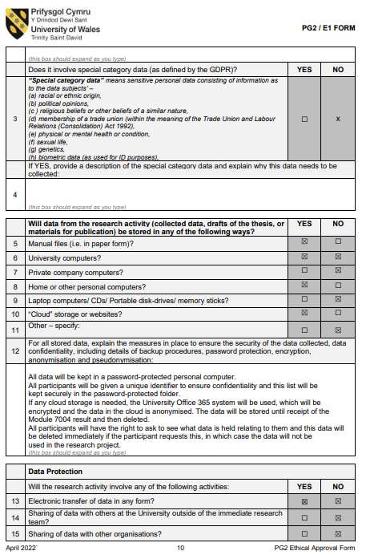
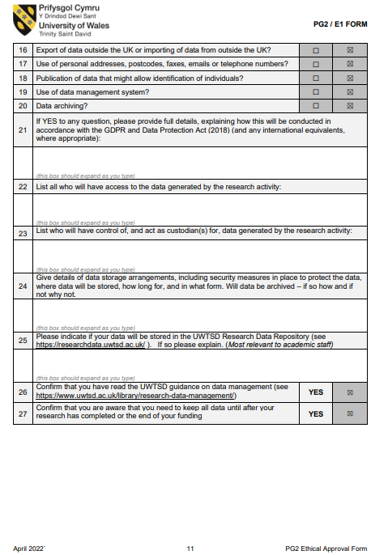
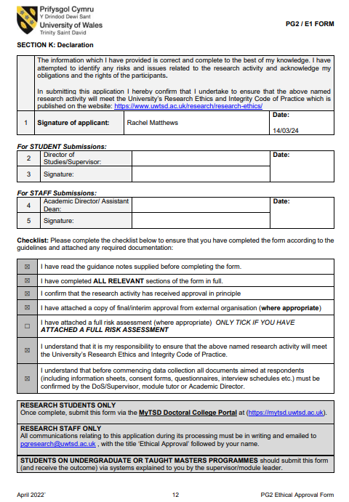
Appendix 5 - Graph to represent quantitative data from the pupil responses to the questionnaire.

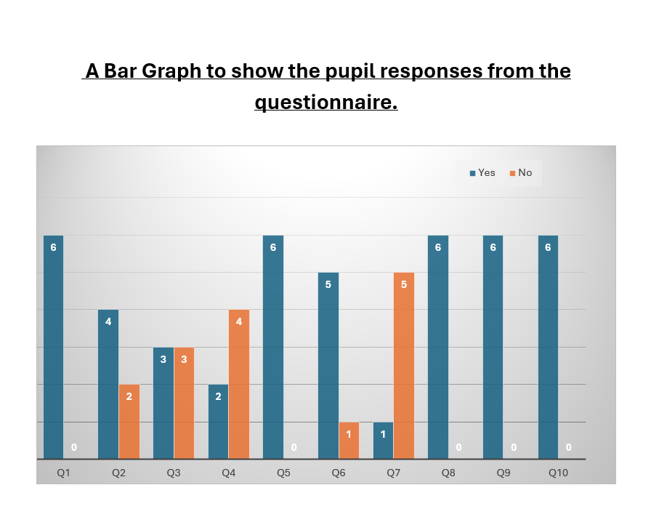

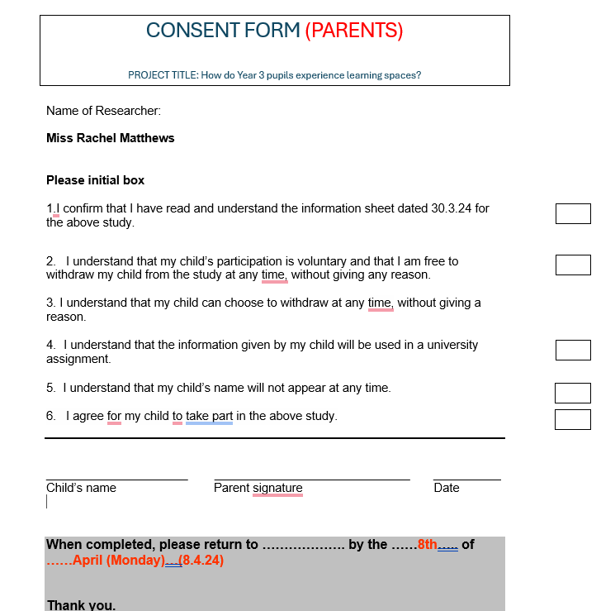
Appendix 6 – Parent Consent Form for Pupil Participation.

Appendix 7 – Staff Consent Form for Participation in Semi -Structured Interview
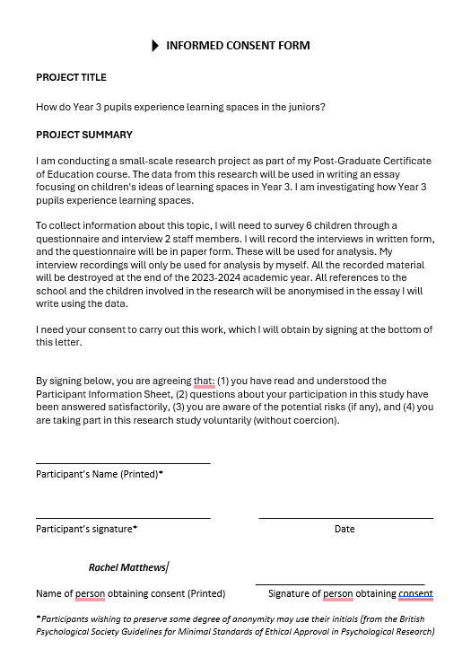
Appendix 8 – Information Sheet about the study for children.
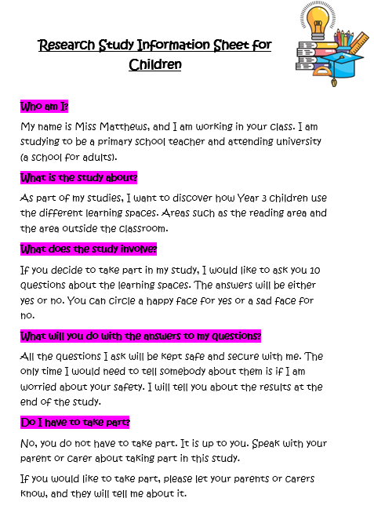
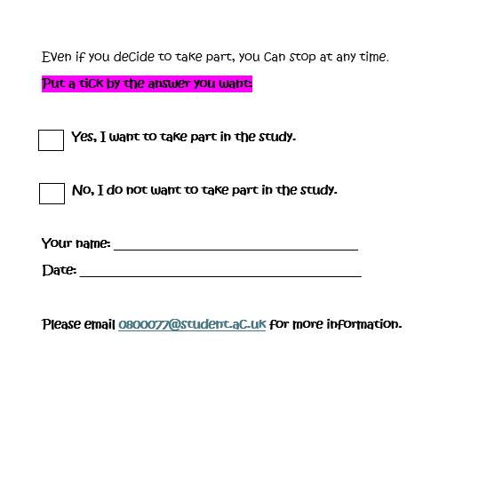

Appendix 9 – Information sheet about the study – Staff
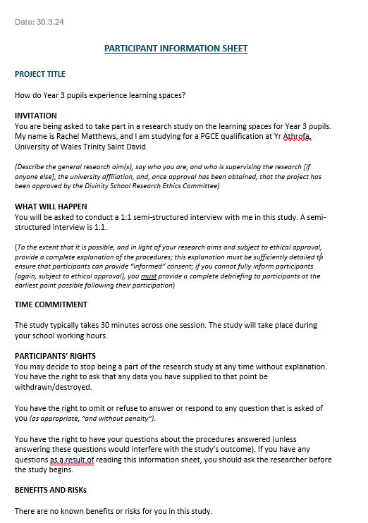
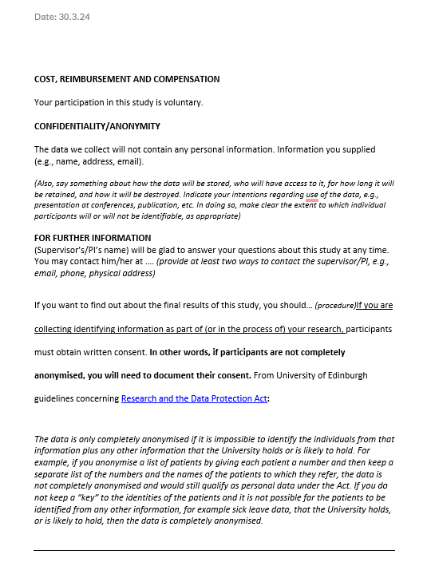

Appendix 10 - Information sheet about the study for Parents
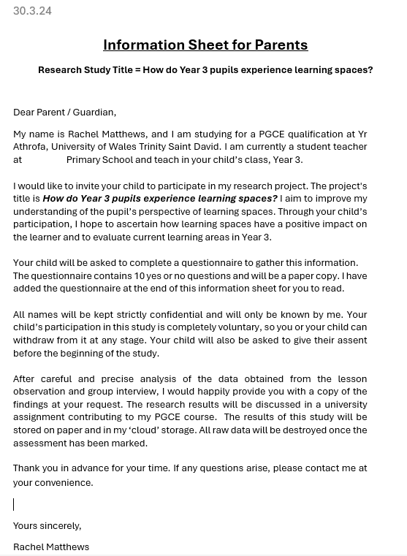
Appendix 11 – Photograph of Oracy Area



