I declare that this assignment is all my own work and that I have acknowledged all materials used from the published or unpublished works of other people. All references have been duly cited.
Critically appraise the procurement and resource planning used within an organisation, such as the UK MOD, to meet the organisation’s strategic objectives such as Army 2020.
ABSTRACT
Against a backdrop of austerity and rapidly changing, diverse global threats, the MOD is attempting to transform defence with an overhauled, more agile acquisition system at the heart of its plans.
MAIN TEXT
“Our national security depends on our economic security, and vice versa. So the first step in our National Security Strategy is to ensure our economy is, and remains, strong.” (Cameron, 2015)
In 2015 David Cameron’s government set out it’s Strategic Defence and Security Review (SDSR) with the intention of refining the 2010 SDSR. The document laid down the United Kingdom’s three National Security Objectives: ‘Protect our people’, ‘Project our influence’ and ‘Promote our prosperity’. These security objectives do not fall solely to the MOD, as they encroach on spheres of influence of other government departments such as DTI, DFID and the FCO. The majority of the MOD’s remit can be found within the ‘Protect’ and ‘Project’ objectives.
The document lays out ‘four particular challenges are likely to drive UK security priorities for the coming decade’:
- Increased threat of terrorism, extremism and instability.
- Resurgence of state-based threats.
- Impact of technology, especially cyber threats.
- Erosion of the rules-based international order.
Central to the 2015 SDSR was the government’s desire to refine its defence industrial plan by taking ‘further action to help the UK’s defence and security industries to grow and compete successfully’ and to ‘drive greater innovation into the UK’s defence procurement to ensure that future investment decisions contribute to a more dynamic and productive economy.’ (HMG, 2015)
In 2017 the government built on this with its Green paper “Building our Industrial Strategy”, which highlighted the need to improve defence procurement and encouraged inward investment. There was ‘…broad support from both industry and the trade unions’ (HoC DC 2017) for this policy and, in his evidence to the House of Commons Defence Committee, Professor Utley argued that the defence industrial policy was ‘…predicated on, among other factors, a particular view of value for money…’ and that ‘…there was “some mileage” in a broader conception of value for money that looked at the: Net economic and security benefits of different acquisition options in terms of where the pound goes: the economic and employment multipliers that are derived from investing in suitable onshore alternatives, fiscal revenues, strategic influence that can be derived from exporting national defence goods and so on’. (HoC DC 2017)
In simple terms this somewhat defines the MOD’s market orientation:
- Efficiencies and savings (not profit making).
- Invest, where possible, in UK industry.
The current ‘Defence Operating Model’ originated from Lord Levene’s ‘Defence Reform Review’ (2010). Within this model is the acquisition system which is ‘…founded on two main principles…– simplicity of approach and clarity of accountability.’ (MOD, 2015)
The model and key elements of the acquisition system is outlined below:
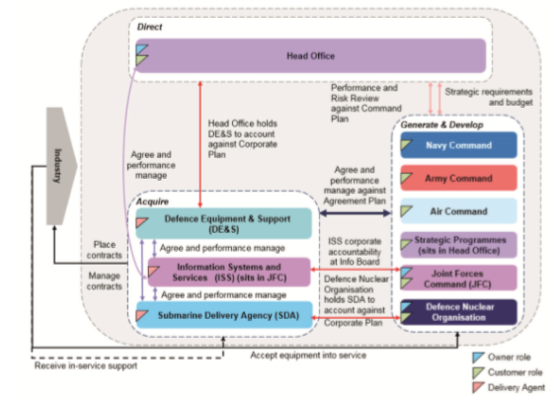
Figure 1. The Acquisition System’s top-level accountabilities, organisations and interactions (DE&S, 2018)
The head office sets strategy, allocates resources, makes high-level investment decisions - and holds the customers and the delivery agents to account. The customers are the four commands (and the Director of Strategic Programmes in Head Office) that are accountable for informed, economic decisions about equipment, logistic support and information services they require to meet their mission. The delivery agents are DE&S and ISS, who ‘…support the customers to make economically rational and evidence-based decisions, by providing consistent and reliable financial, commercial, industrial and technical advice and information...’ and ‘…manage the relationship with suppliers in industry, delivering best value for Defence, to meet the customers’ needs.’ (MOD, 2015)
The work of DE&S is regulated by the ‘Single Source Regulations Office’(SSRO), which is ‘…an independent statutory regulator of the UK government’s procurement of ‘single source’, or non-competitive, military goods, works and services.’ (HoC DC, 2017).
The SSRO exists due to the Currie Review of 2011, which looked into the ‘Government Profit Formula and its Associated Arrangements’ (GPFAA), also known as the ‘Yellow Book’. Established in 1968, it was an agreement between the Treasury and Confederation of British Industry to govern single source defence contracts. Lord Currie was charged with looking at increasing contractor efficiency and value for money for the taxpayer. The review found that there had ‘…undoubtedly been inefficiencies in single source MOD spending, partly a result of inefficiencies on the side of industry and from skilful deployment of Yellow Book regulations to secure returns that, although within the regulations, have not been appropriate’ (Currie, 2011)
The SSRO was therefore established to ‘investigate whether suppliers are being as efficient as possible.’ (Currie, 2011)
Unfortunately, despite the MOD’s claims that the Acquisition Framework had brought ‘step changes in performance’, it comes in for some severe criticism: ‘Professor Taylor warned that…the relationship between DE&S and the front line commands made sense for purchasing products which were already available in the marketplace, it made “little sense at all” for projects requiring significant development effort, or for arranging “sensible in-service support arrangements” (HoC DC, 2017) and this is further compounded by DefenceSynergia which suggested that ‘…if the four DE&S divisions (maritime, land, air and Joint) were embedded within their respective commands, each head of Command would have responsibility not only for the budget and resources, but would also assume accountability and the ability to “tune procurement processes in context”. As a result, “the Four Service Chiefs would be held accountable for the ‘Whole Force’ delivery of their tasked Capabilities”.’ (HoC DC, 2017)
To help achieve the goals of the SDSR the MOD published the Defence Equipment Plan 2016, ‘…pledging to spend £178 billion over the next ten years on defence equipment and support, including eight Type 26 Global Combat ships, new mechanised infantry vehicles and nine new Boeing P–8A Maritime Patrol aircraft.’ (HoC DC, 2017)
Naturally many of these projects now lie within DE&S, which looks to ‘deliver flexible and agile commercial solutions through a simplified “five by six” procurement route model. Our five procurement routes and six standard forms of contract will be supported by a range of process improvements, designed to drive consistency, simplification and speed to market’ (DE&S, 2018)
The ‘five by six procurement model’ can be seen below:
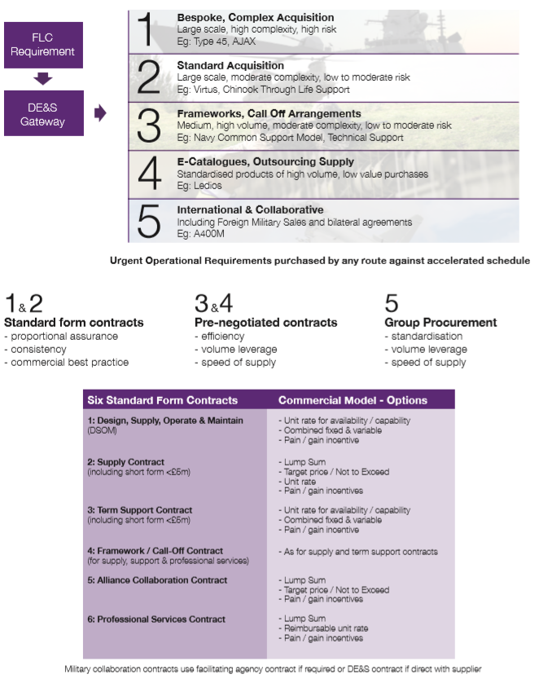
Figure 2. Five by Six Procurement Model (DE&S, 2018)
In short, when a customer approaches DE&S with a requirement then one of five procurement methods will be chosen – dependent on the projects scale, complexity and risk. The Project Team can then use one of six types of contract that they feel is best suited to the project. Standard form contracts are efficient for the procurement of mass goods and services as they ‘…can reduce transaction costs by eliminating the need to negotiate the many details of a contract for each instance a product is sold or a service is used. However, these contracts also have the ability to trick or abuse consumers because of the unequal bargaining power between the parties.’ (www.faircontracts.org, 2018). Pre-negotiation and group procurement contracts allow DE&S to take advantage of their volume leverage to achieve economies of scale and acquire goods at higher speeds.
To enhance the MOD’s procurement capability, it is currently developing the ‘Contracting Purchase and Finance’ tool to ‘provide a single end to end capability for its existing procurement tools.’ (MOD, 2018). It is intended that the tool will replace P2P, DCO, AWARD and all other paper processes; will provide the MOD and suppliers with improved contract visibility and management.
With a large amount of equipment programmes, the MOD has many diverse needs - and these are usually met by specialist suppliers who cater to unique market segments. It can therefore be said that the MOD sometimes operates in ‘fragmented markets’. In other market segments, where technology is jealously guarded by companies (and their host nations governments), it can be argued that the MOD is faced with monopolistic markets. Whilst the defence industrial plan looks to maintain and develop the UK’s workforce skills and sovereign capabilities, Prof Taylor stated that MOD procurement has a somewhat contradictory attitude as it also looked to ‘…buy from the world market in order to gain the maximum freedom possible.’ (HoC DC, 2017). Prof Uttley has argued that ‘…the procurement of off-the-shelf equipment had a negative impact on the number of qualified scientists and engineers employed in the UK.’ (HoC DC, 2017) and this was mirrored by DefenceSynergia who ‘…warned that while increased levels of procurement from the USA may increase “commonality” and “inter-operability” with our key ally, it also had the effect of reducing UK expertise in industrial design, manufacturing and support.’ (HoC DC, 2017). It can also be highlighted that such procurement policies negatively impact on the UK’s export potential, as demonstrated in the fact that it has not sold a new frigate, submarine or destroyer since the 1970’s.
SDSR 2015 contained a government pledge to spend £178 billion over 10 years, with £24.4 billion set aside for new projects. By the time of the release of the 2016 Defence Equipment Plan, the forecasted key spending on defence procurement had risen from £68.5 billion to £82 billion, new equipment support arrangements rose by 28% to £23 billion and contingency provision increased 23% to just over £5 billion. Meanwhile, the cost of supporting existing, in service equipment rose by just 2%. To generate funds the MOD intends to sell off 30% of defence estates, which will also generate savings of £2.4 billion.
Much of the plans affordability is owed to ‘Efficiency Savings’. The MOD needs to make efficiency savings of ‘…a final target figure of £9.8 billion.’ (HoC DC, 2017). However, the National Audit Office ‘…raises concerns about whether the target will be achieved’ and ‘…repeatedly highlights the lack of clarity as to the specific projects that would be targeted for ‘efficiency savings’ (HoC DC, 2017). As highlighted below, the MOD had struggled to meet savings goals laid out in 2015:
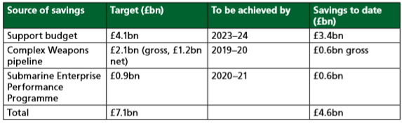
Figure 3. MoD progress against previously announced ‘efficiencies’ (HoC DC, 2017)

The House of Commons Defence Committee endorsed the NAO’s view that ‘affordability of the plan is now at greater risk than at any time since reporting was introduced in 2012”, warning that the MoD “faces the risk that in future it may have to return to a situation where affordability of the portfolio is maintained by delaying or reducing the scope of projects.’ (HoC DC, 2017).
The NAO therefore recommended that the government should:
• “establish clear baselines against which savings are to be measured;
• establish a robust audit trail;
• put in place reporting arrangements which mitigate the risk of double-counting;
• report on risks to deliverability and sustainability of savings; and
• create clear lines of accountability for delivery within budget holders” (HoC DC, 2017)
This criticism has been acted upon by DE&S, who measure their corporate performance against Key Performance Indicators (KPI’s) every 2 months. Each KPI is measured by a metric (usually %) for each customer – Navy, Army, Air, JFC and Director Strategic Programmes. Most are given a health rating of Red (unsatisfactory), Amber (warning) or Green (satisfactory). Each project feeds into this table – and project managers, use similar project management tools and techniques to track progress and costs at a local level. An example of the DE&S KPI’s:
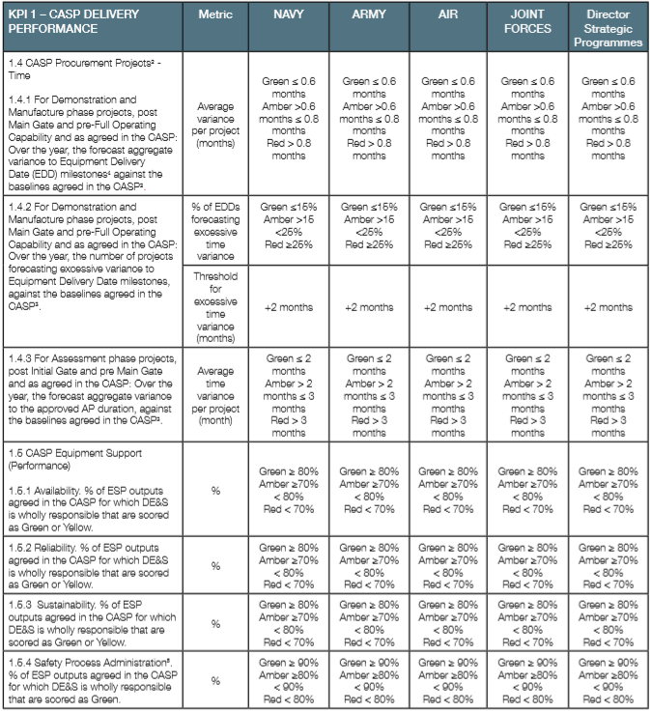
Figure 4. DE & S Key Performance Indicators (DE&S, 2018)
A potential failure point within the MOD procurement organisation is loss of highly skilled personnel. This was highlighted in 2017 by Stephen Lovegrove (MOD PUS) upon the resignation of the DE&S CEO Tony Douglas, who ‘…had been a “real force for change” within DE&S and had “provided an enormous amount of positive momentum” for the organisation.’ His successor, Roger West, departed in 2018. Marcine Waterman, the CE of the SSRO, also departed in late 2017 – after her two predecessors lasted only 2 years in total. At this point it was recommended that (SSRO) ‘…personnel must be chosen, and its funds provided, independently of the MoD.’ (HoC DD, 2017).
Indeed, across the MOD ‘We are developing initiatives for the MOD workforce to help address the skills challenge facing the UK defence sector…We are on track to expand MOD apprenticeship programmes further to train at least 50,000 apprentices by 2020.’ (HMG, 2016). The following stakeholder and relationship map shows some of the competing and complimentary demands for a skilled project manager:
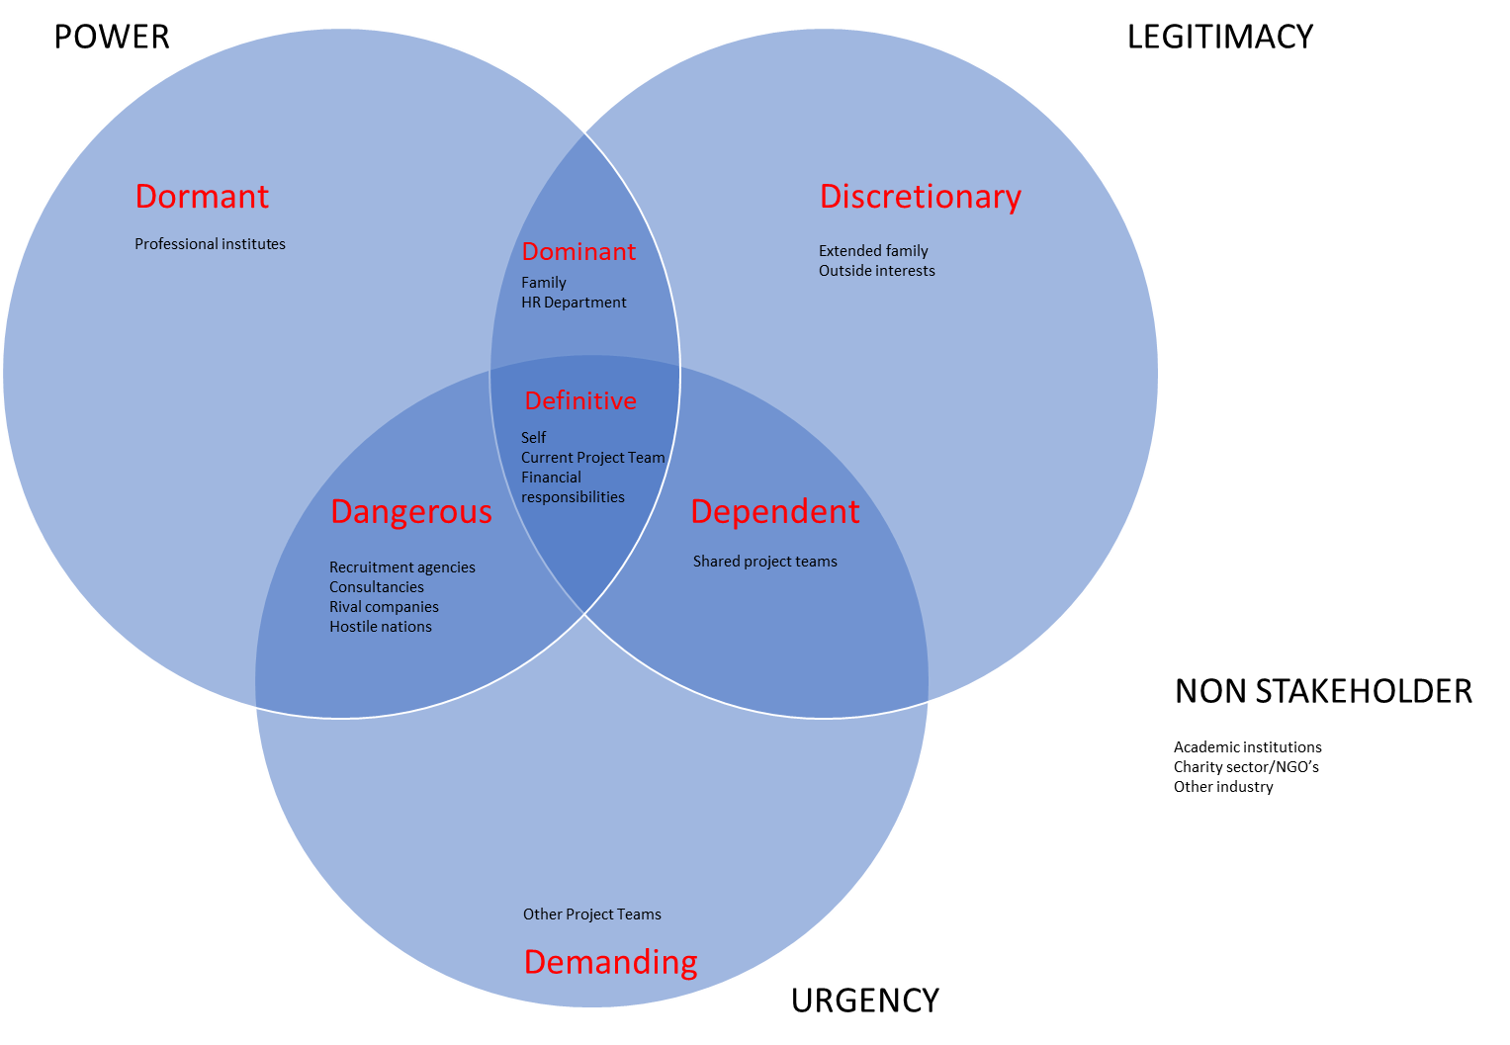
Figure 5. Competing and Complimentary Demands for Skilled Personnel.
The primary requirement to satisfy ones own wants and needs means that ‘the self’ is placed in the definitive class, along with the current project team for which they work – and the need to meet any personal financial obligations they have e.g. Mortgage, bills etc. Some project managers work on secondary projects and so, with less power than the primary project, this team can be seen as ‘dependent’ on them. The family can be classed as ‘dominant’ as they exercise a large degree of power and legitimacy over the individual – but perhaps less urgency, however at times this may change. Dangerous stakeholders may be seen to be rival companies and agencies with the ability to lure the employee away from the project team with the promise of an increased salary, or better conditions. Likewise, a hostile nation, with lots of power and urgency, might look to corrupt, damage or kill employees to further their aims.
If DE & S were unable to attract the right calibre of acquisition staff or project managers then it is likely that projects would struggle to maintain coherence, direction and efficiency resulting in increased costs and overruns. A catastrophic failure could be brought about by a hostile nation or terror organisation if they were to successfully target DE & S, MOD Abbey Wood with the intention of causing mass casualties e.g. Airstrike, bomb attack. Of the 11,400 personnel employed by DE & S across the UK - a significant percentage work at the Abbey Wood site. A mass casualty incident at this location would mean that, in an instant, the MOD would lose huge swathes of professional and corporate knowledge, lose elements of command and control, have its human networks with contractors disrupted, lose physical documentation and plans; also have its e-commerce communications disrupted. The current location of so many project teams in the same location is akin to placing all its eggs one basket. A contingency plan to counter this threat might:
- Embed DE&S divisions into front line commands. As well as giving each Command ‘…accountability and the ability to “tune procurement processes in context”,’ as suggested by DefenceSynergia – it would also offer security advantages to the organisation by not having all of its staff in the same location.

- Encourage more employee home working. Again, this would spread staff out away from one central location. However, it may also act as a recruitment tool, using the prospect of home working as an incentive to tempt high quality staff away from rival employers whilst also retaining current staff.

- Set up satellite offices in regions close to key contractors or in depressed regions able to offer skilled workers and office space at lower prices.
CONCLUSION
The Gray and Levene reviews have triggered a much needed, ambitious transformation programme within the MOD but it is concerning that its projected efficiency savings are unrealistic, that future projects may need to be delayed or reduced - and that the current centralisation of DE&S staff leaves wider defence vulnerable.

Word count: 2544.
List of Figures:
Figure 1. DE&S (2018). The Acquisition System’s top-level accountabilities, organisations and interactions. “DE&S Corporate Plan 2018-2021”
Figure 2. DE&S (2018). Five by Six Procurement Model. “DE&S Corporate Plan 2018-2021”
Figure 3. HoC DC (2017). MoD progress against previously announced ‘efficiencies’ “Gambling on ‘Efficiency’: Defence Acquisition and Procurement.”
Figure 4. DE&S (2018). DE&S Key Performance Indicators. “DE&S Corporate Plan 2018-2021”
Figure 5. Competing and Complimentary Demands for Skilled Personnel.

References:
Cameron, D (2015). Foreword: “National Security Strategy and Strategic Defence and Security Review 2015.” https://assets.publishing.service.gov.uk/government/uploads/system/uploads/attachment_data/file/478936/52309_Cm_9161_NSS_SD_Review_PRINT_only.pdf Retrieved 12 Jun, 2018.
HMG (2015). “National Security Strategy and Strategic Defence and Security Review 2015.” https://assets.publishing.service.gov.uk/government/uploads/system/uploads/attachment_data/file/478936/52309_Cm_9161_NSS_SD_Review_PRINT_only.pdf Retrieved 12 Jun, 2018.
House of Commons Defence Committee (2017). “Gambling on ‘Efficiency’: Defence Acquisition and Procurement.” https://publications.parliament.uk/pa/cm201719/cmselect/cmdfence/431/431.pdf Retrieved 12 Jun, 2018.
Ministry of Defence (2015). “How Defence Works.” https://assets.publishing.service.gov.uk/government/uploads/system/uploads/attachment_data/file/484941/20151208HowDefenceWorksV4_2.pdf Retrieved 19 Jun, 2018.
Lord Currie of Marylebone (2011). “Review of Single Source Pricing Regulations.” https://assets.publishing.service.gov.uk/government/uploads/system/uploads/attachment_data/file/35913/review_single_source_pricing_regs.pdf Retrieved 19 Jun, 2018.
“What are standard form contracts?” http://www.faircontracts.org/what-are-standard-form-contracts Retrieved 20 Jun, 2018.
Ministry of Defence (2018). Leaflet: “Contracting, Purchase & Finance will affect all suppliers involved in MOD procurement…”
HMG (2016). “National Security Strategy and Strategic Defence and Security Review 2015 - First Annual Report 2016.” https://assets.publishing.service.gov.uk/government/uploads/system/uploads/attachment_data/file/575378/national_security_strategy_strategic_defence_security_review_annual_report_2016.pdf Retrieved 21 Jun, 2018.

