BA (Hons) Musical Theatre

Assessment Cover Page

Name: Sienna Cullen-Toppar

Student Number: 2501062
Module Name: Learning in the digital era

Module Code: ADPA4001
Assessment: Reflective video & E-portfolio
Word Count:
(Please do not include your bibliography and reference list in your word count, and make sure the bibliography and reference list are at the end of your work alongside any appendices)

https://youtu.be/eH8WegDDDJQ?feature=shared

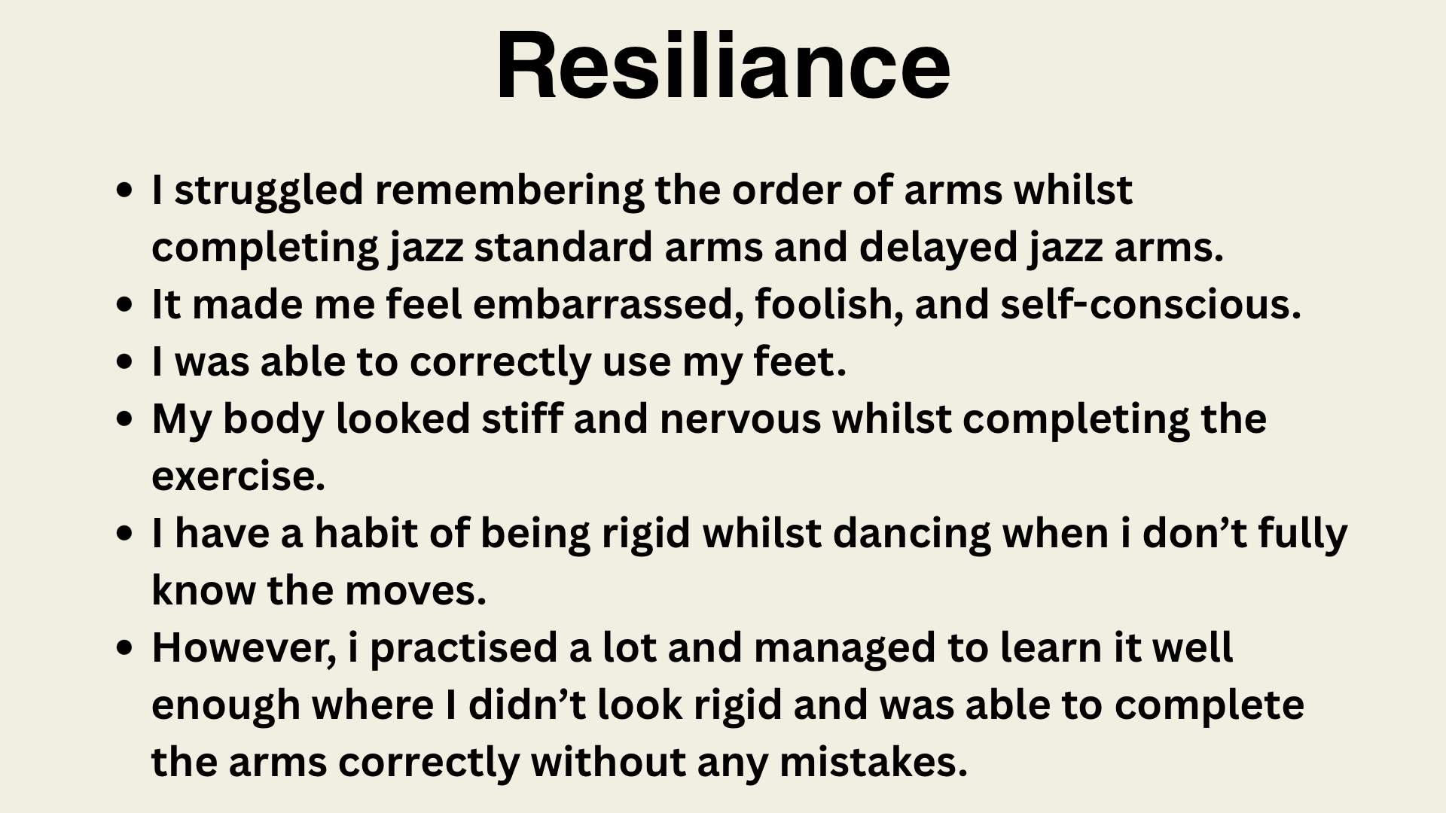
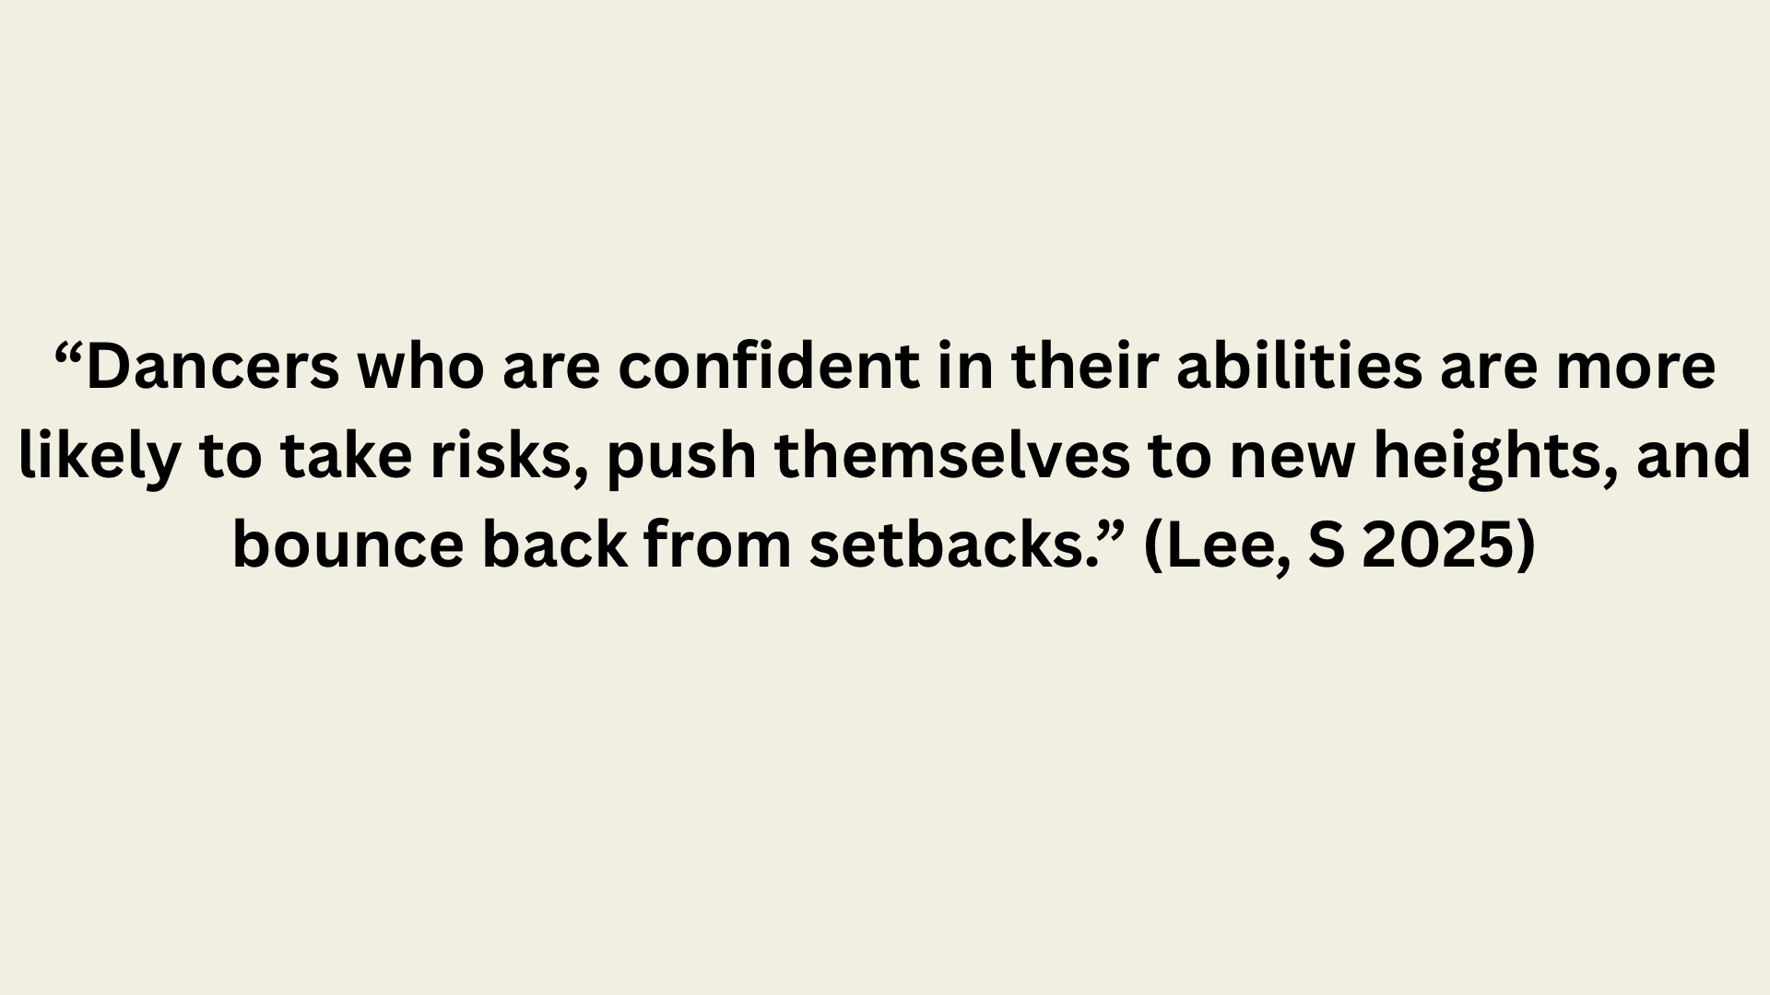
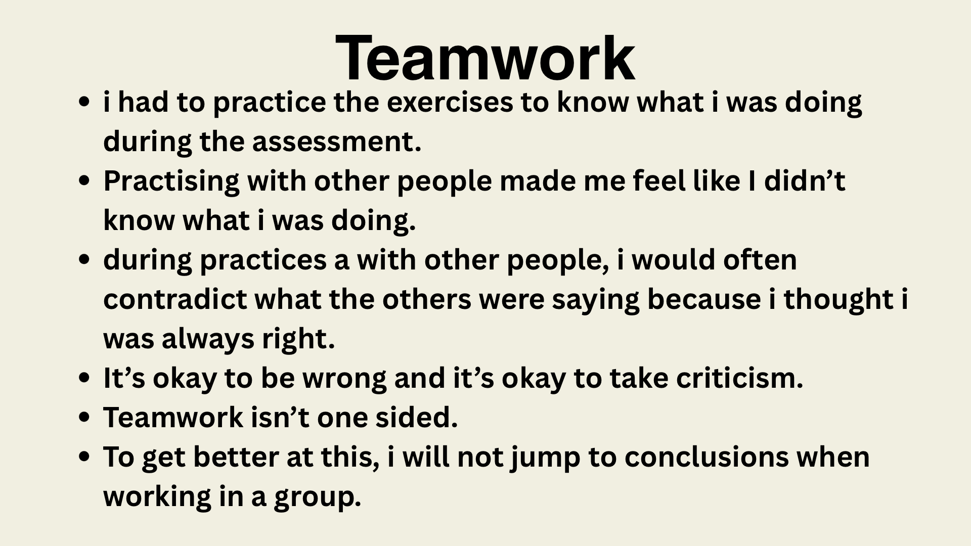

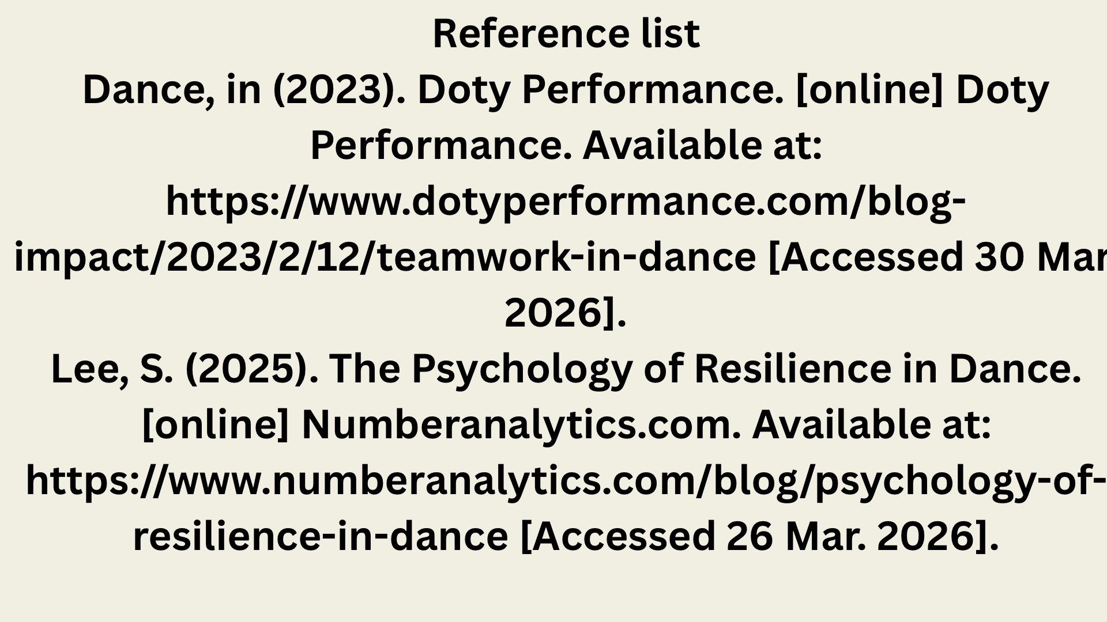
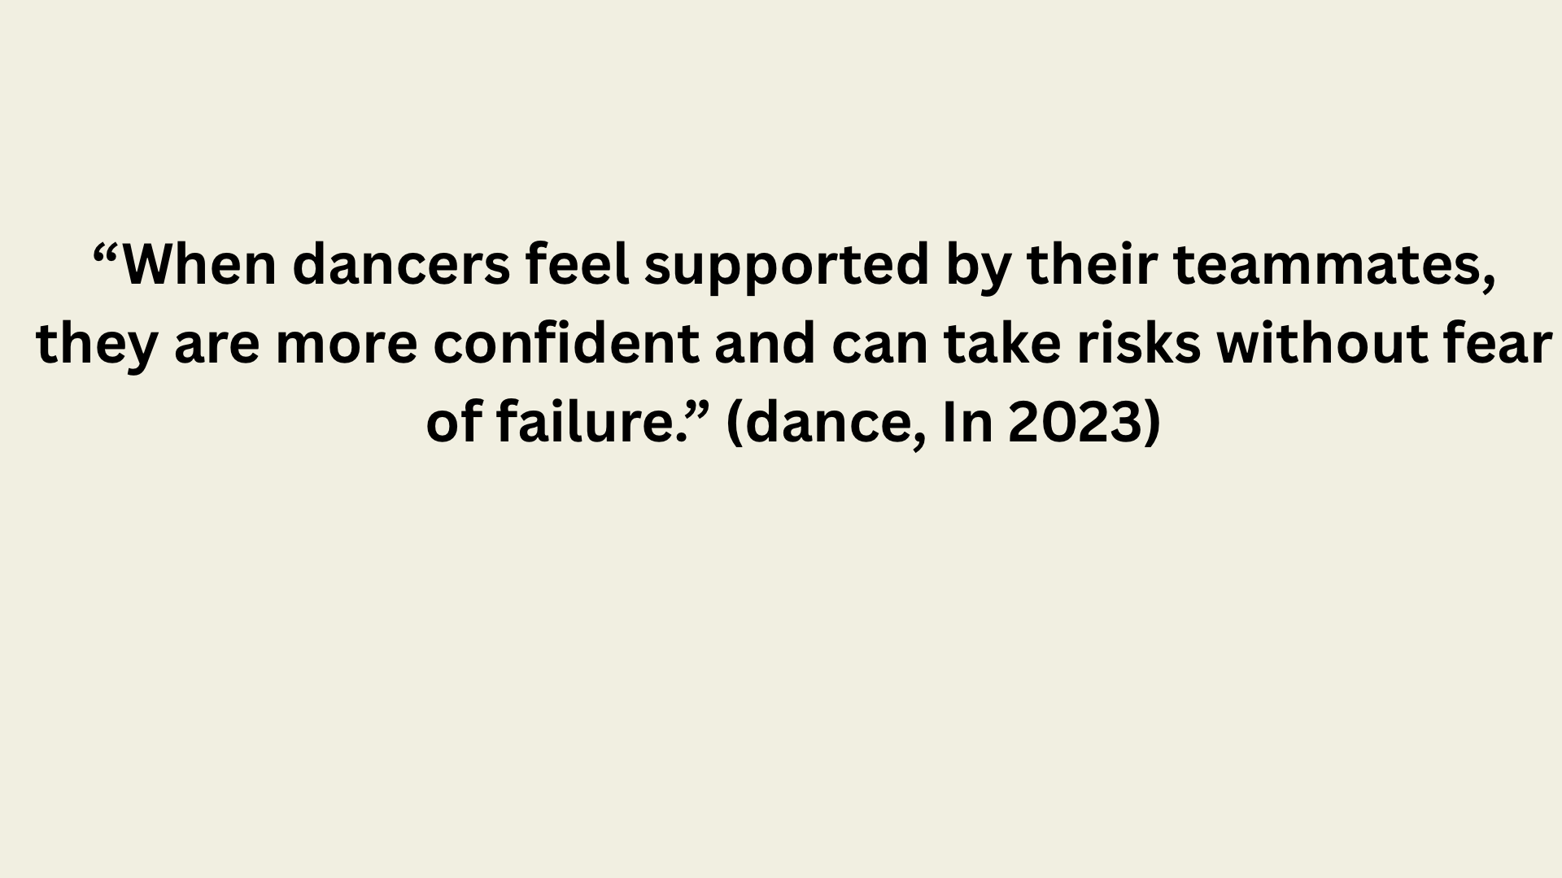

Reference list
Dance, in (2023). Doty Performance. [online] Doty Performance. Available at: https://www.dotyperformance.com/blog-impact/2023/2/12/teamwork-in-dance [Accessed 30 Mar. 2026].
Lee, S. (2025). The Psychology of Resilience in Dance. [online] Numberanalytics.com. Available at: https://www.numberanalytics.com/blog/psychology-of-resilience-in-dance [Accessed 26 Mar. 2026].

