Dissertation – LCBB6000 BA (Hons) Business Management
TITLE: IMPACT OF SOCIAL MEDIA INFLUENCER ON COMPANY BRANDING. A CASE STUDY OF LK BENNETT UK
University of Wales Trinity Saint David (London Campus)
Student Name: Ioan Nemes
Student ID:1921883
Name of the university: University of Wales Trinity Saint David (London Campus)
Submission date:30.04.2024

Abstract
The current research focuses on the impact of influencer-based marketing on social media platforms that focuses on the UK-based fashion retailer LK Bennette. The first chapter of the dissertation establishes the research aims, objectives and relevant questions that provide the required direction for the research execution. It consists of a background of the research, which depicts the current scenario of influencer-based marketing in the UK. It also states the relevant problem statement that needs addressing through the research. The chapter concludes with a structural distribution of the entire dissertation containing key segments executed in it. The second chapter of this dissertation consists of a literature review that provides an effective interpretation that supports the relevance of the topic. It produces the industrial value and impact of influencer-based marketing that is currently practised across organisations. The literature review throughout its theoretical explanations and relevant findings obtained that the current market scenario produces valid requirements of influencer-based branding for the UK based organisations. The fourth chapter describes the themes in relation with the research objectives, this chapter gathers relevant data about the UK fashion industry and the chosen company. The last chapter concludes the overall findings and finds some limitations within the study. Recommendations are given to improve the research along with the scope of future studies.
Table of Contents
1. Introduction 5
1.1 Background of the research 5
1.2 Background of the organisation 6
1.3 Problem Statement 7
1.4 Research Aim 7
1.5 Research Objectives 7
1.6 Research Questions 7
1.7 Research Significance 8
1.8 Dissertation Structure 8
1.9 Summary 9
2. Literature Review 10
2.1 Introduction 10
2.2 Identification of the major characteristics and impact of influencers within organisational branding 10
2.3 Analysis of the necessity of influencer-based branding towards organisational success 12
2.4 Assessment of the barriers related to influencer-based marketing in an International Context 14
2.5 Identification of the relevant strategies that can mitigate the issues related to influencer-based marketing 15
2.5 Conceptual Framework 17
2.6 Literature Gap 17
2.7 Summary 17
3. Research Methodology 18
3.1 Research Onion 18
3.2 Research Philosophy 18
3.2 Research Approach 19
3.3 Research Strategy 19
3.4 Research Design 20
3.5 Sampling Method 20
3.6 Data collection method 21
3.7 Data Analysis 21
3.8 Ethical consideration 22
3.9 Summary 22
4. Findings and Analysis 23
4.1 Introduction 23
4.2 Thematic Analysis 23
4.3 Survey 28
4.4 Data Analysis 36
4.5 Summary 41
5. Conclusion and Recommendations 42
5.1 Overall conclusion 42
5.2 Linking with Objectives 42
5.3 Limitations 44
5.4 Recommendation 44
5.5 Future Scope of the Research 45
References 45
Appendix 51

Introduction

1.1 Background of the research
The promotional aspects in modern organisations are subject to improvisation and exclusive ways of customer engagement that require suitable actions as per the new age considerations. Digital marketing plays a vital role in terms of progressive aspects of branding which allows the brands irrespective of their sizes to target consumers with efficiency. According to Evans et al., (2021), social media marketing is one of the modern platforms of digital marketing that provides inclusive scenarios for brand promotion and brand engagement for the organisation. The different influences in this aspect are the key individuals associated with the field of social media, athletics, entertainment, and public awareness. Influencer-based marketing is one of the features of social media marketing that involves collaboration between brands and influencers for the purpose of promotional activities. Influencer-based marketing is one of the features of social media marketing that involves collaboration between brands and influencers for the purpose of promotional activities. The processes of influencer-based marketing involve multiple entities from different backgrounds and diverse mechanisms. This provides employability and engagement of individuals and ultimately establishes a growing industry in the market.
The UK-based social media marketing scenario projects a progressive attitude in recent times with more influence-based branding and promotion in various organisations. The net spending in influencer-based advertisements that took place in the UK was worth 92 million GBP in the year 2004. The anticipation around the growth of expenditure in this market is 8.64% by 2028 (statista.com, 2024). It demonstrates that influencer branding and marketing promotions are the new trends and requirements for companies in the UK market. In the influencer-based branding alone, the companies are more likely to invest specifically to attract Generation Z towards their products and services. According to a survey published in Statista, 84% of the generation z follows social media influencers from different types of fields followed by millennials with 68% (statista.com, 2023). It depicts a popularity index of social media influencers that attract strategists of branding and promotional activities. Different organisations like Nike, Coca-Cola, Zara, and Unilever are primarily active in this type of marketing. Therefore, influencer-based marketing is a new-age dimension of promotional activities induced by both large and small organisations in the UK-based business sector.
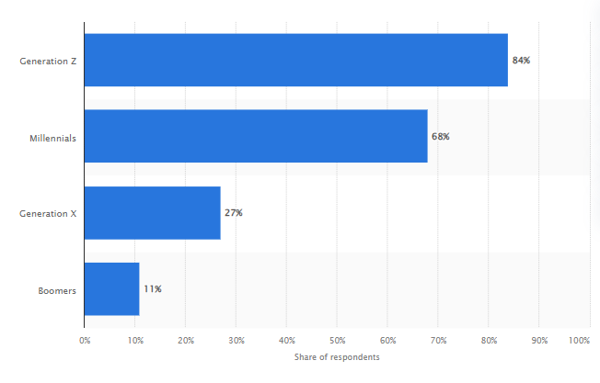
Figure 1: Share of consumers attracted towards social media influencers in the UK
(Source: statista.com, 2023)

1.2 Background of the organisation
LK Bennett is a UK-based fashion brand founded in 1990 in Wimbledon with expertise in fine artisanship and signature detailing on their products (lkbennett.com, 2022). The organisation specialises in its position through its unique British ethos and harnessing elegant shapes and vibrant prints. The company has generated 49 million GBP of revenue in the year 2023 with its annual turnover growing by 30% (fashionunited.uk, 2023). Darren Topp is the CEO of LK Bennett under whom the company has experienced significant market growth for the last two years.

Figure 2: LK Bennett Company Logo
(Source: lkbennett.com, 2022)

1.3 Problem Statement
As per the views of Leung et al., (2022, p.227), the relationship management through influencer based social media marketing requires understanding of independent behavioural aspects. Therefore, organisations often fails to recognise the values and implications of initial relationship management process to acquire effective result out of an influencer based marketing campaign.

1.4 Research Aim
The aim of this study is to investigate the drivers and barriers employing social media influencers for corporate branding, a case study of the LK Bennett.

1.5 Research Objectives
- To identify the major characteristics and impact of social media influencers within a company
- To analyse the necessity of social media influencers for creating a successful brand
- To assess the drivers and barriers of using social media influencers for corporate branding in LK Bennett
- To recommend in which ways LK Bennett can mitigate the issues related to social media influencers

1.6 Research Questions
R1: What are the major characteristics and effectiveness of social media influencers within a company?
R2: What is the significance of social media influencers to create a successful brand?
R3: What are the drivers and barriers of using social media influencers for corporate branding in LK BENNETT?
R4: What recommendations can be provided for LK Bennett to mitigate the issues related to social media influencers?

1.7 Research Significance
As stated by Levin, (2020), the provision of influencer based marketing is still undergoing reformation and changes that requires consideration to transform organisational approaches. The current study add values to the requirements by providing the beneficial attributes of influencer based marketing. The study diagnoses the barriers and challenges with different organisational expels to clarify the exceptional need LK Bennett can suffice with own method of influencer based marketing.

1.8 Dissertation Structure
The current study has a segregation of five different chapters, which offers individual roles in the entire research process. The first chapter is introduction, which establishes the problem statement and curates the aims, objectives, and research questions to provide a roadmap to the entire research. The second chapter, literature review provides precise and acceptable literature based research that surrounds the objectives to identify relevant industry practices. The third chapter is methodology, which discusses the techniques and processes adopted by the researcher for the findings. The fourth chapter produces the information found through secondary measures and provides a discussion based on thematic analysis. The fifth chapter is conclusion that produces the researcher’s final assumptions and limitations based on the entire study.
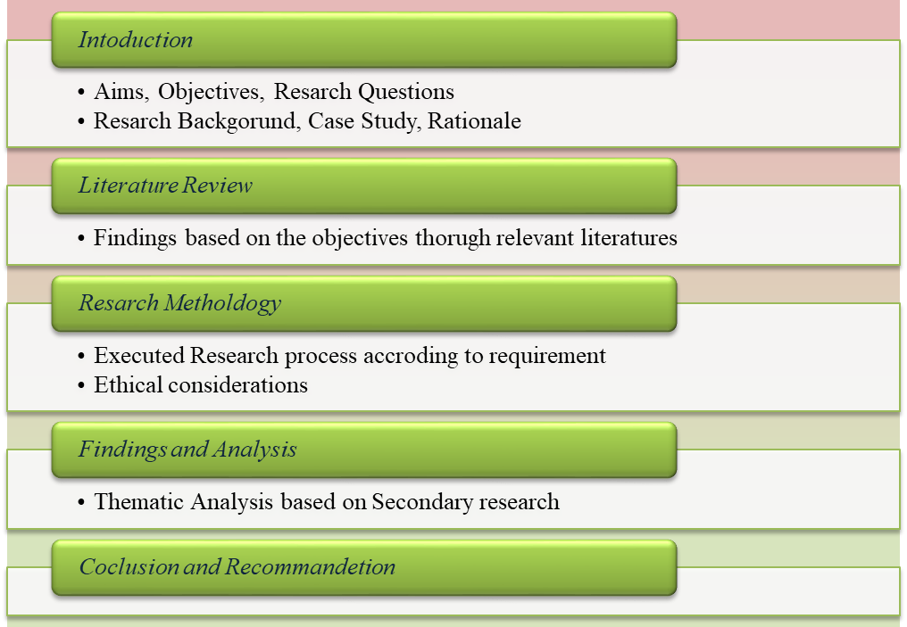
Figure 3: Dissertation Structure

1.9 Summary
The current chapter introduces to the facts related to influencer-based branding and its growth in the UK market. It provides suitable aims, objectives, and research questions as a directive roadmap to the upcoming tasks associated with the dissertation. The chapter also provides a problem statement and rationale for the relevancy of the research with the topic.

2. Literature Review

2.1 Introduction
The current chapter consists of a literature review that provides an evaluation of the characteristics of influencer-based marketing and its relevant aspects in organisational branding. The segmentation of this chapter followed the objectives of the research to establish findings that are relevant to the topic. It also provides a conceptual framework to identify the flow of entities within the scenario that predicts the impact of influencer-based marketing on the branding potential of organisations.

2.2 Identification of the major characteristics and impact of influencers within organisational branding
As per the views of Singh et al., (2020, p.465), influencers are individuals from different fields who endorse brands in promotional activities to increase awareness among the target audience. The potential of influencer-based marketing in the age of digitalisation is substantial as more consumers enjoy engagement of their favourite persona with the brands. There are multiple segments in which influencers can impact branding and promotional activities in an organisational context by establishing growth potential in sales and engagement.
Increased brand awareness
Effective brand awareness strategies involving influencers through social media increase the potential reach of brands towards their target consumers and beyond (Cheung et al., 2020, p.711). The influencers act as the catalyst to increase the visibility of brands as many consumers tend to follow them through social media. For example, Nike’s brand ambassador Cristiano Ronaldo is one of the sole influencers of the brand for which the company witnessed an increased rate of brand awareness. Companies can always maximise the outcome generated through influencers that can generate more sales.
Higher Engagement Rates
High engagement with consumers is one of the vital resources that brands can utilise to achieve more growth in any target market. Influencers act as the medium between the brand and its target consumers to provide better engagement of a brand. According to Forbes, 90% of people have produced more affection towards any brand recommended by individuals with a significant social media presence (forbes.com, 2022). Therefore, brands need to identify the essential influencers that can impact the potential of engagement with customers as a specific source of better brand awareness.
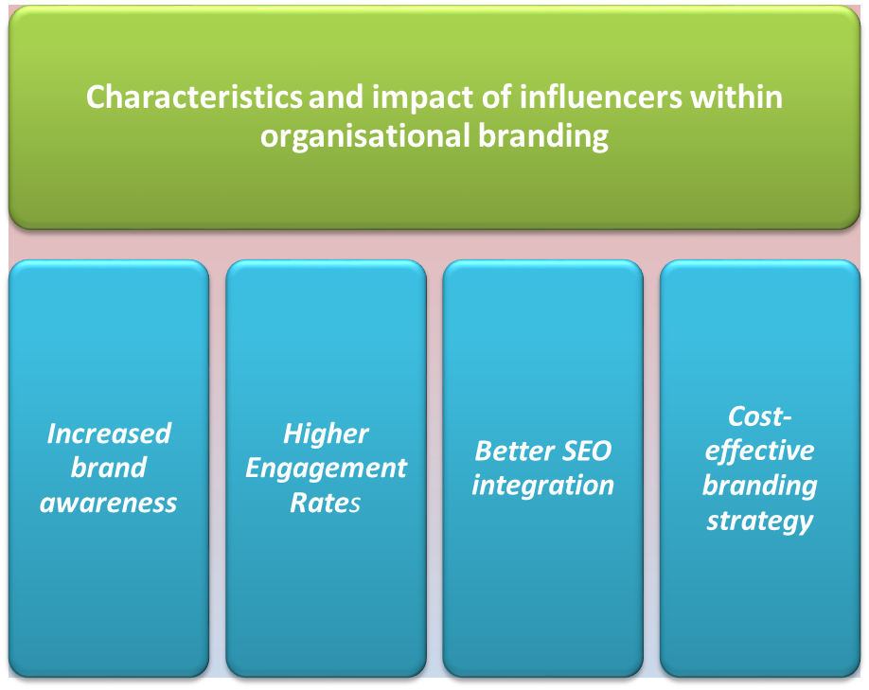
Figure 4: Characteristics and impact of social media influencers in branding
Better SEO integration
Search Engine Optimisation is a digital marketing tool that enables brands to promote their business through social media and the web market by optimised keyword framing. As per the views of Aji et al., (2020, p.94), customers are more likely to engage with different brands as per the influence of their favourite social media influencers. People tend to find a sense of familiarity with any new brand if its products are visible to their favourite sportsmen, entertainment stars or social media influencers. Therefore, first search about the influencers rather than researching for brands and their products or services.
Cost-effective branding strategy
Social media influencer-based branding and promotion can also optimise the investment structures for brands. Influencer-based branding allows companies to optimise their branding structure and promotions through social media and digital marketing. It delivers a more suitable outcome of brand reach than other methods of branding can provide.

2.3 Analysis of the necessity of influencer-based branding towards organisational success
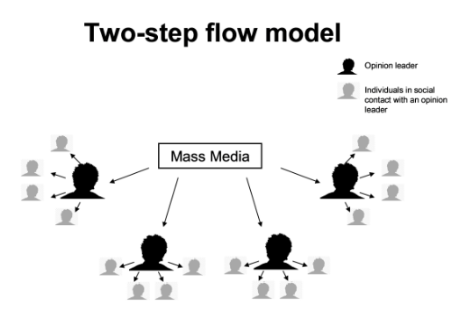
Figure 5: Two-Step flow model
(Source: communicationtheory.org, 2023)
According to Shin, (2022, p.681), the two-step flow theory produces a format of mass communication that ensures that influence-based communication reaches the entities that are even least associated with the nature of the communication. In this format, the three entities associated with the communication model are the opinion leader, individuals with social contact and mass. Therefore, the concept of the new age brand awareness through social media influencers falls in the context of a two-step flow delivery system. Here, the opinion leaders are brands like Rolex, Burberry, and Cadbury while the individuals with social media contact are the chosen influencers. According to social media influencers' ratings Jow Wicks, Giovanna Fletcher and Joe Sugg are the top three influencers in the UK according to the popularity index (yougov.co.uk, 2023). Therefore, the indexes display the relevancy of social media influencers towards brand awareness as these people can upshift or downshift a brand’s reputation through their social media handles. Therefore, brands from different sectors have invested more in social media marketing through influencers in the UK to increase their engagement.
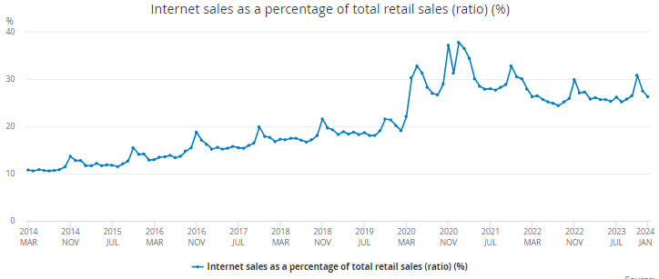
Figure 6: Internet sales ratio in the retail sector of the UK
(Source: ons.gov.uk, 2024)
According to Mintel, 47% of UK-based customers have purchased commodities endorsed by a personality on social media (store.mintel.com, 2024). Another report states that 47% of the UK-based Generation Z customers use social media before using search engines with 29% of the UK-based customers interested in getting recommendations from social media (store.mintel.com, 2023). Outcomes like these suggest that social media influence affects the consumer’s purchase decisions which can deviate their choices according to the recommendations. As per the views of Bade, (2022, p.211) The conversion influence theory suggests that the engagement of a consistent minority can influence the cognitive and interpersonal processes of the majority with direct or indirect approaches. The theoretical aspect suggests that the influencer-based marketing approach taken by most brands is associated with similar processes. Brand endorsement in social media includes the engagement of suitable personalities who tend to have a popular position among target audiences convincing them to purchase in an indirect approach. Therefore, promotions through social media influencers can induce a better brand identity, brand engagement, brand attraction and market expansion. Different platforms such as Facebook, Instagram, the X and YouTube are some of the key mediums brands are using to promote their products and services through this system. The platforms have the most amount of presence of potential customers which is unavailable in other modes of promotions.

2.4 Assessment of the barriers related to influencer-based marketing in an International Context
Fake influencers
As cited by Alwan and Alshurideh, (2022, p.842), fake influencers are one of the major concerns in brand endorsement through social media platforms. The term fake influencers in this context are the individual forged accounts in the name of influencers that the company cannot identify. Therefore, it can lead to an unprecedented loss of brand reputation, identity, awareness and even existing relations. Despite the social media platforms producing significant changes such as blue tick or trusted levels, the organisations find the correct influencers they require. It leads to unintended scams or online frauds that impact the dependability of authentic sources the brand provides through the platforms. According to Ofcom UK, 87% of internet users in the UK have come across uncharacteristic internet scams or fraudulent content in 2023 (ofcom.org.uk, 2023). This relates to the fake social media accounts and engagement that often lead to monetary fraud.
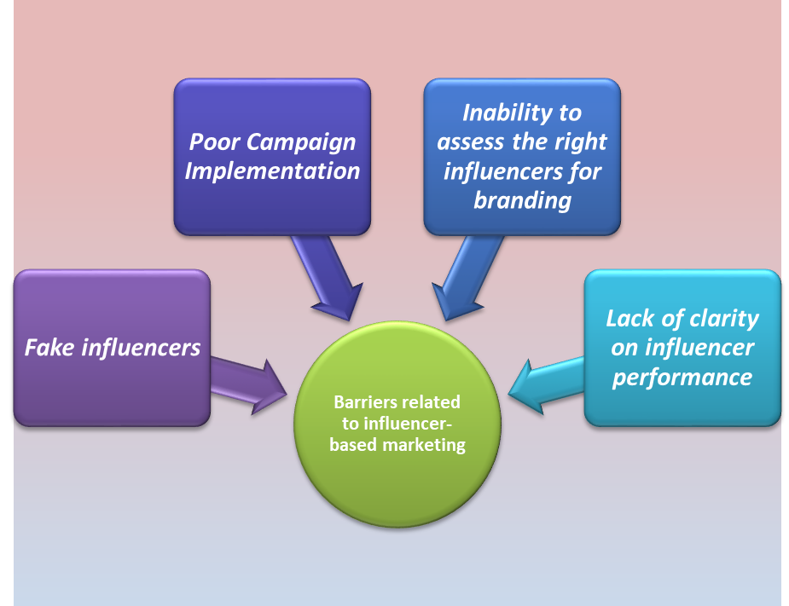
Figure 7: Barriers of influencer-based marketing
Poor Campaign Implementation
Irrespective of the popularity and fame of the chosen social media influencers, the companies can face unintended results out of a brand endorsement. The major causes of this issue are the inability to implement the correct integration protocol and research about audiences and their choices (Ebrahim, 2020, p.291). This can lead to risks for brands that made heavy investments in social media marketing and influencers. The promotional activities relevant to this process often require suitable timing and audiences. For example, brand promotion through influencers can become irrelevant when there is a significant event happening in other networks.
Inability to assess the right influencers for branding
Pop et al., (2022, p.839) depicted that the communication issues between influencers and brands can lead towards unintended results of brand endorsement. The lack of effective planning in this kind of brand endorsement can disrupt the sequential benefits influencer-based marketing produces for brands. Many organisations become unable to fulfil the demands of the influencers which can lead to the disruption of the entire campaign. The projects of brand endorsement through social media influence require effective communication and technicalities for which the companies need specific individuals as per their abilities.
Lack of clarity on influencer performance
As cited by Appel et al., (2020, p.82), during brand endorsement through social media influencers, some companies are unable to produce effective guidelines. It can create confusion between the brand management and influencers, which can lead to unstable performance. If proper clarity is not provided by companies regarding the products and services, the influencers cannot perform and provide justice to the cause. This can lead to an influencer’s lack of engagement with the relevant activities required for the entire program. The contents of the brand endorsements require multiple aspects, which allows the influencers to systematically develop the entire program. Therefore, content that is not suitable for the audience can lead to uncharacteristic results of any influencer-based brand endorsement.

2.5 Identification of the relevant strategies that can mitigate the issues related to influencer-based marketing
Establish effective communication channels for influencers
The primary requirement of establishing social media influence is to provide effective communication among the producers and influencers. Brands that need to endorse through the platform need to have effective communication channels to reduce challenges like misunderstanding or mistrust. This creates a better overall establishment of the brands among influencers that provides both growth and opportunities in this context. In addition to that, creating common channels that provide a platform for both brands and influencers for engagement. It ensures that complete visibility among influencers and producers remains intact so that situations like fake influence and confusion can be avoided. Common channels such as emails, personal messages or interactive sessions can become fruitful for organisations to clarify their positions and necessities to the influencers. It also allows the influencers to depict individual demands and positions regarding their engagement with the entire matter.
Create specific content that addresses the target audience
The quality of content for influencer-based marketing is one of the major features of the success of any activity. The programs and additional aspects such as images, visual aspects and placements are key to the success of the entire campaign. The organisation needs to build up a team consisting of qualified individuals with experience in content marketing and with experience in the procedures and the infrastructure of social media marketing platforms. This ensures that the messages that brands want to pass to the masses through influencers get suitably placed and clarify their intention towards the end users.

2.5 Conceptual Framework
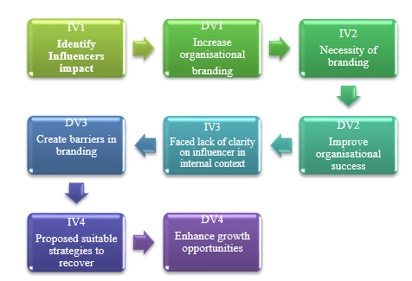
Figure 8: Conceptual Framework

2.6 Literature Gap
The current literature review produces effective information based on the industrial practices relevant to influence-based marketing in social media. The review considers a range of resources that consists of previously published data related to the market and organisational practices. However, it does not provide any specific information about the impact or processes of influencer-based marketing in a transnational context, which creates a literature gap in this segment.

2.7 Summary
The current chapter of the dissertation interprets literature on industrial practices relevant to influencer-based marketing. It provides the specific impacts of the activities organisations take and their influence on branding. The literature review produces theoretical aspects of the activities that demonstrate the necessity of influencer marketing. The chapter also produces some of the barriers organisations face in this context with relevant suggestions to mitigate the situations.

3. Research Methodology

3.1 Research Onion
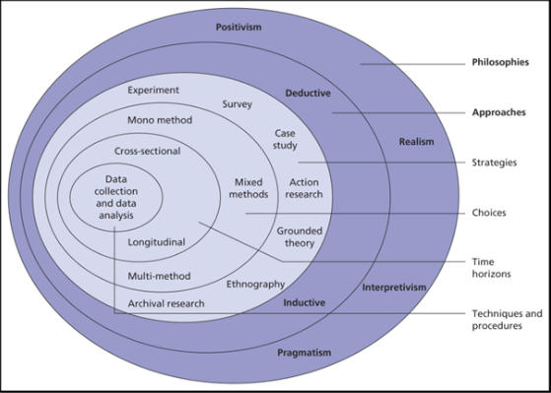
Figure 9: Research onion
(Source: Saunders, 2019)
According to Denscombe, (2012, p 673), research onion is a framework that is used in the research methodology section; this framework helps to show the stages involved in a methodology such as philosophy, approach, strategy, design, data collection, and others. This part is the initial stage of research methodology, it allows a broad overview of the series of decisions made for the research to be completed systematically.

3.2 Research Philosophy
As stated by Blaxter, (2010, p 6184), research philosophy is an opinion that clarifies how information about a phenomenon should be obtained, examined and applied. There are four types of research philosophies: positivist, interpretivist, pragmatist and realistic. The research would follow positivism philosophy; this philosophy would study action and analyse it through the perspective of the values of its culture. In order to attain factual knowledge regarding the social media influencer’s approaches in a business activity the research worker has selected the positivism research philosophy. The reason why this philosophy would be chosen is due to its coherent logic and structure. The philosophy has an orientation toward the generation of practice-relevant findings and attention to disciplinary biases and commitments. Positivism sees humans as active rather than passive and it would produce highly valid data. This philosophy would aim to conduct cross-cultural and complex research with detailed information. The primary drawbacks of interpretivism research philosophy would be related to its subjective nature and ample opportunity for research prejudice. Since personal values and viewpoints would have a significant influence on the data, primary data from interpretivist studies would not be generalised. Hence there might be some compromise in the representativeness and reliability of the data. The research paradigm is the framework that the discipline’s theories and practices fit into to form the research plan. It would guide the analytic techniques, research questions and goal of the study.

3.2 Research Approach
Dul, (2008, p 902), expressed, that there are two types of research approaches: inductive and deductive and this particular research would use an deductive approach.
The process of gathering and analysing research data to formulate concepts and hypotheses based on particular patterns in the data is known as inductive research. There would be a range of advantages offered by the research approach and due to those reasons the research chose this approach. The researcher would be able to formulate a hypothesis based on the findings of the results. On the other hand, it would give the researcher the freedom to experiment with different sources during data collection. The researcher would choose this as it helps in developing a range of concepts and applying those in similar situations. There would be some limitations too in this approach such as, the researcher must carefully choose and arrange data and make sure it is comprehensible to lead the readers to an accurate formulation of the rule.

3.3 Research Strategy
Patton, (2015, p 7788), clarifies research strategy is a detailed plan that shows how the entire data should be collected to extract the best possible outcome according to the research requirements. Qualitative quantitative and mixed are the three types of research strategies in research. The researcher would choose a quantiative strategy for this topic as it comes with a range of benefits.
The main reason for selecting the quantitative strategy is to gain greater knowledge and understanding of the importance of social media influencers' approaches in the business of LK Bennett. The qualitative research strategy would be about collecting non-numeric data. The qualitative research strategy would describe how non-numerical data can eventually be gathered to produce precise results within the allotted time frame. would help the researcher understand specific beliefs, attitudes, and people's behaviour to develop accurate hypotheses based on the research requirements. The researcher would be able to produce a variety of hypotheses from a wide range of sources by using a qualitative research strategy, which was important to take into account to preserve the validity of the entire study. Though the qualitative strategy would be time-consuming and come with limited interpretation, still it would be helpful for this research.

3.4 Research Design
John, (2007, p 1545), pointed out two types of research design: exploratory and explanatory are used in a research; the researcher would follow an explanatory design for this research.
The advantages of this research are providing a better understanding of the existing research problems and a functional explanation of any solutions. These benefits would attract the researcher to apply this design; its low-cost nature and offering a lot of flexibility would help researchers gather more data. Two of the most significant limitations would be a lack of conclusion and biased results; these two would impact the overall research findings.

3.5 Sampling Method
There are a variety of sampling methods applied in research such as random, stratified, snowball, judgemental and others, this research would apply the judgemental sampling method. This sampling is a non-probability technique that allows the researcher to choose based on the researcher's knowledge and judgement. The researcher would get the benefits of choosing this method such as minimum time for execution, approaching the target market directly and giving real-time results. Sampling strategy is important to study the entire population in an effective way. Sample strategy helps to gather reliable information from a large number of people. The research study conducts a survey session with 25 employees of LK Bennett to explore the roles of social media influencers in company branding. With the help of "non-probability" random sampling techniques, the research worker is able to select 25 employees of this brand. On the contrary, judgmental sampling would be unsystematic and vulnerable to errors and lead to bias. The human errors and biases during the data collection would end up influencing the results of the research.

3.6 Data collection method
According to Adams, (2014), the data collection method comprises the acquisition process of specific data that are reliable and effective to use to predict the outcome of a research. The different types of data collection include primary data collection, secondary data collection and mixed method, which includes both primary and secondary data collection. The current research has used secondary and primary data collection to accumulate relevant data about brand endorsement through influencers. The secondary data collection techniques involve the accumulation of data that are already collected and stored in different resources (Duignan, 2016). The benefit of secondary data collection is that the information accumulated is already established and recognisable. The research worker has selected the “primary” data collection method to collect authentic information about the impact of social media influencers on LK Bennett. With the help of the primary data collection method, researchers are able to analyse how social media influencers increase the customer base of the mentioned business. Conducting survey sessions in the research work helps to explore the factors of social media influencer approaches that increase the brand awareness of the mentioned enterprises. The limitation of secondary research is that it restricts the involvement of the researcher which the primary research method provides through raw data collection. This particular research aims to target those resources that collectively target the brand endorsement policies through influencers in social media taken into consideration by LK Bennette UK.

3.7 Data Analysis
The data analysis method encompasses the systematic process of evaluating and depicting suitable outcomes through the accumulated information (O’Gorman, 2015). The data analysis process involves statistical analysis and thematic analysis and survey analysis according to the necessity of individual projects. This particular research has followed a thematic analysis and survey procedure to evaluate the collected data. Thematic analysis is a systematic process that provides the opportunity to establish common them associated with the topic and produce arguments on them. The benefit of thematic analysis is that it enables the researcher to create distinguished outcomes of similar information through deduction. The following study conducts a survey session to collect information regarding the consequences of social media influencers on the financial performance of LK Bennett. In this aspect, survey sessions help gauge the representativeness of employees' views and experiences regarding the role of social media influencers in company branding. The limitation of this analysis is that it cannot provide the process of analysing raw data collected through primary research. This research contains four specific themes that address the impact of influencer-based marketing on social media relevant to LK Bennett UK. The four themes also provide suitable answers to the research questions produced at the beginning of the research and address the problem statement associated with the research.

3.8 Ethical consideration
The ethical considerations are the systematic rules and regulations that produce the measurement of activities relevant to research. The current research observes the relevant guidelines provided by the university to avoid any academic misconduct and maintain the academic integrity of scientific research. The Data Protection Act 2018 provides guidelines that ensure any data provided by the respective owner remains unchanged and that any such activities are punishable offences (legislation.gov.uk, 2024). The current report observes the rules and regulations depicted in the Data Protection Act 2018 and avoids misuse of data that is irrelevant to the context.

3.9 Summary
This chapter produces the systematic processes demonstrating the research activities induced in this dissertation. The entire structure of the methodology has followed the research onion framework to produce multiple segments within the research. The methodology produces the specific actions necessary to identify the impact of influencer-based marketing on social media for LK Bennett UK.

4. Findings and Analysis

4.1 Introduction
The chapter illustrates the findings of the study from the collected data along with its analysis in terms of creating relation with the research objectives. As stated in the previous chapter, thematic analysis is chosen in this section, the collected data are divided into four themes that have a clear relationship with research objectives; this connection helps to gather relevant data about the chosen company and the industry. The first illustrates the role of dynamic third parties and how influencers on social media help to reach a global audience. The second theme states how influencers increase the website traffic and social media exposure of a company. The third theme is about false information sharing through social media and the last theme depicts how customer awareness is created through social media influence.

4.2 Thematic Analysis
Theme 1: Influencers on social media play the role of dynamic third parties who help brands reach a global audience with their message
According to Jaitly and Gautam, (2021, p 1445), influencer marketing has emerged as the go-to strategy for marketers who want to connect with Generation Z. On social media, young adults seek out simple, easily accessible entertainment, ideally in the form of short videos. Influencers, with their easily readable formats and relatable content, provide the solution to this need. Eighty-four per cent of Generation Z in the UK followed influencers, according to a 2023 survey. For more than two-thirds of millennials, the same was true. Their wide audience does not, however, equate to great credibility. In 2022, a ranking of media outlets based on consumer trust placed influencers at the bottom of the list. Merely 28% of British Gen Zers and 18% of millennials who responded said they trusted influencer advertisements (Statista.com, 2024). Additionally, in the UK, these are some of the most complained-about forms of advertising. In 2022, they received 5.3 thousand complaints, which led to over 4,000 cases that needed to be resolved by advertising authorities.
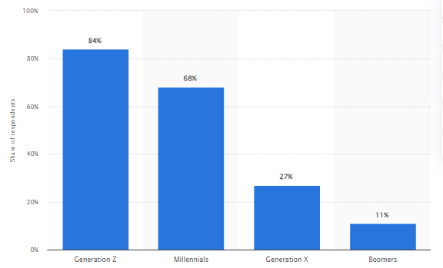
Figure 10: Share of consumers who followed influencers in the United Kingdom
(Source: Statista.com, 2024, Popularity of Influencers UK)
The ways in which LK Bennett uses consumer behaviour as a tool to suggest improvements to their consumption experience result in multiple benefits for the company that engages with their customers. By co-creating better consumption offerings, it also supports and mentors the service providers in the process. Consumer involvement in the ideation of the product's core offering is ensured through co-creation. Moreover, social media influencers can increase digital interaction on social media platforms based on various factors, including post format and message content. Engagement from customers is fueled by interaction and vibrancy, and influencers utilise their expertise to identify and communicate the social needs of their audience to provide value.
Theme 2: Influencers can increase a company's website traffic and social media exposure in order to shape the perception of the brand because of the audience's loyalty
Social networking sites raise awareness, website traffic and social media exposure of LK Bennett, in addition to giving it a platform for communication. Social media influencers, those who can provide social proof and the agencies that plan and organise the launch of profitable influencer marketing campaigns for LK Bennett, are made possible by the rise of digital influence. Agencies work with LK Bennett as marketing partners to design integrated channels that provide end-to-end customer experiences. The rise of social media influencers is a psychological phenomenon, whereby a person believes that an influencer's behaviour is appropriate for LK Bennett. As a result, the business views social media influencers as sources like individuals with a sizable and devoted following. Influencers interact with customers through a variety of social media platforms such as Facebook, Twitter, TikTok, Instagram and YouTube. As third parties, they offer recommendations on behalf of LK Bennett, helping to foster consumer confidence in it. The ability of influencers to drive traffic consumer confidence in it. The ability of influencers to drive traffic to a company’s website and increase its social media exposure to create the brand’s perception is derived from the audience’s loyalty.
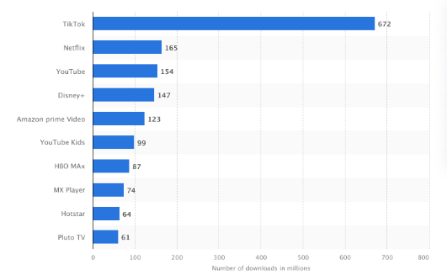
Figure 11: Different social media platforms used by fashion brands
(Source: Charle.co.uk, 2024)
Influencers on social media are becoming more and more popular due to the power that consumers grant them; they are influenced by the opinions of their influencers regarding the brands. The closeness and trust that exist between social media influencers and their followers is what makes them so popular. Influencers contribute to the growth of brands by sharing their personal opinions, which make the products or services more relatable and trustworthy than brand ambassadors' one-way communication. The availability of topical search options to consumers has led to an increase in the popularity of social media influencers.

Theme 3: The role that social media plays in disseminating false information is causing policymakers, managers, and academic researchers to become increasingly concerned
As per a report, close to 50% of consumers in the UK purchased something promoted by a personality followed by them (Mintel.com, 2024). The Consumers battle with scepticism about the believability of recommendations, hence LK Bennett aims to better match with appropriate influencers to persuade consumers that a social media personality genuinely believes in the product they are promoting. Internet users who follow influencers report having been misled about a product by them on social media, according to 42% of users (Mintel.com, 2024).
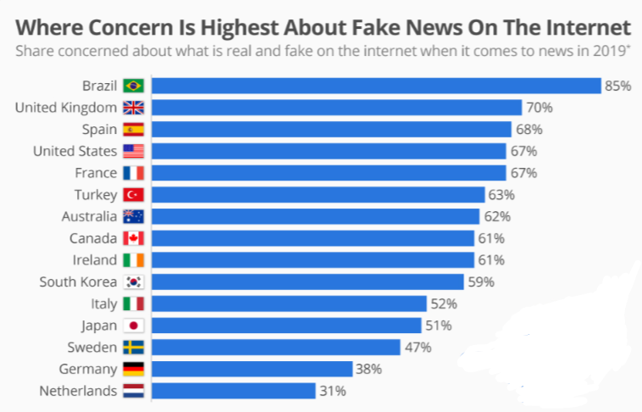
Figure 12: Fake information through social media
(Source: Statista.com, 2019)
Jaitly and Gautam, (2021, p 245), clarified by artificially performing actions such as liking, sharing, and commenting, social bots are known to accelerate the spread of fake news. As opined by Di Domenico et al., (2021, p 6654), social bots play a significant role in spreading fake news on social media for two reasons. For consumers and firms, the negative outcomes of fake news are linked in three ways. First, LK Bennett is targeted by fake news in an attempt to change consumers’ minds about a particular firm or product. It can give legitimacy to fake news and associations can contaminate it. Fake news harms consumers’ brand attitudes. For instance, when a LK Bennett advertisement appears alongside fake news or within a fake news website, consumers’ perceptions of source credibility influence brand trust and, in turn, brand attitudes.
Theme 4: Customers can select relevant information based on their priorities and even determine how they want to receive it by working with influencers
Jaitly and Gautam, (2021, p 5683), state social media influencers employ specific tactics to strategically leverage their network in order to boost customer engagement and shape the brand perception of LK Bennett. Among them are strategies for strengthening bonds with a brand's target markets to boost the brand's reputation. Influencers also influence consumers' perceptions of LK Bennett by bringing attention to various products through their online activities and soliciting consumer comments and feedback in the process. In addition, the function of social media influencers in shaping consumer perception of a brand is to guarantee that the brand can establish a powerful impression in their minds.
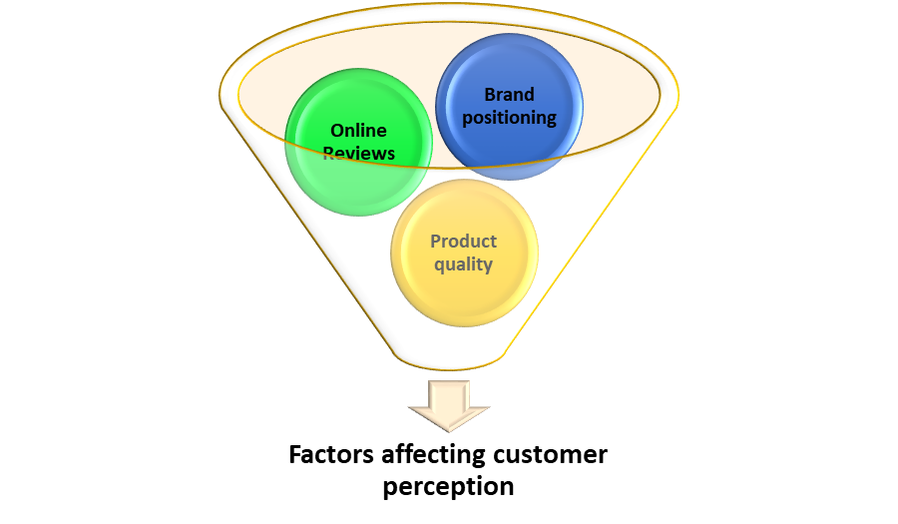
Figure 13: Factors affecting customer perception
Through direct connections with a targeted consumer base, influencers assist them in cultivating brand loyalty in their audience. Influencers provide a two-way channel of communication for the brand, allowing consumers to communicate directly with brands and strengthen their loyalty. Through the development of a thread of user-generated content with customer insights for co-creation, social media influencers also give the business a competitive advantage. Together with generating shared insights, co-creation improves the products' core offerings. LK Bennett can take note of these concepts, to increase brand loyalty. The influencers also serve as a medium for the company to acquire leads, to obtain a competitive advantage over other firms.

4.3 Survey
Q1) How far do you agree that social media influencers accelerate the brand image of LK Bennett?
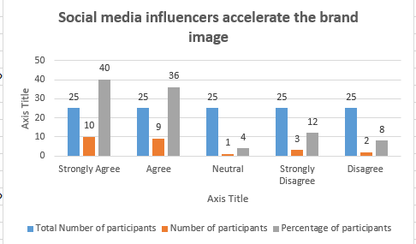
Graph 1: Responses on social media influencers accelerate the brand image of LK Bennett
Based on survey question 1, it analysed that most of the participants agreed with the point that social media influencers accelerate the brand image of LK Bennett. On the other hand, 12% of the respondents disagreed with the point as they think that "Per-pay-Click" allows the brand to increase its brand image in an effective way.

Q2) Do you believe that social media influencers help to engage with potential customers of LK Bennett?
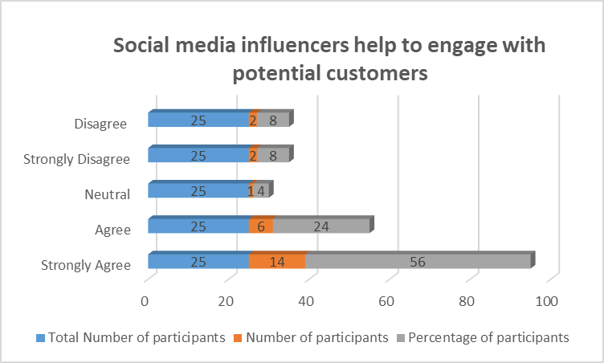
Graph 2: Responses on social media influencers help to engage with potential customers of LK Bennett
From the survey question 2, observes that 56% of total respondents agreed with the point that social media influencers have helped the brand to engage with potential customers fostering brand awareness of the company. In addition, almost 8% of respondents stated that "email marketing" allows LK Bennett to interact with customers in an effective way,
Q3) How far do you agree with the point that social media influencers have big roles in the company culture of LK Bennett?
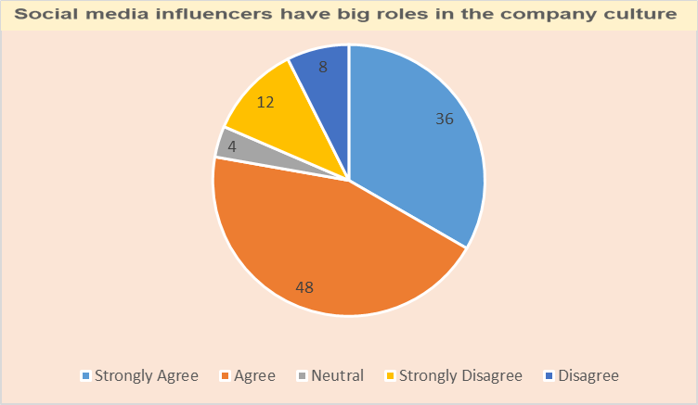
Graph 3: Responses on social media influencers have big roles in the company culture
The above chart depicts that 48% of the respondents agree that social media influencers have big roles in the company culture as they help businesses through "curated content". This curated influences employees' perception in the workplace. These respondents have stated that influencers play a role in highlighting workplace practices, well-being initiatives as well as the overall employee experience. However, 8% of the respondents do not agree with this point as they think that HR managers and employees have played a big role in making a positive work environment.
Q4) Do you believe the fact that social media influencers also help to increase the financial performance of LK Bennett?
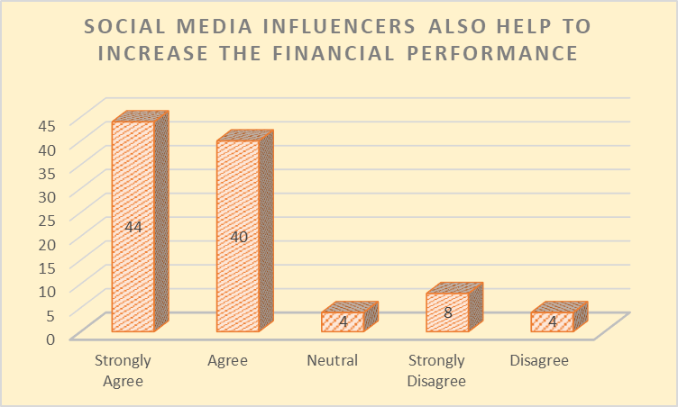
Graph 4: Responses on social media influencers also help to increase the financial performance
The above chart shows that more than 40% of respondents agree with the point that social media influencers help to enhance the financial performance of LK Bennett. Influencer marketing campaigns often have higher engagement as well as conversion rates. Influencers with higher fellowship have the ability in order to derive more important brand exposure and customer engagement because of the larger audience reach. Furthermore, 8% of respondents have disagreed with the point as they think that "content marketing" is a helpful approach for LK Bennett to promote its products and enhance the revenue rate effectively.
Q5) Did you realise that social media influencers' approaches are more effective than traditional marketing approaches?
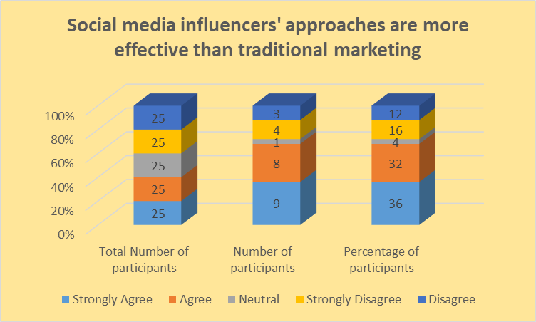
Graph 5: Responses on social media influencers' approaches are more effective than traditional marketing approaches
The mentioned graph shows that 36% of respondents state that social media influencers help to reach a wider audience in a shorter period than a traditional marketing approach. On the other hand, they revealed that the strategies of social media influencers help to promote the products of LK all over the world, which is not possible in traditional marketing approaches. However, some respondents mentioned that traditional marketing permits this business to reach people in ways not afforded to customers by digital.
Q6) Have you ever noticed that social media influencers help to establish credibility in the fashion design and retail industry?
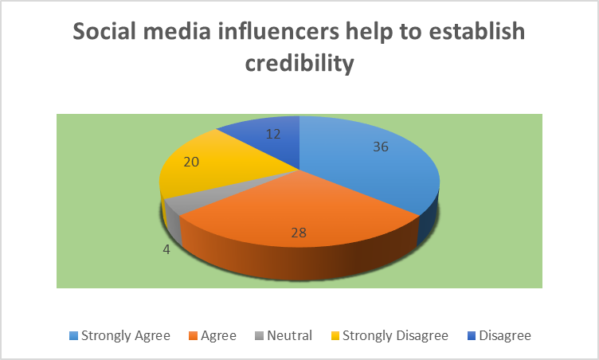
Graph 6: Responses on social media influencers help to establish credibility in the fashion design and retail industry
Based on the response of the participants, it analyses that social media influencers increase a brand’s reach and engagement by creating and sharing engaging content that features the brand, In addition, they enhance LK’s reputation and credibility within the retail industry by endorsing, recommending, and reviewing this brand in a positive light. On the other side, some of the respondents have analysed that using “TV” and “Radio” for promotions strategy helps to increase the credibility of the brand.
Q7) Do you agree with the fact that selecting suitable social media influencers helps to reduce marketing costs?
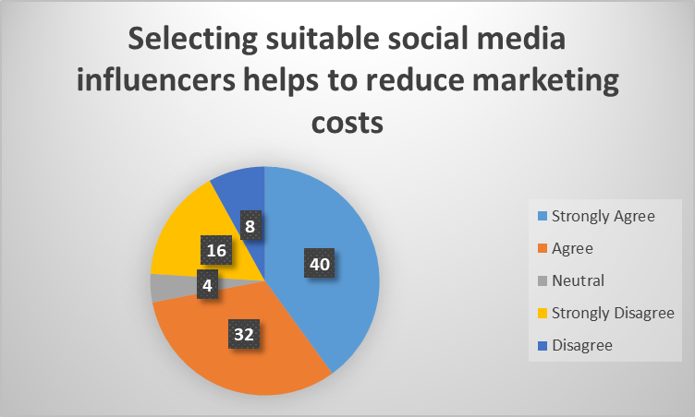
Graph 7: Responses on selecting suitable social media influencers help to reduce marketing costs
According to the responses of the participants, it identifies that suitable social media influencers have high followership on online platforms that help LK Bennett to reach a wider audience effectively. Reaching the target audience in a lesser amount of time and financial resources is possible for the mentioned brand because of the social media influencers. Alongside this, some respondents have mentioned that using search engine optimisation helps to reach the target audience for a lower amount of money.
Q8) How do you support the point that social media influencers promote LK’s products through social media channels?
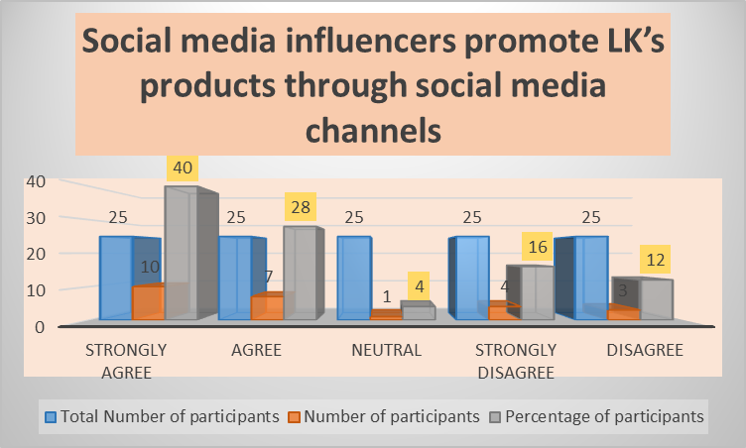
Graph 8: Responses on social media influencers promote LK’s products through social media channels
The above chart shows that more than 40% of respondents have agreed that social media platforms such as "Facebook" , "X", "Instagram" and "Pinterest" are some of the popular social media platforms that social media influencers apply to promote LK's products to the target audience. Furthermore, 16% of participants strongly revealed that social media influencers do not use only online media to promote the products of LK. In this aspect, the influencers use “email" and a direct communication approach to promote LK's products in front of customers.
Q9) Do you have believed that social media influencers help to crack new markets?
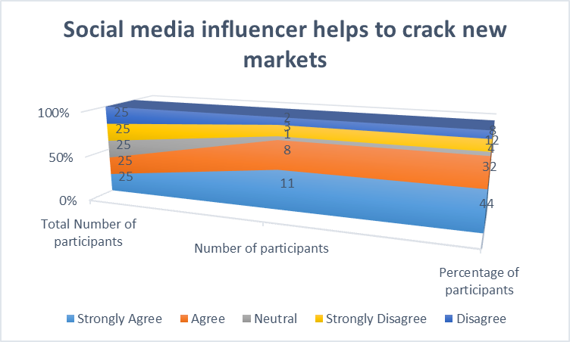
Graph 9: Responses on social media influencer helps to crack new markets
The graph illustrates that more than 44% of respondents have stated that collaborating with social media influencers give LK direct access to a segment of prospects that require and want to purchase the products. Making share-worthy content regarding LK’s products helps reach a new audience of a new location in a shorter period. The common format for content and evaluating social media platforms allow influencers to promote a product in a new region by which a brand can become popular in a new location. However, some of the respondents have mentioned that conducting a proper market research and analysing the requirements of the customers help to crack a new market.
Q10) How far do you believe that in the contemporary business world social media influencers help to increase ROI effectively?
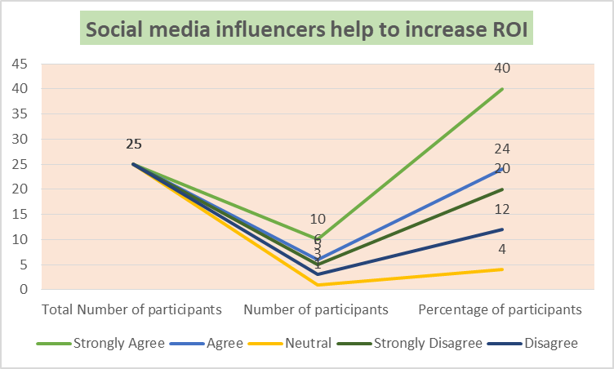
Graph 10: Responses on social media influencers help to increase ROI
It has analysed that More than 40% of participants have stated that social media influencers help to foster ROI by ensuring authentic alignment between the influencer’s brand and LK. These participants have mentioned that influencer marketing also delivers “11*ROI” over other forms of digital media. By sharing links to the website on social media platforms such as Facebook and Instagram, the influencers drive more traffic to their site resulting in ROI of LK.

4.4 Data Analysis
The four themes of the research show that LK Bennett as a fashion brand in the UK is promoting itself through influencer marketing. This type of marketing has both positive and negative aspects; the major negative aspect is the sharing of misinformation that impacts the brand awareness of the company. Quelhas-Brito et al., (2020, p 73), claimed, the concept of fake news is more precise in the sense that the fake news term should be reserved for cases of deliberate presentation of typically false or misleading claims as news, where these are misleading by design, systemic features of the sources and channels by which fake news propagates and thereby manipulates consumers’ pre-existing cognitive biases and heuristics. The dissemination process involves creators who develop and use fake social media profiles to spread fake news online. Common non-human agents exist in the form of social bots, involving computer algorithms that are designed to exhibit human-like behaviour, artificially produce content, and interact with humans on social media.
The social media influencers give LK Bennett another competitive edge, by compiling a series of user-generated content with customer insights for co-creation. Co-creation produces shared insights and improves the products' core offerings. By addressing these concepts, LK Bennett can increase brand loyalty. In addition, the influencers help the company acquire leads, giving it an advantage over its competitors. Chan, (2022, p 2473), argued that for companies to contact potential customers, those who express interest in their product offerings are considered potential customers.
Discussion
The major characteristics and impact of social media influencers within a company
The necessity of social media influencers for creating a successful brand
The drivers and barriers of using social media influencers for corporate branding in LK Bennett
- The drivers of using social media influencers

- The barriers of using social media influencers

Recommendations for LK Bennett to mitigate the issues related to social media influencers

Survey questionnaire 1, analyses that the maximum number of participants have agreed social media influencers foster the brand image of LK Bennett. According to Ouvrein, et al., (2021, p. 1313), social media influencers have become a powerful force in the contemporary business world. With the right collaboration, the business reaches the target audience and drives management. Creating sponsored content, product reviews and affiliate marketing are different types of influencer marketing campaigns. As influencers create "image-based content" and "video-based content" featuring LK's products, awareness of this brand inevitably increases among the followers. For example, influencers use TikTok to make share-worthy content regarding LK's product that helps to reach a wider audience and accelerate the brand image effectively. In this aspect, social media influencers apply "hashtags" in every content that helps LK to become familiar in front of new audiences by which the brand awareness of the entity increases in an effective way. Moreover, by leveraging the influencer's skills and natural abilities LK Bennett fosters meaningful engagement and drives its business growth. On the other side, it also observes that email marketing as well as SEO are other types of marketing approaches that increase the brand image of a company in the corresponding sector.
From the second survey question, it analyses how social media influencers help to reach the target audiences. Influencer marketing offers businesses access to potential customers, making it simple to reach the proper customers with the right messages (Zabel, 2023, p. 3). Influencers have built up a platform and made a channel and after that produce content about specific products of LK that helps to resonate with the followers. With the help of social media channels, the influencers are able to build genuine relationships with followers that help to influence fans to buy the products of LK by which the social media influencers are able to increase the customer base of the entity within the fashion and retail sector. Influencers take over LK's social media account for a set period in order to engage with LK's audiences. Micro-influencers strike a balance between reach and engagement, providing targeted access to particular demographics. Social media influencers often have a knack for making compelling and sharable content to capture attention, evoke emotions along spark conversations that help to increase the customer base of LK Bennett effectively. Micro-influencers often connect with followers with Chatbots and influence them to use the products of this company. Furthermore, it analyses that CRM software and soliciting customer feedback help to communicate with the target customers and engage with them in a proper way.
Based on the third question of the survey, observes that collaborating with influencers helps to create a positive culture within the workplace. Influencers often display idealised versions of their work experiences and promote notions of flexible schedules' impact on the work culture of LK. The similarity between curated online content as well as the reality of the workplace also helps new employees to increase their understanding of the workplace of LK by which the brand is able to strengthen the employee base in an effective way.
It implies from the fourth survey question that, social media influencer increases the profitability rate of LK. One of the most significant aspects of influencer marketing is its adaptability (Joshi, et al., 2023, p. 1). Influencers are attuned to the customer's preferences and needs, enabling them to pivot rapidly in response to changing the conditions of the market. Target audience when finds people on the online platforms share the images of LK’s products then they know and trust the products that help to increase the sales rate of the business. With the help of social media platforms influencers are able to promote particular products of LK in front of the target customers helping to increase the sales of the business in an effective way. In this aspect, the video-based content of LK's products becomes familiar among the people, which helps to increase the purchasing decisions of the customers resulting in the profitability rate of the enterprises. In addition, AI marketing along with landing pages are effective marketing approaches that are applied by companies to increase the sales and revenue rate of the business. One of the main advantages of collaborating with social media influencers is that it offers measurable outcomes. With the application of tracking and analytics, a brand can calculate the success of the influencer marketing campaign and make data-driven decisions about future campaigns in an effective way.
Social media influencers' approaches are more effective than the traditional marketing approaches in the marketing area. After comparing with the traditional marketing approaches, it observes that social media influencers are helpful to reach a wider audience in other regions in a shorter amount of time. Collaborating with popular influencers helps in this aspect to promote the business in an effective way. Producing and distributing traditional marketing materials are expensive and for this reason, LK Bennett prefers the social media influence approach rather than the traditional marketing campaign in the contemporary digital world. On the other side, it is complex for traditional marketing to track ROI and increase the interactivity level between the brand and customers. In this scenario, digital channels offer two-way communication with target customers by which LK is able to get immediate feedback through influencers. Furthermore, traditional marketing depends on visual and audio content, while social media influencer marketing permits a range of content styles, from video reviews to unboxing videos as well as influencer seeding. Besides this, traditional marketing's strength is that it has a tangible presence and still now most customers trust traditional marketing when trying to select a product of a brand. The social media influencers’ approach allows a brand to make informed decisions regarding the marketing strategy and to see a return on the investment.
Based on the sixth survey question, observes that social media influencers accelerate the credibility and authority of LK Bennett in the fashion and retail sector. As per the report, followers trusted influencers and in this situation, when influencers endorse the product of LK, then the followers try to purchase the product. As per the view of Ye, et al., (2021, p. 160), successful influencers have nurtured relationships with their followers based on transparency, reliability as well as expertise. As an outcome, their endorsement holds substantial weight and positively affects the brand reputation of LK. This approach helps to improve the brand credibility of the mentioned brand in the corresponding sector resulting in customer loyalty and the sales rate of the business. Through authentic and genuine interaction, social media influencers are able to create a sense of connection and familiarity. By making eye-catching content social media influencers boost audience participation and drive engagement effectively.
LK Bennett selects suitable social media influencers in its marketing activity to reach the target audience with fewer amount of financial resources. Due to "Low production cost" and "Low CPMs" LK Bennett prefers social media influencer strategy in its marketing activity. As per the report, identifies that it requires 60 pounds in paid advertising approaches while it needs 30 pounds to promote a product through social media influencers in the United Kingdom. In business activity, when compared with traditional marketing methods, such as advertising on print media, influencer marketing is less expensive. On the other side, LK Bennett works with influencers on a campaign basis and in this scenario, the cost of the campaign relies on the influencer's reach, engagement as well as the goals of the campaign.
The survey question 8, analyses that social media influencers mainly depend on online media channels to promote the products of LK Bennett. Applying social media platforms such as Facebook, X, and Instagram as well as TikTok helps influencers connect with fans, which provokes followers to select the product of a brand (Chan, 2022, p. 2694). Offering positive feedback and reviews by influencers regarding LK’s product on social media platforms helps followers to get information about the product, which allows them to select and buy the product. On the other hand, this influencer apply a direct communication approach and email to interact with customers on a regular basis by which they can promote the products in a systematic way.
As per the survey question 9, it analyses that the maximum number of participants agreed that social media influencers help to crack the new market area. Social media influencers have a loyal as well as engaged following by which they evoke emotions and spark conversations with followers. Social media influencers of a specific area understand the nuances of language such as dialects and idiomatic expression, which is vital for effective and culturally sensitive communication. Furthermore, common formats for content such as videos, podcasts, and Infographic help to reach those customers who are in different regions. For example, LK Bennett opened its new store in Edinburgh with the help of social media influencers.
From the tenth survey question, it observes that social media influencers help to increase the ROI in an effective way. By creating and sharing engaging content, influencers attract new customers and build a loyal following that increases the return on investment rate further. On the other hand, by responding to comments and messages, social media influencers try to provoke the customers to select LK's products that accelerate brand loyalty and enrich the ROI rate in a proper way. Furthermore, targeting particular demographics, interests and behaviours of influencers improves the effectiveness of the advertising campaigns and ROI properly. In this aspect, collaborating with social media influencers allows the business to easily track and measure the social media campaign, which permits the business to adjust its strategies along with improve its ROI over time.

4.5 Summary
Thematic analysis is conducted in this chapter to show how influencer marketing is impacting the business of LK Bennett. Four themes are created concerning the research objectives, it helps to extract the appropriate results and conclusion and answer the research questions accordingly. Relevant evidence is provided to show the authenticity and reliability of the data. The data analysis part shows the extracted ideas from the findings and helps to jump to a conclusion.

5. Conclusion and Recommendations

5.1 Overall conclusion
The overall analysis of the research findings helps to jump to the conclusion that the current scenario of the UK fashion industry is one of the biggest motivators of the emergence of influencer marketing. The four objectives of the study: major characteristics and impact of social media influencers, the necessity of social media influencers for creating a successful brand, barriers of social media influencing approach during branding and recommendations in which ways LK Bennett can mitigate the issues related to social media influencers covered all the necessary areas of the company and showed the current and potential impacts. The use of theories and application of secondary, qualitative analysis has influenced the results of the research. The study uses both primary and secondary data collection method to increase the realibility and authenticity of the reserach work.

5.2 Linking with Objectives
The objective one is directly linked with the theme one that shows how social media influencers are impacting the business of the chosen company. It can be seen from the literature review, that social media influencers act as a third-party service provider and help the company to reach the target audience easily. The secondary data collection illustrates that the influencer marketing strategy is a new type of digital marketing that helps to cater to potential customers and increase customer engagement levels. The fisrt objective also linked in the outcomes of survey session’s analysis where it identifies that social media influencers helps to increases the creadibility of a company.
The second objective is linked with theme 2 which describes the necessity of social media influencers in making a successful brand. LK Bennett as a part of the fashion industry in the UK, has significant brand positioning due to its extensive presence in social media. The two-step flow theory helps to analyse how the brand interacted with its customers through several social media platforms and utilised the power of some well-known social media influencers; this approach helped the company to increase brand awareness.
The third objective connects with theme 3 as it shows one of the major barriers regarding the implementation of the social media influencer approach. The secondary data sources that evaluate social media can be used as a platform for false news sharing and due to this LK Bennett’s reputation and customer loyalty can be massively affected.
The last objective is about providing recommendations which directly relate to theme 4. The fourth theme elaborates on how different customer base and their preferences can be achieved by using social media influencers. The application of The conversion influence theory states social media influencers can attract a new customer base through shared insights and help LK Bennett gain a solid competitive advantage.

5.3 Limitations
One of the major limitations of the research is its choice of research methodology. As the researcher has chosen a secondary, qualitative method, it lacks real-time data and information about the industry as well as the company. The lack of information about LK Bennett can impact the research results and influence the future research opportunities. The research did not have statistical analysis that affects the accuracy of the research findings. The research did not use a range of theories hence it has some gaps in theoretical application as well.

5.4 Recommendation
Re 1 Using a more statistical approach
As the research only focuses on secondary data, a more statistical approach by using primary quantitative analysis would be helpful for future research. This type of data collection and analysis helps to gather more real-time information about the company through surveys, interviews and other approaches and eliminates the research biases.
Re 2 Alignment of marketing goals and objectives
The marketing goals and objectives of the company should be connected with its social media influencers approach. The social media influencers have to first understand the mission and values of the company, only then they can use their interaction and promotional powers to attract customers for the company. If the influencers do not have extensive knowledge about the company, the strategy might fail and result in the opposite outcome such as poor brand awareness for the company.
Re 3 Proper research about social media marketing
Before jumping into every social media platform, the company should research in which platform the target audience mostly exists. It is not necessary to have a presence on every platform, it would result in high operating and marketing costs. The products and services offered by the company should relate to the influencer’s values and interests, this would help them to get an easier interaction level.

5.5 Future Scope of the Research
The research is based on finding the impact of social media influencers in making a brand; the current research shows some key literature as well as methodological gaps and these gaps can be utilised in similar research in future. The future research might use different theories and research on some other industries or companies. A comparison could be made between future research and current research to show the different impacts of social media influencers on different companies. Primary research approaches could be chosen to show real-time data collection and evidence.

References
Chapter 1
Evans, D., Bratton, S. and McKee, J., 2021. Social media marketing. AG Printing & Publishing.
fashionunited.uk, 2023. LK Bennett sales boosted by eventwear, turnover up 30 percent. [online] FashionUnited. Available at: https://fashionunited.uk/news/business/lk-bennett-sales-boosted-by-eventwear-turnover-up-30-percent/2023052269668 [Accessed 15 Mar. 2024].
Lkbennett.com. 2022. Our Brand Story | LK Bennett | L.K.Bennett. [online] Available at: https://www.lkbennett.com/our-brand-story#:~:text=LK%20Bennett%20was%20founded%20in,create%20distinctive%20and%20luxury%20pieces.&text=archives%20and%20vintage%20references.&text=of%20shoes%2C%20all%20crafted%20in%20Italy%20and%20Spain. [Accessed 15 Mar. 2024].
statista.com, 2023Popularity of influencers UK 2023 | Statista. [online] Available at: https://www.statista.com/statistics/1440959/share-consumers-follow-influencers-uk/ [Accessed 15 Mar. 2024].
statista.com. 2024. Influencer Advertising - UK | Statista Market Forecast. [online] Available at: https://www.statista.com/outlook/amo/advertising/influencer-advertising/united-kingdom#:~:text=Influencer%20Advertising%20%2D%20United%20Kingdom&text=Ad%20spending%20in%20the%20Influencer,US%241.63bn%20by%202028. [Accessed 15 Mar. 2024].

Chapter 2
Aji, P., Nadhila, V. and Sanny, L., 2020. Effect of social media marketing on Instagram towards purchase intention: Evidence from Indonesia’s ready-to-drink tea industry. International Journal of Data and Network Science, 4(2), pp.91-104. http://m.growingscience.com/beta/ijds/3746-effect-of-social-media-marketing-on-instagram-towards-purchase-intention-evidence-from-indonesias-ready-to-drink-tea-industry.html
Alwan, M. and Alshurideh, M., 2022. The effect of digital marketing on purchase intention: Moderating effect of brand equity. International Journal of Data and Network Science, 6(3), pp.837-848. http://m.growingscience.com/beta/ijds/5372-the-effect-of-digital-marketing-on-purchase-intention-moderating-effect-of-brand-equity.html
Appel, G., Grewal, L., Hadi, R. and Stephen, A.T., 2020. The future of social media in marketing. Journal of the Academy of Marketing science, 48(1), pp.79-95. https://link.springer.com/article/10.1007/s11747-019-00695-1?error=cookies_not_support
Bade, M., 2022. Conversion and contagion in entrepreneurship: A cross‐country analysis. Strategic Entrepreneurship Journal, 16(1), pp.207-239. https://onlinelibrary.wiley.com/doi/abs/10.1002/sej.1412
Cheung, M.L., Pires, G. and Rosenberger, P.J., 2020. The influence of perceived social media marketing elements on consumer–brand engagement and brand knowledge. Asia Pacific Journal of Marketing and Logistics, 32(3), pp.695-720. https://www.emerald.com/insight/content/doi/10.1108/APJML-04-2019-0262/full/www.socialmediaexaminer.com/report2014/
Communication Theory. 2023. Two Step Flow Theory. [online] Available at: https://www.communicationtheory.org/two-step-flow-theory-2/ [Accessed 15 Mar. 2024].
Ebrahim, R.S., 2020. The role of trust in understanding the impact of social media marketing on brand equity and brand loyalty. Journal of Relationship Marketing, 19(4), pp.287-308. https://www.tandfonline.com/doi/abs/10.1080/15332667.2019.1705742
forbes.com, 2022. The Impact Of Influencer And Word-Of-Mouth Marketing. Forbes. [online] 12 Oct. Available at: https://www.forbes.com/sites/jiawertz/2022/05/30/the-impact-of-influencer-and-word-of-mouth-marketing/?sh=7d527a28482a [Accessed 15 Mar. 2024].
Lewis, R. 2024. Internet sales as a percentage of total retail sales (ratio) (%). [online] Ons.gov.uk. Available at: https://www.ons.gov.uk/businessindustryandtrade/retailindustry/timeseries/j4mc/drsi [Accessed 15 Mar. 2024].
Mintel Store. 2023. UK Social Media: Engaging with Brands Market Report 2023. [online] Available at: https://store.mintel.com/report/uk-social-media-engaging-with-brands-market-report [Accessed 15 Mar. 2024].
Mintel Store. 2024. UK Social Media: Influencers Market Report 2023 | Trends. [online] Available at: https://store.mintel.com/report/uk-social-media-influencers-market-report [Accessed 15 Mar. 2024].
Ofcom. 2023. Scale and impact of online fraud revealed. [online] Available at: https://www.ofcom.org.uk/news-centre/2023/scale-and-impact-of-online-fraud-revealed [Accessed 15 Mar. 2024].
Pop, R.A., Săplăcan, Z., Dabija, D.C. and Alt, M.A., 2022. The impact of social media influencers on travel decisions: The role of trust in consumer decision journey. Current Issues in Tourism, 25(5), pp.823-843. https://www.tandfonline.com/doi/abs/10.1080/13683500.2021.1895729
Shin, D., 2022. The perception of humanness in conversational journalism: An algorithmic information-processing perspective. New Media & Society, 24(12), pp.2680-2704. https://journals.sagepub.com/doi/abs/10.1177/1461444821993801
Singh, J., Crisafulli, B. and Xue, M.T., 2020. ‘To trust or not to trust’: The impact of social media influencers on the reputation of corporate brands in crisis. Journal of Business Research, 119, pp.464-480. https://www.sciencedirect.com/science/article/pii/S0148296320302034
Yougov.co.uk. 2023. The most popular influencers in the UK | Entertainment | YouGov Ratings. [online] Available at: https://yougov.co.uk/ratings/entertainment/popularity/influencers/all [Accessed 15 Mar. 2024].
Chapter 3
Adams, J. 2014 Research Methods for Business and Social Science Students. New Delhi: SAGE Publications.
Blaxter, L. 2010 How to research. Fourth edition. Maidenhead, England: McGraw-Hill/Open University Press.
Denscombe, M. 2012 Research proposals: a practical guide. New York: McGraw Hill Open University Press.
Duignan, J., 2016. A dictionary of business research methods. Oxford University Press.
Dul, J. 2008 Case study methodology in business research. Oxford: Butterworth-Heinemann.
John Adams (ed.) 2007 Research methods for graduate business and social science students. London: Response.
Legislation.gov.uk. 2024. Data Protection Act 2018. [online] Available at: https://www.legislation.gov.uk/ukpga/2018/12/contents/enacted [Accessed 15 Mar. 2024].
O’Gorman, K. 2015 Research methods for business & management: a guide to writing your dissertation. 2nd ed. Oxford, England: Goodfellow Publishers Ltd.
Patton, M.Q. 2015 Qualitative research and evaluation methods. 4th edition. Los Angeles: SAGE.
Saunders, M.N.K. 2019 Research methods for business students. 8th ed. Harlow: Pearson.
Chapter 4

Chan, F., 2022. A Study of Social Media Influencers and Impact on Consumer Buying Behaviour in the United Kingdom. International Journal of Business & Management Studies, 3(07), pp.2694-1449. https://ijbms.net/assets/files/1659111546.pdf
Charle.co.uk, 2024. Top 20 influencer marketing statistics you need to know! (2024) Influencer Marketing Statistics: Key Insights and Trends Revealed. Available at: https://www.charle.co.uk/articles/influencer-marketing-statistics/ (Accessed: 15 March 2024).
Di Domenico, G., Sit, J., Ishizaka, A. and Nunan, D., 2021. Fake news, social media and marketing: A systematic review. Journal of Business Research, 124, pp.329-341. https://orca.cardiff.ac.uk/id/eprint/150514/1/Fake_News_Social_Media_and_Marketing.pdf
Jaitly, R.C. and Gautam, O., 2021. Impact of social media influencers on customer engagement and brand perception. International Journal of Internet Marketing and Advertising, 15(2), pp.220-242. https://www.researchgate.net/profile/Omvir-Gautam-3/publication/350998717_Impact_of_social_media_influencers_on_customer_engagement_and_brand_perception/links/63c9104fd7e5841e0bdd17c8/Impact-of-social-media-influencers-on-customer-engagement-and-brand-perception.pdf
Joshi, Y., Lim, W.M., Jagani, K. and Kumar, S., 2023. Social media influencer marketing: foundations, trends, and ways forward. Electronic Commerce Research, pp.1-55. https://link.springer.com/article/10.1007/s10660-023-09719-z
Mintel.com, 2024. UK Social Media: Influencers market report 2023: Trends (2024) Mintel Store. Available at: https://store.mintel.com/report/uk-social-media-influencers-market-report (Accessed: 15 March 2024).
Ouvrein, G., Pabian, S., Giles, D., Hudders, L. and De Backer, C., 2021. The web of influencers. A marketing-audience classification of (potential) social media influencers. Journal of Marketing Management, 37(13-14), pp.1313-1342. https://www.tandfonline.com/doi/abs/10.1080/0267257X.2021.1912142
Quelhas-Brito, P., Brandão, A., Gadekar, M. and Castelo‐Branco, S., 2020. Diffusing fashion information by social media fashion influencers: understanding antecedents and consequences. Journal of Fashion Marketing and Management: An International Journal, 24(2), pp.137-152. https://www.researchgate.net/profile/Amelia-Brandao/publication/339934452_Diffusing_Fashion_Information_by_Social_Media_Fashion_Influencers_Understanding_Antecedents_and_Consequences/links/62bf1da5894d625717be7c63/Diffusing-Fashion-Information-by-Social-Media-Fashion-Influencers-Understanding-Antecedents-and-Consequences.pdf
Statista.com, 2019. McCarthy, N. and Richter, F. (2019) Infographic: Where concern is highest about fake news on the internet, Statista Daily Data. Available at: https://www.statista.com/chart/18343/share-concerned-about-what-is-real-and-fake-on-the-internet/ (Accessed: 15 March 2024).
Statista.com, 2024. Published by Statista Research Department and 11, J. (2024) Popularity of Influencers UK 2023, Statista. Available at: https://www.statista.com/statistics/1440959/share-consumers-follow-influencers-uk/ (Accessed: 15 March 2024).
Statista.com, 2024. Topic: Influencer marketing in the United Kingdom (UK), Statista. Available at: https://www.statista.com/topics/7119/influencer-marketing-in-the-uk/#topicOverview (Accessed: 15 March 2024).
Ye, G., Hudders, L., De Jans, S. and De Veirman, M., 2021. The value of influencer marketing for business: A bibliometric analysis and managerial implications. Journal of Advertising, 50(2), pp.160-178. https://www.tandfonline.com/doi/abs/10.1080/00913367.2020.1857888
Zabel, C., 2023. The Business of Influencing: Business Models of Social Media Influencers–a Literature Review. Nordic Journal of Media Management, 4(3), pp.3-36. https://core.ac.uk/download/pdf/552553421.pdf

Appendix
Tables of respondsents in Survey procedure
Table 1
Criteria | Total Number of participants | Number of participants | Percentage of participants
Strongly Agree | 25 | 10 | 40
Agree | 25 | 9 | 36
Neutral | 25 | 1 | 4
Strongly Disagree | 25 | 3 | 12
Disagree | 25 | 2 | 8

Table 2
Criteria | Total Number of participants | Number of participants | Percentage of participants
Strongly Agree | 25 | 14 | 56
Agree | 25 | 6 | 24
Neutral | 25 | 1 | 4
Strongly Disagree | 25 | 2 | 8
Disagree | 25 | 2 | 8

Table 3
Criteria | Total Number of participants | Number of participants | Percentage of participants
Strongly Agree | 25 | 9 | 36
Agree | 25 | 12 | 48
Neutral | 25 | 1 | 4
Strongly Disagree | 25 | 3 | 12
Disagree | 25 | 2 | 8

Table 4

Criteria | Total Number of participants | Number of participants | Percentage of participants
Strongly Agree | 25 | 11 | 44
Agree | 25 | 10 | 40
Neutral | 25 | 1 | 4
Strongly Disagree | 25 | 2 | 8
Disagree | 25 | 1 | 4

Table 5

Criteria | Total Number of participants | Number of participants | Percentage of participants
Strongly Agree | 25 | 9 | 36
Agree | 25 | 8 | 32
Neutral | 25 | 1 | 4
Strongly Disagree | 25 | 4 | 16
Disagree | 25 | 3 | 12

Table 6
Criteria | Total Number of participants | Number of participants | Percentage of participants
Strongly Agree | 25 | 9 | 36
Agree | 25 | 7 | 28
Neutral | 25 | 1 | 4
Strongly Disagree | 25 | 5 | 20
Disagree | 25 | 3 | 12

Table 7

Criteria | Total Number of participants | Number of participants | Percentage of participants
Strongly Agree | 25 | 10 | 40
Agree | 25 | 8 | 32
Neutral | 25 | 1 | 4
Strongly Disagree | 25 | 4 | 16
Disagree | 25 | 2 | 8

Table 8

Criteria | Total Number of participants | Number of participants | Percentage of participants
Strongly Agree | 25 | 10 | 40
Agree | 25 | 7 | 28
Neutral | 25 | 1 | 4
Strongly Disagree | 25 | 4 | 16
Disagree | 25 | 3 | 12

Table 9
Criteria | Total Number of participants | Number of participants | Percentage of participants
Strongly Agree | 25 | 11 | 44
Agree | 25 | 8 | 32
Neutral | 25 | 1 | 4
Strongly Disagree | 25 | 3 | 12
Disagree | 25 | 2 | 8

Table 10

Criteria | Total Number of participants | Number of participants | Percentage of participants
Strongly Agree | 25 | 10 | 40
Agree | 25 | 6 | 24
Neutral | 25 | 1 | 4
Strongly Disagree | 25 | 5 | 20
Disagree | 25 | 3 | 12

