Movement Practices - Written Summary
Module Code - ADPA4011
Student Number - 2005673

We started our rehearsal process reflecting on all the workshops we had participated in. As a group we spoke about the workshops we found effective and techniques we wanted to use in our piece. The first workshop we spoke about was the volcano theatre workshop. We got to experience 3 workshops from the people at volcano theatre. One with katherine and two with Paul
Katherines workshop was based on stopping and starting in space. I really enjoyed the atmosphere of the space and felt like my skills were expanded and challenged. I felt really comfortable, I could really express myself in space which is normally something I struggle with. There were many fun and valuable tasks in this lesson.The first one i found valuable for improving teamwork was working in groups to create a scene of movement and dialogue displaying rules we would make if we were guards of a gallery. I think this task was really fun and it was an amazing ice breaker and a chance to work with the other girls in my group. It made us all feel much more comfortable around each other. The next task I found beneficial to further improve teamwork was a task where we had to create 4 tablos representing a family portrait. We performed each tablos but in the middle of changing from each tablo we had to become wolves that growl, the wolves growling would intensify throughout each tablo. I found doing this activity allowed me to participate to the maximum because I felt less attention was on me. Discussing with the girls in my final movement piece we decided that we really wanted to open with tablos because we felt it would be really effective to start in close proximity displaying three images of what life was like before lockdown and finish our piece in a tablos in a state of tradaedgy, frozen and unable to move.
In Paul's workshop We did lots of exercises to do with characters. One of the tasks was a group task where we represent things we hate by just using our voices . This was really hard because each time I just wanted to act it out with my body as well as my voice to get into the character I was portraying. This wasn't allowed because Paul wanted us to only use our voice. We didn't feel like any of the techniques in Paul's session would fit into our piece but skills like using our diagrams and voice are skills which we would transfer into how we perform our final piece.
Meregas Sessions
In this season we started with a really calming yoga warm up which was really effective. My movement group really benefited and enjoyed the next task Meraga did with us which was called Hands of power. We had to hold our hand up and move it around the space our partner then had to follow with their whole body but making sure their eyes were always looking at the palm of the hand. This was so effective for gaining focus. During one of our rehearsals with my final movement group we went back to talk about this activity we did with Meraga. We thought it would be really beneficial to use it to represent the speed that covid started affecting people. With Bess standing at one end of the room and Faye at the other and myself in the middle. Bess started to use her own hand to guide herself around the room. With a que in the music she then picked up myself and guided me around the room to then pick Faye up and we were in a slow but fast circle of focus, this was all done through looking at the hand and without any touch. At the end of this session Merega laid lots of photos on the floor and asked us to pick 2 or 3 of the pictures to create a little piece of movement which represented the journey from one photo to another. These are the pictures I Picked:
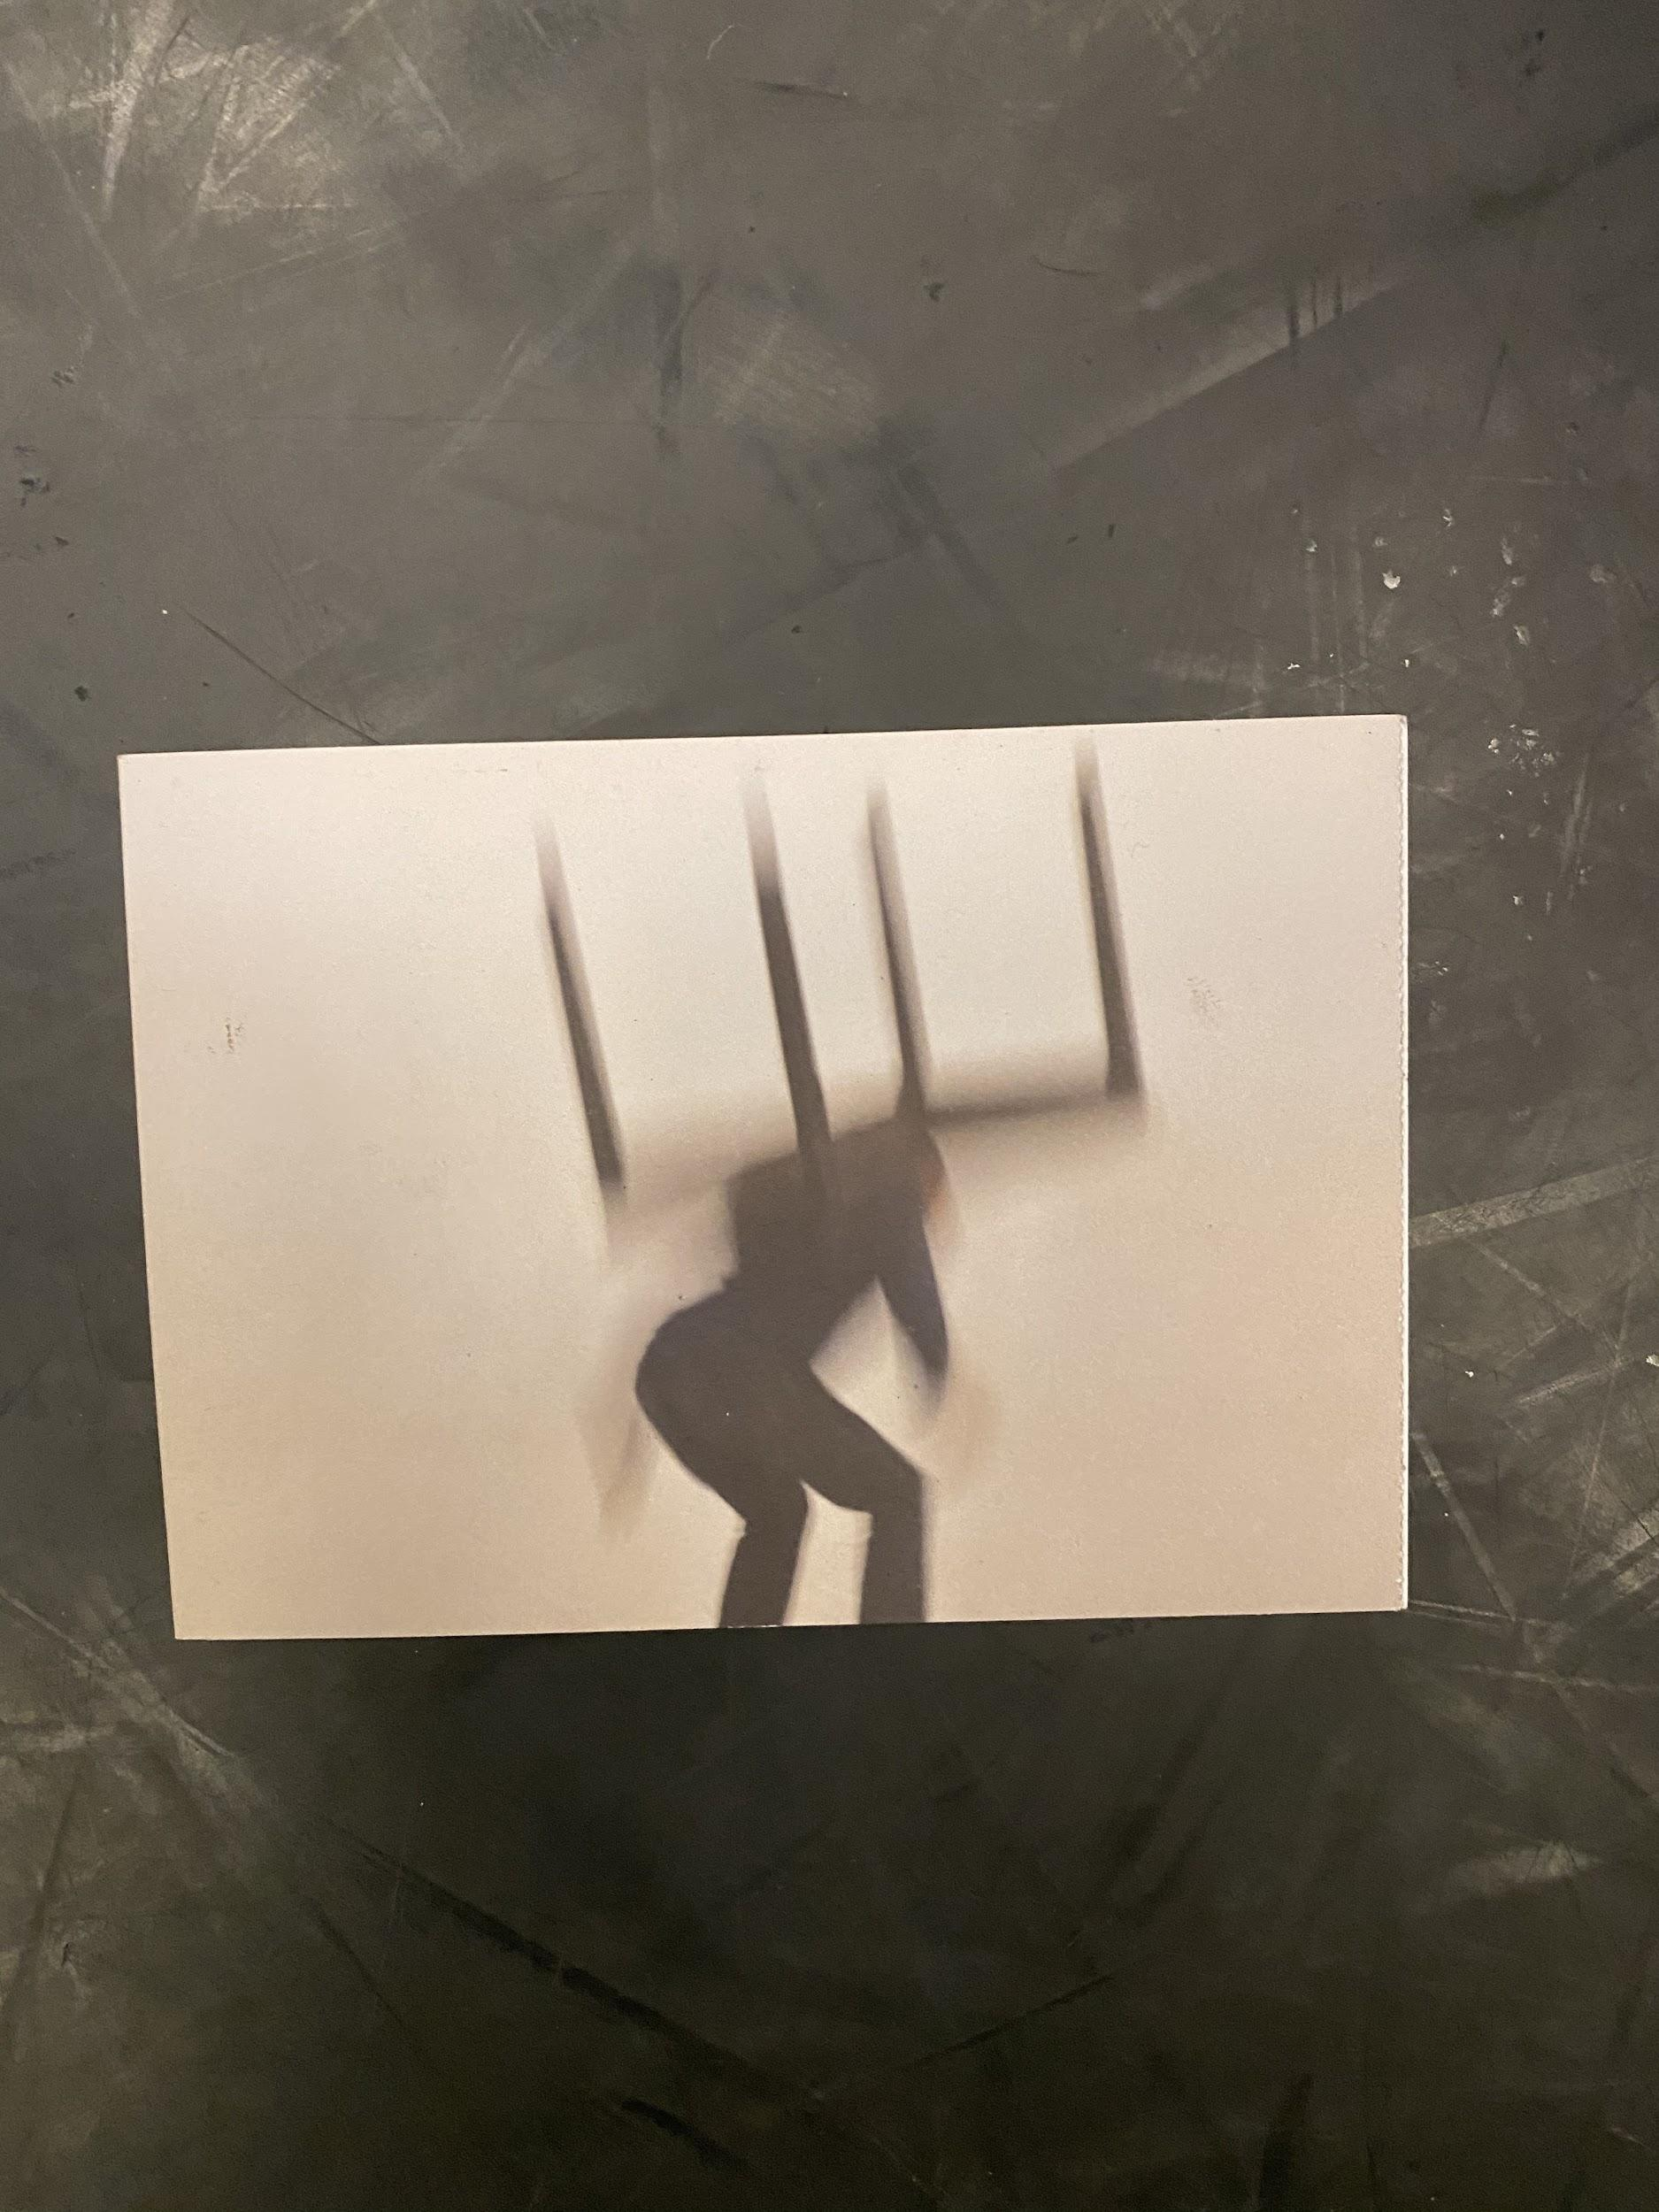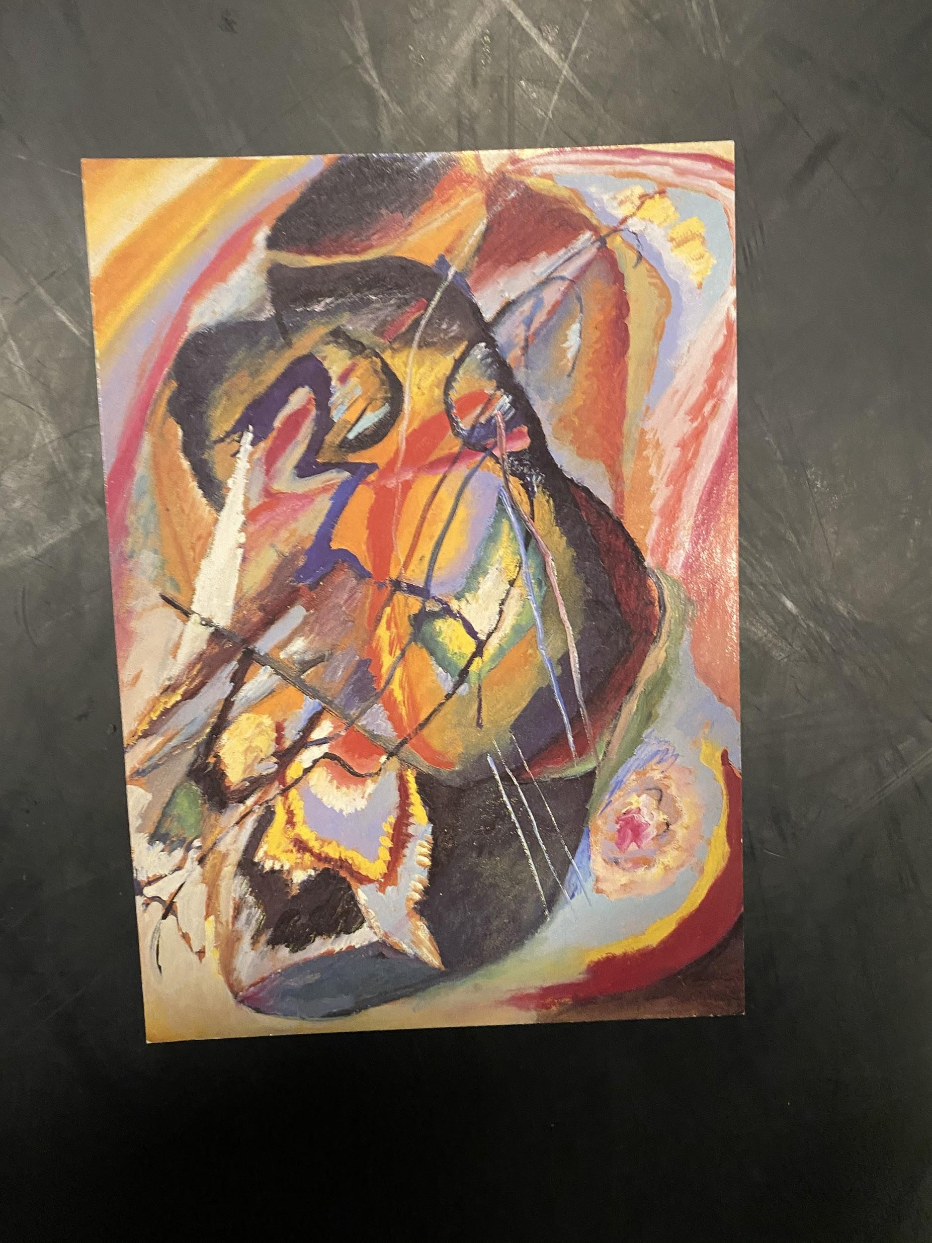
I picked these because I thought they were polar opposites so I thought it would be really easy to create a journey from a dark, gloomy picture to a colorful picture. Me and my Movement group found this task super interesting as we all found that we related our piece to something that we have struggled with. We thought this would be a really good opportunity to develop our sequences into something longer to fit into our final piece. I found this really hard to expand as I was having trouble finding a link between either of the pictures and my experience throughout lockdown. I started off by just moving in a soft way and this was not working, so I then went onto experiment with the dark image and came up with the battle and the power of our mobile phones, going from waiting for people to message u to then becoming obsessed. We wanted this part of our piece to be really tense and for us all to be portraying different problems. We said we would start off by moving a small part of our body and then bit by bit our movements got bigger and spread to the rest of our body.
Sessions with Jonathan
A lot of our inspiration for our final movement pieces came from sessions we did with Jonathan. We found working with center of gravity a really useful way to represent the fight and struggle people faced going into lockdown. In his lesson we experimented with using different parts of our body to lead our walk. We then went on to fight that feeling of being led. This created a completely different image and story. We wanted to use the center of gravity technique to transition from tablos of togetherness at the start of the piece to us breaking out into individual spaces in the room. Where we would go into our individual struggles that we developed with merags techniques. We each used a part of our body to control/lead us. The body part I chose to be led by was my elbow. The next activity of Jonathons that inspired us was the use of Severn Levels of Tension. In his class a few of us got to experiment with this. He read out a story which met each level of tension. We had to interpret what he was saying and act it out. We wanted to include this in our piece to display our main topic of Body Image and the pressures people felt with it during lockdown. To incorporate the Severn Levels of Tension we decided that we would start ctattonic on the floor and then slowly become more awea of our body, looking in disgust, we all then chose a member of the audience to use as a mirror. Walking up to them and standing in their face looking at our bodies distressed.We wanted to use the space ofthe room to build up the tension. This meant moving back and forward through the space to be able to build that tension with the audience. This was very important because we needed to reach a certain point of tension then be able to end our pierce in a state of frozen shock. Feedback from the audience showed that the way we performed this was very effective. A couple of days before our performance we showed our piece to Jonathan, aiming to get some last minute feedback. Our feedback was:
- Ending Sequence - To add in natural sounds of breath into our finale sequence to build the tension with the audience even more.
- Individual Sequence - Start off just looking at the phone and then build it so the phone become the object controlling me / Not being able to put it down

Keeping all our feedback in mind. Overall I think our performance was really strong. Next time I would try and develop sections further to lengthen our piece.

