New prospects for Huawei's future development



December 2022

Module name: Strategic management (BMMB7013)
Name: Weihan Mi
Student number:1915371

Contents

Abstract 3
Chapter one : Introduction 4
1.1：Background of the research 4
1.2：Purpose of the research 5
1.3：Huawei corporate introduction 5
Chapter two : Huawei corporate strategy analysis 8

2.1：External environment analysis 8
2.2：Internal environment analysis 14
2.3：SWOT analysis 16
Chapter three : Huawei corporate future development strategy 21
3.1：Huawei's vision and mission 21
3.2：Huawei development strategy choices 23
Chapter four : Huawei corporate development strategy proposal 26
Chapter five : Conclusion 29
Reference 30

Image contents
1.Image1 7
2.Image2 9
3.Image3 9

Abstract

This paper provides recommendations for the sustainable development of Huawei by analysing its internal and external environment as well as the strategic choices and implementation of its corporate development process. It elaborates on Huawei's external environment and internal resource capabilities in the context of its basic situation, and summarises and analyses the opportunities, threats and the strengths and weaknesses that Huawei faces. After combining its core competencies, the company's strategy is analysed and evaluated by applying a combination of strategic management analysis methods, PESTEL and SWOT analysis, which also provide relevant theoretical insights for private communication companies of the same type when carrying out strategic analysis and strategy optimisation.

Keywords: development strategy、strategic choices and analysis

Chapter one : Introduction
1.1：Background of the research
As the global economy continues to develop, the business environment for companies has changed dramatically. Trade competitors figure it out that the competitive environment is getting to be increasingly complex, the substance of competition is becoming increasingly differing, and the supportability of competitive advantage is diminishing. Enterprises need to see the details and implementation in trade, and update and more effective strategies to adapt to environmental changes, so as to improve their ability to cope with complex environments. So that they can gain corporate advantages in a developing business environment and ensure the long-term development of the company.

The complex business environment promotes the attention of strategic management programs of various enterprises. The strategy formulation of the enterprise has evolved from static analysis to the strategic deployment of the enterprise, in order to respond to different business environments. However, the theory of strategic management of enterprises has not been well developed, and the rules of competition in enterprises are constantly changing, and the theory of strategic management will face higher challenges. Under the role of economic globalisation, private communication enterprises in China will face greater competitive pressure. The global allocation of resources, capital, technology and labour markets have changed dramatically, the increase in competitors has made companies face increasing risk factors and the constant innovation of technology has made competition between companies more intense. In the face of many excellent companies around the world, China's private communication companies have always been at a disadvantage. In the absence of advantages, it is very important for enterprises to accurately analyze the market environment and problems, so as to make the correct strategic deployment.

1.2：Purpose of the research
Strategy is the core of an enterprise, and Huawei's success is inseparable from the strategic positioning and direction it formulates. Nowadays, How to properly deploy a corporate strategy in a competitive market has become a key success factor for enterprises. This paper focuses on Huawei enterprises and analyzes the environment of enterprises to study how Huawei enterprises can gain competitive advantages in a complex and ever-changing business environment, and also provides reference for other enterprises.

1.3：Huawei corporate introduction
Huawei was founded in 1987 and is located in Shenzhen, China. As the world's leading supplier of communications infrastructure and smart terminals, Huawei is also one of the world's top six mobile phone manufacturers. Huawei focuses on the information and communications field, providing competitive products and services for enterprises and consumers. A private enterprise wholly owned by its employees, Huawei currently has around 190 thousand employees and operates in more than 170 countries and regions.
Huawei Enterprise has three main businesses, namely consumer business, operator business and enterprise business. The consumer business is mainly mobile phones, TVs, bracelets, watches and other such products and services for individual consumers, while the operator business is for communication equipment, communication software and services for operators. The enterprise business is mainly in IT services and cloud computing services in addition to carriers. Huawei and carriers have built many networks around the world and have helped more than one-third of the world's population connect. Huawei provides a more open and flexible secure endpoint cloud collaborative communication infrastructure platform for many enterprises in the society, and promotes the digital transformation of society and enterprises. Huawei provides stable and secure devices and services for cloud service customers, and Huawei's smart devices are helping people enjoy a better life and entertainment experience. Huawei not only brings direct tax contributions to the government, but also promotes the development of local employment. More importantly, Huawei has created a digital engine through innovative Information and communication technologies solutions to drive the digital transformation of all industries. It not only promotes economic growth, but also improves people's quality of life.
Huawei is committed to bringing the world of digital devices to everyone and every organization, and creating a fully connected world. Huawei hopes to provide more diversity to the world and make digitalization and intelligence ubiquitous. Huawei is committed to making all industries more flexible and efficient through intelligent platforms, and enabling consumers to experience intelligent personalization in any scenario.
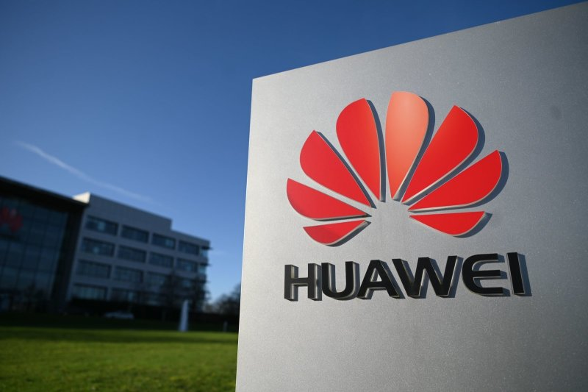
Image1

Chapter two : Huawei corporate strategy analysis
2.1：External environment analysis
Political environment factors, the national government's policies play an important role in the macro management of our business development. China has been actively implementing fiscal and monetary policies in recent years, and the stable domestic political environment has allowed for good and sustainable business development in China. In the “14th Five-Year Plan”, it is pointed out that the state should put the construction of modern information infrastructure in the first place, carry out the deployment of a new generation of information network technology as soon as possible, and implement an encouraging policy to help private information and communication enterprises, digitalization, cloud computing, Internet, 5G and other new technology development and application will be an important direction for the future development of enterprises, which is a very favorable external environment for Huawei. On the other hand, Huawei will no longer have an advantage due to the opening up of the domestic telecommunications market, the increase in the number of companies and the reduction of import tariffs.

In the international environment, as the US tries to cut off Huawei's semiconductor supply, all companies around the world that want to use US facilities to produce chips for Huawei will have to obtain a license from the US. In 2020, the US stops supplying chips to Huawei companies, which will have some impact on Huawei's business, causing it to lose more market share in its mobile phone business. In Huawei's corporate financial report, sales revenue declines by approximately 50% in 2021 compared to 2020, and Huawei is partially transforming its business in order to open up new businesses.
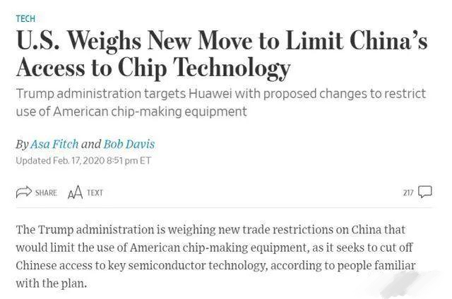
Image2
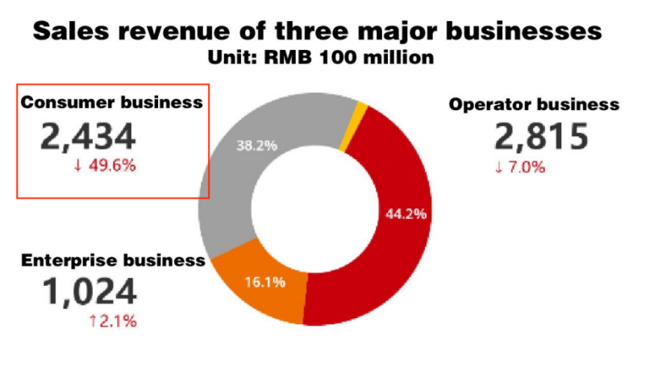
Image3

Economic factors, in the face of severe domestic and international situations and multiple social factors. China's national economy continued to recover this year, and the economic recovery in the third quarter was better than in the second quarter. And society's production needs are constantly improving. The employment and prices of the society are generally relatively stable, people's lives have been effectively guaranteed, and the overall operation of society is within a reasonable range. According to preliminary calculations, China's GDP in the first three quarters grew by 3% year-on-year. And the growth of GDP also shows that consumers' demand for goods and purchasing power have increased, which is conducive to the good development of Huawei. Personal disposable income is a decisive factor influencing consumers, and people's level of disposable income is gradually increasing, as well as their demand for electronic products, with shorter and shorter replacement cycles. In a globalised economy, the global economy is slowing down due to the epidemic, which will have an impact on the growth and profitability of many businesses. However, Huawei has seized the opportunity to make timely adjustments and adapt methods according to its actual situation and development advantages. Economic globalisation has provided favourable conditions for China to utilise the world's resources and has promoted economic development in terms of upgrading and technological advancement of enterprises.

Social and cultural factors, the greatest influence is on the demographic environment and cultural background. The size of the population directly determines the size of the market and the scope for development. China is a huge market and has always been a competitive place for all kinds of companies around the world. According to the Huawei Corporate Finance 2019 report, 59% of the full year's sales revenue came from China. On the other hand, Huawei's corporate market positioning and brand philosophy has increased consumers' sense of national identity, and consumers tend to buy products from national brands. Huawei gains a competitive advantage by being cost effective, and cost effective is the value that customers value most.

Technical factors, science and technology information technology have promoted the positive formation of the global economy. Product innovation and the technical capabilities of enterprises determine the future development of enterprises. The increase in technological and scientific capabilities has contributed to labour productivity and the development of the world economy. Huawei's basic principle for investment in research and development is to insist on investing 10% of its annual revenue in future technological research and development. As the world's largest communication equipment company, Huawei's self developed communication chips are not only superior to competitors in terms of performance, but also have obvious advantages in price. Therefore, Huawei's various products are hot and popular all over the world. Huawei independently developed the Hongmeng system, whis is the first domestic independently developed mobile terminal and operating system in China. Hongmeng system can be used not only on mobile phones, but also on any device with intelligent terminals. As the US controlled the import of Huawei's chips, there was then a US ban on all companies using US technology to process Huawei Kirin chips, which led to restrictions on Huawei's high-end chip technology for mobile phones.With the richest experience and technology in commercial 5G deployment, Huawei has made good progress in network deployment, consumer services and industry applications, and has now deployed more than 3 million 5G base stations worldwide and has entered a period of rapid development, which is an advantage for the company's future growth.

For environmental factors, Huawei is committed to reducing environmental impact and pollution in production and operations. Huawei promotes energy conservation and recycling in various industries through product innovation and solutions, and calls on enterprises in all sectors of society to build a low-carbon society. Huawei actively implements the concept of green sustainable development of the park, and constantly carries out energy-saving innovation and practice from the management and technology levels to create a green and low-carbon park. Continue to pay attention to the energy saving and carbon emission reduction of its own operations, including park facilities, research and development laboratories, production and manufacturing and other aspects, practice the operation mode of high energy efficiency and low emission, and build a sustainable green park ecology. Huawei has been encouraging suppliers to build energy metering systems, reduce energy use and waste, and develop energy-saving and emissions-reduction plans. In 2019, under the leadership and promotion of Huawei, 35 of Huawei's long-term cooperative suppliers participated in energy conservation and emission reduction projects.

Legal factors, Huawei's legal department is deeply involved in the development of business, and the participation of the legal department in business has become a corporate culture of Huawei. The legal department is integrated into all of Huawei's business processes. As an important regulatory system, business cannot be conducted without a legal department. Huawei's legal department consists of two parts, one is the legal supervision part, and the other part is the intellectual property part. Huawei's legal department now has more than 500 employees, and all 500 of them are employees of the firm, not including outside law firms. Outside firms work with more than three law firms in each country, and each has its own division of labor. The ZTE incident in the past exposed Huawei's lagging ability to control compliance risks and obvious loopholes in its compliance management system. At a time when globalization has entered a new stage and competition among enterprises has entered the global value chain, this is a major hidden danger. With the stable development of the global economy, the competition between enterprises has evolved from the competition between individual enterprises to the competition of the global value chain, and the competition mode between enterprises has also changed. In the face of the strengthening of social and government supervision, more and more enterprises have begun to strengthen the management of corporate compliance and legality, and the competition of compliance legalization has become a standard and competition rule for global enterprises.

2.2：Internal environment analysis
Huawei has established a clear and well-defined organisational structure, with various departments exercising mutual supervision and balance. The audit committee of the board of directors, which ensures the independence and authority of the audit. At the same time, Huawei also has an external auditor and an oversight board. In terms of organisational structure, functions, regions and business units are clearly allocated to promote rational operation of the Group. And unlike traditional organisational structures, Huawei uses a two-dimensional matrix structure, divided into regional organisations for development, production and sales in two dimensions: regional and product line. Huawei has set up business units and regional organisations as profit centres for self-management and profit responsibility. Regional centres and business units are linked and there is a strong relationship between indicators such as revenue and profitability of products. Optimisation of product lines brings cost savings and increased demand, contributing to the regional organisation. The profit centre department can combine product and sales incentives, avoiding the pitfalls associated with the unit's organisational structure and clarifying the responsibilities of each organisation. Huawei conducts a comprehensive risk management assessment and they have a risk management department. Huawei has set up three layers of defence for each process, which truly connects the processes and also ensures the independence of each project point. A well-developed risk management system can effectively prevent and avoid various risks. This multi-layered risk management system of Huawei can deal with multiple risks more effectively.

The development of enterprises cannot be achieved without talent, especially international multinational companies cannot be supported by talent, Huawei's talent policy has always been international. On the one hand, Huawei has been recruiting technology and technical talents all over the world, and now Huawei has more than 20 research institutes around the world, and these emerging forces have brought great innovation power to Huawei. On the other hand, local regional organizations adopt management methods to recruit local technical talent, and maintain a certain proportion of local talent recruitment, so that enterprises can adapt more effectively to the local business environment. Currently, Huawei has a localisation rate of around 70% for its overseas employees. Huawei's talent base has helped the company build a solid foundation to compete in markets around the world.

The risks of high-tech enterprises are mainly focused on strategic risks and research risks. Strategic risks refer to the possibility of some deviations in the direction of development and policies of the enterprise. And many companies now produce products that do not meet expectations in the pursuit of research results and market capture leading to the failure of the final strategy. High-tech enterprises also face the challenge of a changing environment when their technology development lags behind market demand, which will lead to a failure of research investment. Huawei has invested a whopping 845 billion in research over 10 years, and Huawei insists on investing 10% of its annual revenue in future technology research and development. With Huawei's current technological development and technical equipment, it has no problem at all surviving in the country. But there is still a lot of room for future development to work on if Huawei wants to take a significant position in the international market. Huawei has not been defeated by the US targeting, but has gradually retreated from the international market to the Chinese market, and Huawei has also carried out some business restructuring and transformation, with some of its consumer businesses gradually transforming into government and commercial businesses. Although Huawei invests a lot of money in technology research and development, China does not yet have the ability to produce high-end chips on its own, what Huawei needs is time.

2.3：SWOT analysis
Advantages, as a high-tech intelligent company, about 40% of Huawei's internal technical talents are engaged in enterprise research projects, but Huawei still recruits technical experts in various fields around the world every year to expand the enterprise talent pool. In return, Huawei is currently the intelligent enterprise with the most international patents in China. This reduces the proportion of Huawei companies that use foreign technology and mitigates the restrictions and influence foreign governments have on Huawei companies in terms of technology. On the other hand, the number of Huawei's technology patents not only increases the company's annual profit margin, but also enhances Huawei's market competitiveness. Huawei currently has many self developed technologies, such as the Harmony System and Kirin mobile phone processors, and these technologies and devices have greatly improved the consumer experience.

At a disadvantage, Huawei enterprises do not have a strong advertising campaign, and the low-profile advertising campaign is not conducive to enhancing the corporate image. The capital of Huawei enterprises is relatively weak compared to international telecommunication companies. As an unlisted company, Huawei has been accumulating technology and solving supply chain problems. Because Huawei is not listed, Huawei is unable to raise funds in the capital market, and has limited funds available compared to listed technology companies. In addition to the mobile phone terminal market, Huawei lacks high-speed business growth, and support for maintaining the large number of staff and research expenses is weak.

Opportunities, starting in 2012, 5G has been recognized in the market as a technological progress and a mobile communication technology replacing 4G. 5G as a core tool to influence various industries and support the intelligence of the economy and society, countries around the world are strengthening their policy and economic support for the 5G industry. Huawei Enterprise has been working on 5G technology since 2009 and started to increase its budget further in 2013. Huawei Enterprise is actively collaborating with research institutions on 5G projects worldwide, In the china innovation forum 2021, Huawei has worked with more than 100 experts around the world on over 300 projects. Through multifaceted efforts and its own development, Huawei has been at the forefront of the world's research into the progress of 5G technology and is also making technological breakthroughs.

Threat, the impact of the epidemic on the world economy is still serious. The larger the enterprise is, the more seriously it will be affected. According to Huawei's financial report in 2021, the revenue from operating businesses decline for the first time. Among them, the impact of the epidemic is extremely important. With the economic contraction caused by the epidemic and the shortage of basic necessities due to epidemic management measures, most people prefer to spend their money on basic necessities rather than high-tech products such as 5G phones. According to an analysis of People's Bank of China savers in the first quarter of 2022, there was a decrease of 1% in the number of users who tended to spend more compared to the previous quarter, while the number of people who tended to save more increased by 2.9%. The bank's financial data shows that people's spending propensity has begun to decline. On the other hand, due to the regular management of the epidemic, the cost of nucleic acid testing makes many governments are not as abundant as before. In the face of regular management of the epidemic, the government will suspend policy support for high-tech enterprises, such as the construction of signal base stations. Huawei Some key technologies of high-end mobile phone chip manufacturing have been controlled by foreign manufacturers, which has led to the contraction of Huawei's development in the international market, and Huawei will suffer from a long-term negative impact.

Through a comprehensive analysis of Huawei, despite the loss of overseas markets, Huawei's brand value, product innovation, and corporate management still have competitive advantages and competitiveness in the market. However, Huawei's excellent product quality, advanced concept and research and development strength are beyond the reach of similar enterprises in China. Moreover, the restriction of the international market further enhances the stickability of Huawei customers in China. From the perspective of long-term enterprise development, Huawei should focus on developing core enterprise technologies and strengthen strategic cooperation with product chain suppliers to achieve complementarity. Further consolidate the core competitiveness of products in order to better maintain market share and position.

Chapter three : Huawei corporate future development strategy
3.1：Huawei's vision and mission
Huawei's vision is to bring the intelligent world to everyone in the world, and to build a digital era in which everything is connected. Huawei has formulated a strategic plan for sustainable development in the future and incorporated it into its overall development strategy as a priority strategy.

Huawei's core values are six aspects, focusing on customer service. Serving customers is the only reason for Huawei's existence, and it is driven by the needs of customers. Take customers as the core, help customers realize their needs, and continue to create sustainable development value for enterprises. Huawei's work is to provide customers with safe and secure services. Realizing customer value is realizing Huawei's brand value. Huawei does not have any scarce resources to rely on, and only through the hard work of the enterprise itself can it more effectively gain the trust of customers. The spirit of struggle is reflected in every detail of creating value for customers. Huawei insists on putting strivers first, so that strivers can get reasonable returns. Huawei's self-criticism is an important criterion for promoting continuous improvement and progress of enterprises, and it is not a self-denial of enterprises. Only continuous improvement can we constantly surpass, and we can better gain respect to achieve the common development goals of enterprises and customers. Huawei's open and enterprising principles are to explore the future and adhere to the spirit of open innovation. Any advanced product and technology can only reflect success when it is transformed into business value. Huawei has always been guided by customer needs and continuously creates new value. Huawei always adheres to the standard of honest cooperation, which is the most important intangible asset of an enterprise and plays a good role in promoting the future development of the enterprise. Teamwork is also a strong guarantee for Huawei to improve work and business efficiency.

Huawei's mission is to focus on customer needs and challenges, and provide competitive solutions and technologies to create more enterprise value and future development momentum for customers. Ten years ago, Huawei put forward the core values driven by the realization of customers' dreams, which has become the common mission of all Huawei employees. Huawei is guided by the needs of enterprises and is committed to improving the competitiveness and profitability of each enterprise. At present, more than 150 million users around the world use Huawei's equipment and technology, and Huawei's presence enriches people's lives and promotes communication between people. Huawei has formed the construction of communication equipment, terminal products and solutions for enterprises. As more operators around the world choose Huawei as their strategic partner, Huawei and its partners will jointly face the challenges of future development and the needs of industry development.

3.2：Huawei development strategy choices
In the face of the impact of the epidemic on the industry, Huawei's operating revenue in 2021 decreased by 28.6%, but its net profit margin increased by 75.9% year-on-year. Huawei has become smaller, but its profitability and access to cash flow have increased, and the company's ability to face uncertain market factors has also been improved. Huawei's future strategic goal is to continue to stabilize the strategic direction of the enterprise, focus on specific strategic plans and solutions, and adjust the company structure and marketing strategy in the existing business conditions.

At present, Huawei uses the previous inventory to maintain the development of the enterprise, and Huawei focuses more on some regional markets and customers. Huawei is the world's largest buyer of semiconductor chips and equipment. China is a huge chip market, with an annual purchase volume of about 400 billion dollars. Many Chinese companies fear the same fate as Huawei and have similar needs. With China's huge chip market, there are sure to be companies willing to invest, and Huawei has been trying to solve problems and suppliers that comply with U.S. regulations. The chairman of Huawei said that if the global industrial chain can resume cooperation and give play to the advantages of the global industrial chain, then Huawei's problems may be solved. Huawei intends to strengthen its software capabilities in the future to further reduce its dependence on and demand for chips and improve its product competitiveness. On the other hand, Huawei will always look for opportunities in the software industry, and when it finds those opportunities, it will invest more to increase the share of software and services revenue.

Huawei said that in the era of intelligent electric vehicles, the automotive industry has undergone great changes. The focus of users has gradually shifted from the mechanical properties of cars to the properties related to intelligence and electrification. With the changing trend of The Times and the huge market, Huawei is full of confidence in the future of the automobile industry. Huawei hopes its investment in this area will boost the development of intelligent and electric car industry. In order to bring continuous opportunities to the enterprise, the enterprise is determined to remain the enabler of the automobile industry, which is the most promising industry in the next decade. Huawei has invested more than 1 billion dollars annually in the automobile industry. Instead of making cars, Huawei helps auto companies combine traditional vehicles with core technologies such as artificial intelligence, new energy and 5G. Huawei will provide a powerful operating system and computing capacity for intelligent vehicles, it includes three digital computing platforms: intelligent driving, cockpit and vehicle control. There is also a series of intelligent operating systems.

In short, Huawei's future strategic direction is threefold. First, it will enhance its software capabilities and strive to maintain its competitive position in the market, and maintain the sales volume of communication equipment by improving the quality of its operating system and products. The second aspect is to adjust the original enterprise structure, further shorten the enterprise management chain, in order to better improve the efficiency of the enterprise and the response speed to business development. The third aspect is to further combine Internet technology with automotive enterprises, and carry out new research and development and creation of technology to create mobile network terminals in the new digital era in the future.

Chapter four : Huawei corporate development strategy proposal
Increase chip research and development capacity according to national policy. Having an indigenously developed chip has been the biggest goal of the Chinese government and all mobile phone companies. By pouring money into research, the chip supply problem will have less of an impact on Huawei's handset production. But Huawei spends a lot of money on research every year, and its competitiveness in the international handset market is still declining. At this stage of development, Huawei disposable capital is not as abundant as before. Only by increasing research funding for mobile phone chip technology can Huawei more effectively escape the negative impact of chip supply suspension.

Improve the ecological environment of smart home appliances. In 2019, Huawei has started developing and researching smart home products with a number of smart companies, and Huawei is responsible for the development and operation of smart home software. For Huawei, Huawei can participate in the construction of smart home industry in the field it is good at, which is conducive to the future development of Huawei, and finally take the lead in seizing market share in the future market.

Continue to deepen product differentiation. In the strategic orientation of market differentiation, Huawei carries out independent research and development and technological innovation, and makes full use of the advantages accumulated in technology, to further strengthen the stability of the market and the differentiation of consumer groups. At the same time, Huawei is also accelerating the acquisition and financing of global famous brand enterprises, laying a solid foundation for breaking through trade barriers and creating new brand enterprise industrial groups, so that it can more effectively enter the international information and communication market.

Strengthen product publicity and expand sales channels. In order to shorten the gap between Huawei and the industry giants, Huawei can make full use of the new media platform for advertising output to promote the brand and brand value. On the other hand, Huawei can further carry out long-term strategic cooperation with product sales channels, and more consumers can buy products conveniently and quickly to promote the brand's market share in the market.

Grasp the field of intelligent vehicles. In the development of the intelligent automobile industry, the concept of software defined vehicles has been widely known. Huawei has accumulated a deep technical foundation in the field of communication technology that other automakers do not have. Huawei should give full play to a large number of mature technologies and related patents accumulated in communication technology solutions, and actively cooperate with automobile manufacturers to apply communication technology to new intelligent vehicles. On the other hand, the technology and experience accumulated by Huawei's cooperation with the automobile industry will lay a foundation for building its own intelligent automobile manufacturing industry in the future.

Chapter five : Conclusion
The global economy has been affected by the epidemic, now more and more enterprises realize the importance of internal management and enterprise strategy. Only the establishment of a good internal control environment and accurate strategic planning, according to the social situation in order to play the ability of enterprises.

Huawei's success has set a model for many small and medium-sized enterprises in China. The company has built a perfect enterprise internal security mechanism, and through the combination of this mechanism and corporate culture to improve the brand loyalty and enthusiasm of employees. Huawei has been constantly observing the market changes and the business environment to adjust its strategic direction, and to develop steadily according to its own capabilities. This is the key factor in Huawei's growth from a small company to a core competitive company.

Reference
[1] Yang Yinghang. 2020. Huawei smart phone marketing strategy research. Jilin university
[2] Sun Yufei. 2018. Huawei high-end smartphone marketing strategy research. East China university of science and technology
[3] Zhang Le. 2020. Huawei's innovation and challenge. China economic review
[4] Wei Jinde. 2017. Research on reverse innovation model of high tech enterprises. Guangxi university
[5] Liu Caihong. 2014. Application analysis of Huawei's smart phone marketing strategy. Taiyuan university of technology
[6] Zhuang Xuemin. 2017. Based on Huawei's strategic transformation analysis. Scientific research management
[7] Liu Feng. 2020. Forward thinking of enterprise development strategy. Business management
[8] Zhang Lan. 2018. Research on Huawei's intellectual property strategy. Beijing university of posts and telecommunications
[9] Wu Jianguo. 2019. Huawei team work method. CITIC press
[10] Zhou Liuzheng. 2016. Huawei innovation. China machine press
[11] Wu Jianguo. 2006. Huawei's world. CITIC press
[12] Chen Xiaoling. 2020. Research on Huawei's business model evolution. Jinan university
[13] Wan Shuang. 2020. Research on the influencing factors of Huawei's brand internationalization. Jilin university
[14] Ding Wei. 2015. Huawei mobile phone marketing channel strategy research in China. Beijing jiaotong university
[15] Liao Yani. 2014. Research on Huawei's marketing strategy. Southwest jiaotong university
[16] Wang Zhiyi. 2018. Huawei mobile phone development strategy research based on SWOT analysis. China's high-tech industry
[17] Sun Huanhuan. 2019. Research on the development of smart phone industrial structure in the context of informatization. Modern shopping malls
[18] Peng Jianfeng. 1997. Huawei's experience in second entrepreneurship. Chinese and foreign management
[19] Liu Chenxu. 2016. Marketing strategy analysis of domestic mobile phones in western europe. Guangdong university of foreign studies
[20] Zhang Pin. 2015. Huawei mobile phone customer satisfaction research. Lanzhou jiaotong university
[21] Wan Shuang. 2020. Research on the influencing factors of Huawei's brand internationalization. Jilin university
[22] Ma Xiaoyuan. 2010. Enterprise environment and enterprise sustainable development. Managing the world
[23] Liu Ligang. 1999. Research on the theory of enterprise sustainable development. Journal of liaoning university
[24] Zeng Ya. 2009. Research on mobile software application store at home and abroad. Beijing university of posts and telecommunications
[25] Zhang Dezhi. 2017. How to go further on the road of internationalization of Chinese brands. People's forum
[26] Peng Ke. 2018. Research on Huawei's brand internationalization strategy. Jiangxi university of finance and economics
[27] Liu Qicheng. 2017. In the era of stock, domestic mobile phones need new development ideas. Communication world
[28] Feng Xin. 2015. China's mobile phone export faces challenges and countermeasures. Foreign economic and trade practice
[29] Sun Jinfang. 2014. Brand strategy boosts corporate culture construction. Business culture
[30] Chen Guo. 2016. Research on promoting the development of enterprise brand internationalization. Contemporary economy
[31] Qiao Yu. 2016. Disadvantages and opportunities of China's internet brand internationalization. East China economic management
[32] Zhu Guifang. 2005. New development of localization strategy of transnational corporations in China. Modern shopping malls
[33] Tao Guihua. 2018. Research on Huawei's cloud computing business development strategy. Nanjing university
[34] Hao Hantao. 2016. Research on Huawei's internationalization strategy. Lanzhou university of finance and economics
[35] Wang Anran. 2014. Research on financial strategy of communication equipment manufacturing companies. Ocean university of China.
[36] Zhou Zhan. 2014. Research on Huawei's accumulated internationalization strategy. Xiangtan university
[37] Ban Yue. 2013. Research on Huawei's international entrepreneurship strategy. Jilin university
[38] Hu Jinbo. 2013. Research on Huawei terminal's development strategy. Lanzhou university
[39] Xu Fei. 2016. Strategic management. China renmin university press
[40] Jiang Juanjuan. 2018. Huawei's globalization strategy analysis and inspiration. Accounting of China's township enterprises
[41] Chen Yongxiu. 2008. Research on enterprise brand strategy selection model. The commercial age
[42] Yu Changchun. 2016. Research on strategic management theory and method. Economic science press
[43] Shi Yanbo. 2014. Centennial brand. Electronic industry press
[44] Xia Hongsheng. 2013. Intangible asset management. Economic management press
[45] Chen Feilong. 2012. Brand operation and management. Economic management press
[46] Cheng Xiao. 2007. Modern enterprise brand operation and innovation. Zhongshan university press
[47] Yu Mingyang. 2005. Course of branding. Fudan university press
[48] Liu Wei. 2004. Brand strategy management practice manual. Guangdong economic publishing house
[49] Weng Xiangdong. 2002. Local brand strategy. Zhejiang people's publishing house
[50] Lu Juan. 2002. Modern enterprise brand development strategy. Nanjing university press

