University of Wales Trinity Saint David - T80
Faculty of engineering



ACHA5010 - Alternative propulsion systems
Kinetic energy recovery

Timothy Vale
2226401
BEng Motorcycle engineering
25/10/2023

Contents
Introduction 3
KERS systems 4
Triumph sprint ST1050 5
Specs 5
Test Mass 5
Frontal area 5
Rolling resistance coefficient 5
Coefficient of aerodynamic drag 5
Coast down test 5
WLTP cycle 6
DATA and calculations 7
KER system specifications 11
Battery 11
Capacitors 12
Motor 13
Controller and management system 13
Hardware 14
Safety and regulations 15
Conclusion 16
References 17
Bibliography 18
Appendix A 20
Motorcycle specifications 20
Appendix B 23
Appendix C 25

Introduction
The relentless quest for enhanced fuel efficiency in vehicles has led to the exploration and adoption of various technological interventions, one of which is the Kinetic Energy Recovery System (KERS). While the automobile industry has witnessed advancements, the motorcycle sector, characterized by its distinctive dynamism and challenges, still offers untapped potential for energy recovery solutions. The 2005 Triumph Sprint ST1050, a mix of sports capability and touring comfort makes this mid-2000s motorcycle an ever popular commuter. As the environmental impact and cost of fuel continue to be significant concerns, the implementation of KERS in such large capacity ICE motorcycles could present notable benefits not only in terms of economy but also in performance augmentation. When it comes to economy the ST1050 is competitive, with an average fuel consumption of between 40 – 50mpg, which is competitive when compared to other 1000cc sports tourers (Bennets, n.d). This study seeks to investigate the potential impact and feasibility of introducing a KERS to the Triumph Sprint ST1050, utilizing its dynamic characteristics, and evaluating the cumulative energy dynamics over the Worldwide harmonized Light vehicle Test Procedure (WLTP) cycle. Through this analysis, we aim to underscore the moments of maximum possible KERS power input, energy storage requirements, and the resultant effect on the motorcycle's overall fuel consumption and rider experience.

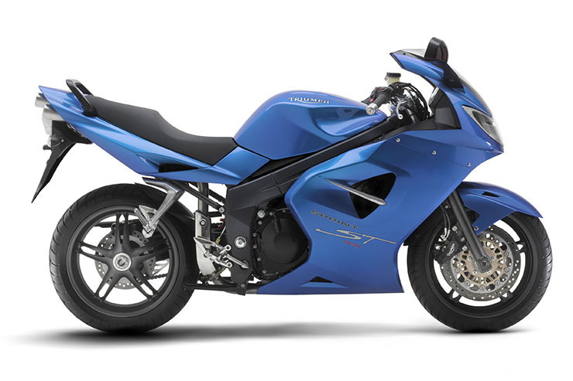
Figure 1 – Triumph Sprint ST 1050 (2005-2010). (Anon,2020)

KERS systems
The Kinetic Energy Recovery System (KERS) represents a significant advancement in regenerative braking technology. It allows vehicles to capture and store kinetic energy, which would otherwise be lost as heat during braking events. This stored energy can then be utilized to enhance the vehicle's acceleration capabilities. KERS has shown its versatility and effectiveness in various transportation modes, including both high-performance motorsports and civilian vehicles. (Kapoor, Parveen, et al. 2013).
In the context of environmental stewardship, the adoption of KERS is increasingly important. It addresses critical concerns such as rising emission levels, the need to preserve ecological integrity, and the dwindling reserves of conventional fossil fuels. The integration of KERS in powertrain development, particularly with the rise of electric and hydrogen propulsion systems, has been shown to improve vehicular range and efficiency. (Chen, Gao, and Ehsani, 1999).
This looks at the theoretical application of KERS in a 2005 Triumph Sprint ST1050 sports tourer motorcycle. We will explore the operational principles of KERS, examine the range of existing technologies, and consider the engineering challenges in retrofitting a motorcycle initially not equipped with this system. The feasibility, benefits, and potential limitations of this integration will be critically assessed to determine its viability in enhancing the motorcycle's fuel efficiency and dynamic performance.
A key component in this system is the half-bridge or H-bridge configuration, coupled with PWM)control, which is essential for driving a motor. The H-bridge circuit facilitates the control of a DC motor's direction and speed, while PWM control modulates the power supplied to the motor. This technique is vital in applications such as robotics and electric vehicles, enabling precise motor control and regenerative braking. By converting kinetic energy into electrical energy, the motor not only aids in propulsion but also contributes to energy conservation. However, managing this energy to prevent overvoltage or overheating is crucial, especially in complex systems like electric vehicles that utilize sophisticated control systems for effective regenerative braking. (Hughes et al., 2019). Moreover, the implementation of KERS in vehicles, including motorcycles, has several advantages. One of the most significant benefits is the enhancement of braking systems. While heavy braking and emergency stops still rely on traditional friction brakes, the addition of regenerative braking through KERS contributes to the longevity of these friction brake systems. This synergy not only saves energy but also improves overall vehicle performance and efficiency.
In summary, this report will provide a comprehensive overview of KERS, focusing on its potential application in a 2005 Triumph Sprint ST1050 sports tourer motorcycle. By examining theoretical aspects, existing technologies, and practical considerations, we aim to present a thorough analysis of the potential enhancements in fuel efficiency and performance that KERS could bring to this motorcycle.

Triumph sprint ST1050

Specs

Test Mass
As outlined in section 5.2.3. of the ECE R68 regulations “The mass of the vehicle shall be its kerb mass plus 180 kg or plus half the full load if greater than 180 kg.” (Un. Ece. Secretariat, 2003)
The wet weight of the sprint is 241 Kg (Anon, 2020). Half the load of the triumph with 1 passenger and ½ luggage capacity would be approximately 100kg. So a total test weight of 341 Kg.

Frontal area
The frontal area of the motorcycle was calculated using a head on photograph of the motorcycle (Appendix A) processed with SolidWorks area calculation feature, giving a result of 0.333m². This is supported by Motorcycle dynamics by Vittore Cossalter (2006). Page 75.

Rolling resistance coefficient
The rolling resistance is calculated by using the mass of the vehicle, gravitational force, and the coefficient of rolling resistant set at 0.2 for a motorcycle according to Motorcycle dynamics by Vittore Cossalter (2006) and corroborated by Ehsani, M. et al. (2019) . This meant the Triumph has a rolling resistance of 66.9N.

Coefficient of aerodynamic drag
The aerodynamic drag on motorcycles is generally high. Due to the triumph being a faired sports tourer the coefficient of aerodynamic drag was estimated to be at the lower end of the typical range at 0.6. (Ehsani, M. et al. (2019) . This number will obviously vary with load of the vehicle. (Foale, 2002)

Coast down test
A coast down test was conducted on the motorcycle and the results were logged with a GPS 2D data acquisition system. However due to limited data acquisition, road topography and condition of the vehicle the data was inconsistent and therefore a more theoretical approach was used to improve accuracy. However the data was used to corroborate the calculated data.

WLTP cycle
The Worldwide Harmonised Light Vehicle Test Procedure (WLTP) replaced the NEDC test for determining official Fuel Consumption and CO2 emissions of new internal combustion engine cars in September 2017, becoming mandatory by September 2018. WLTP aims to offer more accurate and representative fuel consumption and CO2 figures, providing model-specific values at the point of sale. Unlike the previous process, all tests are conducted in a laboratory to enable meaningful car comparisons. The data structure of WLTP results has changed, replacing terms like "urban" and "extra-urban" with "Low," "Medium," "High," "Extra-high," and "Combined" for driving phases. (Vehicle Certification Agency, n.d.)
The WLTP is split into three classes based on the power-to-mass ratio of the vehicle. The Triumph sprint falls into the Class 3 category of the WLTP due to it having a ratio of rated power in W / kerb mass in kg > 34. See appendix B for a full list of WLTP classes.

DATA and calculations
In the context of energy recovery, the quantity of kinetic energy present is directly proportional to the potential for its recovery. Motorcycles, in general, possess less kinetic energy in comparison to other types of road vehicles, making them less optimal for KER applications. However, the Triumph ST1050 is a good choice as far as motorcycles are concerned. Its selection for this specific application is justified by its large-capacity engine and relatively heavier weight, combined with its typical usage in commuting, which collectively contribute to a higher kinetic energy profile suitable for effective energy recovery.

Figure 2 – Velocity over the WLTP cycle.

Figure 3 – Combined forces over the WLTP cycle.
Figure 3 shows the combined calculated resistive forces across the WLTP cycle.
Figure 4 – Power requirement to complete the WLTP cycle.
Figure 5 – Braking energy
The braking energy is the kinetic energy where the power is negative. This is inverted for the graph as this represents the positive amount of energy available to the KERS system from the deceleration events during the WLTP cycle. Looking at the deceleration events, the last one is the largest, however this is due to the WLTP cycle finishing and decelerating from 70 to 0, this is unrealistic to happen in conventional driving conditions and therefore will be excluded as an anomaly. From the three largest deceleration events we can see that there is a maximum of 75.3Kj of energy available to use. This number will help to spec the KERS system components and energy storage.

Figure 6 – Energy at storage stage of KER system.
Figure 6 show the amount of energy available to be stored in the battery and capacitor.
Figure 7 – Energy along the WLTP before and after KER losses.
Figure 7 shows the recoverable energy at every point along the WLTP cycle showing energy into the KER system and energy returned to the wheel at every point along the WLTP cycle.
Figure 8 – Cumulative tractive and braking energy across the WLTP cycle.
The distance between the braking and the tractive energy of approximately 17Kw/h seems a little high for the cumulative losses to friction.
Figure 9 – Cumulative energy before and system losses.
Figure 9 shows the cumulative tractive and braking energy available and the cumulative tractive and braking energy after estimated system losses in and out of the KER system. The difference between the two tractive energy lines represents the energy saving with the KER system in place. Therefore the actual energy recovered after all losses is shown by the grey line in figure 9 at 1.86 KW/h.

KER system specifications
Now that usable energy data has been calculated this will dictate the specifications of the KERS system as follows.
Battery
Reasons to choose a lithium replacement for the stock lead acid triumph battery.
- Lightweight: Lithium batteries are significantly lighter than lead-acid batteries. Reducing weight on a motorcycle can improve handling and overall performance.
- Quick Charging: Lithium batteries charge more rapidly than lead-acid batteries, which is advantageous when combined with a supercapacitor for rapid energy storage and discharge.
- High CCA: The YTX14-BS/YTX12-BS has a high manufacturer-claimed CCA, indicating good cold-cranking performance, which is important for reliable motorcycle starting, especially in colder conditions.
- Maintenance-Free: Like the lead-acid AGM battery, lithium batteries are also maintenance-free, and they tend to have a long service life.
Table 1 – Battery specifications
Specification | Battery Model YTX14-BS/YTX12-BS | JMT Model HJTX14H-FP
Type | Lithium, Maintenance free | Lead Acid (Cast Ca/Ca)
Voltage | 12V | 12V
Capacity (10 Std) | 4 Ah | 12 Ah
Capacity (20-hour) | 8 Ah | 12.6 Ah
Manufacturer claimed CCA | 240A | CCA @ -18°C 200A
Weight (with Acid) | 900g (Lead acid equivalent 4.6kg) | 4.6 kg
Dimensions (±2mm)
Length | 150mm | 150mm
Width | 87mm | 87mm
Height | 93mm | 145mm
Technology | Lithium | Lead Acid (AGM)
Separator | N/A | AGM

Capacitors
Supercapacitors, distinct from lithium-ion batteries, store energy electrostatically and offer rapid charging and discharging with extended lifespans. Developed since the 1950s and gaining prominence with Tesla's acquisition of Maxwell Technologies, their current lower energy density limits widespread adoption. However, they find niche applications in hybrid transportation and public transit systems, benefiting from quick energy top-ups and efficient power regeneration. Recent advancements, especially in graphene-based supercapacitors, are expanding their use into fields like e-motorcycles and spacecraft, promising a potential shift in energy storage technologies. (Youtube, n.d). This makes them a great choice for the primary energy storage and discharge system and a filter between the motor and battery for the KERS.
The capacitor for this KER system will need to be able to hold 69.78 KJ as shown in figure x.
The SkelMod 17V500F capacitor from skeleton technologies is a suitable match in terms of capacity, dimensions and lifecycle. (Full data sheet in appendix B)
Using $E= \frac{1}{2}*c*v^{2}$ to calculate the energy storage capacity we get 72.25 kilojoules of capacity.
In order to determine if 1,000,000 life cycles is sufficient the following calculations were used. Motorcycle average life time milage expectancy = 100,000 miles. A vehicle on the WLTP brakes on average every 550 meters.
Number of brakes = Total distance / Average braking distance
Number of brakes = 100,000 miles * 1,609.34 meters per mile / 550 meters
Number of brakes ≈ 291,816.8
Therefore the brakes will be used approximately 291,817 times in 100,000 miles if you brake on average every 550 meters. Keep in mind that this is an approximation and actual braking frequency may vary depending on driving conditions and habits. The 1,000,000 charge/ discharge cycles of the SkelMod 17V500F are more that capable.
The dimensions of the SkelMod 17V500F are also acceptable and shouldn’t prove too difficult to mount within the confines of the motorcycle.

Motor
When looking for a motor for the KERS system the following key requirements in selecting a suitable motor:
- Motor Type: A brushless motor for higher efficiency, longer lifespan, and lower maintenance.
- Power Output: Approximately 7 kW, calculated based on the need to use 69.78 kJ over a short duration (e.g., 10 seconds). Power (in watts) = Energy (in joules) / Duration (in seconds).
- Torque: Range of 20-40 Nm to provide effective assistance without excessive bulk.
- Speed Compatibility: High RPM capability to match motorcycle operation.
- Voltage Compatibility: Must work with the motorcycle's 12V system, considering any voltage step-up in the KERS design. A DC-DC converter could be used to up the voltage requirement.
- Size and Weight: Compact and lightweight to maintain motorcycle balance and handling.
- Regenerative Braking: Capability for energy recovery during braking.
- Cooling Requirements: Efficient cooling system to prevent overheating. This could be incorporated into the motorcycles existing cooling system.
- Durability and Efficiency: Robust construction to withstand motorcycle conditions and high efficiency for maximum energy conversion. Suitable ingress ratings.
A couple of potentially suitable motors are the DANA TM4 IPM 200 series motors, who also supply e-Axles, gearboxes and hubs or pumps. (Full details in Appendix C) (IPM 200 Motors, n.d.)
And the iEV 180 series from Inetic, who also provide gearboxes and controller systems. (Full details in Appendix C) (iNetic, 2023)
Consultation with either firm and an electrical engineer would be recommended in order to get the most suitable motor for the KER system requirements.

Controller and management system
The controller/management ECU system is crucial for the operation of a Kinetic Energy Recovery System (KERS) in a 1050cc motorcycle. It manages the complex interactions between the motorcycle's 12V system, the KERS motor's 24V-96V range, and the supercapacitor. This system is responsible for efficient energy transfer during regenerative braking, ensuring safety through voltage and current protection, and maintaining the motor's thermal balance. Additionally, it seamlessly integrates the KERS with the motorcycle's existing systems and allows for customization to optimize performance, making it an indispensable component in the effective functioning of the KERS.
Table 2 – Management system requirements.
Aspect | Specification
Voltage Management | Handles varying voltages between 24V-96V motor and 12V system with supercapacitor; ensures seamless power conversion.
Current Handling | Manages peak and continuous current demands of the motor during high power output and regenerative braking.
Regenerative Braking Control | Efficiently directs energy recovered during braking to supercapacitors for storage.
Thermal Management | Actively monitors and manages motor temperature to prevent overheating under high load conditions.
System Integration | Integrates seamlessly with motorcycle’s existing systems, possibly using CAN bus or similar protocols.
Efficiency and Responsiveness | Facilitates efficient energy conversion with minimal losses and rapid response times.
Safety Protocols | Includes overvoltage, undervoltage, overcurrent, and thermal protections for system safety.
Customizability | Offers programmable parameters to tailor performance to specific KERS requirements.
Durability and Reliability | Robust to withstand vibrations and environmental conditions typical in motorcycle operation.
Installation and Maintenance | Designed for ease of installation and user-friendly maintenance, considering the retrofit nature of the KERS.

For initial development and testing the use of a Arduino or Raspberry pi board could be programmed and used to refine the KERS before production or purchase of a more robust and suitable control unit. Again, consultation with an electrical engineer is crucial for final development and testing.

Hardware
Additional hardware and components required are listed but not data specified in table 3 below.
Table 3 – Extra components
Component | Purpose
Relays and Switches | Control the flow of electricity, manage power distribution in the system.
Heat Sink or Cooling System | Dissipate excess heat from the motor and controller.
Voltage Regulator/DC-DC Converter | Convert and stabilize voltage levels between different system components.
Circuit Breakers | Provide a safety mechanism to prevent electrical overloads.
Isolation Modules | Ensure electrical isolation for safety and system integrity.
Sensor Suite | Monitor various parameters like speed, temperature, and voltage.
Mounting Brackets and Clamps | Securely attach components to the motorcycle frame.
Protective Casings | Shield electronic components from environmental factors and vibrations.
Connectors and Terminals | Facilitate secure electrical connections.
Wire Harness Sheathing | Protect wiring from abrasion and environmental damage.
Diagnostic Interface | Allow for system monitoring, troubleshooting, and adjustments.

Safety and regulations
The KERS system would also have to comply with road vehicle regulations and legislation to be used on the road or sold. (Gov.uk, 2023)
This could include:
- Certification and Testing
- Emissions Compliance
- Lighting and Signalling Systems
- Weight and Dimension Regulations
- Noise Regulations
- Electromagnetic Compliance
- Documentation and Labelling
- Insurance and Liability Considerations
- Recall and Maintenance Protocols
- Aftermarket Compliance

Conclusion
This engineering report concludes that the addition of a Kinetic Energy Recovery System (KERS) to the Triumph Sprint ST1050 is a viable method for improving both fuel economy and acceleration. Our detailed analysis reveals that significant amounts of energy, which would typically dissipate as heat during braking, can instead be captured by KERS. Specifically, within the WLTP cycle, up to 75.3Kj of energy can be reclaimed during deceleration events and redirected to aid the internal combustion engine (ICE). This reclaimed energy is especially advantageous during high-spirited rides or track days, providing an instant power boost of a few kilowatts, courtesy of the electric motor's characteristics, which is sure to be appreciated by any biker.
To harness this energy efficiently, a supercapacitor has been selected for its quick charge and discharge capability, matching the motorcycle's need for immediate power delivery. The system's success hinges on the supercapacitor's performance since it determines the amount of energy that can be effectively used for propulsion.
Moreover, a front-wheel-mounted generator has been chosen for its ability to convert kinetic energy to electrical energy adeptly. This generator is integrated with an H-bridge circuit and PWM control, crucial for regulating the power supply and managing the motor's speed and direction. The projected power output from this configuration is designed to provide a significant acceleration boost without imposing excessive demands on the system.
However, incorporating a KERS does introduce additional weight, complexity, and the need for integration with the motorcycle's current setup. It is essential to balance these new elements to preserve the motorcycle's handling and performance. Collaboration with an electrical engineering team and specialists like iNetic is recommended, particularly for potential commercialization.
In terms of driver experience, when KERS is engaged during braking, the driver might feel a smoother deceleration compared to traditional friction brakes, as some of the decelerative force is being used to generate electricity rather than solely relying on friction. Upon re-acceleration, the driver may notice a quicker response or boost from the stored energy, enhancing the vehicle’s performance over a conventional ICE system without KERS. These variations in feel would depend on the design of the KERS and how intrusively it interacts with the vehicle’s conventional braking and power systems.
In closing, the proposed addition of KERS to the Triumph Sprint ST1050 presents a compelling case for enhancing motorcycle performance and efficiency. While the benefits are clear, there must be a concerted effort towards thoughtful design and integration. Further research and development are necessary to polish the system for actual use and leverage its full potential in real-world conditions.

References
Anon, (2020). Triumph Sprint ST 1050: review, specs, photo, video | Triumph Motorcycle Encyclopedia. [online] Available at: https://triumph-specs.com/models/triumph-sprint-st-1050 [Accessed 10 Jan. 2024].
Bennetts (n.d.). Triumph Sprint ST 1050 (2005-2010): Review & Buying Guide. [online] Bennetts UK. Available at: https://www.bennetts.co.uk/bikesocial/reviews/bikes/triumph/sprint-st-1050-2005-review-used [Accessed 10 Jan. 2024].
Bradley, J. (2018) The racing motorcycle. Volume 3, An introduction to chassis set up. Malvern? Broadland Leisure Publications.
Cossalter, Vittore. (2006) Motorcycle dynamics. 2nd English ed. Lulu.
Ehsani, M. et al. (2019) Modern electric, hybrid electric, and fuel cell vehicles. Third edition, International student edition. Boca Raton: CRC Press, an imprint of Taylor & Francis Group.
Energy Act 2023. (2023). Legislation.gov.uk. https://www.legislation.gov.uk/ukpga/2023/52/contents/enacted
iNetic. (n.d.). Inetic.co.uk. https://inetic.co.uk/
IPM 200 motors. (n.d.). Dana TM4. Retrieved January 14, 2024, from https://www.danatm4.com/products/electric-motors/ipm-200/
Kapoor, R. & Parveen, C.M. (2013). 'Comparative Study on Various KERS', International Journal of Innovative Research in Science, Engineering and Technology, Vol. 2, Issue 8, August.
Maxwell Technologies. (n.d.). 16 Volt Small Module. [online] Available at: https://maxwell.com/products/ultracapacitors/16v-small-modules/ [Accessed 14 Jan. 2024].
Un. Ece. Secretariat (2003). Agreement concerning the Adoption of Uniform Technical Prescriptions for Wheeled Vehicles, Equipment and Parts Which Can Be Fitted and/or Be Used on Wheeled Vehicles and the Conditions for Reciprocal Recognition of Approvals Granted on the Basis of These Prescriptions :
Vehicle Certification Agency. (n.d.). Vehicle Certification Agency. [online] Available at: https://www.vehicle-certification-agency.gov.uk/fuel-consumption-co2/the-worldwide-harmonised-light-vehicle-test-procedure/.
www.fuelly.com. (n.d.). Triumph Sprint ST MPG - Actual MPG from 92 Triumph Sprint ST owners. [online] Available at: https://www.fuelly.com/motorcycle/triumph/sprint_st [Accessed 12 Jan. 2024].
www.fuelly.com. (n.d.). Triumph Sprint ST MPG - Actual MPG from 92 Triumph Sprint ST owners. [online] Available at: https://www.fuelly.com/motorcycle/triumph/sprint_st.
www.mouser.co.uk. (n.d.). Electronic Components Distributor - Mouser Electronics United Kingdom. [online] Available at: https://www.mouser.co.uk/.

Bibliography
‘KERS’ (2019) A Dictionary of Mechanical Engineering. 2nd edn. Oxford University Press.
Anon, (2020). Triumph Sprint ST 1050: review, specs, photo, video | Triumph Motorcycle Encyclopaedia. [online] Available at: https://triumph-specs.com/models/triumph-sprint-st-1050 [Accessed 10 Jan. 2024].
Anon, (2023). Home - iNetic Traction. [online] Available at: https://inetictraction.com/ [Accessed 14 Jan. 2024].
Bennetts (n.d.). Triumph Sprint ST 1050 (2005-2010): Review & Buying Guide. [online] Bennetts UK. Available at: https://www.bennetts.co.uk/bikesocial/reviews/bikes/triumph/sprint-st-1050-2005-review-used [Accessed 10 Jan. 2024].
Biker Rated. (2020). Triumph Battery Replacement Chart. [online] Available at: https://bikerrated.com/gear/maintenance/triumph-battery-replacement-chart/ [Accessed 14 Jan. 2024].
Boretti, A.A. (2013) Kinetic energy recovery systems for racing cars. Warrendale, Pennsylvania, USA: SAE International.
Bradley, J. (2018) The racing motorcycle. Volume 3, An introduction to chassis set up. Malvern? Broadland Leisure Publications.
Bradley, J. (2018) The racing motorcycle. Volume 3, An introduction to chassis set up. Malvern? Broadland Leisure Publications.
Cossalter, Vittore. (2006) Motorcycle dynamics. 2nd English ed. Lulu.
Ehsani, M. et al. (2019) Modern electric, hybrid electric, and fuel cell vehicles. Third edition, International student edition. Boca Raton: CRC Press, an imprint of Taylor & Francis Group.
Ehsani, M., Gao, Y. and Miller, J.M. (2007) ‘Hybrid Electric Vehicles: Architecture and Motor Drives’, Proceedings of the IEEE, 95(4), pp. 719–728. Available at: https://doi.org/10.1109/JPROC.2007.892492.
Energy Act 2023. (2023). Legislation.gov.uk. https://www.legislation.gov.uk/ukpga/2023/52/contents/enacted
Farnell.com. (2019). Farnell UK - Electronic Components Distributor. [online] Available at: https://uk.farnell.com/.
Foale, Tony. (2002) Motorcycle handling and chassis design : the art and science. England: Tony Foale.
Hughes, Austin. and Drury, Bill. (2013) Electric motors and drives : fundamentals, types and applications. 4th ed. Oxford: Newnes.
iNetic. (n.d.). Inetic.co.uk. https://inetic.co.uk/
IPM 200 motors. (n.d.). Dana TM4. Retrieved January 14, 2024, from https://www.danatm4.com/products/electric-motors/ipm-200/
Kapoor, R. & Parveen, C.M. (2013). 'Comparative Study on Various KERS', International Journal of Innovative Research in Science, Engineering and Technology, Vol. 2, Issue 8, August.
Maxwell Technologies. (n.d.). 16 Volt Small Module. [online] Available at: https://maxwell.com/products/ultracapacitors/16v-small-modules/ [Accessed 14 Jan. 2024].
Rego, N. and Castro, R. (2023) ‘Regenerative Braking Applied to a Student Team’s Electric Racing Motorcycle Prototype: A Theoretical Study’, Applied sciences, 13(6), pp. 3784-. Available at: https://doi.org/10.3390/app13063784.
uk.rs-online.com. (n.d.). DC Motors | RS Components. [online] Available at: https://uk.rs-online.com/web/c/automation-control-gear/electric-motors/dc-motors/.
Un. Ece. Secretariat (2003). Agreement concerning the Adoption of Uniform Technical Prescriptions for Wheeled Vehicles, Equipment and Parts Which Can Be Fitted and/or Be Used on Wheeled Vehicles and the Conditions for Reciprocal Recognition of Approvals Granted on the Basis of These Prescriptions :
Vehicle Certification Agency. (n.d.). Vehicle Certification Agency. [online] Available at: https://www.vehicle-certification-agency.gov.uk/fuel-consumption-co2/the-worldwide-harmonised-light-vehicle-test-procedure/.
White Motorcycle Concepts. (n.d.). SUSTAINABILITY. [online] Available at: https://whitemotorcycleconcepts.com/sustainability/ [Accessed 14 Jan. 2024].
www.fuelly.com. (n.d.). Triumph Sprint ST MPG - Actual MPG from 92 Triumph Sprint ST owners. [online] Available at: https://www.fuelly.com/motorcycle/triumph/sprint_st [Accessed 12 Jan. 2024].
www.mordorintelligence.com. (n.d.). Supercapacitors Companies - Top Company List. [online] Available at: https://www.mordorintelligence.com/industry-reports/supercapacitors-market/companies#:~:text=Supercapacitors%20Top%20Companies%20Eaton%20Corporation%20PLC%20Skeleton%20Technologies [Accessed 14 Jan. 2024].
www.mouser.co.uk. (n.d.). Electronic Components Distributor - Mouser Electronics United Kingdom. [online] Available at: https://www.mouser.co.uk/.
www.roboteq.com. (n.d.). Controlled Regenerative Braking using Real Time Speed Sensing. [online] Available at: https://www.roboteq.com/applications/all-blogs/24-controlled-regenerative-braking-using-real-time-speed-sensing [Accessed 14 Jan. 2024].
www.youtube.com. (n.d.). Supercapacitors explained - the future of energy storage? [online] Available at: https://www.youtube.com/watch?v=-7T-6XdiRTw.

Appendix A

Motorcycle specifications
Table 1 – Motorcycle specs (Anon, 2020)
Triumph Sprint ST1050 (2005-2010) specifications
ENGINE
Engine (type) | Liquid-cooled, 4-stroke
Cylinder arrangement | 3-cylinders, transverse in-line
Bore & Stroke | 79,0 x 71,4 mm
Displacement | 1050 cm³ (64,1 cu. in)
Compression ratio | 12.0:1
Valve train | Chain driven DOHC, 4 valves per cylinder
Max. power | 125,0 hp (91,9 kW) / 9250 rpm1
 | 125,0 hp (91,9 kW) / 9100 rpm2
 | 127,0 hp (93,4 kW) / 9250 rpm3
 | 129,0 hp (95 kW) / 9250 rpm4
Max. torque | 104,0 Nm (10,6 kg*m) / 5000 rpm5
 | 105,0 Nm (10,7 kg*m) / 7500 rpm6
 | 107,0 Nm (10,9 kg*m) / 7500 rpm7
 | 103,0 Nm (10,5 kg*m) / 7500 rpm8
Acceleration 0 to 100 km/h (0-60 mph) | 3,38 sec.9
Top speed | 257 km/h (160 mph)10
Fuel system (type) | Fuel Injection
Fuel economy / consumption | 6,31 l / 100 km (37,3 mpg)11
DRIVE TRAIN
Clutch | Wet, multi-plate, cable operated
Transmission | 6-speed
Final drive | Chain
Gear ratio
I | 2.733
II | 1.947
III | 1.545
IV | 1.291
V | 1.154
VI | 1.074
FRAME
Frame (type) | Twin-spar (aluminium)
Front suspension, travel | 43 mm telescopic fork Showa (adjustable spring pre-load), 120 mm / 4,7 in
Rear suspension, travel | Swingarm with mono-shock Showa (adjustable spring pre-load & rebound damping), 140 mm / 5,5 in
Front tire size | 120/70-ZR17
Rear tire size | 180/55-ZR17
Front brake | Double disc, 320 mm, 4-piston callipers (ABS, from 2006)
Rear brake | Single disc, 255 mm, 2-piston calliper (ABS, from 2006)
Fuel capacity | 21,0 l / 5,54 US gal.12
 | 20,0 l / 5,2 US gal.13
Low level warning lamp | 4,0 l / 1,05 US gal.
Fuel type | Unleaded 95 RON (US 89 CLC/AKI)
ELECTRICAL
Ignition system | Digital Inductive
Alternator | 12V-420W
Battery | 12V-10Ah
DIMENSIONS
Overall length | 2114 mm / 83,2 in
Overall width | 745 mm / 29,3 in
Overall height | 1228 mm / 48,3 in
Seat height | 805 mm / 31,7 in
Wheelbase | 1457 mm / 57,4 in
Ground clearance
Dry weight | 210 kg / 462 lbs
 | 213 kg / 469 lbs – Sprint ST 1050 (ABS)
Curb (wet) weight | 241 kg / 530 lbs
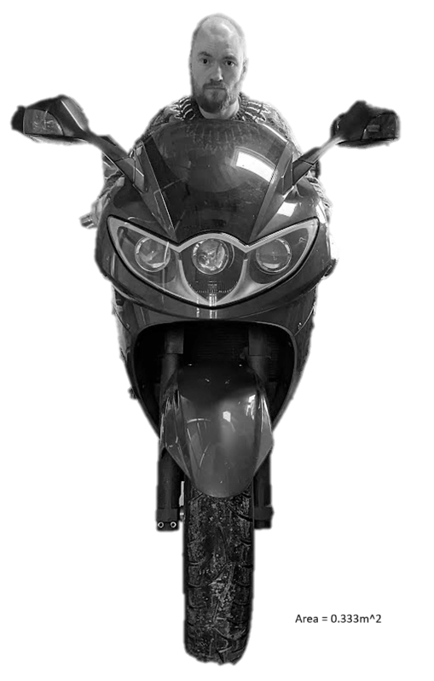
Frontal area

Appendix B
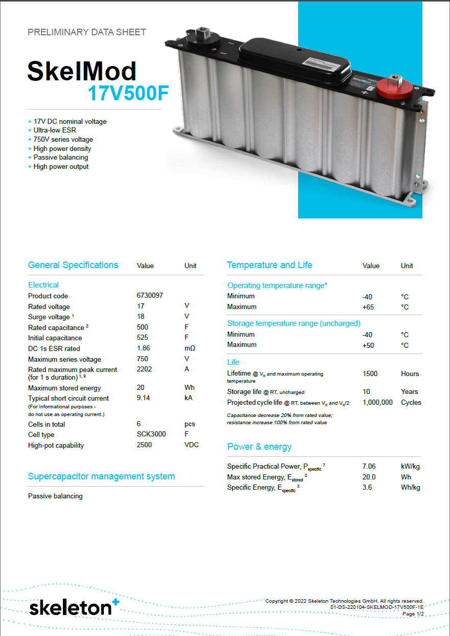
Capacitor data sheet.
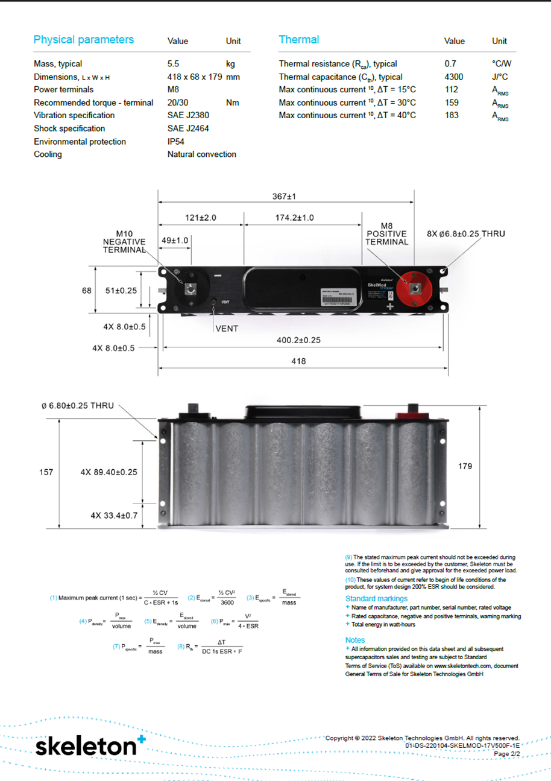

Appendix C
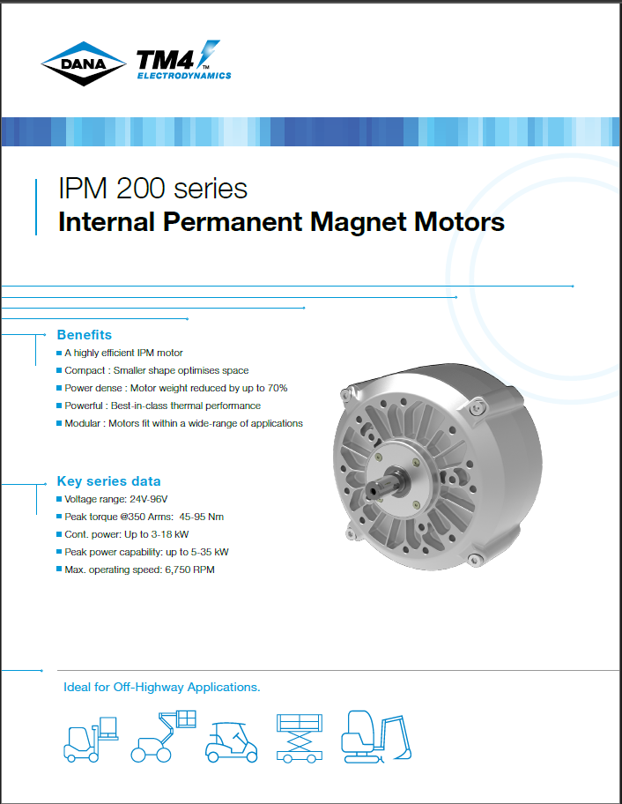
DANA IPM 200 motor

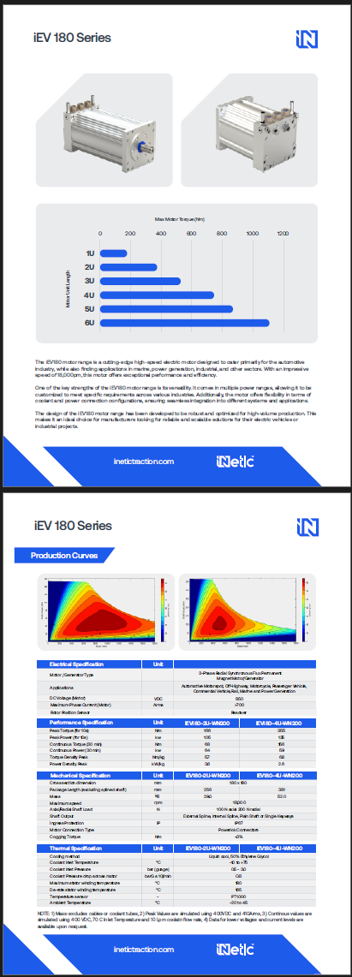
iNetic iEV 180 motor

