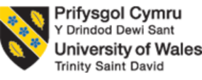

Programme: | Cert HE Business Skills for the Workplace
Module: | Employability and Career Development
Module code: | LCLM4005
Lecturer Name: | Yohan Mendis
Student Name: | Zaffar Hussain
Student ID: | 2436275

Table of Contents
Task 1: Comparison of Two Job Adverts 3
1.1 Introduction to the Job Adverts 3
1.2 Key Skills and Knowledge Required 4
1.3 Common Skills Identified 5
1.4 Importance of Communication Skills 5
Task 2: Self-Assessment and Evidence of Employability 6
2.1 Self-Assessment Using SWOT Analysis 6
2.3 Evidence of Employability 8
Task 3: Employment Goals and Personal Development Plan 10
3.1 Short-Term and Long-Term Career Goals 10
3.2 Personal Development Plan (PDP) 11
Reference list 12
Appendix - Self Learning Assessments 13

Task 1: Comparison of Two Job Adverts

1.1 Introduction to the Job Adverts
Two job adverts were chosen and evaluated to ascertain what the most important skills and knowledge should be utilized in a marketing career. The former is an entry-level job in Krome Technologies Ltd, Chertsey, which is Digital Marketing Assistant. The second advert is an advert of a marketing executive at Funding London, London. The two jobs have been selected as such advertisements due to their relevance in my career interests in terms of marketing and online communication. Digital Marketing Assistant is a low level marketing position.
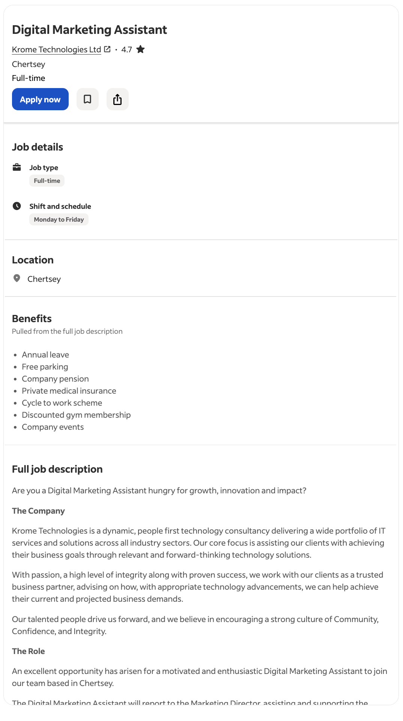
Fig 1: Job Advert 1; Source: (Indeed.UK, 2026)
As opposed to that of the Marketing Executive whereby there has been an added responsibility of planning and executing marketing campaigns.
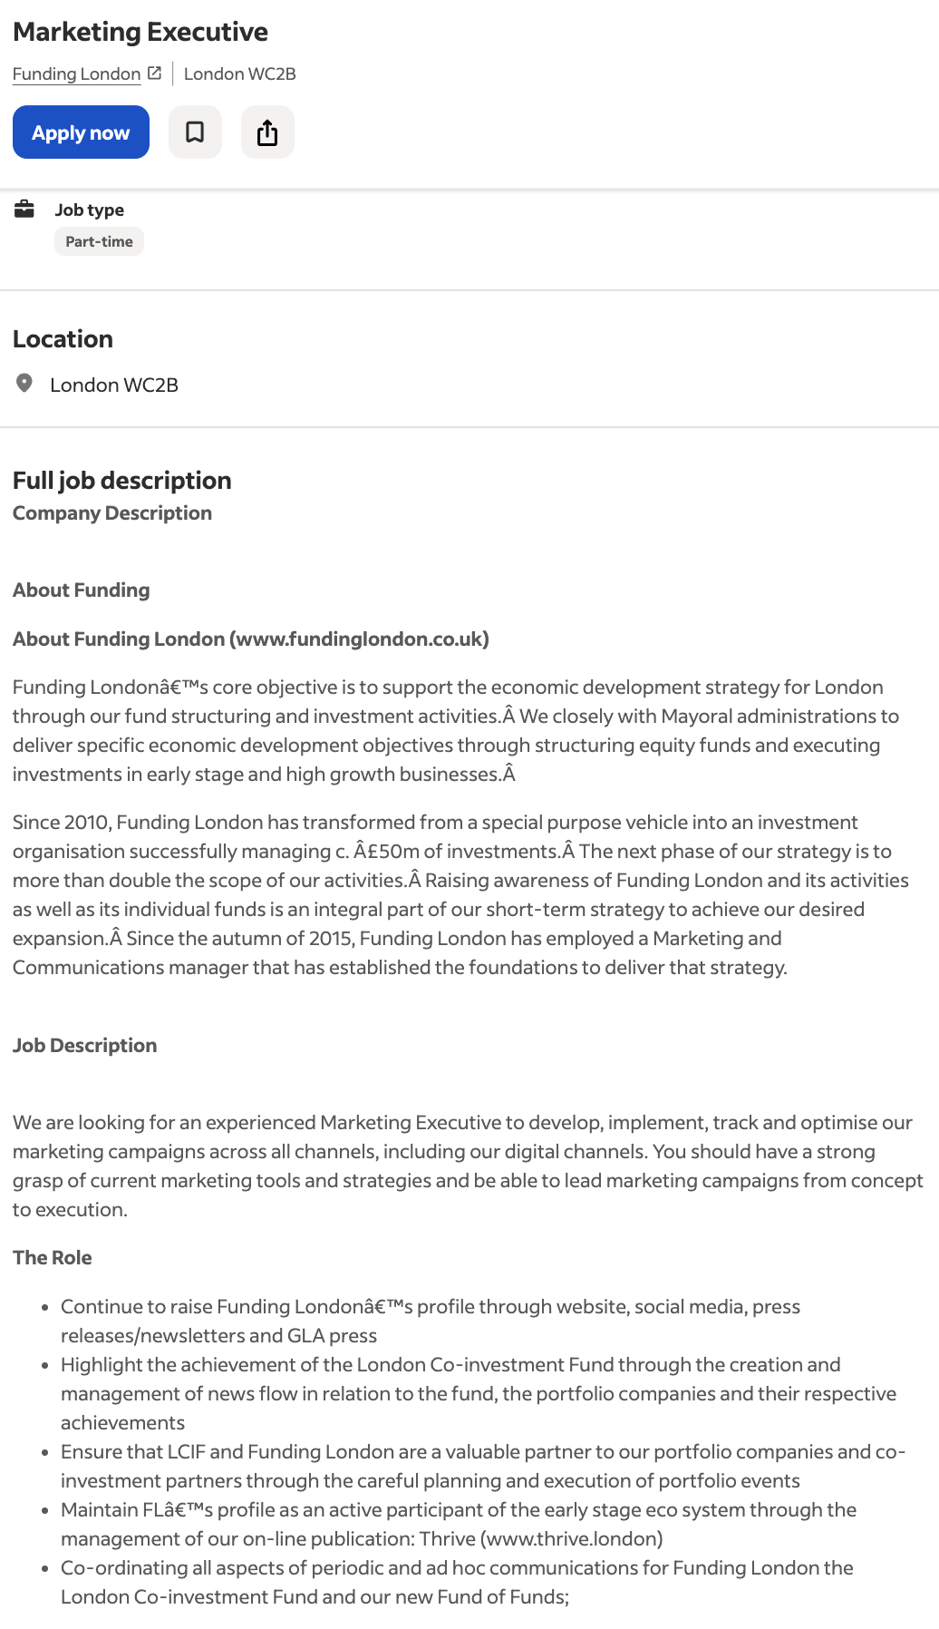
Fig 2: Job Advert 2; Source: (Indeed.UK, 2026)

1.2 Key Skills and Knowledge Required
The Digital Marketing Assistant advert is aimed at assisting the marketing team in the areas of online practices, including social media assistance, campaign assistance and online content creation. The job demands the experience in digital marketing tools and platforms, communication and organisational skills. The advert also emphasizes the essence of teamwork and ability to support marketing strategies that foster business objectives. The company also appreciates innovative workers who would like to be hired in order to achieve business expansion and technology solutions.
The Marketing Executive job at Funding London focuses on the planning, implementation and assessment of marketing campaigns across different media such as online platforms. The role also requires one to be knowledgeable in marketing tools and strategies and coordinate campaigns in formulation to implementation.

1.3 Common Skills Identified
In spite of these variations, the two job adverts have a number of common skills. These are teamwork, communication, digital marketing knowledge and creativity. These are universal skills that are required when working in the field of marketing since the professionals have to cooperate with their colleagues, develop interesting content and deliver marketing messages to the audience.

1.4 Importance of Communication Skills
The communication is one of the key strengths of both ads. In marketing, communication is crucial as it requires professionals to express ideas clearly, communicate marketing messages, and collaborate with teams and customers. Excellent communication abilities ensure that organisations develop a rapport with customers and conduct effective marketing campaigns. As a result, I gained more confidence in communication and collaboration with other people, which is a vital skill in a future marketing career.

Task 2: Self-Assessment and Evidence of Employability

2.1 Self-Assessment Using SWOT Analysis
Self-assessment is also a useful practise and allows an individual to gain insight into strengths and weaknesses (Yan and Carless, 2021). To evaluate my employability and career preparedness, I tried to create a SWOT analysis, based on my academic experiences, in-class assignments, and results of other self-assessment tools, such as a career motivation test, a learning style quiz, and a personality test.
Strengths: My greatest strength lies in my visualisation of learning. According to the learning style test, my results are as follows, using the results of the self-assessment tests: Visual: 45; Tactile: 30; Auditory: 25, which indicates that I like visual media such as diagrams, presentations and written information in learning (see appendix of self-assessment tests). This is one of the learning styles that allows me to absorb intricate information quickly in a visual form. Another strength is my organisational and analytical mindset, which was exposed by the personality test. My personality type portrays traits such as observant, feeling-oriented, and structured in decision-making. These characteristics also allow me to process information critically and work systematically. They are applicable in marketing and business relations where data analysis and planning are critical (Tiwari, 2024). Additionally, my career motivation test indicates that I am highly motivated by financial reward, with a score of 60. It implies that I am interested in my professional development and financial stability, which motivates me to work hard, and I will be able to achieve professional success in the long run. The motivation helps me improve my skills and take chances that may help me in my career development.
Weaknesses: Despite my strengths, there are areas I need to improve. One of the weaknesses is that my personality test scores show introversion (51% introverted). It might be beneficial to the intended work, but at times can make networking and work-related communication difficult. Marketing roles often involve engagement with clients, colleagues, and stakeholders, so I need to become more confident in this domain. The second area of weakness is poor experience in marketing as a professional. Although I have acquired theoretical knowledge during my studies, I still need some more practise in practise business environment. The development of such practical marketing skills, campaign management, market analysis, and digital marketing tools will be useful in contributing to my employability (Chinnapakjarusiri et al., 2024).
Opportunities: Opportunities can constitute professional skill development. My school provides career development, workshops, and networking events that enable graduates to prepare for work. These will give me a chance to acquire such skills as writing a CV, interview organisation, and networking. Teamwork, communication, and problem-solving skills can also be used in academic assignments and group projects (Bhaskar et al., 2025). An internship or part-time experience related to marketing would also be a valuable practical experience and would enable me to practice theoretical knowledge in real-life scenarios.
Threats: Along with such opportunities, my employability may be influenced by external challenges. The high competition in the job market is one of the threats, especially in the marketing and business careers, where there are numerous graduates seeking comparable jobs. Employers usually give preference to those who have relevant experience and have developed digital skills (Tee et al., 2024). Another problem is the high rate of digital marketing technology change. Marketing experts should continuously refresh themselves in new platforms, tools and consumer trends. Unless people constantly evolve their skills, they can be in the competitive job market.
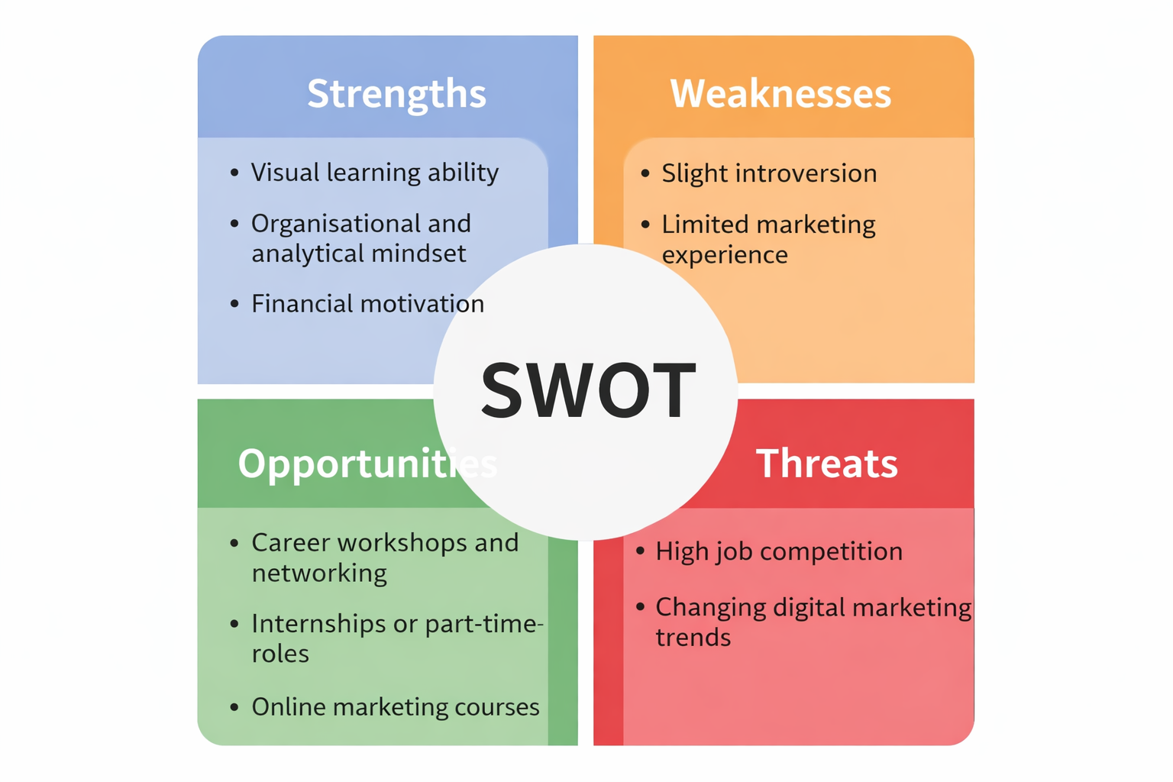
Fig 3: SWOT Analysis; Source: User-Created

2.3 Evidence of Employability
My education and individual development courses show that I am slowly acquiring the qualities I need to work. To begin, I have acquired skills in research, analysis, and presentation through my coursework and academic modules. In group projects and presentations, I worked with peers to discuss business problems and provide resolutions. These exercises served to enhance my communication and teamwork skills.
Second, group assignments and classroom discussions have enabled me to work with various individuals and coordinate tasks in a team. This practice is useful in marketing positions, where teamwork and collaboration are a prerequisite.
The personality and learning style tests also reveal evidence of self-awareness and personal growth (Rayner, 2019). The knowledge that I am a visual learner will help me use effective learning strategies such as diagrams, charts, and visual presentations. In a similar vein, knowing my personality also assisted me in identifying areas of weakness, specifically in communication and networking.
Moreover, tutor and peer responses on group work and presentations have assisted me in recognising my strengths and weaknesses. Constructive feedback will help me to work on my confidence, presentation, and professional communication.
Altogether, these experiences indicate that I am actively gaining the skills I will need to work in the future. I can enhance my employability by further developing my communication skills, accumulating hands-on marketing experience, and studying career development opportunities, which will allow me to establish a successful career in marketing.

Task 3: Employment Goals and Personal Development Plan

3.1 Short-Term and Long-Term Career Goals
In order to enhance my employability skills, I have come up with several short-term and long-term career objectives based on the weaknesses that I identified during my SWOT analysis. A limitation that was also found to be one of the weaknesses was my limited professional experience in marketing. Thus, my immediate target is to acquire some practical experience in the form of internships, part-time jobs, or volunteering positions within the marketing sphere. This objective is relevant as practical work will help me to use the theoretical knowledge acquired during my study and train real skills at work.
The other short-term goal is to improve my communication and networking skills since my personality test revealed that I am generally a little introverted. My communication skills will be enhanced, and I will be more confident to communicate with other colleagues, clients, and other industry professionals. To achieve this, I will be making appearances at group discussions, career workshops and class presentations at my university.
Another long-term goal is to become a successful digital marketer and with time, I will become a successful digital marketer and may be hired as a Marketing Executive or a Digital marketing Manager. In order to achieve this goal, there should be great analytical, creative and strategic thinking. This is a long term goal that aligns with my career drive to achieve professional growth and financial status.

3.2 Personal Development Plan (PDP)
Weakness | Action | Timeline | Resources | Measure of Progress
Limited marketing experience | Apply for internships or part-time marketing roles | Short-term (6–12 months) | University career services, job portals | Internship secured or relevant experience gained
Communication confidence | Participate in presentations and networking events | Short-term | University workshops, group projects | Improved presentation feedback and confidence
Digital marketing knowledge | Complete online courses in SEO, analytics, and social media marketing | Long-term (1–2 years) | LinkedIn Learning, online certifications | Certificates completed and improved practical skills

Reference list
Bhaskar, C.V., Priyadharshini, P.R., Sujatha, Govindharaj, P. and Sam, D.P. (2025). The role of group projects in enhancing soft skills. Humanities and Social Sciences Communications, [online] 12(1), pp.1–8. doi:https://doi.org/10.1057/s41599-025-04807-x.
Chinnapakjarusiri, N., Khotabut, P., Nakpleung, P. and Moolngearn, P. (2024). Digital Marketing Skills in the Digital Economy: A Review Article. ResearchGate, [online] 3(3), pp.1–9. Available at: https://www.researchgate.net/publication/388103193_Digital_Marketing_Skills_in_the_Digital_Economy_A_Review_Article.
Indeed.UK (2026). Digital Marketing Assistant Work, jobs (with Salaries) | Indeed United Kingdom. [online] Indeed.com. Available at: https://uk.indeed.com/jobs?q=Digital+Marketing+Assistant%2C&l=&from=searchOnDesktopSerp&vjk=a2c3689f548599b8 [Accessed 14 Mar. 2026].
Rayner, H. (2019). Personality and self-awareness. Assessment and Development Matters, 11(1), pp.7–10. doi:https://doi.org/10.53841/bpsadm.2019.11.1.7.
Tee, P.K., Wong, L.C., Dada, M., Song, B.L. and Ng, C.P. (2024). Demand for digital skills, skill gaps and graduate employability: Evidence from employers in Malaysia. F1000Research, 13, pp.389–389. doi:https://doi.org/10.12688/f1000research.148514.1.
Tiwari, V. (2024). Role of Data Analytics in Business Decision Making. Knowledgeable Research A Multidisciplinary Journal, 3(01), pp.18–27. doi:https://doi.org/10.57067/0zr57x43.
Yan, Z. and Carless, D. (2021). Self-assessment is about more than self: the enabling role of feedback literacy. Assessment & Evaluation in Higher Education, [online] 47(7), pp.1–13. doi:https://doi.org/10.1080/02602938.2021.2001431.

Appendix - Self Learning Assessments
Assessment 1: Career Motivation Test
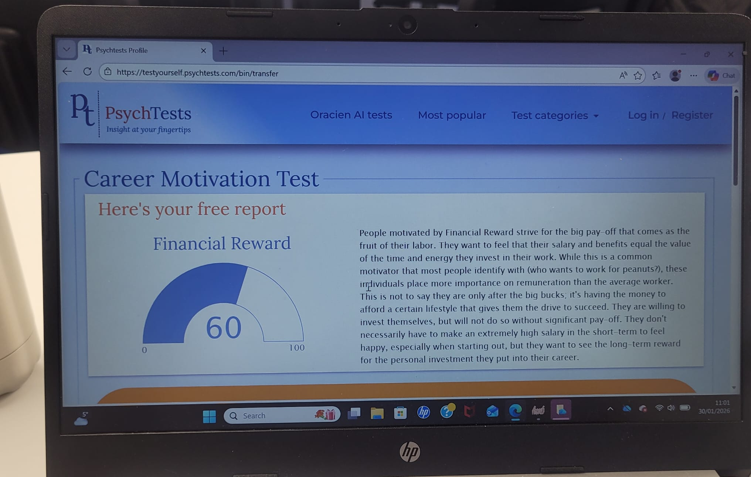

Assessment 2: Learning Style
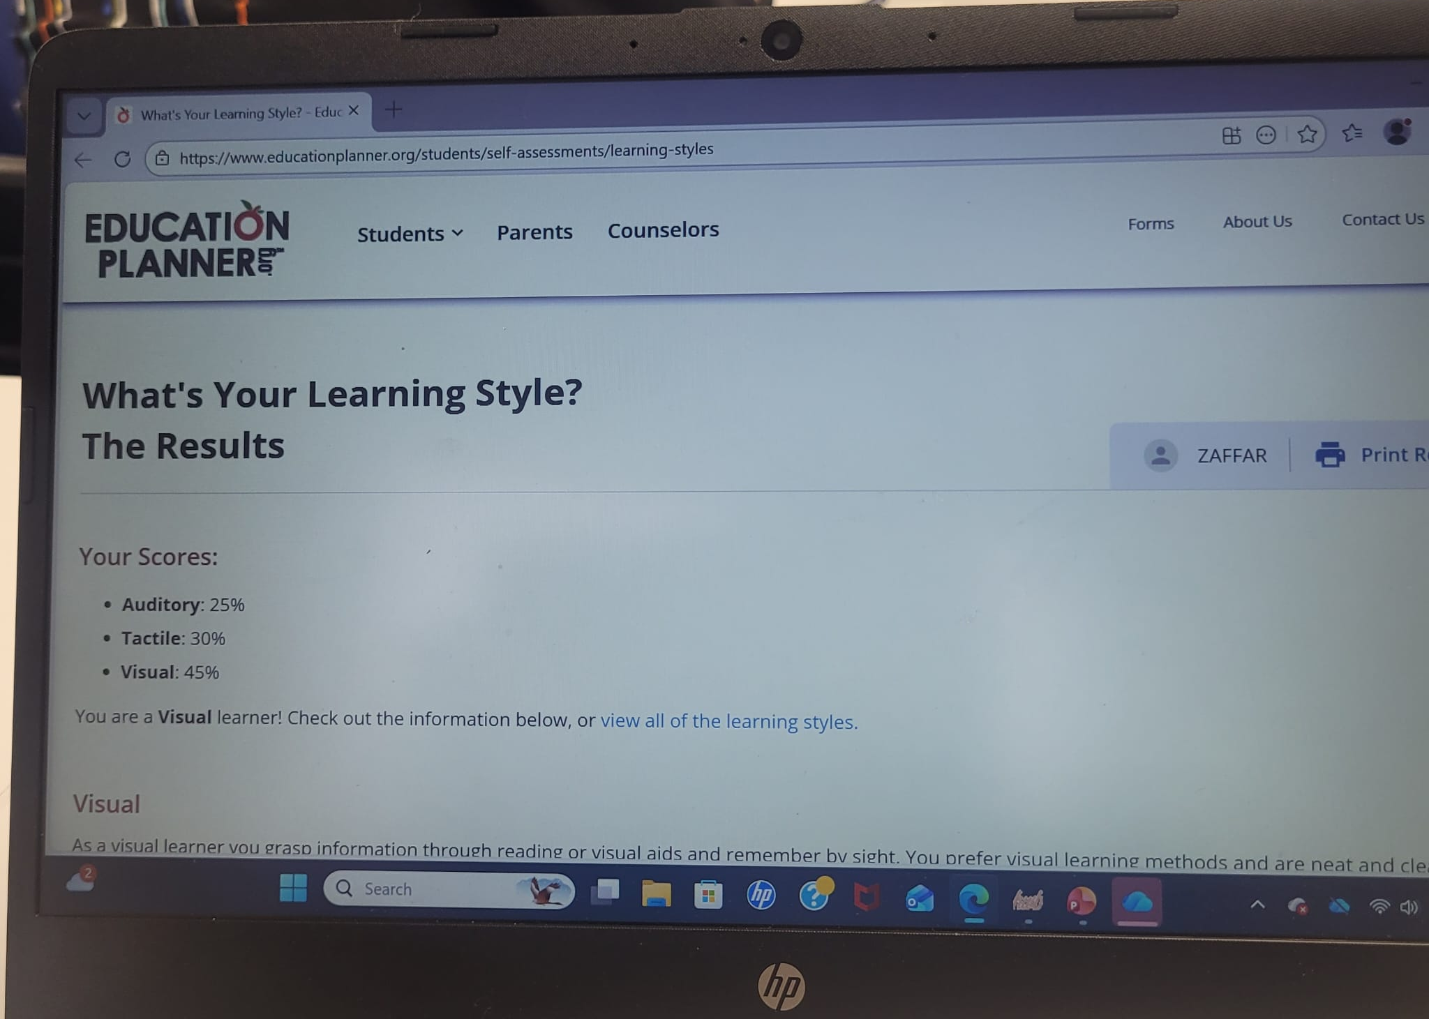

Assessment 3: Personality Test


