E-Portfolio



MODULE NAME: Academic Skills for the Digital Era (BMSW4013)
Student Name: SALMA farache 2408621
Lecturer Name: Ffion Cumberpatc

Contents

Essay – Effective study strategies for the dijital Era 2
Reference List 2
report –Time Management an essential skill for student success 2
Reference List 2
Video Tutorial – How to use “the university’s library” to Enhance Your Academic Performance 2
Reference List 2

Essay: Effective study strategies for the digital era
word count:852

In the digital era, students encounter a unique combination of opportunities and challenges in their education. With countless online resources, learning apps, and digital tools, there is a lot of ways to enhance learning. However, these tools also provide distractions that can impair focus and productivity. The suitable strategies and mindset can bring success to any student, but failing to use these can result in any student underachieving (Cottrell, 2019). To excel in this environment, students in higher education must adopt effective study strategies that nurture technology’s benefits while avoiding its potential drawbacks. This essay will critically analyse three strategies: time management, virtual learning environments, and digital note taking, exploring their theoretical application and how to apply them to higher education. Digital media impacts students’ academic performance, with a focus on time management as a skill to mitigate distractions (Wang et al., 2021).

Time management is essential in the digital age, as distractions such as social media, online gaming, and limitless streaming services may easily disrupt study sessions. These digital distractions make it much more difficult to stay focused and productive, highlighting the value of time management. The Eisenhower Matrix is essential in the digital era, when students are overwhelmed with information and requests. It helps them to effectively filter out the noise and prioritise duties. For example, a student may receive a notification regarding the release of a new video game. Using the Eisenhower Matrix, they can label this as a 'Delete' task, indicating that it is a non-urgent and irrelevant distraction that can be removed in order to focus on more important academic tasks. Williams provides a detailed breakdown of how students can apply the Eisenhower Matrix in specific scenarios, such as sorting through social media notifications, emails, and school assignments, to maintain focus and manage their workload effectively (Williams, 2021). These time management practices give students the tools and strategies they need to deal with the world of technology successfully. They encourage focused concentration, reduce distractions, and assist students in prioritising their academic goals in a world that continually competes for their attention.
Virtual Learning Environments (VLE), like Moodle, have become crucial to higher education, providing as a hub for course materials, communication, and engagement (Cottrell,2023). VLEs offer various benefits, including access to course materials lecture notes, readings, assignments, and other resources are easily accessible. Using features which promote constructive dialogue and interactive learning activities encourages a deep approach to learning, the development of communication skills and enhanced understanding of content (Kember,2010). Students can connect with professors and peers via live video call, chat, and online meetings. Students can access materials and participate in discussions at any time and from any location, providing flexibility and convenience. For example, a student researching a theoretical method can use the VLE to access primary sources, scholarly papers, and recorded video lectures, as well as engage in online discussions with classmates to analyse different perspectives and increase their understanding.

Digital note-taking tools also provide various advantages over traditional pen and paper methods. They allow for easy organisation and accessibility where notes can be labelled, categorised, and rapidly searched for keywords. Also, images can be integrated to our notes for more clarity. Notes can be accessed from any device, at any time. There are various programs that allows different note-taking techniques. For example, visual learners use Canva that allows them to create visually appealing notes using diagrams and mind maps. Miller Focuses on how visual and collaborative tools like Canva and Miro support visual learners and enhance engagement (Miller,2021). A student attending a professional career development lecture might use a digital note-taking app to record the presentation, include relevant images and web links, and highlight important points for later review. They might then share these notes to other students, encouraging collaborative learning and ensuring that everyone has access to comprehensive study materials.

While the strategies discussed have significant advantages, they require careful consideration. For example, The Eisenhower Matrix could be oversimplifying sometimes. Where not all tasks go under the labelled section. Not only that, but also this technique leads to ignoring our future goals which will decrease our planning ahead skills (Allen, 2015). Time management strategies demand dedication and self-awareness to be effective. VLEs, while convenient, can lead to information overload if not used strategically, and limit in person face to face interaction between students and lecturers (Anderson, 2008). While digital notetaking is flexible, it may not be appropriate for all learning styles, and relying too heavily on technology might impact the development of traditional note-taking skills (Berkovatz & Guzman, 2011). Thus, further research is needed to fully understand the limitations and optimize effective study strategies in the digital era.

In conclusion, the digital era brings both obstacles and opportunity for students in higher education. By adopting effective study strategies like time management, applying VLEs, and embracing digital notetaking, students can navigate the digital tools with greater confidence and achieve academic success. These strategies, when used thoughtfully and adapted to individual requirements and learning styles, enable students to maximise their learning, improve their understanding, and thrive in the constantly evolving environment of higher education.

Reference List
Allen, D. (2015) Getting things done: The art of stress-free productivity. Penguin.
Anderson, T. (2008) The theory and practice of online learning. Athabasca University.
Berkovatz, J. and de Guzman, E. (2011) The Evolution of Note Taking: A Study on Traditional Hard Copy Methods Vs The Emerging Soft Copy Method.
Cottrell, S. (2019) The study skills handbook. 5th ed. London: Red Globe Press.
Cottrell, S. (2023) Critical thinking skills: effective analysis, argument and reflection. 4th ed. London: Bloomsbury Academic.
Kember, D., McNaught, C., Chong, F.C.Y., Lam, P. and Cheng, K.F. (2010) Understanding the ways in which design features of educational websites impact upon student learning outcomes in blended learning environments. Computers & Education, 55(3), pp.1183-1192.
Miller, C. (2021) Visual learning and digital tools: How digital platforms like Canva and Miro support active and collaborative learning. Journal of Educational Technology Systems, 49(4), pp.527-545.
Wang, Z. and Tchernev, J. (2021) Digital media use and its impact on academic performance and time management among college students. Computers in Human Behavior, 122, p.106837.
Williams, T. (2021) Time management for students in a digital world: Practical applications of the Eisenhower Matrix. Student Success Journal, 46(4), pp.87-99.

Report: “Time Management”: An Essential Skill for Student Success
Word count: 767

Executive Summary

Time management is a crucial skill for student success in higher education, allowing students to balance academic tasks with personal life and reduce stress (Misra et al.,2000). By using tools like the Eisenhower Matrix to prioritize tasks and the Pomodoro Technique to maintain focus, students can improve productivity and reach their goals more efficiently. Along with setting clear goals, creating a balanced schedule, and minimizing distractions, these strategies support a structured approach to academics and promote personal growth for future success.
Introduction:
Success in academics requires students to develop essential skills that enable them to handle both academic and personal challenges effectively (Conley, 2012). Among these skills, time management stands out as the most crucial feature. With effective time management, students can prioritize tasks, reduce stress, and make the most of their study hours. By mastering time management skills, students can enhance their productivity and build a strong foundation for success in their studies and beyond. Time itself is not what matters but rather how that time is used to achieve individual and organizational goals (Van, 2021). This essay will discuss different time management techniques like Eisenhower Matrix technique and Pomodoro techniques.

To have the skills to manage our time, we should target the root cause. In this case we should have self-management. Self-management skills are important for success. They serve as a strong foundation for the development of all other abilities and the action required to achieve our goals (Cottrell, 2021). Effective time management allows students to balance academic responsibilities with personal and social activities, reducing stress and preventing delays. For example, a student managing classes, assignments, and part-time work can benefit greatly from planning their schedule in advance. Tools like Google Calendar or Notion provide digital solutions for organizing tasks. Setting reminders for deadlines, and even creating checklists to boost productivity is beneficial. Thus, consistent time management is the key for success.

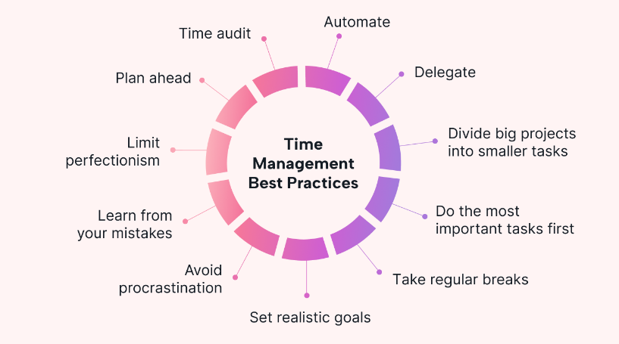

Eisenhower Matrix technique:
One particularly valuable time management tool for students is the Eisenhower Matrix. The Eisenhower Decision Principle guides the evaluation of tasks, which are categorised into the most appropriate quadrant based on urgency and priority. This technique helps students prioritize tasks based on their urgency and importance, making it easier to decide where to start when faced with a long to-do list (Mfondoum, 2019). For instance, if a student has a paper due tomorrow, exam preparation for next week, and a club meeting today, the Eisenhower Matrix would guide them to focus first on the paper (urgent and important) while planning a later study session for the exam (important but not urgent) and potentially rescheduling or minimizing time on the club meeting (less urgent). This system helps students address high-priority tasks without getting overwhelmed by less crucial ones, thus making their time usage more strategic. However, not all tasks fit neatly into urgent/important categories. Thus, it is important to use additional criteria like deadlines and dependencies to add depth to the prioritization (Allen, 2015). Another drawback is neglect of Long-Term Goals. The matrix may push users to focus only on immediate tasks, ignoring strategic objectives.so, it is crucial to regularly re-examine long-term goals and assign them appropriate time slots (Allen, 2015).

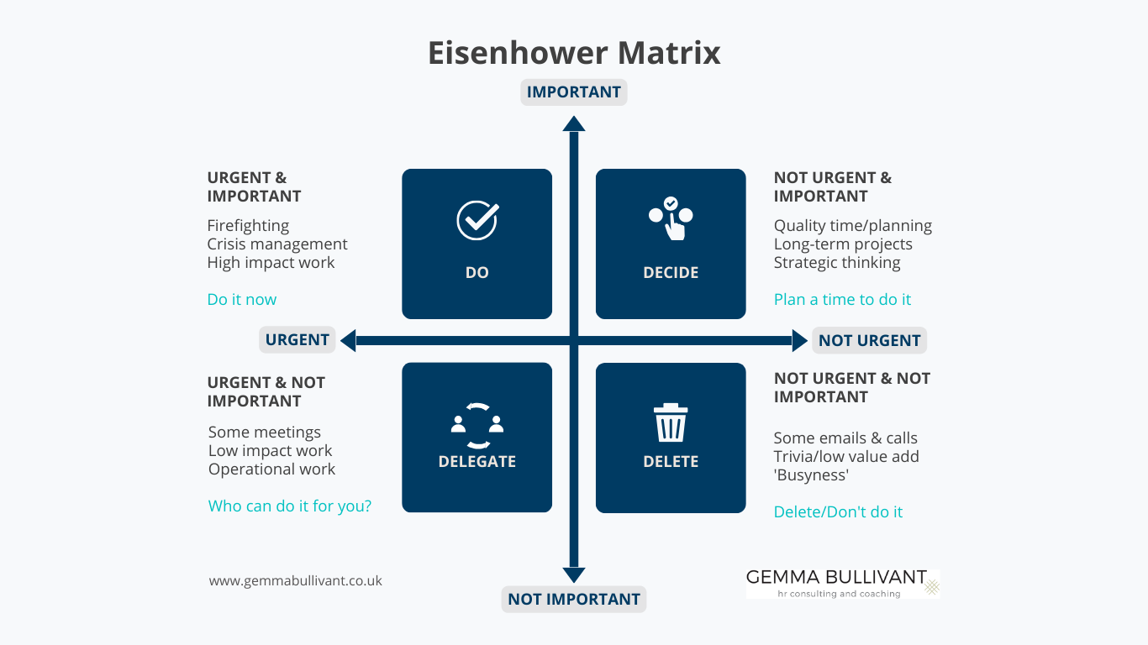

Pomodoro Technique:
Another useful tool for organizing time effectively is the Pomodoro Technique. According to Cirillo, respected time-management system has completely changed how he operates in (Cirillo, 2018). This method involves working in 25-minute focused intervals, followed by short breaks. For example, a student preparing for an exam might set a timer for 25 minutes to study without interruptions and then take a 5-minute break to refresh. This approach can increase productivity by breaking down long study sessions into manageable chunks, helping students stay focused and maintain energy throughout their study time. Apps like Focus Keeper make it easy to implement the Pomodoro Technique by tracking study sessions and break times. It is necessary to be careful of its drawbacks like frequent breaks can interrupt tasks requiring intense concentration (Dizon et al., 2021). To avoid such thing, adjust Pomodoro intervals to longer periods like 50-minute sessions for example to maintain focus. Another disadvantage is that regular breaks might feel unnecessary or wasteful for quick tasks (Dizon et al., 2021). So, it is better to group smaller tasks together to complete within one Pomodoro interval. By adopting these time management tools and strategies, students gain the ability to manage multiple responsibilities more effectively, prevent procrastination, and maintain a healthy balance between their academic and personal lives. Developing this skill not only contributes to academic success but also prepares students with practical tools for managing tasks in their future careers. Time management skills and solution-focused thinking enable us to perform successfully under pressure (Cottrell, 2021).

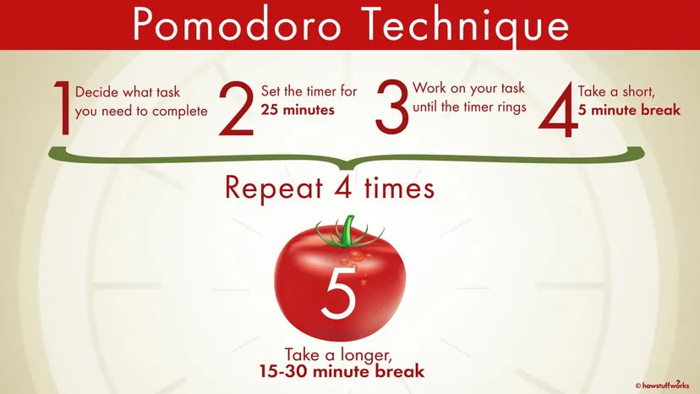

Conclusion:

In conclusion, effective time management is a key skill for success in higher education (Britton et al.,1991). By using tools like the Eisenhower Matrix and the Pomodoro Technique, students can prioritize tasks, reduce stress, and make steady progress toward their goals. These strategies help students balance their studies with personal life, setting them up not only for academic success but also for a well-balanced, productive future (Mackenzie ,1997).

Recommendations:
Here are some recommendations for students seeking to enhance their time management skills for academic success:
- Use Time Management Tools Consistently: Incorporate tools like digital apps, the Eisenhower Matrix, or the Pomodoro Technique into your daily routine to help prioritize tasks and stay organized.
- Set Clear Goals: Break down large assignments or study sessions into smaller and set specific deadlines. This makes it easier to track progress and avoid feeling overwhelmed.

- Limit Distractions During Study Time: Identify and reduce potential distractions like phone notifications or social media. This helps iprove productivity during dedicated study periods.

Reference List

Allen, D. (2015) Getting things done: The art of stress-free productivity. Penguin.
Britton, B. K., & Tesser, A. (1991) Effects of time-management practices on college grades. Journal of Educational Psychology, 83(3), 405–41
Bullivant, G. (2023) How to operate more strategically using the Eisenhower Matrix. Available at: https://gemmabullivant.co.uk/how-to-operate-more-strategically-using-the-eisenhower-matrix/ (Accessed: 4 November 2024).
Cirillo, F. (2018) The Pomodoro Technique: The Acclaimed Time-Management System That Has Transformed How We Work. 2nd ed. New York: Penguin Random House.
Conley, D. T. (2012). College and Career Ready: Helping All Students Succeed Beyond High School. Jossey-Bass.
Cottrell, S. (2021) Skills for Success: Personal Development and Employability. Macmillan Education UK. Available from: ProQuest Ebook Central [Accessed 30 October 2024].
Cottrell, S. (2021) Skills for Success: Personal Development and Employability. London: Macmillan Education UK. Available from: ProQuest Ebook Central [Accessed 30 October 2024].
Dizon, R.J., Ermitanio, H.D., Estevez, D.M., Ferrer, J., Flores, S.J., Fontanilla, K.M., Frias, A., Galang, E., Guei, N.F. and Sugay, J. (2021) The effects of pomodoro technique on academic-related tasks, procrastination behaviour, and academic motivation among college students in a mixed online learning environment. Globus Journal of Progressive Education, 11(2), pp.58-63.
Mackenzie, A. (1997) The Time Trap: The Classic Book on Time Management. 3rd ed. New York: AMACOM.
Mfondoum, A.H.N., Tchindjang, M., Valery, J., Mfondoum, M. and Makouet, I.(2019) Eisenhower matrix* Saaty AHP= Strong actions prioritization? Theoretical literature and lessons drawn from empirical evidences. Iaetsd Journal For Advanced Research In Applied Sciences.
Misra, R. & McKean, M. (2000) College students' academic stress and its relation to their anxiety, time management, and leisure satisfaction. American Journal of Health Studies, 16(1), pp. 41–51.

Motion Blog. (2023) 13-time management techniques to boost your productivity. Available at: https://www.usemotion.com/blog/time-management-techniques (Accessed: 4 November 2024).
Smartnmagic. (2023) Pomodoro Technique: Method to increase your effectiveness. Available at: https://smartnmagic.com/blogs/solutions/pomodoro-technique-method-to-increase-your-effectiveness (Accessed: 4 November 2024).
Van, F. (2021) Quality Time: Productivity Through Time Management. Charlotte, NC: Information Age Publishing, Incorporated. Available from: ProQuest eBook Central [Accessed 30 October 2024].

Video Tutorial – How to use the University’s library to Enhance Your Academic Performance

Words count:215

The UWTSD library offers a range of tools and services that can significantly enhance your study effectiveness. With a simple search function, you can easily access a vast collection of resources, from print books to e-books, journals, and databases. For printed books, the system provides detailed information about each book’s location, making it easy to find what you need without wasting time. Internet library offers you a great collection of online resources that are categorised by subject. It has all the features of a usual library including cataloguing, referencing, archives, and special collections (What Career Live, 2023).
For digital resources, the library offers a wide selection of e-books that can be accessed remotely, allowing for flexible study sessions

To save valuable resources for future reference, the library provides features like "Saved Items" or personalized reading lists where you can store links to useful materials. Additionally, if you encounter any queries during your research, the library staff are available for support, offering guidance on how to use resources effectively, search strategies, and even citation help. Thomas discusses the impact of university libraries on academic success, exploring how resources, study spaces, and librarian support contribute to effective learning (Thomas, 2019). Using these tools deepens understanding, improves critical thinking skills and increases knowledge on a variety of topics.

Stream practise.webm

Reference List
Thomas, P. (2019) University Libraries and Student Achievement: A Study on Resources and Academic Support. Journal of Academic Libraries, 45(3), pp.245-259.
What Career Live, (2023) The best research tools for successful students. What Career Live. Available at: https://www.whatcareerlive.co.uk/the-best-research-tools-for-successful-students/ [Accessed 5 November 2024].

