Welsh National Police Memorial Report
Abbie Messer
2011661
Technology and Environment 1
M4X01974

Welsh National Police Memorial Report
The brief for this project consisted of group work to design the Welsh National Police Memorial. We were instructed to design a suitable memorial for the police for Cathays Park, Cardiff. We were given guidance such as materials, size and design preferences from the client which influenced and facilitated the design process.
Prior to our first group meeting I conducted research into existing memorials and the proposed site, Cathays Park, including weather conditions (Meteoblue, nd), sun path (Time and Date, nd) and surroundings (Cardiff Council, 2009) in order to gain an understanding for the project.
During the first meeting on February 16th 2021, we discussed how we wanted to progress. To begin, I proposed that we each collect existing memorials to create a mood board as well as come up with concept ideas. From here we utilised Microsoft Teams and Miro for meetings and for uploading work which proved efficient.
On February 23rd we discussed our individual mood boards; I later combined the mood boards into one. This process helped us to make decisions in terms of materiality and concepts. I presented my concepts to the group and we discussed concept development which we would continue with during the next meeting. We also considered task allocation depending on what each person felt they could do best; this effective method of organisation was continued throughout the project. We also discussed what I had already completed in terms of site analysis and what still needed to be done.
The 26th saw the development of our final concept. We each showed our concept sketches and developed a design that encapsulated these ideas. We completed further sketches during the meeting outlining how we wanted the concept to look as well as discussing materiality and scale based on the client’s preferences. We concluded this call with a concept comprising of a middle area surrounded either side by highly durable Corten steel panels (Bryan, 2010, p.402) with cut outs creating a pattern of light. At the end of the area there is a central slate memorial with a cut out of the South Wales Police crest and an engraved plaque. Once we had our final idea we planned to look into the materiality for final dimensions to be decided. By this time myself and another group member gathered site analysis information in preparation for it to be drawn onto a site map. This meeting saw the start of our group’s effective collaboration which continued throughout.
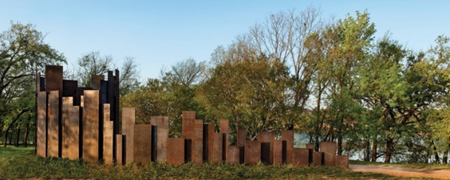
Prior to the forth meeting we each carried out research into chosen materials – Corten steel, Welsh slate and concrete, documenting our discoveries. My main findings from research were the advantages and disadvantages of Corten (Octal, nd), that slate doesn’t need much maintenance (Mill Hill Slate Quarries, 2020) and that it is sustainable (UK Slate, 2020) in comparison to concrete (IWBC, 2019), as well as the thickness of Corten steel by looking at another project using ¾ inch panels (Miró Rivera Architects, nd). Before the meeting I drew a plan and elevation and worked out dimensions. I presented these dimensions to the group on March 2nd. During this meeting we discussed dimensions and the required alterations. I suggested I reconfigure the dimensions and we have a meeting the following day to ensure these are agreed upon to advance with the project. On the 3rd we agreed on final dimensions. We also discussed how the memorial would be constructed.
Figure. 1 Trail Restroom by Miró Rivera Architects who utilised ¾ inch Corten steel panels (Miró Rivera Architects, nd). (Photography by: Paul Finkel, nd)
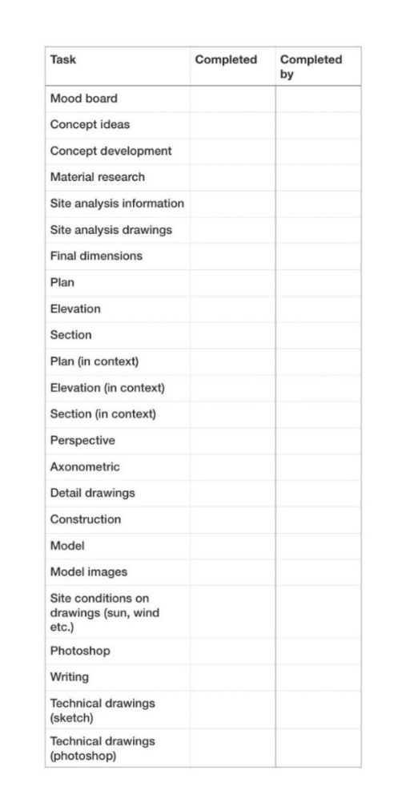
On the 4th following a tutorial with our lecturer we had another meeting finalising the construction. During the meeting we discussed measurements in terms of technology. As well as this we considered what tasks needed to be completed and we split the work. I made a comprehensive checklist of each task to track who was completing them and what had been completed.
Figure. 2 Checklist for individual tasks for the memorial project. (Credit: Abbie Messer, 2021)
From here I focussed on the drawings that I was to complete. Using agreed measurements I drew a section showing the construction including the foundations, a plan, section, elevations and drawings of individual Corten steel panels. I then drew an axonometric and exploded axonometric showing the different elements.
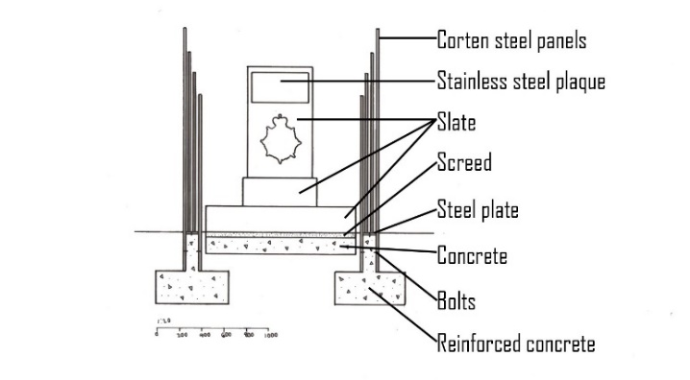
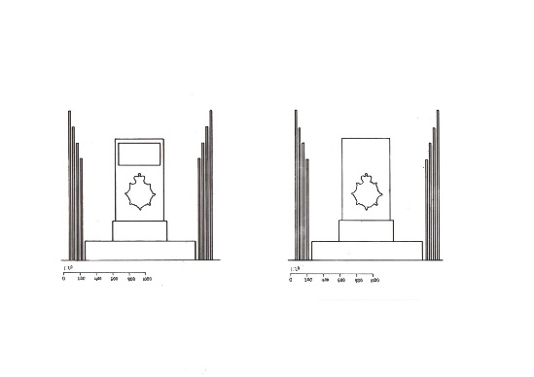
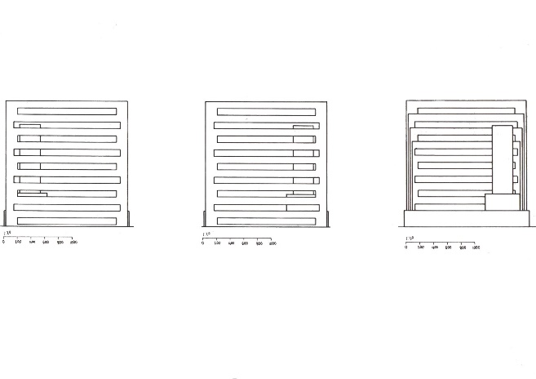
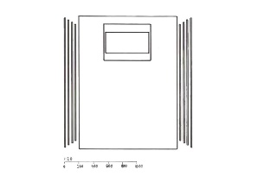
Figure. 3 From left to right: front elevation, back elevation, side elevation, side elevation, internal section, plan. (Credit: Abbie Messer, 2021)
Figure. 4 Section of the memorial showing foundation details. (Credit: Abbie Messer, 2021)

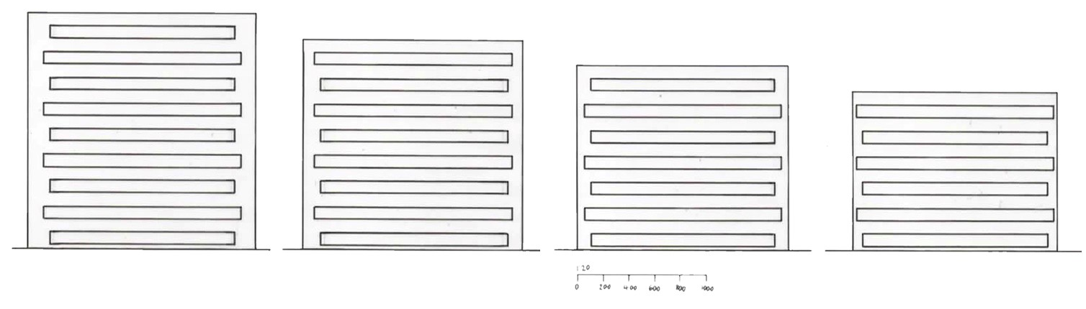Figure. 5 Different sized Corten steel panels. (Credit: Abbie Messer, 2021)
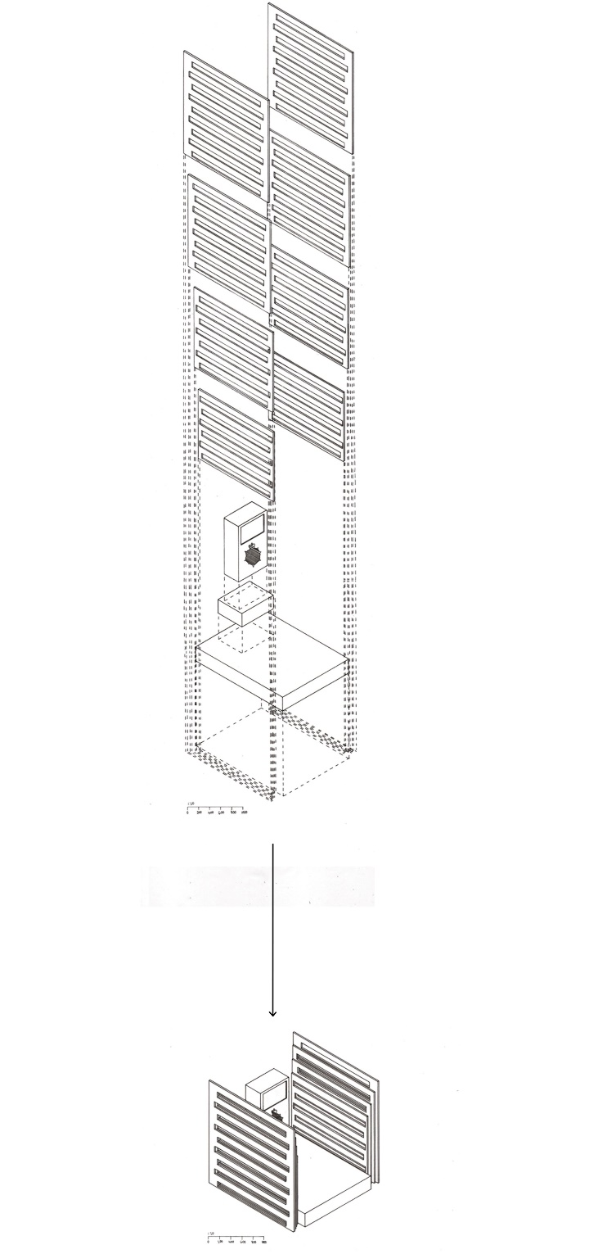
Figure. 6 Exploded axonometric into an axonometric showing the placement of the Corten steel panels and the plinth. (Credit: Abbie Messer, 2021)
The following meeting on the 7th saw us discussing final elements of the design including positioning and the last details of construction; welding Corten steel panels to a steel plate and bolting into the reinforced concrete foundation. After finalising these aspects we reviewed our progress and plan to complete the project.
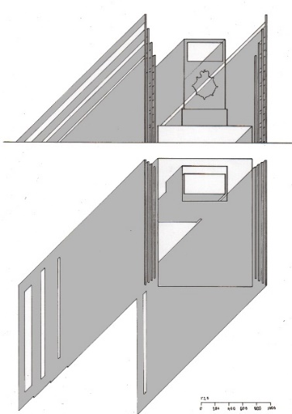
I next completed drawings showing the memorial’s relationship with light and the patterns the gaps in the Corten steel create on the ground. I also drew an axonometric showing the Corten steel panels attaching to the foundations as well as the surrounding gravel. To achieve a clear visualisation of the concept I completed a watercolour painting to show colours and light. Although from this point much of the drawings were completed by individuals, we continued to have progress meetings which helped us produce a coherent design, to communicate with each other to make sure we were all on the same page and to ensure we were on schedule.
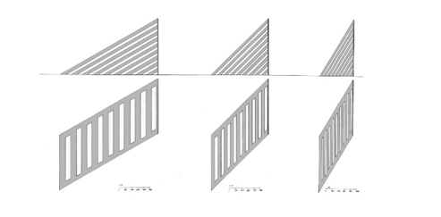
Figure. 7 Shadows of the memorial. (Credit: Abbie Messer, 2021)

Figure. 8 Diagram of light patterns created by the cut outs in the Corten steel panel at different sun angles. From left to right: 60 degrees, 45 degrees, 30 degrees. (Credit: Abbie Messer, 2021)
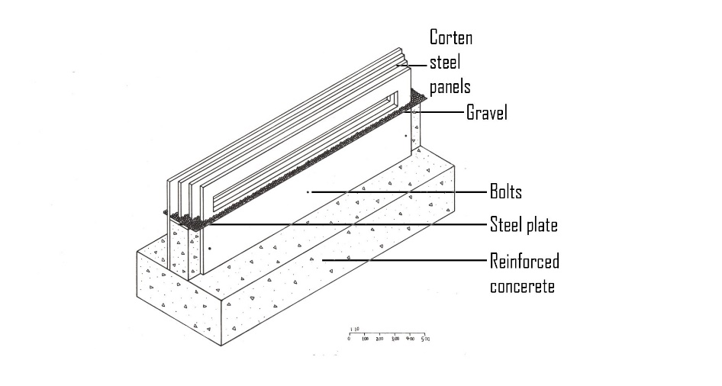
Figure. 9 Axonometric of Corten steel panels inserted into the foundations. (Credit: Abbie Messer, 2021)
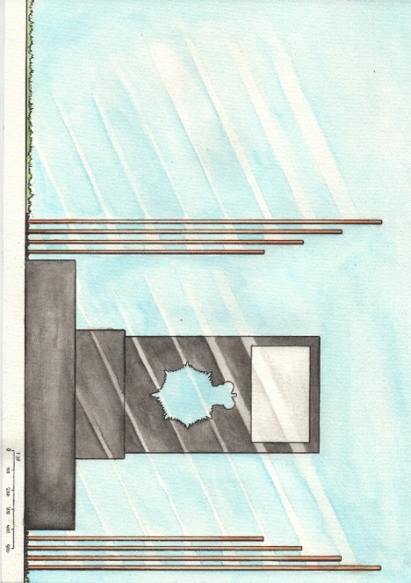
Figure. 10 Painting of concept in watercolour (Credit: Abbie Messer, 2021)
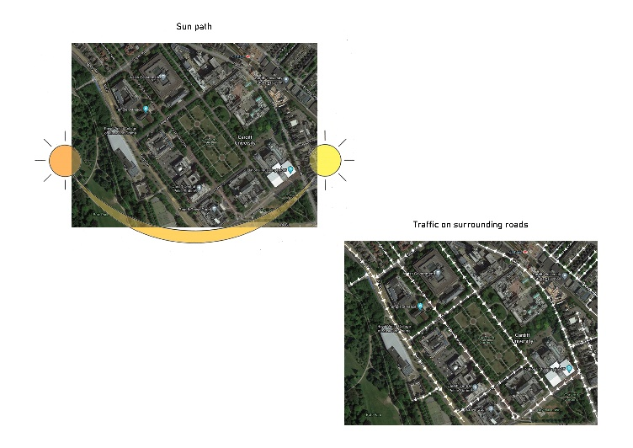
From here we understood what remained to reach completion; our next meeting on the 12th was therefore a progress update and to check the group was as a whole happy with their upcoming tasks. Similarly, on the 18th we continued to review progress as well as outstanding elements. From here we split site analysis drawings based on previously gathered research. These regular meetings to check on development helped to ensure we were organised and had continuous communication. We then carried out final tasks, I completed detail drawings of fixings as well as a perspective drawing.
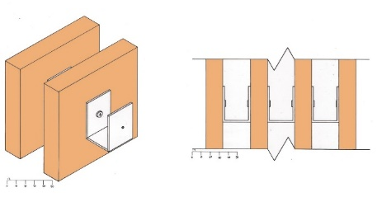
Figure. 11 The site analysis drawings that I was responsible for including sun path and traffic flow. (Drawing Credit: Abbie Messer, 2021) (Photo credit: Google Maps, 2021)
Figure. 12 Drawings showing the fixings on the Corten steel. Left: Axonometric. Right: Detail drawing. (Credit: Abbie Messer, 2021)
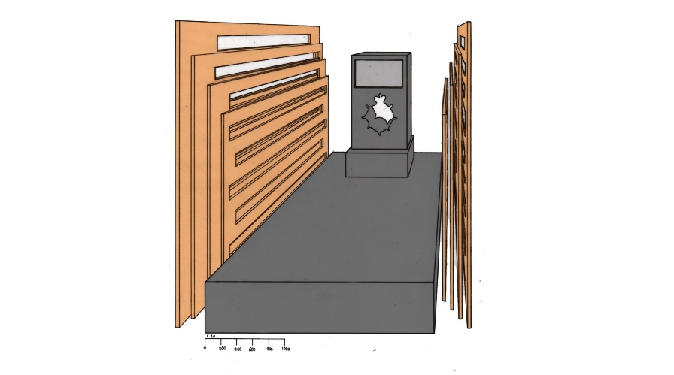
Figure. 13 One point perspective of the final memorial design. (Credit: Abbie Messer, 2021)
I then worked on presentation to ensure a clear visualisation of the final design. I showed this development on March 22nd and discussed what was left for us to write about in terms of annotations and explaining various aspects of the project for a coherent, clear final outcome to complete the narrative of the memorial.
To conclude, as a group we were coordinated through creating lists of tasks and who was completing them, as well as organising frequent meetings; this ensured we had good communication. A problem we faced was managing the workload of a small project resulting in relatively small amounts when split, we therefore had to efficiently plan. Furthermore, there was the fact that one member of the group did not contribute, however, those who did had a combined effort which inevitably translated to the final design despite being unable to meet in person. Therefore, my experience working in a group has been overall a positive one and gave a valuable insight into a team dynamic which would be further experienced in university as well as post university into practice.

References
Bryan, T. (2010) Construction Technology Analysis and Choice. 2nd edn. Chichester: Wiley-Blackwell.
Cardiff Council (2009) Cardiff City Centre Conservation Area Appraisals. Available at: https://www.cardiff.gov.uk/eng/resident/planning/documents/cathays%20park-a.pdf (Accessed: 14 February 2021)
Finkel, P. (nd) Trail Restroom [Photograph]. Available at: https://www.mirorivera.com/trail-restroom (Accessed: 27 February 2021)
Google Maps (2021) Cardiff [Photograph]. Available at: https://www.google.co.uk/maps/@51.4930853,-3.1465531,17922m/data=!3m1!1e3 (Accessed: 18 March 2021)
IWBC (2019) Why Building With Concrete is not Sustainable. Available at: https://www.iwbcc.com/why-building-with-concrete-is-not-sustainable/ (Accessed: 1 March 2021)
Meteoblue (nd) Climate Cardiff. Available at: https://www.meteoblue.com/en/weather/historyclimate/climatemodelled/cardiff_united-kingdom_2653822 (Accessed: 14 February 2021)
Mill Hill Slate Quarries (2020) Everything You Need to Know About Slate: From Its Uses to Mining In a Slate Quarry. Available at: https://www.millhillslatequarries.co.uk/everything-you-need-to-know-about-slate-from-its-uses-to-mining-in-a-slate-quarry (Accessed: 1 March 2021)
Miró Rivera Architects (nd) Trail Restroom. Available at: https://www.mirorivera.com/trail-restroom (Accessed: 27 February 2021)
Miró Rivera Architects (nd) Trail Restroom [Photograph]. Available at: https://www.mirorivera.com/trail-restroom (Accessed: 27 February 2021)
Octal (nd) Weathering Steel (Corten) – An Impressive Construction Material. Available at: https://www.octalsteel.com/corten-weathering-steel (Accessed: 27 February 2021)
Time and Date (nd) Cardiff, Wales, United Kingdom — Sunrise, Sunset, and Daylength, February 2021. Available at: https://www.timeanddate.com/sun/uk/cardiff?month=2&year=2021 (Accessed: 14 February 2021)
UK Slate (2020) Why Slate is Environmentally-Friendly. Available at: https://www.slate.uk.com/news/why-slate-is-environmentally-friendly/#:~:text=Slate%20is%20a%20popular%20material%20used%20for%20an,to%20its%20abundance,%20heat-retaining%20properties%20and%20environmentally%20friendliness (Accessed: 1 March 2021)
Word count: 1084

