Ashlie Day – 1901731
ECED7006
Assignment 2
Identify ONE activist/campaigning group in the news and critically reflect upon why this movement has developed, the aims and objectives of the group and consider what barriers to equity need to be resolved.
Link to sway: https://sway.office.com/i6RrFGzyfrxGoYE3?ref=Link

Children and Young People's Rights Office (CYPRO Team)
Identify ONE activist/campaigning group in the news and critically reflect upon why this movement has developed the aims and objectives of the group and consider what barriers to equity nee…
Go to this Sway

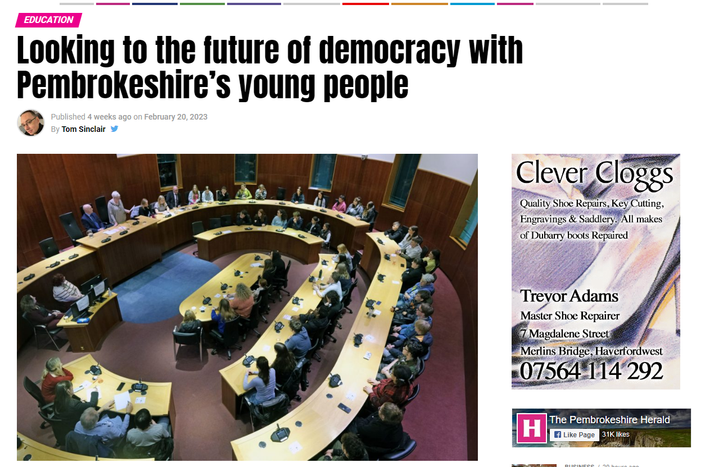
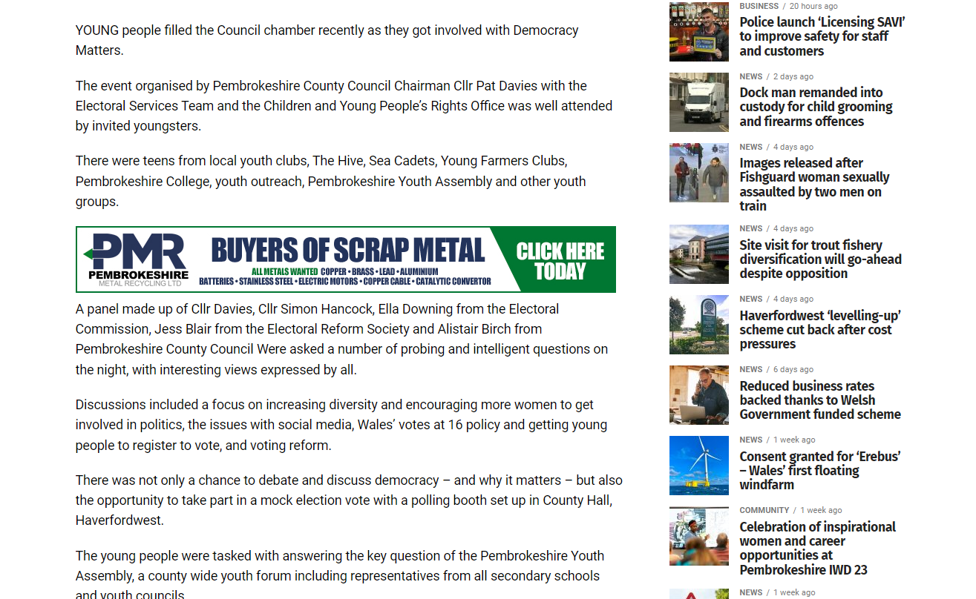
Looking to the future of democracy with Pembrokeshire’s young people – The Pembrokeshire Herald (pembrokeshire-herald.com)
Sinclair, T. (2023). Looking to the future of democracy with Pembrokeshire’s Young People. Pembrokeshire: Pembrokeshire Herald.

Youths debate in Council chambers – The Pembrokeshire Herald (pembrokeshire-herald.com)
Pembrokeshire Herald. (2016). Youths debate in council chambers. Pembrokeshire: Pembrokeshire Herald.

