Student Name: Stanimira Yuliyanova Dimitrova
Student Number: 1909125
Lecturer Name: Magdalena Wronska
Module Name: Principles of Health and Social Care Practice
Module Code: BMHP5002 (LON)
Assessment Component 1

Page Content
Introduction................................................................................................3
Care home………………………………………………………………………3
Hospice………………………………………………………………………….5
Care visits……………………………………………………………………….7
Conclusion………………………………………………………………………8
References……………………………………………………………………...8

Introduction

In this course work, we will look at a situation in which a couple over the age of eighty-five are forced to cope due to glass circumstances. Miss T and Mr. T are a couple who have been dealing with everyday life all their lives, and despite their age, until recently they were self-sufficient and independent, able to take care of each other and able to do everything by themselves. Their fate is not easy and their age is influenced and Mr. T develops a disease called progressive dementia, for this reason Miss T had more responsibilities and obligations related to the household and her husband. While at one-point Miss T fell and injured her hip, which led to her being hospitalized and operated on. Once the operation goes well and she returns home, she has a mobility framework that makes her realize that her family needs outside help to cope with the household and continue to live independently. For this reason, Miss T began to consider options, and became interested in institutions to support Mr. T's own care and that of herself. She also wants to have someone professional to help her recover faster and improve her mobility, and to help her prematurely with household and social responsibilities, anything that would help them live on the same way, before the incident with Miss T. After researching her, she understands that there are three options, each of which we will look at in this assimilation and summarize which of the options is most appropriate for Miss and Mr. T.

Care home

The first option that is offered to the elderly couple is to enter a care home. The care homes provide not only shelter for the elderly, but also care to help them in their daily tasks and needs. This includes helping with washing your face or teeth, taking a shower, rubbing in creams according to the individual's needs, helping with men's shaving, dressing the individual, giving the daily dose of medication (because most adults forget about taking im) or even for the movement of the individual. In different cases the needs are different and some of the individuals need a chest of drawers or a bed pan, the square staff are always there to help. These are the aids that attract adults to move to such a house, because after a certain age, people begin not to feel full of rain for one reason or another and seek help in their daily needs. The square home itself is a living environment inhabited by a large number of elderly people, in most cases they live in single rooms to have their own space and feel at home and at the same time have access to 24 hours help, from working in this home. Due to the large number of elderly people living in one place, there is a favorable environment in square homes for the creation of new social interactions and the creation of new friendships, as long as the individual himself wants.
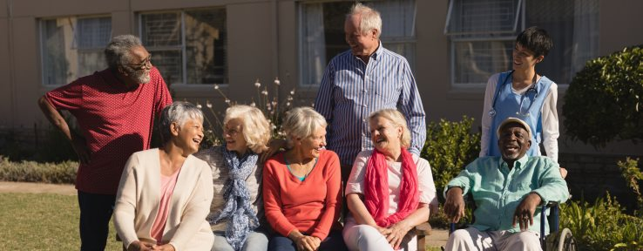There are different care homes that offer different types of care in addition to the basic ones listed so far, such as assistance with the movement of the individual, or with his nutrition, or even monitoring whether he receives enough water, we also have homes registered with special care for patients with dementia or terminal illness, and these homes are surrounded by dedicated and well-trained staff who can care for patients in the best possible way. The carers take care of all the clinical interventions that people admitted to such a home need, such as changing the catheter bag, stoma or other specific needs of the individual. When these individuals are surrounded by trained professionals, they know they are in good hands for twenty-four hours, because even if the person himself does not feel worse or something is wrong, employees are very experienced and can judge if there are signs of malaise and will act immediately to prevent deterioration. This creates a security in the elderly person, and peace of mind that there is always someone who will monitor his symptoms, strive for his health to be normal and that no important medications will be missed. For families who want to take care of their loved ones on their own, but are worried about taking a vacation all year round, especially to go on vacation or even to relax for a few days, there is an option in most care homes where you can year ahead plan the stay of a person as well as your vacation. Not worrying that the person in need of care will be left unattended, because you can always keep a room only for a certain period of time, and be sure that good care will be provided to your loved one (Gordon et al, 2013).
(Rochdale Borough Council, 2020).

In the case of Miss and Mr. T, an option such as a care home is less desirable due to the fact that Mr. T suffers from progressive dementia, which requires more specialized care and supervision. Such care is offered in specialized care homes, which would lead to the separation of the elderly couple. In order for Miss T to recover more quickly, and not to worry about her husband, on his part, in the event of a change of circumstances and the absence of his wife, there is a high probability that his condition will worsen. The option to split into different care homes is not a good option for the older couple.

Hospice

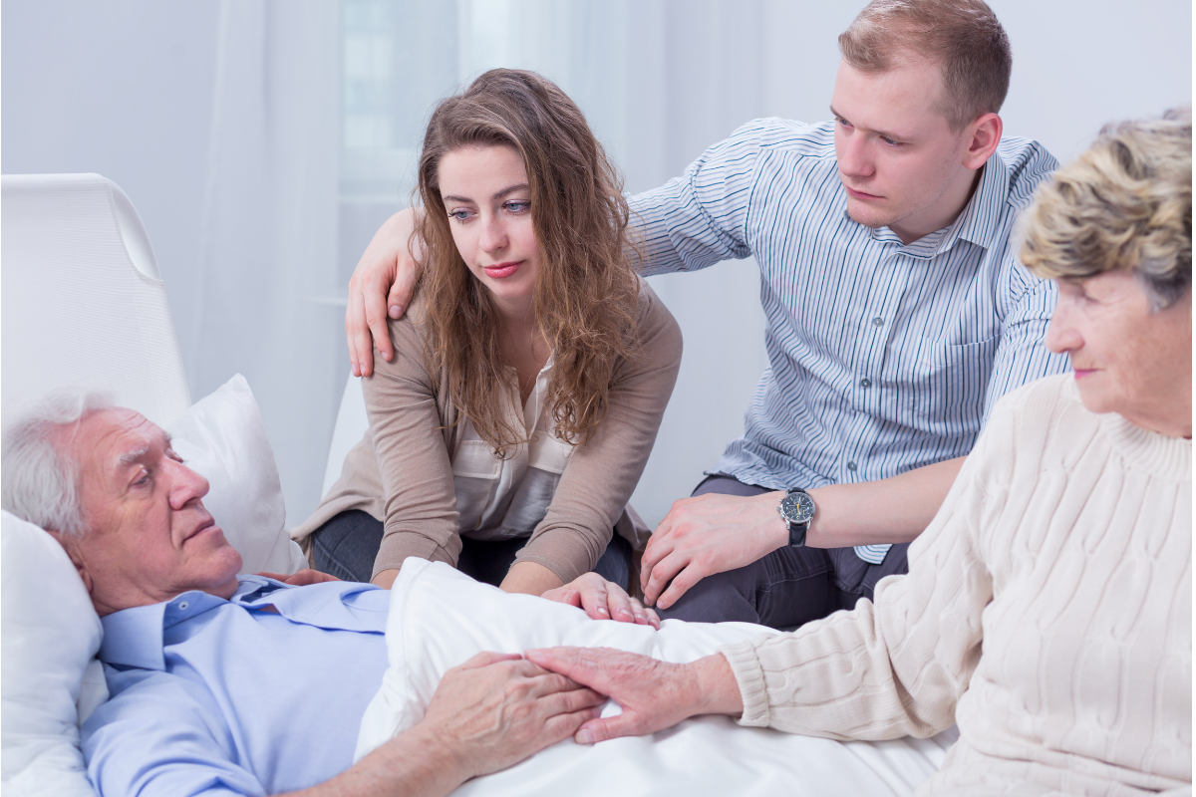The next option we have for Miss and Mr. T is to admit them to a hospice. Most people, hearing the word hospice, are imagining a gloomy place filled with silence, darkness and obscurity, where people go to spend the rest of their lives because they are sick with an incurable disease or they are just about to die. A hospice is a place where seriously ill people are beaten before their death to spend their last days cared for by well-trained people, and some patients simply do not want to die in front of their loved ones or be a burden, so they choose such a place. In fact, the hospice is full of life, they are designed to be pleasant places, family and loved ones are always welcome to visit, and the place itself is not like a hospital, in which the relatives of the patient can visit, at any time of the day and even spend the night there. Rather, the hospice is like a bustling residential building, even if it is filled with torment and compassion. The goal of hospices is to have the best possible quality of care in order to prolong the life of a person suffering from a life-threatening disease or terminal illness. The hospices themselves are equipped with rooms for entertainment of the hospitalized, as well as huge green areas, for walking and taking fresh air, there the food is always freshly prepared by the hospice chefs and there is a choice of menu, so sick people cannot always afford it. will allow at home. The hospice has specially trained nurses and doctors for terminally ill people, they are more in contact with their patients due to the reason that they spend quality time with them. Which makes them get to know them as people, not just serve them, which is again an advantage for the patient. Visits to the hospice can be for exercise, outpatient and day services and doing day therapies such as physiotherapy. Referral of patients to this type of institution can occur at any time of his illness, no matter if it is early or late. Despite all the amenities provided by the hospice, some people prefer no matter what their illness they are dying in them. For people who prefer to spend the last days of their lives at home, the hospice provides vital advice and support to the relatives of the individual on how to care before and after his death. When it comes to the end of someone's life, most people would choose to spend their last days at home surrounded by acquaintances of relatives and family, but still each person is individual and thinks differently (Kane, Robert et al, 1984).
(Crossroads Hospice, 2020).

As we are already familiar with the case of Miss and Mist T, we know that they have always been independent and took care of themselves, a place like a hospice would change all their habits and take away their autonomy, and we do not aim for that. Miss T has a tendency to recover and needs care for a certain period of time, she does not have a terminal diagnosis, so she has no reason to enter the hospice. Mr. T has a condition called progressive dementia, which tends to get worse. In this disease it is very difficult to determine when death will occur, due to the fact that individuals with variable symptoms, one day is fine, and the next does not recognize anyone. Placing Mr. T in a hospice would worsen his condition and make it worse. The two should not separate, so the option of her staying at home and being accommodated in a hospice is dropped.

Care visits

As the years go by, a person is more prone to accidents and risks affecting his health. For older people who want to live alone, it is vital to have someone they can count on to look after them or even pass by to exchange two words or any stories. Home visits are just that, a carer goes at certain hours to make sure everything is okay, to give medication or even to make sure that the patient is alive and well and does not need anything. Home visits are perfect for older people who want to stay independent at home and still receive extra help with household chores and everything needed to save a person's life as it was despite the illnesses and afflictions that affected them (bluebird care, 2020).

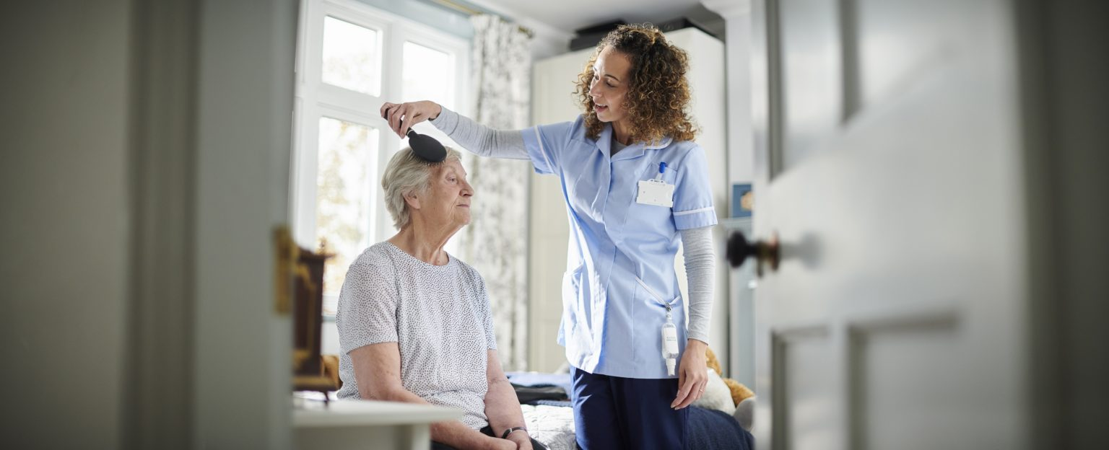Miss and Mr. T, need just such care to maintain their autonomy and remain independent and continue to feel self-sufficient and self-sufficient as much as possible and to continue their lives as it was until before the incident with Miss T. Miss T is not mobile at the moment after the incident with her, which means that she cannot go to the toilet on her own and will have to use diapers, which means that there is a risk of perisher sore will need a carrion four times. per day, and if she is in a wheelchair or needs a hoist, two carriages are needed for this purpose. The other need that Miss T has is rehabilitation, for this purpose a visit to a physiotherapist is needed. She is a convention and can make decisions on her own, while men can't, and for that there must be a next of kind, in this case it's her, so it depends on her what decision they will make and how many careers they will have. Due to the fact that she is not mobile and men and has progressive dementia, she will not be able to keep track of when she is where and what she is doing, therefore at any moment he may decide to go out and go somewhere, and then not be able to go home. In order to remain independent, they have to make some changes in the house in which they are. As a start, I would suggest installing an alarm service that is connected to the agency of the drivers who will visit them, so they will be able to give signals quickly in case of emergency, either because of the actions of Mr. or because the condition of one of the two has gotten worse. This service is very good and will work flawlessly because it has quick access to the agency at the touch of a button and help will be sent. The other thing the family needs to change is the visual scope of the house. Since Miss T cannot move and observe Mr. T, she must do so in some way so that she can adequately signal to the company, if necessary. In case she does not want to install cameras, the other solution to the problem is to install sensors at the exits to monitor the departure of the house.
(Care 1st Homecare & Live-in, 2012-2020).

Conclusion
No matter what decision Miss T makes, in the first place she must be sure that both she and her husband will be well cared for. How they will feel and their health are also essential and they must pay attention. in making the decision. Miss T herself has a good prognosis for the future, and her rehab, but let's not forget that she is eighty-five years old and will take longer to recover from the fracture. The couple need to keep their old way of life so that Mr. T doesn't get worse, and that would help Miss T recover faster.

References
Rochdale Borough Council (2020) Residential care home [Online] Available at: http://www.rochdale.gov.uk/carehomes/
[Accessed 15 December 2020].

Gordon, A.L., Franklin, M., Bradshaw, L., Logan, P., Elliott, R. and Gladman, J.R.F. (2013) Health status of UK care home residents: a cohort study Age and Ageing, 43(1), pp.97–103.

Crossroads Hospice (2020) What is Hospice Care Like? [Online] Available at: https://www.crossroadshospice.com/hospice-palliative-care-blog/2019/may/29/what-is-hospice-care-like/
[Accessed 16 December 2020].

Kane, Robert., Bernstein, L., Wales, J., Leibowitz, A. and Kaplan, S. (1984) A RANDOMISED CONTROLLED TRIAL OF HOSPICE CARE. The Lancet, [Online] 323(8382), pp.890–894. Available at: https://www.sciencedirect.com/science/article/abs/pii/S0140673684913497/
[Accessed 16 December 2020].

bluebird care (2020) Home Care | Domiciliary Care | Home Care Services | Bluebird Care [Online] Available at: https://www.bluebirdcare.co.uk/services/252/domiciliary-care/
[Accessed 17 December 2020].

Care 1st Homecare & Live-in (2012-2020) Homecare Visits | Bristol | Berkshire | Swindon | UK [Online] Available at: https://care1sthomecare.co.uk/our-services/homecare-visits/
[Accessed 17 December 2020].

