

MODULE CODE: ECPT6006

ASSESSMENT COMPONENT: A Critical Evaluation of the Role of Digital Innovation in Professional Practice

STUDENT NAME: Morgan Jones

STUDENT NUMBER: 2210512

Word Count: Approx 4875 words

Use of Generative AI in Assessment

(Lecturer to indicate Yes or No against each element)

RESEARCH | For this assessment, you can use Generative AI to support you in research, including searching for bibliography, using tools to summarise, compare and interrogate materials. | Yes ☒  No ☐
STRUCTURE | For this assessment, you can use Generative AI to support you in structuring your submission, including creating a draft argument structure, identifying parts and headings, etc. | Yes ☒  No ☐
PROOFREADING | For this assessment, you can use Generative AI to check your own text/creation for grammatical and syntactical mistakes, including rephrasing of your own work within specific standards. | Yes ☒  No ☐
WRITING | For this assessment, you can use Generative AI to create text for submission. | Yes ☐  No ☒
CREATIVE | For this assessment, you can use Generative AI to create creative materials, such as images. | Yes ☒  No ☐
PROGRAMING | For this assessment, you can use Generative AI to create and check code. | Yes ☐  No ☒
NONE | For this assessment, you are not allowed to use any type of Generative AI support. This includes research support, structure support, writing/proofreading support and creative support. | Yes ☐  No ☒

AI Acknowledgement
I confirm that I have not used any AI tools in the research and creation of this assignment.
I confirm that I have not presented any AI generated materials as my own work.
I confirm that I have copies of my drafts, notes, and other resources I used, which I may be asked to provide in evidence.

Contents

1.0 Introduction…………………………………………………………………………………………..…..5
2.0 The Role of Digital Innovation and Virtual Learning Environments in Adapting Lessons for Differentiation and Inclusion……………………………………………………..……8
2.1 Technology integration Matrix (Digital innovation)………………………………………..……8
2.2 Virtual Learning Environments (VLE)…………………………………………………………….11
3.0 Selection and Justification of appropriate teaching tool………………………………14
4.0 Application of the chosen learning tool………………………………………………………17
4.1 Setting up my digital tool – Virtual Learning Environment (Moodle)…………………….18
5.0 Evaluation and Reflection……………………………………………………………………….…24
6.0 References……………………………………………………………………………………………….27
7.0 Appendices………………………………………………………………………………………………29
7.1 Lesson Plan……………………………………………………………………………………………….29

1.0 Introduction
This assignment with critically evaluate how digital innovation has become a central part of modern teaching practice, reshaping how educators deliver lessons and engage learners. In education and training, digital tools support flexible learning, improve accessibility, and enable teachers to create more engaging and effective learning experiences. Understanding how and why these tools are used is essential, as it allows educators to make informed decisions about their teaching strategies and adapt to the diverse needs and expectations of learners.
As digital technologies continue to evolve, so too does the theory surrounding their use. Researchers and educators have developed several models to help make sense of how technology can support meaningful learning.
Frameworks such as,
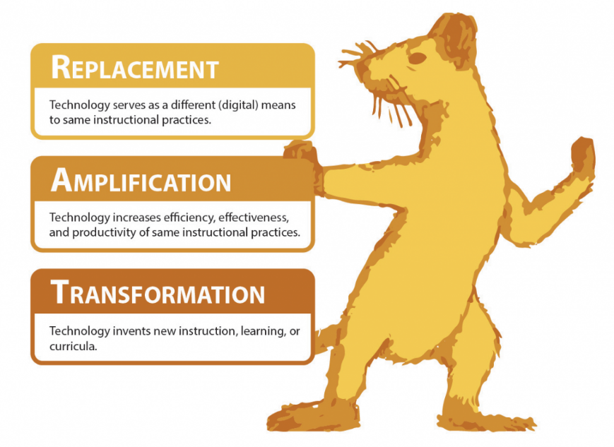
Figure 1 Artwork Depicting the RAT Framework
RAT: The Replacement, Amplification, Transformation framework is a model used to evaluate technology integration, helping educators reflect on how the digital tools they bring into their teaching supports both their learners and their own practice (Read, 2022).

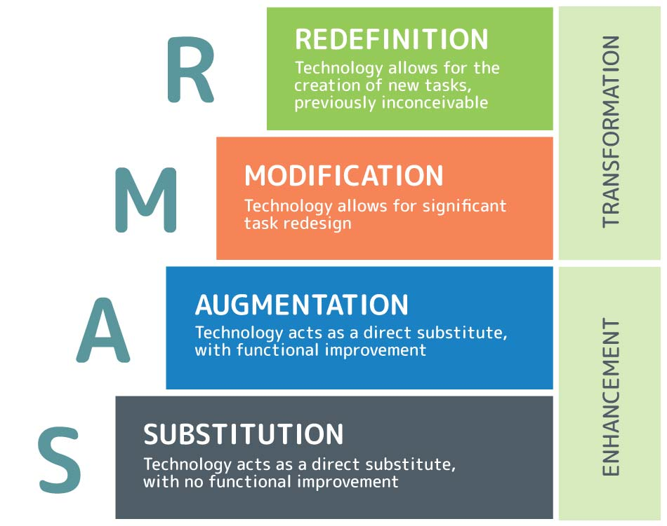
Figure 2 Visualization of each stage of the SAMR model
SAMR: The SAMR model shows how educational technology can range from enhancing learning (substitution, augmentation) to transforming it (modification, redefinition), with effectiveness depending on how and when it is applied (Best, 2020).

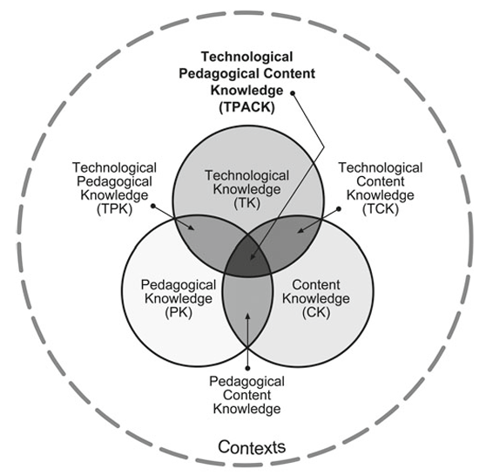
Figure 3 The technological pedagogical content knowledge framework
TPACK: The TPACK framework shows that effective teaching requires understanding how technology, pedagogy, and content interact, allowing teachers to create context-specific strategies that integrate all three areas (Koehler, Mishra, Kereluik, Shin & Graham, 2013, pp. 101-103).

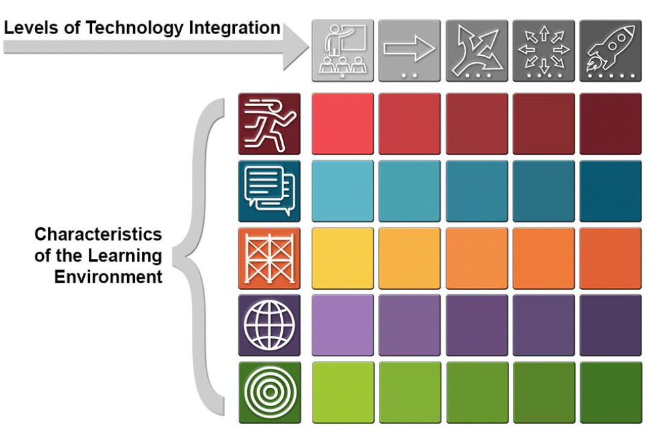
Figure 4 The Technology Integration Matrix
TIM: The Technology Integration Matrix is a framework that connects five features of meaningful learning with five levels of technology integration to guide effective integration of technological use (University of South Florida, College of Education, 2019).
All offer structured ways to evaluate the role of digital tools and understand their impact on teaching and learning. These models highlight that effective digital innovation is not just about including technology for the sake of it, but about finding the right balance between purpose, pedagogy, and practice. This approach aligns closely with the Welsh Professional Standards (reference), which emphasise reflective, evidence-informed teaching, the effective use of resources, and meeting the diverse needs of learners. By using these frameworks, educators can ensure that digital tools are integrated thoughtfully to support professional practice, enhance learning outcomes, and maintain inclusive and high-quality teaching standards.

2.0 The Role of Digital Innovation and Virtual Learning Environments in Adapting Lessons for Differentiation and Inclusion (1220 words).
Digital innovation has become an essential part of modern teaching, especially when it comes to meeting the diverse needs of learners. Virtual Learning Environments (VLEs) like Moodle now play a key role in helping educators offer structured, flexible, accessible, and differentiated learning opportunities. Research shows that when technology is used purposefully, it can support a more inclusive teaching approach by giving students multiple ways to engage with content, revisit material, and work at a pace that suits their individual learning style. To understand how this can be achieved in practice, models such as the Technology Integration Matrix (TIM) offer useful guidance. TIM highlights how technology can move from simple adoption to more transformative teaching practices that actively support collaboration, independence, and personalisation. By drawing on this framework, this assignment explores how digital innovation, specifically using a VLE, can enhance inclusion and differentiation in the learning environment. The aim is not just to show what digital tools can do, but to understand how they can genuinely improve teaching practice when used thoughtfully and with learners’ needs in mind.
2.1 Technology integration Matrix (Digital innovation)
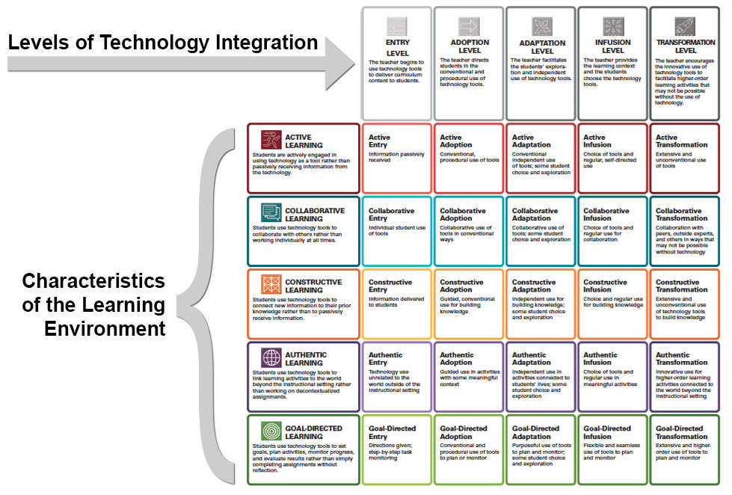
Figure 5 Detailed Chart of The Technology Integration Matrix (TIM)
The Technology Integration Matrix (TIM) offers a framework for evaluating and guiding how technology is used to enhance learning. It identifies five key characteristics of meaningful learning environments, including:
•Active •Collaborative •Constructive
•Authentic •Goal-driven
These characteristics correspond to five progressive levels of technology integration:
•Entry •Adoption •Adaptation
•Infusion •Transformation.
Together, the five characteristics of meaningful learning environments and the five levels of technology integration form a matrix consisting of 25 cells, as seen in Figure 5. TIM was developed in 2005 by the Florida Center for Instructional Technology (FCIT) and is now in its third edition since 2019 (FCIT, 2019).

TIM has been proven to give educators a structured way to consider technology integration within teaching, as supported by a study that supports its use. This study highlights that a structured framework approach strengthens metacognition through integrating technology into teaching, by helping teachers connect International Society for Technology in Education standards (ISTE, 2008) with content, pedagogy, and effective lesson design (McKenna, Otieno, and Schulz, pp.86-88, 2016).
The foundation of TIM is built on constructivist learning theory and research-informed teaching practice, which offers a shared language for understanding meaningful technology use. Rather than assessing teachers themselves or isolated tasks, it focuses on evaluating the pedagogical quality of whole lessons, making it a practical tool for guiding thoughtful technology integration (FCIT, 2019).
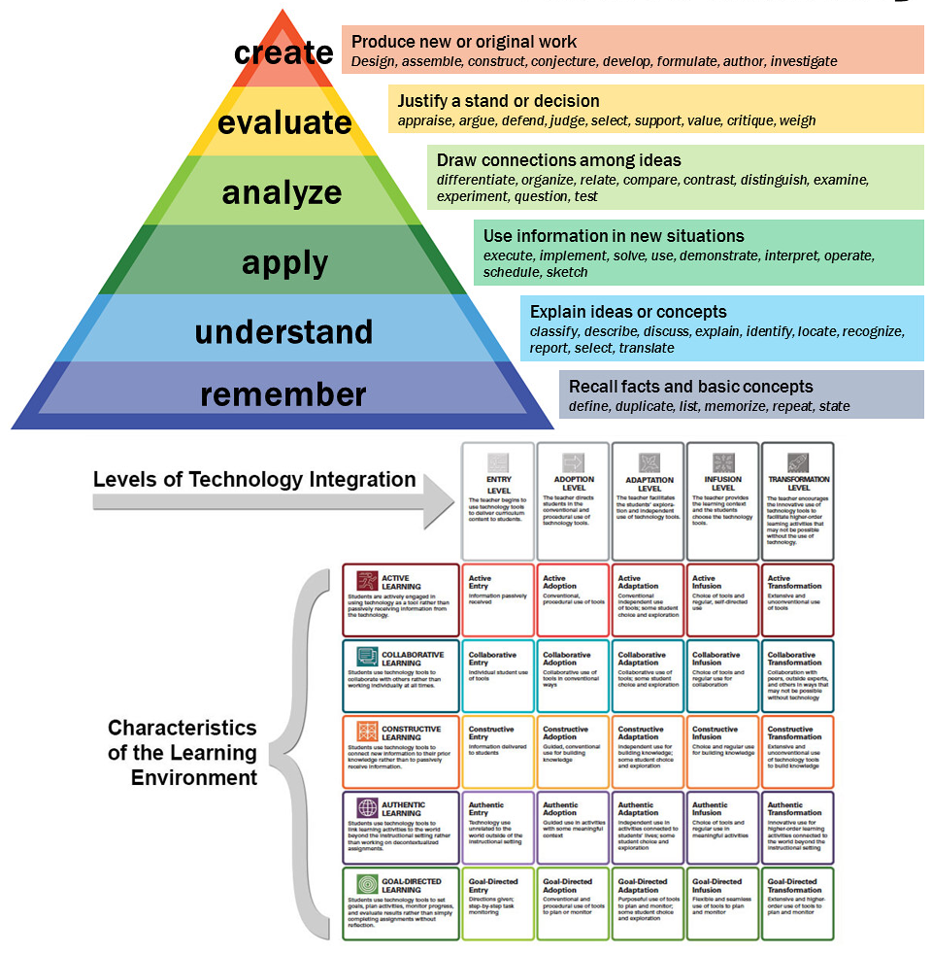
Figure 6 Bloom's Taxonomy and TIM frameworks comparison
With the TIM framework grounded in pedagogy, comparisons can be drawn between TIM and Bloom's Taxonomy. TIM and Bloom’s Taxonomy provide structured frameworks to guide teaching and learning. Bloom’s Taxonomy organizes cognitive skills into six hierarchical levels, encouraging learners to build foundational knowledge before progressing to higher-order thinking such as analysis and creation. Similarly, TIM structures technology integration across levels of complexity, from Entry to Transformation, emphasizing increasingly sophisticated use of technology to support learning. Both frameworks use clear, actionable criteria, Bloom through measurable verbs and TIM through defined characteristics of meaningful learning, to guide lesson design, curriculum planning, and assessment alignment. In essence, while Bloom focuses on the progression of cognitive skills and TIM emphasizes the progression of pedagogically meaningful technology use, both serve as practical tools for educators to scaffold learning experiences and ensure alignment between objectives, instruction, and evaluation (McLeod, 2025).
While TIM is pedagogically grounded, it has limitations that can affect its practical use in classrooms. While frameworks like TIM aim to guide effective technology use, research on digital integration highlights potential drawbacks similar to those seen with mobile devices in classrooms. Studies indicate that technology can distract students, reduce engagement with lesson content, and create opportunities for off-task behaviour such as social media use, cheating, or accessing inappropriate material (Pedro, Barbosa, & Santos, pp.1-13, 2018).
Also mentioned in the paper “Evaluating technology integration in education: a framework for professional development” highlights that successful technology integration relies on teachers’ skills, confidence, and the support they receive, rather than merely having access to tools. It emphasizes the importance of carefully designed professional development programs that provide active learning opportunities, encourage collaboration, and offer ongoing support to strengthen teachers’ ability to integrate technology effectively (Siyam, Siyam, Hussain, & Alqaryouti. 2025).

2.2 Virtual Learning Environments (VLE)
VLEs are particularly effective in supporting the diverse learning preferences identified by the VARK model, which categorises learners as Visual, Auditory, Read/Write, or Kinaesthetic (Fleming & Mills, 2016).
•Visual learners can benefit from infographics, diagrams, interactive 3D models and video demonstrations that make concepts easier to understand.
•Auditory learners can benefit from podcasts and recorded lectures, allowing them to process information through listening.
•Read/write learners gain from textual resources, online articles, lecture notes and structured guides that they can study and annotate at their own pace.
•Kinaesthetic learners are supported through interactive simulations, virtual labs, and hands-on activities within the VLE that allow for experimentation, practice, and the application of skills directly.
Teachers can enhance student engagement by presenting content in a variety of formats, allowing learners to interact with the material in multiple ways. While it is not necessary to present every topic in all four VARK modalities, providing a balanced mix throughout the course ensures that different learners have opportunities to engage in ways that suit them best. Care should be taken not to overwhelm students with too many options, even though those with an integrative preference may be inclined to use multiple formats. Clear course organization is essential to highlight key learning points and prevent cognitive overload. Understanding learners’ individual needs, particularly those with aural or kinaesthetic preferences, allows teachers to offer additional guidance and support as students adjust to online learning. Instructors should also recognize that students may need to develop self-study, time-management, and technology skills, and may require strategies to remain motivated and engaged. Finally, providing alternatives to face-to-face communication, such as discussion forums, collaborative tasks, and virtual meetings, ensures that interaction remains effective. By thoughtfully designing VLEs in this way, teachers can create an inclusive and flexible learning environment that accommodates all learning preferences and promotes engagement and achievement (Vark Learn, 2025).
There is evidence that VLEs can support improved academic performance when they are well structured and easy to navigate. (Sun, Tsai, Finger, Chen and Yeh, pp. 1183–1202. 2008) found that system usability and clarity of content organisation were strongly linked to student satisfaction and perceived learning effectiveness. When learners can easily locate resources and understand expectations, cognitive load is reduced, allowing greater focus on learning tasks. This supports the idea that VLEs are most effective not simply because they are digital, but because they are intentionally designed to support learning processes.
To further add to this, research on online teaching suggests that students tend to engage more and perform better when courses are well structured, resources are clearly organised, and interactive elements such as activities or discussions are included. When materials within a VLE are easy to find and logically laid out, learners can concentrate on understanding the content rather than figuring out how to use the platform, supporting stronger engagement and more effective learning (Liaw, pp.864-873. 2008).
Although Virtual Learning Environments offer many advantages, a key limitation is the reduced opportunity for face-to-face interaction, which can affect social presence and collaborative learning. (Garrison, Anderson and Archer, pp.87-105. 2000) argue that effective learning depends on the interaction of social, cognitive and teaching presence, and that online settings can feel isolating if interaction is not intentionally designed. In VLE-based learning, students may experience fewer spontaneous peer discussions and less immediate feedback, which can negatively impact motivation and shared understanding. This highlights the need for VLEs to incorporate structured collaborative activities and opportunities for dialogue to maintain engagement and support meaningful learning.
Another challenge with VLEs is that they can highlight existing digital inequalities. Not all learners have consistent access to reliable internet, suitable devices, or a quiet place to study, which can make it harder for them to engage fully with online learning (Helsper, Eynon, pp.696–713. 2013) . In addition, students with lower levels of digital confidence may spend more time working out how to use the platform than focusing on the learning itself. Without appropriate guidance and support, this can lead to frustration, reduced motivation, and weaker learning outcomes (Beetham, Sharpe, p18. 2019).

3.0 Selection and Justification of Appropriate Teaching Tool
Moodle has been selected as my primary digital tool because it functions as a central hub for managing and delivering learning resources, supporting a flexible and inclusive virtual learning environment. Its use demonstrates a commitment to learners and their learning by removing unnecessary barriers to access and ensuring all students can engage with lesson materials safely, consistently, and at their own pace. This aligns with the Professional Standards for Wales, particularly the commitment to inspiring, supporting and stretching learners while taking account of their starting points and progression options (Welsh Government, 2023).
The use of Moodle aligns closely with pedagogical theory and digital innovation frameworks, particularly the Technology Integration Matrix (TIM), which emphasises the progressive and meaningful integration of technology into teaching. As previously mentioned TIM identifies five characteristics of effective learning (active, collaborative, constructive, authentic, and goal-directed) across five levels of technology integration, ranging from Entry to Transformation (FCIT, 2019). By situating Moodle within this framework, the intention is not merely to deliver content digitally, but to plan and deliver effective learning experiences that enhance engagement, collaboration, and learner autonomy. This reflects the professional standard of using a range of media, including digital technologies effectively to enhance the learning process (Welsh Government, 2023).
Moodle is intended to act as a centralised hub to support differentiated and inclusive learning by providing multiple ways for students to access and interact with materials. For the planned lesson, students are able to download pre-prepared 3D barrel assets for use in Adobe Substance 3D Painter. Providing standardised 3D models ensures consistency across the cohort and allows the lesson to focus on texturing rather than modelling. This supports equality of opportunity by ensuring all learners begin the practical task from the same starting point, regardless of prior modelling experience. In doing so, it aligns with the professional commitment to valuing and promoting diversity, equality of opportunity and inclusion (Welsh Government, 2023).
To support varied learning preferences, instructional content from the live demonstration will be uploaded to Moodle in PowerPoint format, allowing students to revisit explanations independently. This approach reflects a commitment to inclusive practice and learner well-being, as students are not disadvantaged if they require more time to process information or revisit complex steps. Visual learners benefit from step-by-step screenshots, read/write learners from written explanations, and kinaesthetic learners from applying techniques using the downloadable assets. Additional auditory support is provided through narrated content, while a supplementary video tutorial on UV unwrapping enables independent consolidation of foundational knowledge.
This multi-modal approach demonstrates an understanding of how learners engage differently with digital content, whilst supporting students in sharing responsibility for their own learning by enabling them to choose how and when they engage with materials which encourages self-directed practice and reflection (Welsh Government, 2023).
Students are also able to upload screenshots of their completed textured models via a OneDrive link embedded within Moodle. This enables peer discussion and feedback, supporting collaborative learning and the development of reflective skills. By facilitating opportunities for learners to share and discuss their work, the digital tool supports positive and respectful learning relationships and aligns with the professional commitment to building positive and collaborative relationships within the learning environment (Welsh Government, 2023).
The inclusion of a video tutorial on UV unwrapping further demonstrates the use of digital technology to extend learning beyond the live session. While UV mapping is introduced during the lesson, the resource allows learners to explore techniques in greater depth at their own pace. This supports progression and empowers learners to identify and address gaps in their own understanding, aligning with the standard of enabling learners to evaluate their own progress and set challenging goals (Welsh Government, 2023).
From a professional practice perspective, Moodle also supports effective planning, assessment, and reflection. Centralising resources, submissions, and engagement data allows for monitoring learner interaction with materials and identifying where additional support may be required. This reflects the professional standard of using assessment of and for learning to support learner progress, as well as using evidence to improve practice through reflection on learner engagement and outcomes (Welsh Government, 2023).
It is important to acknowledge limitations in the planned use of Moodle. Research suggests that poorly structured digital environments can overwhelm learners or encourage off-task behaviour (Pedro, Barbosa, & Santos, pp. 1–13. 2018). Additionally, effective integration relies on teacher confidence and digital competence rather than access alone (Siyam, 2025). Recognising these limitations reflects critical reflection on professional practice and aligns with the standard of critically appraising my own teaching with the adaption through consideration, reflection and feedback (Welsh Government, 2023). These risks are mitigated through careful organisation of materials, clear instructions, and structured scaffolding content.
In conclusion, Moodle has been selected as the digital tool for this session because it supports inclusive, differentiated, and learner-centred teaching while aligning with professional standards for further education in Wales (Welsh Government, 2023). Its use demonstrates effective digital practice through structured resource delivery, opportunities for collaboration and self-directed learning, and mechanisms for feedback and reflection. Furthermore, it is Informed by pedagogical frameworks and professional standards, the implementation of Moodle enhances lesson design, supports diverse learners, and contributes to the ongoing development of digital and professional teaching practice.

4.0 Application of Digital Tool – Adobe Substance Painter 3D Workshop


Figure 7 Moodle

For my digital tool I used Moodle as it serves as the central digital hub for all resources, supporting a flexible and inclusive virtual learning environment. Students were able to download pre-prepared low-poly and high-poly barrel assets, which ensured consistency and allows the lesson to focus on texturing rather than modelling. Instructions from the live demonstration were uploaded as a PowerPoint, enabling students to follow the content at their own pace. A OneDrive link is also provided for students to upload screenshots of their completed textured barrels, which are then shared with the class to facilitate group discussion and peer feedback. Additionally, a video tutorial on UV unwrapping, an essential step for texturing, is made available to support students who wish to practice these techniques independently. By centralising these resources on Moodle, the lesson creates a diverse and adaptable learning environment, allowing students to engage with materials in multiple ways and promoting differentiated and inclusive teaching practices.

Link to student work:LEVEL 4 - Intro to 3D - Substance Painter Screenshots
Link to lecture PowerPoint:Level 4 - Intro to 3D - SubstancePainter.pptx
Link to UV unwrapping video tutorial:https://www.youtube.com/watch?v=nzrf0VNRP40

4.1 Setting up my digital tool – Virtual Learning Environment (Moodle)
Using Moodle as a digital tool was straightforward, as I was already familiar with the interface. Uploading materials functioned much like posting content to a blog. I needed to make the 3D modelled assets available for students to download, as well as provide a separate PowerPoint for them to follow. I also set up a secure area where students could upload their screenshots and included a link to a YouTube video tutorial. Below, I'll outline how I set this up:
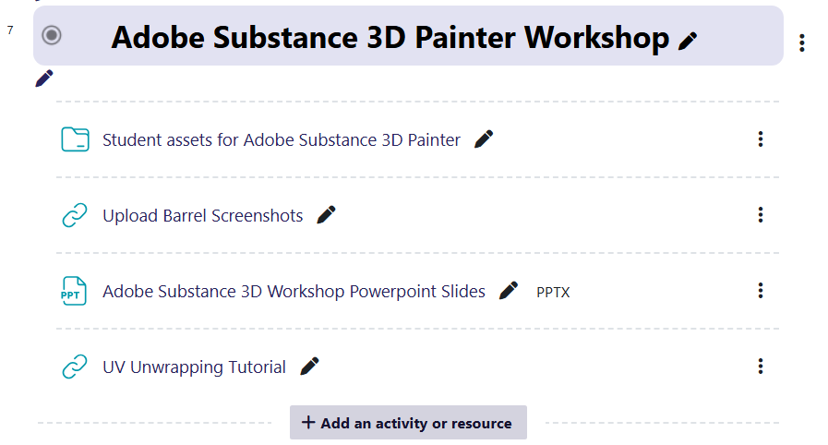
Figure 8: Adobe Substance 3D Painter Workshop section in Moodle
Using Moodle’s edit mode, I was able to create a dedicated section specifically for the session. This section could also be set to “hidden,” ensuring students could not access the content until the day of the lesson.
Within the section, there is an option called “Add an activity or resource”, as shown in Figure 8. Selecting this opens a list of tools that can be used for assessment, feedback, communication, collaboration, content interaction, submissions, and resource sharing.
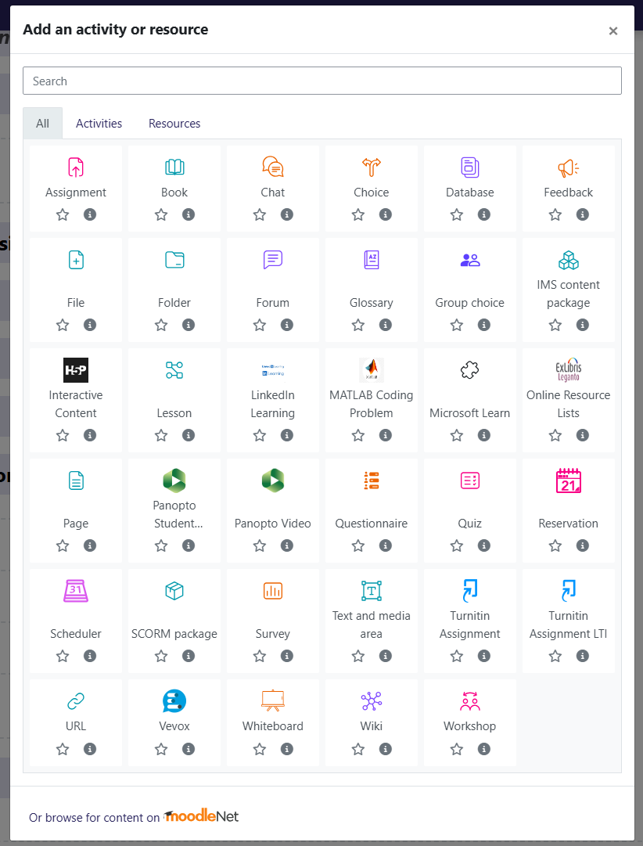
Figure 9: Moodle Activity List

In this case the following activities were used:
•File •Folder •URL x2
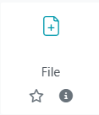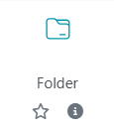

The File activity was implemented to upload a copy of the PowerPoint demonstration, providing students with a visual recap of the live Adobe Substance 3D Painter session.
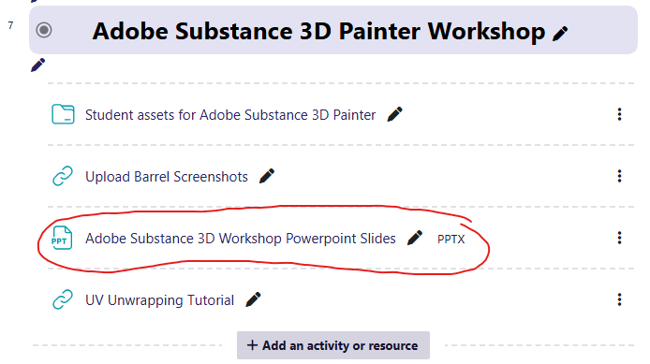
Figure 10: Adobe Substance 3D painter PowerPoint slides download link.
The Folder resource was used to upload a collection containing two FBX files of an oil barrel 3D asset, a low and a high-poly model.
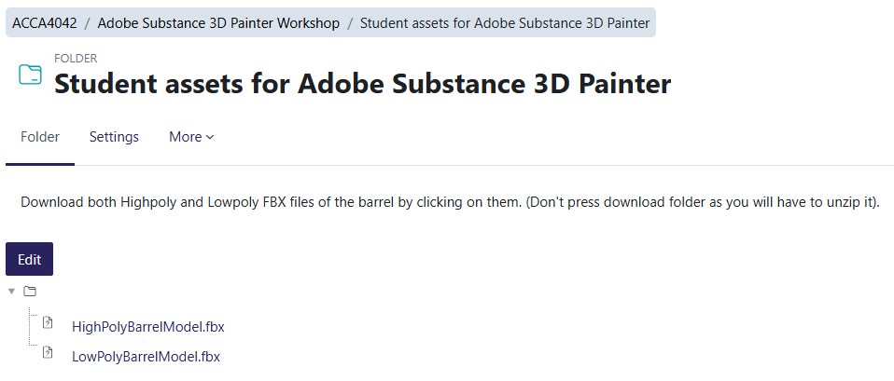
Figure 11: 3D Assets download activity.

The URL activity was used twice, each for a different purpose. The first provided a link to a OneDrive folder where students could upload screenshots of their work.
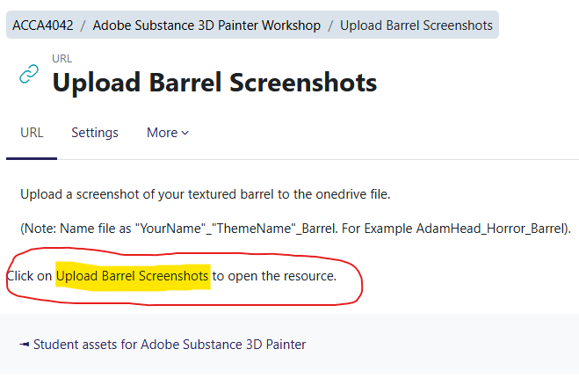
Figure 12 Upload screenshots activity - OneDrive link.

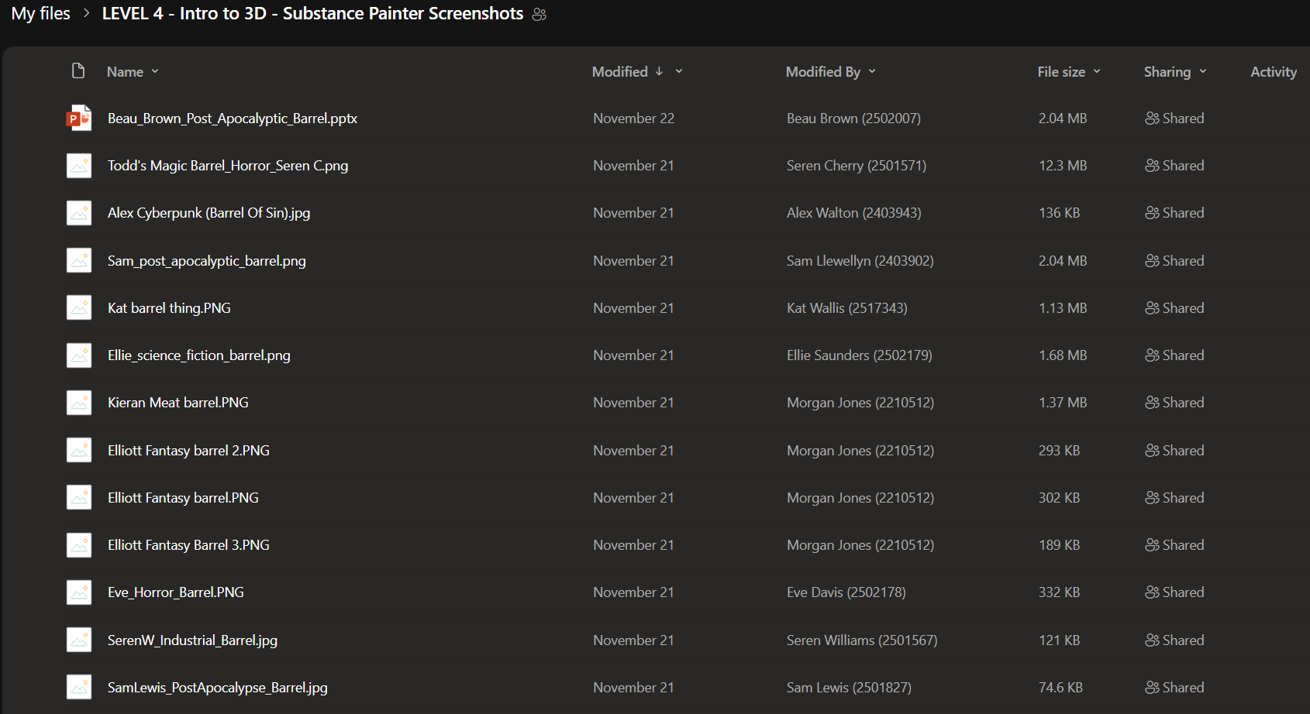
Figure 13 OneDrive file for screenshots of students' work.
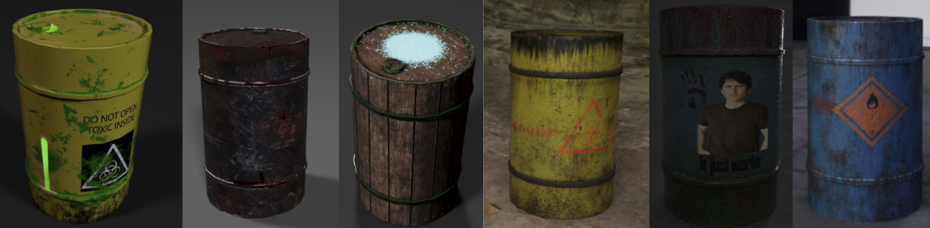
Figure 14 Examples of students' work.
The second URL activity directed students to a UV unwrapping video tutorial that was created for the session.

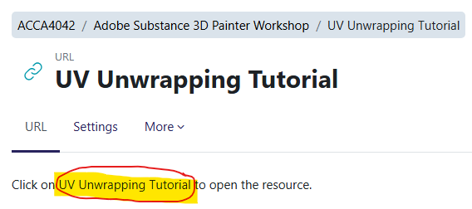
Figure 15 UV Unwrapping Tutorial activity - Youtube link.

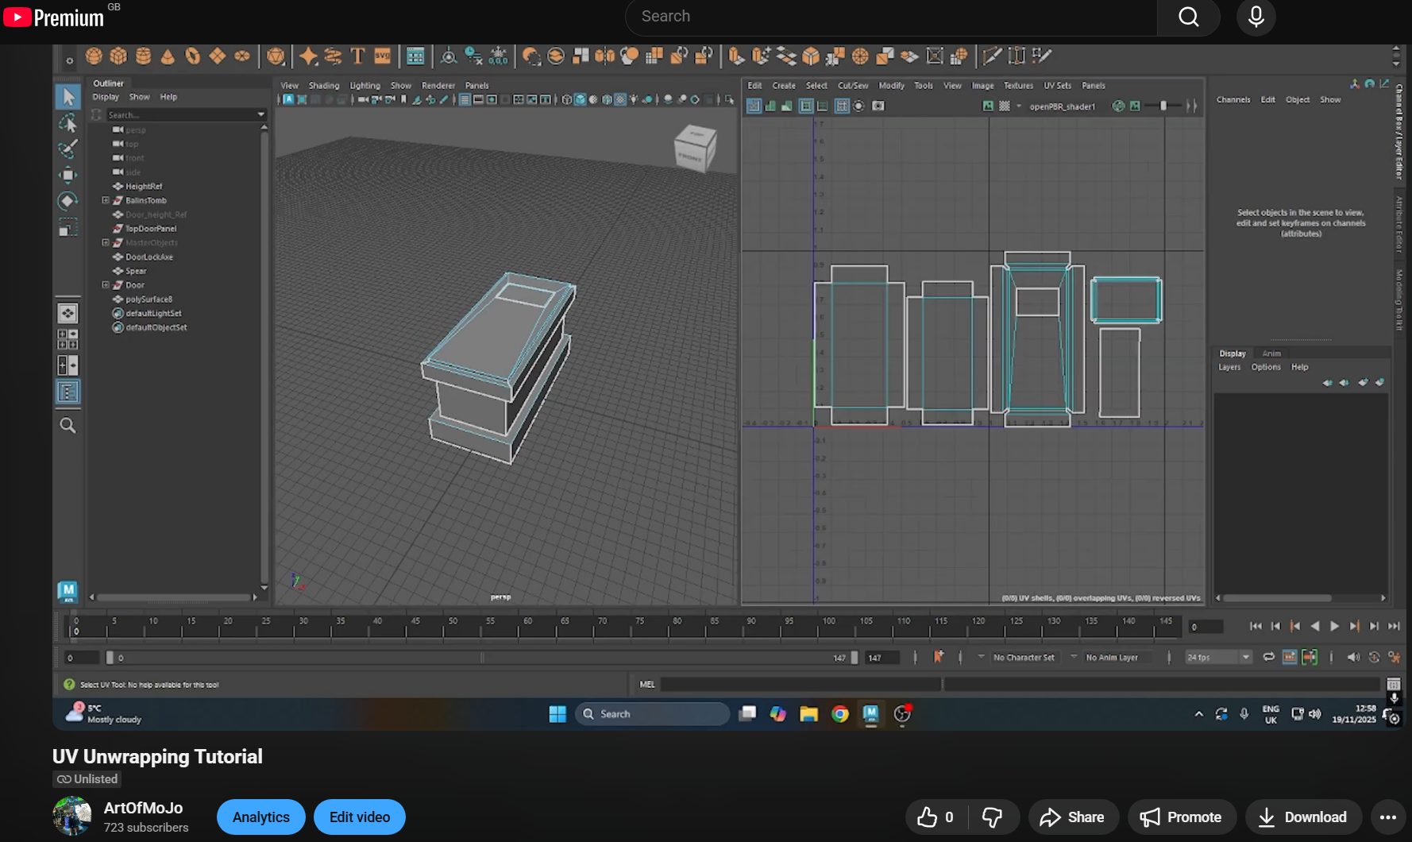
Figure 16 UV Unwrapping Tutorial screenshot
Moodle also allowed the tracking of students that accessed specific activities, therefore enabling the ability to monitor engagement with the content. This insight can also help identify students’ preferred learning styles. For example, those who downloaded and followed the PowerPoint likely have a reading/writing preference according to the VARK model (Fleming & Mills, 2016).
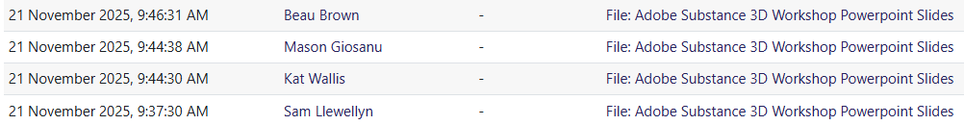
Figure 17 Moodle student activity log.

In practice, I was able to use Moodle as a digital tool to create a virtual learning environment where students could download resources, submit work for feedback and peer discussion, follow the lesson’s PowerPoint at their own pace, and access additional content, in this case a video tutorial. This platform is a useful application in the delivery of a structured, differentiated and inclusive lesson.

5.0 Evaluation and Reflection
The digital tool central to this session was Moodle, functioning as a hub for all lesson resources and providing a structured virtual learning environment. Its implementation was intended to support differentiated, inclusive, and flexible learning, allowing students to access materials at their own pace and engage in self-directed learning. Reflecting on its use, Moodle successfully enabled the centralisation of pre-prepared 3D assets, PowerPoint instructions, a UV unwrapping video tutorial, and a OneDrive submission system. This integration of resources directly aligned with the intended outcomes of supporting student engagement, skill development, and independent practice.
Students were able to download low and high-poly barrel assets in advance, which ensured consistency in the lesson and allowed the practical focus to remain on texturing. The ability to provide standardised resources through Moodle was effective in achieving the lesson’s learning objectives mentioned by my PCET observer. During the session, I observed that students were able to begin working immediately upon starting the software demonstration, as all necessary files were readily accessible. This seamless access reduced barriers to learning and allowed the practical session to run smoothly, demonstrating Moodle’s capacity to support organised access to materials.
The instructional content uploaded as a PowerPoint complemented the live demonstration, providing students with the opportunity to revisit key points and screenshots at their own pace. This function proved particularly beneficial for students who arrived late or needed additional reinforcement, aligning with the principles of differentiated instruction. Students who engaged with the PowerPoint alongside the practical session were able to consolidate their learning independently, highlighting the tool’s role in supporting flexible learning pathways. The PowerPoint also allowed students to visualise the step-by-step process of texturing, which reinforced understanding and offered a scaffolded approach to acquiring new technical skills.
A video tutorial on UV unwrapping, hosted via YouTube and linked through Moodle, further extended the opportunities for self-directed learning. While the lesson introduced basic UV techniques, students could use the video to explore more advanced concepts and practice at their own pace. This additional support ensured that students could bridge knowledge gaps independently, illustrating the value of resources in a blended learning environment. The combination of downloadable assets, the PowerPoint, and the video tutorial exemplified a multi-modal approach that catered to different learning styles, including visual, read/write, and kinaesthetic preferences.
The submission and feedback mechanism, via a OneDrive link, was another critical feature of Moodle that positively impacted the session. By allowing students to upload screenshots of their completed textured models, the tool facilitated peer review, discussion, and reflective practice. Sharing student work within the virtual environment encouraged engagement and provided opportunities for collaborative learning, even in a largely practical session. Additionally, this system enabled monitoring of student progress efficiently, tracked engagement, and identified those who might require further support, demonstrating the tool’s potential to aid formative assessment and personalised guidance.
From a practical standpoint, the ease of setting up Moodle contributed to its effectiveness. Creating a dedicated section for the workshop, uploading files, and configuring access to the OneDrive and video links was straightforward, enabling smooth preparation and implementation. Features such as the ability to hide content until the lesson day ensured that students accessed materials in an organised manner, reducing confusion and maintaining lesson flow. The structured organisation of resources within Moodle supports cognitive load management, as students were able to locate and engage with materials without distraction or uncertainty.
Despite these benefits, some limitations were observed. While Moodle allowed for centralisation of resources, the tool’s effectiveness depended on student familiarity with the platform. A small number of students required initial guidance to access the uploaded materials, which temporarily slowed the start of the practical session. Additionally, the reliance on external links, such as the OneDrive folder and YouTube video, introduced potential accessibility issues, such as connectivity problems or platform restrictions. These considerations highlight the need for contingency planning and clear instructions when implementing digital tools to support inclusive learning.
The use of Moodle also revealed insights into engagement patterns. By tracking student access to files and submissions, I was able to identify which resources were most utilised and which students engaged independently. For example, students who accessed the PowerPoint and video tutorial before or during the practical session appeared more confident and self-directed in applying texturing techniques. This data provides valuable feedback on the efficacy of resources and informs future lesson planning, including the sequencing of materials and the provision of optional support resources.
In terms of professional practice, the implementation of Moodle demonstrated alignment with digital innovation frameworks, particularly the Technology Integration Matrix (TIM). The platform enabled active, constructive, and goal-directed engagement, allowing students to collaborate and reflect on their work, access multiple learning pathways, and develop technical skills independently. The structured use of Moodle supports professional standards in managing effective, inclusive learning environments, illustrating the benefits of thoughtful technology integration in teaching practice.
For future development, considerations include improving initial student orientation to the platform to ensure smooth access, reviewing the accessibility of linked resources, and integrating more interactive elements directly within Moodle, such as a quiz activity over a discussion prompt. Expanding the functionality of the tool in this way could further enhance engagement, provide better formative assessment opportunities, and strengthen collaborative learning. Additionally, continued reflection on student interaction with resources will support iterative improvement, ensuring that the digital tool remains responsive to learner needs.
In conclusion, the use of Moodle in this session effectively supported differentiated and inclusive learning. Its role as a central hub for resources, combined with instructional content and submission mechanisms, allowed students to engage flexibly and independently with the lesson material. While minor limitations related to access and familiarity were observed, the overall impact on teaching and learning was positive, demonstrating the potential of thoughtfully implemented digital tools to enhance lesson delivery, student engagement, and professional practice. Reflection on this experience provides clear guidance for future sessions, including optimising accessibility, supporting self-directed learning, and exploring additional interactive features to further improve the learning experience.

6.0 References
Beetham, H. and Sharpe, R. (2019) Rethinking pedagogy for a digital age. 3rd edn. p.18 (Accessed: 23 November 2025).
Best, J. (2020) The SAMR Model Explained (With 15 Practical Examples). 3P Learning. Available at: https://www.3plearning.com/blog/connectingsamrmodel/ (Accessed: 23 November 2025).
Fleming, N. & Mills, C. (2016. The VARK Modalities: Visual, Aural, Read/write & Kinesthetic. Available at: https://vark-learn.com/introduction-to-vark/the-vark-modalities/ (Accessed: 3 December 2025).
Florida Center for Instructional Technology (FCIT) (2019) Background. Available at: https://fcit.usf.edu/matrix/matrix/background/ (Accessed: 3 December 2025).
Florida Center for Instructional Technology (FCIT) (2019) The Technology Integration Matrix. Available at: https://fcit.usf.edu/matrix/matrix/ (Accessed: 28 November 2025).
Garrison, D.R., Anderson, T. and Archer, W. (2000) Critical inquiry in a text-based environment: Computer conferencing in higher education. The Internet and Higher Education, pp.87–105. https://doi.org/10.1016/S1096-7516(00)00016-6 (Accessed: 4 December 2025)
Helsper, E.J. and Eynon, R. (2013) Distinct skill pathways to digital engagement, European Journal of Communication, pp. 696–713. (Accessed: 23 November 2025).
International Society for Technology in Education (2008) ISTE Standards. Available at: https://iste.org/standards (Accessed: 3 December 2025).
Koehler, M.J., Mishra, P., Kereluik, K., Shin, T.S. & Graham, C.R. (2013) The Technological Pedagogical Content Knowledge (TPACK) Framework for Teachers and Teacher Educators: Handbook of Research on Educational Communications and Technology. New York: Springer. Available at: https://www.punyamishra.com/wp-content/uploads/2013/08/TPACK-handbookchapter-2013.pdf (Accessed: 23 November 2025).
Liaw, S. S. (2008) Investigating students’ perceived satisfaction, behavioral intention, and effectiveness of e-learning: A case study of the Blackboard system, Computers & Education, pp. 864–873. doi: 10.1016/j.compedu.2007.09.005 (Accessed: 23 November 2025).
McKenna, K., Otieno, C. and Schulz, L. (2016) How does use of the Technology Integration Matrix influence preservice educators’ metacognition about technology integration in teaching and learning practices? Available at: https://files.eric.ed.gov/fulltext/ED579661.pdf (Accessed: 3 December 2025).
McLeod, S. (2025) Bloom’s Taxonomy of Learning | Domain Levels Explained, SimplyPsychology. Available at: https://www.simplypsychology.org/blooms-taxonomy.html (Accessed: 3 December 2025).
Pedro, L., Barbosa, C., & Santos, C. (2018) A critical review of mobile learning integration in formal educational contexts, International Journal of Educational Technology in Higher Education, pp. 1–13. Available at: https://link.springer.com/article/10.1186/s41239-018-0091-4 (Accessed: 3 December 2025).
Read, M. F. (2022) The RAT Technology Integration Model. EdTech Books. Available at: https://edtechbooks.org/encyclopedia/rat (Accessed: 23 November 2025).
Siyam, Y., Siyam, N., Hussain, M., & Alqaryouti, O. (2025) Evaluating technology integration in education: a framework for professional development, Discover Education, 4, Article 53. Available at: https://link.springer.com/article/10.1007/s44217-025-00448-z (Accessed: 3 December 2025).
Sun, P. C., Tsai, R. J., Finger, G., Chen, Y. Y. and Yeh, D. (2008) What drives a successful e-learning? An empirical investigation of the critical factors influencing learner satisfaction, Computers & Education, pp. 1183–1202. Available at: https://www.researchgate.net/profile/Glenn-Finger/publication/260001547_What_drives_a_successful/data/0deec52eff42e17362000000/What-drives-a-successful.pdf?origin=publication_list (Accessed: 4 December 2025).
University of South Florida, College of Education (2019) TIM: Table of Summary Descriptors – Technology Integration Matrix (TIM). [PDF] Available at: https://fcit.usf.edu/matrix/wp-content/uploads/2019/05/2019_TIM_Complete_Descriptors-A4.pdf (Accessed: 23 November 2025).
Vark Learn (2025) How to Improve Online Learning with VARK. VARKLearn. Available at: https://vark-learn.com/vark-and-online-learning/ (Accessed: 3 December 2025).
Welsh Government (2023) Professional standards for further education teachers, work-based learning practitioners and adult learning practitioners in Wales. [online] Available at: https://hwb.gov.wales/storage/460a740a-7bf1-4c7b-b4ae-348ae380879b/professional-standards-further-education-teachers-work-based-learning-practitioners-wales.pdf (Accessed: 29 November 2025).

7.0 Appendices
7.1 Lesson plan

Lesson Plan Template



Lesson Plan

Topic: Adobe Substance 3D Painter |  | Class: Introduction to 3D Modelling – Level 4
Date:28/09/2025 | Length of lesson: 2 Hours |  | Number of students: 14-18
Resources required:

•PC for lecturer
•PC for each student
•Adobe Substance 3D Painter installed
•PowerPoint slides
•Room 203/209
•Display board
•Access to Moodle (UV unwrap video tutorial, instructional slides, downloadable 3D oil barrel asset, upload location for screenshots)

Aim of Lesson:

•To teach students how to prepare 3D models in Maya for import into Adobe Substance 3D Painter.
•To demonstrate how to export assets from Maya and import them into Substance Painter.
•To introduce students to Substance Painter’s interface, tools, and workflows for baking and applying textures.

Learning Outcomes – The Learners Should Be Able To:

•Prepare a 3D model for texturing in Substance Painter.
•Export a 3D model correctly from Maya using Export Selection or Game Exporter.
•Import a mesh into Adobe Substance 3D Painter with correct settings.
•Navigate the Substance Painter interface confidently.
•Bake mesh maps and understand their purpose.
•Apply materials, smart materials, masks, filters, fonts and brushes within Substance Painter to texture a model.
•Produce a fully textured 3D oil barrel asset and upload a screenshot to Moodle for assessment and comparison.
Previous student knowledge required for the session:

•Beginner knowledge of Autodesk Maya.
•Understanding of Photoshop UI not required, but helpful for navigating Substance Painter due to UI similarities.
Anticipated difficulties (if applicable):

•Substance Painter not functioning on student PCs:
Contingency: Provide visual step-by-step PowerPoint slides of the texturing process.
•Lecturer PC issues preventing live demonstration:
Contingency: Use laptop with slides. Live demo may be limited, but slides still provide full instructional content.

Professional Standards (where are these being met within the session)

Commitment to learners, learning, safety and well-being
- Ensuring safe and supportive digital working environment; offering one-to-one support during practical task.

Value and promote diversity, equality, and inclusion
- Providing accessible resources; ensuring varied paces of learning are supported; allowing students independent exploration.

Importance of Welsh culture and language
- Providing bilingual terminology where appropriate.

Dignity, courtesy, and respect
- Encouraging peer feedback during practical work; modelling respectful critique when reviewing uploads.

Maintain and update subject knowledge
- Demonstrating latest Substance Painter workflows; using up-to-date industry techniques such as baking high-poly to low-poly maps.

Plan and deliver effective learning, teaching, and assessment
- Structured demonstration > guided practice > independent task > upload for assessment.

Enable learners to share responsibility for their own learning
- Students manage their own texture workflow, prepare their own model, and evaluate their work via Moodle uploads.

Critically reflect on own values, knowledge, and skills
- Encouraging students to reflect on what worked well in their texture and what needs improvement.

Lesson Detail:

Stage | Focus | Strategy | Time
Introduction  Development  Plenary/conclusion | Register.  Introduction and session overview.  Preparing models for exporting.  Students download assets.  Importing models to substance painter.  Navigating substance painter.  Baking mesh maps.  Live Demonstration.  Student practical session.  Upload & comparison | Take attendance and settle students.  Discuss lesson plan, aims, learning outcomes.  Checklist for model preparation breakdown.  Students access Moodle and download 3D oil barrel files.  Demonstrate importing in to substance painter.  Walkthrough of substance painter user interface.  Demonstrate nomal/AO/curvature/position map baking by baking a highpoly model's details on to a low poly model.  Lecturer textures an oil barrel using a range of tools and workflows.  Students texture their own oil barrel in substance painter.  Students upload screenshots to moodle, group comparison and feedforward. | 5 minutes  5 minutes.  5 minutes.  5 minutes.  5 minutes.  5 minutes.  5 minutes.  25 minutes.  30-45minutes.  Remainder of session (20-15mins).

Assessment Strategies: when and how are they included within the lesson?
Formative assessment during demonstration:
•Lecturer checks understanding through questioning while explaining UVs, exporting, and baking.

Observation during practical workshop:
•Lecturer circulates, offering guidance and identifying misunderstandings in real time.

Peer assessment:
•Students can observe and discuss each other's barrels during the working session.

Summative-style evidence submission:
•Students upload a screenshot of their textured model to Moodle for feedback.
•Allows comparison of results.
•Demonstrates technical competence.
•Provides evidence of meeting learning outcomes.

Informal reflection (to be completed after the session)

Overall, I felt the session went well, and after discussing it with my observer I’m genuinely pleased with how the lesson turned out. I did start the session feeling slightly anxious, mainly due to the low number of students present at 9:00am. With only four students initially in the room, and the session being heavily practical, I was concerned that late arrivals would miss key setup steps. By 9:05am, only one additional student had arrived, so I decided to begin in respect of those who were on time. This early worry, combined with being observed, made me speak faster than planned, which meant I covered my introductory content much quicker than expected. In hindsight, this actually worked in the students’ favour as it allowed for extended hands-on time with the software.

Most of the remaining students arrived by around 9:30am, and I made sure to welcome them, reassure them that they could catch up, and explain that they’d receive 1-to-1 support during the practical section. This allowed me to keep the pace consistent for the students who arrived on time, while still supporting those who joined later.

My observer highlighted several positive aspects of the session, including my confidence in the subject, my clear explanations, and my ability to move around the room and support students individually. They also noted that students felt comfortable asking questions, which suggests that I’m building good rapport and creating a supportive environment.

The main development points were related to pace and presentation. I recognise my tendency to speak quickly when nervous, and I plan to work on strategies to slow down; for example, pausing intentionally after each tool demonstration to check understanding. My observer also noted that my PowerPoint colour scheme may not be as accessible for some ALN learners. This is an important consideration, and I’ll bring this forward to the course manager since the template was provided to me.

One additional point from the observation was about incorporating more group discussion. Although I did facilitate a group review at the end of the session by displaying everyone’s work, I agree that earlier peer-to-peer conversation could strengthen engagement. Encouraging students to briefly discuss their texture designs and reflect on feedback which would help build confidence and reinforce learning.

Overall, I’m happy with how the lesson went. The feedback has given me clear, manageable next steps, and I feel more confident moving forward in refining my pacing, accessibility considerations, and opportunities for group interaction.

