Marketing Management
ASSESSMENT 2


NAME : HILAL MOHAMMED KUNJU
STUDENT ID : 2131572
MODULE : LCMB7001
LECTURER : TUSHARA BALENDRAN
WORD COUNT : 2000

Contents
Introduction 4
PESTEL Analysis 4
Porters Five Forces 6
SWOT Analysis 7
Segmentation Targeting and Positioning 9
Marketing Mix 10
Conclusion and Recommendations 11
References 13

Introduction
Effective marketing strategy is a comprehensive plan formulated typically for attaining the marketing objective of the firm. According to Varadarajan (2015), the fundamental objective of marketing strategy is to attain and communicate a sustainable competitive benefit over competitive companies. In this context, through this report, the researcher will critically appraise the key marketing operations and the contributions of the marketing department to the firm. Further, the researcher will also critically analyse marketing management with a view to adding value. This report will consider the case of H&M, the leading fashion retail company to conduct a detailed environmental marketing analysis taking into consideration of various key external influencing factors along with the assessment of the internal environment and also the role that marketing plays within the firm. Based on the detailed analysis, the researcher will also include a recommendation for future marketing strategies for H&M.

PESTEL Analysis
A PESTEL analysis is generally a strategic framework often employed to examine a company's business environment (Pan et al., 2019). In this section, the PESTEL analysis of H&M in the UK market conduct for analysing the external macros factors affecting the firm.
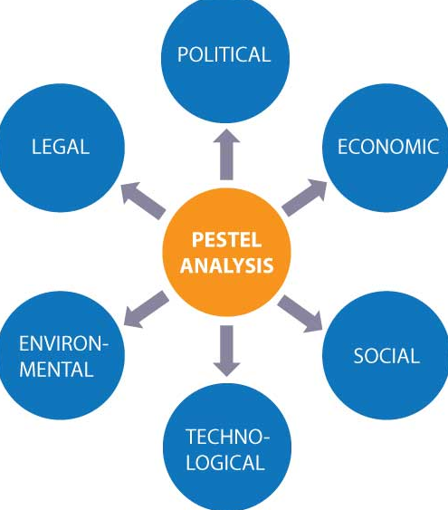
Figure 1: PESTEL analysis
Source: Zentner et al. (2020)
Political: Analysing political risk is increasingly significant for the organisation H&M as a global brand with several stores worldwide (Thompson and McLarney, 2017). The franchised stores of H&M increases political instability in many countries and markets, including Egypt, Turkey, and Egypt, and says that they closely scrutinise any changes and have contingency strategies to deal with political uncertainty as beneficially as possible for the company's stakeholders and the company itself (Fahy and Jobber, 2019). The Brexit has also outcomes in a difficult political scenario to work in. Thus, the H&M has franchises have unpredictable and unstable political climates in UK, thus the political factors are unfavourable for H&M in the UK market.
Economic: As with any other business, the Covid-19 pandemic has harmed the H&M group. Consumer purchasing behaviour has altered significantly since the Covid-19 pandemic period as supply chains have been severely disrupted. Due to this pandemic, the world has faced an economic collapse (Grose, 2011). However, the H&M currently did perform it smart through emphasising intensively on online selling in the challenging times, which could not fully eradicate the loss however it set aside them on their bases. Notwithstanding the adverse effects that Brexit has had on monetary forms around Europe, H&M bunch reports that its June 2017 deals expanded by 7% in neighborhood money contrasted with June 2016 and by 10% when changed over into Swedish cash, the Krona (Grose, 2011). Import inflation, duties, laws, and currency fluctuations in several nations lead to brand insecurity. H&M must be particularly careful with its pricing policies in each nation they operate to maintain a competitive advantage (Eisenberg, 2019). Thus, the economic factors are both favourable and unfavourable to H&M.
Social: Technological: across all standard stages, H&M has serious areas of strength for a media presence, with various pages committed to every country where it works (Baines et al., 2013). H&M has handled to stay up with all of the most delinquent fashion and trends requirements to remain competitive .Besides, the most wonderful thing about H&M is that it offers an efficient option in contrast to a few people who wish to look smart on a limited spending plan (Grose, 2011). H&M's outsider strategies provider in the UK, Hermes, has gained notoriety for mechanical advancement and a tremendous organization of store network devices to screen all coordinated factors exercises, improving the company's administration.
The organisation keeps on building their application for cell phones, most as of late presenting the H&M club capability, which empowers clients to accumulate reward focuses from coming up and online buys by taking on the application for cell phones (Sutherland, and Figari, 2013). In this way, the mechanical elements are exceptionally good for H&M to remain its serious situation on the lookout.
Environmental: H&M plans to be 100 percent sustainable and roundabout by 2030.As part of this it implies that all things will be created from old H&M items, and just strong and reused materials will be utilized for items.(Nieman et al., 2018). In 2020, H&M were ranked sustainable customers goods brand and also ranked the third position in the cotton sustainability in the year 2020. Thus, it was evidenced that the environmental factors are fully favourable for H&M.
Legal: H&M has the funds to cover legitimate issues, and the organization has carried out a severe gamble the board framework to keep questions from repeating, taking into account that it is so unsafe to the organization's image (Baines et al., 2013). Intellectual property rights (IPR) are a severe problem in the fashion business. Several fashion manufacturers and designers routinely steal designs and concepts from other artists. It jeopardises the company's products and designs (Eisenberg, 2019). H&M have faith in in being transparent, they make several financial along with the performance reports to the customers, thus it evidenced that legal factors are favourable for H&M.

Porters Five Forces
The Porters five fore tool analyse the competitive intensity and thus the attractiveness of the marketplace (Shokeen, 2016). In this section, the Porters five force model can be adopted to analyse the UK market in which H&M works, regarding of attractiveness through inherent revenue potential.
Rivalry Among Existing Firms (High): Rivalry is fierce as there are various common retailers, both small and large. Moreover, slow growth as an outcome of the economic downturn has reduced demand in the apparel industry, competitive pressures.
Threat of New Entrant (High): New entrants represent a critical danger Plus, moving toward the style retail area doesn't require huge capital speculations, thus numerous people have the infers to send off their own dress line. Besides, there are various assembling workers for hire possible, which most likely added to the business being more inviting to new entrants. (Kumbara et al., 2020).
Bargaining Power of Buyers (High): Consumers have a lot of bargaining leverage because there are so many retailers in the present industry. Consumers incur minimal switching costs because switching from one company to another is completely free (Sandberg and Abrahamsson, 2022).
Bargaining Power of Suppliers (Low): Supplier bargaining power is low because there are numerous suppliers with hardly differentiation. The raised internationalisation, and therefore international trade, gives fashion retailers more opportunities to source from foreign manufacturers (Mo, 2015).
Threat of Substitute Products or Services (Low): Rivalry is fierce due to the number of related retailers, including both small and large companies. Moreover, slow development as a result of the recession has reduced demand in the apparel sector, competitive pressures (Ge and Li, 2019).

SWOT Analysis
The SWOT analysis is a model adopted to analyse an organisation’s competitive position and to make a detailed strategic planning (Benzaghta et al., 2021). In the opinion of Phadermrod et al. (2019) the SWOT analysis tool analyze the core strengths, opportunities, threats and weakness that lead to the fact-based analysis and innovative ideas. In this section, the SWOT analysis tool is adopted for analyzing the external and internal factors, along with the future and current potential of H&M in the UK market.
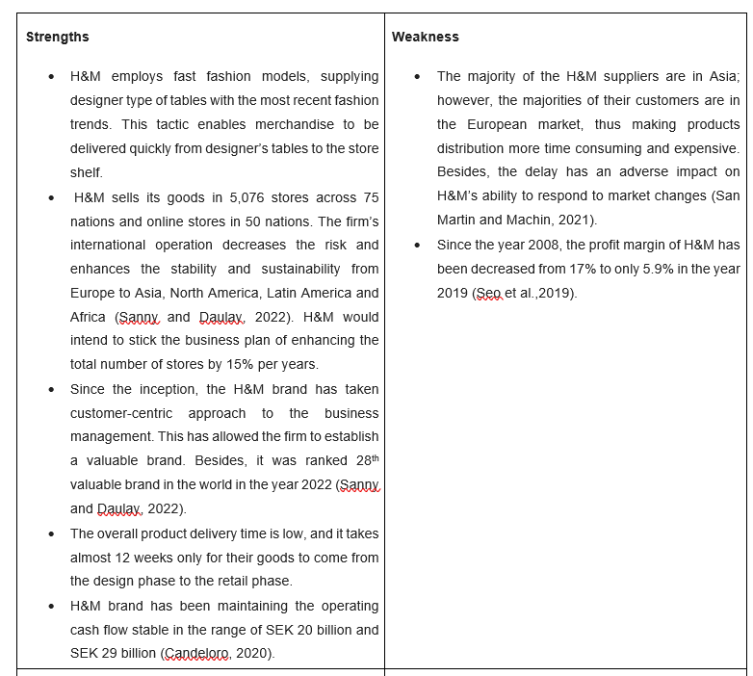
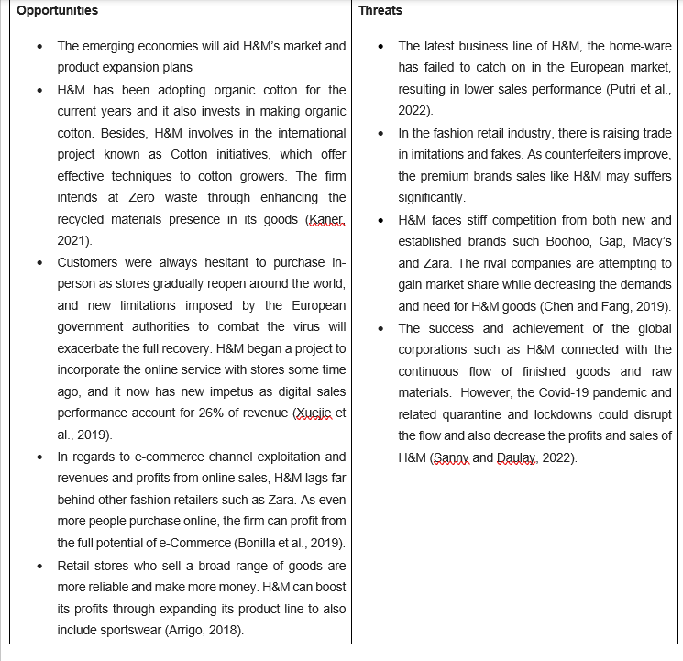
Table 1: SWOT analysis of H&M
Source: created by author

Segmentation Targeting and Positioning
Segmentation: H&M has utilised demographic and psychographic segmentation to reach all of its clients. Since, H&M has stores, globaly. This signifies that the firm caters to a wide range of cultures, religions, and lifestyles (Uggla, 2017). This signifies that the firm caters to various cultures, religions, and lifestyles; which has results its marketing must be done differently in various places.
Segments by class: strategy of H&M groups to give a fabulous fashion at affordable costs, mainly to the students, working class and lower middle class (Åsberg and Uggla, 2019).
Segments by home: Women between the age group of 15 and 30 who resides at home, in their first residence, or in student dorms in an urban area are the most common segment (Saraswat, 2018).
Segments by age: The most common demographic is women aged 15 to 30 years old, generally referred to as Y generation, who are ambitious and have the purchasing power (Jiang, 2020).
Segments by family life: Usually, college to graduate ladies lives at home alone, in dorms, or their first house, either alone or as a new couple without infants (Kaul, 2019).
Targeting: The determination of planned clients to whom an organization tries to sell labor and products. H&M's objective clients are popular clients who think about buying a social movement that gives pleasure in their regular routines and wishes to follow design without spending lot of cash (Prasetya and Iskandar, 2014). H&M's objective segment is youngsters. Despite the fact that H&M sells embellishments and attire for individuals of any age, its objective client is ladies (Jiang, 2020).
Positioning: A positioning strategy is a promotional strategy places a brand in a specific position associate to rival brands in the customer's mind. H&M give customers superior grade, trendy merchandise at the least possible cost. The H&M sells fast-fashion clothes and European-influenced apparel in the American market (Kaul, 2019). H&M sells clothing in various styles, such as men's business, women's casual, footwear, children's wear, and accessories. H&M is, the biggest in Europe, and the world's second-largest clothes store, heavily involved in E-commerce. (Uggla, 2015).

Marketing Mix
The marketing strategy of H&M survey the brand with the marketing mix model which covers the 4Ps. There are many showcasing procedures like estimating approach, item development and advancement arranging and so forth. These exchange procedures, as for H&M 4Ps marketing mix, helps the organization prevail in the ongoing cutthroat commercial center.
Product: H&M's focus has been on quality along with the latest fashion at reasonable prices. Hence, they are capable of launching brand new product offerings regularly. At least 25 % of H&M's stock includes fast-fashion merchandise, and the younger generation discovers them to be reasonably priced and chic and trendy. As a result, they attract the younger population and increase product sales. The company's products are designed by a special design team (Lee et al., 2014).
Price: H&M's price strategy is based on their consumer's needs, which are high fashion and low prices. H&M outsourced production to nations with much lower labour costs (Kim and Park, 2013). In addition, the H&M group provides various schemes and discounts on their fresh and core stocks. It is evident that the pricing for these items was economical and reasonable, and hence H&M was able to afford the discounted price (Abril and Rodriguez-Cánovas, 2016). This also enables the company to continuously restock its merchandise with the newest and most fashionable items(Kim and Park, 2013). As compared to the rival brands, the H&M goods are prices lowers as part of its pricing strategy.
Promotion: H&M group conducts a striking event promotion in which top and best fashion designers are invited to design and create clothing specifically for them. This approach enhances the product and brand image, making it more stylish and affluent (De Bruin-Reynolds et al., 2015). H&M group's target consumers include young women looking for more fashionable clothing at a low price. Youthful people have much information at their disposal (Kim and Park, 2013). H&M employed a multi-channel promotion strategy of sales, including online promotion, sales promotion, and advertising,. As a result of H&M’s multi-channel strategy the exposure has grown.
Place: According to Nam et al. (2015), the clients find the H&M retail locations exceptionally helpful on the grounds that they can look for different items in a single place. The firm has grown at a rapid rate in places that are both reasonably priced and easily accessible. Also, they have used the slowing economy to protect a few high-profile and beneficial places at very reasonable (prices HR and Aithal, 2020).

Conclusion and Recommendations
Through conducting a detailed external and internal market analysis the researcher was capable to comprehend the strength, opportunities, weaknesses, and threats that affect H&M in the UK market. Furthermore, through this report, the significance of adopting different analysis tools to enhance the development and performance of the firm was analysed. By conducting different market analysis, the need for further market development for H&M was analysed. Based on the analysis it was evidenced that the Ansoff matrix is an effective tool for enhancing the marketing strategies of H&M. To begin relating the Ansoff matrix to H&M, consider Market Penetration. H&M should promote its existing customers to make additional purchases. H&M should bring new items on a regular basis to keep customers returning to see the new fashions. It should have a distinctive selling point for its goods that distinguishes it from other rival companies such as Zara and Gap.
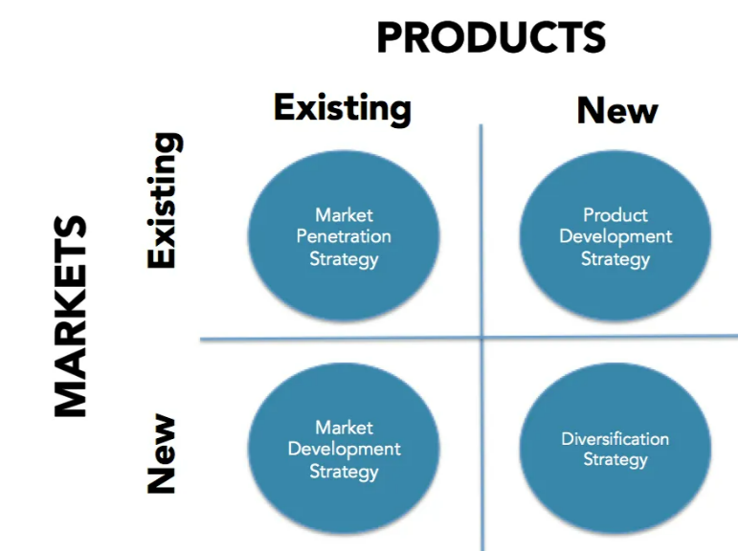
Figure 2: Ansoff matrix
Source: Hussain et al. (2013)
The competitive marketing tactics, existing goods, and existing markets call for the expansion strategy or else market penetration through an emphasis on the best customers, enhance cost position, the alternative focus for differentiae and strategically innovate to maintain a competitive position.

References
Abril, C. and Rodriguez-Cánovas, B. (2016) Marketing mix effects on private labels brand equity. European journal of management and business economics, 25(3), pp.168-175.
Arrigo, E. (2018) The key role of retail stores in fast fashion companies: The H&M case study. In Contemporary case studies on fashion production, marketing and operations (pp. 121-137). Springer, Singapore.
Åsberg, P. and Uggla, H. (2019) Introducing multi-dimensional brand architecture: Taking structure, market orientation and stakeholder alignment into account. Journal of Brand Management, 26(5), pp.483-496.
Baines, P., Fill, C. and Page, K. (2013) Essentials of marketing. London: Oxford University Press.
Benzaghta, M.A., Elwalda, A., Mousa, M.M., Erkan, I. and Rahman, M. (2021) SWOT analysis applications: An integrative literature review. Journal of Global Business Insights, 6(1), pp.55-73.
Bonilla, M.D.R., del Olmo Arriaga, J.L. and Andreu, D. (2019) The interaction of Instagram followers in the fast fashion sector: The case of Hennes and Mauritz (H&M). Journal of Global Fashion Marketing, 10(4), pp.342-357.
Candeloro, D. (2020) Towards sustainable fashion: the role of artificial intelligence---H&M, Stella McCartney, Farfetch, Moosejaw: A Multiple Case Study. ZoneModa Journal, 10(2), pp.91-105.
Chen, X.J. and Fang, G. (2019). Analysis on green marketing strategy of clothing firm: take H&M for example. In Proceedings of the 2019 International Conference on Management Science and Industrial Engineering (pp. 146-150).
De Bruin-Reynolds, L., Roberts-Lombard, M. and de Meyer, C. (2015) The traditional internal marketing mix and its perceived influence on graduate employee satisfaction in an emerging economy. Journal of Global Business and Technology, 11(1), pp.24-38.
Eisenberg, P. (2019) Financial Analysis of Primark Stores Ltd. with regard to a Stock Exchange Floatation (IPO). International Journal of Management, 7(1), pp.91-112.
Fahy, J. and Jobber, D. (2019) EBOOK: Foundations of Marketing, 6e. London: McGraw Hill.
Ge, L. and Li, C. (2019). Analysis of competitive Power of Chinese Sports Apparel Brand based on Porter's five Force Model. In Proceedings of the 2019 3rd International Conference on Information System and Data Mining (pp. 54-58).
Grose, V. (2011) Basics Fashion Management 01: Concept to Customer. London: Bloomsbury Publishing.
Grose, V. (2011) Basics Fashion Management 01: Fashion Merchandising. London: Bloomsbury Publishing.
HR, G. and Aithal, P.S. (2020) Establishing True Lifestyle Brand in India: An Integrated Marketing Mix Framework. International Journal of Management, Technology, and Social Sciences (IJMTS),(June 2020), 5(1), pp.261-284.
Jiang, S. (2020) A Comparative Analysis of Chinese and British Consumers’ Consumption Behaviours and Attitudes Toward Fast-Fashion Brand as Zara and H&M. Asian Journal of Social Science Studies, 5(2), p.17.
Kaner, G. (2021) Greenwashing: How Difficult It Is to Be Transparent to the Consumer—H&M Case Study. In Green Marketing in Emerging Markets (pp. 203-226). Palgrave Macmillan, Cham.
Kaul, D. ( 2019) Segmenting and Targeting in Indian Market. ANVESHAK-International Journal of Management, 8(1), pp.121-125.
Kim, E.Y. and Park, K. (2013) Marketing mix elements influencing brand attitude strength: Global vs. domestic SPA brands. Journal of Global Scholars of Marketing Science, 23(3), pp.263-281.
Kumbara, A. (2020) THE ANALYSIS OF PORTER'S FIVE FORCES IN LUCKY TEXTILE GROUP IN FACING THE COMPETITION OF TEXTILE INDUSTRY. Dinasti International Journal of Economics, Finance & Accounting, 1(3), pp.397-412.
Lee, C.H., Ko, E., Tikkanen, H., Phan, M.C.T., Aiello, G., Donvito, R. and Raithel, S. (2014) Marketing mix and customer equity of SPA brands: Cross-cultural perspectives. Journal of Business Research, 67(10), pp.2155-2163.
Mo, Z. (2015) Internationalization process of fast fashion retailers: evidence of H&M and Zara. International Journal of Business and Management, 10(3), p.217.
Morrison, J., 2020. The Global business environment: towards sustainability?. London: Bloomsbury Publishing.
Nam, H., Son, H. and Lee, Y. (2015) Effect of SPA brand consumers' emotional consumption value orientation and assessment of marketing mix attributes on brand loyalty. Journal of the Korean Society of Costume, 65(4), pp.45-60.
Niemann, W., Mannya, K. and Kotzé, T. (2018) Global sourcing risk management approaches: A study of small clothing and textile retailers in Gauteng. The Southern African Journal of Entrepreneurship and Small Business Management, 10(1), pp.1-15.
Pan, W., Chen, L. and Zhan, W. (2019) PESTEL analysis of construction productivity enhancement strategies: A case study of three economies. Journal of Management in Engineering, 35(1), p.05018013.
Phadermrod, B., Crowder, R.M. and Wills, G.B. (2019) Importance-performance analysis based SWOT analysis. International journal of information management, 44, pp.194-203.
Prasetya, C. and Iskandar, B.P. (2014) Perceptual map of online fashion store. Journal of Business and Management, 3(4), pp.432-439.
Putri, L.M., Wardhani, I.D., Maulana, W.A., Armadiana, A., Aurelya, A.T. and Pratminingsih, S.A. (2022) EFFECT OF PRODUCT ATTRIBUTES, BRAND IMAGE AND SALES PROMOTION ON H&M PURCHASE DECISIONS. CENTRAL ASIA AND THE CAUCASUS, 23(1).
San Martin, V.C. and Machin, D. (2021) The legitimization of the use of sweat shops by H&M in the Swedish press. Journal of language and politics, 20(2), pp.254-276.
Sandberg, E. and Abrahamsson, M. (2022) Exploring organizational learning and experimental logistics development at the global fashion retailer H&M. Global Business and Organizational Excellence, 41(2), pp.6-20.
Sanny, A. and Daulay, M.T. (2022) Analysis of Factors Affecting Consumer Satisfaction at H&M Medan. United International Journal for Research & Technology, 3(3), pp.112-116.
Sanny, A. and Daulay, M.T. (2022) Analysis of Factors Affecting Consumer Satisfaction at H&M Medan. United International Journal for Research & Technology, 3(3), pp.112-116.
Saraswat, S. (2018) Strategies v/s Consumer Perception of Brand Zara-India. IITM Journal of Management and IT, 9(2), pp.68-80.
Seo, K. and Suh, S. (2019) A study on the characteristics and social values of vegan fashion in H&M and Zara. Journal of Fashion Business, 23(6), pp.86-100.
Shokeen, S. (2016) Porter's Model: A Critical Examination. International Journal of Engineering and Management Research (IJEMR), 6(3), pp.178-183.
Sutherland, H. and Figari, F. (2013) EUROMOD: the European Union tax-benefit microsimulation model. International journal of microsimulation, 6(1), pp.4-26.
Thompson, J. and McLarney, C. (2017) What effects will the strategy changes undertaken by next Plc have on themselves and their competition in the UK Clothing Retail Market?. Journal of Commerce and Management Thought, 8(2), p.234.
Uggla, H. (2015) Aligning brand portfolio strategy with business strategy. IUP Journal of Brand Management, 12(3), p.7.
Uggla, H. (2017) The price of luxury. IUP Journal of Brand Management, 14(2).
Varadarajan, R. (2015) Strategic marketing, marketing strategy and market strategy. AMS review, 5(3), pp.78-90.
Xuejie, C., Chang, Q. and GuangHao, Z. (2019). Research on Innovation supply chain Management in Fast Fashion Industry——A comparative analysis of ZARA and H&M. In 2019 3rd International Conference on Education, Culture and Social Development (ICECSD 2019) (pp. 7-16). Atlantis Press.
Zentner, K., Fritze, A., Kloster, A. and Romaniuk, L. (2020) A Comparative PESTEL Analysis of Canada and China's Management of Energy Markets. Journal of Applied Business & Economics, 22(12).

