Business Report
Comparison of Two Shangri-La Hotel and Travelodge Hotel
Financial Management for the Hotel Industry
Module Code: BMIH5007
Student Name: Zakia shirin Nishai
Student ID: 2208336
Lecturer Name: Tristan Hawkins

Executive summary
The present report has shed light on the effective comparison of the two different reputed organisations in the current business market. The various important factors of the organisation have been discussed in the report. In the present context of the study, the discussion of the two hospitality organisations has taken place including Shangri-La Hotels and Travelodge Hotels. Along with this, the comparison of the organisations has taken place very eff effectively by addressing the different factors properly. Different strategies have played a significant role in defining the strengths and managing marketing opportunities for developing sustainable growth and demand in the hospitality sector in the UK.
Table of Contents
Introduction 4
Overview of the organisations 4
Revenue comparison of the organisations 5
Market Position for two organisations 8
Potential growth of two organisations 9
Organisations’ financial commitment to CSR 10
Recommendations 11
Conclusion 12
References 13

Introduction
The present study will be focused on the most important discussion of the comparison between two different hotel organisations such as Shangri-La Hotels and Travelodge Hotels. In order to compare the different business organisations different important factors such as revenue, market position, potential growth and the financial report of the organisations.

Overview of the organisations
A proper analysis is going to be made for Shangri-La Hotels and Travelodge Hotels. Shangri-La Hotels and Resorts is a luxury hotel group that manages expectations of hospitality and managing effective experiences worldwide. Need was founded in 1971 and has grown as an effective premium hotel brand. This hotel is opening different key destinations including Middle East Asia Pacific North America and Europe. It provides effective services proper accommodations and different dining options and gives comfort and luxury to travellers (Liu, 2020). Every property reflects local culture helping to manage their experience and providing for proper amenities and managing culture. Based on the luxurious accommodations these hotels provide world-class facilities for managing fitness centre award-winning spa event space for corporate gatherings and gaining (Shangri-La Group, 2020). They are managing proper commitment to control Environmental Conservation and helping community engagement to take effective initiatives for managing different properties (Page and Connell, 2022). It is a five-star luxury hotel that provides world-class services, managing design and architecture and controlling different dining experiences. Special about this hotel are based celebrity endorsed gyms, stylish cosy rooms, cop working spaces and craft beers and managing different events.
The mission and vision statement of Shangri-La Hotels and Resorts is based on providing the first choice for colleagues, guests and business partners. They are providing guest services, providing proper experiences to the customers (Wu, 2021). The Shangri-La was started in 1971 based on the first deluxe hotel and implemented effective services for helping worldwide. The main purpose of Shangri-La is to create a moment of joy by helping people and getting engaged with each other. Shangri-La is managing different business districts and managing different meeting facilities, corporate events and business gatherings. Shangri-La Hotels Is based on a luxury hotel brand mainly known for exceptional service accommodation and amenities. Managing operations in between global destinations and mainly targeting travellers to manage personalized services and luxury experiences.UK this hotel is operating in a prime location and managing personalised services. It is based in a prime location in London and helps travellers manage tourist destinations and develops revenue rates.
Travelodge Hotels was founded in 1985 and it is the first budget hotel chain that manages 600 hotels and 46000 bedrooms in the UK, Spain and Ireland (Travelodge.co.uk, 2024). Travelodge was the first budget hotel in the UK that offered amazing views from the regional locations and city centre. The main strength of Travelodge Is based on providing proper hospitality care to the customers managing geographical locations controlling reputation and mainly focusing on the market share date and budget segmentation. They have expanded their hotel industries from 600 different hotels throughout Ireland UK and Spain. The main target market of Travelodge is the visitors to the UK and it is a private company that operates in the hospitality industries and hotel sectors (Guix and Font, 2020). It mainly focuses on the basic amenities including higher services and room facilities for managing this luxury hotel.

Revenue comparison of the organisations
The revenue rate of Shangri-La Hotels Is based on different key factors including food and beverage room and rates spa events function. Shangri-La Hotels offers higher quality services and plays a significant role in developing the revenue rate and managing catering services. This hotel is developing their spa facilities managing different amenities and attracting most of the guest to pay in specific amount for their experience.
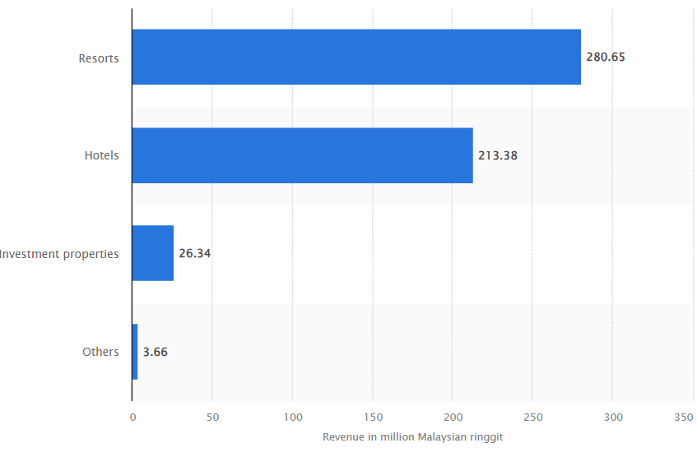
Figure 1: Revenue of Shangri-La Hotels in 2019
(Source: Statista, 2024)
Shangri-La Hotels manages mainly fine dining restaurants contributes to revenue generation trains divers and manages accommodations. The sales rate of Shangri-La Hotels was 496.62 million as compared to last year around 352.72 million. This hotel helps to manage higher room rates and control the budget of the hotels, reflecting the luxurious experience and managing different communities for the guests (Jeng et al., 2022). On the other hand, Travelodge Hotel mainly focuses on providing proper accommodations for managing the values of the travellers based on different properties in the UK mainly in the airport city centre and different service areas.
Travelodge is managing the demographics of the travellers managing their families and providing them proper services. The revenue rate of Travelodge is based on different key factors, including corporate accounts room occupancy, and leisure travel (Gazzola et al., 2020). Travelodge mainly attracts traveller’s loser tourists and families and provides proper value to manage convenience and affordability.
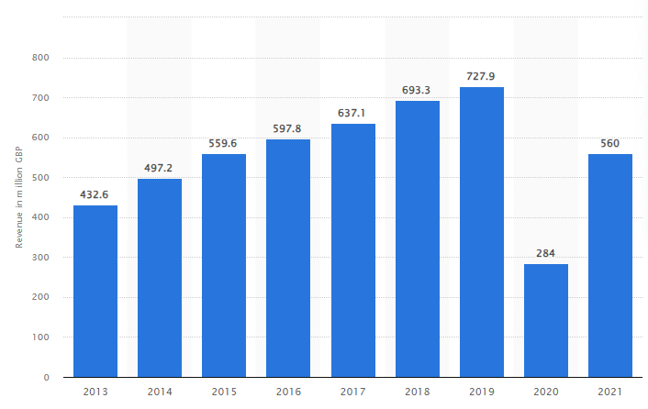
Figure 2: Revenue rate of Travelodge from 2013 to 2021
(Source: Statista, 2024)
Specialization and promotions are needed to provide proper discounts to Chinese contributions and demand to generate revenue growth. Travelodge is mainly focusing on the room revenue rate managing additional income rates by offering Wi-Fi services breakfast and late check-out fees. along with this, Travelodge is helping travellers to connect with partners' corporate agreements and providing proper discounts to manage the consistency and corporate clients to develop the revenue rate from different business bookings. Shangri-La Hotel Travelodge is based on different segments in the hospitality market in the UK (Shangrila, 2024). It is based on different budgets and preferences and provides premium experiences to the customer.
It is daily focusing on accessibility and affordability that is resulting in the development of business strategies and revenue generation (Dasgupta and Jamader, 2024). Travelodge has been developed in 2022 and increased to around £212.9m. UK Travelodge has increased its revenue rate to around 560 million British pounds in 2021 that is reflecting the previous year's total revenue of around 280 million. This hotel is paying around £8.44 per hour for cleaning and £11.22 per hour for the team members. Receptionist cost is around £60000 per year including food and beverage and £19285 per year for sales. The main marketing channel of Travelodge is YouTube This channel helps to reach a greater audience by managing different criteria and controlling engagement at different levels. In the year 2022, the cash flow rate was £116.6m and the repayment rate was £100m of debt.

Market Position for two organisations
Market position for Travelodge Hotel
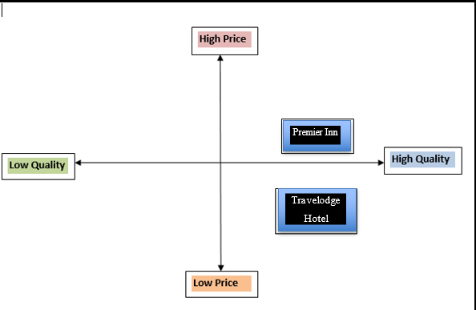
Figure 3: Positioning Map for Travelodge Hotel
(Source: Created by Learner)
The main competitor of the Travelodge hotel is Premier Inn. Travelodge is based on an effective market position and it is based on considerable market share for handling budget and accommodation. Travelodge is following a higher quality and lower price pricing strategy. Customer demographics are based on families, budget-conscious individuals and business travellers. Positioning mapshelpsto manage product advantages and deliveradvantages for the customers (Alzate et al., 2022). The direct competitor of this organisation is Premier Inn which is controlling its market position, handling budget-conscious people who are mainly focusing on affordability and quality.
Market position for Shangri-La Hotel
Shangri-La Hotel is based on the luxury hotel market that is mainly offering higher quality accommodations and the competitor of this organisation is Mandarin Oriental. It is based on effective market share, focusing on the travellers, upscale segment and business professionals. Brand perception is based on delivering luxurious amenities and proper services. They are mainly attracting business professionals.
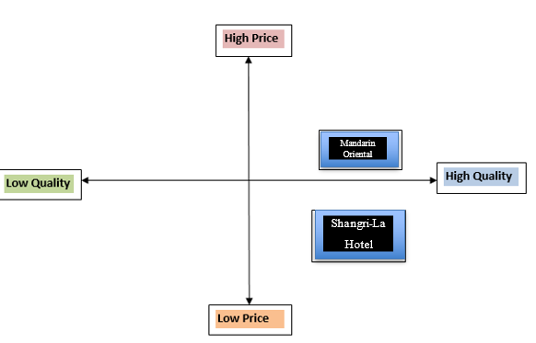
Figure 4: Positioning map for Shangri-La Hotel
(Source: Created by Learner)
Among those two hotels, Shangri-La Hotel is much better for higher quality services at a competitive price and attracting most of the travellers. On the other hand, Travelodge is mainly dealing with budget-conscious people.

Potential growth of two organisations
The potential growth of Travelodge Hotel and Shangri-La Hotel in the UK is mainly based on different key factors that are mainly based on market trends, competitive dynamics, consumer preferences and strategic interventions in the UK. Shangri-La Hotels is managing demand for their accommodations and operating in different cities in the UK. They are expanding their market in other countries and developing high-spending tourist demands for developing revenue growth (Dasgupta and Jamader, 2024). Shangri-La is developing the brand reputation rate and managing competitiveness in the UK market. It is managing different dining options, managing personalised services and managing spa treatment. Market diversification is managing business travellers for managing target audiences and it is managing corporate events, retreats and weddings. A proper investment for responsible tourism practices and sustainability is managing environmental access and managing consumer preferences.
Proper implementation of the eco-friendly initiatives mainly waste initiatives, eco-friendly initiatives and community engagement actions are attracting brand images for the Shangri-La for managing responsible guests. It is managing digital innovation for developing guests' experiences managing guests' satisfaction and controlling efficiency. Proper implementation of the mobile check-in, personalised services and managing the digital marketing strategy for developing digital marketing strategies and developing guest management and improving loyalty programs. It is managing proper contributions for managing revenue growth and developing brand differentiations. Travelodge hotels are developing demands for managing accommodations in the UK and developing value-based options. A proper explanation is needed for managing value-based orientations for managing tourist destinations managing marketing demands and controlling occupation rates.
Travel programs are managing loyalty programs and managing proper partnerships with car rental companies, and airlines and helping travel providers manage guest retention and develop bookings. With proper implementation of the Different marketing campaigns mainly family customer segmentations business, travellers are developing brand awareness and attracting most other guests (Gabellini and Scaramuzzi, 2022). It promotes seasonal promotions and special offers packages with the help of social media digital channels and partnerships to help different travel agencies in the time of developing revenue rates and driving booking. Travelodge is developing strategic partnerships to manage overall expansion in the new marketing segmentation. It is managing high-demand locations controlling city centre airport tourist hotspots and developing the revenue rate of the Travelodge. It is managing operational efficiency controlling revenue management strategies decreasing the risk of the cost and developing growth rate and profitability (Martinho, 2020). A proper investment in technological solutions helps with property management issues and providing proper guest services to develop guest satisfaction rates and manage efficiency to increase operational expenses (Sima et al., 2020). This is mainly focusing on brand differentiation segmentation market diversification initiatives and the growth rate. On the other hand, Travelodge is mainly controlling travellers' program accommodation demands and marketing strategies.

Organisations’ financial commitment to CSR
CSR or corporate social responsibility is one of the most important pillars that strengthen the foundation of the business of an organisation. As far as the business of Shangri-La Hotels is concerned the organisation has taken the most important initiatives in order to provide the best services to the consumers the organisation has focused on the different environmental factors effectively. To address the issue of carbon emissions, it has adopted the approach of reducing carbon emissions by 15% in 2025 (Shangri-La Hotels, 2024). On the other hand, in order to address the intensity of the energy waste it also has emphasised the reduction of 15% of water usage. The waste of water also has been taken into account by the organisation by reducing it by 5%. The proper development of the organisation in different aspects therefore has been possible through the successful incorporation of different important sustainable approaches by the organisation (Shangri-La Hotels, 2024). In order to reduce plastic waste Shangri-La Hotels has focused on the reduction of plastic use by 50% in 2026.
On the other hand, Travelodge Hotels has emphasised the development of the business of the organisation by addressing gender diversity as well as gender equality. The successful participation of both men and women in the business field (Travelodge Hotels, 2024). Along with this, the concept of social inclusion has been effectively addressed by Travelodge Hotels. The organisation also has stressed the provisions of the legislation, The Environment Act of 2021. The various important legal strategies have shaped the point of view of the organisation towards developing environmental sustainability properly. The organisation also has stressed the best care for its targeted customers (Travelodge Hotels, 2024). Along with this, focusing on this fact has made the organisation able to develop its strong relationship with customers as well as grab the best outcomes from the market.
Both the reputed hospitality organisations in the current competitive market have been able to develop their business market by addressing the different types of sustainable policies as well as investing in this field properly (Drury,2021).

Recommendations
The effective approaches that have been taken into account by both organisations in the current market also will be able to develop their business market. In the present context, Travelodge Hotels has to take into account the best accounting management. Effective accounting management will be possible for the enhancement of the financial management of the organisation (Finkler et al., 2022). On the other hand, the Shangri-La Hotels will be able to enhance its business performance by addressing effective performance management properly. Proper performance management is very important in order to have a positive impact on the business field of the organisation.

Conclusion
In the discussion of the study, there are various important facts that have been effectively discussed. The information of the study has focused on the development of the business of the organisation. Both Travelodge and Shangri La Hotel have played significant roles in managing the hospitality market in the UK.

References
Alzate, M., Arce-Urriza, M. and Cebollada, J., 2022. Mining the text of online consumer reviews to analyze brand image and brand positioning. Journal of Retailing and Consumer Services, 67, p.102989.
Dasgupta, D.S. and Jamader, A.R., 2024. Comprehensive Housekeeping Guidebook. Available at SSRN 4731150.
Drury C 2021 (11th Ed) Management and Cost Accounting, London, Prentice Hall
Finkler, S.A., Calabrese, T.D. and Smith, D.L., 2022. Financial management for public, health, and not-for-profit organizations. CQ Press.
Gabellini, S. and Scaramuzzi, S., 2022. Evolving consumption trends, marketing strategies, and governance settings in ornamental horticulture: A grey literature review. Horticulturae, 8(3), p.234.
Gazzola, P., Pavione, E., Pezzetti, R. and Grechi, D., 2020. Trends in the fashion industry. The perception of sustainability and circular economy: A gender/generation quantitative approach. Sustainability, 12(7), p.2809.
Guix, M. and Font, X., 2020. The Materiality Balanced Scorecard: A framework for stakeholder-led integration of sustainable hospitality management and reporting. International Journal of Hospitality Management, 91, p.102634.
Jeng, C.C., Huang, E., Meo, S. and Shelley, L., 2022. Combating Sex Trafficking: The Role of the Hotel—Moral and Ethical Questions. Religions 13: 138.
Liu, Y.P., 2020. Trust Between Customers and Hotels: Through the Expression of Trust of Customers.
Martinho, V.J.P.D., 2020. Food marketing as a special ingredient in consumer choices: the main insights from existing literature. Foods, 9(11), p.1651.
Page, S.J. and Connell, J., 2020. Tourism accommodation and hospitality services. In Tourism (pp. 216-241). Routledge.
Shangri-La Group 2020. About Shangri-La. [online] Shangri-la.com. Available at: https://www.shangri-la.com/group/our-story/about-shangri-la
Shangri-La Hotels, 2024. SUSTAINABILITY REPORT 2022 - Sitecore - Shangri-La Hotel. [online] Available at: <https://sitecore-cd.shangri-la.com/-/media/Project/Shangri-La-Group/Investor/Files/Corporate-Governance-and-CSR/Sustainability-Reports/2022_SLA_Sustainability-Report_EN.pdf
Shangrila, 2024. Luxury 5 Star Hotel in London | The Shard | Shangri-La. [Online] Available at:<https://www.shangri-la.com/en/london/shangrila/
Sima, V., Gheorghe, I.G., Subić, J. and Nancu, D., 2020. Influences of the industry 4.0 revolution on the human capital development and consumer behaviour: A systematic review. Sustainability, 12(10), p.4035.
Statista, 2024. Annual revenue of Travelodge UK from 2013 to 2021. [Online] Available at:<https://www.statista.com/statistics/429089/travelodge-total-revenue-united-kingdom-uk/>
Statista, 2024. Revenue of Shangri-La Hotels (Malaysia) Berhad in 2019, by business segment. [Online] Available at:<https://www.statista.com/statistics/1199674/shangri-la-malaysia-revenue-by-business-segment/
Travelodge Hotels, 2024. Our Sustainability Plan 2022. [online] Available at: <https://www.travelodgesustainability.co.uk/wp-content/uploads/sites/2/2022/05/Better-Future-Report-2022.pdf
Travelodge.co.uk, 2024. Travelodge | Great value hotels throughout the UK & Ireland. [Online] Available at:<https://www.travelodge.co.uk/
Wu, S.Y., 2021. A Study on Promotion Strategies and Purchase Intention during the epidemic situation-In the Travelodge Industry.

