

Islamic Finance

Student Name: Dean Chilcott

Student ID: 1403144

Contents

Executive Summary 3
Background 4
Islamic Finance in Practice 5
Advantages and Disadvantages of Islamic Finance 5
Analysis of Islamic Finance 6
Bibliography 10

Executive Summary

This report was commissioned to analyse the success of Islamic finance whilst critically evaluating whether Islamic finance is a means to financial institutions avoiding the peaks and troughs that have occurred in the financial markets;

From the research the following recommendations can be made;

- The Conventional banking industry could reduce economic disparity applying the philosophies of Islamic finance.

- Islamic Finance principles could be used to avoid boom and bust patterns in conventional finance, Islamic finance promotes responsible financial practises and avoids over-debiting the financial institution.

- Islamic Finance could also aid conventional institutions in encouraging longer term investments, the Islamic approach promotes a slower more throughout decision making process.

Background

Islamic Finance practises are guided by Shari’ah Law and based around the teachings of the Qur’an, the Sunnah, meaning the practices and sayings of the prophet Muhammad. Islamic financial institutions therefore follow practises such as interest free transactions. Goods and services that are illegal from the Islamic point of view cannot be produced or consumed, activities or transactions involving speculation must be avoided, known as gharar, and Zakat, the compulsory Islamic tax must be paid.

The main principles of Islamic finance are that wealth must be generated from legitimate trade and asset-based investments, meaning the use of money for the purposes of making money is forbidden, the investment must also have an ethical benefit to the wider society and not solely a return, the risk must be shared by the individual and institution and all harmful activities referred to as” Haram” must be avoided. (Cook, January 2005)

The Bank of London and the Middle East suggests that Islamic finance main principles are focused on the avoidance of harmful activities such as charging interest, further to this, institutions must ensure that ambiguity, referred to as Gharar, or gambling and speculation known as Maysair is minimised in transactions. (Warwick-Ching, 2010)

Islamic finance practises are most prevalent in the Gulf Cooperation Council countries. They are also growing in popularity in other countries all currently experiencing growth in its Islamic financial markets. The Islamic markets growth generally exceeds that of the conventional market as illustrated below.

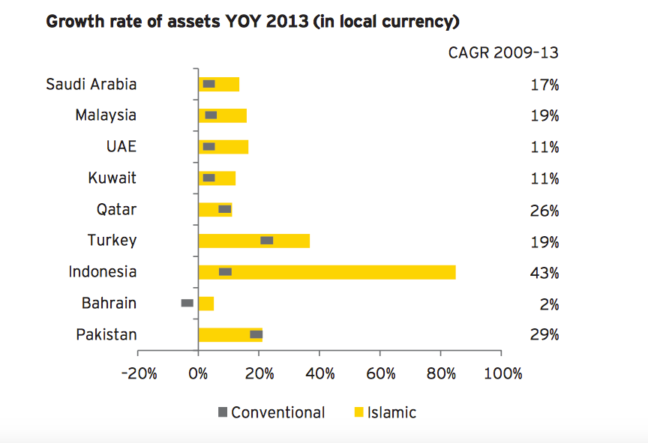
(Hirst, 2015)

Islamic Finance in Practice

There are a number of instruments used in Islamic Finance, below are a few examples:

Ijara- a leasing arrangement under which a financial institution buys an item for a customer and then leases this over a pre-determined period to them

Mudaraba- a specialised investment by an expert under which the customer and the bank share any profit, customers risk losing money if the investment is unsuccessful, although the bank will not charge handling fees unless a profit is achieved.

Murabaha- a form of credit enabling a customer to make a purchase without the need to take out an interest-bearing loan, the bank buys the item and sells it on to the customer on a deferred basis.

Musharake- an investment partnership in which profit-sharing terms are established on advance and losses are fixed at the amount invested.
(Warwick-Ching, 2010)

Advantages and Disadvantages of Islamic Finance

A key advantage of Islamic finance is that the Islamic finance industry has experienced incredible growth over the past decade, growing at a rate of 10-12%, this is attributed to the following advantages over conventional finance:

The Islamic finance industry promotes financial justice, this is at the very core of the Islamic model, this kind of banking creates a balance for the profit or loss between and individual and a financial institute, the output of a business venture is shared equally between the entrepreneur and the financer.

Financial Inclusion is another benefit of this kind of finance. Muslims refrain from banking in a conventional manner as this is based on paying and receiving interest which is prohibited. Islamic banking removes these barriers and allows Muslims to make use of a banking system.

Islamic finance reduces the impact of harmful products or practises, this means that investments are approached with caution and the decision making process differs from that of a conventional system. Businesses that appear to pose a high risk are usually not invested in this could be why the global 2008 financial crisis had minimal impact upon the Islamic finance industry, due to the audits and analysis undertaken by Islamic finance institutes. This lessens the occurrence of risk and promotes financial stability by avoiding over debiting the banks.

Islamic Finance also has a heightened focus on ethical and moral values, this promotes socially desirable investments rather than changing exclusively profit, this system better supports the individual, the institution and the community at large promoting responsible behaviour and a better corporate social responsibility from organisations. (Aims Education, 2018)

Islamic finance is not without its potential drawbacks, the following can be regarded as disadvantages to the Islamic business model;

As institutions that operate under Islamic finance are governed by Shari’ah Law, there is no central authority in order to deem what is compliant as this is based upon religious teachings and so understanding of what is permissible under this system varies among different jurisdictions.

Due to the growth within the industry more complex banking products are now available. The banks are not harmonised as regulatory standards differ when compared to the conventional system that is highly regulated by a measurable body. For example: the sale of debt is allowed in Malaysian Islamic financial institutes, however, prohibited by other Islamic banks. (Changeboard Team, 2017)

Further to this Islamic Laws also introduce an element of risk to businesses as it places a limit on products such as conventional insurance, meaning that in a period of loss the business could be more harshly affected than under a conventional finance approach. (Exportiamo, 2016)

Analysis of Islamic Finance

Focusing on the global financial crisis of 2008 the western conventional banking system was devastated by this crash, the Islamic economy and financial system remained unscathed. Muslims attribute this to the fact that the Islamic banking model is anchored on honourable values such as credibility and transparency allowing the system to support security and safety in any financial transactions.

Furthermore, this is also attributed to the importance placed upon institutions by Shari’ah Law when avoiding financial transactions that involve unsubstantiated risk or uncertainty (gharar) or unfairness and taking other people's money unjustly. (Othman, 2012)

A crisis of such a magnitude as the subprime mortgage scandal bringing about the financial crash would not be plausible under Islamic financial markets as it is against their principles to sell debt against debt and so as a result the global financial crisis would not have occurred under the principles of Islamic finance (Al-Haddad, 2008).

Islamic finance could be regarded as a means to financial institutions avoiding the peaks and troughs that have occurred in the financial markets. The continued growth of the Islamic Model, could be due to its responsible and carefully considered practises to avoid over-debiting. The Islamic finance market has grown and is expected to experience further growth, its success as a model is detailed below.

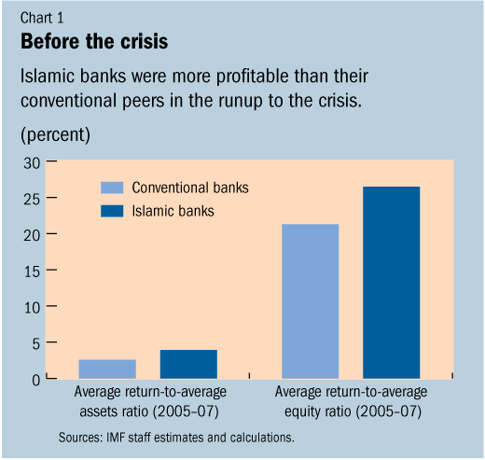
In order to illustrate Islamic finance resilience to the economic crisis, chart 1 provides information prior to the financial crash; this demonstrates that in this example, focusing on banking data covering 2007-2010 of Islamic and conventional banks in Bahrain, Jordan, Kuwait, Malaysia, Qatar, Saudi Arabia, Turkey and the United Arab Emirates, Islamic Banks were more profitable in the first instance.

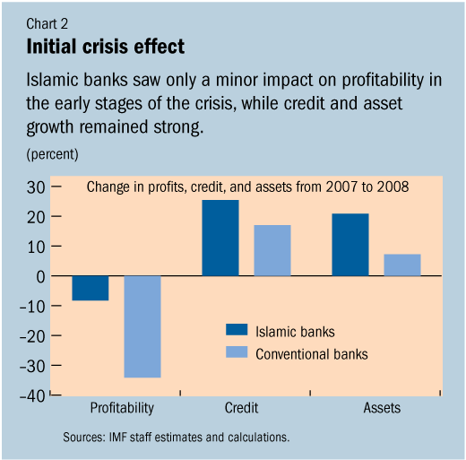
This IMF Study suggests that Islamic Banks fared differently when compared with conventional banks; this is attributed to smaller investments, lower leverage and the adherence to Islamic Banking principles that negated the impact of the financial crisis.

According to the study the average profitability of Islamic Banks before the crisis was higher than that of conventional banking, however, for 2008 and 2009 has similar performance to conventional banks, Indicating that Islamic finance boasts improved cumulative profitability but also implying that the higher profitability was not driving by a strategy of greater risk taking in Islamic finance.
(IMF, 2010)

Islamic Finance experienced its third consecutive year of single digit growth – 7.0% growth in 2016, compared with 7.3% in 2015 and 9.3% in 2014. (Dubai Islamic Bank, 2017) This is representative of the industries success in Dubai.
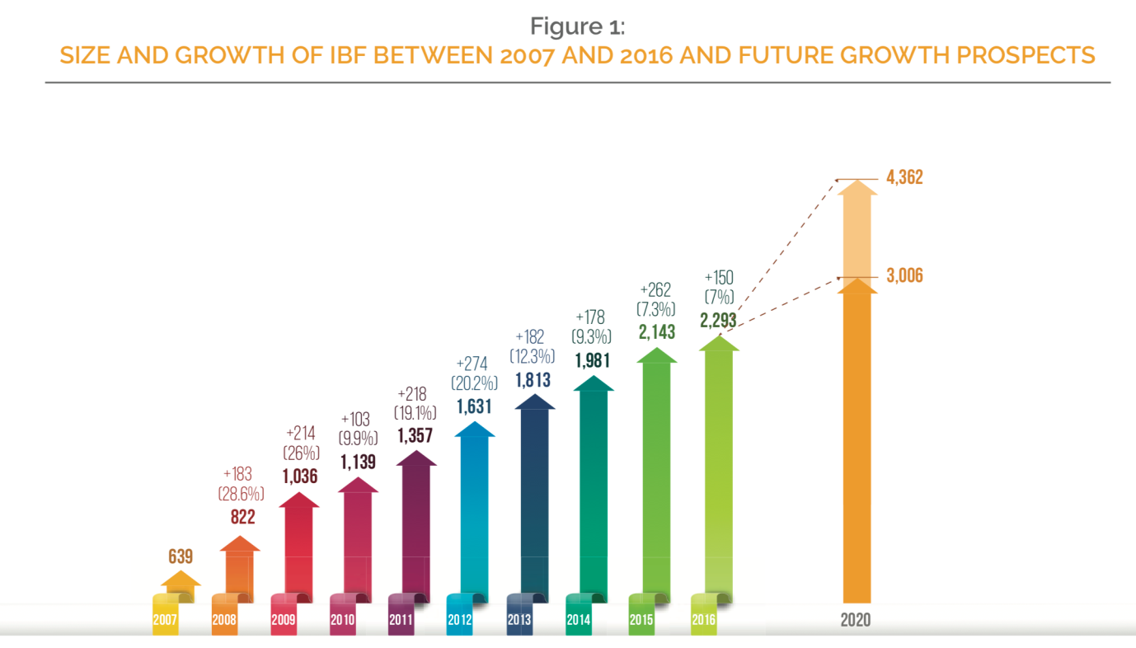

Focusing on the Malaysian financial environment an initial sign of success within the Islamic financial market is that Islamic banks within Malaysia increased their liquidity holdings during the financial crisis when compared to conventional banks. (Dridi, 2010) suggests in an IMF study that Islamic Banks have achieved a stronger credit growth compared to conventional banking in almost all countries.

According to research by the IMF, the Islamic financial markets achieved credit and asset growth twice as high when compared to conventional finance during 2007-2009. (El-Hawary, 2007) shows that profits of Islamic financial institutions were around 15 billion dollars in 2007 and by 2012 assets were projected to reach 1, 600 billion, with revenues of up to 120 billion dollars.

Interestingly, data available from Pakistan’s conventional and Islamic banking sector in table 2 gives us a different understanding of the dual banking system. It is clear that profitability is higher in conventional banking as opposed to Islamic Banking. The data also suggests that conventional banking takes the edge of liquidity management, however, Islamic banking excels in credit risk management and solvency management.

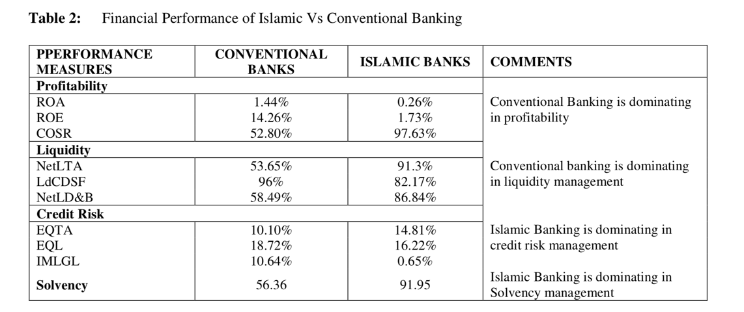

(Hanif, 2012)

Recommendations

A recommendation drawn from this research would be that the conventional banking industry could reduce economic disparity applying the philosophies of Islamic finance, understanding that Islam does not prohibit accumulating wealth, rather promotes doing so under shared responsibility.
Utilising Islamic principles, conventional financial institutions would result in investments benefiting people at multiple levels creating a greater social impact and would encourage more sustainable, reliable investments providing a more responsible investment policy ensuring that risk is properly managed.

Furthermore, Islamic finance promotes responsible financial practises and avoids over debiting itself, focusing on the financial crash triggers by sub-prime mortgages, this would have been prohibited under Islamic finance and so would not have had such a drastic effect on the markets. Islamic finance allows for more gradual growth rather than peaks and troughs in conventional finance.

Islamic Finance could also aid conventional institutions in encouraging longer term investments, the Islamic approach promotes a slower more throughout decision making process, investors actively seek to make a socially responsible choice as opposed to focusing entirely on profit, this is to avoid investment in companies that are considered harmful, the initial phase eliminates projects that cause harm, a second stage eliminates investments that carry to high a risk and this goes a long way in promoting greater investment stability across the market. (Jamaldeen, 2012)

Bibliography
Aims Education. (2018). www.aims.education. Retrieved December 9th, 2018, from http://www.aims.education/islamic-finance-blog/advantages-of-islamic-banking-and-finance/
Al-Haddad, H. a.-D. (2008). Boom, Bust, Crunch: Is There an Islamic Solution? Retrieved December 10th, 2018, from http://www.islamic-finance.com/item153_f.htm
Changeboard Team. (2017, July 31). The challenges facing Islamic banking. Changeboard , p. 1.
Cook, B. J. (January 2005). Islamic Banking and Finance inTheory and Practice: The Experienceof Malaysia and Bahrain. The American Journal of Islamic Social Sciences , 22 (2), 70.
Dridi, J. &. (2010). Have Islamic Banks Been Impacted Differently than Conventional Banks During the Recent Global Crisis? Washington: International Monetary Fun.
Dubai Islamic Bank. (2017). GLOBAL ISLAMIC FINANCE REPORT . Dubai: Dubai Islamic Bank.
El-Hawary, D. G. (2007). Diversity in the regulation of Islamic Financial Institutions. The Quarterly Review of Economics and Finance.
Exportiamo. (2016). Exportiamo.it. Retrieved December 9th, 2018, from http://www.exportiamo.it/aree-tematiche/12877/islamic-commercial-law-limits-advantages-and-disadvantages/
Hanif, M. (2012). Comparative Performance Study of Conventional and Islamic Banking in Pakistan. International Research Journal of Finance and Economics , 1450-2887 (83), 68-70.
Hirst, T. (2015, July 20th). These are the top 9 countries for Islamic finance. World Economic Forum .
Hussain, M. (2015). An Overview Of Islamic Finance. IMF Working Paper , WP/15/120, 4.
IMF. (2010, October 4th). IMF Survey: Islamic Banks: More Resilient to Crisis? Retrieved December 11, 2018, from www.imf.org: https://www.imf.org/en/News/Articles/2015/09/28/04/53/sores100410a
Jamaldeen, F. ( 2012). Islamic Finance for dummies. Saudi Arabia: Wiley.
Othman, R. (2012). Islamic Banking: The Firewall Against The Global Financial Crisis . Journal of Applied Business Research , (1) (28), 9-14.
Warwick-Ching, L. (2010, July 14). Beginners’ Guide to Islamic Finance. Financial Times .

