Project Initiation Document

Name: Scott Mainwaring
Student Number: 1701633
Course: Project Management and Research Methods (ACDA5004)
Lecturer: Sue Maw

Table of Contents

Section 1: Introduction
Section 1.1: Purpose………………………………………………….3
Section 1.2: Solution………………………………………………….3
Section 2: Project Definition
Section 2.1: Objectives……………………………………………….3
Section 2.2: Scope
Section 2.2.1: Inclusions……………………………………....4
Section 2.2.2: Exclusion……………………………………….4
Section 3: Constraints……………………………………………………….4
Section 4: Authority
Section 4.1: Project Roles……………………………………………5
Section 4.2: Gantt Chart……………………………………………...5
Section 5: Resources………………………………………………………..6
Section 6: References……………………………………………………….7

1. Introduction
1.1 Purpose
The purpose of this project is an attempt to try and make our local communities safer by providing help in the occurrence of a natural disaster. A small group was formed and has started working on a project gathering ideas to form a solution. The group members for this project are Scott Mainwaring, Daniel Newman and Josh Ford.
This document will cover the objectives, scope, constraints, authority and resources needed for this project. This structure will allow us to form the basis of project management and also fully assess the overall success of the project.

1.2 Solution
The solution the group came up with was a web based application that allowed people in their community to enter their postcode into a search box and view all the current residents living within that area. Information such as house number and street address are compulsory to add in order for users to view the houses in that street and also a status option so that a resident can be deemed as ‘safe’ or ‘unsafe’. The purpose of this information would allow rescuers to check what people have been affected by the disaster and allocate more time to those who’s status is marked as ‘unsafe’. This could potentially speed up the time it takes for a community to recover from a disaster. The website will also show when the user last logged in. This will be helpful because it will allow for continuous checks on the community members to see if they’re okay. A notes section will also be included in the website for users to use. They can use this section to ask people for spare clothes or food for example. Other details like first name and surname will be asked to be entered by the user but these are optional due to the [1]Data Protection Act. If the user does enter these optional entries, they will have to agree to have that information displayed. Users data will be wiped every two weeks and will need to be re-entered. This is done to make sure that the users are still safe.

2. Project Definition
2.1 Objectives
- One objective is to successfully develop a web based solution that can help users know whether or not someone is safe during a disaster.

- Another objective is to make the application easy-to-use by displaying suitable options for public users when they have to record their status.

- An objective outcome would be for this solution to allocate and potentially save a lot of time for rescuers by allowing them to help community members that actually need help rather than them spending time helping those who are deemed ‘safe’ on the web application. The outcome can be measured by seeing how many people were missing or found in similar disasters and also the time it took to rescue people in danger then compare the results a suitable amount of time after the disaster.

- If more people are found faster and deemed ‘safe’ than the compared disasters, then the project would be a successful solution.

2.2 Scope
2.2.1 Inclusions
The homepage of the website will include standard information such as how to navigate around the website The homepage will also show information on how this system is intended to be used. The signup page will contain a form that needs to be filled out. The signup page will give clear instructions on what data needs to be entered and for any optional data there will be a notice explaining that any optional data entered will be displayed to the public. The signup page will give the user a unique identifier that will then be used to edit their data when needed. The edit data page will allow the user to update or change any information needed. This page will also give the user the ability to state whether or not they’re ‘safe’.

2.2.2 Exclusion
Not everyone will choose to use this web application which means there will be data missing regardless of the user being safe or not.

3. Constraints
Only users house numbers and street address are required to be displayed. Any other information such as first name, surname or phone number is classed as optional information and will only be displayed if the user chooses to enter these fields and agree to the terms due to the [1]Data Protection Act.
Another constraint would be that if community’s connection to the internet was lost nobody would be able to update their status for people to see if they’re safe or not. According to reports, on July 30th, 2012 India suffered
“the largest electrical outage in history (so far) … affected an area encompassing about 670 million people, which is around 9% of the world’s population”. [2]

4. Authority
4.1 Project Roles
Scott Mainwaring – Lead Developer, Designer
Daniel Newman – Project Manager, Developer, Designer
Josh Ford – Lead Designer, Developer
Sue Maw – Project Sponsor

4.2 Gantt Chart
Below are images of the groups Gantt chart. The Gantt chart shows who’s designated to what task and also when a certain task is taking place. The deadline for the project was set to 18/01/2019 which is more than enough time to complete this project, but the extra time will allow the group to complete the task even in the absence of a team member due to illness.
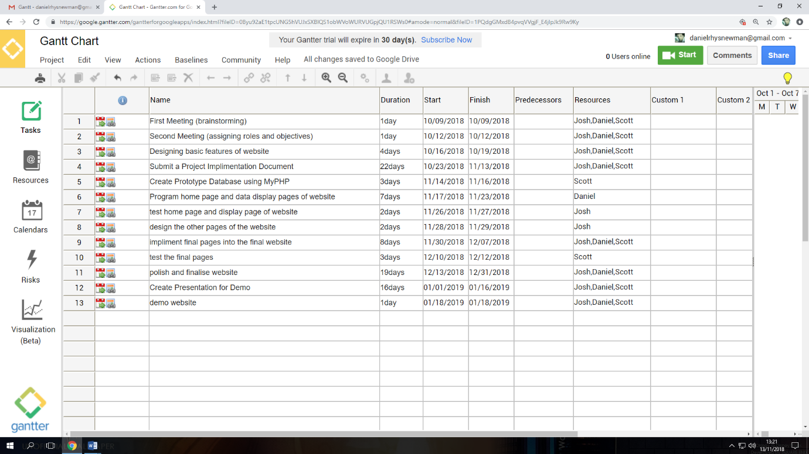
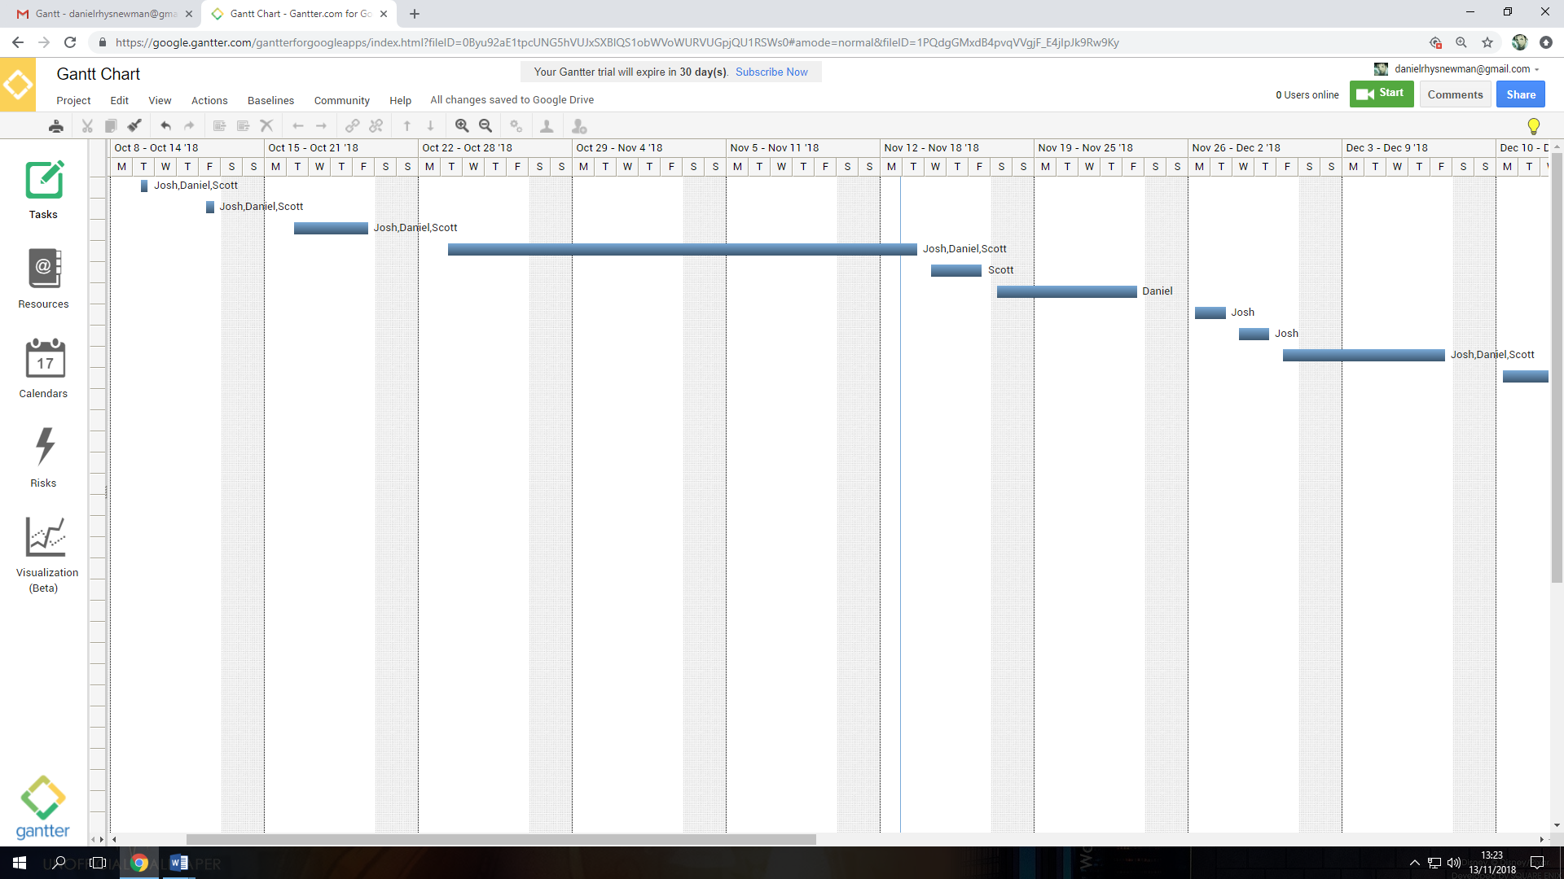

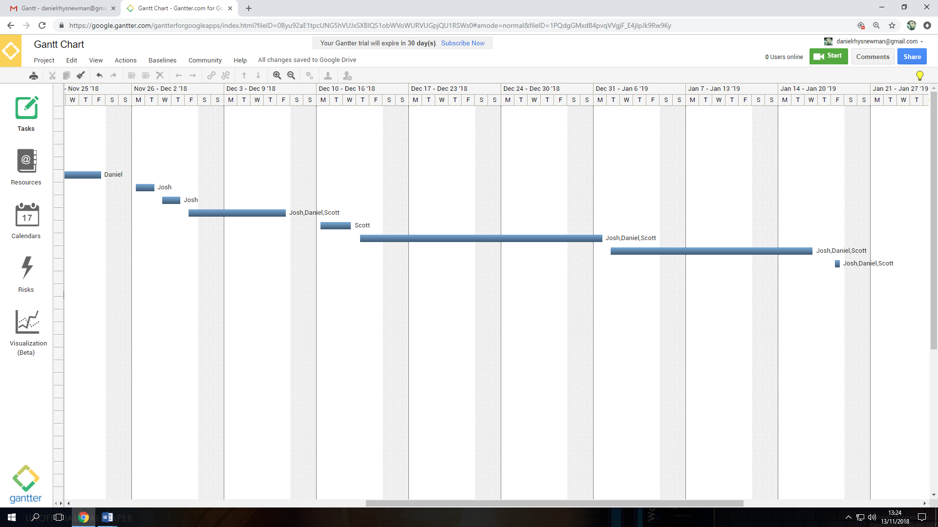

5. Resources
The website will be developed using HTML, CSS for styling, JavaScript and some PHP to link the database to the website.
The websites database will be created using [3]phpMyAdmin and will be tested on a XAMPP/WAMPP server as a demo.
The website will eventually be hosted by a hosting company once it has been fully developed. The hosting company used are [4]Siteground.

6. References

[1] | British Government, “Data Protection Act 2018,” Government, 23 May 2018. [Online]. Available: https://www.gov.uk/government/collections/data-protection-act-2018. [Accessed 15 November 2018].
[2] | “India blackouts leave 700 million without power,” The Guardian, 31 July 2012. [Online]. Available: https://www.theguardian.com/world/2012/jul/31/india-blackout-electricity-power-cuts. [Accessed 15 November 2018].
[3] | “phpMyAdmin,” phpMyAdmin, 2003. [Online]. Available: https://www.phpmyadmin.net/. [Accessed 15 November 2018].
[4] | “SiteGround Hosting,” SiteGround, 22 April 2004. [Online]. Available: https://www.siteground.co.uk/. [Accessed 15 November 2018].

