Andrew Davies
2213112@student.uwtsd.ac.uk

NOSS Assignment 2
Andrew Davies 2213112

GANTT chart
Following this order ensures that the domain exists before DNS, DNS before DHCP, VPN before DHCP. Nothing therefore will fail for lack of dependencies
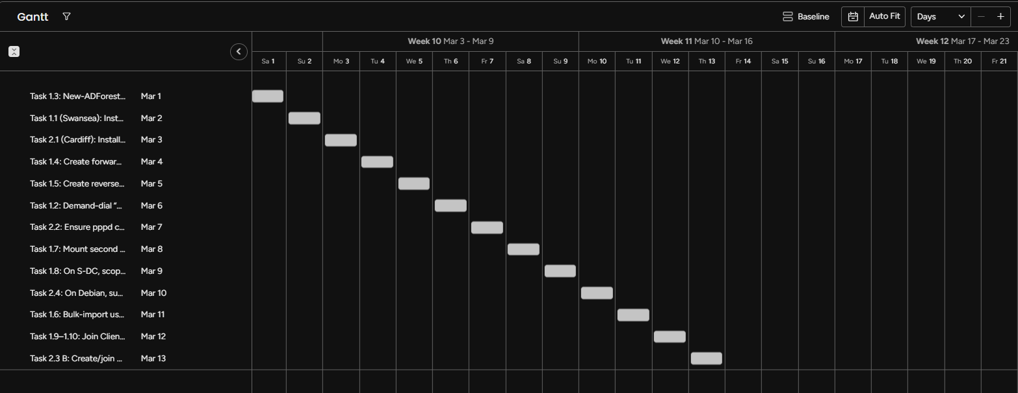

1.1 PRAS Installed:
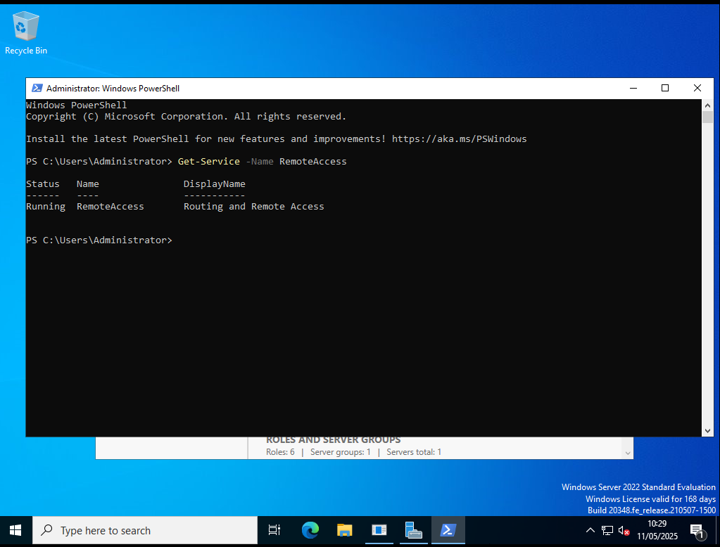
  - Firewall allowing ICMP traffic
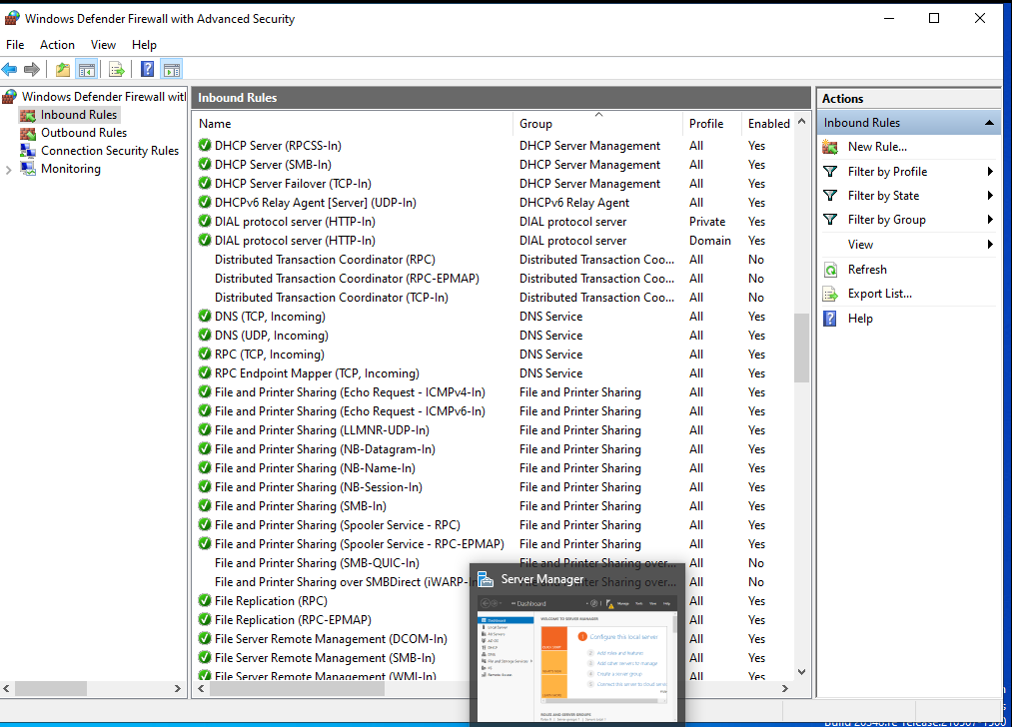
1.2 CServer VPN Connected
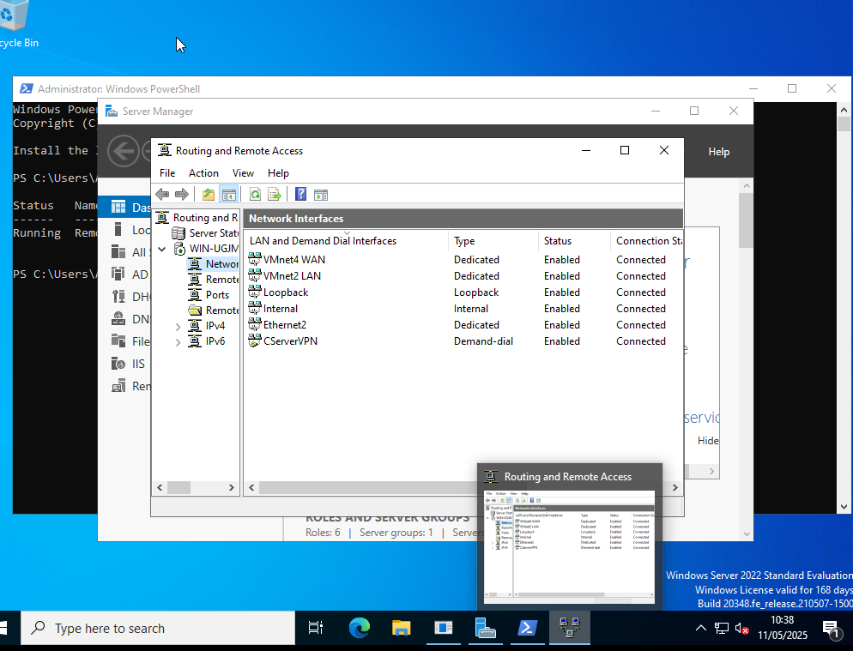
1.2 Connection set to persistent
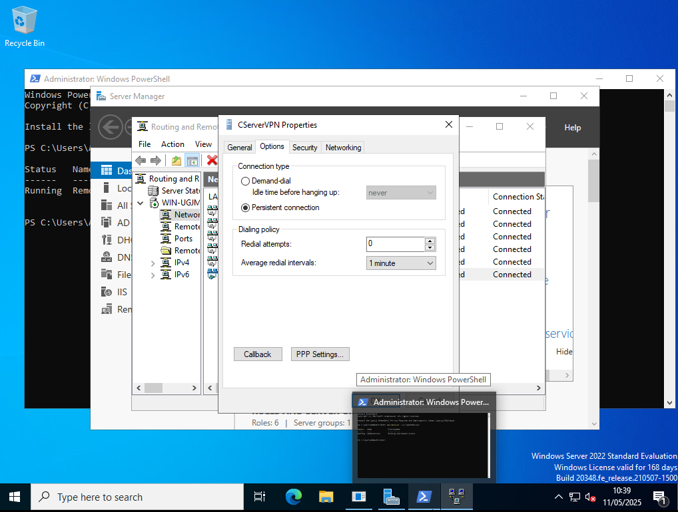
Test ping to CServer
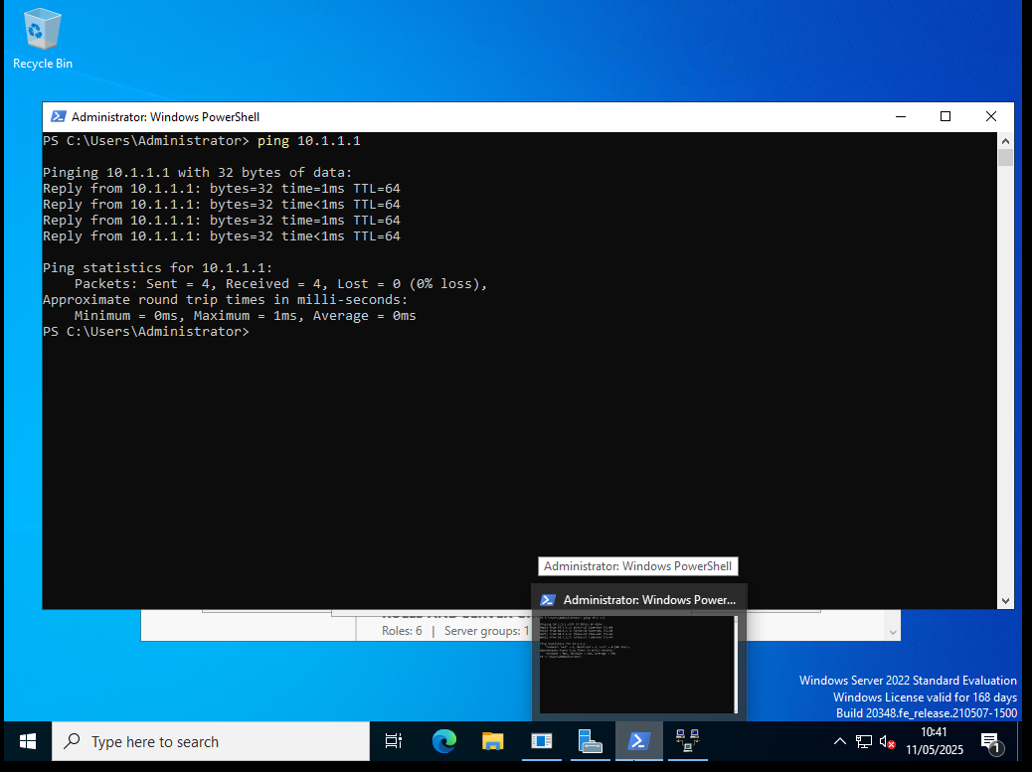
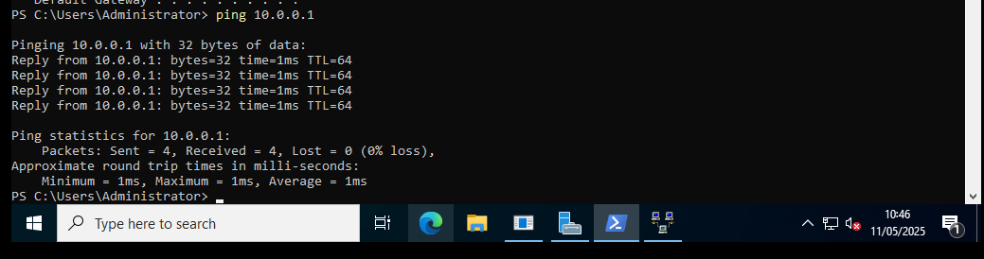
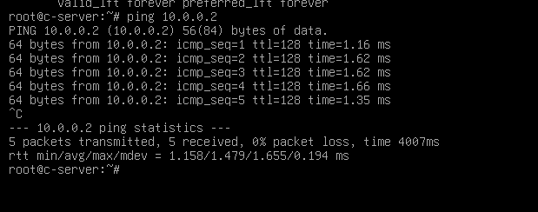
1.3 Forest set up Andrew.acca
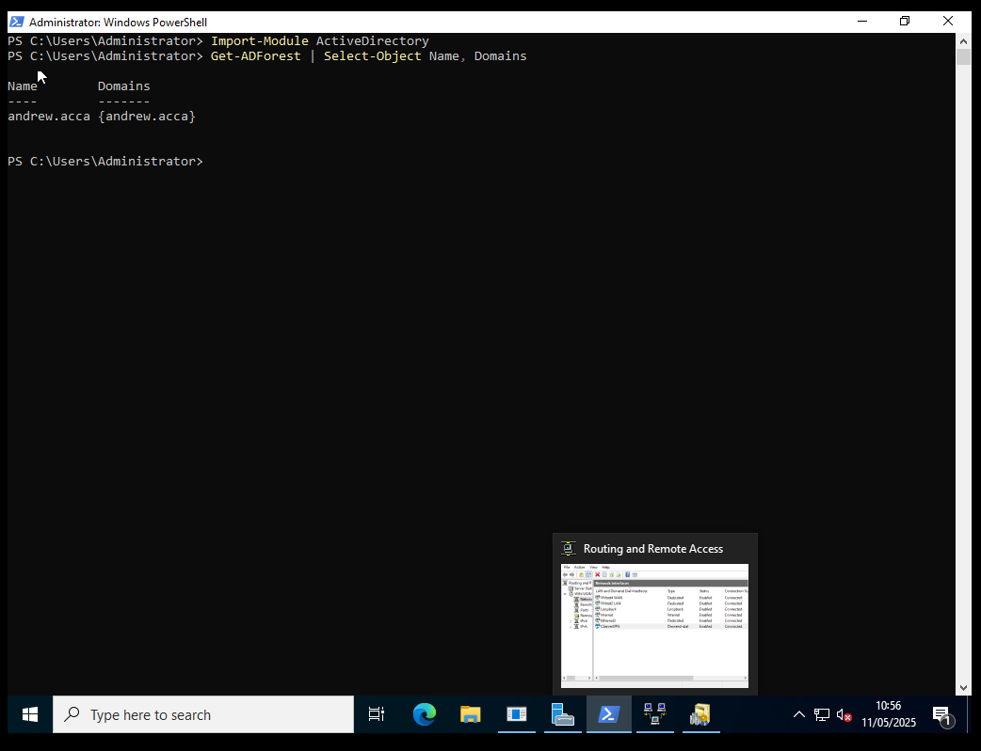
  - A-Records Forward Lookup Zone
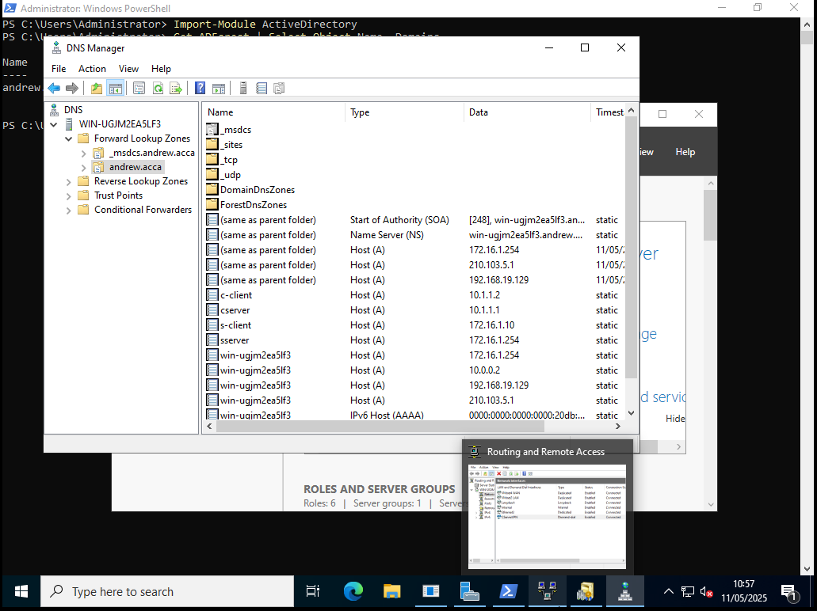
1.5 Reverse lookup zones
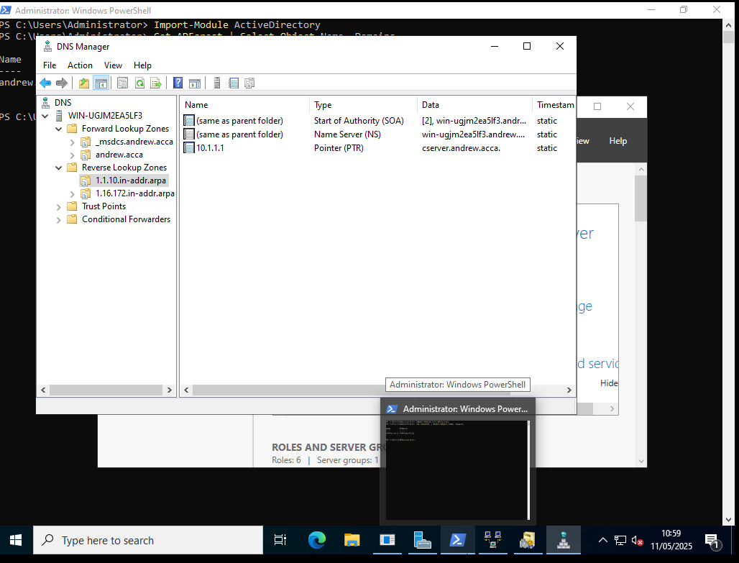
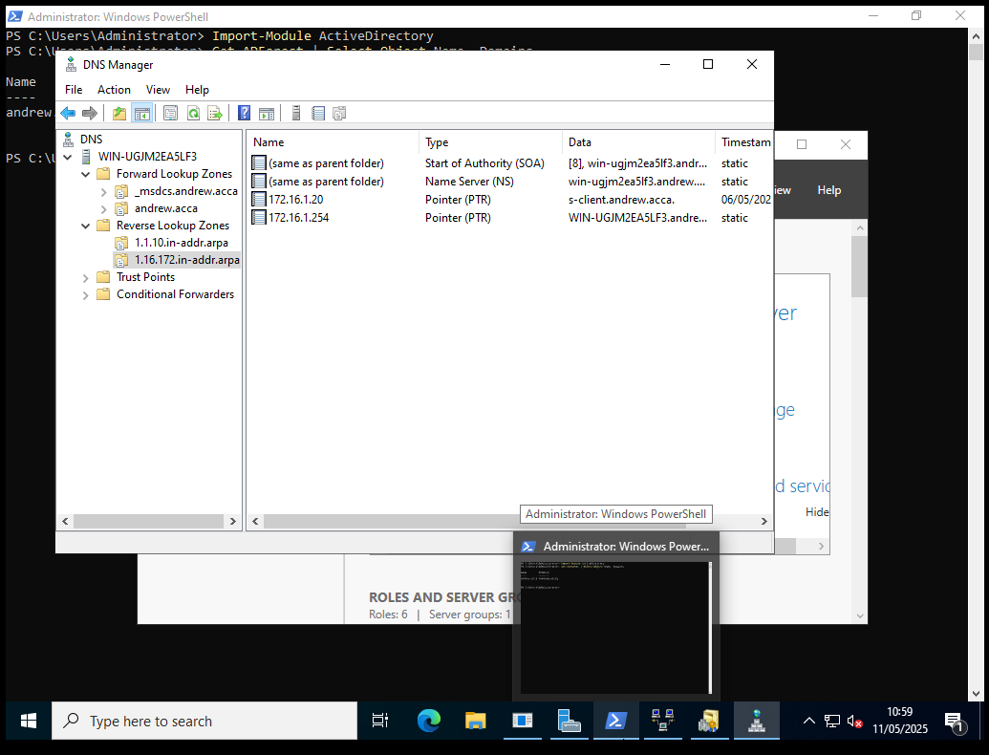
1.6 User Accounts
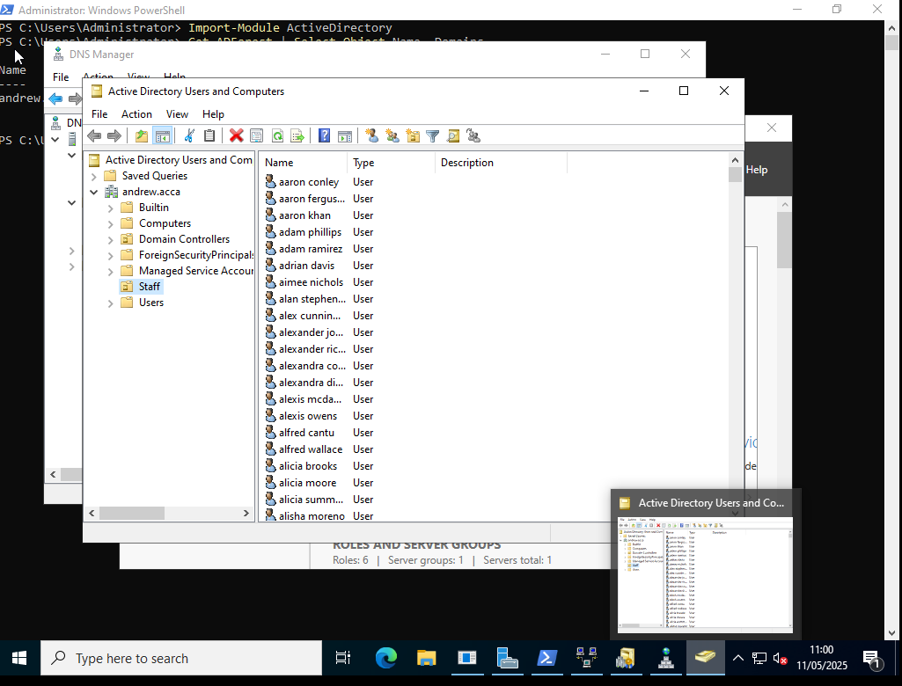
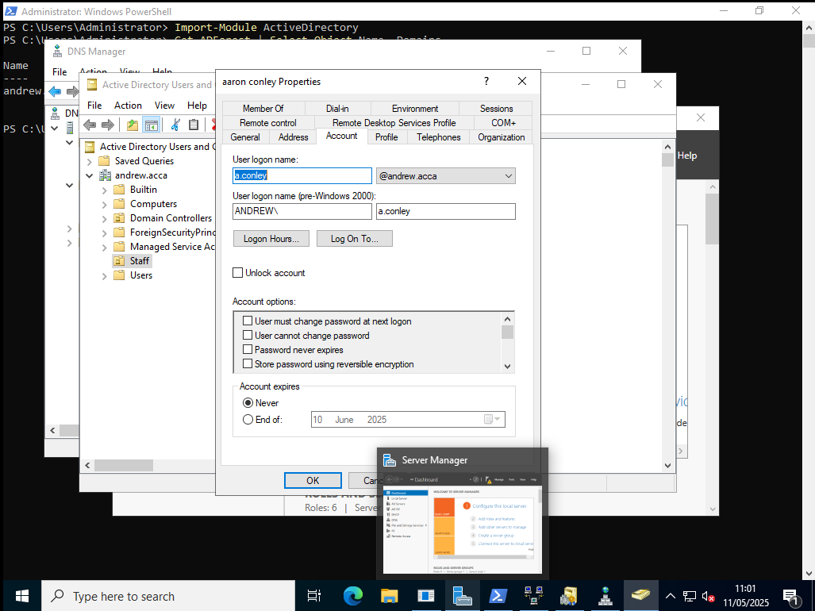
1.8 DHCP Scope
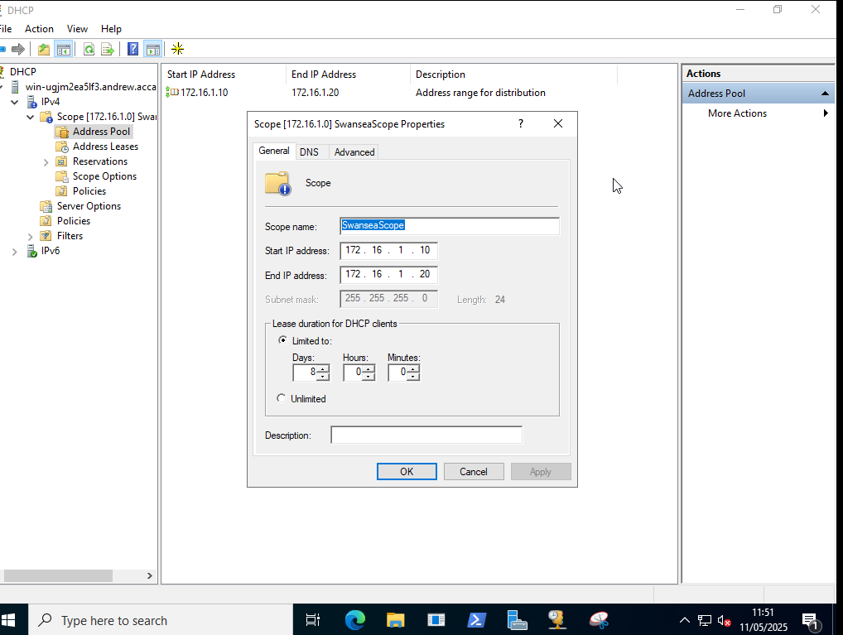
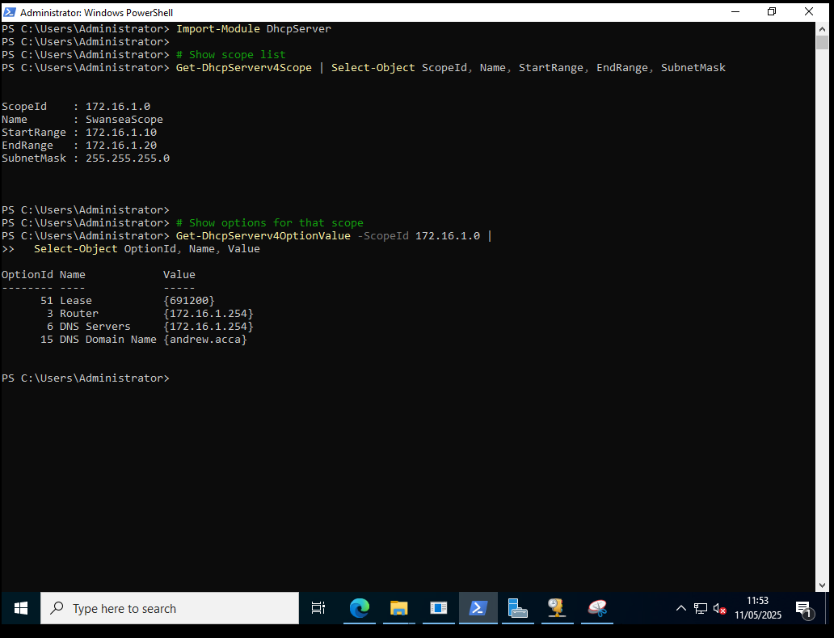
1.9/1.10 Clinet S1 joined domain + DHCP Address
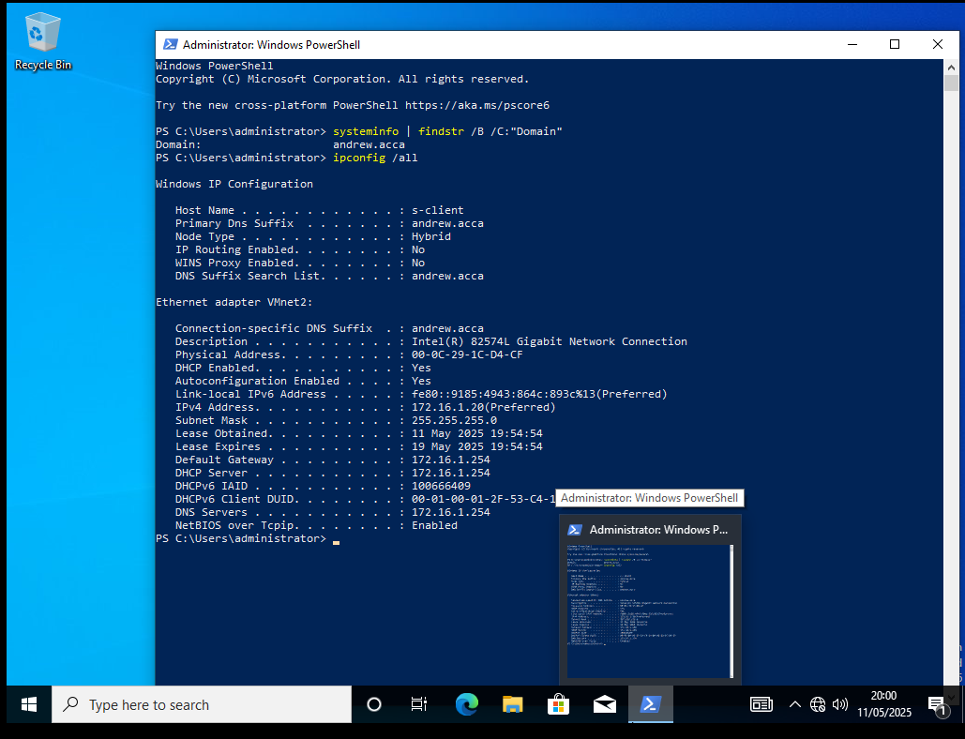
2.1 IP Forwarding
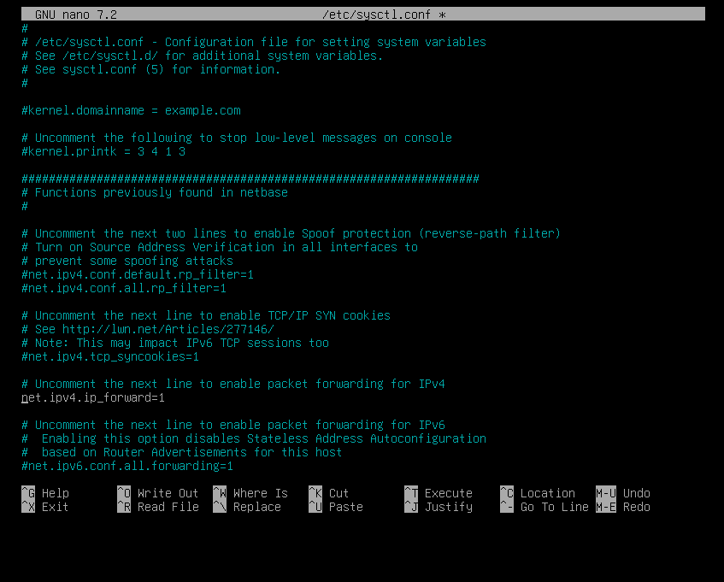
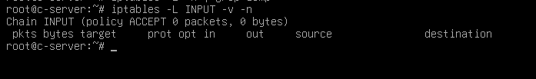
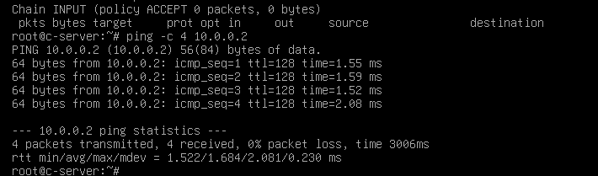
2.2 PPTPD running on CServer
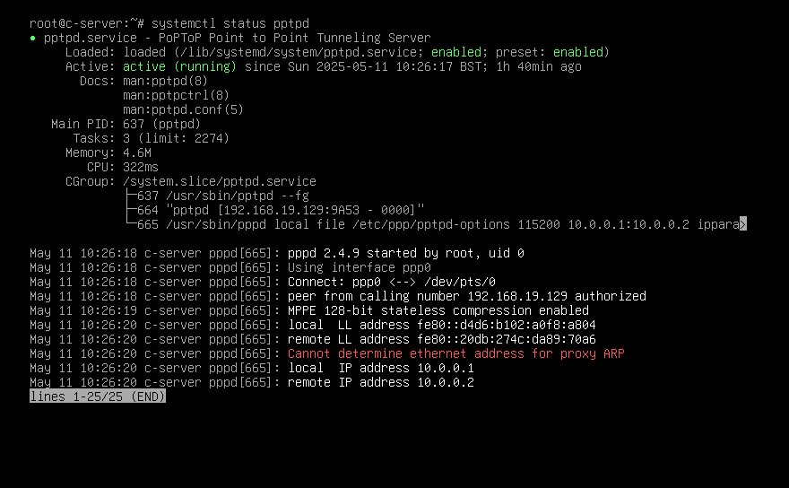
PPTPD config on CServer
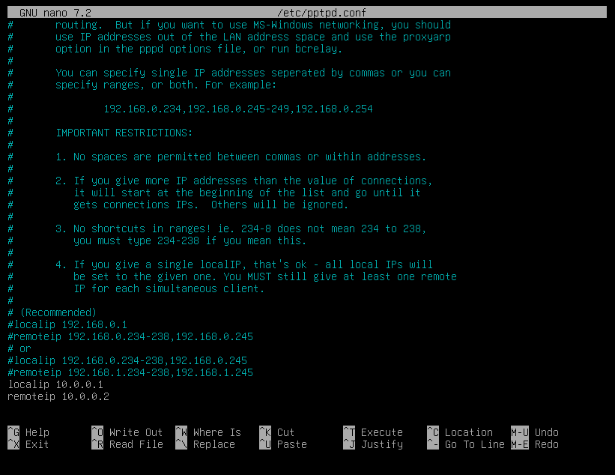
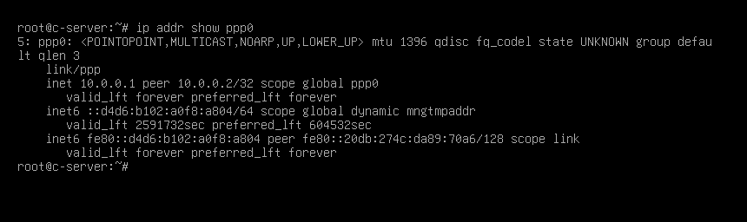
Route showing any traffic destined for SServer is forwarded through VPN link
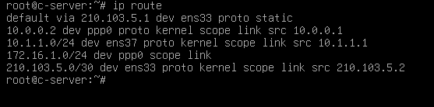
2.3 Joined Cardiff devices to Andrew.acca + 2.5 join ClientC1
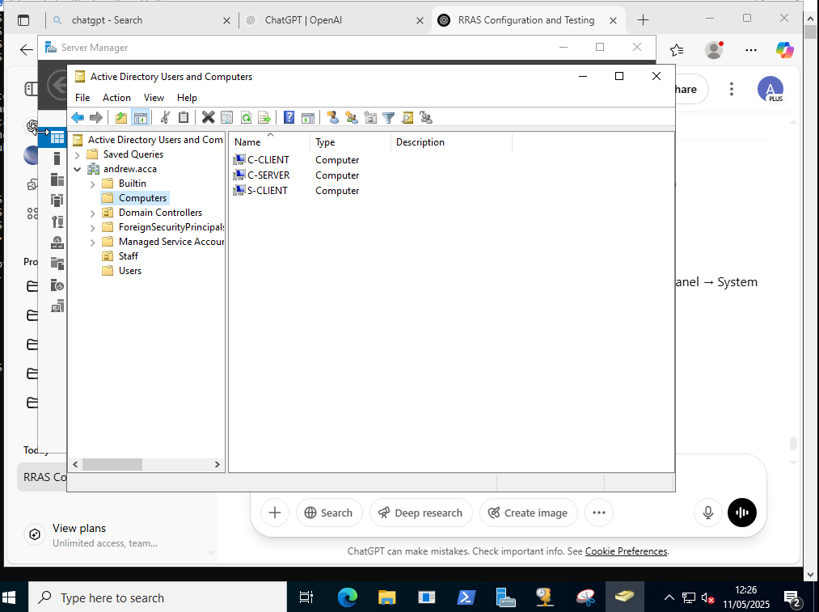
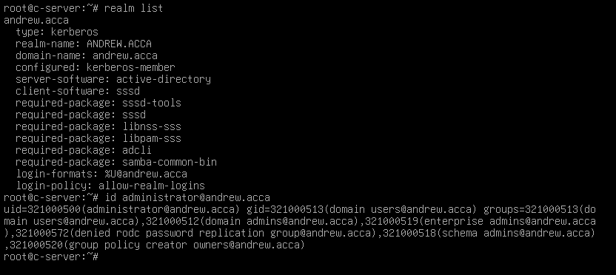
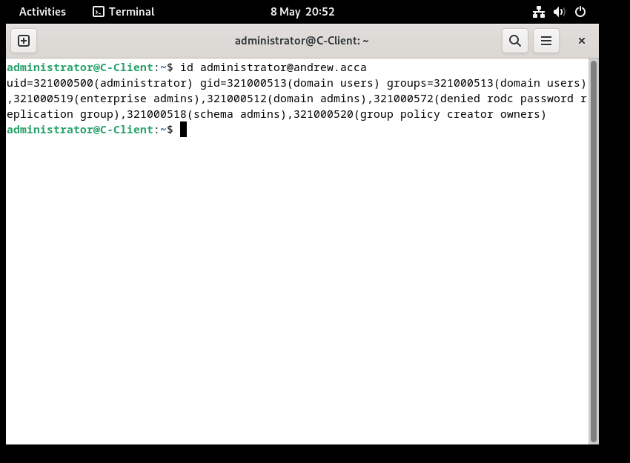
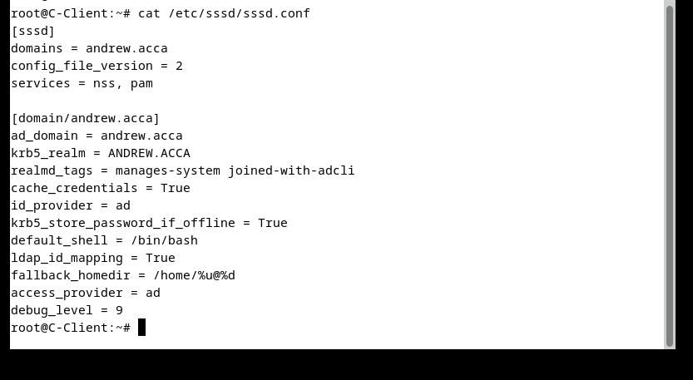

A-Records in DNS Manager
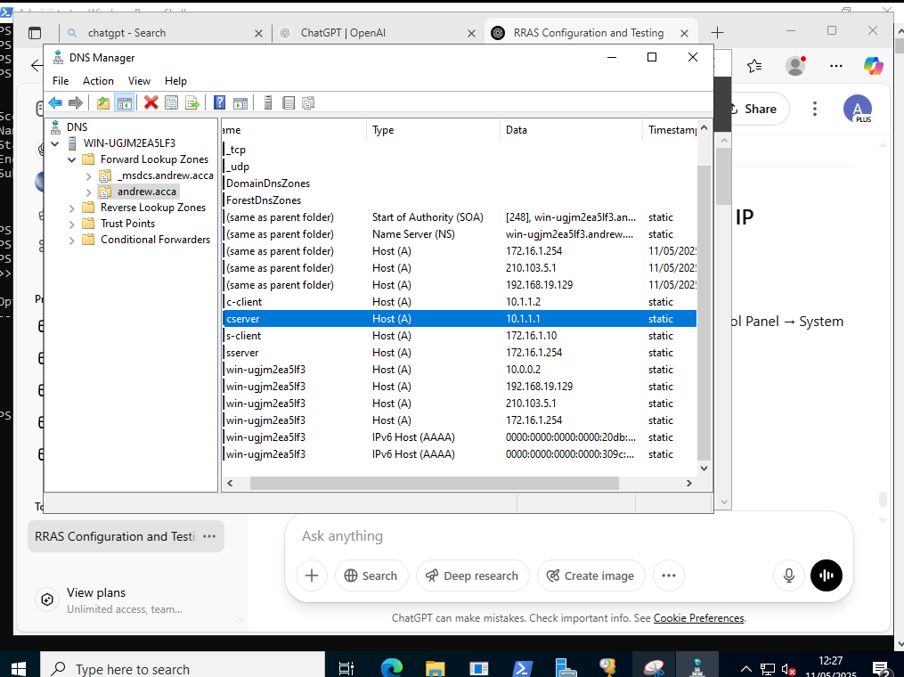
The Cardiff devices were joined directly to Andrew.acca to simplify the administration. One set of ground policy objects can cover both sites, and the network is small enough that separate domains aren’t needed. You’d need a child domain if you needed to delegate administration. For example, if Cardiff had its own IT team, you could give them full control without touching the parent domain.
Reverse lookup pointer configured:
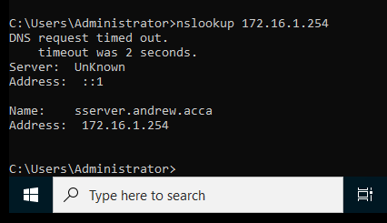
2.4 DHCP
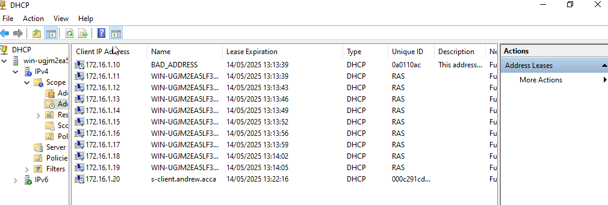
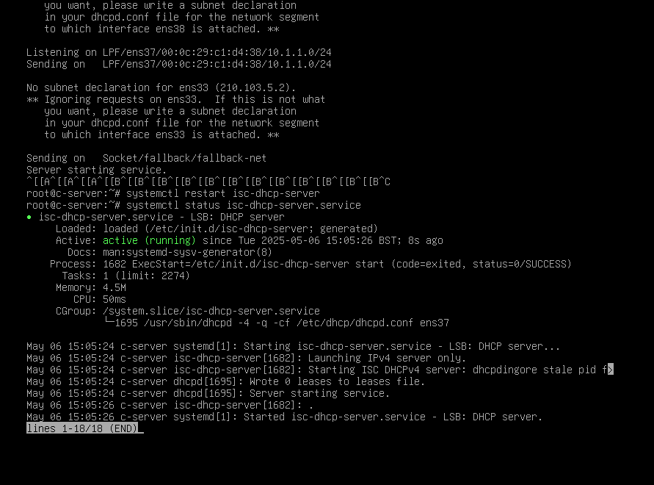
3. Test connectivity


