BA Leadership and Management Skills for the Workplace
Assignment Title: Developing Emotional Intelligence Skills for the Workplace

Firon Miah
ID 1605305
Ze Zouk

Table of Contents
Introduction 3
Exploring the concepts of emotional intelligence and its relevance at Syngenta 4
Importance of emotional intelligence at Syngenta 6
Contributions of emotional intelligence at Syngenta 7
Emotional intelligence concerning organizational development 8
Emotional intelligence (EI) in building workplace relationship 9
Contribution of EI and mindfulness approach in developing empathy, improving performance, and greater well-being 11
Overview of different models and frameworks of Emotional Intelligence 11
Application of Daniel Goldman framework of emotional intelligence in Syngenta 13
Exploring How Daniel Goldman Framework at Syngenta 15
Bar On’s Theory of Emotional Intelligence 16
Application of Simmons EQ profile Syngenta 18
Developing and Improving Emotional Intelligence 20
The Connection between Feeling and Thinking 20
Contribution of Feeling to the Performance 20
Personal Development Plan for Emotional Intelligence 21
Conclusion 24
References 25

Introduction
The 21st century is the era of globalization and competition. The success of a business largely depends on resource adequacy, internal and external environmental factors, and effective leadership & management in the workplace. Leadership and management refer to the function of managers and leaders that help to maximize efficiency and productivity to explore the organizational objectives. Emotional intelligence has made leadership and management more effective and efficient. It enables the leaders to encourage the intrinsic motivation of the employees to explore organizational goals. Emotional intelligence contributes to explore individual and organizational objectives simultaneously (Dollard, 2019). Considering the significance of emotional intelligence in leadership and management this report aims at exploring the importance of emotional intelligence in the workplace and the relationship between emotional intelligence, effective communication, management, and business opportunities. To explore this objective, the report will focus on the concepts and philosophy of emotional intelligence in the workplace, apply and evaluate different models and theories, and critically appraise the importance of mindfulness and emotional intelligence in the workplace. To explore this objective is a critical analysis of leadership and management in the area of emotional intelligence I have selected Syngenta, is one of the leading plant science companies in the world.

- Company overview

Syngenta is one of the leading plant science businesses in the world which was founded in 2000. It promotes essential agriculture through innovative and creative research and technology. It aims at bringing plant potential to life. It offers its services to farmers to a government in more than 90 countries. Currently, more than 29000 employees are working there with revenue of more than $12.65 billion in 2018 (Syngenta, 2019).
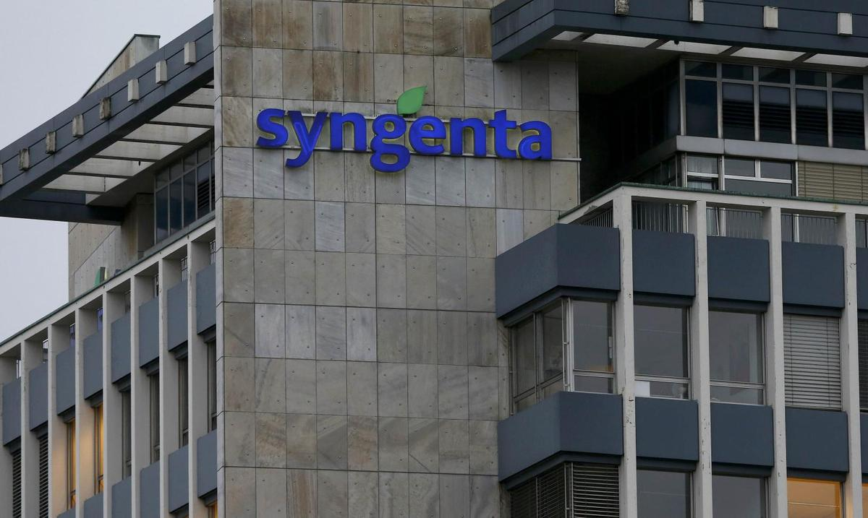
Figure: Syngenta
Source: (Syngenta, 2019)

Exploring the concepts of emotional intelligence and its relevance at Syngenta
- Emotional intelligence
Emotional intelligence is defined as the capability of a person to control and manage his/her emotions as well as the emotions of others in making decisions. In other words, emotional intelligence refers to the ability of a person to manage his negative emotions, practice empathy, and bounce back from adversity in making decisions (Shapira-Lishchinsky, 2016).
Meires, (2018) also described workplace emotional intelligence as the capability to be aware of, express, and control emotions as well as handling interpersonal relationships diplomatically and empathically to explore organizational and individual objectives simultaneously.
Daniel Goldman described five key elements of emotional intelligence. These elements are:
- Self-awareness
- Self-regulation
- Social skill
- Empathy and
- Motivation
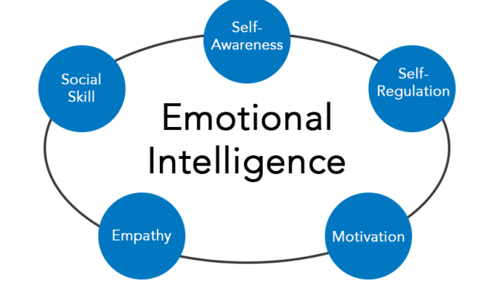
Figure: Emotional intelligence framework
Source: (Meires, 2018)
A higher level of control in each area can make a leader very effective in the workplace. The more control in each of these areas the higher emotional intelligence a leader or manager will have. A solid understanding of the emotions of the surrounding people and taking actions accordingly affect performance positively. A better leader is expected to relate his work with others and response to these elements cautiously. Domain and competencies of emotional intelligence are as follows:
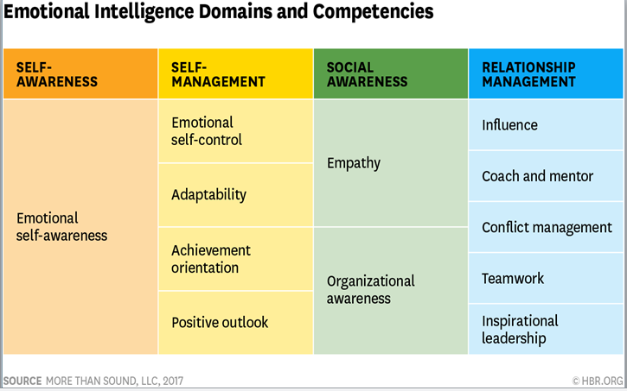
- Mindfulness
Mindfulness is defined as a psychological process of personal awareness that refers to paying attention on purpose in the present moment. Psychologist believes that mindfulness can be developed through training and practice of meditation (Shapira-Lishchinsky, 2016).
Mindfulness is very crucial for innovative and challenging tasks in the workplace. It can incorporate all the six senses together to explore aims.

Importance of emotional intelligence at Syngenta
The workplace is often considered as the second home. But we should not expose all our emotions in the workplace. Workplace at Syngenta is a formalized area where leaders and managers need to work according to some exposed and hidden rules and standards. Brief descriptions of the importance of emotional intelligence at Syngenta are as follows:
- Increases team and organizational performance
- Improves decision making
- Increases job satisfaction and reduces turnover
- Increases personal well-being
- Increases leadership ability and efficiency
- Decreases occupational stress

Contributions of emotional intelligence at Syngenta
Syngenta is the leading plant science business in the world. It is a highly innovative company. Some of the competitors of Syngenta like Monsanto Company, Wynnstay Group, Plant Impact, and Gunus are also growing very fast. Among them, Wynnstay Company has a history of more than 100 years. Besides, numerous small and large plant science organizations are launching with the raising significance of plant science. To be in the leading position in the plant science industry for a long time Syngenta needs to focus on its effective leadership and management where the emotional intelligence of the leaders and managers is considered as the core competencies of sustainable success nowadays (Dollard, 2019). The importance of emotional intelligence in Syngenta is as follows:
- Emotional intelligence in the workplace increases collaboration among the employees in the workplace. As a result, they are willing to share knowledge, skills, and experience with others. Thus it creates a positive workplace culture. Collaboration among the employees will lead to higher job satisfaction resulting in a lower level of turnover at Syngenta.
- Emotional intelligence helps to resolve conflicts diplomatically. As a result, it tends to increase team performance and increase innovation which is the desired concern of Syngenta.
- Emotional intelligence incorporates self-awareness, self-regulation, empathy, integrity, and social skills which help to build strong positive relationships among the performing groups (Meires, 2018). As a result, it eliminates communication gaps and brings all the performing units together. It will result in synergy benefits to Syngenta as well.
- The emotional intelligence of the leaders and managers ensures effective communication, promotes team performance, and resolve workplace conflicts which foster organizational growth and good customer relationships.
- Emotional intelligence helps to build trust among the employees which are the prerequisite for success in leadership and management.
In other words, the emotional intelligence of the leaders and managers at Syngenta has ensured effective top management, good organizational communication, effective teamwork, resolve workplace conflicts, increase employee motivation and morale, and ensure superior innovation. These variables are required interrelated and can ensure sustainable growth of Syngenta for a longer period.

Emotional intelligence concerning organizational development
Leadership 21st-century focuses on various psychological concepts to develop potential self-awareness in the workplace. The most useful tactic that is used by innovative managers and leaders is emotional intelligence. Average performance is more in the jewel position at all. Emotional intelligence is the concept in the workplace that can bring all the potential efforts together in exploring the business opportunities from global competition.
- Workplace success depends on the interaction of human resource
An organization is a device of various interdependent resources. Among them, human resource is considered as the most valuable and competitive resource. But it is a diverse blend of various skills and competencies. Working together accounting for the potentiality of the employees can lead to success. Thus managing soft skills like communication and teamwork are crucial for attaining goals (Meires, 2018). The emotional intelligence of the employees helps them to learn how to cultivate good relationships and maintain them appropriately. Thus self-awareness, social skills, and self-regulation contribute to organizational success in a wider picture.
Emotional intelligence is considered as the fundamental aspects of leadership and management. The success of leadership and management comes from empathy. Besides, emotional intelligence builds effective leadership qualities. Thus, leaders having control over his emotions and feelings can be an effective boss. So, organizational success comes from effective leadership and effective leadership comes from a sense of emotional intelligence (Shapira-Lishchinsky, 2016).
- Emotional intelligence can be noticed by its absence
Positive and sharing organizational culture intensifies organizational success. Syngenta believes in teamwork and sharing of knowledge and skills. Emotional intelligence among the employees has ensured it. But organizations with a lack of sharing culture suffer from numerous barriers like lack of effective communication, management, and failure to explore goals. Leaders and managers within these organizations can feel the importance of emotional intelligence as the most crucial source of positive workplace culture (Mindtools, 2019).
- Emotional intelligence and recruitment & selection
Emotional intelligence is not by the born quality of human beings. With the increase of age emotional intelligence also increases. But some psychological issues promote the development and improvement of emotional intelligence very quickly. The emotional intelligence of human resource managers enables them to select the best employees who have positive aspects of emotional intelligence. They are supposed to lead the organization effectively for a longer period. So, the prudency of recruitment and selection is also uplifted by emotional intelligence. Emotional intelligence also contributes to the career success of the employees.
In summary, emotional intelligence contributes to all the functioning units and psychological issues to an organization.

Emotional intelligence (EI) in building workplace relationship
Syngenta is well known for its innovative teamwork and strong relationship among the employees. Emotional intelligence has a very big contribution to such a relationship. The following process shows how EI builds a strong relationship in Syngenta:
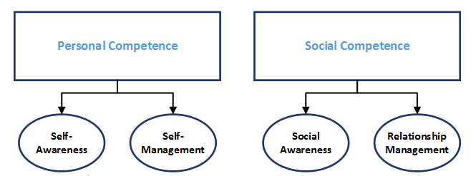
Figure: Emotional intelligence and workplace relationship
Source: (Dollard, 2019)
In the case of building and managing workplace relationship, social competence including social awareness and relationship management play a very big role. But emotional intelligence focuses on self-awareness as well as self-management which are the sources of social-awareness and relationship management. It enables the employees on how to respond to a piece of bad news like a piece of good news. Thus it increases the ability to manage stress, recognize and manage our emotions, effectively communicate nonverbally, use humor and play in relationships, and resolve conflicts (Mindtools, 2019). These elements are the core factors for building a relationship in the workplace which are the contributions of EI. So, we can describe EI as the prominent factor for building workplace relationships at Syngenta.
- Emotional intelligence and workplace culture
There are different types of organizational culture exist within the business organizations including clan culture, adhocracy culture, market culture, hierarchy culture, etc. Syngenta is most probably the best example of clan culture. Syngenta has very friendly working conditions with effective teamwork, participation, and consensus. Their leadership aims at building an effective team, empowering the employees, raising engagement, and increasing effective communication. They encourage employee participation and focus on value-driven strategy including commitment and development. These features of workplace culture at Syngenta can be explained by the contributions of the emotional intelligence of the leaders and managers. Most of the features of clan culture can be explained by the elements of emotional intelligence. So, emotional intelligence also contributes to developing a supportive and positive workplace culture (Meires, 2018).

Contribution of EI and mindfulness approach in developing empathy, improving performance, and greater well-being

Overview of different models and frameworks of Emotional Intelligence
Numerous models and theories have contributed to the development and improvement of EI within the organization. An organization may have different values, perceptions, cultures, beliefs, and business strategies but the core objectives of business organizations are the maximization of organizational wealth and the well-being of the working people within the organization. Emotional intelligence can incorporate all these diverse things towards the goals. Thus different models can help to explore the goals in different ways. In this regard, the EI model of Daniel Goldman focused on five key areas including self-awareness, self-regulation, social skill, empathy, and motivation.
Bar-on’s model of emotional intelligence focused on interpersonal skills, intrapersonal skills, stress management, adaptability, and general mood. The model disclosed some areas under each dimension. Intrapersonal skills encompass with self-regard, independence, self-actualization, emotional self-awareness, and assertiveness. Interpersonal skills require empathy and social responsibility. Reality testing, flexibility, and problem-solving are the key areas of adaptability where stress tolerance, impulse control, optimism, and happiness are the factors of stress management (Shapira-Lishchinsky, 2016).
The Mayer-Salovey-Caruso Emotional Intelligence Test (MSCEIT) is also used in the arena of EI which was emerged from an intelligence-testing. The testing model focused on four branches of EI including perceiving emotions, facilitating thought, understanding emotions, and managing emotions (Meires, 2018).
There are some other models of EI as well like ‘Richard Boyatzis’ Framework of emotional Intelligent (EI), Leadership and EI (Simmons EQ profile)s, etc. all of these models have contributed to the development and improvement of EI of the leaders and managers.

Application of Daniel Goldman framework of emotional intelligence in Syngenta
After the development of this model, it is considered as the most effective way to a model of emotional intelligence. The model focuses on five key elements that are considered as the most crucial area that can build strong leadership and management (Dollard, 2019). The application of the model at Syngenta is as follows:
- Self-awareness
It is the most dominant element of emotional intelligence. To increase self-awareness, leaders and managers at Syngenta try to understand their strengths and weaknesses clearly. A clear understanding of strengths increases self-confidence. On the other hand, weaknesses enable people to become aware of their lacking (Meires, 2018). Thus they need to take action to improve their weaknesses. They keep records to improve weaknesses and use self-evaluation tools. They also try to control anger and make their emotions at work to develop a strong sense of self-awareness.
- Self-regulation
Leaders and managers often make a verbal attack. But it can create wrong images for the employees. Self-regulation is all about controlling personal behavior in different challenging situations (Dollard, 2019). To increase self-regulation leaders at Syngenta focus on their values, ethics, and the points of accountability. It ensures their calmness on the eve of difficulties and challenges. Thus they also try to build strong self-regulation by practicing being calm and knowing the situational challenges of the employees.
- Empathy
Empathy refers to the ability of the leaders and managers to put them in the position of the employees. Leaders at Syngenta believe that empathy promotes teamwork and increases Jon engagement. For a strong sense of empathy, leaders at Syngenta provide constructive feedback and try to understand the need of their subordinates. They focus on the body language to understand the actual feelings. So, decisions incorporated with the feelings of the employees raise the possibility of success.
- Motivation
The organizational resource is always limited but the perception of the employees is unlimited. Personal performance may not always suit for organizational rewards. Leaders and managers at Syngenta focus on their job objectives, leadership motivation assessment, and optimism behavior to keep them motivated in unfavorable situations. They try to explore the reasons behind the unfavorable situations and try to improve those areas for future success (Syngenta, 2019).
- Social skills
Syngenta is an innovation-seeking organization. It believes in empowering the employees. They encourage their employees to participate in the decision-making process and try to ensure effective communication among the employees. Thus effective communication skills of the leaders and managers are crucial here. Leaders having good social skills are often founded to be a good communicator. Leaders at Syngenta are experts in coordinating their teams to support new mission and objectives. They are simply open to hearing the bad news as good news. They have developed good conflict resolution skills to increase team performance. They praise the achievement of the team members. They believe praising the team members is very crucial for building a loyal employee base. Even there is an open innovation platform at Syngenta that encourages and promotes positive workplace culture. Most of the leaders and managers have a solid understanding of how their social skills affect employees around them (Syngenta, 2019). As a result, they become able to make Syngenta as the most supportive second home to the employees.
Leaders and managers at Syngenta believe in developing and improving self-awareness, self-regulation, motivation, social skills, empathy for effective leadership and management. They take time for that and practice it for a very long period. Thus they become emotionally excellent leaders in the business world.

Exploring How Daniel Goldman Framework at Syngenta
We have explored how EI is applied by the leaders and managers at Syngenta. But there are some key areas and sources of EI that ensure proper application of the model. We can describe it using the below framework.

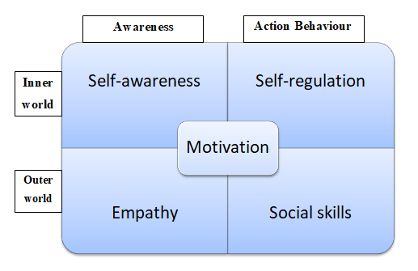
Figure: EI framework
Source: (Dollard, 2019)

The emotional intelligence of the leaders and managers at Syngenta starts with self-awareness which is a combination of inner perception/self-understanding/inner world and personal awareness. When a leader or manager has the required self-awareness his/her emotional intelligence is expressed through his action behavior. Action behavior is also explained by self-regulation. On the other hand, while self-awareness goes to the practice/outer world/workplace it raises empathy. Where leaders and managers try to put them in the position of the employees to explore the actual situation it is described by their empathy. Again self-regulation is expressed in the form of social skills in the workplace/outer world by increasing effective communication skills and controlling anger/emotions/behavior (Shapira-Lishchinsky, 2016). Similarly, empathy also results in social skills which are followed by the action behavior of the leaders and managers in the workplace. Thus awareness opens the gateway to social skills. Thus it enhances optimism, compassion, diligence, affability, politeness, and discipline in the workplace. All these activities are driven by personal motivation. Motivation drives the potential behavior for the effective development and implementation of emotional intelligence in the workplace.

Bar On’s Theory of Emotional Intelligence
Bar On’s theory of emotional intelligence wad developed in 1997. The major differences between the traditional model of emotional intelligence and Bar On’s model are that the Bar On’s model focuses on the personal characteristics in five interrelated domains. These domains are:
EQ scales | EQ sub-scales
Intrapersonal skills | Assertiveness
Intrapersonal skills | Emotional self-awareness
Intrapersonal skills | Independence
Intrapersonal skills | Self-actualization
Intrapersonal skills | Self-regard
Interpersonal skills | Empathy
Interpersonal skills | Social responsibility
Interpersonal skills | Interpersonal relationship
Adaptability skills | Flexibility
Adaptability skills | Problem-solving
Adaptability skills | Reality testing
Stress management skills | Self-regulation
Stress management skills | Impulse control
General mood | Optimism
General mood | Happiness

- Intrapersonal skills
This section of the model includes self-regard, assertiveness, emotional self-awareness, self-actualization, and independence. As a part of the intrapersonal skills of leaders and managers at Syngenta should focus on mutual respect for self-regard, they should try to realize their potentiality for self-actualization. Assertiveness can be improved through expressing feelings, beliefs, and thoughts to defend the rights of the employees in a non-destructive manner.

- Interpersonal skills
As we have discussed earlier that empathy is one of the most dominant elements of effective leadership and emotional intelligence. It enables the leader to make the employees as a follower. Thus leaders and managers at Syngenta should understand, appreciate, and aware of the emotions of the employees to build empathy among them. For social responsibility, they should try to demonstrate themselves as a contributing, cooperative, and constructive member of the social group. Interpersonal relationships can be improved by maintaining a mutually satisfying relationship in the workplace (Mindtools, 2019).
- Adaptability skills
Leadership and management is a dynamic task. It depends on human behavior and situational factors that don't follow any sequences or patterns. To make the appropriate decisions, Leaders and managers should have the ability to adjust their emotions, behavior, and thoughts with changing situations. Besides, they also need to develop reality testing skills by comparing the objective outcomes with the experienced outcomes. Thus effective problem-solving skills can also make them efficient in case of drawing solutions in an unexpected situation.
- Stress management
Stress management is very crucial for raising the intrinsic motivation of the employees. Stress management enables leaders and managers to become an effective counselor and motivator. It is the art of controlling anger and negative feelings (Shapira-Lishchinsky, 2016). Leaders and managers at Syngenta should focus on diplomatic control of impulse and negative emotions.
- General mood
Self-satisfaction and self-motivation are the biggest drivers for superior performance. Motivated leaders and managers bear positive minds and can evaluate the performance of the employees positively. Being an innovation seeker company, Syngenta always focuses on the intrinsic motivation of the employees. Thus in the adverse situation, they focus on positive sides and try to take a lesson from failure.

Application of Simmons EQ profile Syngenta
Syngenta is an innovative plant science organization with an employee base of more than 28,000. Every year, Syngenta is hiring more than thousands of employees from different parts of the world. Besides, their existing employee base has also different aspects of emotional intelligence. They are required for a different level of training and development programs. So, a proper measurement tool of emotional intelligence is very crucial
To keep Syngenta on the top of the business game for a longer period Syngenta needs to match the right person to the right job. It will help to develop further effective leadership and management, decrease turnover, and increase profit. Thus Simmons EQ profile provides an integrated measurement tool that is a function of the lower and central parts of the brain. These parts are made up of emotional drivers and behavioral tendencies that are motivated by emotional feelings. Measurement is EQ is more crucial than IQ because only 20% of the success can be explained by a higher IQ. EQ or character also contributes to building a strong workplace relationship and positive culture (Lynn, 2017). Thus EQ profile of Simmons consists of a multi-scaled instrument that focuses on measuring 13 character traits. These are:

- Energy
- Stress
- Optimism
- Work
- Change
- Detail
- Self-esteem
- Courage
- Assertive
- Direction
- Sociable
- Tolerance
- Considerations of others

Proper measurement of these areas can provide Syngenta a proper and accurate insight into how a candidate or employee can be expected to perform at work. Besides, it will also enable Syngenta to measure the fitness of a manager and leader for specific types of work. It is efficient as well as cost-effective because numerous online sites provide this management tool. It has a tremendous accuracy rating of 97%. Several organizations have found that the application of Simmons EQ profile has reduced annual turnover by 10% (Mindtools, 2019). So, the tool can be also very effective for Syngenta for further development as well.

Developing and Improving Emotional Intelligence

The Connection between Feeling and Thinking
Feelings are different from thinking. We often consider feelings as a function of external events, situations, and actions of others. Thus major words that describe our feelings are tense, angry, upset, anxious, jealous, sad, cheerful, excited, joyful, irritated, depressed, annoyed, scared, frustrated, tired, flat, enraged, etc. it is sometimes quite difficult to express feelings in a single word. There are different situational factors, the behavior of others, and external factors that influence our feelings. For example, some actions of leaders and managers can make the employees nervous (Dollard, 2019).
On the other, personal feelings are significantly influenced by our thinking where thinking is a function of our beliefs, attitudes, culture, values, and emotions. Our thinking is a habitual and automatic thing that drives our feelings. For example, in the same incidence/situation different people can react differently. Someone can be calm but someone can response angrily because we have different thoughts and most of the time we response to a particular situation unconsciously due to a difference in thoughts. There are three types of personal thinking including positive thinking, negative thinking, and neutral thinking. These levels of thinking to shape our feelings. Thus we can explain thinking as a driver of our feelings. To control our feelings in the workplace we need to focus on controlling our thinking (Lynn, 2017). Developing positive thinkings in the workplace can lead to positive workplace culture, behavior, values, norms, and attitudes.

Contribution of Feeling to the Performance
Performance/outcome is a function of ability, motivation, and available opportunities. Motivation leads us towards the desirable performance by raising concentration. It exerts a higher level of energy to explore the goals. On the other hand, motivation comes from positive feelings and internal satisfaction. In the same way, Feeling depends on mood, emotions, beliefs, and attitudes. Positiveness among the factors bring positive feelings, positive feeling brings motivation, motivation brings job engagement and concentration, and job engagement results in the superior performance. In other words, we can say that positive feeling results in superior performance and negative feeling result in inferior performance (Mindtools, 2019).
Thus an alternative approach for superior performance can be the process of eliminating negative feelings. as a leader or manager of Syngenta, we need to focus on the sources of bad feelings. Bad feelings may come from personal distress. Personal distress refers to negative emotions that may come from personal suffering. An employee may not give his/her best efforts and can result in performance below the benchmark. But he/she has the potential ability and opportunities. Best leaders and managers try to explore those bad emotions and keep them in the position of the employees (described by empathy as an element of emotional intelligence). Thus they can provide the best solutions to reduce bad emotions and increase the intrinsic satisfaction of the employees. As a result, employees feel them as a part of the organization which is described by Corporate Citizenship Behavior and try their best to ensure the optimum performance and vice versa (Lynn, 2017).
In other words, we can explain superior performance as an outcome of our positive feelings and poor performance as an outcome of negative feelings.

Personal Development Plan for Emotional Intelligence
From the detailed analysis of emotional intelligence in the area of leadership and management of Syngenta, I have explored some core requirements of emotional intelligence including self-awareness, self-regulation/stress management, empathy, social skills, interpersonal skills, etc. Thus to develop an integrated personal development plan, I need to focus on my current level of competencies, learning style, motivation level, and mindset tools. Since we are considering emotional intelligence, I need to improve my self-awareness, stress management, relationship management, empathy, interpersonal skills, and social skills to make me competent in leadership & management in the area of emotional intelligence. The personal improvement plan is as follows:
Area of improvement | Action plan | Required resources and supports | Benchmark of success | Timeframe
Self-awareness | I will focus on my strengths, weaknesses, values, beliefs, drivers, and objectives to explore the impact of these factors on others. Thus I will focus on reducing weaknesses to build self-confidence. | I can use different online mindset tools. Besides, the support of colleagues and friends is crucial here. | There are numerous self-awareness measurement tools available online including both the free and paid version. My target is to achieve the 90th percentile. | All of these elements of emotional intelligence are subject to continual learning and development. Thus I will focus on improving these areas in three integrated timeframes. The first phase will consist of 4 months, the second and third phase will consist of three and four-month consecutively.
Self-regulations/ stress-management | I will practice managing my disruptive emotions and impulse to adapt to changing and unexpected circumstances. | Control and un-control situations that can lead me to anger and overwhelm. | Benchmark will depend on the time. At the first timeframe, 50% control over such situations will be the success criteria.
Interpersonal skills | To improve my interpersonal skills in the workplace and personal life I will focus on cultivating a positive outlook, practicing active listening, acknowledge the achievements of others, being assertive, controlling emotions, and practice empathy. | To improve interpersonal skills, I require diversified human resources who have different perceptions, beliefs, values, and culture. | An integrated feedback loop will be used to measure the improvement of interpersonal skills, social skills, and empathy. For the first period, the benchmark is 70th percentile, for the 2nd-period benchmark is 80th percentile and for the 3rd session, the benchmark is 90th percentile.
Empathy | I will raise my consciousness and try to recognize, consider, and understand the feelings and emotions of others while making decisions. | I require controlled human resource supports,
Social skills | In the area of the development and improvement of social skills, I will practice to be a social person, ask open-ended questions, create goals and objectives for myself, encourage others to talk, and practice empathy and good manners. | A diversified manpower source as well as supportive friends and colleagues at the very beginning level.
Motivation | To improve my self-motivation level I will think about my achievements, strengths, provide self-feedback, and evaluate my performance on my own and enjoy these factors. If I get any deviations, I will try to explore the reasons behind the failure. | I require self-assessment online tool to explore self-motivation level continually. | Sine a score more than 90th percentile in self-motivation quizzes are considered as higher level, my objective is also the same.
Besides, I will also practice managing my negative emotions. I will also try to draw a conclusion from a variety of perspectives and try to think things objectively to manage my negative emotions.
I also need to be a good communicator in the workplace. For this, I need to focus on selecting a strong vocabulary. In this regard, I also need centering on verbal and non-verbal cues to get a clear insight into the feelings and emotions of my colleagues and subordinates.
I also need to practice bounce backing from adversity. I need to know my stressors and be proactive to have less of it.
Thus the continual practice of this action plan can easily lead me to be emotionally intelligent in the workplace.

Conclusion
Emotional intelligence builds effective leadership and management and leaders & managers build tone for the organization. A lack of emotional intelligence of the leaders and managers can lead to poor organizational performance through lower job engagements and higher turnover (Mindtools, 2019). Thus innovative business organization like Syngenta has already incorporated the concurrent issues regarding emotional intelligence in their leadership and management techniques. Thus emotional intelligence of the leaders and managers has enabled innovative product development as efficiently as possible. They encourage, recognize, and celebrate the achievements of the employees for motivation and engagement, focus on continual improvement of their weaknesses to build self-confidence and self-awareness, avoid verbal attack and control anger & impulse for self-regulation, and aware of the feelings and emotions of the employees for empathy. Thus the empowerment of the employees and the higher productive employees, leadership, and management are the outcomes of emotional intelligence. As a learner of business management, we need to practice the key components of emotional intelligence continues to develop and improve our leadership and management competencies.

References
Beard, A (2014), 'Mindfulness in the Age of Complexity', Harvard Business Review, 92, 3, pp. 68-73, Business Source Complete, EBSCOhost, viewed 9th August 12, 2019.
Cherniss, C. and Goleman, D. (2003). The Emotionally Intelligent Workplace. Wiley.
Ciarrochi, J., Forgas, J. and Mayer, J. (2006). Emotional intelligence in everyday life. New York: Psychology Press.
Dollard, C. (2019). Emotional Intelligence Is Key to Successful Leadership. [online] The Gottman Institute. Available at: https://www.gottman.com/blog/emotional-intelligence-key-successful-leadership/ [Accessed 12 Aug. 2019].
Felmaowr, R. (2019). Syngenta - HRD UK. [online] HRD UK. Available at: https://www.hrdsummit.com/companies-cpt/syngenta/ [Accessed 12 Aug. 2019].
Goleman, D. (2005) Emotional Intelligence: Why it can matter more than IQ, New York: Bantam House.
Lynn, A. (2017). quick emotional intelligence activities for busy managers. New York: AMACOM / American Management Association.
Matthews, G., Zeidner, M., and Roberts, R. (2012). Emotional intelligence 101. New York: Springer Pub.
Meires, J. (2018). Workplace Incivility - The Essentials: Using Emotional Intelligence to Curtail Bullying in the Workplace. Urologic Nursing, 38(3), p.150.
MENDELSON RICHARD A. (2015). EMOTIONAL INTELLIGENCE IN THE WORKPLACE. [Place of publication not identified]: SCHOLARS' Press.
Mindtools (2019). Emotional Intelligence in Leadership: Learning How to Be More Aware. [online] Mindtools.com. Available at: https://www.mindtools.com/pages/article/newLDR_45.htm [Accessed 12 Aug. 2019].
Mohla, N. (2015). Human Drama Inc. New Delhi: SAGE Publications.
Shapira-Lishchinsky, O. and Levy-Gazenfrantz, T. (2016). The multifaceted nature of mentors’ authentic leadership and mentees’ emotional intelligence. Educational Management Administration & Leadership, 44(6), pp.951-969.
Syngenta (2019). Syngenta. [online] Syngenta.com. Available at: https://www.syngenta.com/ [Accessed 12 Aug. 2019].
TEDx Talks (2019). How Emotional Intelligence Makes Leaders More Impactful | Gemma Garcia Goodall | TEDxIESEBarcelona. [online] YouTube. Available at: https://www.youtube.com/watch?v=75obHtjUsG8 [Accessed 12 Aug. 2019].

