1.
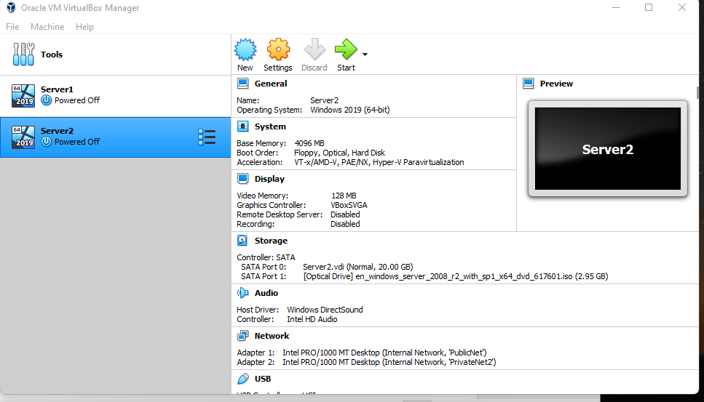
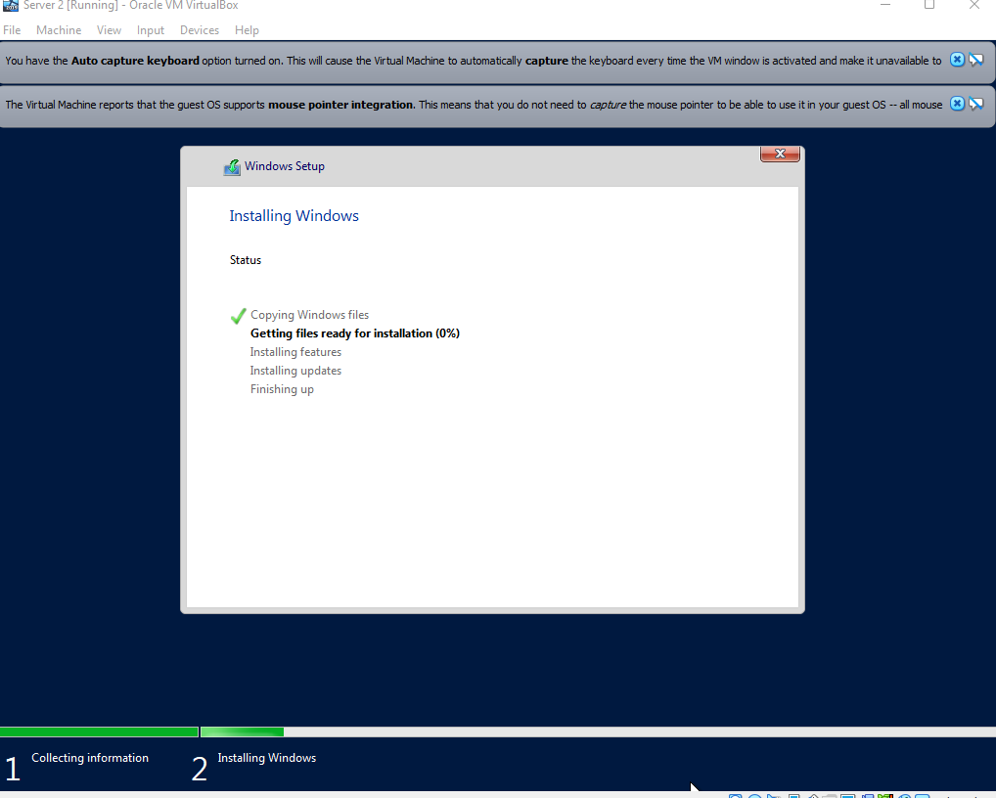

Server 1
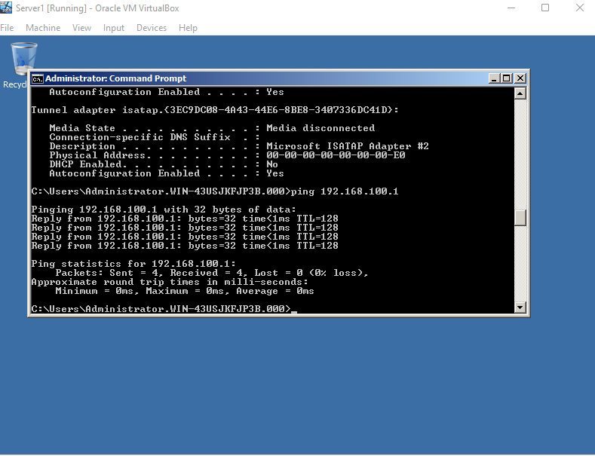
Server 2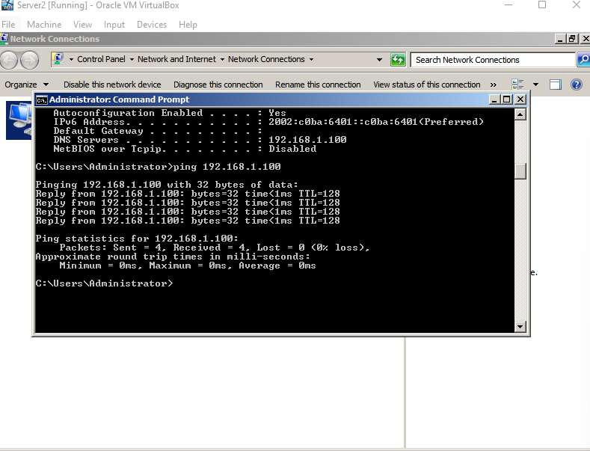
Q1.
As a result, a type 2 hypervisor can be used with a wide range of hardware. Installing a type 2 is also a lot easier than installing a type 1. Because anything that impacts the stability of the base operating system can also affect the guest operating system and virtual machine, Type 2 has the disadvantage of having more points of failure. . [1]

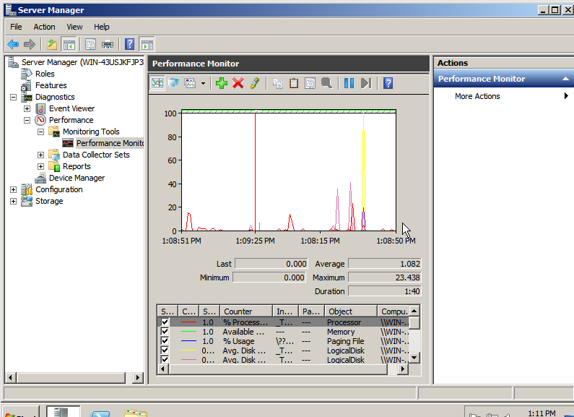
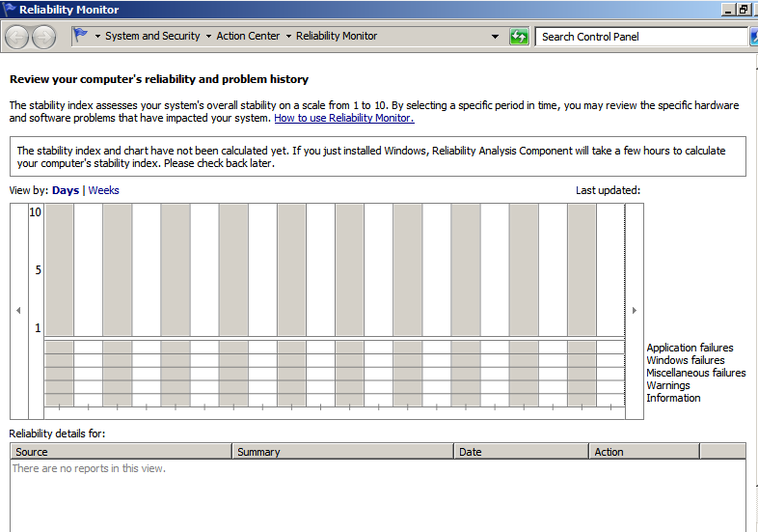

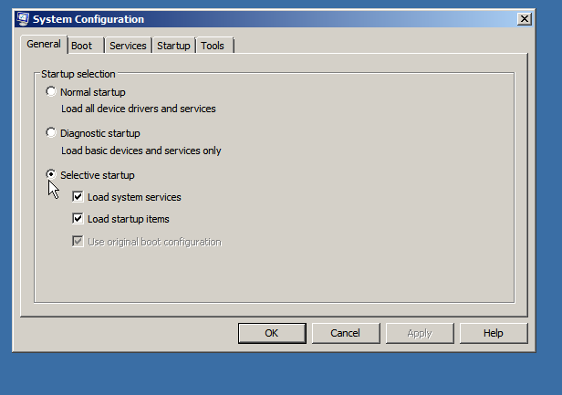

Q2.
Network monitoring assists in determining the exact location of a network problem or establishing that the network is not the problem. Continuous monitoring can aid in the early detection of potential issues. It implies that issues can be dealt with before they reach the users. The following are some of the benefits of network monitoring: [2]
- Faster resolution of issues
- Recognize security threats.
- Obtain immediate benefits ROI
- Organize networks that are expanding and changing

Q3.
Active Directory is a directory service that keeps track of network object data and makes it easier for administrators and users to find and utilise. Using a structured data store, Active Directory organises directory information logically and hierarchically. [3]

Q4.
A domain is a sphere of knowledge or a control region. 1) A domain is a field of knowledge identified by a term in computers and telecommunication in general. The knowledge is usually a collection of facts about a set of programme entities or a set of network points or addresses.
A forest is an undirected graph with at most one path connecting any two vertices. A forest is equivalently an undirected acyclic graph with all its linked components being trees; in other words, the graph is a disjoint union of trees.
In Active Directory, the schema is the blueprint for data storage. Each Active Directory object is an instance of a schema class. A user object is an instance of the user class, for example. Attributes describe the kind of data that a class, and consequently a subclass of that class, can store.
A domain controller is a server that oversees network and identity security and serves as the domain's gatekeeper for user authentication and authorization to IT resources. [4]

Q5.
The four steps of DHCP operations are server discovery, IP lease offer, IP lease request, and IP lease acknowledgement. DORA stands for discovery, offer, request, and acknowledgment. [5]

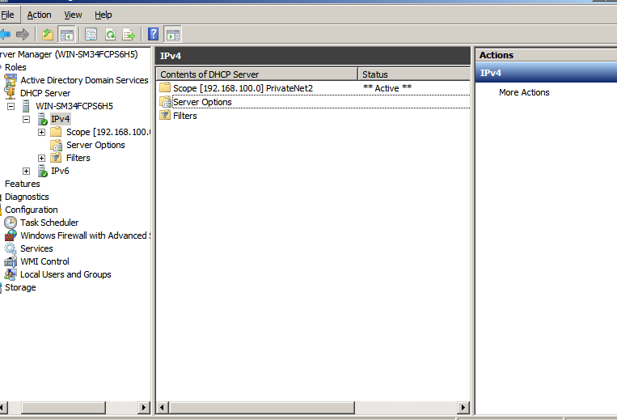

References

[1] | [Online]. Available: https://securitywing.com/types-virtualization-technology/#:~:text=That%20is%20why%20a%20type,OS%20and%20the%20virtual%20machine.. [Accessed 04 2022].
[2] | [Online]. Available: https://www.helpsystems.com/blog/top-benefits-network-monitoring. [Accessed 04 2022].
[3] | [Online]. Available: https://docs.microsoft.com/en-us/windows-server/identity/ad-ds/get-started/virtual-dc/active-directory-domain-services-overview#:~:text=Active%20Directory%20stores%20information%20about,hierarchical%20organization%20of%20directory%20information.. [Accessed 04 2022].
[4] | [Online]. Available: https://techdirectarchive.com/2020/04/11/what-is-active-directory-forest-trees-and-domain/. [Accessed 04 2022].
[5] | [Online]. Available: https://en.wikipedia.org/wiki/Dynamic_Host_Configuration_Protocol. [Accessed 04 2022].

