

Programme: Master of Business Administration
Module:
Module code: LCMB7026
Title :
Word count: 5460
Lecturer :
Student Name :
Student ID:
Submission Date-

Table of Contents
- Introduction……………………………………………………………… 3
- Comparative Analysis of the Macroenvironment (PESTEL)……….. 3-6
- Consumer Behaviour and Cultural Comparison…………………….. 6-7
- Comparative Analysis of STP Strategies…………………………….. 7-8
- International Marketing Mix (7Ps) Comparison……………………… 8-12
- Directional Development Strategy in Bangladesh……………………12
- Ethical Issues in Marketing Mix………………………………………... 13-14
- Recommendations……………………………………………………… 14-15
- Conclusion……………………………………………………………….. 15
- Reflective Account Gibbs Reflective Cycle…………………………… 16-18
References………………………………………………………………. 19-21

1.0 Introduction
Mercedes-Benz, which is a flagship brand of Mercedes-Benz Group AG (formerly Daimler AG) is one of the most recognisable luxury automobile manufacturers in the world. The brand was established in 1926 and has developed the image of being a brand associated with engineering quality, prestige, and innovation (Mercedes-Benz Group, 2023). Mercedes-Benz operates in more than 150 countries, which makes it one of the most genuine global brands as it has to work within extremely different market environments without losing its fundamental brand identity (Hollensen, 2020).
The present report is an attempt at a comparative analysis of the international marketing strategies of Mercedes-Benz in two radically different markets namely a home country of the company, Germany, the fourth-largest economy in the world, and one of the South Asian economies, Bangladesh, with an ever-growing prosperous group. Germany is a well-established and very competitive luxury car market, and Bangladesh is an upcoming market with a nascent luxury car ownership (World Bank, 2024). These two countries are useful to give an interesting contrast of a saturated developed market or the frontier market, giving a critical analysis of how the Mercedes-Benz adjust to its marketing strategies in entirely different socio-economic and cultural environments.
The established international marketing models such as PESTEL analysis, STP (Segmentation, Targeting, and Positioning), and the extended marketing mix (7Ps) are used in the report to analyze and compare the strategies of the brand. The report also examines the directional development strategy of the brand in Bangladesh as well as considering ethical issues and providing future guidelines on how Mercedes-Benz should internationalise its marketing strategy.
2.0 Comparative Analysis of Macroenvironment: PESTEL Framework.
2.1 Political Factors
Germany is politically stable in the EU, and its commitment to serving its automotive sector using industrial policies, research and development incentives, and favourable trade conditions in the single market has a long history (Economist Intelligence Unit, 2023). The charging infrastructure and EV subsidies are also encouraged by the government to support the greener mobility (Federal Ministry for Economic Affairs and Energy, 2023). This provides a stable environment on which to plan strategy and invest within the country.
Bangladesh is more politically restless as unrest, strikes, and issues of governance are still taking place on a periodic basis (Rahman, 2022). The governments have been willing to develop economically and expand their infrastructure, yet the imported duty on luxury cars is ranging between 300-800 per cent, which makes it unaffordable, and they are protecting their own industries (National Board of Revenue Bangladesh, 2023).
Strategic implication: Germany offers political assistance that allows making long-term investments and aligning EV policies. Mercedes-Benz needs to be cautious in Bangladesh: it should sell at a low volume with high margin, have good networks, and monitor its regulatory environment. The participation in business associations can be effective to secure the ability to predict the import process and the possible EV-related policy backup.
2.2 Economic Factors
Germany is the largest economy in Europe, having the GDP of around EUR 3.87 trillion and per capita GDP of more than EUR 46,000 (Statistisches Bundesamt, 2024). This provides a wide range of consumers with high-end cars, as middle and higher classes will buy the premium segment. The inflation, the supply chain impact, and the recessionary forces have impacted consumer confidence (International Monetary Fund, 2024), but flexible financing such as leasing is necessary.
The growth in GDP of Bangladesh is usually higher than 6 per cent, and the total GDP is about USD 460 billion PPP, yet the per capita income is approximately USD 2,800 (World Bank, 2024). The few rich people are located in a small circle of elite with their concentration in Dhaka and Chittagong leading to the development of a niche luxury market (Bangladesh Bureau of Statistics, 2023).
Strategic implication: In Germany, Mercedes-Benz will be able to reach out to various income and lifestyle, entry-premium to ultra-luxury, by utilizing pricing flexibility and financing opportunities. In Bangladesh, the wealthy elites and corporate purchasers should be targeted with the focus on exclusivity, high margins, and premium after sales services. They cannot use volume-led strategies.
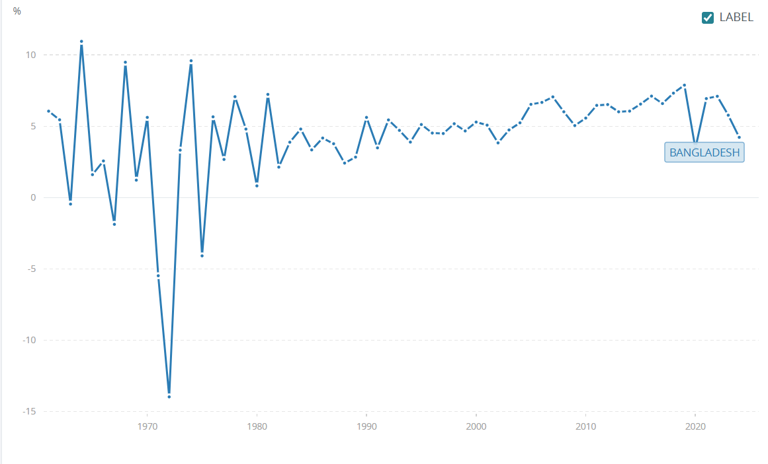
Soure: Bangladesh annual GDP growth rate, 2013–2023 (World Bank, 2024).
2.3 Social Factors
The German society places importance on engineering brilliance, dependability, ecology and usefulness. Cars are means of mobility and objects of industrial pride (Hofstede Insights, 2023). The issue of environmental sensitivity and aging will determine the demand of hybrid/electric cars and features related to comfort (Statista, 2024).
Bangladesh is a collectivism society, and the luxury consumption is associated with the status, family honor, and commercial prosperity (Haque and Sultana, 2021). Highend cars are status symbols of affluence and success.
Strategic implication: In Germany, marketing needs to be on performance, technology and sustainability and attract rational, feature-oriented consumers. In Bangladesh, the communications must focus on prestige, reputation of the family, executive achievement and comfort by the chauffeur with larger sedans and SUVs being given priority.
2.4 Technological Factors
Germany is the most technologically advanced in the automotive sector and in EVs, autonomous driving, connected cars, and Industry 4.0 production. Mercedes-Benz enjoys the advantage of highly qualified engineers, research and development, and good supplier base (Mercedes-Benz Group, 2023). Online configurators and related services are supported by digital infrastructure.
The technological environment in Bangladesh is also on the rise, and mobile internet penetration and the development of a digital economy are increasing (Bangladesh Telecommunication Regulatory Commission, 2023). There is a lack of automotive infrastructure such as EV charging and progressive service centres, which impact the ownership experience (Asian Development Bank, 2023).
Strategic implication: Mercedes-Benz will be able to exploit high-tech products and digital services in Germany. In Bangladesh, the strategy must concentrate on models that are reliable and roadworthy and make investments in diagnostics, spare parts logistics, and training of technicians, although EV implementation should be held back until infrastructure is enhanced.
2.5 Environmental Factors
Germany has very stringent environmental rules, such as the Euro 7 standards and is planning to eliminate internal combustion engine sales by 2035 (European Commission, 2023). Demand of sustainable mobility is higher when consumers are more aware of the environment.
Air pollution, flooding, and climate vulnerability are evident issues in Bangladesh, whereas the environmental regulations of cars are enforced weakly (Ministry of Environment, Forest and Climate Change Bangladesh, 2023). More awareness is being created, particularly in Dhaka (Alam, 2022).
Strategic implication: Mercedes-Benz will have to incorporate sustainability in products and brand communications in Germany. The firm can establish brand credibility in Bangladesh through advertising cleaner technologies, efficient models and EV preparedness of the future.
2.6 Legal Factors

Germany has a well-developed legal system, good consumer protection, motor safety, Intellectual Property, and data protection (GDPR) (Kotler and Keller, 2021). This gives certainty in the law despite the compliance costs.
Bangladesh is a complex country in the legal context of foreign luxury brands; there are bureaucratic import licenses, changing laws, and unequal enforcement (World Bank, 2024). There are several governmental bodies that add to the administrative load.
Strategy implication: Germany espouses standardised high quality operations. In Bangladesh, it is necessary to collaborate with local middlemen with experience and be strict with import compliance and paperwork. It is better to selective enter the market, rather than to expand it quickly.
9.0 Conclusion
This comparative study illustrates that Mercedes-Benz uses a hybrid approach of international marketing, that is, global standardisation and local adaptation in Germany and Bangladesh. The brand has a stable worldwide identity that revolves around luxury, engineering perfection, innovation and prestige that is evident through its core values, high-end positioning and quality. Nevertheless, the delivery using the marketing mix is adjusted to the local market conditions.
Mercedes-Benz has a more or less standardised multi-sector approach in Germany, a fully developed and highly competitive market, with stringent environmental policies. It has got a wide range of products, widespread dealership coverage, transparent pricing and combined promotions with a focus on technology, sustainability, and performance. The company is used to the high-importation duties, small market size, infrastructure bridge and the cultural connotation of the luxury in Bangladesh. The brand is being positioned as an ultra-exclusive status symbol, whereby targeting has been narrowed down, distribution selective, and promotion of the brand based on relationships, where prestige, family reputation and business success are emphasized.
These results are in line with the international marketing theory: no full standardisation and no complete adaptation is adequate. The key to sustainable success in the long-term lies in global brand consistency in line with local responsiveness, especially as Mercedes-Benz moves towards sustainable luxury and electric mobility.
3.0 Consumer behaviour and cultural comparison.
When comparing consumer behaviour and cultural dimension, one can point out the existence of major differences that influence the marketing of Mercedes-Benz in Germany and Bangladesh. Germany has a low degree of power distance (35) according to Hofstede (Hofstede Insights, 2023), as Germany is an egalitarian society in which the consumption of luxuries is not motivated by the desire to represent one’s status. German consumers are also highly individualistic (67) meaning that they value personal preferences, rational consideration and forming their self- expression. The score is high in uncertainty avoidance (65) and this explains why they prefer reliability, safety certifications, and comprehensive technical information in buying vehicles. The process of making decisions is informed, and one will compare the specifications, fuel efficiency, environmental and resale value extensively (Solomon et al., 2019). The test drives, online configurators and independent reviews are put at the centre stage, but the brand loyalty is competing with BMW and Audi Porsche and Tesla.
Bangladesh on the other hand has a high score in power distance (80) which is indicative of a hierarchical society whose luxury cars are used as visible indicators of social status (Hofstede Insights, 2023). The score of low individualism (20) means that the choices taken are strongly conditioned by the family, social networks, and community perception (Haque and Sultana, 2021). The purchasing decisions are relationship-oriented, as they are based on a referral, brand prestige, and the quality of after-sale services (Rahman, 2022). Competition is not very intense as it mainly competes with BMW, Toyota Land Cruiser, Lexus. The markets are also further differentiated by cultures: German owners often drive themselves, valuing performance, whereas the Bangladeshi owners hire chauffeurs, enjoy rear-seat comfort, privacy, and exterior image, which shapes product preferences and marketing messages.
4.0 Comparative STP Strategy Analysis.
4.1 Segmentation
In Germany, Mercedes-Benz uses multi-variable segmentation, incorporating demographic (income, age, occupation), psychographic (lifestyle, values, sustainability attitudes), and behavioural variables (usage patterns, brand loyalty, benefit sought) (Kotler and Keller, 2021). Sub-segments will be young professionals who like the A-Class and CLA, long-established executives who will favor the E-Class and S-Class, green consumers who will be interested in the EQ electric line, and performance fans who will be targeted by AMG models.
The market is limited in Bangladesh; hence, segmentation is even slimmer. The demographic segment is concentrated on extremely high income earners who can afford vehicles in the case of extremely high importation duties (Doole and Lowe, 2012). They are concentrated mostly in Dhaka and to some extent in Chittagong. Psychographic segments are set apart: old industrialists who do not need the transport to be flashy (S-Class), the younger entrepreneurs who want the car to signal style (GLC, GLE SUVs), and corporate fleet purchasers who require an executive automobile (E-Class).
4.2 Targeting
Differentiated targeting is applied to Germany, where the offerings of the A-Class (approximately EUR30,000) to Maybach (more than EUR200,000) are offered to various segments (Mercedes-Benz Germany, 2024). Bangladesh uses concentrated targeting of the ultra-rich elite, of less than 50,000 in the country (Choudhury, 2023) such as industrialists, top executives, real estate developers, and garment tycoons. The entry-level models cost more than BDT 1.5 crore (~PS120,000).
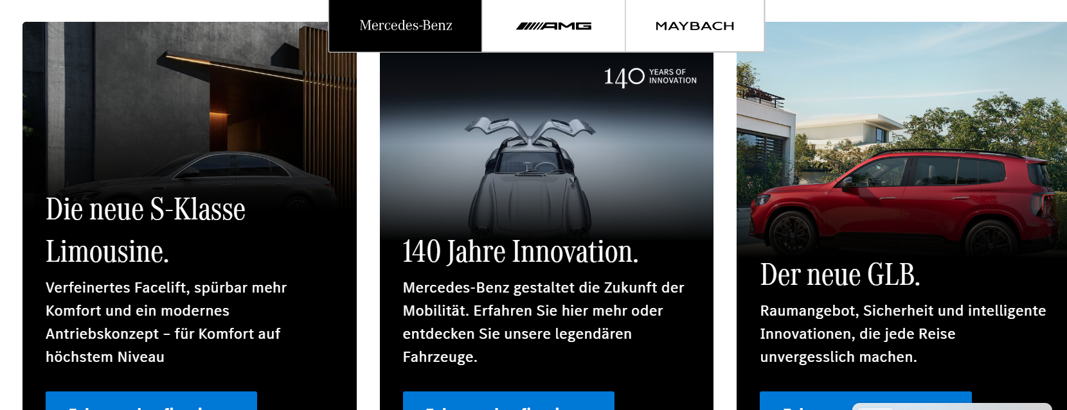
Soures: Mercedes-Benz Germany model portfolio illustrating multi-segment targeting (Mercedes-Benz Germany, 2024).
4.3 Positioning
In Germany, Mercedes-Benz is also working on the principle of positioning itself as The Best or Nothing, focusing on engineering excellence, safety, innovation, and sustainable luxury, which are reflected in the EQ range (Mercedes-Benz Group, 2023). In Bangladesh, it is the ultimate success, money, and exclusivity by exploiting extreme prices and scarcity to communicate social prestige. Competitive positioning aims at legacy and prestige instead of technical excellence (Haque and Sultana, 2021).
5.0 Comparison of International Marketing Mix (7Ps).
5.1 Product
Mercedes-Benz in Germany has a wide product line-up that cuts across various luxury automotive segments. It features small cars like the A-Class and B-Class, executive sedans like the C-Class, E-Class, and S-Class, a broad selection of SUVs in the category of GLA to GLS, high-performance AMG sports cars, the electric cars under the EQ brand, and luxury-ultra-luxury maybach cars (Mercedes-Benz Germany, 2024). German-market cars are focused on high-tech engineering, driving ability and the cutting-edge technology. A variety of innovations is implemented in most vehicles, including the MBUX Hyperscreen infotainment system, state-of-the-art driver-assistance technologies, and the advanced electric powertrains.
The range of products in Bangladesh is significantly smaller with respect to market size, lack of regulation and infrastructural value. They offer high-end luxury models mostly the S-Class that is a model that is perceived to be the pinnacle of prestige among the Bangladeshi elite market. SUVs like the GLE and GLC have become popular as well due to their high driving position and the fact that they are only suitable in the uneven road conditions in Dhaka (Choudhury, 2023). Certain real product modifications are also visible such as improved air-filtering systems to deal with urban contamination, increased comfort packages on rear seats to be used by chauffeurs and suspension reinforcement to deal with local roads. Fully electric models are still very few as there is no proper network of charging points and no powerful state temptatives toward the use of electric vehicles.
5.2 Price
In Germany, Mercedes Benz uses premium pricing strategy in line with its luxury brand positioning at the same time being competitive with its competitors like BMW and Audi. Pricing is fairly open and manufacturer suggested retail prices are clearly published and various financing options are offered to consumers. The wider range of professionals and business customers is enabled to use the brand through leasing programmes, corporate fleet plans, and flexible payment alternatives (Czinkota and Ronkainen, 2013). Also, a strong established certified pre-owned market would stabilise residual values and assist in developing long-term brand loyalty.
In Bangladesh, the level of pricing is drastically exaggerated because of the duties and taxes that the government has placed on imports. In Germany, a luxury model that costs approximately EUR100,000 would cost three to four times that price following the accruing duties, the additional taxes, value-added tax, and advance income tax (National Board of Revenue Bangladesh, 2023). Since Mercedes-Benz does not have any extensive official network of dealerships in the country, the cars are frequently imported via proper dealerships or other personal importation channels. The sources of finance are few, and buying is normally done by direct payment. This pricing system solidifies the exclusivity of the brand at the cost of the total demand in the market.
5.3 Place (Distribution)
Germany enjoys well established distribution systems. Mercedes-Benz has a large and spread over authorised dealership network with flagship brand centres situated in major cities. There is also the option of factory delivery to customers with production plants located in Sindelfingen and Bremen where the cars are delivered to the buyers. Over the recent years, the company has incorporated online buying instruments, online car configurators, and home deliveries into an omnichannel retail platform (Mercedes-Benz Group, 2023).
In Bangladesh distribution is much more restricted. The main channel is working on the local distributor Rancon Group where the sales are mainly based in Dhaka. The small size of the market and the complexity of the regulations do not encourage the large scale development of the dealership. This leads to a comparatively limited number of showrooms and after sales services rely heavily on imported spares, which has the effect of increasing lead times of maintenance.
5.4 Promotion
The German promotional strategies are based on integrated marketing communications. Mercedes-Benz focuses on heavy investment in the television ads, online campaigns, social networks, and sponsorship of cultural or sport events. Experience marketing is also noticeable, especially with the Mercedes-Benz Museum in Stuttgart, which enhances brand legacy and feelings towards the customers (Fill and Turnbull, 2019). Innovation, sustainability and high-performance engineering are often stressed in marketing communication.
Promotion activity is more selective and relationship based in Bangladesh. Since the target market is mostly high-net-worth and business elites, a strong marketing communication approach depends on personal networking and invitation-only events and personal relationship management (Choudhury, 2023). Advertising through mass media is low and brand prestige tends to be propagated by word of mouth within the powerful social and business networks.
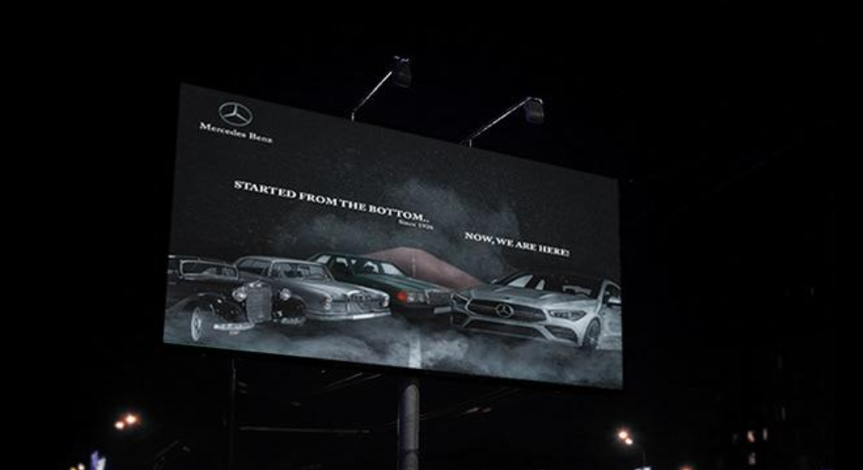
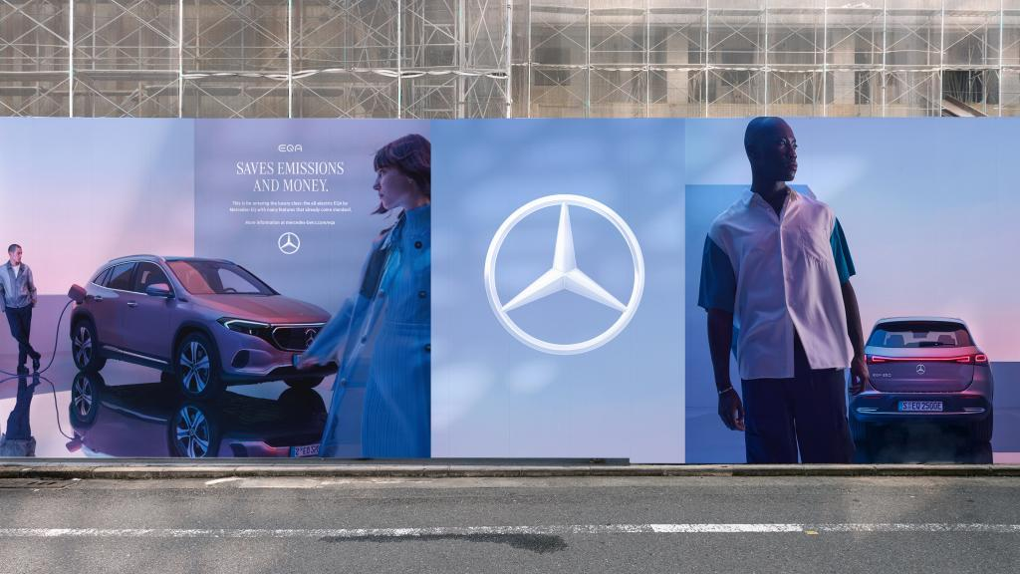

5.5 People
The professional knowledge and the technical skills form the people element of the marketing mix in Germany. The sales consultants are trained on internal programmes and have a good understanding of the specifications of the vehicles, the options of financing, and features of technology. The technicians serve with sophisticated diagnostic tools and are certified by manufacturers, which guarantees good quality of service throughout the dealership chain (Gronroos, 2015).
Bangladesh Customer relationships are more on individual relationship management than technical consultation. The value of trust and reputation in the elite consumer markets is demonstrated by the fact that sales representatives tend to build long-lasting personal relationships with clients. Although the service staff is supposed to deliver high-quality services, the scarcity of factory-trained technicians may at times compromise service delivery (Rahman, 2022).
5.6 Process
Germany is so much more standardised and technological in its operations process. Customers are able to design vehicles online, monitor progress of production digitally and deliver scheduled with well organized hand over processes. The service appointments are combined with digital records of maintenance and predictive service message, forming an effective and transparent customer experience (Mercedes-Benz Group, 2023).
Bangladesh is relatively less formalised in processes. The process of importing a car includes the process of going through the customs procedures, the computing of duties and the process of registration, which can make the process of delivery take a lot of time. The after-sales operations also rely on imported components and outside logistics, which lead to the increase of service turnaround times (Choudhury, 2023).
5.7 Physical Evidence
Physical evidence in Germany portrays the premium brand identity by having architecturally advanced dealerships in Germany that are designed following international retailing standards. Perceptions of engineering finesse and exquisiteness are strengthened in the luxurious customer lounges, branded merchandise and technologically upgraded showroom settings. Brand heritage and experiential engagement is further reinforced by the fact that there is the Mercedes-Benz Museum in Stuttgart (Mercedes-Benz Group, 2023).
The physical evidence environment in Bangladesh is less developed since the retail footprint is smaller in the country. In Dhaka, there are premium showrooms offering a sophisticated environment when it comes to vehicle display, yet the entire ecosystem of branded retail experiences is not very large. Therefore, the vehicles are the strongest physical manifestation of brand quality. The three-pointed star symbol is an iconic social marker of a social status of wealth and prosperity in the Bangladeshi community (Haque and Sultana, 2021).
6.0 Bangladesh Directional Development Strategy.
The Ansoff Matrix (Ansoff, 1957) can be used to analyse the directional development strategy of the Mercedes-Benz in Bangladesh. The company has mainly pursued a market development strategy whereby it has moved into a new geographic market with its current luxurious vehicle portfolio.
Mercedes-Benz has taken a safe entry strategy founded on indirect exporting via authorised distributors instead of setting up a wholly owned subsidiary. This plan transfers the financial risk in the market that is associated with regulatory complexity, limited sales volume, and political uncertainty (Hollensen, 2020). Practically, the brand is run by the local company Rancon Group, which offers market insight and already developed business contacts when the producer keeps the brand levels with the help of the distributors contracts ( Rancon Group, 2023).
Growth wise, the strategy also indicates the gradual market penetration in the small yet growing luxury market of the country. Though the amount of potential buyers is still low, there is the opportunity to appeal to the high-net-worth consumers who already buy competitor luxury cars or are not in the high-end car market yet. Empowering after sales services, building brand awareness, and establishing long-term relationships with the customers are thus at the core of the expansion strategy of the company (Doole and Lowe, 2012).
There is still, however, a limitation of product development opportunities by infrastructure and policy conditions. Electric vehicles, which is one of the key parts of the global strategy of Mercedes-Benz, is impeded by such factors, as the absence of charging stations and incentives (Asian Development Bank, 2023). The Bangladesh strategy therefore takes the current focus on traditional luxury models which may fit the current market environment.
7.0 Marketing Mix Ethical Issues.
The marketing operations of Mercedes-Benz in Germany and Bangladesh presuppose several ethical concerns, which should be carefully thought of. These issues are associated with consumption of luxuries, fashionable distribution, and eco-friendliness. The assessment of such problems will allow evaluating the consistency of global marketing strategies of the company with the principles of responsible and sustainable business practices.
7.1 Bangladesh Ethical Issues.
Promotion of conspicuous luxury consumption happens to be one of the most prominent ethical issues in Bangladesh. Nevertheless, in spite of consistent economic growth, the number of people living below the national poverty line remains at 18.7 percent, as reported by the World Bank (2024). Imports of luxury cars into the country have an average price of BDT 3-8 crore including duties and taxes. Advertising goods of this high price point in a nation where there is a high level of socio-economic disparity begs the question on whether marketing luxury products is socially responsible or not (Kapferer and Bastien, 2012). Extravagant demonstrations of the wealth due to the ownership of luxurious vehicles can contribute to the aggravation of social tensions and strengthen the current class divisions.
One more ethical problem is transparency in pricing and channels of importing vehicles. Bangladesh does not depend on an authorised manufacturer distribution network but on the private importers and parallel import markets to a large extent. These parallel channels are not always open with respect to compliance with duties and vehicle history, compliance of the warranty and after sales services (Rahman, 2022). Though it is not in direct control of such grey market transactions, the brand has an ethical duty to save the consumer against any misleading efforts and provisions of vehicles with the name Mercedes-Benz to satisfy the necessary safety and quality standards.
There is also a significant issue concerning environmental ethics. Mercedes-Benz in Germany is a company that focuses much on sustainability communication, electrification, and carbon footprint promises. Nevertheless, marketing efforts in Bangladesh refer to the environmental responsibility much less. This disparity could give an impression that sustainability communications are used selectively based on consumer expectations. The scholars believe that marketing ethically needs to be aligned to ongoing reporting on environmental issues across markets, but not just emphasise sustainability in those areas where consumers have pressure (Crane and Matten, 2020).
7.2 Ethical Issues in Germany
At Mercedes-Benz in Germany, the company has been ethically questioned concerning the controversial diesel emissions. The German Federal Motor Transport Authority initiated investigations that resulted in regulatory measures after the company was ordered to recall over 280, 000 vehicles because of emission compliance concerns (Kollewe, 2019). These accusations posed some serious ethical concerns about the claims of marketing on environmental performance especially since much emphasis on environmental efficiency had been highlighted in marketing campaigns.
Moreover, environmental lobby groups like Greenpeace (2022) have attacked the sustainability marketing of the company. Opinions differ, critics of electric mobility state that it may be a kind of greenwashing to promote electric mobility and still offer large high-emission SUVs and high-performance models. This case raises a moral conflict between the true environmental concern and marketability of high-performance cars.
8.0 Recommendations
As per the above discussion, there are a number of recommendations that can enhance the international marketing strategy of Mercedes-Benz.
To begin with, the company must consider setting up a formal representative office or joint venture in Bangladesh to have more control of the brand representation, service quality, and customer experience. The closer direct presence would put the brand in a favorable position to as the high-income consumer base in Bangladesh is steadily increasing (Hollensen, 2020).
Second, Mercedes-Benz ought to invest in accredited after sales service facilities in Bangladesh. Having certified service centres equipped with trained technicians and good availability of parts would go a long way in enhancing customer trust and satisfaction in the long run of owning the vehicles (Gronroos, 2015).
Third, the company must produce culturally sensitive marketing messages that resonate with the local cultures like family status, business performance, and social leadership as well as incorporating messages on sustainability and corporate citizenship (De Mooij, 2019).
Lastly, Mercedes-Benz needs to enhance the credibility of its sustainability stance across the world by speeding up the electrification process and guaranteeing that the environmental performance analyses described in marketing communicative messages have quantifiable and demonstrable improvements (Crane and Matten, 2020).
9.0 Conclusion
This comparative study illustrates that Mercedes-Benz uses a hybrid approach of international marketing, that is, global standardisation and local adaptation in Germany and Bangladesh. The brand has a stable worldwide identity that revolves around luxury, engineering perfection, innovation and prestige that is evident through its core values, high-end positioning and quality. Nevertheless, the delivery using the marketing mix is adjusted to the local market conditions.
Mercedes-Benz has a more or less standardised multi-sector approach in Germany, a fully developed and highly competitive market, with stringent environmental policies. It has got a wide range of products, widespread dealership coverage, transparent pricing and combined promotions with a focus on technology, sustainability, and performance. The company is used to the high-importation duties, small market size, infrastructure bridge and the cultural connotation of the luxury in Bangladesh. The brand is being positioned as an ultra-exclusive status symbol, whereby targeting has been narrowed down, distribution selective, and promotion of the brand based on relationships, where prestige, family reputation and business success are emphasized.
These results are in line with the international marketing theory: no full standardisation and no complete adaptation is adequate. The key to sustainable success in the long-term lies in global brand consistency in line with local responsiveness, especially as Mercedes-Benz moves towards sustainable luxury and electric mobility.
Section 2: Reflective Account
Reflective Account Gibbs Reflective Cycle.
Description
In this evaluation, I was given the responsibility to compile an extensive report of comparing the international marketing strategies by Mercedes-Benz in Germany and Bangladesh. The methodology followed in conducting the research was to collect information using academic textbooks, journal articles, industry reports, and government publications, and trustworthy online resources. I used existing marketing models such as PESTEL, STP, the marketing mix of 7Ps, Ansoff Matrix as well as cultural dimensions by Hofstede to organize the analysis. This took a few weeks, and it was a series of research, analysis, draft, and revision.
Feelings
I was at first excited and feared the task. I found the selection of Bangladesh and Germany interesting due to the strong difference between the two markets, but I feared the accessibility of academic literature that specifically covered the luxury automobile market in Bangladesh. This was one of the issues that turned out to be not fully unfounded; whereas the data concerning the German automotive market was easy to acquire, obtaining the truthful, peer-reviewed information about the activity of Mercedes-Benz in Bangladesh demanded much more effort and ingenuity in the methodology. One of the frustrations I met when carrying out the PESTEL analysis was the struggle to locate existing and verifiable information on the exact import business tactics of Bangladesh because in many instances information was not easily located in a single governmental document. I was however beginning to experience a sense of achievement as the comparative analysis was formed and significant points could be made by the juxtaposition of these two vastly different markets.
Evaluation
A number of features of the research and analysis process were successful. The use of the proven marketing models gave a sense of order and guaranteed a thorough approach to the factual factors. PESTEL framework was specifically useful in helping to systematically identify and compare macroenvironmental variables in order to see how deep political and economic variables influence the market strategy of Mercedes-Benz in Bangladesh relative to Germany. Application of the cultural dimensions framework by Hofstede added a lot of value to the cultural analysis offering theoretical basis to differences in consumer behaviour.
Some difficulties were however experienced. Due to the constrained range of Bangladesh-specific academic literature on the topic of luxury automotive marketing, some of the analysis was based upon wider research on luxury consumption in the developing economies and supported by industry reports and the news coverage. This would have lowered the specificity and academic rigour of some arguments. I also tried to make the report as comprehensive as possible at the beginning and this was not feasible given the word limit. Choosing where to give more in-depth coverage was very enduring editorial choices that I had to face and eventually I decided the best way forward would be with the comparisons of cultural and marketing mix because it would be the most analysis-intensive part.
Analysis
Taking a retrospective look at the process through the wider learning theories, I realise that the process demanded what Bloom would classify using his taxonomy as higher-order cognitive skills namely analysis, evaluation, and synthesis (Bloom et al., 1956). The task being comparative did not just call out the description of each market, but the need to identify significant patterns, describe cause-effect relations, and produce evaluative judgment regarding the effectiveness of the strategies.
The study exercise revealed that triangulation is critical in international marketing studies. The use of the single type of sources would have provided an incomplete picture; the synthesis of the academic theory, government statistics, industry analysis, and journalistic reporting made a stronger basis to rely on in terms of the analysis. This experience helped me reaffirm my belief regarding the weaknesses of desk-based international marketing research and the benefit that primary research methods like interviews with Mercedes-Benz distributors in Bangladesh would provide.
I also noted the issue on the ground that might require western-based marketing systems to be implemented in non-western settings, which is of concern to such scholars like De Mooij (2019). The 7ps model, though effective in terms of arranging the comparison, was occasionally not sufficient to explain the abstract, inter-relations-based luxury marketing in Bangladesh where informal networks and personal contacts make their mark but cannot be categorised as the branches of the marketing mix.
Conclusion
Such an evaluation has enriched my perception of the complexity that exists in international marketing strategy. The greatest learning outcome is that effective international marketing goes beyond mere standardisation-adaptation adjudication; it needs to be based upon basic brand reconstruction, customer value generation, and competitive alignment to every market scenario. As evidenced by the case of Mercedes-Benz, even the most globally recognised brands have to work through the deepest local variations in the economic conditions, cultural values, regulatory environments, and infrastructure that dictate all the aspects of the marketing mix.
I have also been taught to be very critical about the sources that I go through, especially when doing research work on a new market where the quality and availability of data might not be dependable. It has helped me to improve my academic writing skills especially in the ability to synthesise information in various sources into a well-coherent and argumentative analysis.
Action Plan
Gaining research skills in future, I will develop the technique of systematic literature search, including the regional databases, government and industry sources, and non-English materials, in order to expand horizons. To reinforce the depth of the analysis, I will use several cultural frameworks, including the GLOBE study and the model created by Trompenaars, as well as Hofstede, as this way, cross-cultural analyses will be robust.

The time management processes will be enhanced by the better definition of milestones when data collection, analysis, drafting, and revision should be conducted to conduct more critical evaluation and decrease dependence on descriptive writing. To enhance relevance and originality, I will supplement small-scale primary research, which will include interviewing practitioners, distributors or consumers, with secondary research.
The acquired skills (PESTEL, STP, and marketing mix analysis) can be applied to the marketing field, the consulting field, and the strategic planning field, where they assist in decisions concerning the market entry. In addition to my studies, this assessment has enhanced my comparative environment, evidence, and critical interpretation skills in cultural, regulatory, and social influences of consumer behaviour and business strategy.
References
Alam, M. (2022) 'Urban air quality and transportation policy in Dhaka: challenges and prospects', Journal of South Asian Development, 17(2), pp. 198-221.
Ansoff, H.I. (1957) 'Strategies for diversification', Harvard Business Review, 35(5), pp. 113-124.
Asian Development Bank (2023) Bangladesh Transport Sector Assessment. Manila: ADB Publications.
Bangladesh Bureau of Statistics (2023) Statistical Yearbook of Bangladesh 2023. Dhaka: Ministry of Planning.
Bangladesh Telecommunication Regulatory Commission (2023) Annual Report 2022-2023. Dhaka: BTRC.
Bloom, B.S., Engelhart, M.D., Furst, E.J., Hill, W.H. and Krathwohl, D.R. (1956) Taxonomy of Educational Objectives: The Classification of Educational Goals. Handbook I: Cognitive Domain. New York: David McKay.
Choudhury, T. (2023) 'Luxury automobile market dynamics in Bangladesh', South Asian Business Review, 8(1), pp. 45-62.
Crane, A. and Matten, D. (2020) Business Ethics: Managing Corporate Citizenship and Sustainability in the Age of Globalization. 5th edn. Oxford: Oxford University Press.
Czinkota, M.R. and Ronkainen, I.A. (2013) International Marketing. 10th edn. Mason, OH: Cengage Learning.
De Mooij, M. (2019) Global Marketing and Advertising: Understanding Cultural Paradoxes. 5th edn. London: SAGE Publications.
De Mooij, M. (2019) Global Marketing and Advertising: Understanding Cultural Paradoxes. 5th edn. London: SAGE Publications.
Doole, I. and Lowe, R. (2012) International Marketing Strategy. 6th edn. London: Cengage Learning.
Economist Intelligence Unit (2023) Germany Country Report Q4 2023. London: EIU.
European Commission (2023) Euro 7 Motor Vehicle Emission Standards. Brussels: European Commission.
Federal Ministry for Economic Affairs and Energy (2023) National Platform for Electric Mobility: Progress Report. Berlin: BMWi.
Fill, C. and Turnbull, S. (2019) Marketing Communications: Touchpoints, Sharing and Disruption. 8th edn. Harlow: Pearson Education.
Greenpeace (2022) Greenwash Alert: European Automotive Industry Sustainability Claims. Amsterdam: Greenpeace International.
Grönroos, C. (2015) Service Management and Marketing: Managing the Service Profit Logic. 4th edn. Chichester: John Wiley & Sons.
Haque, A. and Sultana, S. (2021) 'Luxury consumption behaviour in Bangladesh: the role of social status and cultural identity', Asian Journal of Business Research, 11(3), pp. 78-95.
Hofstede Insights (2023) Country Comparison: Germany and Bangladesh. Available at: https://www.hofstede-insights.com/country-comparison/ (Accessed: 15 January 2025).
Hollensen, S. (2020) Global Marketing. 8th edn. Harlow: Pearson Education.
International Monetary Fund (2024) World Economic Outlook: January 2024 Update. Washington, DC: IMF.
Johnson, G., Whittington, R., Regnér, P., Angwin, D. and Scholes, K. (2020) Exploring Strategy: Text and Cases. 12th edn. Harlow: Pearson Education.
Kapferer, J.N. and Bastien, V. (2012) The Luxury Strategy: Break the Rules of Marketing to Build Luxury Brands. 2nd edn. London: Kogan Page.
Kollewe, J. (2019) 'Mercedes-Benz owner Daimler to pay €870m fine over diesel cheating', The Guardian, 24 September.
Kotler, P. and Keller, K.L. (2021) Marketing Management. 16th edn. Harlow: Pearson Education.
Mercedes-Benz Germany (2024) Model Range and Pricing. Available at: https://www.mercedes-benz.de (Accessed: 15 January 2025).
Mercedes-Benz Group (2023) Annual Report 2022. Stuttgart: Mercedes-Benz Group AG.
Ministry of Environment, Forest and Climate Change Bangladesh (2023) Bangladesh Environmental Policy Review. Dhaka: Government of Bangladesh.
National Board of Revenue Bangladesh (2023) Customs Tariff Schedule 2023-2024. Dhaka: NBR.
Rahman, M. (2022) 'Market entry challenges for luxury brands in Bangladesh', International Journal of Emerging Markets, 17(4), pp. 512-530.
Rancon Group (2023) Corporate Profile and Brand Partnerships. Available at: https://www.rancongroup.com (Accessed: 15 January 2025).
Solomon, M.R., Bamossy, G.J., Askegaard, S. and Hogg, M.K. (2019) Consumer Behaviour: A European Perspective. 7th edn. Harlow: Pearson Education.
Statista (2024) Automotive Industry in Germany: Statistics and Facts. Available at: https://www.statista.com (Accessed: 15 January 2025).
Statistisches Bundesamt (2024) National Accounts: Gross Domestic Product 2023. Wiesbaden: Federal Statistical Office.
World Bank (2024) Bangladesh Development Update. Washington, DC: World Bank Group.
Mercedes-Benz Germany, 2024. Model portfolio illustrating multi-segment targeting. Mercedes-Benz Deutschland official website. Available at: https://www.mercedes-benz.de/ [Accessed 26 March 2026].
World Bank, 2024. GDP growth (annual %) – Bangladesh. World Bank Open Data. Available at: https://data.worldbank.org/indicator/NY.GDP.MKTP.KD.ZG?locations=BD [Accessed 26 March 2026].

