

Improving Upon an Existing
Electrokinetic Dewatering Solution
For Cattle Slurry

Project submitted as part of the requirements for the award of MEng Computer System and Electronics (Applied Environmental Engineering)

Group Project

Written by Feran Kanda, Liam Thomas, James Neucker, Rhys Miller
May 2018

Abstract
Most dairy farms currently store their cattle slurry in large storage tanks, which produce substantial amounts of methane especially in warm conditions. Due to the large amounts of methane produced the risk of asphyxiation is real. The amount of slurry that is produced is large and requires large storage tanks to contain the waste.
Last year’s student’s developed a reactor in an attempt to combat this issue. Using electro kinetic dewatering they were able to extract some of the water from the slurry. However, their design contained several issues causing the reactor to not perform optimally.
Due to flaws in the reactor design it was calculated that 50.07% of the slurry that was loaded into their reactor was not undergoing the electro kinetic process, therefore heavily affecting the efficiency of the design.
The initial design wasn’t implemented due to time constraints, but the secondary design that was implemented still resolved the issues that were present. The issues were resolved by introducing a gravel filter between the bottom of the anode and the mesh filter to prevent the mesh from clogging and adding a cap to the bottom of the anode. This allowed for a greater percentage of the slurry to undergo the process.
Several methods for potential control systems that could be implemented into the new design were discussed, as well as feasibility of renewables to power the process.
The results gained from the new design prove that the issues were resolved. The new design extracted 40.06% more water in 58.43% less time. Over a 90-minute period where 30 Watts of power has been consumed by the reactor, 225ml was collected compared to the result of 49ml from the previous year, resulting in a 456% efficiency increase. The H-S theory explaining the movement of water throughout the reaction, was also proved using the XRF results that showed the distribution of aluminium and iron in the dry and wet samples.
The final tests provided unexpected results due to the exhaustion of the electrodes, causing multiple holes in the walls of the Cathode. For further testing to continue the reactor will require new electrodes as the current electrodes are no longer fit for purpose.

Acknowledgements
We would like to express our gratitude to the University of Wales Trinity Saint David (UWTSD) Swansea for the opportunity of our studies to progress throughout the completion of our 4-years towards a Master’s Degree in Engineering.

The group sincerely convey our gratefulness to Dr Gary Jones and Matt Hunt for their continuous support through the entire duration of the project.

The group would like to express its sincerest thanks towards Professor Phil Morgan and everyone at Power&Water for providing the opportunity and experience of working alongside an environmental company.

Thanks, are owed to Sergio Garate Poyanco for allowing use of his lab and providing us with equipment to aid us throughout the duration of the project whenever it was required.

Thanks go to Dr Steve Mosey and Andrew Thorn for their contribution to the course providing information necessary to the project.

Our gratitude goes to John Owen, the manager of Gelli Aur Farm for providing advice and allowing access to the farm whenever needed.

Thanks go to Dr Kath Ficken at Swansea University for her assistance with the analysis of the water sample through the use of XRF.

Disclaimer
Each section in the chapter is labelled to state the individual contribution to the report of all the members. Supported solo documents are also provided alongside this thesis. Each section of the chapters will be labelled with as follows:
(FK) – Feran Kanda
(LT) – Liam Thomas
(JN) – James Neucker
(RM) – Rhys Miller
(Group) – Worked as a group

Declaration
As a group, we, Feran Kanda, Liam Thomas, James Neucker and Rhys Miller, declare that we are the sole authors of this Project; that all references cited have been consulted; that we have conducted all work of which this is a record, and that the finished work lies within the prescribed word limits. This work has not previously been accepted as part of any other degree submission.

Signed: ......................................................... (FK)

Signed: ......................................................... (LT)

Signed: ......................................................... (JN)

Signed: ......................................................... (RM)

Date: ...............................................

Form of Consent
We, Feran Kanda, Liam Thomas, James Neucker and Rhys Miller hereby consent that our Project, submitted in candidature for the MEng Computer Systems and Electronics (Applied Environmental Engineering) degree, if successful, may be made available for interlibrary loan or photocopying (subject to the law of copyright), and that the title and abstract may be made available to outside organisations.

Signed: ...............................................……… (FK)

Signed: ....................................................... (LT)

Signed: ....................................................... (JN)

Signed: ....................................................... (RM)

Date: ...............................................
Contents
Abstract 2
Acknowledgements 3
Declaration 5
Form of Consent 6
Table of Figures 10
Table of Tables 13
Table of Equations 14
Introduction 15
Farm (LT) 17
Current Treatment Process and Previous Work (LT) 17
Literature Review 18
Hydraulic Head Pressure (LT) 18
Hydraulic Gradient (LT) 18
Hydro Power (LT) 19
Turbines (LT) 20
Costing Considerations (LT) 24
Environmental Considerations (LT) 24
Conclusion (LT) 25
Solar (FK) 26
The Photovoltaic Array 26
PV system sizing 26
Environmental impact and safety of PV systems 27
PV array investigation at a farm in Loughborough 27
PV systems reduce the cost of power 27
Methods of Control (RM) 29
Open-Loop Systems (RM) 29
Closed-Loop Systems (RM) 29
Fertilizers & Their Makeup (RM) 30
Energy content in Slurry (RM) 32
Biomass Hazards (RM) 34
Micro Grid (FK) 35
Types of Micro-grid (FK) 36
Hybrid system 38
Biomass (FK) 39
United Nations Environment Programme (FK) 39
Agriculture Biomass (FK) 40
Environmental Issues (FK) 40
Converting Biomass to Energy (FK) 41
Bioenergy (FK) 42
Anaerobic fermentation (FK) 44
Hydraulic Permeability (JN) 47
Hydraulic Conductivity (JN) 48
pH Gradient (JN) 49
Physical Property Changes (JN) 50
Helmholtz-Smouluchoski Theory (JN) 51
Electrophoresis (JN) 53
Filtration (RM) 55
Sand Filters (RM) 56
Test of 2016 – 17 System 58
Design (JN) 59
2016-17 Design 59
New Design Requirements 63
Initial Design 1 64
Design 1 Analysis 66
Design 2 Analysis 66
Design 3 Analysis 68
Feasibility of Renewable Energy Resources 71
Hydro (LT) 71
Costing (LT) 71
Considerations (LT) 72
Wind (JN) 73
Potential Control Systems 77
Limiting Current & Reversing Polarity (RM) 77
Brief Background Research (RM) 78
Components (RM) 83
Block Diagram & Flow Chart (RM) 85
Circuit Design (RM) 87
Circuit Schematic (RM) 88
PCB Design (RM) 89
Controlling Flow Rate (LT) 91
Flow Rate (LT) 91
Pressure (LT) 94
Summary (LT) 95
Implementation 96
Purchasing new parts (Group) 96
Disassembly & Reassembly (Group) 98
Preparation (Group) 99
XRF Analysis (Group) 100
Tests & Results 102
Week 1 102
Test 1 (Group) 102
Test 2 (Group) 106
Test 3 (Group) 109
Test 4 (Group) 112
Test 5 (Group) 115
Week One Testing Results (Group) 119
Week One Results Compared to Previous Year’s (Group) 120
Week 2 121
Test 1 (Group) 121
Test 2 (Group) 123
Test 3 (Group) 125
Test 4 (Group) 128
Test 5 (Group) 131
Test 6 (Group) 135
Week 2 Testing Results (Group) 138
Overall XRF Analysis (Group) 138
Reactor (Group) 142
Cathode deteriorating (Group) 144
Conclusions 149
Conclusion 149
Reflection 150
Future Improvements 151
References 153

Table of Figures
Figure 1 - Last Year’s Reactor (2) 17
Figure 2 - Hydro Usage in the UK (8) 19
Figure 3 - Archimedean Screw (11) 20
Figure 4 - Crossflow Turbine (12) 21
Figure 5 - Kaplan Turbine (13) 21
Figure 6 - Pelton Turbine (15) 22
Figure 7 - Francis Turbine (16) 23
Figure 8 - Turbine Chart Power-Head-Flow (17) 24
Figure 9 - Gelli Aur (18) 25
Figure 10 - Photovoltaic Array & alternative energy sources (78) 26
Figure 11 - Output Results of Photovoltaic arrays, source (20) 28
Figure 12: Example of an Open-Loop system (69) 29
Figure 13: Example of a Closed-Loop system (69) 29
Figure 14: An example of thermal energy using biomass as fuel (27). 32
Figure 15 - Driving integrated energy solution on and off (micro-grid) 35
Figure 16 - (a) Potential Converter Location, (b) Conventional AC Technology, (c) DC Microgrid. Source: (33) 36
Figure 17 - Configuration of DC Microgrids. Source: (82) 37
Figure 18 - Comparison table of AC and DC Microgrids. Source (82) 37
Figure 19 - Solar & Wind Hybrid system. Source: (34) 38
Figure 20 - Biomass Energy. Source: (81) 39
Figure 21 - Landfill Waste. Source: (80) 39
Figure 22 - Agriculture Waste. Source: (79) 40
Figure 23 - Biomass conversion to Energy. Source: (37) 41
Figure 24 - Level of Use for Energy Conversion. Source: (37) 42
Figure 25 - Table Source and forms of bioenergy. Source: (38) 43
Figure 26 - Applied technologies to transform biomass into secondary energy source. Source: (40) 43
Figure 27 - Biochemistry of methane gas production. Source: (40) 45
Figure 28 - Most commonly used anaerobic reactors type: (A) Completely mixed anaerobic digester, (B) UASB reactor, (C) AFB reactor, (D) Up flow AF reactor. Source: (38) 46
Figure 29 : Fluid Velocity Distribution 51
Figure 30: An example of a Mixed-Media filter consisting of Anthracite, Sand & Gravel (48). 55
Figure 31: Example of a Recirculating Sand Filter (52). 56
Figure 32 - Beaker & Reactor 58
Figure 33 – The previous Reactor 58
Figure 34 - Weighing the Slurry 58
Figure 35 : 2016-17 Reactor 62
Figure 36 : Design 1 65
Figure 37 : Design 2 67
Figure 38 : Design 3 Final 69
Figure 39: Rendered Image of Reactor 3 70
Figure 40 - Annual Max Flow Rates for Towy River at Ty Castell (53) 71
Figure 41 - Installation and Maintenance Costs of Hydro Schemes (54) 71
Figure 42 - Installation Costs Compared to Head Height (54) 72
Figure 43 :HAWT 73
Figure 44 : VAWT 74
Figure 45 : Average Wind Speeds Carmarthen 2017 (55) 74
Figure 46: Example of a PIC (70) 78
Figure 47: An example of a Double Pole Double Throw Relay (58) 79
Figure 48: Example of a 555 Timer (59) 80
Figure 49: Example of a Digital Potentiometer (75) 81
Figure 50: Example of a DC/DC Converter (61) 82
Figure 51: PIC16F887 & Datasheet (72) 83
Figure 52: 40.52.7.024.0000 DPDT Relay (73) 83
Figure 53: LM555CM Timer (74) 83
Figure 54: PR2 Soil Moisture Profile Probe & Datasheet (71) 84
Figure 55: LM2673T DC/DC Converter (77) 84
Figure 56: AD5220BN10 Digital Potentiometer (76) 84
Figure 57: Block Diagram for Control System 85
Figure 58: Flow Chart for Control System 86
Figure 59: Circuit Design for Current Limiting & Reverse-Polarity Control System in Proteus 87
Figure 60: Circuit Schematic of Current Limiting & Reverse-Polarity Control System in easy-pc 88
Figure 61: PCB Design of Current Limiting & Reverse Polarity Control System in easy-pc 89
Figure 62: 3D Model of Complete PCB Design for Current Limiting & Reverse Polarity Control System in easy-pc 90
Figure 63- Bernoulli's Equation (63) 91
Figure 64 - Turbine Flow Meter (65) 92
Figure 65 - Optical Flow meter (66) 92
Figure 66 - Insertion Style Optical Flow Meter (66) 93
Figure 67 - Ultrasonic Flow Meter (67) 94
Figure 68 - Hydraulic Force (68) 95
Figure 69: Purchased Nuts & Bolts 96
Figure 70: Purchased Outer Pipe 96
Figure 71: Purchased Anode 97
Figure 72: Disassembled Top & Bottom half of the reactor 98
Figure 73: New Reactor Design Constructed 98
Figure 74 - Slurry Sample 99
Figure 75 - Samples in test tubes 100
Figure 76 - XRF sample Discs 100
Figure 77 - Inside the XRF machine 101
Figure 78 - Loading the XRF machine 101
Figure 79 - XRF Machine in operation 101
Figure 80 – Week 1 Test 1 Graph 102
Figure 81 - Week 1 Test 1 Samples 103
Figure 82 – Week 1 Test 2 Graph 106
Figure 83 - Week 1 Test 2 Wet & Dry Samples 107
Figure 84 - Anode after Test 2 107
Figure 85 – Week 1 Test 3 Graph 109
Figure 86 - Week 1 Test 3 Water and Dry Samples 110
Figure 87 - Anode after Test 3 110
Figure 88 – Week 1 Test 4 Graph 112
Figure 89 - Week 1 Test 4 Water and Dry Samples 113
Figure 90 – Week 1 Test 5 Graph 115
Figure 91 - Week 1 Test 5 Water and Dry samples 116
Figure 92 – Week 2 Test 1 Results 121
Figure 93 - Reactor Filled with Slurry 122
Figure 94 - Reactor Gravity Test 122
Figure 95 - Week 2 Test 2 Graph 123
Figure 96- Week 2 Test 3 Graph 125
Figure 97 - Week 2 Test 3 Samples 126
Figure 98 - Reactor covered with Condensation Bag 126
Figure 99 - Week 2 Test 4 Graph 128
Figure 100 – Week 2 Test 4 Water Sample 129
Figure 101 - Week 2 Test 5 Graph 131
Figure 102 - Cathode Bubbling 132
Figure 103 - Hole in the Cathode 133
Figure 104 - Week 2 Test 5 Water Sample 133
Figure 105 - Week 2 Test 6 Graph 135
Figure 106 - Week 2 Test 6 Samples 136
Figure 107 : Aluminium Content Dry Sample 139
Figure 108 : Aluminium Content Wet 139
Figure 109 : Iron Content Dry 140
Figure 110 : Iron Content Wet 140
Figure 111 – The Anode 142
Figure 112 - The Anode & Seal cap off 142
Figure 113 - The Anode & Seal cap on 143
Figure 114 - Old Anode Vs New Anode 143
Figure 115 - System Sealed with Duct Tape 144
Figure 116 - System without Duct Tape 145
Figure 117 - System Swelling 145
Figure 118 - System Swelling on the Right 146
Figure 119 - Hole in the System 146
Figure 120 - Another hole on the opposite side of the system 147
Figure 121 - Inside the system (Cathode) 147
Figure 122 - Shining light through the deteriorated hole 148

Table of Tables
Table 1 - Summary of Turbines 23
Table 2 - Week 1 Test 1 Results 102
Table 3 - XRF Results Week 1 Test 1 104
Table 4 – Week 1 Test 2 Results 106
Table 5 - XRF Results Week 1 Test 2 108
Table 6 – Week 1 Test 3 Results 109
Table 7 - XRF Results Week 1 Test 3 111
Table 8 – Week 1 Test 4 Results 112
Table 9 - Week 1 Test 4 XRF Results 114
Table 10 - Week 1 Test 5 Results 115
Table 11 Test 5 XRF results 117
Table 12 - Week 1 Results 119
Table 13 - Week 1 and Last Year’s Results 120
Table 14 – Week 2 Test 1 Results 121
Table 15 - Week 2 Test 2 Results 123
Table 16 - Week 2 Test 3 Results 125
Table 17: Week 2 Test 3 XRF 127
Table 18 - Week 2 Test 4 Results 128
Table 19 : Week 2 Test 4 130
Table 20 - Week 2 Test 5 Results 131
Table 21 - Week 2 Test 5 XRF Results 134
Table 21 - Week 2 Test 6 Results 135
Table 22 - Week 2 Test 6 XRF Results 137
Table 22: Week 2 Results 138

Table of Equations
Equation 1 - Hydraulic Head Pressure 18
Equation 2 - Hydraulic Gradient 18
Equation 3: Reduction in pore water pressure (42) 47
Equation 4 : Darcy's Law 48
Equation 5 : H-S Equation 52
Equation 6 : Electric Field Strength 52
Equation 7 : Oxidation Reaction 53
Equation 8 : Reduction Reaction 53
Equation 9 : Coulombs Law 53
Equation 10 : Coulombs Force 54
Equation 11 : Coulombs Force (Rearranged) 54
Equation 12 : Force Due to Friction 54
Equation 13 : Equilibrium of Forces 54
Equation 14 : H-S Equation 59
Equation 15 : Prime Mover 75
Equation 16: Cycle Time of a 555 Timer (60) 80

Introduction
Dairy farms with hundreds of cows produce a lot of slurry, which consists of cattle manure, hay, straw and a large percentage of water that accumulates from the wash down of the milking parlours after each milking. The slurry is then usually stored in tank, where it then collects more water as a result of rainfall entering the slurry drainage system. Storage of this slurry is dangerous as the stored waste can produce large quantities of Methane in warm conditions, the production of Methane results in the presence of a potentially explosive atmosphere. When there is a high percentage of Methane in the atmosphere the risk of asphyxiation is increased providing the airflow to the location is not high enough to vent the gas. The combination of the large volume and the potential hazards mean that the storage and disposal of cattle slurry is costly with this project aimed at reducing the risk and costs by investigating the potential impacts of electro kinetic dewatering of the slurry.
Previous work has been completed to provide potential solutions to the problems discussed above, this included the construction and testing of an electro kinetic dewatering reactor which was built with the aim of reducing the water content of the slurry that was produced on the Gelli Aur Farm in partnership with Power and Water, and UWTSD. With the reduced water content, it is thought that the production of Methane from dewatered waste would be reduced along with the associated hazards and a reduction in the volume of storage area would be achieved.
The aim for this project was to improve on the existing design for electro kinetic dewatering of cattle slurry that was produced by last year’s students and to investigate the potential of the new design over a greater range of operating conditions to highlight the optimum operating limits.
The original design had several issues causing inefficiencies most notably the reaction chamber of the original reactor did not provide a uniform distribution of an electric field in which the saturated waste was exposed to, this resulted in a significant amount of the waste not being subjected to the dewatering process.
The goal was to attempt to remove as many as these inefficiencies as possible by redesigning the current reactor with the main target of producing a reaction chamber that would provide a uniformly distributed electric field in which the waste could dewater in with the greatest efficiency. Further improvements to the original design include designing some potential control systems to maintain a uniform flow of slurry, a consistent supply of current to the electrodes or reversing polarity to extend the lifetime of the electrodes. The design process will also consider various methods of powering the system with renewable energy, to further reduce environmental impact.
Background Research

Farm (LT)
Coleg Sir Gar Gelli Aur farm is a dairy farm is located in the Twyi valley in Llandelio. The farm has over 500 cows, 400 of which are dairy cows which are divided into two 200 herds. There is also a small beef enterprise and 400 breeding Ewes.
Since it is part of Coleg Sir Gar, Gelli Aur is also a place of study where student come to learn agricultural engineering and other countryside related studies. It is also home to the Farm Resource Centre which houses The Dairy Development Centre (DDC). The DDC aims to improve the Welsh dairy industry. (1)

Current Treatment Process and Previous Work (LT)
There is currently no treatment process in place at the farm, the excrement is washed to the end of the barn and then scraped out into channels. The slurry is then pumped into one of two towers, which have a combined volume of 2327.2m³.
Last year’s students designed an Electro kinetic dewatering system. This system would remove the water from the slurry by running an electric current through it using two electrodes. The reactor consisted of an aluminium cylinder being used as the cathode and a smaller diameter steel anode which went inside the cathode. The anode was attached to cathode using a threaded nylon rod. Two flanges then connected the outside electrode to a tap. Above the entrance to the tap was a filter to prevent any solids escaping through the tap.
When powered on the electric current would draw the water towards the cathode, the water would then run down the cathode wall, through the filter and out the tap. There was then a beaker on a weighing scale which would collect and weigh the water extracted from the slurry.
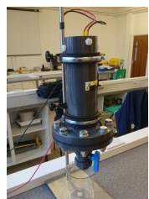
Figure 1 - Last Year’s Reactor (2)

Literature Review

Hydraulic Head Pressure (LT)
Hydraulic head pressure is the measurement of liquid pressure above a single point, not an area. (3) It is a principle used in the development of hydro power stations, particularly dams.
Hydraulic head pressure is measured in meters and is measured from the top of the liquid to the bottom and the total energy at any given point is the sum of the kinetic energy of the fluid, the energy from the pressure of the fluid and the energy from the height of the fluid. (4)
Hydraulic head pressure can be expressed by the following equation:

$$φ= \frac{P}{γ}= \frac{P}{ρg}$$
Equation 1 - Hydraulic Head Pressure
Where:
$$P= gauge pressure=(Force per unit area, often Pa or psi),$$
$$γ=unit weight of the liquid=(Force per unit volume, typically N·m-3 or lbf/ft³),$$
$$ρ= density of the liquid=(Mass per unit volume, frequently kg·m-3), and$$
$g=gravitational acceleration=(velocity change per unit time, often m·s-2)$ (4)

Hydraulic Gradient (LT)
The hydraulic gradient is a vector gradient of each of the individual head measurements over the length of the liquids path. It can be calculated with the following equation.

$$i= \frac{δh}{δl}= \frac{h2-h1}{length}$$
Equation 2 - Hydraulic Gradient
Where:
$$i\left\{\backslash displaystyle i\right\} =hydraulic gradient (dimensionless),$$
$$dh\left\{\backslash displaystyle dh\right\} =difference between two hydraulic heads (Length, usually in m or ft)$$
$dl\left\{\backslash displaystyle dl\right\}= flow path length between the two piezometers (Length, usually in m or ft)$$CITATION Hyd18 \backslash l 2057 (4)$

Hydro Power (LT)
Hydro power has been around for almost a century and therefore the technologies behind it are refined and efficient, with over 90% energy conversion efficiency. (5) Due to the nature of water flow Hydro power can generate electricity 24 hours a day and provided it is a suitable location will generate a substantial amount of electricity even during unideal conditions.
Hydro power contributes to almost 20% of the world's electricity. (6) As of 2012 it contributed to 1.3% of the United Kingdom’s electricity generation. (7)
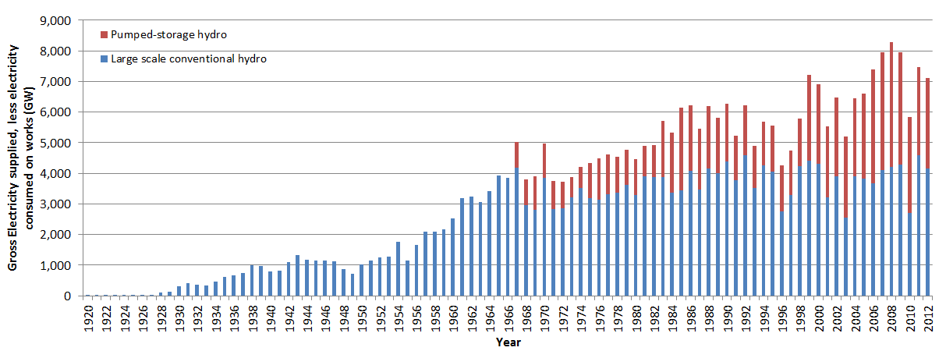
Figure 2 - Hydro Usage in the UK (8)
The above figure shows the gross electricity supplied to the UK through hydropower and it shows that large-scale conventional schemes generation has been constant from 1964 ranging from around 2500GW to 4500GW. Showing that hydropower development has been stagnant within the UK for around 50 years.
Hydroelectricity converts the kinetic energy or gravitational potential energy from water into electrical energy. This energy is converted to electrical energy by use of a turbine. In the UK there are 3 types of hydropower schemes:
- Storage Schemes - A dam creates an artificial lake known as a reservoir, the reservoir provides water to the dam.

- Run-of-river schemes – Rely on the flow of a river, a weir can also be used to adjust the flow rate of the river. Run of river schemes can also be designed using diversion, where water is channelled away from the river.

- Pumped storage - Pumped storage incorporates two reservoirs. When there is low demand, the water is pumped from the lower reservoir to the higher reservoir; the water is then released during times of high demand. Due to the use of electricity this method is not considered to be a renewable energy source. (5)

Turbines (LT)
Turbines use the kinetic energy of the water to drive a generator, converting that energy into electrical energy. There multiple types of turbines, each one having a specific use case.

Archimedean screw (LT)
The Archimedean screw is one of the more modern types of turbine, having only been used within the last decade. The concept has been used for other methods outside of power generation though. (9) They are typically used in low heads of 1.5-5 meters and medium to high flows of 1-20m³/s. (10)
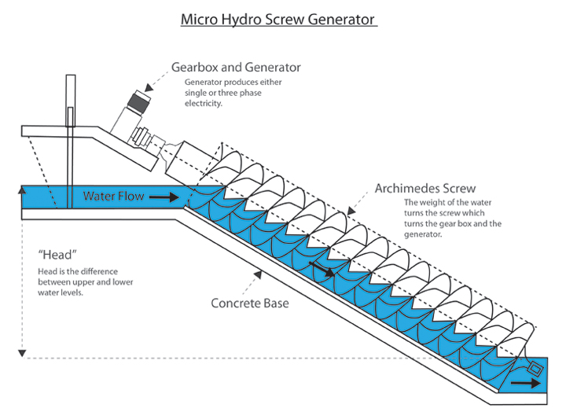a
Figure 3 - Archimedean Screw (11)
In the above figure, you can see the water enters the screw through the top and the weight of the water pushes against the helical fights rotating the screw and allowing the water to flow to the next level. The rotational energy of the screw is then converted using a generator. (9) Archimedean screws are typically used for small-scale hydro schemes with power outputs ranging from 5kW to 500kW.

Cross flow Turbine (LT)
Cross flow Turbines are a common turbine within the UK’s small hydro schemes. (12) They are used for low to medium head of 2-40 meters and low to medium flows of 0.1-5m³/s. (10)
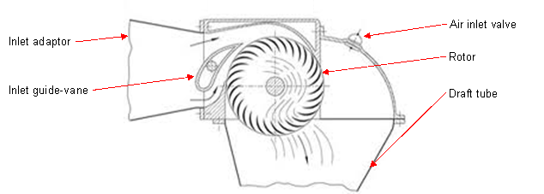
Figure 4 - Crossflow Turbine (12)
The previous figure shows the flow of water through a cross flow turbine. The water flows both under and over the inlet guide vane, which directs the water flow to hit the rotor at the correct angle, maximising efficiency. The water then flows across the upper blades of the rotor, down through the centre and ten across the lower blades. Cross flow turbines typically have a power output between 5kW and 100kW. (12)

Kaplan Turbine (LT)
Kaplan turbines are similar to a propeller except the blades are adjustable. They are typically used on low to medium heads 1.5 – 20 meters and medium to high flows 3-30m³/s, this is due to them being relatively expensive and other options being more suited to high head situations. (13)
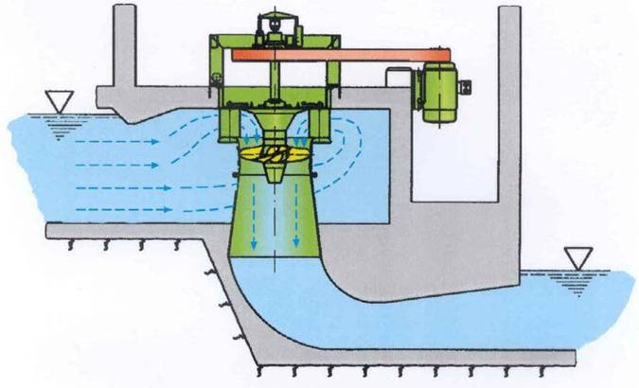
Figure 5 - Kaplan Turbine (13)
Kaplan turbines can be installed in both vertical axis and horizontal axis, within the UK vertical axis is the more common orientation due to its smaller footprint. The water is guided of the entire turbine rather than entering at just one side. The angle of the guide vanes and the rotor blades can be adjusted to suit the flow of water. Vertical Kaplan Turbines can have a power output of up to 3000kW. (14)

Pelton Turbines (LT)
Pelton turbines are used for high heads of greater than 25 meters and low flows of 0.01 – 0.5m³/s. (15) They are compact, and the associated pipework is small making them easier to install than an equivalently powered Kaplan Turbine.
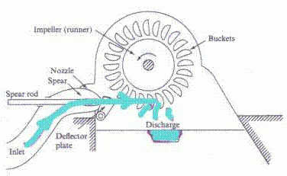
Figure 6 - Pelton Turbine (15)
The above figure shows how a Pelton turbine functions. The water enters on the left hand side and passes through the spear jet. The spear jet allows for the flow rate to be adjusted by moving to spear closer and further away from the nozzle. The water then flows over the rotor converting the kinetic energy into rotational energy.
The Turgo turbine is a development of the Pelton turbine, allowing it to handle higher flow rates than a Pelton of the same size. The only difference in operation is the when the water hits the rotor it exits on the opposite side rather than the bottom. (15)

Francis Turbine (LT)
Francis turbines are no longer commonly used outside of larger storage systems. There are many Francis turbines that have been installed previously. They are most effective with low to medium heads of 1.5-20m and medium flows 0.5-4m³/s. (10)
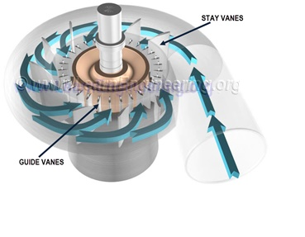
Figure 7 - Francis Turbine (16)
Francis Turbine rotates along the vertical axis. The water flow into the turbine is radial and exits the turbine through the bottom, like the Kaplan turbine.

Summary (LT)
Table 1 - Summary of Turbines
Specification | Archimedean Screw | Crossflow Turbine | Kaplan Turbine | Pelton Turbine | Francis Turbine
Flow (M³/s) | 1-20 | 0.5-5 | 3-30 | 0.01-0.5 | 0.5-4
Head (meters) | 1.5-5 | 2-40 | 1.5-20 | 25+ | 1.5-20
Power Output | 5-500kW | 5-100kW | Up to 3000kW | From several kW to tens of MW | Hundreds of kW to tens of MW

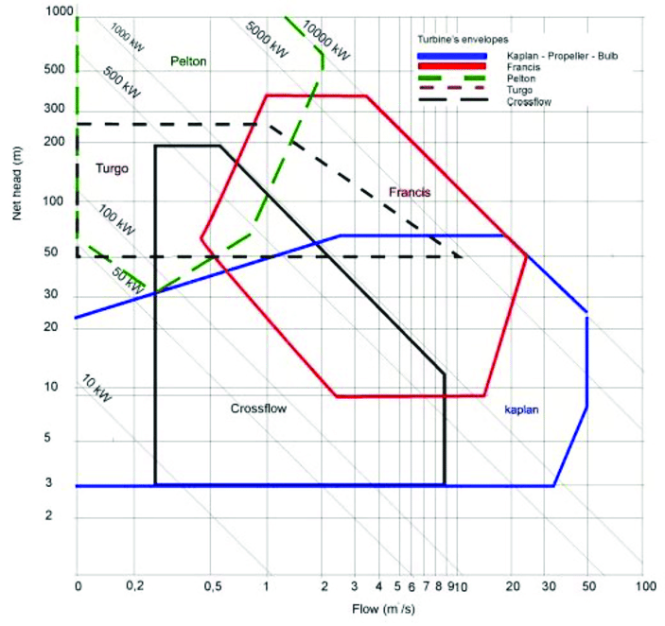
Figure 8 - Turbine Chart Power-Head-Flow (17)

Costing Considerations (LT)
- Development and Implementation – These costs while scale proportionally with the size of the scheme. Larger schemes that require more terraforming will cost considerably more.
- Maintenance – Maintenance costs for all sizes of schemes should be relatively small to begin with since turbines are reliable. As time goes on the maintenance costs will increase as the scheme gets older and the structural integrity diminishes.
- Licensing and Abstraction – Costs will increase if a third party owns the land and will further increase if abstraction is required as an abstraction license is required.

Environmental Considerations (LT)
- Local Wildlife – Fish and other aquatic animals living within the river could be obstructed by the scheme; certain scenarios will require an alternate path upstream for the wildlife.
- Local Plant life – Some plant life will be destroyed during the terraforming and construction of the scheme.
- Pollution – The construction of the scheme will cause substantial pollution but there will also be significant sound pollution when the scheme is running.
- Recreational Activities – Fishing, Kayaking and Swimming activities will be affected.

Conclusion (LT)
Due to hydro power being a well-developed efficient form of renewable energy and the river towy being within a third of a mile of the farm site. This river could have the energy potential for small scale hydro scheme to power the system. The red area highlights the most likely area for the reactor to be built and implemented.
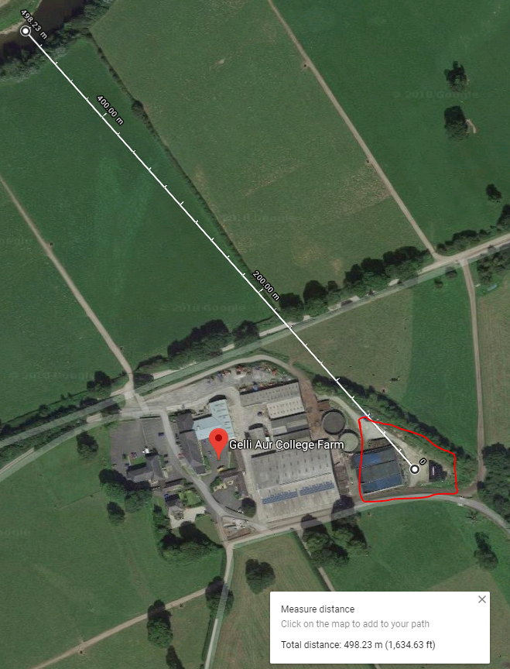
Figure 9 - Gelli Aur (18)

Solar (FK)

The Photovoltaic Array
Most of the UK energy for industrial and domestic use has been obtained from fossil fuels; coal, oil and gas. Renewable energy can be considered as an alternative way of producing energy.
Basic principles of photovoltaic energy conversion, concentrating initially on devices using mono crystalline silicon. Photovoltaic energy systems are traditionally used to supply power in remote locations and they often charge batteries to ensure continuity. The energy produce from the systems can also be feed into local or national electricity grid. (19)
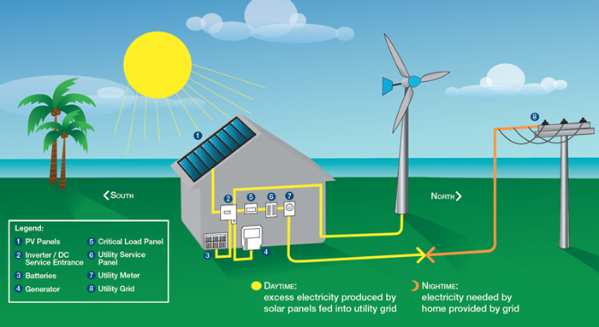
Figure 10 - Photovoltaic Array & alternative energy sources (78)

PV system sizing
There are important questions that a PV energy system designer needs to know before building a system. Important questions such as;
- How many PV modules would be required for a site?
- What are the daily, weekly and seasonal variations in electrical demand?
- What are the daily, weekly and seasonal variations in the amount of solar radiation in the area where the system is situated?
- What is the proposed orientation and tilt angle of the PV array?
- For how many sunless days will the battery need to be able to provide backup electricity? (19)

Environmental impact and safety of PV systems
Photovoltaic is one of the renewable energy source that can be developed in the farm to produce energy. Photovoltaic systems probably have lower environmental impact than that of any other renewable or non-renewable electricity system. The solar panels are non-polluting and require little maintenance. The energy from the sun can be captured and stored for consumption without causing much harm to the environment. (19)
When PV systems are in operation they emit no gaseous or liquid pollutants and no radioactive substances. However, there is a slight risk that a fire breaking out in an array of PV systems due to the small amount of quantities of toxic substances. PV modules are safe in the mechanical sense because the systems do have any moving parts and they emit no noise once they are installed. However, as with many other electrical equipment there are some risks of electric shocks, but mostly in larger system operating voltages that are higher than 12 – 48 V. (19)

PV array investigation at a farm in Loughborough
An investigation was carried out on integrated non-fossil fuel electrical power system at a farm in Loughborough. The investigation was carried out on the performance and economic viability of the system for both electrical consumption on the farm and export to the national electricity grid for supply to other consumers. The investigation was done over a one-year period, to take account of the climate variations during different seasons in a year. (20)
An array of PV modules was installed at the farm which was rated at 6kWp, where a peak watt (WP) is an output of 1W at the light intensity of 1000 ${W/m}^{2}$ and a temperature of 25$℃$. The array position was changed to between summer and winter to maximise the solar energy received. In addition, an array of lead-acid battery cells, with 54 cells each rated at 2V connected in series to give 110V 1200Ah nominal capacity to store the energy produced, ready to be used by the farm. (20)

PV systems reduce the cost of power
It has been estimated that up to 10% of the 275TWh of electricity used annually in the UK could be obtained from wind and solar sources, saving up to ${3X10}^{10}$ of 10 Kg of CO² emission. (20)
Figure below shows the result from the array of photovoltaic farm in Loughborough. The results were obtained and strategies were developed to optimise the profit/energy ratio. An energy saving method was used from the results and the battery energy were only exported during the most advantageous period of day. At a point where the export tariffs were high. Thus, the farm’s balance of payment figures return (export - import) using normal electricity tariff rates was almost doubled from £1467 to £2985. (20)

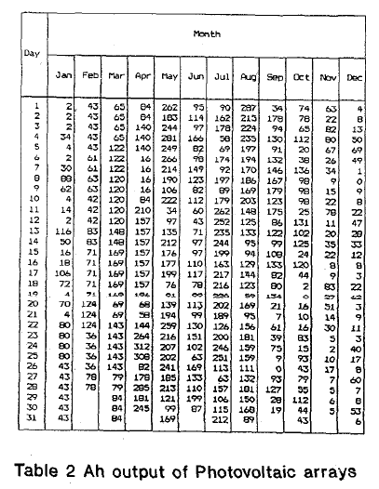
Figure 11 - Output Results of Photovoltaic arrays, source (20)

Methods of Control (RM)
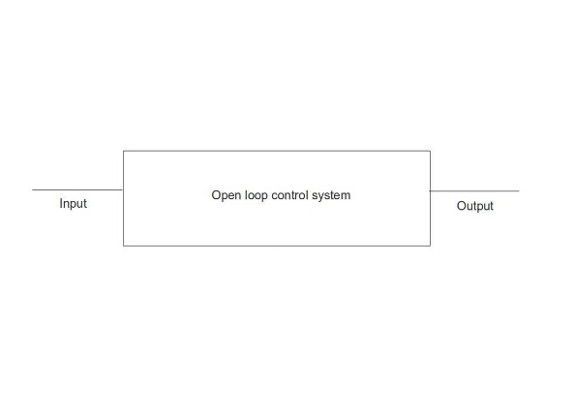
There are several ways to implement a control system to achieve the desired outcome, all of which fall under one of two types of control systems. These are:

Open-Loop Systems (RM)
Open-loop systems are control loops which do not make use of feedback loop. Because of this, there is no way for the control system to identify if a variation from the desired output has occurred and cannot correct for any errors. Any errors that do occur need to be corrected manually by changing the input to the system.
Figure 12: Example of an Open-Loop system (69)
The simplicity of these control systems makes development relatively cheap while requiring fewer components. However, the application of these systems is limited because of the inability to account for errors and overall reliability. (21)

Closed-Loop Systems (RM)
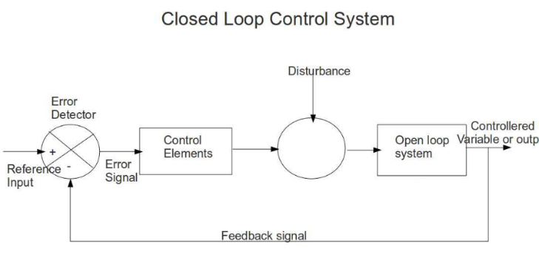
Closed-loop systems are control loops which make use of a feedback loop to feed information about the output back into the control system. By doing this, it is possible to make fine adjustments to the output of the overall system so that small variations and errors can be corrected. This eliminates the need for manual adjustments and can be left to run by itself without supervision.
Figure 13: Example of a Closed-Loop system (69)
These types of control systems can be complex in design due to the different ways in which the feedback can be manipulated and utilised to adjust the output. This means that they are often relatively expensive. These systems can also be difficult to setup depending on if a custom solution is developed or if an existing controller is used. (21)

Fertilizers & Their Makeup (RM)
Fertilizers are additives for plants & crops which are high in nutrient content and help promote plant growth. They are usually produced organically from decomposed organic material such as food waste or manufactured through chemical processes. The makeup of a fertilizer mainly consists of the three following elements (22):
- Nitrogen – This is important as it helps to form proteins. A sign of low nitrogen content in plants are pale green or yellow leaves. Nitrogen is mainly found as:
- Calcium Nitrate
- Sodium Nitrate
- Potassium Nitrate
- Di-Ammonium Phosphate
- Mono-Ammonium Phosphate
- Liquid Nitrogen
- Urea
- Phosphorus – This is essential for overall health in plants and helps in photosynthesis. Phosphorus is usually found as Phosphorite or naturally occurring rock phosphate. This material will break down into another material called “orthophosphate” which can be absorbed by plants.
- Potassium – This helps to resist diseases and periods of drought as well as help develop strong roots. However, a high potassium content can become harmful to plants and may cause salt damage. Potassium is mainly found as:
- Potassium Hydroxide
- Potassium Sulphate
- Potassium Chloride
- Potassium Nitrate
There are also other secondary and tertiary nutrients that can be found in fertilizers in very small amounts which also help in plant development and general health such as sulphur, calcium, magnesium, copper, zinc, boron, iron, manganese & molybdenum. The benefits of each of these elements range from helping to develop proteins, chlorophyll, cell walls & during metabolism (23).

On average, the moisture content in fertilizers varies from 0.5% to 5% with some reaching as high as 12% depending on the production process used (24). Generally, it is best to have a very low moisture content as it is more economically viable for transport and improves the efficiency of the fertilizer. A high moisture content can affect the nutrient content of the fertilizer and may cause caking.

Energy content in Slurry (RM)
The energy content of biofuels from combustion, such as manure, are usually measured using the standard measurement “British Thermal Unit”, or BTU. The BTU is a measurement which describes the amount of energy or heat required to raise the temperature of a pint of water by one degree Fahrenheit. A single BTU is equal to 1,055 joules, and 3412 BTU’s is equal to 1kWh (25).
The energy content from combustion is also described by a Higher Heating Value, or HHV. This value shows the energy content in a fixed amount of manure that can be obtained from combustion assuming that any energy lost during the process is captured via a secondary condensation process.
There is also a Lower Heating Value, or LHV which describes the energy content in a fixed amount of manure and assumes that there is no secondary condensation process to capture energy lost during combustion. As a result, the LHV is always less than the HHV as the LHV is usually 90%-95% the HHV.
When the biofuel is being burned, any moisture in the biofuel will be released in the combustion chamber and absorb some of the heat in the chamber. This means that some of the potential energy is lost and can either be redirected into a secondary condensation chamber to condense the water vapour or directed to an exhaust pipe and become permanently lost (26).
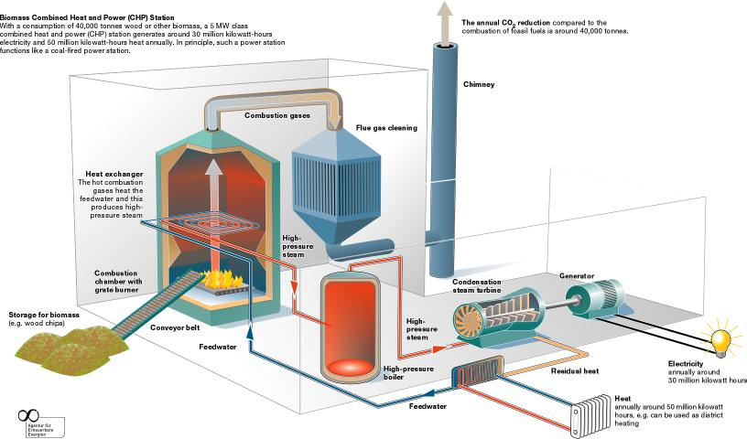
Figure 14: An example of thermal energy using biomass as fuel (27).
Above is an example of a process where biomass fuels are combusted to heat up water and turn it into high pressure steam. The gases emitted exit through a chimney and are not collected, so the energy potential would be the LHV.
The HHV for cow manure begins at around 8,500 BTU/lb, or 18,780 BTU/kg, assuming that there is no moisture and all the material is combustible. To obtain an accurate measurement which takes into account the amount of ash & moisture in the biofuel, these percentages must be subtracted from the total value. For example (28): A biofuel with 15% ash and 60% moisture would give a BTU value of 2,890 BTU/lb.

Biomass Hazards (RM)
While there is a potential from using manure as a source of electricity, there are several safety hazards from the gases emitted during combustion or while being stored. These include (29):
Hydrogen Sulphide (H2S) –
- Heavier than air, so it will settle at bottom of storage tanks.
- Distinct rotten egg smell, loss of sense of smell.
- Low levels cause eye & respiratory tract irritation (breathing tubes).
- Moderate levels cause dizziness, nausea & headaches.
- High levels paralyze nerve cells in the nose, losing any sense of smell.
Ammonia (NH3) –
- Sharp, penetrating odour at low levels.
- Heavier than air.
- Moderate levels cause eye & respiratory tract irritation.
- High levels cause ulceration of the eyes & severe irritation to respiratory tract.
Carbon Dioxide (CO2) –
- Heavier than air.
- Difficult to detect.
- Replaces air and can cause asphyxiation.
- Low levels cause shortness of breath and dizziness.
- Major cause of animal death in poorly ventilated areas.
Methane (CH4) –
- Odourless.
- Lighter than air so it accumulates at top of storage tanks.
- Can cause asphyxiation at high concentrations.
- Flammable.
- Difficult to detect without equipment.

Micro Grid (FK)
Micro-grids are energy systems that combine different types of energy resources and distribute it to the consumer. Generally, most micro-grids systems operate in isolated off grid areas. However, they can also be connected to the main grid. Micro-grids generally consist of components such as generators, energy storage and control equipment. Hence why, such system could be useful in off-grid communities. Especially in regions with attractive renewable energy resources, such as hydro, wind, solar and biomass. For example, diesel generators coupled with wind turbines, or an array of photovoltaic cells and biomass systems can all be combined as one energy source. (30)
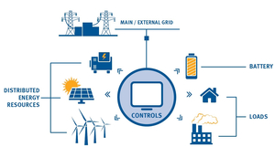

Figure 15 - Driving integrated energy solution on and off (micro-grid)

Figure above, above shows a diagram of a driving integrated energy solutions on and off-grid. As previously mentioned, energy is collected from the renewable source, such as wind turbines, photovoltaic (solar panels) and biomass. These energies are controlled to be distributed to either the consumers (loads), main/ external grids or stored in battery energy storage to be used when needed. (30)
An autonomous generation system such as micro-grids can utilised all the available renewable energy and can also reduce the dependency on the main grid power, which is predominantly fossil fuel. However, compared to fossil fuel, renewable energy is not completely reliable because different types of renewable are affected by different factors. For example, changes in nature. Hence, firm power cannot be guaranteed for an autonomous system. (31)
On the other hand, one of the advantages of having an autonomous generation system is that the power generated from all the renewable energy sources can be stored in a battery energy storage. As a result, the battery storage can be helpful in lowering power fluctuation, increase predictability and operate effectively. (31)

Types of Micro-grid (FK)
The micro-grids include two kinds of forms: AC micro-grid and DC micro-grid system. At present, there are many micro-grid systems developed around the world. With the increasing demand for energy crisis and environmental protect the research on the technology of DC micro-grids is still in progress. (32)
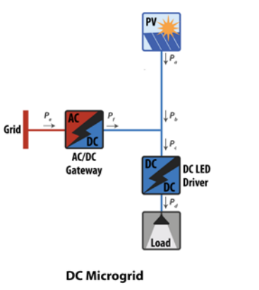
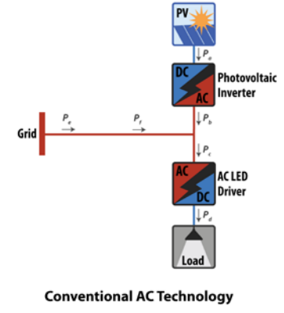
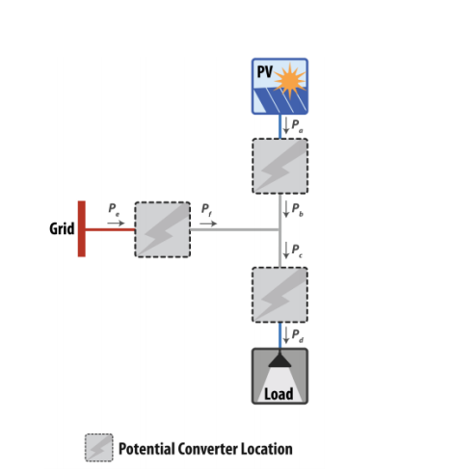
Figure 16 - (a) Potential Converter Location, (b) Conventional AC Technology, (c) DC Microgrid. Source: (33)

Figure above shows three configurations of a micro-grid, potential converter location, and conventional AC and DC micro-grid systems. The first diagram shows the locations for potential converters, meaning AC/DC or DC/AC converters can be added between different stages. The second diagram shows the conventional AC system and this system requires two conversions between the energy source and the load. In contrast, DC systems can be configured to operate using only a single conversion as shown in the DC micro-grid diagram. In this case, the AC/DC gateway converter acts as a rectifier and provides a balance power to operate the load. The DC driver matches voltages from the source and supplies the power between the renewable energy source and the load (33)
A DC micro-grid system can be designed to provide power to our project’s reactor because most of the renewable power sources have DC links at their interface converter stages. Meaning it can be connected directly to the DC load. Bidirectional DC/AC converter are used to connect with an AC utility grid, as shown in figure below. One of the reasons, a DC micro-grid would be preferred over an AC micro-grid is because our reactor operates using a DC power source. Other factors that can be included are generalised in the table of comparison between an AC and DC micro grid, as shown in figure 3 below.
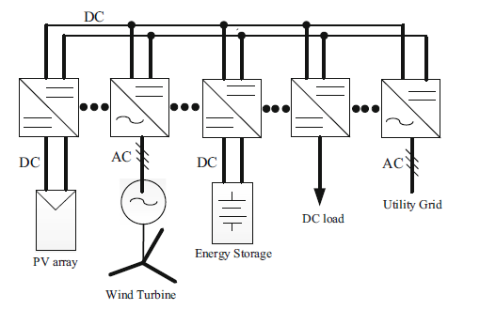

Figure 17 - Configuration of DC Microgrids. Source: (82)

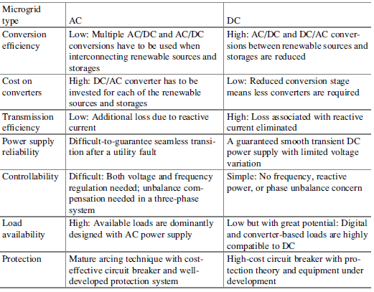
Figure 18 - Comparison table of AC and DC Microgrids. Source (82)

Hybrid system
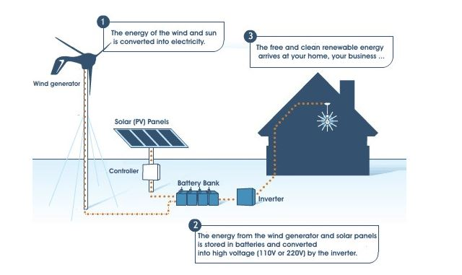
Figure 19 - Solar & Wind Hybrid system. Source: (34)

Figure 17, above shows a diagram a hybrid system consisting of wind turbine and a solar photovoltaic array of panels, used together to provide greater energy output and increased system efficiency.
In a hybrid system, the renewable energy collected can be operated effectively by operating each energy source at an optimum operating point, which is also referred as maximum power point tracking. This can be achieved by using power electronics based controls. (31)
Introducing power electronics based controls, eliminates the challenge of managing the intermittent energy with the power demand. (35). Energy control strategies of a micro-grid includes load switching and distribute generations control methods. Also, reference (36) proposes control strategies for energy management system in a micro-grid. Suggesting three strategies of controls. One is to control the voltage and frequency output of distributed generation and this was developed in standalone mode. Secondly, for a grid connected mode an active power and reactive power control strategy. Lastly, a droop control strategy to control the storage technologies in the micro-grid. Which are used for load balancing. (36)

Biomass (FK)
Biomass can be any form of residual stalk, straw, leaves, roots, husk, nut or seed shells, waste wood and animal husbandry waste. One of the main advantages, of using biomass to produce energy is that, it is a renewable resource that has a steady and abundant supply. Especially those biomass resource that are a by-product of agricultural activity. (37) Initially the main objective of the project is to dewater the slurry. However, there are biomass technologies that can be considered to capture the methane production from the cow manure.
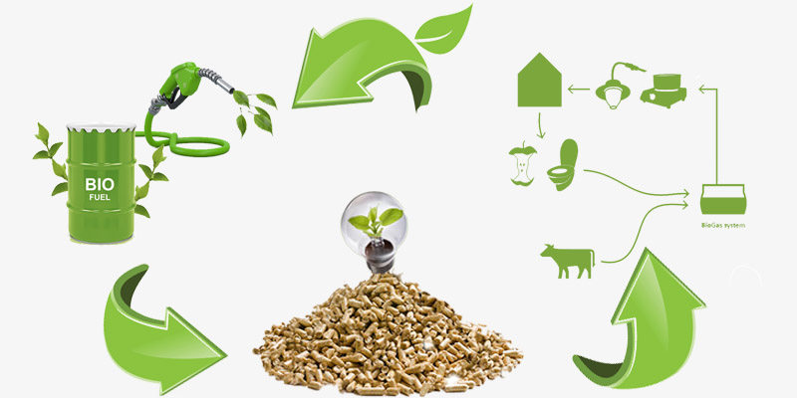

Figure 20 - Biomass Energy. Source: (81)

United Nations Environment Programme (FK)
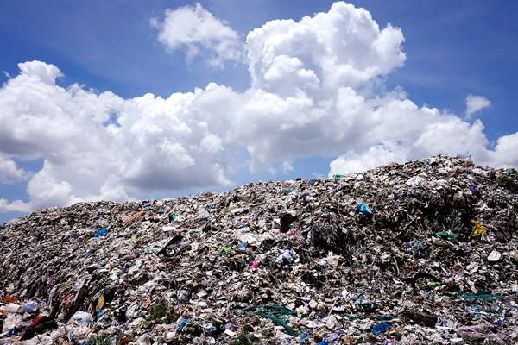
Based on the existing data on conversion technologies available from the United Nations Environment Programme, compendium on agricultural biomass, it is hoped that there will be a growing interest in biomass so that it would be valuable resource and not just as waste. It has been shown that with appropriate segregation and recycling systems a significant amount of waste can be diverted from landfills and converted into resource. (37)
Figure 21 - Landfill Waste. Source: (80)

Agriculture Biomass (FK)
It is estimated that, 140 billion metric tons of biomass is generated globally every year from agriculture. Thus, agriculture biomass is considered as one of the major source in present world, which can be converted to an enormous amount of energy. As a raw material, biomass wastes have an attractive potential for large-scale industries and community-level enterprises. Equivalent to approximately 50 billion tons of oil agriculture biomass waste can be converted to energy and substantially displace fossil fuel, reduce emissions of greenhouse gases and provide renewable energy to some 16 billion people in developing countries, which still lack access to electricity. (37)

Environmental Issues (FK)
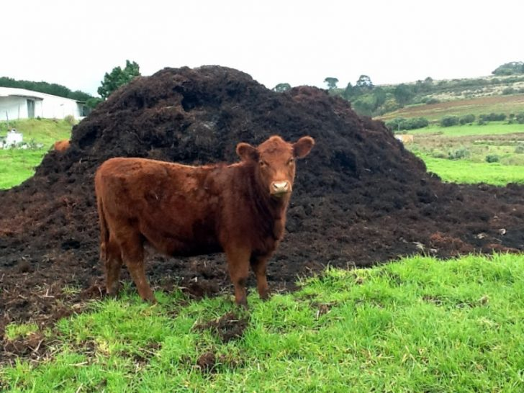
In the recent years the development of industrial and economic, municipal solid waste has increased rapidly. The outcome of this rapid growth is becoming a burgeoning problem as rotten waste agricultural biomass emits methane and leachate, and open burning by the farmers to clear the lands generate CO2 and other local pollutants. While this may be the case, managing waste agricultural biomass and converting it into a material resource would reduce the handling costs for many farms, plus generate revenue from the sale of recovered materials and energy. In addition, minimise greenhouse gas emissions and contribute to energy security and climate change mitigation. (37)
Figure 22 - Agriculture Waste. Source: (79)

There are two types of conversion with regards to biomass waste. The first technology is conversion of waste biomass to materials and the second is conversion of waste to energy. Agricultural waste has high nutrient value. (37) Once the water is removed from the slurry the nutrient can be recovered and reused by the farmers.

Converting Biomass to Energy (FK)
There are various technologies available that can convert agricultural biomass waste into energy product such as heat and steam, electricity, producer gas, synthetic fuel oil, charcoal, methane, ethanol, bio-diesel and methane. The technologies used to convert this biomass into energy are range from highly sophisticated equipment from industrialised countries to simple technologies from developing countries. (37)
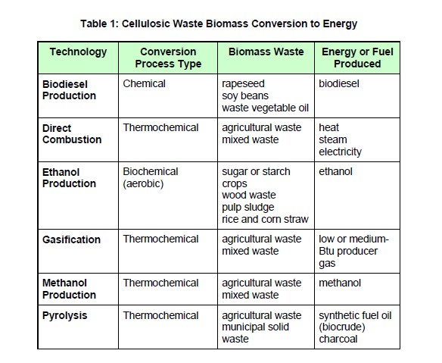
Figure 23 - Biomass conversion to Energy. Source: (37)

Figure above, shows the different the specific energy product that can be generated from the different kind of biomass waste. (37)

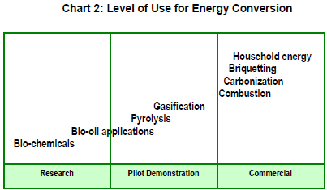
Figure 24 - Level of Use for Energy Conversion. Source: (37)
Figure above, shows the level of use of the different conversion technologies for energy. (37)

Bioenergy (FK)
Biomass can be used to produce bioenergy. Organic materials from plants and animal’s origin derived from agricultural, forestry production, by-product, industrial, urban wastes can be used for producing bioenergy. Bioenergy includes bio-power, biofuels, bio heat and biogas. (38)
Bio-power is the energy or electricity produced from biomass via a combustion conversion technology of the feedstock. (38)
Biofuels on the other hand, are fluids or gaseous fuels used to power engines in private or public transport. Biofuels such as ethanol, ethylic alcohol derived from starch and sugar crops, biodiesel produced from trans esterification of vegetable oils and synthetic biofuels. (38)
Bio heat is the thermal energy produced from biomass via combustion of the feedstock and it is generally used for space heating or in production processes requiring process heat such as steam. In some cases, bio heat is also generated with bio-power. (38)
Biogas is methane or similar gases produced from anaerobe digestion. This biomass can also produce energy that can be used as a transport fuel in engines for gaseous fuels or used for heating or warming water. Lastly, the gas can be used to drive motor/generators to produce electricity. (38)

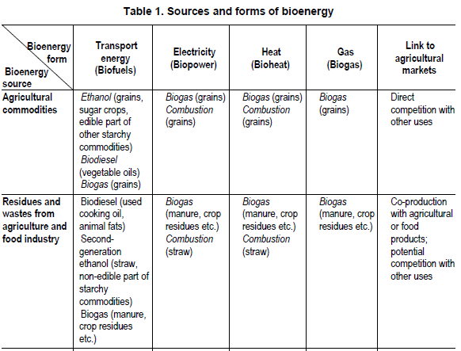
Figure 25 - Table Source and forms of bioenergy. Source: (38)

Based on the biomass conversion table shown in figure 1, the two main thermal processes by which dry biomass can be converted to more useful energy forms in the power and heat sector are combustion and gasification. However, other than these two technologies another process which can be useful is the biochemical transformation process using anaerobic fermentation. Wet biomass material such as animal manure or crop material can be utilised by this anaerobic fermentation process to produce energy and reduce the costs of drying the biomass.
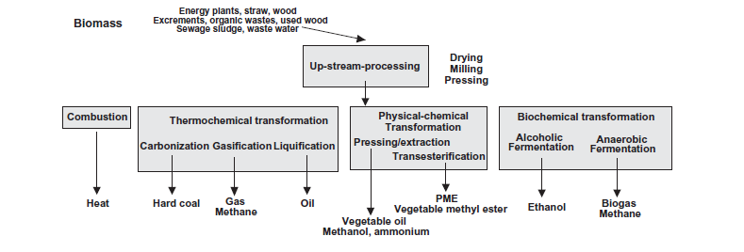
Figure 26 - Applied technologies to transform biomass into secondary energy source. Source: (40)

Anaerobic fermentation (FK)
The biological process to produce this biogas is known as anaerobic digestion (AD). (Biogas (In Tech) Page 91). As previously mentioned, biogas consists of gases such carbon dioxide (CO2): 35 to 40%; Methane (CH4): 55 to 70%; and sulphide of Hydrogenate (SH2): 0, 1% and in minor proportion for Nitrogen (N2): 0, 5 to 5%, Hydrogen (H2): 1 to 3%, Water Vapour: Traces. (39)

Organics conversion in anaerobic systems (FK)
In terms of chemistry and microbiology, producing methane can be a multi complex process, because the organic matters in waste water would need to be degraded to basic constituents in order to obtain methane as gas. (40)
Four main stages in methane fermentation
Generally, methane fermentation is divided into four degradation stages; hydrolysis, acid genesis, acetogenesis, and methanogenisis. Each individual stage carries out different groups of microorganisms. (41)
- Hydrolysis
Hydrolysis is the first stage of degradation, where it consists in the transformation of complex organic matters such as protein, carbohydrates and lipids into soluble products such as, sugar, long-chain fatty acids, amino acids and glycerine. (41)
It is important to note that during this stage the hydrolysis carbohydrates takes place within in the few hours. The hydrolysis of protein and lipids on the other hand takes place within few days rather than hours. Lastly, the lignocellulose and lignin degrade only slowly and incompletely. The anaerobic microorganisms’ uses up the oxygen dissolved in the water. (40)
- Acid genesis
Acid genesis is the second stage of degradation, where the bacteria use the hydrolysis product formed in the first stage to form intermediate compounds such as organic acids and volatile fatty acids. These fatty acids along with the ethanol are converted to hydrogen, carbon dioxide and acetic acid by groups of bacteria known as hydrogen-producing acetogenic bacteria (e.g., acetate, Lactate, Butyrate, Propionate, Succinate, and Ethanol). (41)
- Acetogenic
Acetogenic is the third stage of degradation, where the organic acids are partially oxidized by the bacteria called acetogenic to produce additional quantities of hydrogen and acetic acid. During acetogenic stage the homo-acetogenic microorganisms gradually reduce hydrogen (H2) and carbon dioxide (CO2) to acetic acid. However, the acetogenic bacteria also produces hydrogen (H2). (40)
Acetate formation by oxidation of long-chain fatty acids occurs on its own and is thermodynamically enabled only with very low hydrogen pressures. Thus, acetogenic bacteria can obtain energy necessary for their survival and grow during the low hydrogen (H2) concentrations. The role of acetogenic bacteria is vital to the overall anaerobic process because they convert the fermentative intermediates to methanogenisis substrates, H2, CO2, acetic acids and unicarbon compounds. (40)
- Methanogenisis – What is it?
Methanogenesis is the fourth and last stage of degradation, where both acetic acid and hydrogen are the raw material for the growth of methanogenic bacteria. During this stage the acetic acid and hydrogen produce in the previous stage is convertted to biogas, which is composed of mainly methane, carbon dioxide and hydrogen sulfide. (41)
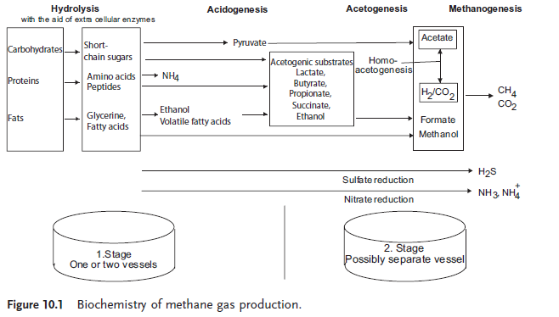
Figure 27 - Biochemistry of methane gas production. Source: (40)

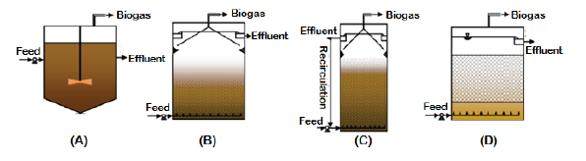The digestion takes places in a sealed vessel (the digester) and it’s within this vessel that bacteria ferment the organic material without the present of oxygen. In order for the fermentation to work properly the material content needs to properly mix and be kept in the correct temperature. Varying the temperature of the digester tank can affect the methane production. The temperature of the digester can be increased to the mesospheric range (30-35 degrees) and the feedstock remains in the digester typically for 15-30 days, or into the thermophilic range (55-65 degrees) where the residence time is typically 12-15 days. The thermophilic digestion system offers a higher methane production, but it requires more expensive technology, monitoring and greater energy input. Generally, 30-60% of the biomass solids are converted into biogas and the high conversion rates depends on longer residence time. (38)
Figure 28 - Most commonly used anaerobic reactors type: (A) Completely mixed anaerobic digester, (B) UASB reactor, (C) AFB reactor, (D) Up flow AF reactor. Source: (38)

Hydraulic Permeability (JN)

The hydraulic permeability of the waste that is loaded into the reactor will change as the electro-kinetic dewatering takes place, this is due to the liquid that is stored within the sample migrating from locations near the anode towards the cathode. This means that the liquid that is removed from the samples will migrate to the outside wall of the reactor (Cathode).
As the liquid moves from the anode towards the cathode the sample in which the liquid has migrated from will increase in density due to the vacant capillaries that the water has migrated through collapsing and increasing the solid matters density. The collapse of the capillaries also effects the hydraulic permeability of the sample as the ability of the water to pass through the sample is decreased as a result of the increased density, to continue with a continuous flow of liquid and electric current, the sample would have to be subjected to an increase in pressure at the anode and a decrease in pressure at the cathode to aid with the migration of fluid when a constant current is applied.
Where:
$$u = - ke/kh. gw. V$$
Equation 3: Reduction in pore water pressure (42)
Where:
$$u = pore water pressure$$
$$Ke = coefficient of electro osmotic permeability$$
$$Kh = coefficient of hydraulic permeability$$
$$GW = density of water$$
$$V = voltage applied between electrodes$$
From this the voltage can be predicted to increase as the resistance of the sample increases from changing hydraulic permeability and electro osmotic permeability to maintain a constant current. With a power pack that is planned to be used the voltage cap will be set, once this is met the resistance of the sample will increase but as the cap is set this will result in the current across the sample within the reactor decreasing.

Hydraulic Conductivity (JN)
Hydraulic Conductivity is the ability of a fluid to migrate through pores of fractures of a material and is dependent on the intrinsic permeability of the material, the fluids saturation of the material and the fluids density and viscosity. The term ‘Saturated Hydraulic Conductivity’ is the movement of the fluid through a saturated material. Hydraulic Conductivity is also known as the coefficient of permeability and is given the value ‘K’.

Water coefficient of permeability of saturated soil is a function of void ratio (e) only. For unsaturated soil, the water coefficient of permeability is a function of void ratio (e) and volumetric water content (θ). This relationship is commonly expressed by a suction-dependent hydraulic conductivity function...
(43)
To determine the amount of fluid flow as a result of electro kinetic processes Darcy’s law can be utilised to calculate fluid volume flow;
$$Q= K_{e }I_{e} A$$
Equation 4 : Darcy's Law
Where;
$$Q = Volumetric flow rate of fluid$$
$$Ke = Coefficient of electroosmotic conductivity$$
$$I.e. = Hydraulic gradient of electroosmotic flow$$
$$A = Total area that is perpendicular to fluid flow$$
The values of coefficient electroosmotic conductivity of different soils lie in the narrow range of 1×10-9 to 1×10-8 m 2 / V s
(44)
It can be expected by analysing Darcy’s Law that the volumetric flow rate of the fluid through the sample will reduce as the electro osmotic conductivity increases, the electro osmotic conductivity K_{e} will decrease as the resistance of the sample increases.
When using the power pack to power the reactor the voltage will be capped, once the voltage reaches the limit the current will then begin to drop and this in turn will reduce the volumetric flow rate of the liquid through the sample and the yield at this point will decrease as a result.

pH Gradient (JN)
With application of an electric field across the saturated waste electrolysis will occur with the pH at the anode decreasing and increasing at the cathode due to this effect a pH gradient in the waste will be present. This is caused by electro migration where different chemical species which are charged in relation to the physical movement of a fluid, Anions will migrate to the Anode and Cations that are present will migrate towards the Cathode when a direct current is applied across the sample.
With application of an electric field across the saturated waste electrolysis will occur with the pH at the anode decreasing and increasing at the cathode due to this effect a pH gradient in the waste will occur. The result of the pH gradient will be an alkaline sample at the Cathode and a slightly acidic sample at the Anode.
Utilising the pH gradient of the waste that will be produced as a result of electrolysis it may be possible to split the waste after dewatering to produce two waste materials that are of different pH values with the waste that is closest to the anode having a lower pH and the waste closest to the cathode having a greater pH value.
Understanding the effect of the pH gradient on the waste that is dewatered during the process may produce two waste types that have a greater variety of applications as an example the lower pH value waste can be used as an effective crop fertiliser as certain plants require fertilizer with Ph. 5.5 to 7 to with others requiring waste of a higher pH, matching the right fertilizers pH will provide effective chemical reactions within the plants. Splitting the waste once it has been subjected to the effects of the reactor will allow the waste to be utilised for different purposes and has the potential of increasing the value of the dewatered waste.
The pH change is a result of the electro kinetic extraction process caused by the application of a Direct Current electric field and has the potential when utilised to add different chemicals to the soil if there is the need to remove contaminants, this would be achieved by selecting an anode that contains high quantities of the inhibitor that can aid with the neutralisation of the contaminant. In the case of the Reactor used for this project the Anode will be made from mild steel and the Cathode being made from Aluminium. The ionic migration that occurs during electro osmosis can be described as the movement of Anions and Cations relative to the movement of the fluid within the waste,
Anions (negatively charged ions) are moved towards the anode (positive electrode) and Cations (positively charged ions) are moved towards the cathode (negative electrode)
(44)
To analyse this during testing of the reactor the dried matter that will be present within the reactor will be subjected to pH testing at various points along the length and the width of the waste, this will allow for the pH gradient within the waste to be analysed to highlight the potential uses of the waste.

Physical Property Changes (JN)
During the time the sample will spend in the reactor undergoing the electro kinetic dewatering the physical properties will change as a result of the dewatering process and the application of a direct current across the saturated waste. As a result of water removal from the saturated waste the physical behaviour of the waste will go from that of a fluid to the properties of a plastic material when under tension the sample will fracture providing sufficient dewatering has occurred. The physical properties as discussed previously relating to Hydraulic Permeability and Conductivity will alter as a result of the change from a fluid waste to a plastic waste. The Plastic Limit is the point at which the waste is dewatered so that it behaviour under tension is plastic. It is represented by the percentages of water contents of the waste where the waste has plastic properties.
As water is removed from the waste the total volume of the waste is expected to decrease as a result of the collapsing of the fractures and capillaries collapsing due to the water removal, this will only occur until the waste reaches its shrinkage limit where the volume of water that has been removed will not further decrease the volume of waste within the reactor. It is not thought that the waste will reach the shrinkage limit as the waste is approximately 96% water and the time and power consumption needed to dewater the saturated waste by a high enough percentage is not available for this test.
As a result of electrolysis of water there will be an increase in the OH⁻ ion presence near the cathode and as a result this causes an increased value for zeta potential in turn increasing the flow of the fluid at this point. The increase of the zeta potential at the cathode is expected to produce a fully saturated environment at the Cathode and that the liquid removed from the waste will reach and then filter by gravity through to the base.
Zeta potential is the charge that develops at the interface between a solid surface and its liquid medium. This potential, which is measured in Millivolts.
(45)

Helmholtz-Smouluchoski Theory (JN)
H-S theory was developed to describe electro kinetic phenomena within a porous media that is saturated with fluid, the saturated media in this case is the slurry that will be processed within the reactor. A porous media is media that has capillary channels within it which allow fluid to migrate from one location to another as a result of compression, heating or in the case of this project electro kinetic osmosis. As the slurry will be obtained directly from the slurry tanks the media can be assumed to be fully saturated with liquid. H-S theory uses the theory that the media is constructed of many capillaries that are fully loaded with a liquid, the H-S theory regards the wall surface of the capillaries as electrical condenser. When the surface of the capillary is negatively charged it forms a mobile cationic ion layer near to the closest solid particle.
The application of a direct current to the saturated media and electrolyte allows the mobile cationic layer to migrate in the direction of the cathode, in the case of the reactor construction for this project the liquid will be migrating in the direction of the outside wall of the rector. The ions that are present in the saturated media are distributed near and far away from the charged surface of the capillaries, the ions that are present in the capillaries that are at a distance greater than the distance of the slip plane migrate towards the cathode with the fluid when the direct current is applied.
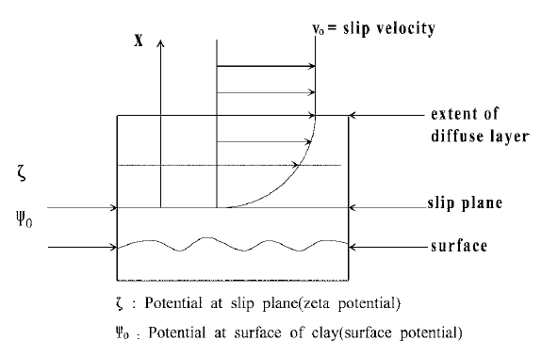
Figure 29 : Fluid Velocity Distribution
(46)
Utilising the H-S theory the migration of the fluid and the cations within the fluid that are present within the capillaries of the saturated media can be calculated using the following equation;
$$V_{e}= \frac{ε ς}{η} E_{z}$$
Equation 5 : H-S Equation
(46)
Where;
$$E_{z}=Electric Field Strength$$
$$V_{e}=Electroosmotic velocity between parallel plates$$
$$η=Viscosity of Liquid$$
$$ε=Permittivity of Media$$
$$ς=Zeta Potential$$
Analysing the H-S equation the variables that are available for alteration for this project is the Electric field strength, which can be calculated using the following equation;
$$E= \frac{k . Q}{d^{2}}$$
Equation 6 : Electric Field Strength
Where;
$$E=Electric field Strength$$
$$Q=Quantity of Charge$$
$$k=Electrostatic Constant=8.99× {10}^{9} Nm^{2}/C^{2}$$
$$d=Distance of Separation from Source Charge$$
To vary the electric field strength the distance between the electrodes can change and also the current can be varied to alter the quantity of charge that the saturated media is subjected to.
With the application of a direct current through the saturated media via an Anode and Cathode it is known that two reactions take place, with oxidation occurring at the Anode from the following reaction;
$$2H_{2}O → O_{2}+4H^{+}-4e^{-}$$
Equation 7 : Oxidation Reaction
At the location of the Cathode for the reactor the internal wall will allow for a reduction process to occur, this reaction is shown below;
$$2H_{2}O+2e^{-} → H_{2 }+2OH^{-}$$
Equation 8 : Reduction Reaction
By analysing the H-S theory equation and the oxidation and reduction reactions that occur and that direction of the fluid is in that of the cathode it can be expected that the pH gradient that will occur will be higher than the original pH at the Cathode by a greater amount than the pH at the Anode will be reduced by.
This is due to the fluid velocity being in the direction of the cathode and in turn increases the migration velocity of the Cations that are positioned at a greater distance than the slip plane of the capillary. As the fluid velocity is directed towards the Cathode the Anions that are generated at the Cathode have a lower velocity than the Anions as they must overcome the static forces of the media and the fluid flow velocity in to opposite direction to migrate towards the Anode.

Electrophoresis (JN)

Electrophoresis is a phenomenon that occurs when particles are present in a solution that is in an electric field, where the migration of the ions can be predicted due to the presence of the electric field. Electrophoresis is based on Coulombs law;
$$F= k_{e }\frac{q1 q2}{r^{2}}$$
Equation 9 : Coulombs Law
Where;
$$k_{e}=Coulombs Constant=8.9875 × {10}^{9} N/m^{2} C^{-2}$$
$$q1 and q2=signed magnitude of the charges$$
$$r=Distance between charges$$
$$F=Force of interaction between charges$$
Using Coulombs force, the force that is experienced by a particle in an electric field can be calculated and therefore the movement of that particle can be predicted in a fluid.
$$E= \frac{F}{q}$$
Equation 10 : Coulombs Force
Where;
$$E=Electric Field$$
$$F=Coulombs Force$$
$$q=Charge of the particle$$
This can be rearranged to determine the force on the particle,
$$F=E ×q$$
Equation 11 : Coulombs Force (Rearranged)
Once the force acting in the particle has been calculated the direction that the particle will migrate due to electrophoresis can be established, the migration of the particle is affected by the drag forces that occur when passing a body through a fluid where the velocity is reduced due to friction. To calculate the drag experienced by a particle that is present in a liquid the following equation can be used;
$$Fd=f ×v$$
Equation 12 : Force Due to Friction
Where;
$$Fd=Force due to friction$$
$$f=Frictional coefficient of the fluid$$
$$v=Velocity of particle$$
For movement to occur due to electrophoresis the migration of the particle must be independent of the electric field forces and results in the Force due to friction being equal to the Force resulting from the presence of the electric field;
$$FE=Fd= 0$$
Equation 13 : Equilibrium of Forces
With the understanding that the forces that are required to be in equilibrium for the right conditions to allow electrophoresis and the complexity of the chemical composition of the waste that is being dewatered the effects of electrophoresis will be negligible and the movement of the ions in the waste as it is dewatered will be determined by the strength of the electric field and the H-S theory.

Filtration (RM)
Filtration is a process which helps to remove suspended solids from wastewater. This is done by passing the water through a filter media such as sand, anthracite or garnet, or by passing the water through a membrane filter. By using filtration, it is possible to remove any remaining unwanted suspended solids in the water that have not already been removed from previous processes.
The type of media used to filter the water can affect the end result as the particle size & shape determine how much suspended solid is removed from the solution. For example, fine sand is good for removing most solids but does not allow for ample build-up due to the fewer pits present in the media and may require cleaning via backwash sooner than if a coarser sand was selected (47).
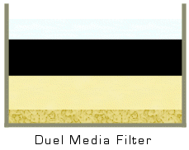
Combining media filters to form mixed-media filters instead of single-media filters is also an option which allows for a finer removal of solids and usually last for longer periods of time before a backwash is needed. The composition of a mixed-media filter can also affect the filtration process by controlling where the larger particles are removed in the filter. For example, a top layer of anthracite will remove larger particles towards the top while leaving the smaller particles suspended in the lower sand layer (48).
Figure 30: An example of a Mixed-Media filter consisting of Anthracite, Sand & Gravel (48).
There are several types of media which can be used for filtration. These types of media are (49):
- Sand – Very common filter media used to remove a range of suspended solids from water. Available in a wide range of particle sizes from coarse to fine depending on the application, relatively cheap.
- Anthracite – Usually found in Mixed-Media filters as it helps to increase the overall efficiency of the filtration process by removing larger particles in place of other media. Typically used as a top layer to keep the larger particles on top during filtration for easy removal when backwashing.
- Gravel – Used as a foundation layer in Mixed-Media filters to provide support.
- Garnet – Used in place of sand in Mixed-Media filters when removal of smaller particles is needed which cannot be achieved by fine sand.
- Carbon – A more expensive filter media which is used to remove taste & odour from the solution as well as organic solids.

Sand Filters (RM)
Sand is the most notable media used for water treatment as it is highly cost effective as well as readily available for anyone that wishes to treat water whether it be a large business or a small community. They are also fairly low maintenance as long as the majority of solids have been removed by a previous process to prevent clogging (50).
There are two ways to implement a sand filter. These are called:
Single-Pass filter (50) – A layer of gravel for support which surrounds distribution pipes, followed by the layer of sand as well as another top layer of gravel. These filters are used as a cheap and cost effective way to treat dirty water as it can help to remove unwanted tastes & odour from the water as well as remove suspended solids. The filter can also help to remove pathogens within the water, making it potable and safe to drink.
Recirculating filter (51) – This consists of an open sand filter with a bottom layer of gravel for support. Water passes through the filter from a recirculation tank, which is in turn fed by a septic tank. The bottom layer of gravel surrounds distribution pipes which feed the water back to the recirculation tank. The system works by passing the water through the filter several times until the water has been removed of the required amount of solids, at which point the water is distributed to a further step either for more treatment or to be collected.
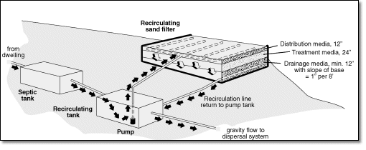
Figure 31: Example of a Recirculating Sand Filter (52).
The advantages of using Recirculating filters are that they are efficient at removing solids from the water and provide high quality potable water while also being fairly low maintenance and requiring little supervision. However, the system must be regularly cleaned and maintained to ensure that it does not clog and could become expensive if the necessary media is not locally available.
Either of these filters can be used to achieve a rapid or slow flow output by correctly choosing the type of media used in the filter. A fine sand can remove more impurities from the water, thus making the process of removal slower while a more coarse sand will allow for more water to pass through, thus achieving a higher flow throughput.

Test of 2016 – 17 System
The previous system was first set up to be operated and tested before any changes were made to the reactor. The water was collected in a beaker placed underneath the reactor and a weighing scale was used to measure the amount of water produced from the reactor.

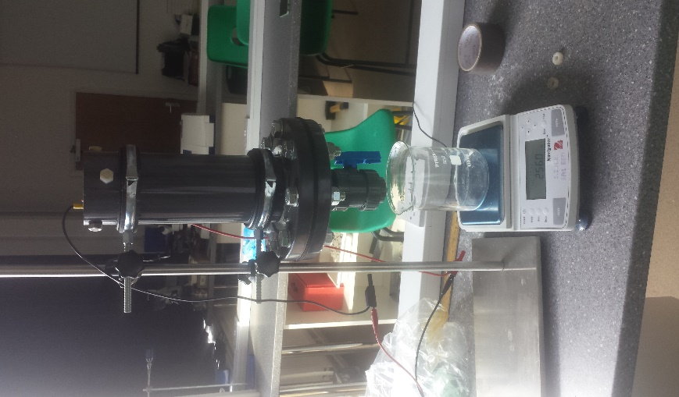
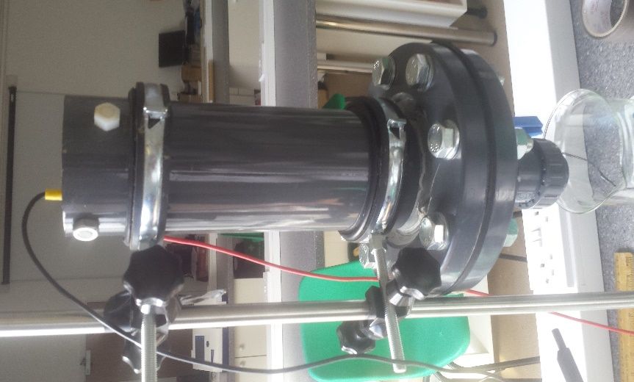

Figure 32 - Beaker & Reactor
Figure 33 – The previous Reactor

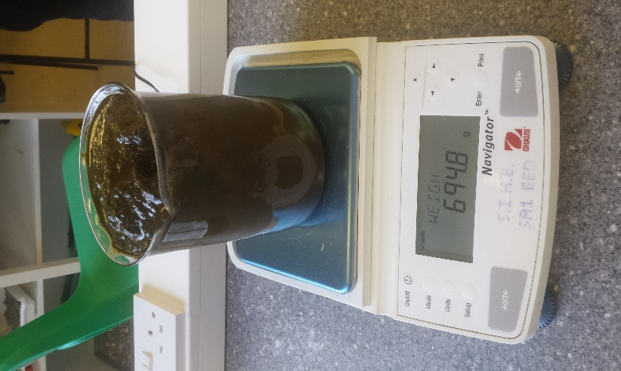
The slurry collected from the farm was weighed before been poured into the system.
Figure 34 - Weighing the Slurry
The entire process was done to check if the system was operating correctly and to also check if there was any damage to the system from the previous tests.

Design (JN)

2016-17 Design
The previous reactor design that was used for the last academic year comprised of the outer aluminium cathode inserted into a flange that was bolted to a base flange. In between the two flanges sat two gaskets that held the water permeable membrane.
To understand the working process of the original reactor design, a test was completed with the reactor set up as the previous report described, the reactor was loaded with 1kg of slurry and the power source was attached with a current of 1.5 amps and a voltage of 10.
During the test issues with the original design were highlighted, as the slurry was loaded into the reactor it was found that the base of the anode was not flush with the membrane. This gap between the membrane and the base of the anode allowed for the slurry when loaded into the reactor to flow up through the centre of the anode. With slurry in the centre of the anode the waste is not in a position where the current is passing from the anode through the waste and to the cathode. This issue prevents the electro osmotic flow of fluid through the waste and can be shown by the H-S equation below;
$$V_{e}= \frac{ε ς}{η} E_{z}$$
Equation 14 : H-S Equation
(46)
Where;
$$E_{z}=Electric Field Strength$$
$$V_{e}=Electroosmotic velocity between parallel plates$$
$$η=Viscosity of Liquid$$
$$ε=Permittivity of Media$$
$$ς=Zeta Potential$$
As the electric field within the centre of the anode is far weaker than the area between the outside of the anode and the inside of the cathode the Electro osmotic velocity is greatly reduced. This was proved when the test was completed, and the centre of the anode contained slurry that was still in the liquid form whilst the slurry outside the anode had reduced in moisture content, the area that is below the anode and on top of the membrane was also in liquid form as the current was unable to pass through the volume of slurry. Assuming that the volume of slurry was 1litre the following volume that entered the centre of the anode and was below the anode was calculated as;
Volume of slurry between the base of the anode and above the membrane;
$$π ×{0.057}^{2}=0.01020703453m^{2}$$
$$0.01020703453 ×0.0292=0.000298045m^{3}$$
$$Slurry not processed at base=0.000298045m^{3}$$
Approximately 1kg of slurry has a volume of 1 litre which is equal to 0.001m³.
The remaining volume of slurry that is above this is;
$$0.001-0.000298045=0.000701954m^{3}$$
The cross-sectional area of the anode was required to be calculated;
$$\left(π × {0.031}^{2}\right)-\left(π × {0.025}^{2}\right)=0.001055575 m^{3}$$
The internal cross-sectional area of the Cathode was calculated as;
$$π ×{0.05}^{2}=0.007853981 m^{2}$$
To calculate the internal area total cross-sectional area was completed by;
$$Internal Cathode C.S.A-Total Anode C.S.A=Total internal C.S.A$$
$$0.007853981-0.001055575=0.006798406m^{2}$$
Therefore, the height at which the remaining volume of slurry will reach to inside the reactor is calculated by;
$$C.S.A ×Height=Volume$$
$$Height=\frac{Volumme}{C.S.A}$$
$$Height= \frac{0.000701954}{0.006798406}$$
$$Height=0.1032527331m$$
The internal cross-sectional area of the anode is calculated as;
$$Anode internal C.S.A= π × {0.025}^{2}=0.001963495m^{2}$$
The volume of slurry that enters the centre of the anode in liquid form at the beginning of the process is;
$$Volume of Slurry inside Anode= Anode internal C.S.A ×height of slurry inside reactor$$
$$0.001963495 ×0.1032527331=0.000202736 m^{3}$$
The total volume of slurry that is inside the reactor but is not subjected to the flow of current due to the location of the slurry and electrodes is;
$$Vol of Slurry inside Anode+Vol below anode and above the membrane=Non reacted$$
$$0.000298045+0.000202736=0.000500781m^{3}$$
$$0.000500781m^{3}=0.500781 litres$$
The percentage of 1 litre of slurry that is loaded into the reactor but is not subjected to the electro osmotic process is;
$$50.0781\%$$
To improve on this unreacted waste within the reactor the flow of liquid slurry to the unreactive areas must be prevented as the efficiency of the reactor is greatly reduced in terms of the waste processed. The wet slurry that remains inside the anode and below the reaction chamber sits directly above the water permeable membrane; this wet slurry prevents the flow of removed water from passing through the membrane into a measuring beaker. It is necessary to create a route that the removed liquid can travel through and exit the reactor through the tap.
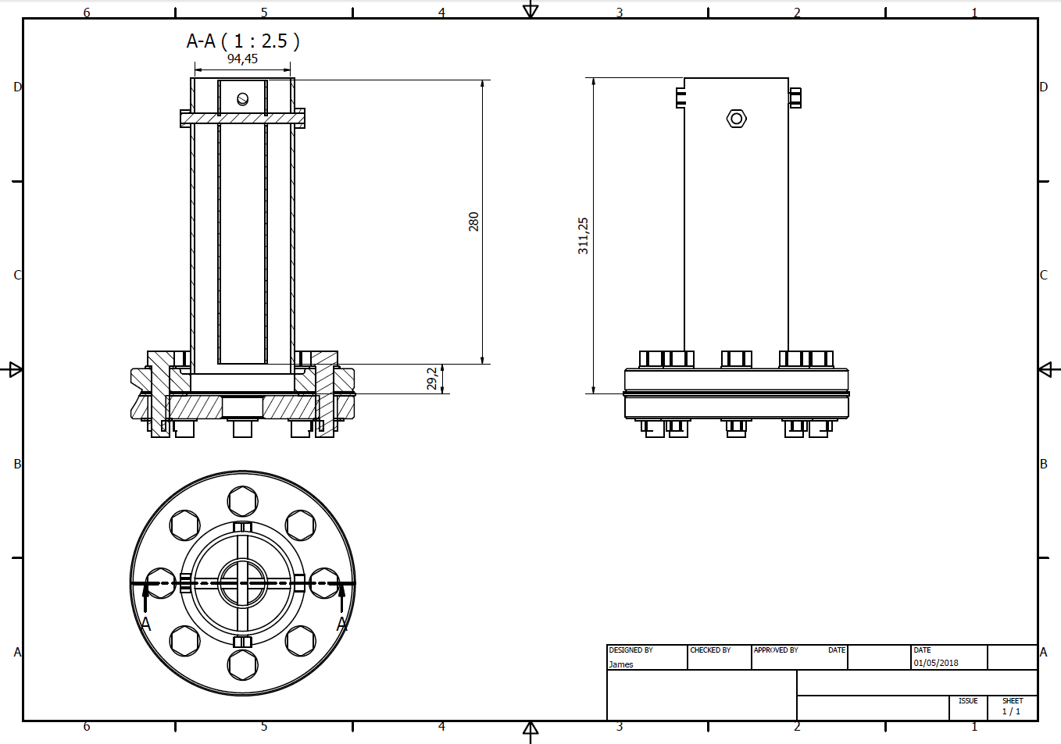
Figure 35 : 2016-17 Reactor

New Design Requirements
The issues outlined with 2016-17’s design highlighted that the efficiency of the design was greatly reduced by the amount of slurry that was not in a location that was subjected to the electrical current. To prevent the waste form flowing up into the anode a cap that is made from a nonconductive malleable material will be manufactured that will seal the base of the anode and prevent the slurry from flowing up through the centre.
The addition of a cap on the base of the anode will also increase the level that the slurry will reach internally, with the anode being submerged in a greater depth of slurry the amount of waste that will be in contact with the reactive current will be greatly increased and the overall efficiency of the electro-kinetic dewatering will be increased.
The next issue that has to be overcome was the space at the base of the anode and the top of the membrane that allows a pool of slurry to accumulate, this wet slurry that is not dewatered prevents the liquid from the dewatering process from migrating through the membrane as the pool of wet slurry acts as a barrier for the liquid and introduces an increased lag time between the liquid being removed from the waste and exiting the reactor.
To simply overcome the issue of the blocked membrane a conduit can be used to allow the liquid to pass from the dewatering area and through the membrane without any contact between the wet slurry and the membrane. The application of a gravel filter between the slurry and the membrane would prevent blocking the membrane but also allow the liquid to pass through whilst preventing the slurry from passing through.
To accommodate the application of gravel an extension would be required to house the filter. An extension would require additional modifications to the components list, where additional bolts would be required to seal the two flanges and prevent any liquid slurry loss.
The current reactor with modifications does offer the potential to become a continuous process if an extension to the reactor is added between the two flanges allowing the wet slurry to be pumped in and through the reaction chamber with the removed liquid running down the internal wall of the cathode with the dewatered slurry moving towards the top of the reactor and exiting at the top.

Initial Design 1
The initial design that was generated included a cap on the base of the anode to prevent slurry from passing up the vacant space inside the anode a tank extension to allow a volume of wet slurry to be contained in at the base of the reactor and an inlet to the tank to allow more wet slurry to be introduced into the process under pressure to push the dewatered waste from the reaction chamber through the top of the reactor.
To place a gravel filter above the membrane in this design would require an additional cylinder that would be situated above the membrane that would contain the gravel and prevent any moving slurry that has been introduced into the system from picking up loose stones and slowly eroding the depth of the gravel filter down which would reduce the effectiveness of the filter.
Design 1 would also require an additional tank of slurry that can be pressurised with an air source to ensure that the waste that is pumped into the reactor moves through the reactor with minimal air bubbles which would impede the dewatering process.
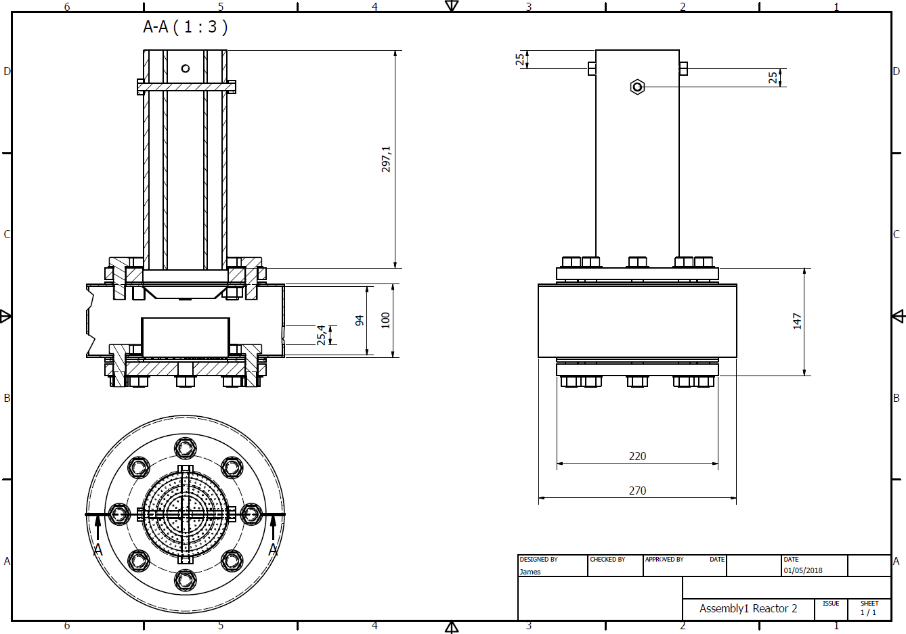
Figure 36 : Design 1

Design 1 Analysis
The initial design 1 when analysed indicated issues with the time required to purchase and construct the reactor in its current design which was based on it being utilised as a continuous process where the slurry is constantly moving through the reaction chamber. The issues with obtaining the parts were not with the additional bolts as they were of a standard size that are widely available but with the construction of the extension tank.
The addition of the extension tank and the additional slurry tank and air supply would increase the amount of time required for parts delivery and construction greatly as the tank its self would have to be capable of working under pressure whilst remaining water tight. Tank would have to be made by a specialist fabricator as the design and construction would require the use of tools and skills that are not available, this in turn would also increase the overall cost of the project.
It was decided that the design of a continuous process for this reactor was not feasible given the time scale of the project and the extra costs involved. The design issues for Design 1 could be overcome if alterations were made with the view of keeping the reactor as a batch reactor which would limit the components list and the construction time.

Design 2 Analysis
Design 2 was developed with the basic principles of the original reactor and the alterations made in design 1 but simplified to improve the efficiency of the rector and also the manufacturing time.
The extension tank in design 2 had become a 145mm depth tube that was to contain pure gravel that would prevent the wet slurry from contacting the membrane; the anode was shortened by 30mm to allow a further 50mm on top of the extension for the addition of more gravel.
The addition of the increased gravel filter depth allowed the slurry that is loaded into the reactor to be in full contact with the reaction chamber and in turn would increase the efficiency as the slurry that is loaded into the reactor would be in full contact with the two electrodes allowing for 100% of the waste to be processed. The increased gravel depth and shorter anode also allowed for a greater surface are of the sacrificial anode to be in contact with the same amount of waste as the original, which showed worse signs of corrosion near the base than the mid-point of the anode and would eventually erode in an inefficient way as the top half would remain with a reasonable wall thickness and the bottom half would be all but eroded. The shorter anode is thought to erode in an even manner through 80% of its length.
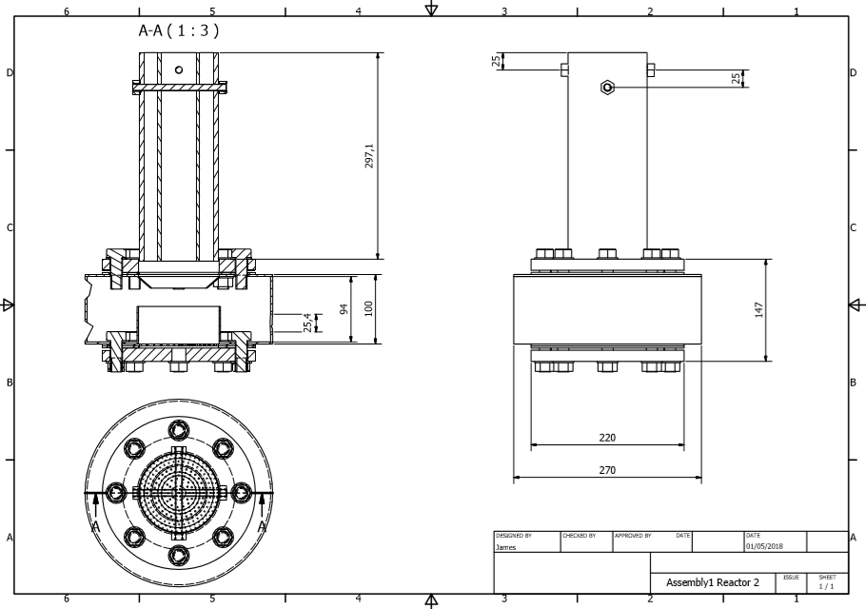
Figure 37 : Design 2

Design 3 Analysis
The issues that were present with time scale of construction and the cost of ordering custom parts for design 2 had to be overcome as the project risked overrunning the agreed timescale. To overcome these issues design 2 was altered to simplify the construction and to reduce the complexity of the components needed.
The issue with the custom tank for design two was rectified by reducing the diameter of the tank so that the tank only held the gravel filter, this was able to be done as the reactor was not going to be used as a continuous process, but as a batch reactor that would not be under any pressure other than the head pressure from loading the reaction chamber with slurry. The reduced tank was now a 101mm diameter mild steel tube with a wall thickness of 3mm which was purchased and cut to size by a local metals supplier.
To ensure that the new tank would be secure in between the two flanges alternate bolts had to be acquired to create a secure seal at both the top and bottom of the tank, to ensure a tight seal the two gaskets would have to be removed as they would pinch at pressure points and buckle resulting in an insecure seal. To create a complete seal between the tank and the flanges sealant would be used to fix the tank into position.
To join the two flanges together long bolts with a thread running partially along the length of the bolt would be used, the closest bolts that were available were Hexagon Bolts M16 x 240mm Grade 8.8 Zinc Plated DIN931, these bolts were purchased along with M16 washers and M16 Hex Nuts A2 Stainless Steel DIN934 with the bolts and the nuts both having a coarse 2mm thread depth that was sufficient for the required torque to secure the tank in place.
The smaller than also allowed the internal filter container to be removed as the new tank was of the same diameter as the original filter container.
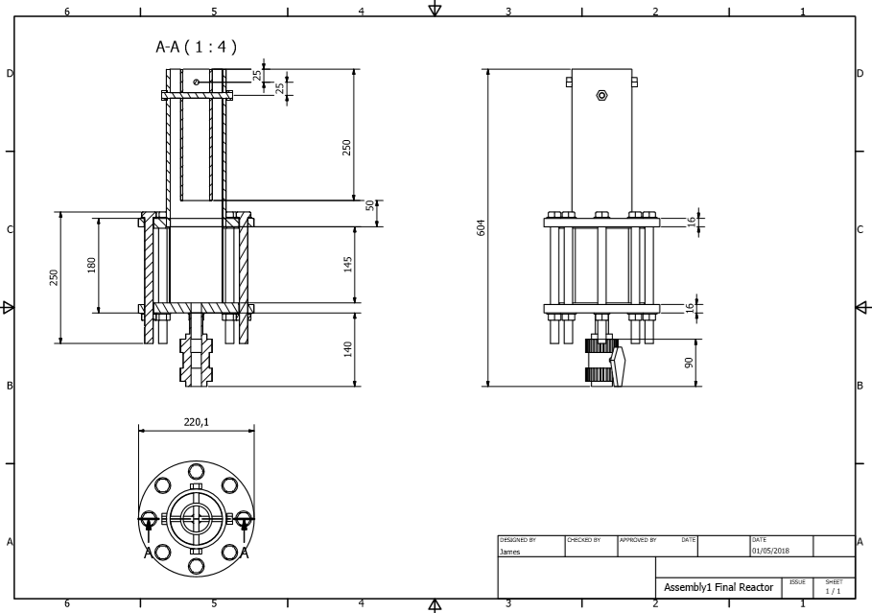
Figure 38 : Design 3 Final
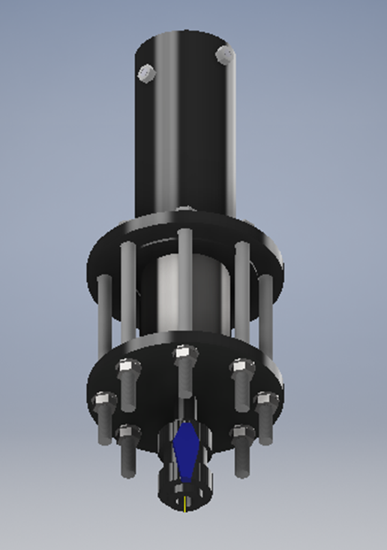
Figure 39: Rendered Image of Reactor 3

Feasibility of Renewable Energy Resources
This chapter will investigate the feasibility of each the previously mentioned renewable energies for implementation on the farm.

Hydro (LT)
The flow rate of the river Towy is required to conclude which hydro power turbine is most suitable.
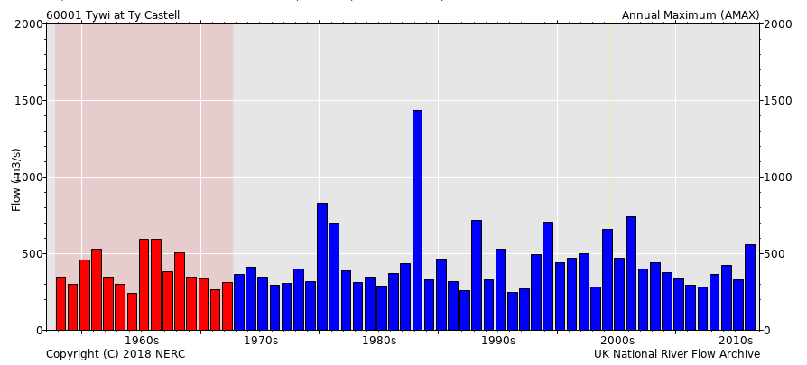
Figure 40 - Annual Max Flow Rates for Towy River at Ty Castell (53)
The above figure shows the annual max flow rates for the river Towy at Ty Castell with is around 10 miles downstream from Gelli Aur. Using this graph, the average flow rate of the river is estimated to be around 150ms⁻³.
Abstracting 10% of the flow rate would provide 15 m³/s to use for hydro power. Based on the low head, high flow nature of the Towy River, 2-3 Archimedean screw turbines at 5m in diameter would be suitable for this process.

Costing (LT)
Despite it being a relatively small scheme that usually means the cost/kW is higher.
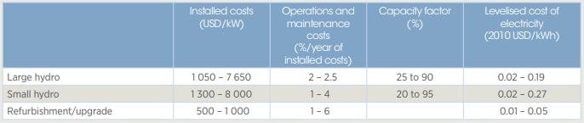
Figure 41 - Installation and Maintenance Costs of Hydro Schemes (54)
As shown in the above figure small scale hydro schemes typically range from 1300-8000 USD/kW installation costs. 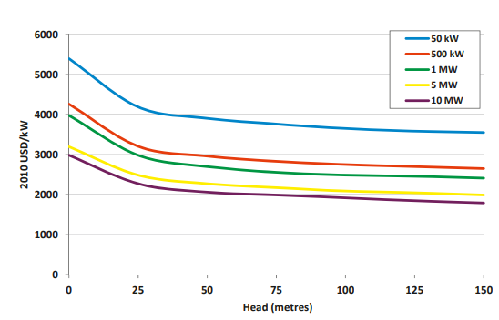
Figure 42 - Installation Costs Compared to Head Height (54)
Using the information in the previous two figures, installing a hydro scheme at Gelli Aur could range from 4000-5500USD/kW. The cost of the installation will be affected largely by how big the scheme is. With the flow rate of the river the scheme has the potential to not only power the process but even part of the farm. If the scheme was large enough it could even be a source of revenue.
Assuming it was to only power the process abstracting less than 10% of the flow rate of the river Towy would be required and using a 20-30kW turbine. The estimated installation price would be 110,000- 165,000USD.

Considerations (LT)
There are several considerations before the installation of a hydro power scheme.
- Planning permission from the council would be required before construction can start
- Abstraction license would be required to divert flow from the river
- Consideration to wildlife, due to there being a high population of salmon in the river Towy, Archimedean screw turbines are considered to be fish friendly
- Consideration of recreational activities such as fishing

Wind (JN)
The Gelli Aur farm is in the county of Carmarthenshire, where there is currently the ongoing construction of a large wind farm by the welsh government the Brechfa Forest Wind Farm that is to contain 40 Wind Energy Conversion Systems with the potential to generate 90MW of power, the wind farm is due to be completed in 2018.
The presence of the Brechfa Forest Wind farm and its location which is not a great distance from Gelli Aur farm suggests that powering the Slurry dewatering process with WECS is a potential solution for larger processing of the cattle slurry. The wind turbines that are used in the Brechfa Forest are around 140 metres tall and have been met with local protests to the obstruction to local views. The WECS used are Horizontal Axis Wind Turbines (HAWT) where the axis of the wind turbine is parallel to the ground.
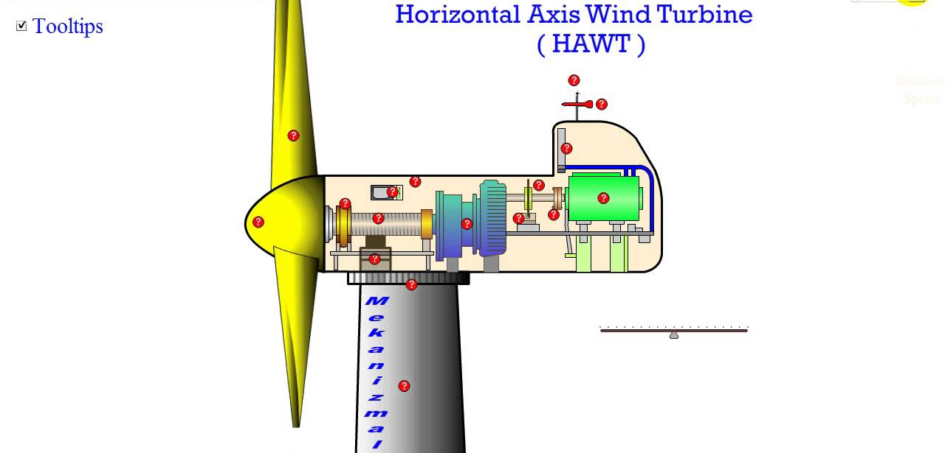
Figure 43 :HAWT
The construction of the HAWT allows for the wind turbine to remain operational during a range of wind speeds as the shaft connected to the blades is connected to a gear box which allows the various rotational speeds of the blades to be converted over a greater range of rpm into usable momentum for the generator. The HAWT is generally favoured over the Vertical Axis Wind Turbine as the power generation potential is greater over a greater range of conditions, where the VAWT are generally used in locations where space is of a premium.
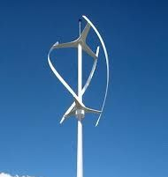
Figure 44 : VAWT
For a location such as Carmarthen the HAWT would be the WECS of choice as the wind fluctuates greatly over the course of the year due to the inconsistent weather patterns that are experienced by the region.
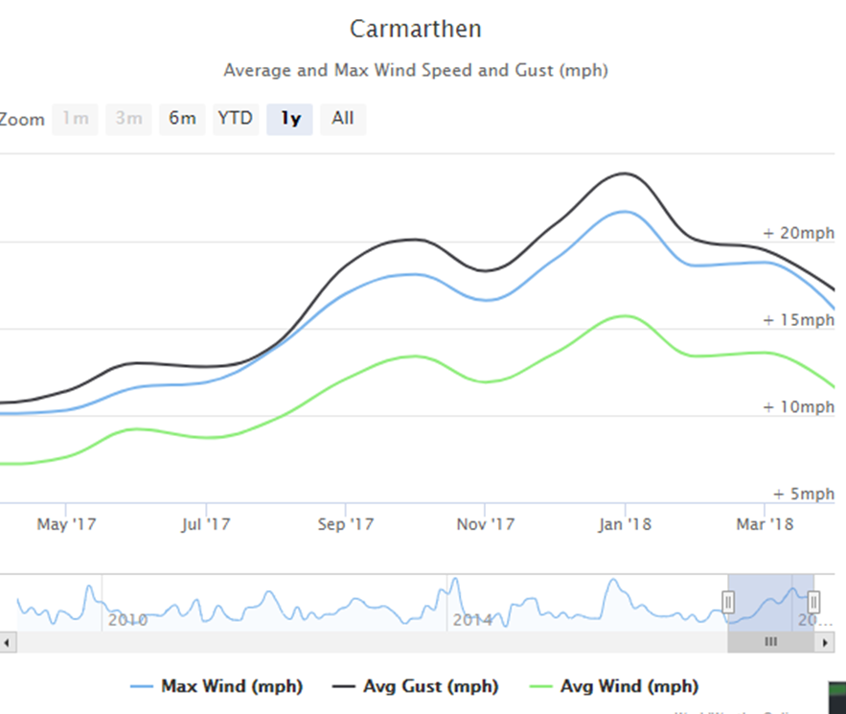
Figure 45 : Average Wind Speeds Carmarthen 2017 (55)
As can be seen from the graph above the fluctuations in wind speeds over the year vary greatly with the peak wind speed average being in January and the lowest wind speed average being in April and May. This fluctuation in wind speed would indicate that the use of HAWT WECS would be the most successful. The reasoning behind this is the use of the gear box allowing the rotation of the blades at various rpm to be stepped up or down to generate power. The output shaft of the Gearbox provides direct rotational power to the generator which is typically a permanent magnet synchronous generator where permanent magnets are used to induce an alternating current, with each rotation of the shaft the North and South Pole pass the armature which is stationary.
$$\frac{P}{120}$$
$$P=Number of Magnetic Rotor Poles$$
$$120=Number of Pole Passes of Armature$$
The power that passes through the generator is a function of the torque and revolution of the input shaft.
$$Pm=Tm ×RPM$$
Equation 15 : Prime Mover
$$Pm=Mechanical Power (Watts)$$
$$Tm=Torque \frac{N*m}{rads}$$
$$RPM=Revolutions per minute$$
To obtain a greater electrical output the torque of the shaft must be increased which is why the application of a HAWT WECS with a gear box for this location would provide the greatest amount of power.
The use of a WECS of this construction allows the most power to be converted over the range of wind speeds, where the actual power absorbed by the WECS is limited by the Betz law where;
‘Betz concluded that this value is 59.3%, meaning that at most only 59.3% of the kinetic energy from wind can be used to spin the turbine and generate electricity. In reality, turbines cannot reach the Betz limit, and common efficiencies are in the 35-45% range’
(56)
Although the construction of a large wind farm in the county has already begun, the location of the farm is in an area of restricted planning as it is in close proximity to the Brecon Beacons national park and also the National Trusts Dinefwr Park and the construction of a wind turbine or WECS array is likely to not be granted planning permission by the local government and positioning of a WECS at some distance from these locations would incur extra costs from cabling, groundwork’s and connection fees.

Potential Control Systems
This section will investigate the possible control systems that could be developed and implemented alongside the reactor to improve overall performance.

Limiting Current & Reversing Polarity (RM)
This control system involves regularly reversing the polarity of the power input to the reactor at set intervals using a custom circuit design. The circuit will also be able to take readings from the reactor using a moisture sensor to help assess when to limit the current being used to power the reactor.
The hypothesis is that if the polarity of the input being delivered to the electrodes is reversed at regular intervals, the electrode will deteriorate at a slower rate than if the polarity was not reversed.
An additional hypothesis is that as the moisture content of the slurry in the reactor decreases, the current can be adjusted to lower the overall power consumption.


Brief Background Research (RM)

PIC Controllers (RM)
PIC’s, or Programmable Interface Controllers, are multipurpose chips that are outfitted with numerous features so that they can perform a wide range of tasks. PIC’s are also relatively easy to setup & implement due to their average size as well as being inexpensive.
Figure 46: Example of a PIC (70)
There are different types of PIC families from 8-bit to 32-bit. A higher bit count indicates that the PIC can perform mathematical equations with more accuracy. Each PIC also has a different set of specifications to choose from such as program memory for the code, RAM for any data being collected, pin count, CPU speed, Operational Voltage, etc. (57)
There are also a range of peripherals that can be selected from when choosing a PIC such as:
- The speed of the Internal Oscillator, which dictates the overall processing speed of the PIC when performing calculations.
- Comparators, which can be used to compare two values.
- Operational Amplifiers, which can be used to positively or negatively amplify a signal.
- Number of A/D Converters for analogue-to-digital conversion, as well as the max resolution, which can dictate the accuracy of the final value.
- Number of D/A Converters digital-to-analogue conversion, as well as the max resolution, which can dictate the accuracy of the final value.
- 8-bit/16-bit digital timers, which can be used to keep track of subjects such as time by incrementing the internal value of each counter.
- PWM outputs, which can be used to produce a regular square-wave signal, as well as the max resolution of that signal.
- Watchdog timer, which can be used to as a safety condition or interrupt to alert the controller when a specific amount of time has passed where the timer has not received a signal.
- USB Module(s), which can be used to interface the PIC with third-party devices.

Double Pole Double Throw Relays (RM)
DPDT’s are a type of discrete circuit which can be used to easily switch between different loads by applying a voltage across the internal inductor coil. Depending on how the terminals are connected, a DPDT can have many uses, such as reversing the direction of current to make a DC motor spin in a different direction, as shown in the example below.
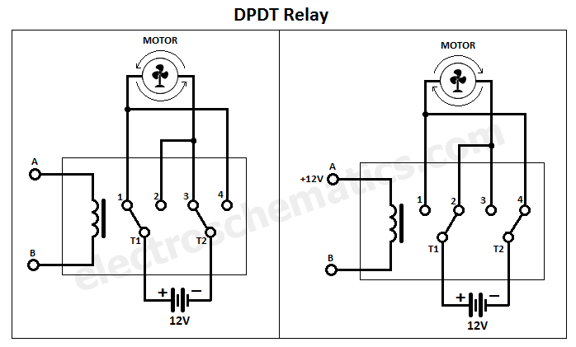
Figure 47: An example of a Double Pole Double Throw Relay (58)
In the case of the proposed control system, a DPDT relay can be used to reverse the direction of current through the reactor and changing the roles of anode and cathode between the electrodes. By doing this, it is theorised that the lifespan of the electrodes can be extended as the role of sacrificial anode will be shared. This process would be controlled by a PIC, which in turn would rely on a 555 timer to track the amount of time passed. The PIC can then use this information to determine when to toggle the DPDT relay.

555 Timers (RM)
A 555 timer is a type of IC which can be used to output a DC pulse, with the length dependant on
the surrounding components. 555 timers are a very versatile chip as they can be operated in either Mono stable Mode, which outputs a single pulse when activated, or A-stable mode, which will regularly output a square wave.
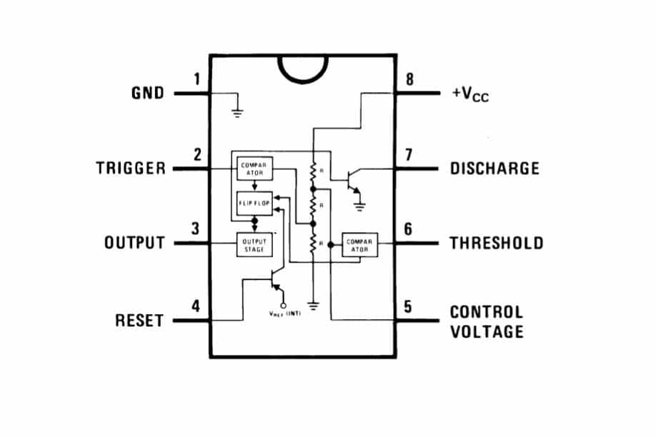
Figure 48: Example of a 555 Timer (59)
To calculate the cycle time of the 555 timer, the following equation can be used to calculate the necessary resistor and capacitor values needed to create a circuit which will output the desired oscillation cycle. R1 and R2 indicate a pair of resistors whereas C1 indicates a timing capacitor.
$$T=0.693\left(R1+\left(2*R2\right)\right)*C1$$
Equation 16: Cycle Time of a 555 Timer (60)
In the case of the proposed control system, a 555 timer can be used to provide a square wave to the PIC which will aid in determining when to toggle the DPDT relay and switch the direction of current.
By doing this, the amount of time passed can be tracked while also saving on the amount of instructions and memory needed by the PIC during programming.

Digital Potentiometers (RM)
Digital Potentiometers are resistors which can be adjusted for different resistance values via a digital input from a controller such as a PIC. These devices are useful as they allow for a system to be controlled automatically by changing the resistance and thus affecting other parts of the circuit.
The resistance can either be stepped up or down depending on the input, meaning that the value of the digital potentiometer is limited by the maximum resistance as well as the total number of steps from the maximum, to zero.
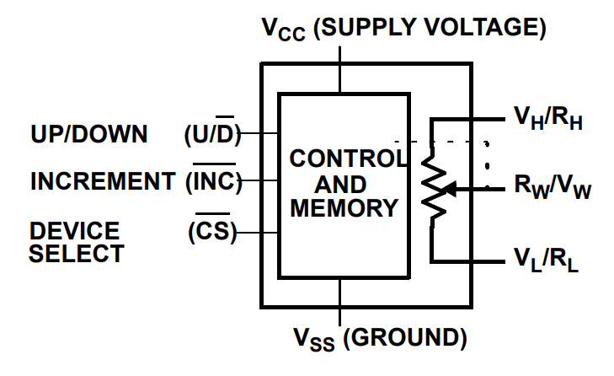

Figure 49: Example of a Digital Potentiometer (75)

In the case of the proposed control system, the Potentiometer will be controlled by the PIC to adjust the current limit of the DC/DC converter chosen. A second potentiometer can also be used to adjust the cycle time of the 555 timer, changing the rate of toggle for the DPDT relay. This will enable further control over the circuit by the pic as the user can adjust the resistor values via a user interface to the PIC.

DC/DC Converters (RM)
DC/DC Converters are devices which can downscale a DC power source to the desired voltage and current depending on the surrounding components and converter selected. These devices are useful for power management in a circuit as they allow for devices that use lower voltage & current rating to be used alongside a high voltage power supply.
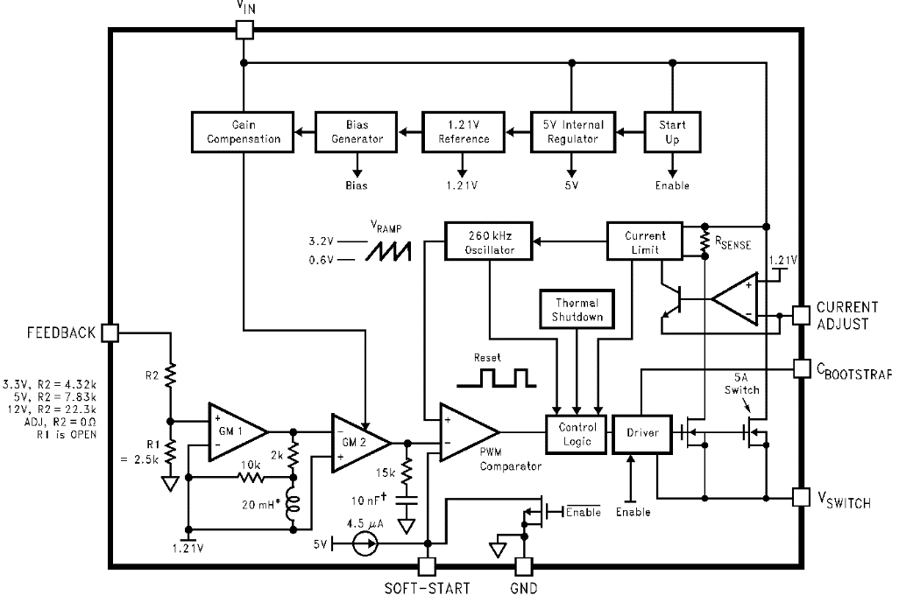

Figure 50: Example of a DC/DC Converter (61)
In the case of the proposed control system, the DC/DC Converter will be used to control the current output used to power the reactor. The converter will be indirectly controlled by a PIC with the use of a Digital Potentiometer as it will be connected to the current adjust pin. This will allow the current to be adjusted automatically with the voltage being changed to maintain a constant current output.


Components (RM)
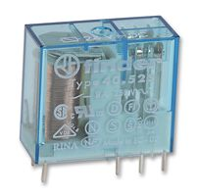

The main component that will be used is a PIC16F887. This PIC has been chosen as it can easily meet the required pins and possesses ample internal memory for the programming code as well as storing any necessary data.
Figure 51: PIC16F887 & Datasheet (72)

Additional components that are needed include the DPDT Relay “40.52.7.024.0000”. This DPDT relay was chosen as it can easily be mounted to a PCB or breadboard for testing and allows overhead of up to 24V and 8A which can help avoid overheating and will help when operating the reactor at a higher voltage or amperage.
Figure 52: 40.52.7.024.0000 DPDT Relay (73)

An LM555CM timer has been selected which can be configured to generate 0.1MHz, or 100,000 cycles per second. The surrounding resistors & capacitors selected will be used to configure the output frequency so that it is appropriate. The 555 timer can be powered by the same power supply used to operate the reactor and can be downscaled using a DC-DC converter to obtain a suitable operating current and voltage.
Figure 53: LM555CM Timer (74)
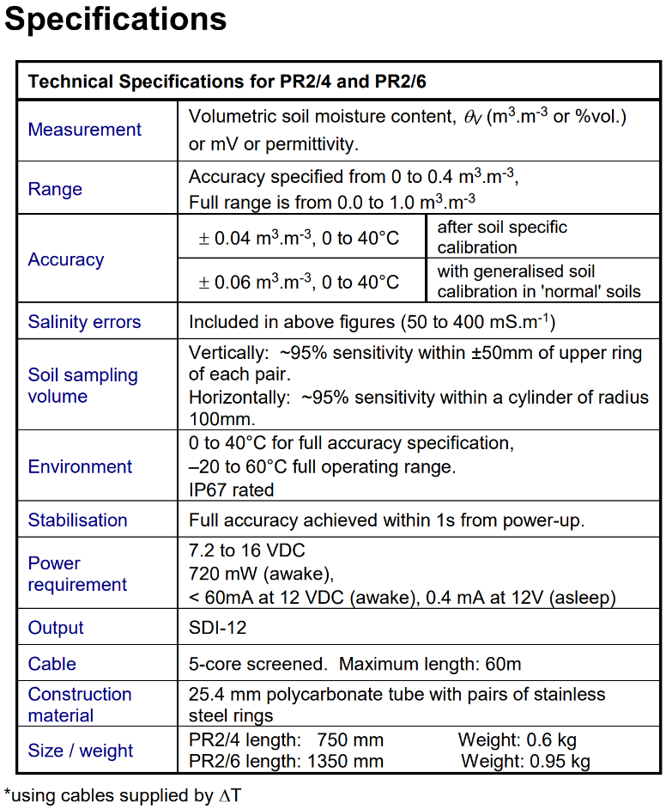
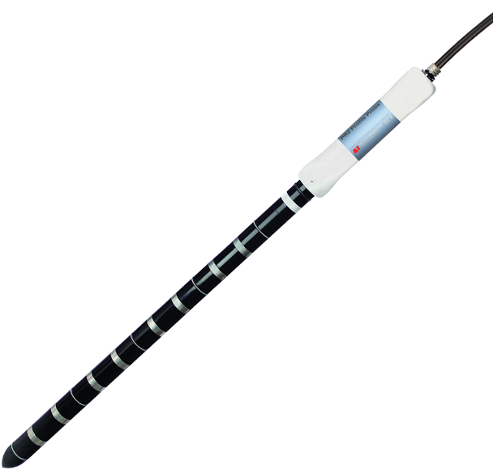

Figure 54: PR2 Soil Moisture Profile Probe & Datasheet (71)
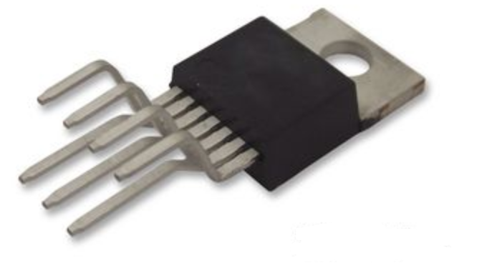
The PR2 moisture sensor can be used to monitor the moisture content of the slurry inside the reactor to obtain a full profile of the entire reactor from top to bottom with a length of 40cm.
The probe can be used alongside a compatible data logger from the same company, or can directly feed the data to the PIC using a digital input pin.

The “LM2376T” DC/DC Converter has been chosen as it allows up to 40V input and can generate a 3A output which is suitable. The device can be configured for different current outputs depending on the surrounding components which is ideal for the control system.
Figure 55: LM2673T DC/DC Converter (77)
The “AD5220BN10” Digital Potentiometer has been chosen as can be adjusted to different resistance values between 0-10K Ohms with 128 different steps.
Figure 56: AD5220BN10 Digital Potentiometer (76)
The potentiometer can be controlled by a PIC, allowing the control system to change the current output of the DC/DC Converter automatically.

Block Diagram & Flow Chart (RM)
The Block diagram shows the flow of power as well as information throughout the circuit from the reactor PSU to the reactor. It also shows how the DPDT relay is controlled by the PIC, which is reliant on the 555 timer to track time. The PIC also provides information for the LCD display and allows the user to input information with the use of several buttons.
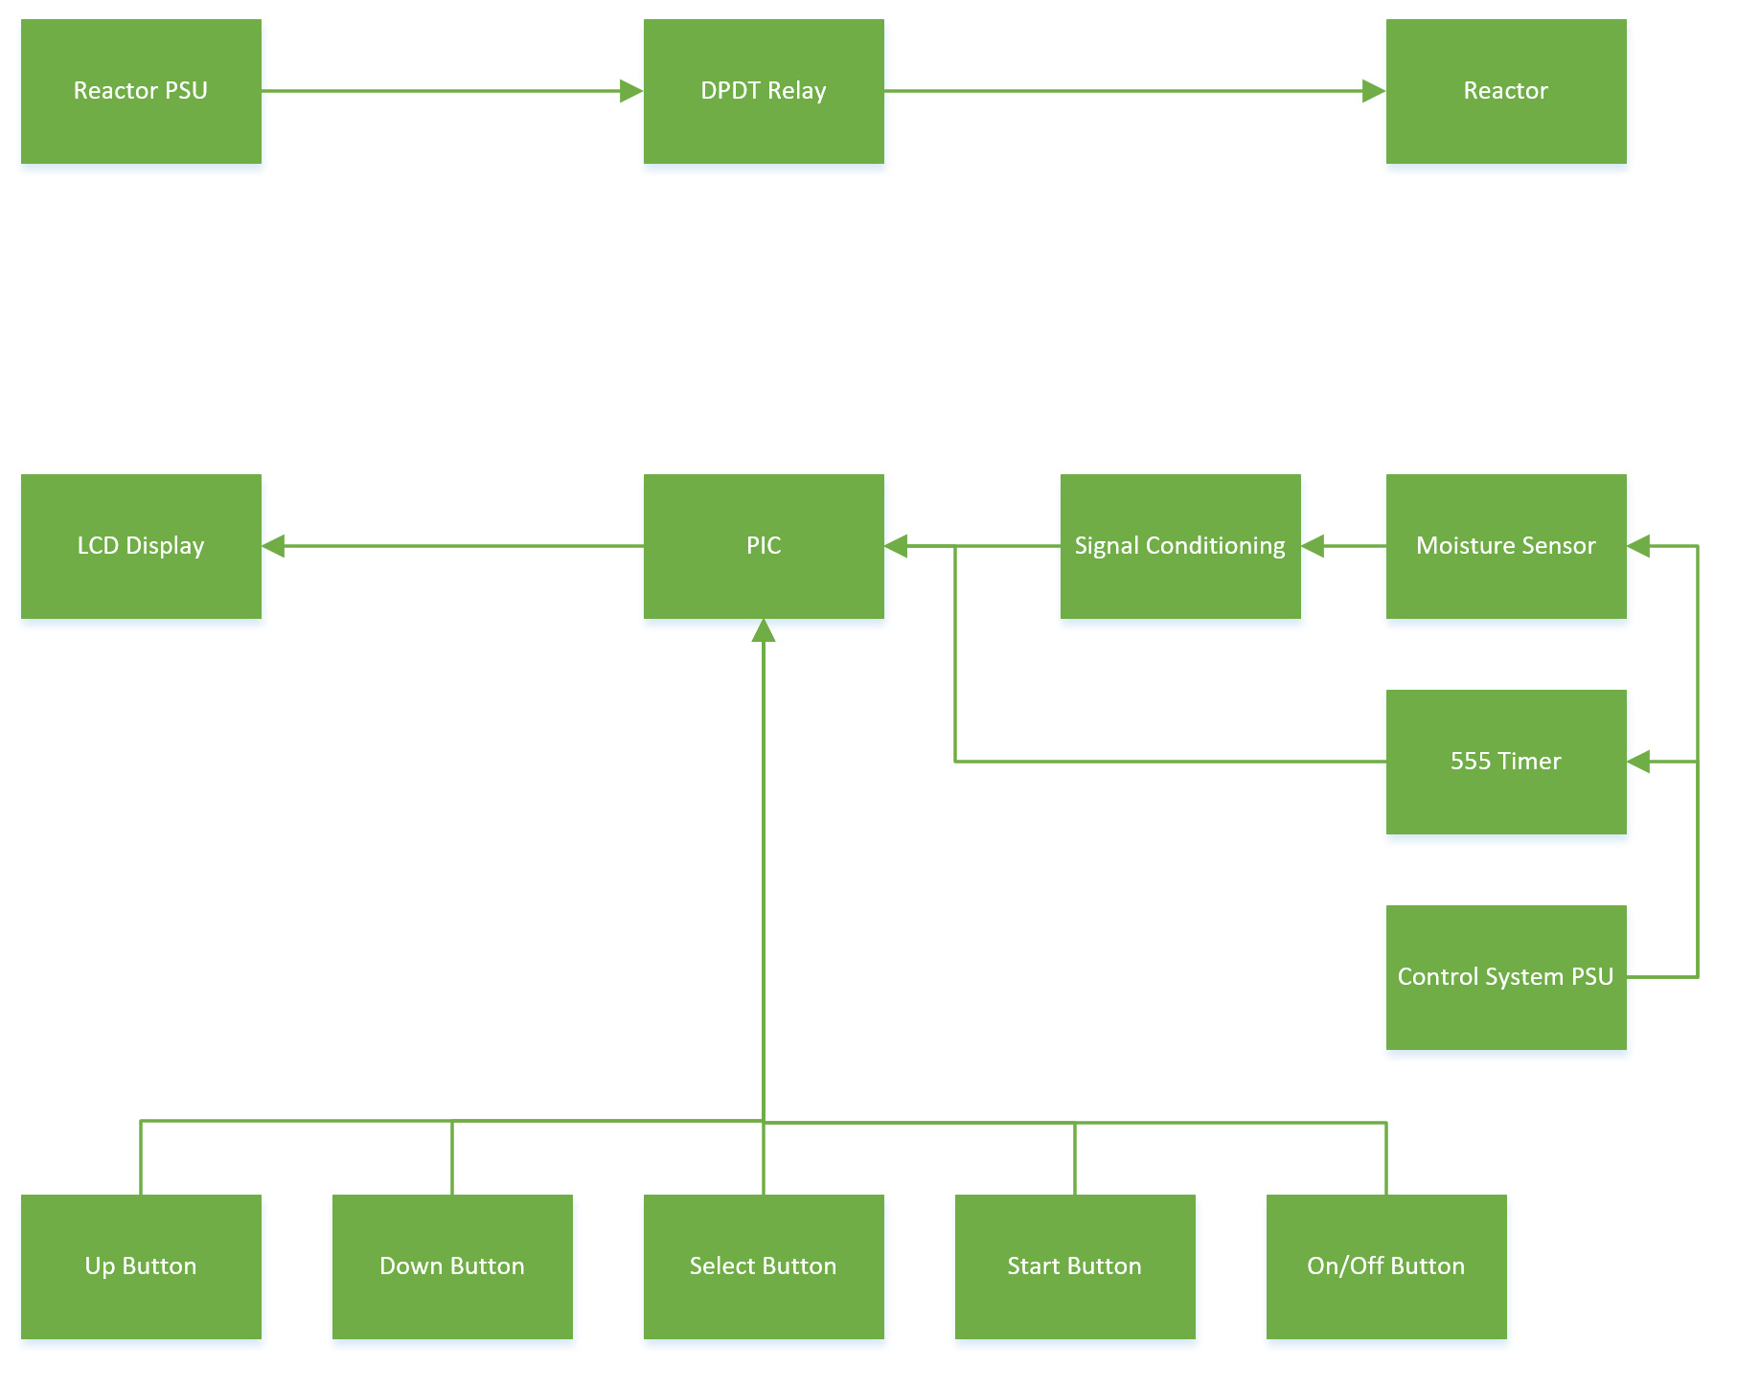
Figure 57: Block Diagram for Control System
The Flow chart shows the operation loop of the circuit. When the power supplies are turned on,
the circuit will operate, and power will flow to the reactor as normal. The user can then select to
use either control the direction of current or to also control the amount of current being delivered to the reactor. The circuit will then use the data outputted from the 55 timer and moisture sensor to make the decisions when toggling the DPDT and choosing the set value for output current.
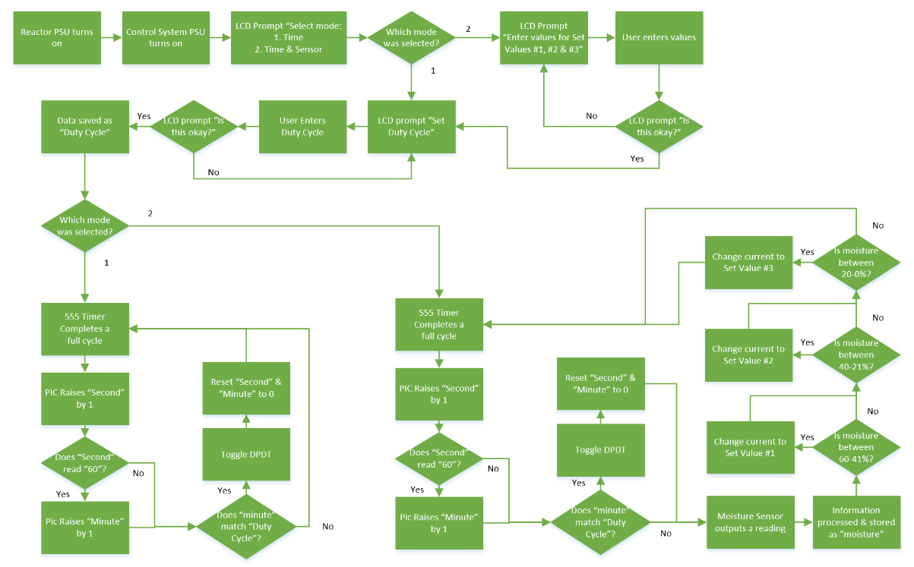
Figure 58: Flow Chart for Control System

Circuit Design (RM)
The circuit design shows the power supply for the reactor being directed through a DPDT relay, which is controlled by the PIC. The PIC will change the flow of current by toggling the DPDT Relay, depending on the amount of time passed which is tracked by the 555 timer. The 555 timer can be adjusted by the user during initial setup by changing the resistance of the digital potentiometer.
A moisture sensor, along with signal conditioning to prevent data corruption, will also be used to feed information to the pic so that it can decide what resistance value the second potentiometer, near the DC-DC Converter, should be set to. The DC-DC Converter will then limit the current of the reactor power supply depending on the resistor value. An LCD display and a selection of buttons are also implemented as a user interface so that the system can be turned on or all while also allowing the user further control over the system.
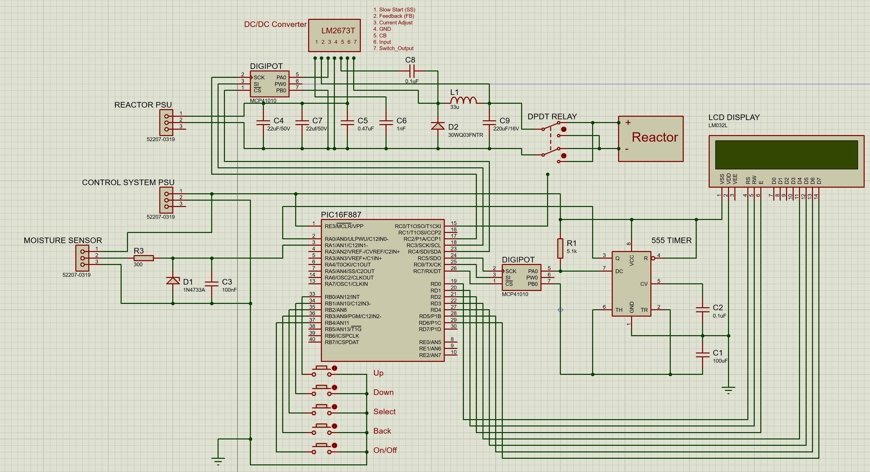
Figure 59: Circuit Design for Current Limiting & Reverse-Polarity Control System in Proteus

Circuit Schematic (RM)
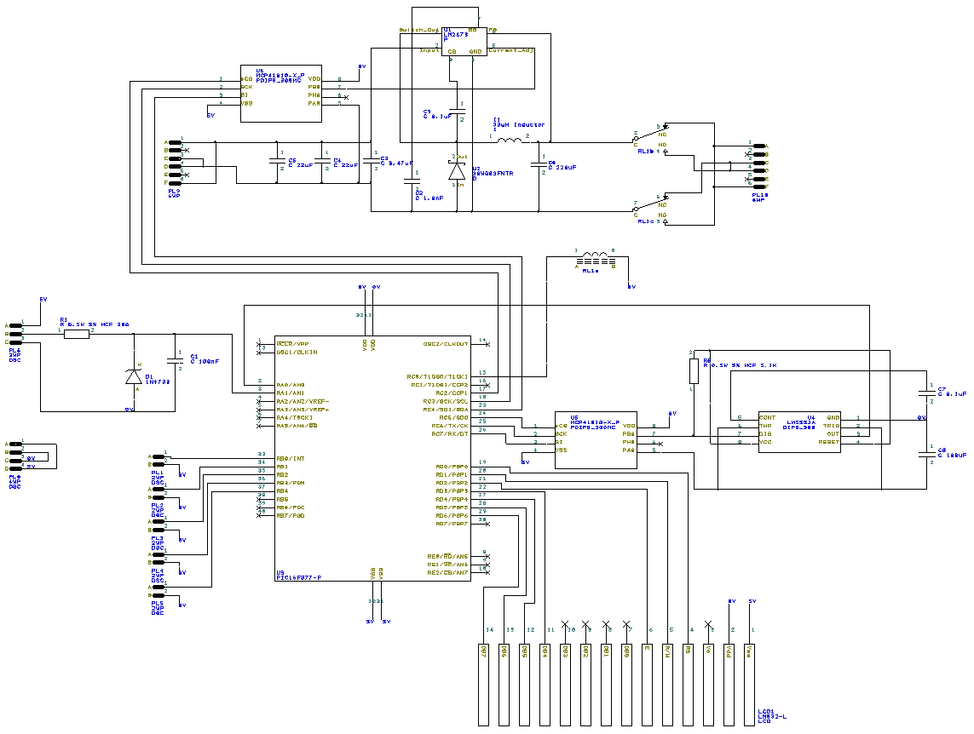
Figure 60: Circuit Schematic of Current Limiting & Reverse-Polarity Control System in easy-pc
Above is the complete circuit schematic of the proposed control system. This schematic is an accurate representation of the final design as real components have been used following all the necessary standards. This means that the schematic can be followed and used to construct a complete and functional PCB.

PCB Design (RM)
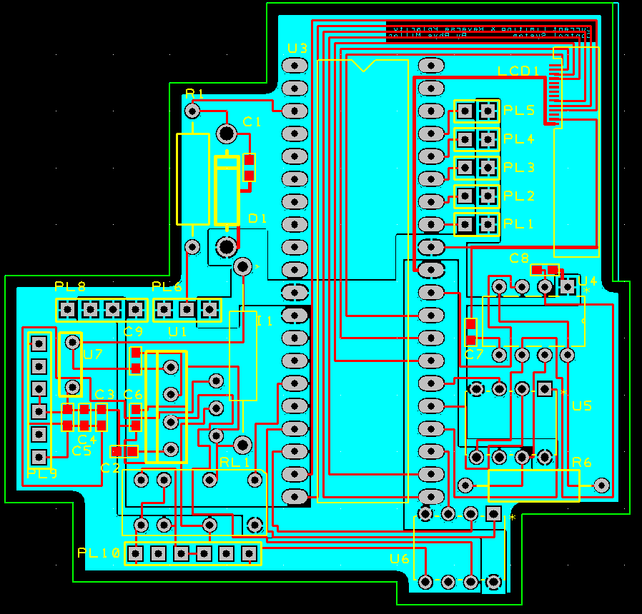

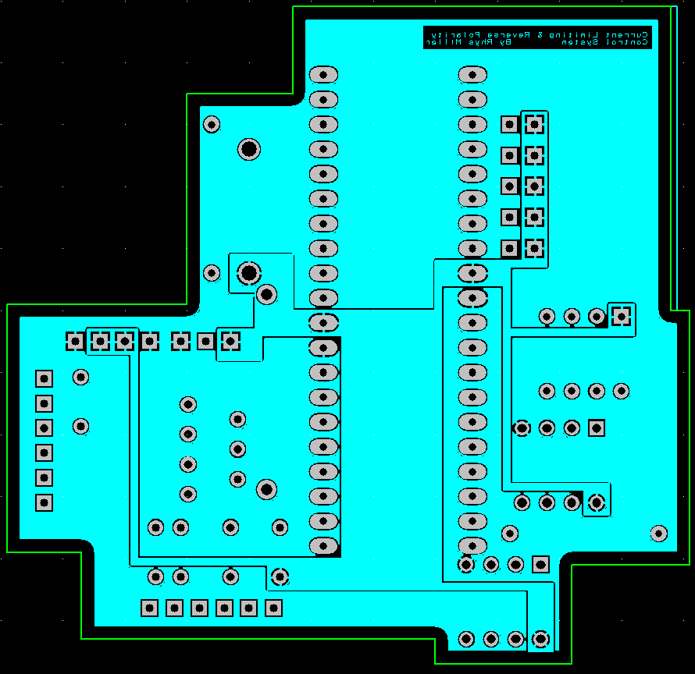
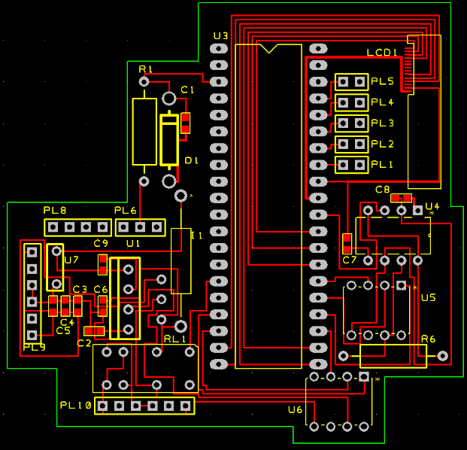

Figure 61: PCB Design of Current Limiting & Reverse Polarity Control System in easy-pc
This is the complete PCB design for the previously shown circuit schematic.
All components & connections shown are accurate and the PCB is within the allowed set tolerances. This means that there are no design rule contradictions and can be used to produce a functional PCB with a third-party manufacturer.
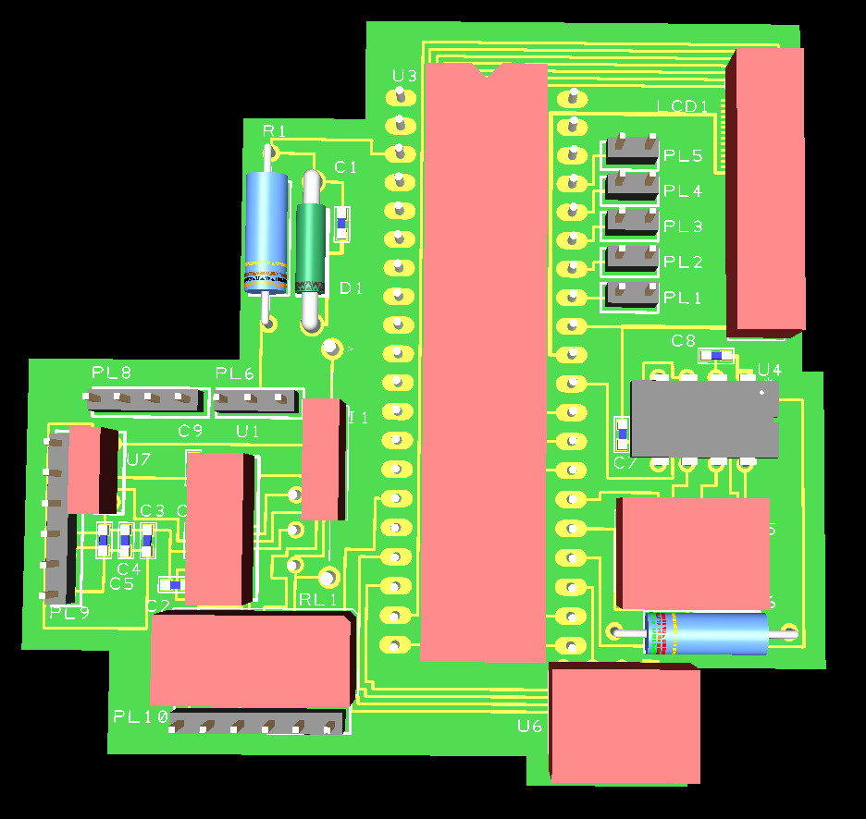
This is the 3D model representation of the complete PCB design. Some components cannot be properly represented as they do not exist in the library for the “easy-pc” software. As a result, they are instead represnted by red blocks, which follow the correct dimensions where appropriate.

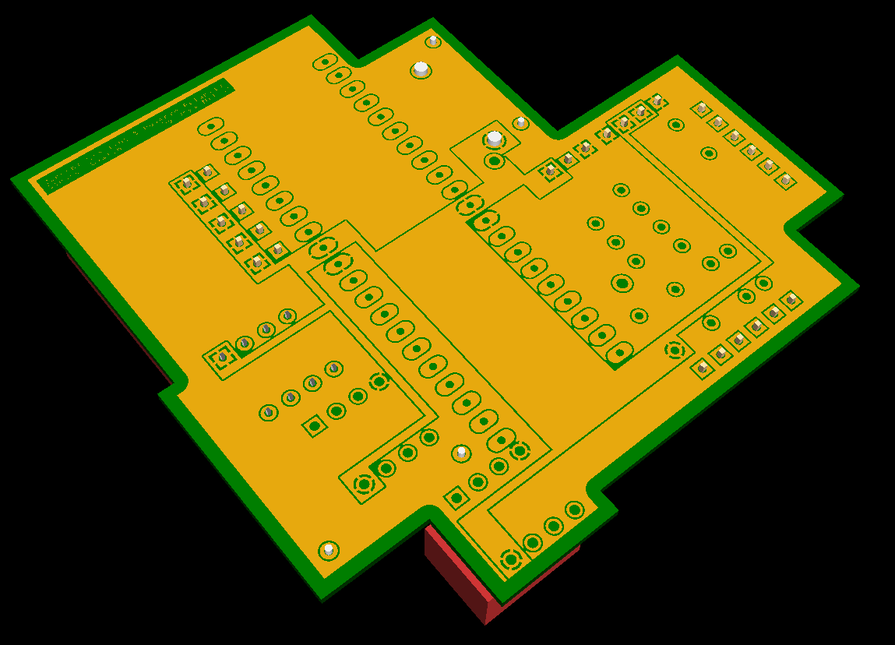
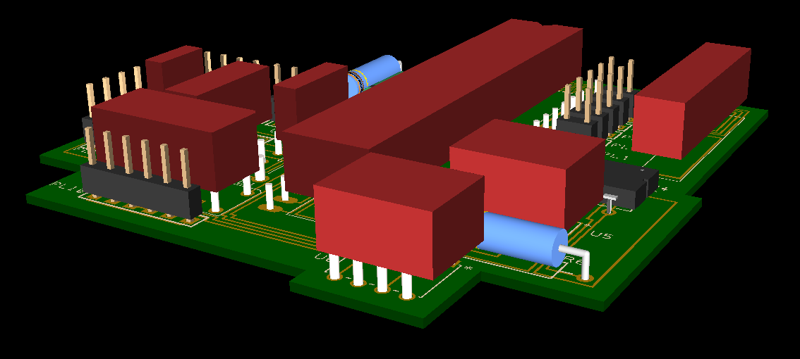
Figure 62: 3D Model of Complete PCB Design for Current Limiting & Reverse Polarity Control System in easy-pc

Controlling Flow Rate (LT)
The Second method for controlling the system would be controlling the flow rate from the tank into the reactor. As the slurry travels from the tank to the reactor the pressure inside the tank will decrease. Therefore, the flow rate of the slurry through the pipe will also decrease.
If the flow rate within the pipe is monitored the pressure can be adjusted within the tank, whether it be through putting weight on top of the slurry, sealing the tank and pumping air into it or some other method.

Flow Rate (LT)
There are numerous methods of measuring flow rate ranging from pressure differentials to optical sensors.

Pressure Differential (LT)
Flow rate can be measured using differential pressure flow meters, they use Bernoulli’s equation measure the flows of a liquid through a pipe. (62)
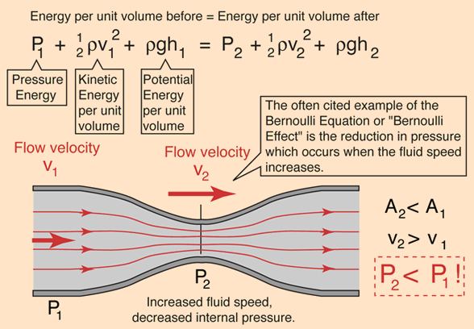
Figure 63- Bernoulli's Equation (63)
To measure flow rate and constriction in the pipe is introduced which creates a pressure drop within the pipe, as flow rate increases the pressure drop in the pipe increases.

Turbine Flow Meter (LT)
A turbine flow meter measures flow rate from the mechanical action of the turbine rotating. The turbine is positioned in the path of the fluid stream and when the fluid impinges on the turbine it begins to rotate. When the rotation has reached a steady speed the rotation velocity is proportional to the fluid velocity.
Turbine flow rate meters are more suitable to higher flow rates than pressure meters since they result in less pressure loss. They are less accurate in low flow rate situations though. (64)
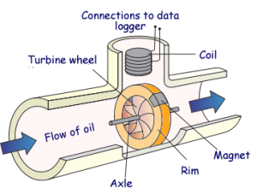
Figure 64 - Turbine Flow Meter (65)

Optical Flow Measurement (LT)
Flow of a fluid can also be measured using light, through use of a laser and optical sensors. Two lasers shine light through the fluid. When a particle passes through the laser the sensor on the opposite side of the pipe detects the refraction and emits a pulse. When the particle passes through the second laser the sensor emits another pulse. The time delay between these two pulses is inversely proportional the velocity of the fluid. (66)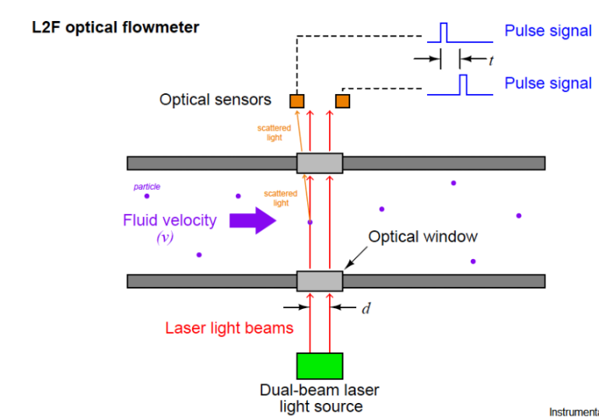
Figure 65 - Optical Flow meter (66)
An alternative method of optical flow rate measurement is by using a probe that is inserted within the pipe. However, this method only measures the velocity at that point and without the addition of temperature and pressure measurements may not be accurate for the entire fluid stream. With all three calculations the Reynolds number for that fluid which will give a representation for how consistent the velocity of the fluid is.
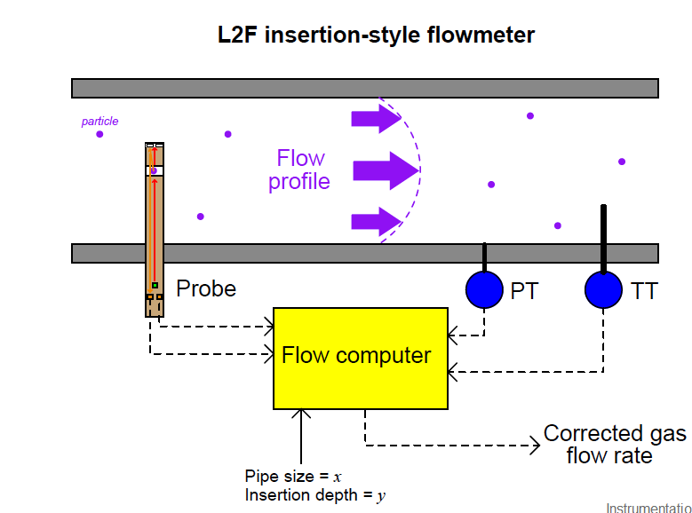
Figure 66 - Insertion Style Optical Flow Meter (66)

Ultrasonic (LT)
Ultrasonic flow rate measurement works similarly to optical flow rate measurement. Instead of reflecting light off particles within the water it uses ultrasound. The meter consists of a transmitting and receiving element. The transmitter emits ultrasonic waves with are then reflected of particles within the fluid, when the waves are reflected the sound wave changes frequency, this frequency change is proportional to the rate of flow of the liquid. It is known as the Doppler Effect.
This technology generally doesn’t work with clean water and requires at least 100 parts per million of suspended solid of which are 100 microns or larger. (67)
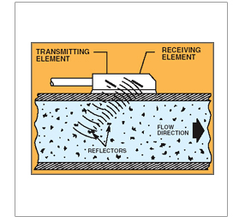
Figure 67 - Ultrasonic Flow Meter (67)

Pressure (LT)
The simplest method to increase the pressure within the tank is to place weight on top of the slurry. The issue with this method is that it cannot be controlled, the only way to reduce the pressure is remove weights manually and the only way to increase pressure is to add weights manually.

Motor (LT)
Instead of adding and removing weights manually, a DC motor attached to the end of threaded rod. A threaded plate would then be on the rod which would raise and lower as the rod is rotated by the motor. Since the motor can be controlled in both directions with the use of H Bridge it would allow for the increasing and decreasing of pressure within the tank.
A stepping motor may be more suitable for this application due to its ability for more precise rotation because it makes use of multiple coil winding pairs for specific rotation angles. This would allow for slower more controlled rotations of threaded rod, which may be required due to the slow flow rate of the slurry.

Hydraulics (LT)
A similar process to the motor and threaded rod design, except the pressure would be applied by using a hydraulic press. This would be significantly more expensive alternative to the motor and threaded rod, it would also be more complicated to control. Both methods require small movements, due to the nature of system. The tank has a larger area than the reactor thus a small movement from the fluid within the tank will result in a large movement of the fluid within the reactor.
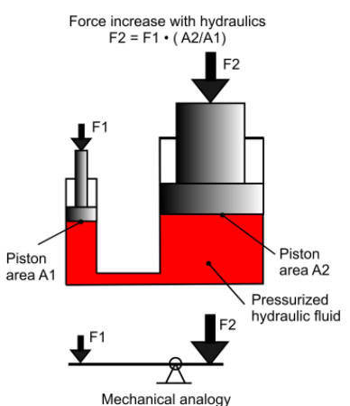
Figure 68 - Hydraulic Force (68)

Air (LT)
Alternatively, air pressure within the tank could be utilised to increase the flow of slurry into the reactor. This could be achieved by sealing tank and either pumping air into the tank or having another tank filled with air and using a valve to control the flow of air into the slurry tank. Using a valve would allow for greater control of airflow into the tank but the air tanks used within this method would require replacing.

Summary (LT)
The most suitable method would be using an impellor within the pipe connecting the slurry tank to the reactor to measure flow rate and a sealed tank using an air pump to increase the pressure within the tank.
This method would be used due to its relative simplicity, the flow rate sensor would be connected to magnet. Each revolution of the sensor would be detected by a Hall Effect sensor which in turn would send a pulse to a microchip. The microchip could then count the number of pulses per second, using the pulses per second and diameter of the pipe the flow rate of the slurry can be calculated. Depending on if the flow rate is above or below the set target the microchip can send out the single to pump more air into the container or drain it out.

Implementation

Purchasing new parts (Group)
In order to make the improvements, additional parts were needed to extend the overall length of the reactor.
Below is an image of the nuts & bolts needed to extend the Reactor, the nuts & bolts are 23mm in diameter while the bolts were 240mm total length.
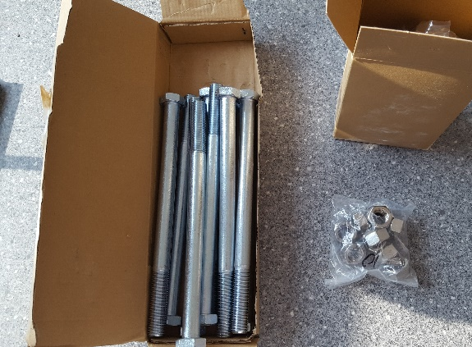
Figure 69: Purchased Nuts & Bolts
Below is an image of the additional pipe needed to extend the reactor, the pipe is made of Mild Steel and is 145mm in length, 101mm in diameter. Only one pipe was used as two were purchased as spare parts.
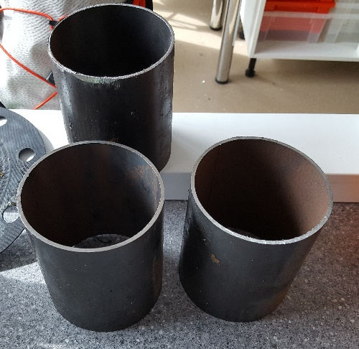
Figure 70: Purchased Outer Pipe

Below is a new electrode to replace the anode used during last year’s testing, the measurements are the same between both electrodes while the new electrode is made from Mild Steel as the material of the previous electrode was undocumented.
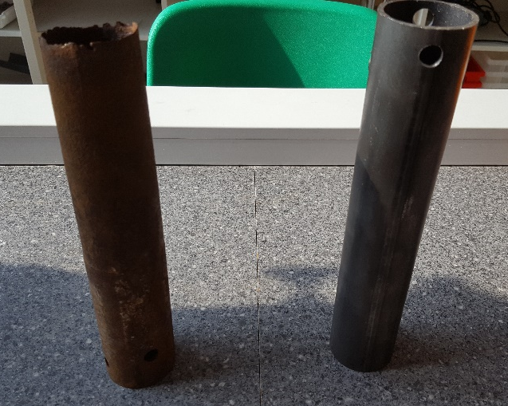
Figure 71: Purchased Anode

Disassembly & Reassembly (Group)
The old reactor was disassembled so that it could be cleaned out and extended by affixing the new pipe in between the top and bottom sections of the reactor by using a strong sealant. This would then be held in place by the purchased nuts & bolts. The system was then checked to ensure that it was watertight by charging the reactor with water. 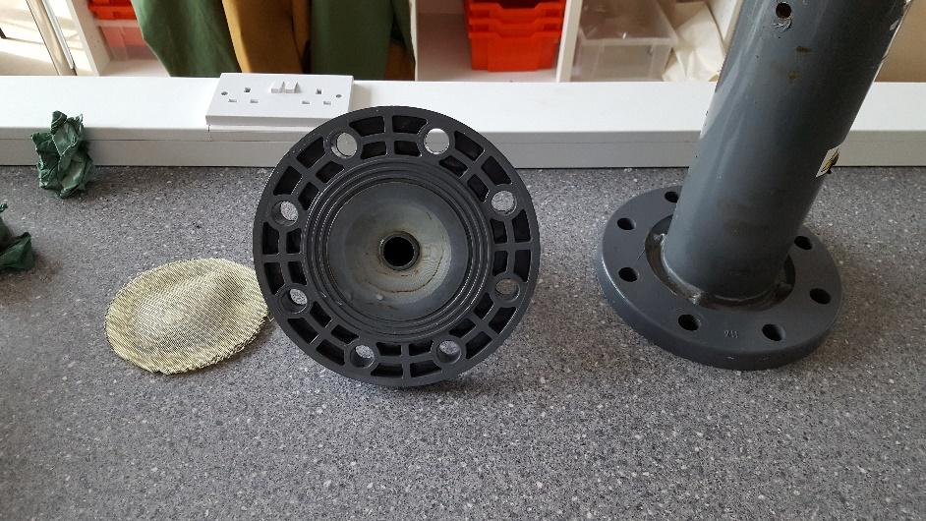
Figure 72: Disassembled Top & Bottom half of the reactor
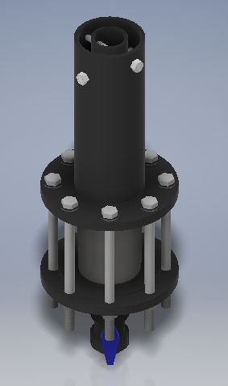
The improved reactor design matches expectations shown in the 3D CAD Drawing made previously along with all the final measurements.
With these improvements, more slurry can be loaded into the reactor as well as allowing additional room for mixed media filters to be used for separating the slurry from the final product.
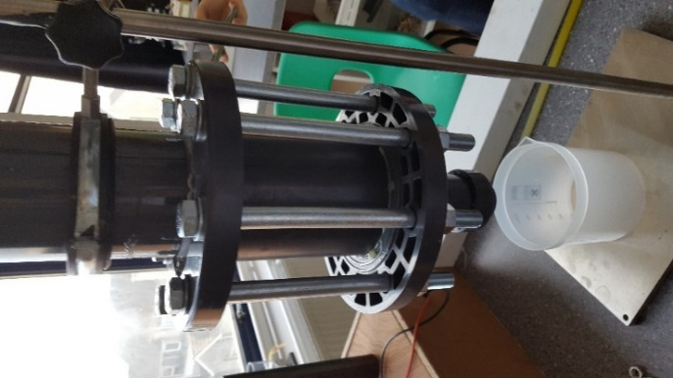
Figure 73: New Reactor Design Constructed

Preparation (Group)
Two sets of slurry samples were collected from the Gelli Aur Farm, each of which were approximately 6 litres. The consistency of the samples shared similar characteristics in terms of the total amount of water present and were both used within 4 days of collection to avoid the build-up of harmful gases.
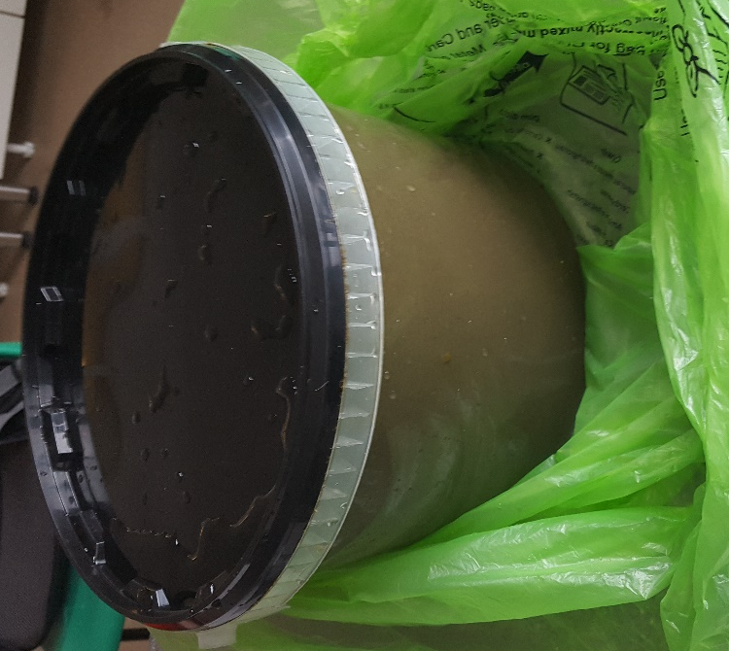
Figure 74 - Slurry Sample

XRF Analysis (Group)
Each sample produce from the tests were collected and placed in small test tubes. These samples were taken for further testing and analysed through X-ray fluorescence (XRF) to determine the chemical composition of each sample.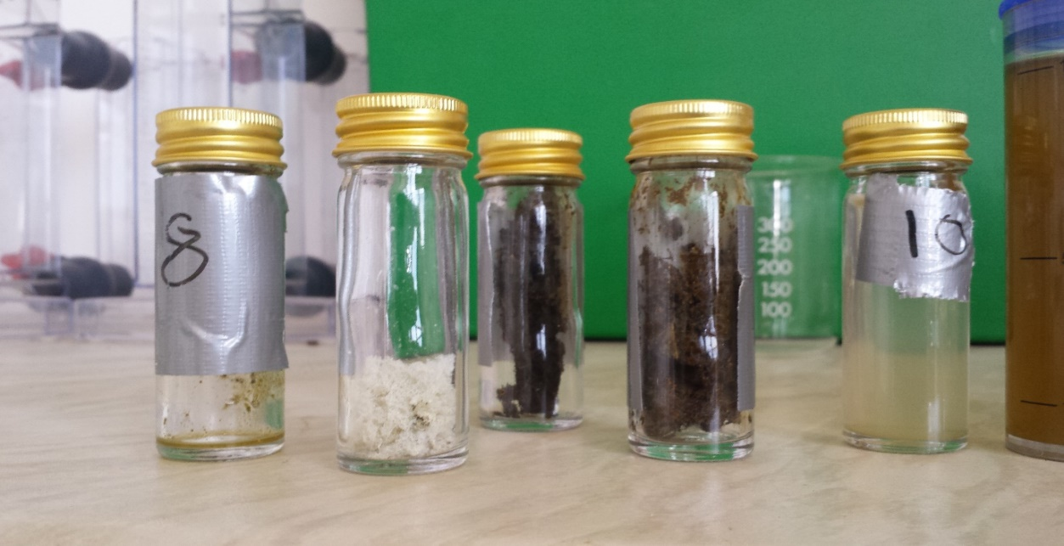
Figure 75 - Samples in test tubes
The samples from the tests were then placed on small XRF disc of 20$μl$ and labelled.
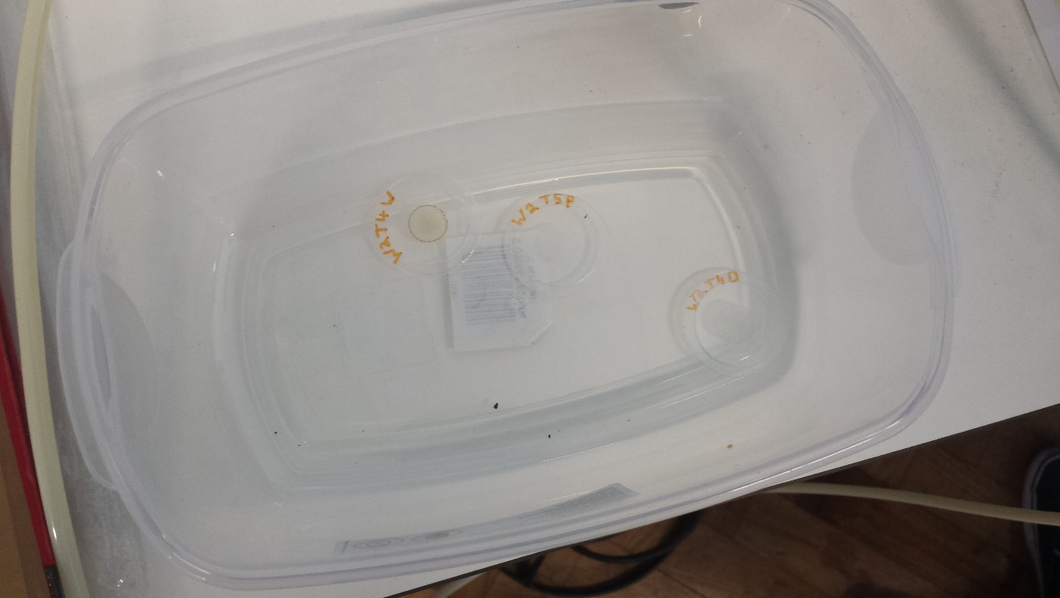
Figure 76 - XRF sample Discs

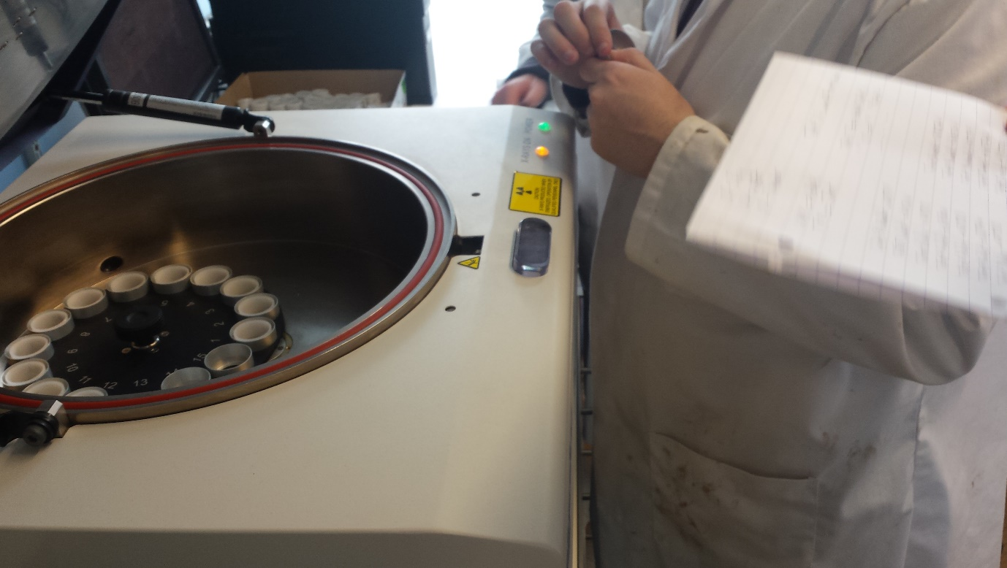
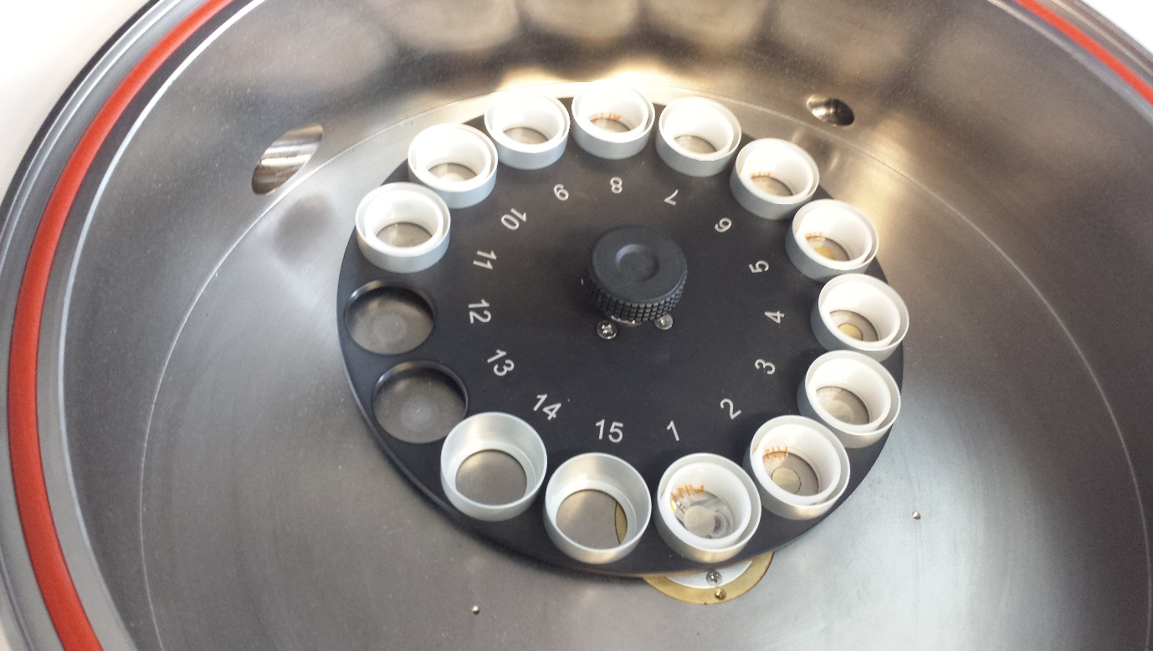
Figure 77 - Inside the XRF machine
Figure 78 - Loading the XRF machine

The XRF discs were placed inside the machine to measure the organic and inorganic matters inside the samples. The XRF scans each disc using X-ray waves and produces different results for each sample.
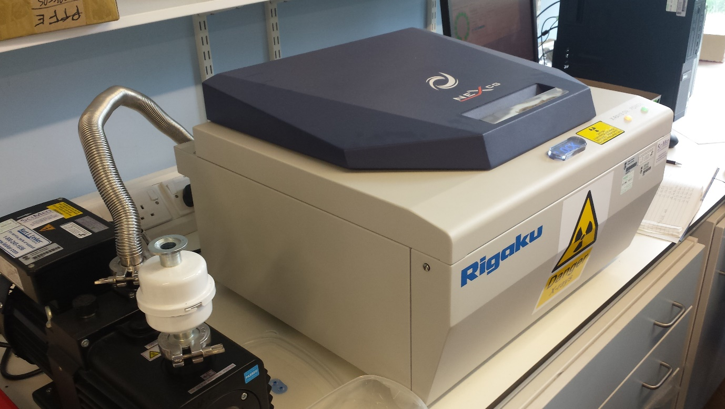
Figure 79 - XRF Machine in operation

Tests & Results

Week 1

Test 1 (Group)
Voltage Cap: 40V Current: 2A Volume of Slurry: 1100ml
Volume of Charge Water: 500ml Gravel Depth: 145mm Date of Sample: 16/04/18
Table 2 - Week 1 Test 1 Results
Day | Time | Time Passed  (Minutes) | Volume Slurry & Charge Water (ml) | Volume of Slurry Water (ml)
Monday | 12:05 (Tap Closed) | 0 | 0 | 0
 | 12:51 (Tap Opened) | 46 | 0 | 0
 | 13:30 | 85 | 575 | 75
 | 14:30 | 145 | 595 | 95
 | 15:00 | 175 | 600 | 100
Tuesday | 10:10 | 1325 | 715 | 215
End Voltage: 40V End Current: 0A
PH at Anode: 8 PH at Cathode: 6.8
Moisture at top: 20% Moisture at bottom: 23%
Figure 80 – Week 1 Test 1 Graph
The first test was ran for just over 22 hours using a sample that was obtained on the 15th April. For the first 45 minutes of the test the reactor was switched on with the tap closed, with the 500ml of water the reactor had been charged which didn’t exit before the reaction had started as the tap was kept closed. After 45 minutes the tap was opened and within half an hour the whole 500ml of fresh water had been drained plus 75ml from the slurry. At the time of the last reading for that day, 100ml of slurry water had been drained which is 46.5% of the total slurry water drained.
At the end of the test the voltage had increased to the maximum cap of 40V and the current had decreased to 0A. Looking inside the reactor the slurry had come away from the outside wall (Cathode), this likely broke the circuit which is why no current was flowing.
Below the dried slurry was a pool of wet slurry sitting on top of the gravel, this was likely due to the surface of the gravel being 70mm lower than the bottom of the anode. This resulted in some slurry never being in contact with the electrodes, hence why it was still so wet. The moisture content of the dryer slurry did increase going down the anode, increasing from 20 % at the top to 23% at the bottom.
The pH of the slurry also got more acidic as it went towards the cathode, with the pH at the anode being 8 and at the cathode being 6.8.
At the top of the anode was a white power, which was collected from analysis, shown on the left-hand side of the figure below. In the centre was the dry slurry sample and the right was the drained water sample.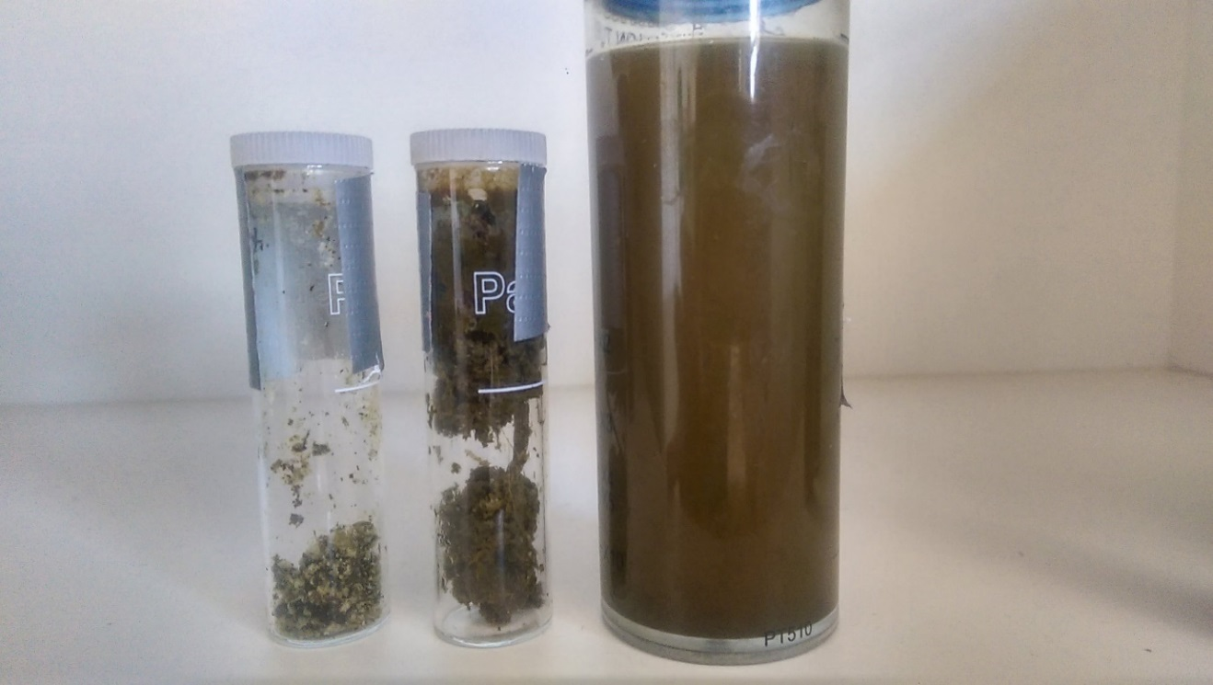
Figure 81 - Week 1 Test 1 Samples
Table 3 - XRF Results Week 1 Test 1
Element | Wet sample (PPM) | Dry Sample (PPM) | Powder Sample (PPM)
Sodium (Na) | 79.1 | ND | ND
Magnesium (Mg) | 75.9 | 188 | 36.5
Aluminium (Al) | 35.5 | 790 | 387
Silicon (Si) | 26.9 | 207 | 41.4
Phosphorus (P) | 14.6 | 37.4 | 11.6
Sulfur (S) | 18.4 | 31.4 | 20.2
Chlorine (Cl) | 111 | 58.7 | 206
Potassium (K) | 365 | 162 | 16.8
Calcium (Ca) | 69.8 | 334 | 45.2
Titanium (Ti) | 0.648 | 2.44 | 0.239
Manganese (Mn) | 0.859 | 10.8 | 1.71
Iron (Fe) | 8.11 | 665 | 180
Cobalt (Co) | 2.07 | ND | 0.534
Copper (Cu) | 0.864 | 2.23 | 1.68
Zinc (Zn) | 1.55 | 3.39 | 1.04
Bromine (Br) | 0.544 | 0.38 | 0.781
Rubidium (Rb) | 0.411 | 0.294 | 0.114
Strontium (Sr) | 0.369 | 1.18 | ND
Tantalum (Ta) | ND | 0.456 | ND
Platinum (Pt) | ND | ND | 0.33
Lead (Pb) | ND | 0.391 | ND
The above table displays the XRF results for the first test of week 1, it contained three samples; one from the water extracted, one from the dried solids and one from the white powder that was present at the top of the reactor.
There is a significant increase in aluminium in both the dry and powder samples compared to the wet sample. From 35.5PPM in the wet sample to 790PPM and 387PPM in the dry and powder samples. This is due to the degradation of the cathode which was made of aluminium. Due to the abundance of aluminium within the white powder, it is safe to assume that the white powder itself is aluminium.
There was also a significant increase of iron again in both the dry and powder samples in comparison to the wet sample. Increasing from 8.11PPM in the wet sample to 665PPM and 180PPM in the dry and powder samples. This is due to the degradation of the anode which was made of steel.

Two of the three elements crucial to plant growth also had significant changes between the dry and wet samples. Potassium had a substantial decrease in the dry sample compared to wet, going from 365PPm to 162PPM. Although, phosphorous increased in the dry sample compared to wet going from 14.6PPM to 37.2PPM.

Test 2 (Group)
Voltage Cap: 25V Current: 2A Volume of Slurry: 1100ml
Volume of Charge Water: 0ml Gravel Depth: 195mm Date of Sample: 17/04/18
Table 4 – Week 1 Test 2 Results
Day | Time | Time Passed  (Minutes) | Volume of Water (ml)
Tuesday | 12:30 | 0 | 0
 | 13:00 | 30 | 80
 | 13:30 | 60 | 90
 | 14:00 | 90 | 100
 | 14:30 | 120 | 110
Wednesday | 10:00 | 1290 | 355
End Voltage: 25V End Current: 0.39A
PH at Anode: 8 PH at Cathode: 5.8
Moisture at top: 30% Moisture at bottom: 35% Volume in Condensation bag: 25ml

Figure 82 – Week 1 Test 2 Graph

The second test was ran for 21 and half hours using the 1 day old sample collected on the 16th April. For this test the tap was opened from the beginning since the system was not charged with water. The gravel depth was also increased from 145mm to 215mm to prevent the puddle of slurry sitting on top of the reactor without being in contact with the electrodes.
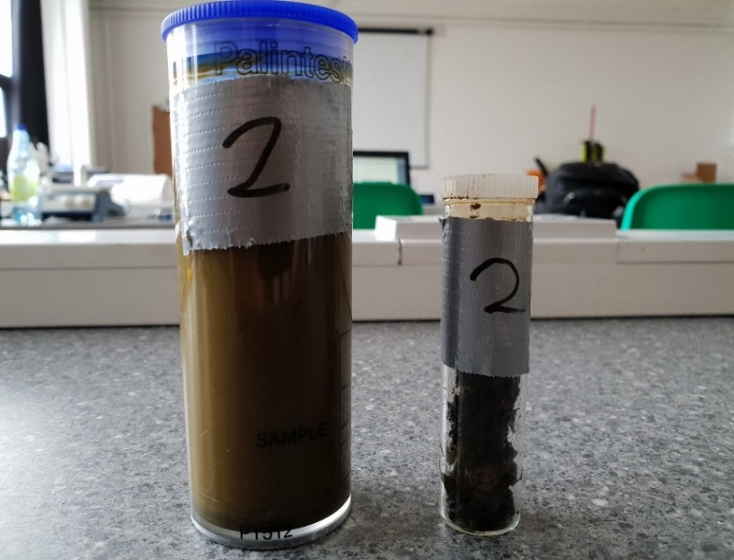
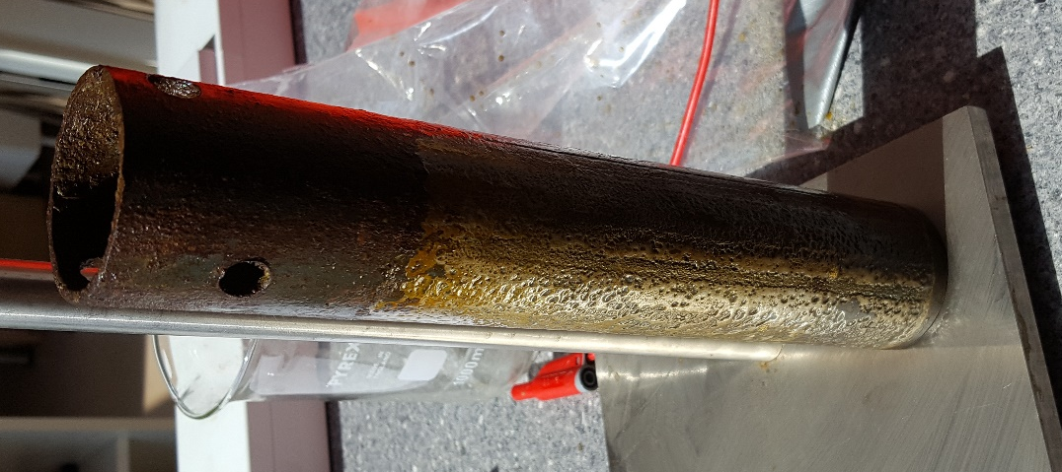
After 2 hours 110ml of water had been drained from the reactor which is 30.9% of the total amount for this test. After a further 19 and half hours another 245ml had been drained in addition to the 25ml collected in the condensation bag, totalling 380ml for the second test. An extra 165ml had been drained compared to the first test which is a 76.7% increase.
Figure 83 - Week 1 Test 2 Wet & Dry Samples
At the end of the test the voltage had reached the cap of 25 but 0.39A was still flowing. After looking inside the reactor the dried slurry was still in contact with both electrodes, which is why there was still a small amount of current flowing.
Increasing the gravel depth successfully filled the gap that was present between the bottom of the anode and the gravel surface in the first test. It is likely the reason for the increase in results, due to more slurry being in contact with the electrodes.
Figure 84 - Anode after Test 2
The image to the left shows that by using a thicker gravel filter of 215mm, the slurry remains in contact with the anode at a higher level.
As with the first test there continued to be a pH gradient present, with the pH at the anode being 8 and the pH at the cathode being 5.8.
Table 5 - XRF Results Week 1 Test 2
Element | Wet sample (PPM) | Dry Sample (PPM)
Sodium (Na) | 471 | ND
Magnesium (Mg) | 110 | 17.4
Aluminium (Al) | 371 | 75.2
Silicon (Si) | 75.7 | 109
Phosphorus (P) | 23.6 | 30.9
Sulfur (S) | 31.4 | 54.2
Chlorine (Cl) | 257 | 615
Potassium (K) | 1500 | 30.2
Calcium (Ca) | 135 | 197
Titanium (Ti) | 1.08 | ND
Manganese (Mn) | 2.21 | 16.3
Iron (Fe) | 17.3 | 3360
Cobalt (Co) | ND | 3.14
Nickel (Ni) | 0.1 | 0.809
Copper (Cu) | 1.23 | 2.13
Zinc (Zn) | 1.89 | 2.61
Gallium (Ga) | 0.143 | ND
Bromine (Br) | 1.14 | 3.55
Rubidium (Rb) | 1.21 | 0.308
Strontium (Sr) | 0.63 | 0.737
Molybdenum (Mo) | 6.63 | ND
Yttrium (Y) | ND | 1.01
The above table displays the XRF results for the second test of week 1. This table contains a wet and a dry sample, taken from the same sources as previous.
Life before, there is a noticeable difference in Aluminium, Sodium and Chlorine content in the Wet sample. There is also a very noticeable amount of Potassium in the wet sample, showing that the nutrients are being contained to the water being removed. There is also a very noticeable amount of Iron in the Dry sample, showing that any iron present is kept to the solids inside the reactor.

Test 3 (Group)
Voltage Cap: 25V Current: 4A Volume of Slurry: 1100ml
Volume of Charge Water: 0ml Gravel Depth: 195mm Date of Sample: 18/04/18

Table 6 – Week 1 Test 3 Results
Day | Time | Time Passed  (Minutes) | Volume of Water (ml)
Wednesday | 12:20 | 0 | 0
 | 12:50 | 30 | 200
 | 13:20 | 60 | 210
 | 13:50 | 90 | 225
 | 14:00 | 120 | 240
 | 14:20 | 150 | 250
 | 14:50 | 180 | 290
Thursday | 09:50 | 1310 | 390
End Voltage: 25V End Current: 0.32A
PH at Anode: 8 PH at Cathode: 6.8
Moisture at top: 45% Moisture at bottom: 56% Volume in Condensation Bag: 30ml

Figure 85 – Week 1 Test 3 Graph
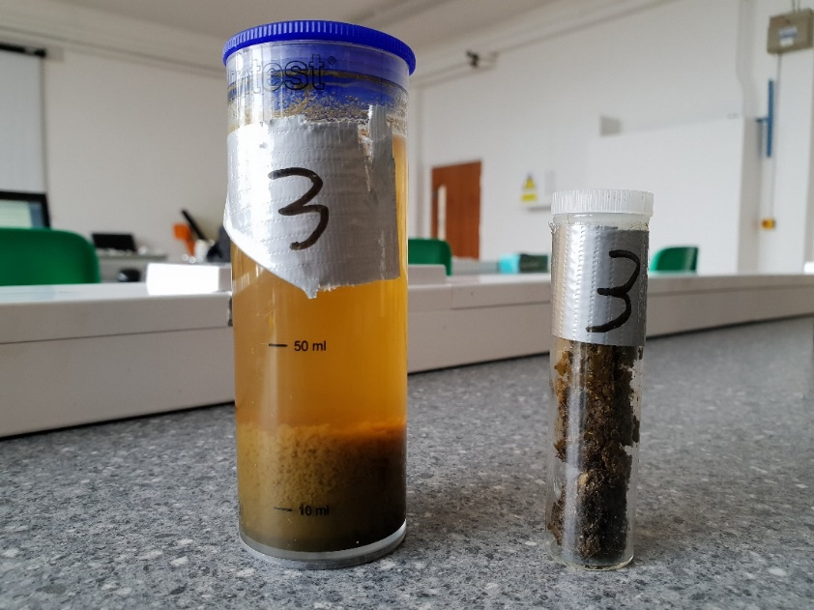
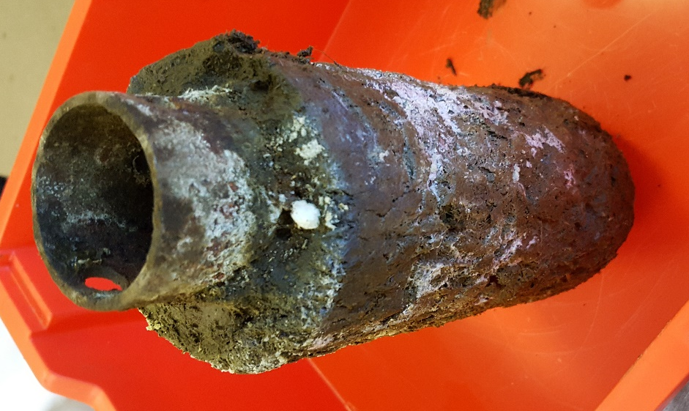
The third test was conducted for 21 and a half hours using the slurry sample obtained on 16th April, which was now 2 days old. The system continued to use a gravel depth of 215mm and was not charged with water since these factors produced better results than the first test.
Figure 86 - Week 1 Test 3 Water and Dry Samples

Figure 87 - Anode after Test 3
After two hours 250ml of water had been drained from the reactor which was 64.1% of the water that had been drained after the test was completed. After the 21 and a half hours a further 140ml had been drained, and there was 30ml in the condensation bag totalling 420ml for the third test. The third test had drained 55ml more than the second test which is a 15.5% increase.
At the end of the test the power supply had reached the set voltage limit of 25V and the current had decreased from 4A to 0.32A.
The image to the left shows the anode removed after conducting the test. Much like the other tests conducted, the dried slurry forms a soft layer surrounding the electrode as well as a white-powder substance forming on the surface.
As with the previous 2 tests there was a pH gradient present, with the pH at the anode being and 6.8 at the cathode.

Table 7 - XRF Results Week 1 Test 3
Element | Wet sample (PPM) | Dry Sample (PPM)
Sodium (Na) | 385 | 18.2
Magnesium (Mg) | 105 | 127
Aluminium (Al) | 951 | 444
Silicon (Si) | 57.1 | 191
Phosphorus (P) | 25.1 | 38.4
Sulfur (S) | 28.1 | 40
Chlorine (Cl) | 105 | 192
Potassium (K) | 1670 | 95.9
Calcium (Ca) | 83.1 | 475
Titanium (Ti) | 0.471 | 2.51
Manganese (Mn) | 1.71 | 13.6
Iron (Fe) | 15.5 | 1830
Cobalt (Co) | ND | 6.72
Copper (Cu) | 1.22 | 2.67
Zinc (Zn) | 1.87 | 2.95
Gallium (Ga) | 0.13 | ND
Arsenic (As) | ND | 0.167
Selenium (Se) | ND | 0.0701
Bromine (Br) | 0.307 | 0.929
Rubidium (Rb) | 0.968 | 0.45
Strontium (Sr) | 0.737 | 0.377
Tantalum (Ta) | ND | 0.694
The above table displays the XRF results for the third test of week 1. This table contains a wet and a dry sample, taken from the same sources as previous.
Life before, there is a noticeable difference in Aluminium & Sodium in the Wet sample with a 507ppm difference between them. Again, there is a very noticeable amount of Potassium in the wet sample, showing that the nutrients are being contained to the water being removed. There is also a very noticeable amount of Iron in the Dry sample, showing that any iron present is kept to the solids inside the reactor.

Test 4 (Group)
Voltage Cap: 25V Current: 3A Volume of Slurry: 1100ml Date of Sample: 19/04/18
Volume of Charge Water: 0ml Gravel Depth: 145mm Sand Depth: 50mm
Table 8 – Week 1 Test 4 Results
Day | Time | Time Passed  (Minutes) | Volume of Water (ml)
Thursday | 11:50 | 0 | 0
 | 12:20 | 30 | 74
 | 12:50 | 60 | 92
 | 13:10 | 80 | 105
 | 13:20 | 90 | 118
 | 13:35 | 105 | 122
 | 13:50 | 120 | 130
 | 14:00 | 130 | 138
 | 14:25 | 155 | 158
 | 14:50 | 180 | 182
 | 15:20 | 210 | 198
 | 15:26 | 216 | 204
Friday | 10:00 | 1330 | 390
End Voltage: 25V End Current: 0.33A
PH at Anode: 8 PH at Cathode: 6.8 Volume in Condensation bag: 40ml

Figure 88 – Week 1 Test 4 Graph
The fourth test was ran for 22 hours using the sample collected on the 16th April. By this point, the same is 3 days old. Again, the system was not charged with water as the results produced suggested that there was no need. The gravel filter was reduced back to 145mm and a new layer of sand was added on top with a depth of 50mm. This was done to observe the behavioural changes between a single media gravel filter and a dual media gravel & sand filter.
After 2 hours, 130ml of water had been drained from the reactor which is 33.3% of the total amount for this test. After a further 20 hours, another 260ml had been drained along with 40ml being collected in the condensation bag, giving a total of 390ml for the fourth test. This is the same amount as the previous test, which used a higher amperage as well as a different filter media.
At the end of the test the voltage had reached the cap of 25V and was generating 0.33A.
Introducing the new sand layer to the filter along with using a lower amperage produces the same end results as the previous test. This is an improvement as less overall power is being used.
As with the previous tests, there is still a pH gradient present within the reactor after the test was finished, with the pH at the anode being 8 and the pH at the cathode being 6.8.
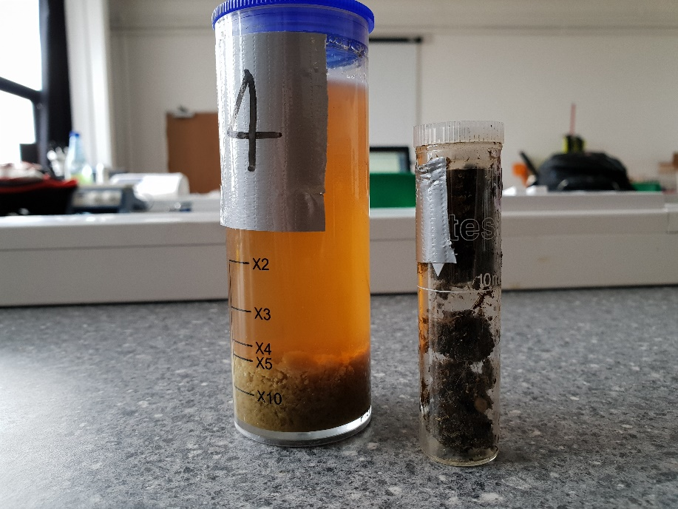
Figure 89 - Week 1 Test 4 Water and Dry Samples

Table 9 - Week 1 Test 4 XRF Results
Element | Wet sample (PPM) | Dry Sample (PPM)
Sodium (Na) | 410 | 15.4
Magnesium (Mg) | 4.56 | 92.6
Aluminium (Al) | 667 | 263
Silicon (Si) | 8.04 | 208
Phosphorus (P) | 4.06 | 41.1
Sulfur (S) | 15.9 | 45
Chlorine (Cl) | 80.4 | 141
Potassium (K) | 2200 | 98
Calcium (Ca) | 9.19 | 420
Titanium (Ti) | ND | 1.94
Manganese (Mn) | ND | 12
Iron (Fe) | 2.87 | 2680
Cobalt (Co) | ND | 1.15
Copper (Cu) | 0.728 | 4.31
Zinc (Zn) | 1.08 | 3.44
Gallium (Ga) | 0.169 | ND
Arsenic (As) | ND | ND
Bromine (Br) | 0.326 | 0.69
Rubidium (Rb) | 1.39 | 0.3
Strontium (Sr) | ND | 2.09
Tantalum (Ta)

The above table displays the results for the XRF analysis of test 3’s wet and dry samples. As with test 2 and test 3 there is more iron in the dry sample and more aluminium in the wet. Both due to the respective electrodes corroding. However, during the process the water is drawn to the outer electrode (cathode) which is made of aluminium and the solid is drawn to the centre electrode (anode) which is made of steel. This explains why there has consistently been higher content of iron and aluminium in the dry and wet samples respectively.

Test 5 (Group)
Voltage Cap: 25V Current: 1A Volume of Slurry: 1100ml Date of Sample: 20/04/18
Volume of Charge Water: 0ml Gravel Depth: 145mm Sand Depth: 50mm
Table 10 - Week 1 Test 5 Results
Day | Time | Time Passed  (Minutes) | Volume of Water (ml)
Friday | 14:27 | 0 | 0
 | 14:43 | 16 | 52
 | 15:03 | 36 | 112
 | 15:34 | 67 | 118
 | 15:50 | 83 | 118
 | 15:58 | 91 | 122
 | 15:18 | 111 | 122
 | 15:28 | 121 | 125
Monday | 10:00 | 4113 | 400

End Voltage: 25V End Current: 0.06A
PH at Anode: 8 PH at Cathode: 6.8 Volume in Condensation bag: 10ml

Figure 90 – Week 1 Test 5 Graph
The fifth test was ran for 68 and a half hours using the sample collected on the 16th April. By this point, the same is 4 days old and has been disposed of due to the gases being generated.
Again, the system was not charged with water as the previous results produced suggested that there was no need. The current was reduced to 1A and the test was extended from the ~22 hour period up to 68 hours. This was done to observe the behavioural changes when the reactor is operated over an extended period of time.
After one hour, 125ml of water had been drained from the reactor which is 31.25% of the total amount for this test. After a further 67 hours, an additional 275ml had been drained along with 10ml being collected in the condensation bag, giving a total of 410ml for the fourth test. These results are similar to previous tests despite the extended period of which the test was conducted. The amount collected in the condensation bag is noticeably less than previous tests, which could suggest some of the water vapour may have dissipated.
At the end of the test the voltage had reached the cap of 25V and was generating 0.06A.
Extending the time in which the reactor is operational yielded a similar amount of water as previous tests, which shows that obtaining additional water after a set point proves difficult due to either the additional power needed.
As with the previous tests, there is still a pH gradient present within the reactor after the test was finished, with the pH at the anode being 8 and the pH at the cathode being 6.8.
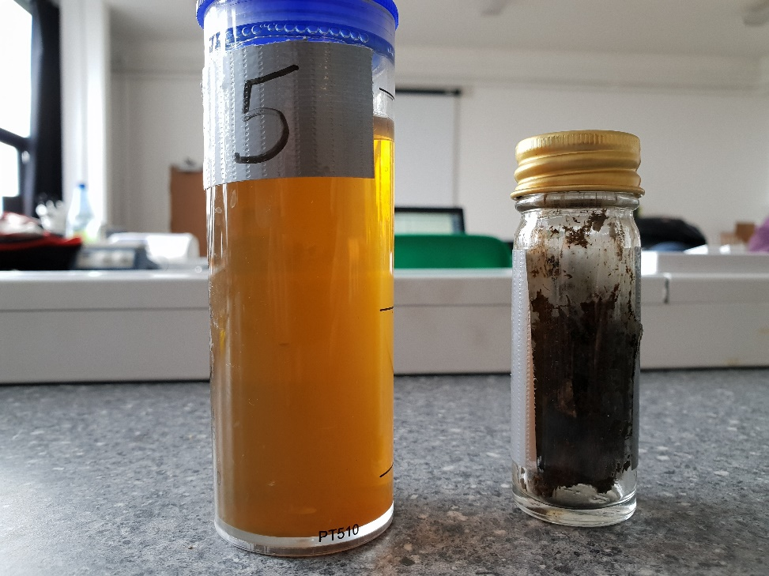
Figure 91 - Week 1 Test 5 Water and Dry samples
Element | Wet sample (PPM) | Dry Sample (PPM)
Sodium (Na) | 820 | 27
Magnesium (Mg) | 7.71 | 186
Aluminium (Al) | 1790 | 526
Silicon (Si) | 16.2 | 328
Phosphorus (P) | 6.88 | 46.1
Sulphur (S) | 12.6 | 45.7
Chlorine (Cl) | 167 | 169
Potassium (K) | 2660 | 124
Calcium (Ca) | 11.8 | 562
Titanium (Ti) | ND | 4.75
Manganese (Mn) | ND | 22
Iron (Fe) | 5.39 | 3270
Cobalt (Co) | ND | 4.25
Copper (Cu) | 0.989 | 3.77
Zinc (Zn) | 1.05 | 5.3
Gallium (Ga) | 0.346 | 0.238
Arsenic (As) | ND | 0.293
Selenium (Se) | ND | ND
Bromine (Br) | 0.234 | 1.15
Rubidium (Rb) | 1.8 | 0.951
Strontium (Sr) | ND | 4.53
Tantalum (Ta) | ND | ND
Table 11 Test 5 XRF results
As is shown from the table above test five indicated the presence of excessive amounts of iron in the dry waste after the test had been completed as the sacrificial cathode eroded due to the ion release from the electrolysis reaction. The iron content of the dry waste was greater than the liquid as the movement of the liquid during the dewatering process is in the direction of the anode and as a result the iron must pass through the solid waste as it is attracted towards the anode, whereas the aluminium that is eroded from the outer anode is constantly subjected to liquid passing over the internal wall of the reactor and as a result removes the oxidised aluminium ions which remain present in the liquid the drains through the reactor.
The dry waste with a higher iron content at the location of the cathode had a lower pH than the waste in contact with the outer anode and as a result showed signs of a pH gradient across the cross-sectional area of the waste. The content of iron and aluminium was of lower ppm in both samples when compared to tests of higher currents as the emission of the ions from the electrodes is directly affected to the strength of the electric field shown in the H-S theory.

Week One Testing Results (Group)
Table 12 - Week 1 Results
The results from the first week of testing show that by increasing the current from 2A to 4A when using a single media gravel filter, a higher yield of water can be obtained. As well as this, the results show that despite using a single media gravel filter of 145mm, or when using a dial media filter with 145mm gravel & 50mm sand, the yield of water can be raised by increasing the amount of current.

Week One Results Compared to Previous Year’s (Group)
Table 13 - Week 1 and Last Year’s Results

When compared to the results obtained from the previous year, the results show an overall improvement from the changes made to the reactor as well as the current used during testing.
The graph shows that a higher yield of water has been obtained in a shorter time frame while also consuming less overall power.

Week 2

Test 1 (Group)
Voltage Cap: 0V Current: 0A Volume of Slurry: 1100ml
Volume of Charge Water: 0ml Gravel Depth: 195mm Date of Sample: 23/04/18
Table 14 – Week 2 Test 1 Results
Day | Time | Time Passed  (Minutes) | Volume of Water (ml)
Monday | 11:40 | 0 | 0
 | 11:50 | 10 | 10
 | 12:00 | 20 | 10
 | 12:10 | 30 | 11
 | 12:20 | 40 | 15
 | 12:30 | 50 | 15
 | 12:40 | 60 | 15
 | 12:50 | 70 | 16
 | 13:00 | 80 | 16
 | 13:10 | 90 | 20

Figure 92 – Week 2 Test 1 Results
Based on the findings obtained from the first week’s results, it was thought to carry out another set of tests on the reactor but using the forces of gravity only. The test was conducted over a 90 minutes period without powering up the reactor. The reactor was first filled with 195mm of gravel, which was acting as the filter and then 1100ml of slurry was added on top of the gravel, as shown in figure.

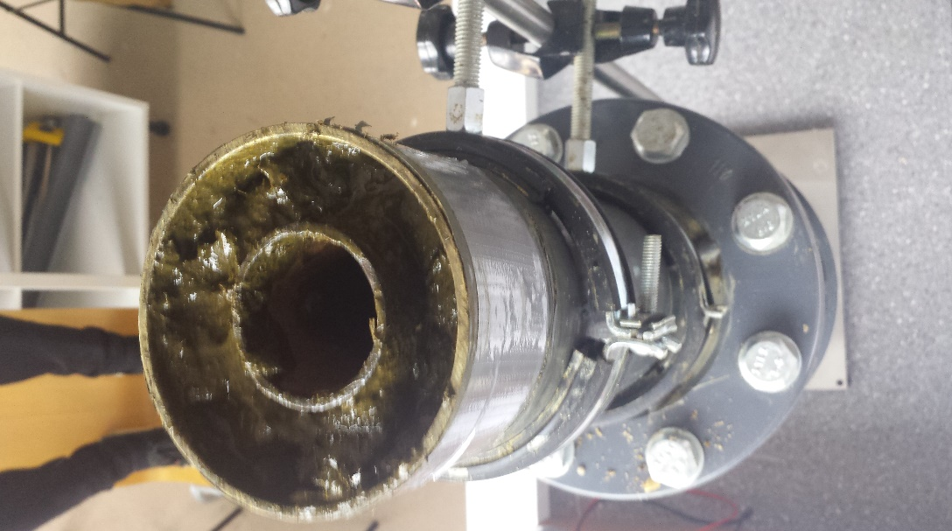
Figure 93 - Reactor Filled with Slurry
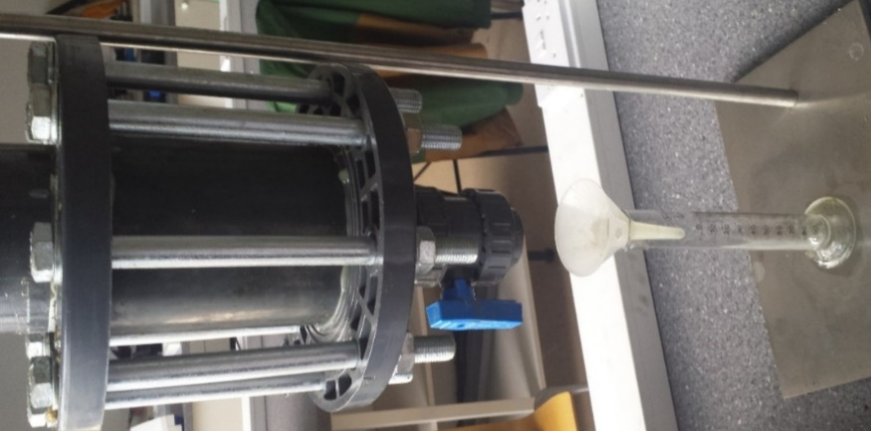

Figure 94 - Reactor Gravity Test
Gradually small drips of water were drained out the slurry and 10ml of water was collected in the first 10 minutes. However, the fact that there was no voltage or current connected to the reactor meant that the volume of water drained out of the slurry was going to be low, compared to the previous test conducted while the reactor was powered up with current.
The results were recorded every 10 minutes. It was found that, slight increases in the drops of water drained from the slurry between 30 - 40 minutes and between 80 - 90 minutes of testing. At the end of the test, the reactor was only able to produce 20ml of water from 1100ml of slurry.

Test 2 (Group)
Voltage Cap: 0V Current: 0A Volume of Slurry: 1100ml Date of Sample: 23/04/18
Volume of Charge Water: 0ml Gravel Depth: 145mm Sand Depth: 50mm
Table 15 - Week 2 Test 2 Results
Day | Time | Time Passed  (Minutes) | Volume of Water (ml)
Monday | 13:40 | 0 | 0
 | 13:50 | 10 | 8
 | 14:00 | 20 | 10
 | 14:10 | 30 | 10
 | 14:20 | 40 | 10
 | 14:30 | 50 | 10
 | 14:40 | 60 | 12
 | 14:50 | 70 | 15
 | 15:00 | 80 | 15
 | 15:10 | 90 | 15

Figure 95 - Week 2 Test 2 Graph

After completing the first gravity test the reactor needed to be cleaned and left to dry thoroughly before conducting the second gravity test. The second test was conducted over the same amount of time, using the same sample which was obtained from the farm. However, as previously mentioned the amount of gravel used in the second gravity test was reduced from 195mm to 145mm of gravel, simply because a new layer of sand was added on top with a depth of 50mm to create a dual media of gravel & sand filter.
Compared to the previous test, the drops of water coming out the reactor were a lot slower. As a result, only 8ml of water was collected in the first ten minutes and it wasn’t until 20 minutes of testing that we were able to reach the 10ml mark. The drops of water increased between 50 – 70 minutes of testing which then caused a 5ml increase. At the end of the test, the reactor was only able to produce 15ml of water from 1100ml of slurry.
It was found that with the addition of sand in the filter, meant that most of the water was been absorbed and only a small amount of it could pass through. As a result, the amount of collected at the end of the test was 5ml less than the gravel only gravity test.

Test 3 (Group)
Voltage Cap: 25V Current: 2A Volume of Slurry: 1100ml Date of Sample: 23/04/18
Volume of Charge Water: 0ml Gravel Depth: 145 mm Sand Depth: 50mm
Table 16 - Week 2 Test 3 Results
Day | Time | Time Passed  (Minutes) | Volume of Water (ml)
Tuesday | 15:40 | 0 | 0
 | 15:50 | 10 | 42
 | 16:00 | 20 | 47
 | 16:10 | 30 | 51
 | 16:20 | 40 | 57
 | 16:30 | 50 | 60
 | 16:40 | 60 | 61
 | 16:50 | 70 | 65
 | 17:00 | 80 | 65
 | 17:10 | 90 | 78
End Voltage: 25V End Current: 0.07A
PH at Anode: 8 PH at Cathode: 7
Moisture at top: Moisture at bottom: Volume in Condensation Bag: 20mg
Figure 96- Week 2 Test 3 Graph
At this point it was decided not to do a sand only gravity test but to re-run the gravel and sand test and power up the reactor using 25 volts and 2 amps. The third test was conducted over the same amount of time, using the same sample as the previous two tests. This was vital that all three tests were conducted in the same manner to ensure that our results were constant and accurate
Just after 10 minutes of testing we were able to collect 42ml amount of water drained from the reactor and this gradually increased over time. After one hour, 61ml of water was drained from the reactor. At the end of the test, the voltage had reached 25V and was generating 0.07A and the reactor produced 78ml of water from 1100ml of slurry.
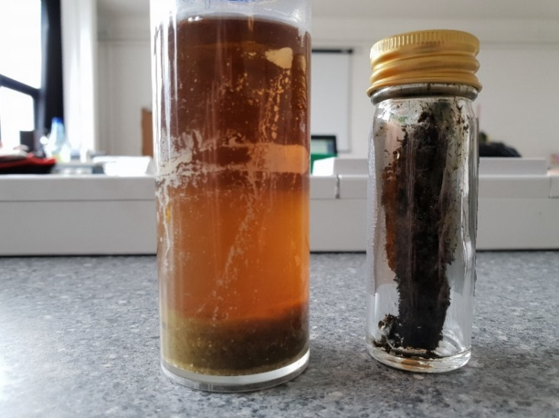
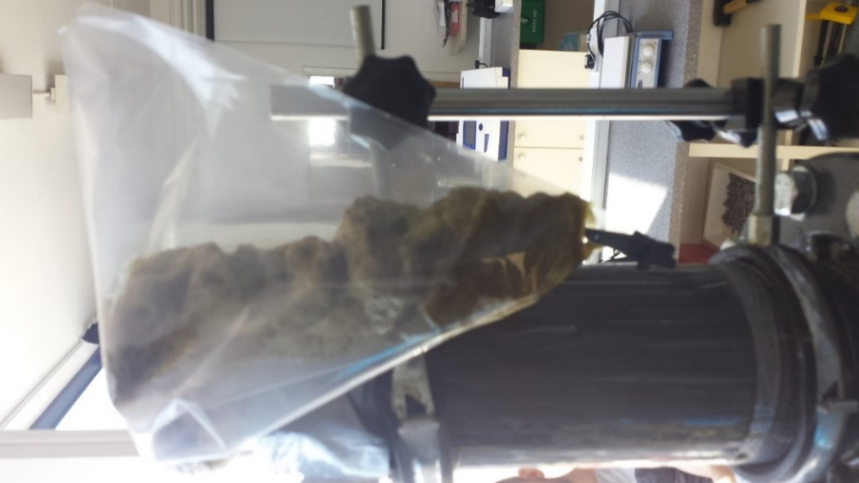
Figure 97 - Week 2 Test 3 Samples
Figure 98 - Reactor covered with Condensation Bag
It was found that with the addition of the condensation bag on top of the reactor, meant that all the form and evaporated water was captured in the bag. Hence, 20ml of the 78ml was collected from the condensation bag.

Element | Wet sample (PPM) | Dry Sample (PPM)
Sodium (Na) | 16.1 | 428
Magnesium (Mg) | 32.3 | 14.3
Aluminium (Al) | 140 | 939
Silicon (Si) | 423 | 21.6
Phosphorus (P) | 47.1 | 7.5
Sulphur (S) | 51.5 | 23.7
Chlorine (Cl) | 309 | 40.6
Potassium (K) | 39 | 3910
Calcium (Ca) | 1030 | 24.8
Titanium (Ti) | 9.82 | ND
Manganese (Mn) | 8.5 | 0.378
Iron (Fe) | 1370 | 6.29
Cobalt (Co) | 3.25 | ND
Copper (Cu) | 3.34 | 2.15
Zinc (Zn) | ND | 0.281
Gallium (Ga) | ND | 0.187
Arsenic (As) | ND | ND
Selenium (Se) | 1.69 | 0.441
Bromine (Br) | 0.462 | 2.26
Rubidium (Rb) | 2.77 | ND
Strontium (Sr) | 16.1 | 428
Tantalum (Ta) | 32.3 | 14.3
Table 17: Week 2 Test 3 XRF
As is seen in previous tests the amount of iron present in the dry sample is far greater than in the wet sample and the aluminium presence in the wet sample is greater than the amount found in the dry sample this is due to the migration of the fluid from the cathode towards the anode.
What is noticeable from this test is the presence of sodium which is much higher than the tests run previously, the abundance of sodium is likely to be from the addition of the sand layer in the filter as the sand is almost certainly from a coastal source and not from an inland source, this addition of sand would almost certainly explain the rapid increase in Sodium levels seen in this test.

Test 4 (Group)
Voltage Cap: 40V Current: 2A Volume of Slurry: 1100ml
Volume of Charge Water: 0ml Gravel Depth: 195mm Date of Sample: 23/04/18
Table 18 - Week 2 Test 4 Results
Day | Time | Time Passed  (Minutes) | Volume of Water (ml)
Tuesday | 12:05 | 0 | 0
 | 12:15 | 10 | 50
 | 12:25 | 20 | 76
 | 12:35 | 30 | 76
 | 12:45 | 40 | 77
 | 12:55 | 50 | 82
 | 13:05 | 60 | 82
 | 13:15 | 70 | 90
 | 13:25 | 80 | 91
 | 13:35 | 90 | 91
End Voltage: 5V End Current: 1.98A
PH at Anode: 5.8 PH at Cathode: 8

Figure 99 - Week 2 Test 4 Graph
This test was run for 90 minutes with on a sample that was collected on the 21st f April, the sample that was collected on this date had a higher viscosity than the previous sample and was expected to yield less liquid than the previous tests at the same current. The rector and the filter were prepared in the same manner as the previous tests.
Over the 90-minute test the liquid rapidly left the reactor initially with the rate of yield decreasing as time increased this is thought to be related to the performance of the membrane that is used to filter the liquid as it exits the reactor. The membrane because of its liquid permeable design will load with liquid then discharge the absorbed liquid rapidly and then require time to re-charge with liquid before releasing the liquid out f the reactor. The gravel depth prevents a layer of waste from forming in an area that is not subjected to the effects of the electrical current within the reactor.
The waste that was removed from the reactor after this test still had a high moisture content as the amount of liquid removed was near the 10% mark of the total moisture content of the 1100ml of waste loaded.
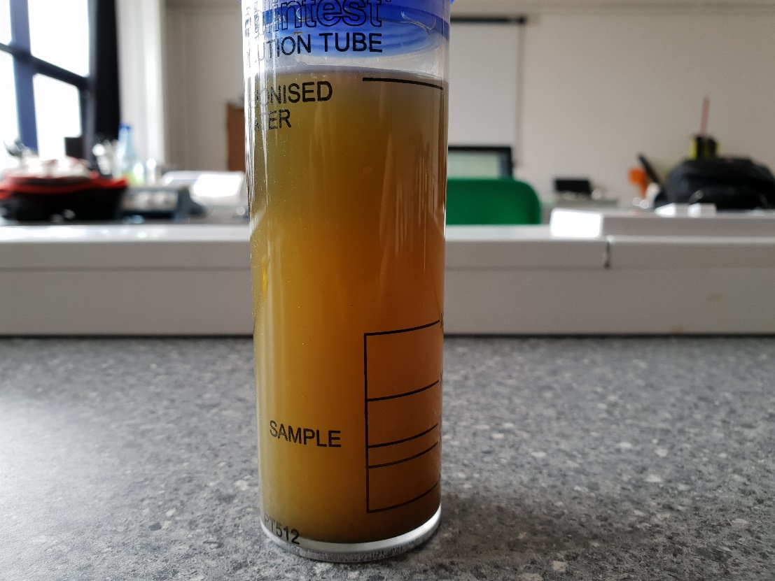
Figure 100 – Week 2 Test 4 Water Sample

Element | Wet sample (PPM) | Dry Sample (PPM)
Sodium (Na) | 81.5 | ND
Magnesium (Mg) | 25.8 | 6.13
Aluminium (Al) | 221 | 51.6
Silicon (Si) | 37.4 | 11.5
Phosphorus (P) | 8.48 | 1.61
Sulphur (S) | 12.9 | 3.98
Chlorine (Cl) | 41 | 9.29
Potassium (K) | 833 | 96.5
Calcium (Ca) | 48.1 | 16.8
Titanium (Ti) | 0.368 | ND
Manganese (Mn) | 0.448 | ND
Iron (Fe) | 9.31 | 2.76
Cobalt (Co) | ND | ND
Copper (Cu) | 1.11 | 2.26
Zinc (Zn) | 1.6 | 1.34
Gallium (Ga) | ND | ND
Arsenic (As) | ND | ND
Selenium (Se) | 0.0524 | ND
Bromine (Br) | 0.264 | ND
Rubidium (Rb) | 0.493 | ND
Strontium (Sr) | ND | ND
Tantalum (Ta) | ND | ND
Table 19 : Week 2 Test 4
From the XRF results for week 2 test 4 there is a noticeable drop in the measurement of iron and aluminium when compared to previous test. As the tests in week two were run for a period of ninety minutes, the time that the electric field was applied to the waste was not sufficient enough to allow the migration of iron through the waste in sufficient quantities as seen in tests run for longer periods.
As a result of the short detention time in the reaction chamber and after the test was completed the reactor was starting to show signs of exhaustion with the outside of the Cathode in particular showing signs of oxidation where the plastic coating began to bubble which could have been a contributing factor to the reduction in iron and aluminium seen in the samples that were taken from the later tests.

Test 5 (Group)
Voltage Cap: 40V Current: 4A Volume of Slurry: 1100ml
Volume of Charge Water: 0ml Gravel Depth: 195mm Date of Sample: 23/04/18
Table 20 - Week 2 Test 5 Results
Day | Time | Time Passed  (Minutes) | Volume of Water (ml)
Tuesday | 14:45 | 0 | 0
 | 14:55 | 10 | 55
 | 15:05 | 20 | 57
 | 15:15 | 30 | 57
 | 15:25 | 40 | 62
 | 15:35 | 50 | 75
 | 15:45 | 60 | 80
 | 15:55 | 70 | 86
 | 16:05 | 80 | 105
 | 16:15 | 90 | 127
Wednesday | 10:00 | 1155 | 336

End Voltage: 25V End Current: 0A
PH at Anode: 8 PH at Cathode: 5.8
Figure 101 - Week 2 Test 5 Graph

Test ten was run with a current of 4 amps and was left to run for a total time of 19 hours and 45 minutes and finished the test with a current of 0 amps and a voltage of 25 as a result of the resistance of the waste increasing as time increased and the connection between the power pack and the anode. As is seen with previous tests the membrane prevents a continuous yield of liquid from being measured evidence of this is the readings of 55,57,57 and 62 ml over the course of 30 minutes, this is thought to be evidence of the time taken for the membrane to become fully saturated with liquid from the reactor process. What is not known is the time that the current across the reactor drops, if the current could potentially be maintained the dewatering of the waste by the reactor may be more successful but also far more efficient as the power consumption could be adjusted and limited to the point until the power consumption to yield ratio becomes too great.
Overnight the yield continued to increase and was measured at 336 ml which was not the greatest yield measured, it is thought that the sample used may have had a lower moisture content than previous samples and also that the reactor during this test was not performing to the same standard as previous tests as a result of the anode and cathode becoming depleted of available ions.
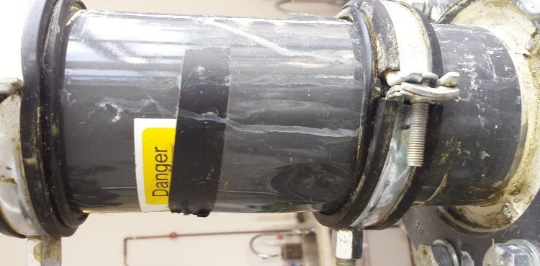
Figure 102 - Cathode Bubbling
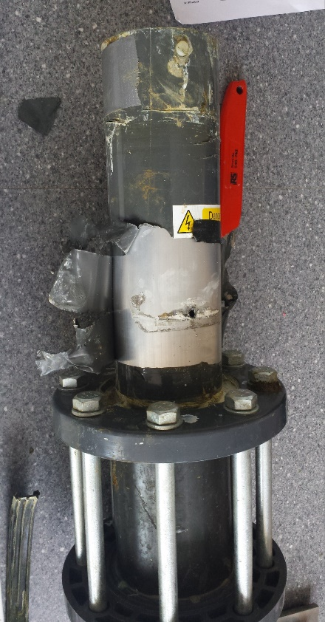
Figure 103 - Hole in the Cathode
Once the testing was completed it was discovered that the material that the cathode was made of had corroded to such an extent that the external wall of the cathode that was structurally integral to supporting the reactor had failed and two holes had appeared, evidence of this was noted before the inspection of the reactor where the liquid that was being released from the process was leaking through the external wall of the reactor and was collecting around the top flange of the reactor.
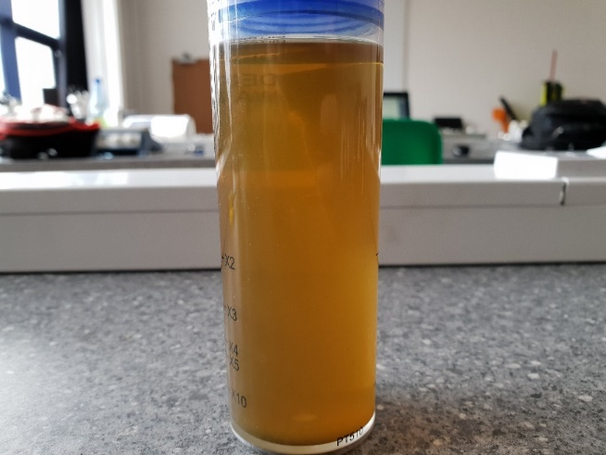
What is noticeable form the results for test ten is that the performance of the reactor up to the 70-minute mark is lower than test nine and test eleven particularly from the ten-minute point to the forty-minute point. It is likely that at this point the pouter wall of the cathode had failed and the liquid that was produced was exiting through the fractures in the material. Up to the seventy-minute mark it is thought that the amount of aluminium oxide produced was not sufficient enough to seal the fracture, once the seventy-minute mark was reached and the aluminium oxide had reached a sufficient volume to act as a barrier to the liquid the performance of the reactor rapidly increased producing a higher yield than any other test run with the same sample for the ninety minutes.
Figure 104 - Week 2 Test 5 Water Sample

Table 21 - Week 2 Test 5 XRF Results
Element | Wet (PPM)
Sodium (Na) | 145
Magnesium (Mg) | ND
Aluminium (Al) | 1230
Silicon (Si) | 10.5
Phosphorus (P) | 3.1
Sulphur (S) | 4.36
Chlorine (Cl) | 18.5
Potassium (K) | 68.4
Calcium (Ca) | 11.7
Titanium (Ti) | ND
Manganese (Mn) | ND
Iron (Fe) | 910
Cobalt (Co) | ND
Copper (Cu) | 0.764
Zinc (Zn) | 0.916
Gallium (Ga) | 0.201
Arsenic (As) | ND
Selenium (Se) | ND
Bromine (Br) | 0.0956
Rubidium (Rb) | 0.903
Strontium (Sr) | ND
Tantalum (Ta) | ND

At this point the reactor had become inefficient as a result of the complete exhaustion of the Cathode exhausting and the inside wall showing signs of heavy oxidation which impacted the current flow through the waste and the H-S theory shows that the impact of a reduced electric field impacts the mobility of the ions in electro osmosis.

Test 6 (Group)
Voltage Cap: 40V Current: 4A Volume of Slurry: 1100ml
Volume of Charge Water: 0ml Gravel Depth: 145mm Date of Sample: 23/04/18
Sand Depth: 50mm
Table 22 - Week 2 Test 6 Results
Day | Time | Time Passed  (Minutes) | Volume of Water (ml)
Wednesday | 12:50 | 0 | 0
 | 13:00 | 10 | 50
 | 13:10 | 20 | 71
 | 13:20 | 30 | 76
 | 13:30 | 40 | 80
 | 13:40 | 50 | 85
 | 13:50 | 60 | 89
 | 14:00 | 70 | 91
 | 14:10 | 80 | 95
 | 14:20 | 90 | 97
End Voltage: 5V End Current: 4A
PH at Anode: 8 PH at Cathode: 5.8
Figure 105 - Week 2 Test 6 Graph

The final test was run for a period of 90 minutes, this test used a filter that was 145mm gravel and 70mm sand with a current of four amps, the previous test showed signs that the reactor was beginning to fail and liquid was leaking from the outside wall. This was witnessed with this test but was not showing the same volume of liquid leaking, this is thought to be a result of the holes that had appeared partially sealing with the aluminium oxide that was present at the time of inspection.
What is noticeable from the test eleven is that the peak that is seen in test tens results towards the end of the ninety-minute test does not appear, this can be linked to the ability of the sand to absorb the liquid produced and release it at a slower rate than a pure gravel filter. Over a ninety-minute test the effect of the membrane becoming saturated with fluid and then discharging relatively quickly is not seen with a sand filter as the sand acts as a damper for the discharged fluid.
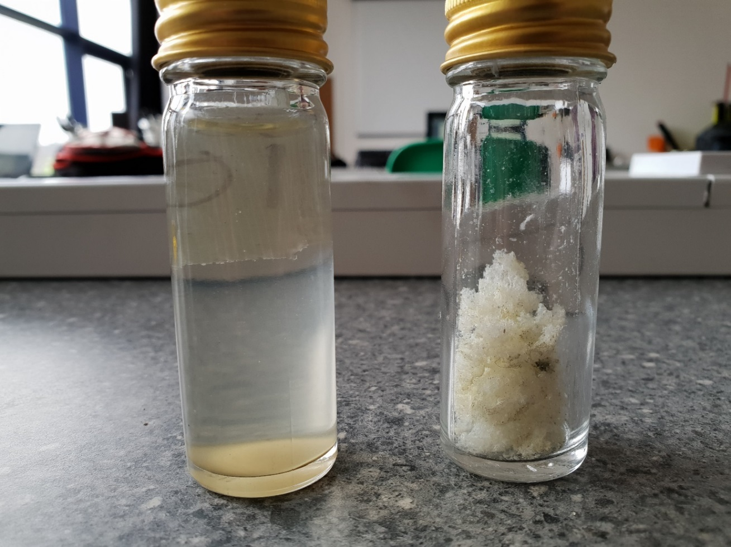
Figure 106 - Week 2 Test 6 Samples
In the figure above, on the left-hand side is a sample of the drainage water and on the right is a sample of the white power that was forming on the top of the electrode.
Table 23 - Week 2 Test 6 XRF Results
Element | Wet sample (PPM) | Powder Sample (PPM)
Sodium (Na) | ND | 29.3
Magnesium (Mg) | ND | 7.66
Aluminium (Al) | 26.2 | 402
Silicon (Si) | 18.6 | 14.6
Phosphorus (P) | 0.592 | 0.893
Sulphur (S) | 5.72 | 4.26
Chlorine (Cl) | 10.6 | 9.51
Potassium (K) | 68.4 | 143
Calcium (Ca) | 11.7 | 16.1
Titanium (Ti) | ND | ND
Manganese (Mn) | 0.127 | ND
Iron (Fe) | 5.48 | 2.96
Cobalt (Co) | ND | ND
Copper (Cu) | 0.57 | 2.7
Zinc (Zn) | 0.956 | 1.29
Gallium (Ga) | ND | ND
Arsenic (As) | ND | ND
Selenium (Se) | ND | ND
Bromine (Br) | ND | 0.0716
Rubidium (Rb) | ND | 0.143
Strontium (Sr) | ND | ND
Tantalum (Ta) | ND | 0.382

The table above shows that test six has very low ppm values for multiple elements in comparison to previous tests. For example, the ppm for Sodium, Magnesium, and Aluminium & Phosphorus is significantly lower than in previous tests where the values were up to twenty times greater. This is especially true for Potassium as in previous tests, it has been proven that the wet sample can be expected to hold values of around 1000ppm or more.
There are also several elements which do not have any recorded data. This can be associated with the fact that after testing, there was a leak discovered underneath the clamp, allowing outside air to enter the middle of the chamber and also allowing fluid to leak from the outer reactor wall. The overall turbidity and colour of water from the test also reflects this as it is noticeably clearer than previous results.

Week 2 Testing Results (Group)
Table 24: Week 2 Results
The results from the second week of testing show that the effect of gravity on the results obtained is significantly low as there is only up to a 20ml difference after 90 minutes. The results also show that by using a higher current, the result can be greater than if a lower current was being used. Finally, it is evident that the type of media filter used also effects the result as the single media gravel filter yielded more water than those that used a mixed gravel & sand filter.

Overall XRF Analysis (Group)
The XRF analysis of all the tests show that during the tests that last for the greatest amount of time resulted in higher amounts of aluminium and iron in both the wet and dry samples, this is thought to be as a result of the time the tests were run for with the tests run for a period of ninety minutes gaining less iron and aluminium than the tests run for 20+ hours.
It has to be noted that the tests that were run in week two were run in a reaction chamber that was showing signs of severe oxidation of the Cathode which resulted in the reaction between the two electrode becoming less efficient as the conductivity of the Cathode reduced as the Oxidation of the Aluminium increased.

Figure 107 : Aluminium Content Dry Sample
The Aluminium content of the week one test one dry waste sample was much higher than the other dry samples, this may have been caused by the reactor producing a layer of aluminium oxide prior to the testing began and resulted in the first test absorbing a greater amount than the other tests.

Figure 108 : Aluminium Content Wet
The aluminium content of the wet samples which were expected to contain more aluminium due to the liquid drawn out of the waste during the reaction was to run down the aluminium cathode and some degree of mixing was occurring. From the wet sample graph for aluminium content the highest values were week 1 test five and week 2 test five with week one test five running for a period of 68 hours which was a test completed over the course of a weekend at a current of 1 amp, week two test five was run for ninety minutes at a current of 4 amps which saw a Al content in the XRF analysis of 1230 ppm compared to 1790 for week one test five. This provides some evidence that the rate of Aluminium oxidation at the cathode is directly related to the electric field strength and the flow of current in the reaction chamber.

Figure 109 : Iron Content Dry

Figure 110 : Iron Content Wet
The Iron content of the dry waste samples were far greater than the Iron contents of the liquid samples, this is evidence to confirm the H-S theory as the sacrificial anode gives up iron ions during the electro kinetic dewatering process, these ions are then available to migrate in the fluid that is drawn towards the Cathode.
During Migration of the fluid from the Anode towards the Cathode the Iron ions which have mixed with the fluid are transported towards the Cathode with the fluid, this transportation through the pores of the solid waste is likely to cause the iron ions to become trapped in the pores that the fluid passes through. As the dewatering process continues the pores that the liquid travels through constrict as a result of the increasing pore pressure caused by the removal of liquid, the iron ions velocity will decrease as the passage through the pores requires greater amounts of pressure energy to migrate, this then results in the iron ions depositing in the dry sample, evidence of this is seen by the high iron content in the dry waste.

Reactor (Group)
Once the inside Anode was washed and thoroughly dried from the final tests. The Anode was then inspected, and it was found that the middle part of the Anode was worn off more compared to the bottom end of the Anode.
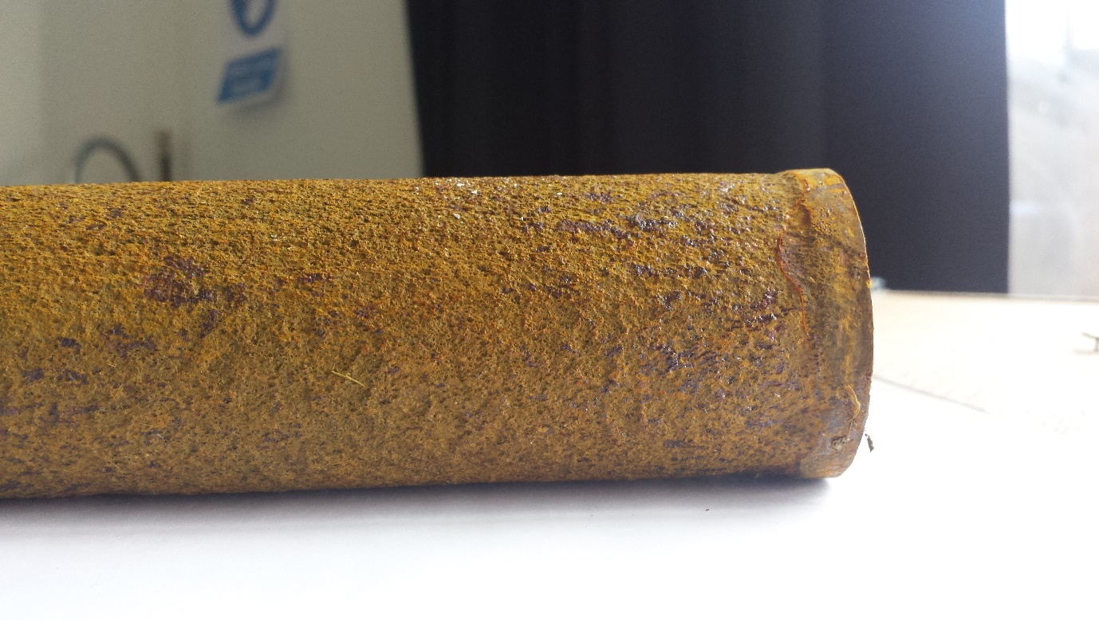

Figure 111 – The Anode

It was believed that, this may have occurred because the bottom end of the Anode was sealed to prevent the slurry from entering the inside the Anode. It was assumed that the layers of the anode were removed due to oxidation reaction occurring which deteriorate the electrode.
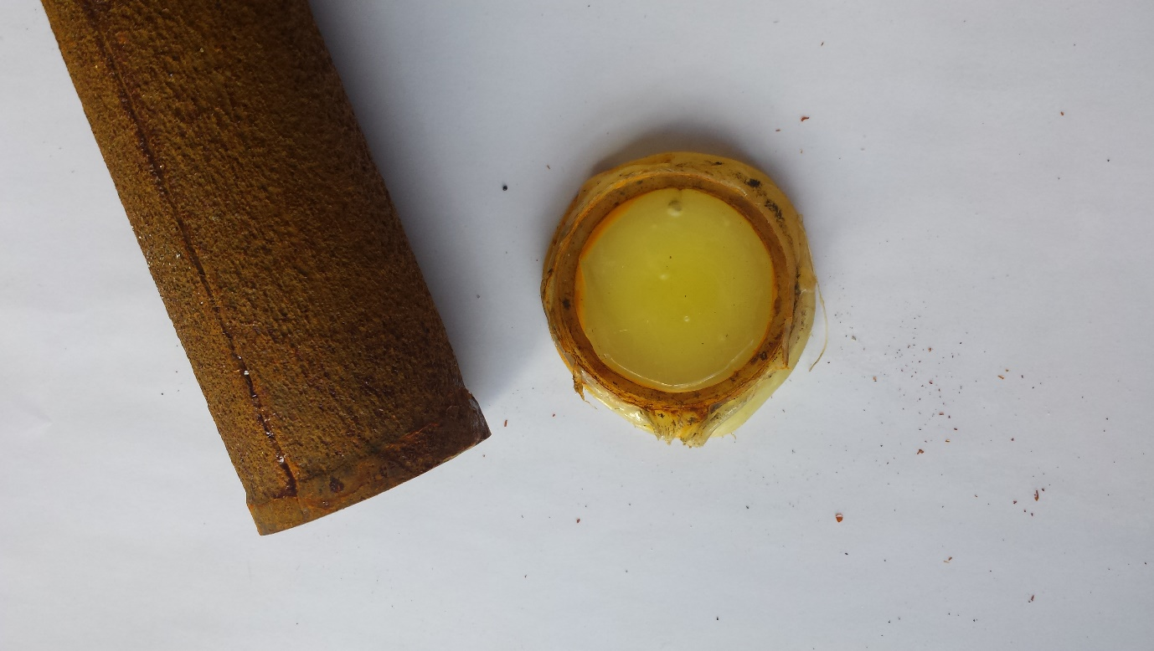
Figure 112 - The Anode & Seal cap off

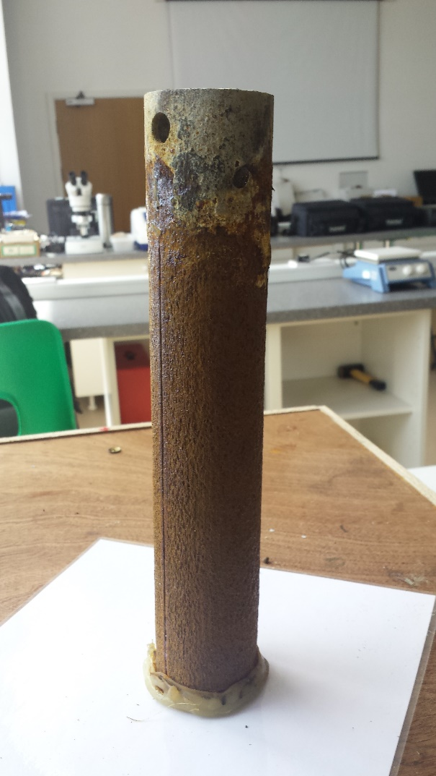
Figure 113 - The Anode & Seal cap on

By adding the seal cap on the bottom of the Anode we managed to prevent the base of the Anode to deteriorate completely and combine with the dry slurry. When compared with the old Anode, the new Anode was corroded far more after final stage of testing as shown in the Figure below.
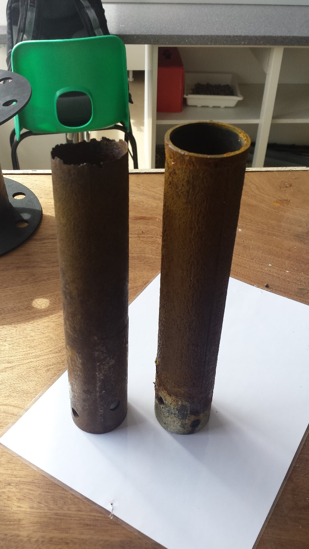

Figure 114 - Old Anode Vs New Anode

Cathode deteriorating (Group)
Although, the top of the reactor was sealed with a plastic bag to capture the evaporated water, it was found that the tape could not prevent some of the water escaping down the side of the reactor.
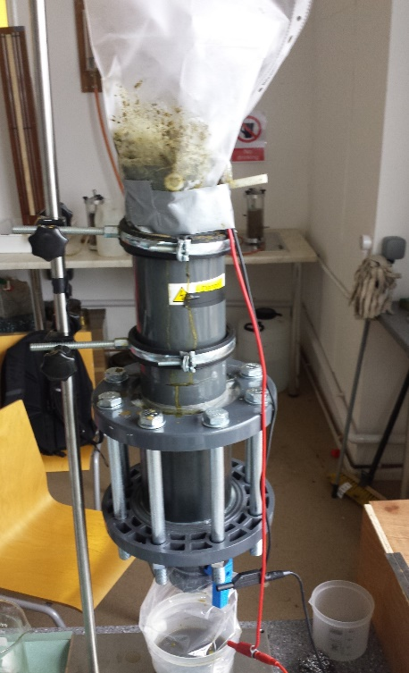
Figure 115 - System Sealed with Duct Tape
After undertaking the final test, it was found that the sides of the reactor were slightly expanded. At first it was though that the heat produced from the reactor may have caused the swellings.
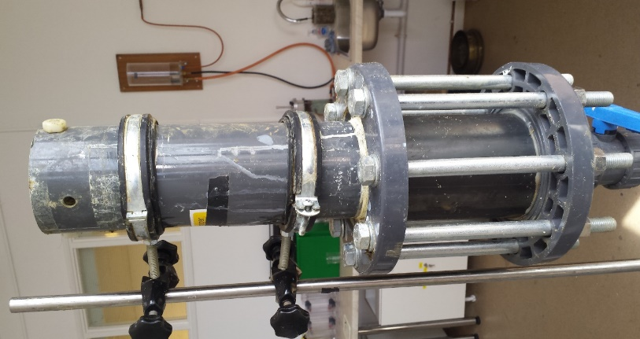
Figure 116 - System without Duct Tape
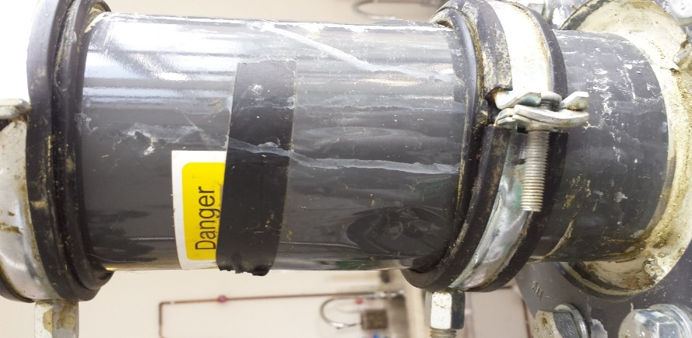
Figure 117 - System Swelling
At this point we wanted to discover the cause of this swelling. The first attempt was to press the swelling to find out, if there was any liquid inside the swelling. However, it was found that there was no liquid inside the swelling.
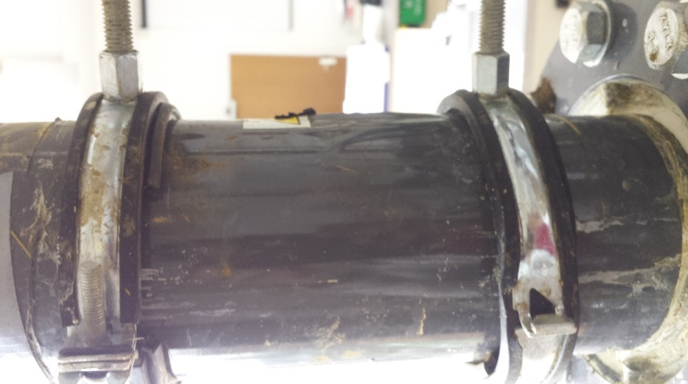
Figure 118 - System Swelling on the Right
The next step was to peel off the outer cover of the reactor to discover the exact cause of the swellings. Once the outer cover was peeled off, a hole was found on the side of the reactor. It was thought to remove cover completely and in doing so, another hole was found almost at an identical place to the first hole. This discovery also explained the reason some dry white substance was found along with the slurry.
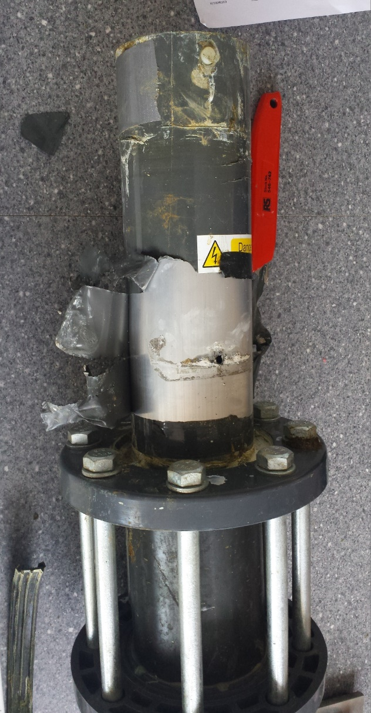
Figure 119 - Hole in the System
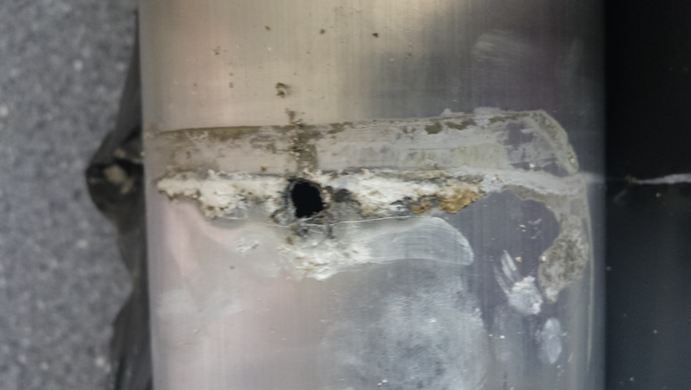
Figure 120 - Another hole on the opposite side of the system
Looking down inside the system, it was clear that the system (cathode) started to deteriorate. This also explained why there was small sounds of crackling while the tests were conducted and even during the cleaning process.

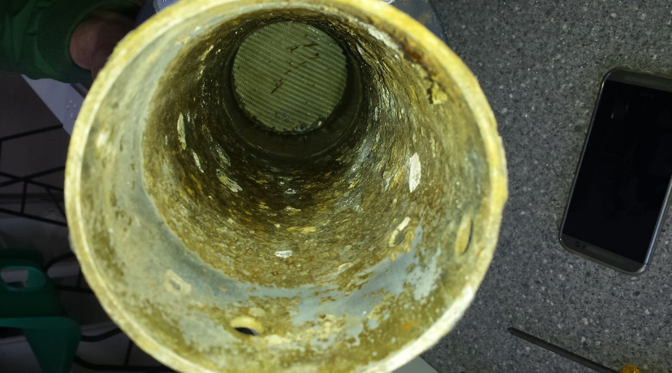
Figure 121 - Inside the system (Cathode)

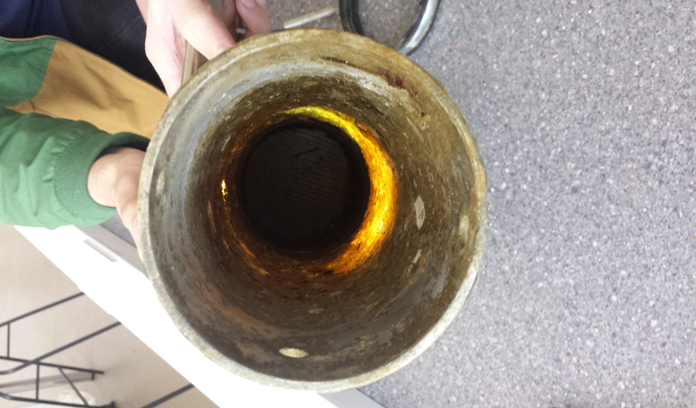
Figure 122 - Shining light through the deteriorated hole

Conclusions

Conclusion
To conclude, the issues that were present in the 2016-17 reactor were solved. By introducing a gravel filer in-between the bottom of the anode and the mesh filter, and adding a cap to the bottom of the anode, the slurry was uniformly distributed across the entire reaction chamber resulting in a significantly higher percentage of the batch undergoing the reaction.
This has been proven by comparing the best result from the previous reactor to the best result from the new design. Last year 307ml was drained in 3200 minutes, this year 430ml was drained in 1330 minutes, which is a 40.06% in water drained and was achieved in 58.43% less time. The power consumption was also improved as the reactor was powered for less time to acquire a greater yield. After 30 Watts have been consumed over 90 minutes, a total of 225ml was collected compared to an amount of 49.3ml from last year, resulting in a 456% increase in efficiency.
With the improved efficiencies that were gained this year, additional issues arose with the reactors design. Most notably the exhaustion of the Aluminium Cathode which eventually eroded to such an extent that the liquid removed during the dewatering process was passing through the external wall of the reactor and was collecting around the base of the Anode.
The collection of the foam that was produced during the dewatering process at lower amperage was produced in a volume that was manageable compared to the amount of foam that was produced during the tests run at higher amperages, with the higher amperage tests foam leaking from the collection bag.
The XRF results confirm the predictions of the H-S theory that the electro osmotic velocity of the particles that are present in the waste will be in the direction of the Cathode. From the XRF analysis the dry waste absorbed greater amounts of the iron ions, which were released as part of the electro kinetic dewatering reaction this indicates the movement of the water migrated in the direction from the Anode towards the Cathode, this is also confirmed by the high Aluminium content of the liquid waste that was produced. As the dry waste did not contain the high level of Aluminium that was measured in the liquid waste it can be predicted that the liquid that was removed had passed over the Cathode and exited the reactor through the media filter and then through the membrane.
The presence of the pH gradient in the dry waste that was collected also showed evidence that the H-S theory was correct and with the dry waste at the Cathode having a pH of around 8 and the pH of the waste near the Anode having a pH of around 6.8. The presence of the pH gradient also provides evidence that the waste that is processed has the potential to be used form multiple purposes if separated, with the potential of increasing the value of the processed waste as fertilizers for different uses.
In addition to developing an improved reactor, a complete control system was designed which can be carried out, implemented and iterated upon for future reactor designs. A complete schematic diagram as well as PCB design was developed which shows all the necessary components to allow for the circuit to function. Similar components can be used as substitutes in the event that the component is no longer available.
The feasibility studies carried out for Hydro, Solar and Wind have shown that from all the possible renewable energy sources that could be used to power the reactor, Hydro was the most achievable as there was a nearby river source with a flow rate of up to 250ms⁻³, of which 10% could be extracted using a 20-30 Kw turbine, and would cost around 110,000 to 165,000 USD. This would provide an ample amount of power for a scaled up version of the improved reactor which could be used commercially to continuously dewater large amount of cow slurry.

Reflection
There are several positive aspects which can be taken away from the project. This includes learning how to adapt our different backgrounds and skillsets to an unfamiliar task as well as gaining knowledge about a new field of work. The experience gained from working alongside Power&Water as well as seeing the problem first-hand at Gelli Aur farm has been valuable and has helped us understand the research that was necessary. All the research conducted has also helped us gain a good understanding of the field and in the end, has allowed us to develop an improved design which meets expectations.
There was also some negative aspects of the project which did not go as planned. This includes the final reactor design not completely matching the intended initial design as the moisture collected was done using an inefficient method. The diameter of the base tank was also decreased and was used to create the gravel filter instead of allowing for more slurry to be stored in the reactor. Also, the reactor was still used to dewater batches of slurry rather than changed to become a continuous process along with installing a second chamber for storing slurry before being moved to the reactor. This would have been done using a compressed air system, which would also require additional materials for implementation.

Future Improvements
Design the initial idea
There is still room for improvement for the project. Initial, we had several ideas of improving the system and these were:
- Extending the base of the reactor
- Adding water on top of the sand filter
- Slurry feeding Tank
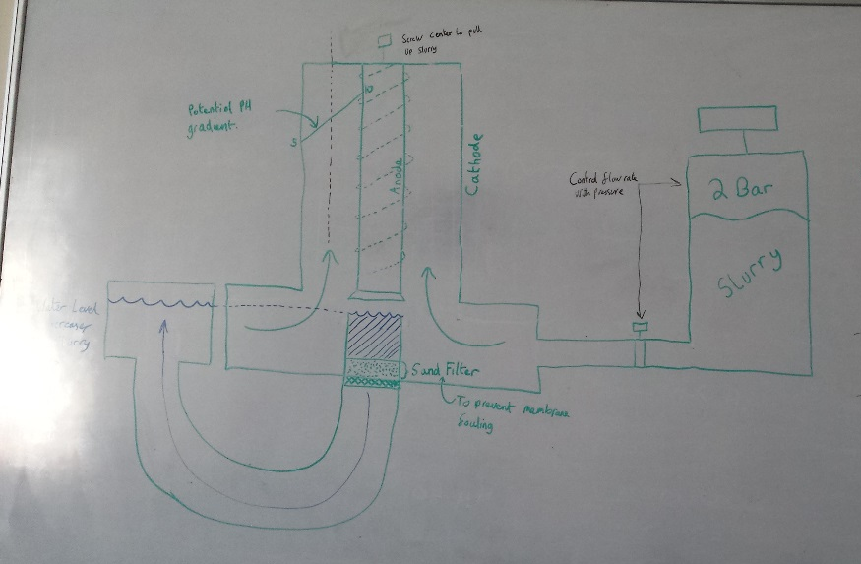

Extending the base of the reactor
The idea of extending the reactor was thought of to ensure there was enough space for the water to sit on top of the filter and enough space to feed the slurry into the reactor.
Water
The idea of adding fresh water in the system is to ensure that the sand filter was kept clean and also to backwash the filter. An additional water tank would be require to level out the water on top of the filter.

Slurry Tank
Another idea that was thought of was to have a small tank filled with slurry and use the forces of pressure to pump the slurry into the system.
Design a continuous process
Another way of improving the system would be to have a continuous process rather than having a batch system. Having a continuous system would be more desirable because it saves time, energy, operation costs and also increases the productivity.
Control system on the system
A control system could be used to control the flow of slurry that is fed into the system and also control the entire system remotely without physically switching the system on or off.
Powering the system using renewable energy
Testing the system using renewable energy would be another future improvement for the system. The entire system could be powered using photovoltaic and several tests could be carried to

References
1. Campuses. Coleg Sir Gar. [Online] [Cited: 13 April 2018.] http://www.colegsirgar.ac.uk/en/about-coleg-sir-gar/campuses.
2. Stephens, Adam Paul, Vismonte, Ryan Anthony and Amoruso, Angelo Michele. An Investigation into the Feasibility of Electrokinetic Dewatering of Cattle Slurry. 2017.
3. Chanson, Hubert. Hydraulics of Open Channel Flow: An Introduction. 2004.
4. Hydraulic Head Pressure. Engineers Edge. [Online] [Cited: 5 March 2018.] https://www.engineersedge.com/hydraulic/hydraulic_head_pressure_10054.htm.
5. Harnessing Hydroelectric Power. Gov UK. [Online] [Cited: 26 February 2018.] https://www.gov.uk/guidance/harnessing-hydroelectric-power.
6. Hydropower. National Geographic. [Online] [Cited: 26 February 2018.] https://www.nationalgeographic.com/environment/global-warming/hydropower/.
7. Hydro Energy. [Online] [Cited: 26 February 2018.] https://web.archive.org/web/20121127194425/http://www.decc.gov.uk/en/content/cms/meeting_energy/hydro/use/use.aspx.
8. Hydro Electricity in the United Kingdom. Wikipedia. [Online] [Cited: 26 February 2018.] https://en.wikipedia.org/wiki/Hydroelectricity_in_the_United_Kingdom#/media/File:UK_hydro_elec_supplied.PNG.
9. Archimedean Screw Turbine. Renewables First. [Online] [Cited: 06 March 2018.] http://www.renewablesfirst.co.uk/hydropower/hydropower-learning-centre/archimedean-screw-hydro-turbine/.
10. Hydro Power Turbines. Renewables First. [Online] [Cited: 06 March 2018.] http://www.renewablesfirst.co.uk/hydropower/hydropower-turbines/.
11. Grid Tied Screw Generator. Green Bug Energy. [Online] [Cited: 06 March 2018.] http://greenbugenergy.com/shop-hydro/shop-hydro-products-services/grid-tied-screw-generators#prettyPhoto.
12. Crossflow Turbines. Renewables First. [Online] [Cited: 06 March 2018.] http://www.renewablesfirst.co.uk/hydropower/hydropower-learning-centre/crossflow-turbines/.
13. Kaplan Turbines. Renewables First. [Online] [Cited: 06 March 2018.] http://www.renewablesfirst.co.uk/hydropower/hydropower-learning-centre/kaplan-turbines/.
14. Kaplan Turbines. Ossberger. [Online] [Cited: 12 March 2018.] http://hts-inc.com/images/S-160.pdf.
15. Pelton Turbines. Renewables First. [Online] http://www.renewablesfirst.co.uk/hydropower/hydropower-learning-centre/pelton-and-turgo-turbines/.
16. Francis Turbine. Brain Kart. [Online] [Cited: 09 March 2018.] http://www.brainkart.com/article/Francis-Turbine_3509/.
17. Radial Turbine Selection Chart. Research Gate. [Online] [Cited: 12 March 2018.] https://www.researchgate.net/figure/Radial-turbine-selection-chart-by-net-head-flow-2_fig1_315922768.
18. Google Maps. Google. [Online] [Cited: 1 May 2018.] https://www.google.co.uk/maps/place/Gelli+Aur+College+Farm/@51.8716154,-4.044875,641m/data=!3m1!1e3!4m5!3m4!1s0x486ee4dcfe64b3a5:0x6ec540a62125c9d6!8m2!3d51.8703909!4d-4.0449228.
19. Boyle, Godfrey. Renewable Energy Power For Sustainable Future. New York : Oxford University Press Inc., 2004.
20. A Marmount, V V Vadher, I R Smith & J G Kettleborough. An Integrated Non-Fossil Fue Electrical Power System. Ezulwni Valley, Swaziland : IEEE, 2002.
21. IDC Technologies. Instrumentation. IDC Technologies. [Online] [Cited: 26 February 2018.] http://www.idc-online.com/technical_references/pdfs/instrumentation/Types_of_control_systems.pdf.
22. Tucker, M. Ray. Essential Plant Nutrients: Their Presence in North Carolina Soils and Role in Plant Nutrition. s.l. : North Carolina State University, 1999.
23. McKenzie, Dr. Ross. Crop Nutritiun and Fertilizer Requirements. Lethbridge : Alberta Agriculture, 1998.
24. FAO. AGP - Fertilizer Specifications. Food and Agriculture Organizaton of the United Nations. [Online] [Cited: 2 March 2018.] http://www.fao.org/agriculture/crops/thematic-sitemap/theme/spi/plantnutrition/fertspecs/en/.
25. Documen Information Design Inc. British Thermal Unit (BTU), MBTU, MMBTU. Energy Dictionary. [Online] [Cited: 4 March 2018.] https://www.energyvortex.com/energydictionary/british_thermal_unit_(btu)__mbtu__mmbtu.html.
26. eXtension. What is the difference between the "higher heating value" (HHV) and "lower heating value" (LHV) of a biomass fuel, and why is the difference important? eXtension. [Online] 4 February 2008. [Cited: 4 March 2018.] http://articles.extension.org/pages/38753/what-is-the-difference-between-the-higher-heating-value-hhv-and-lower-heating-value-lhv-of-a-biomass.
27. Minh, Do Mgic. Thailand eyes Biomass. Broadgate Financial. [Online] 5 September 2013. [Cited: 4 March 2018.] http://www.broadgatefinancial.com/blog/thailand-eyes-biomass/.
28. eXtension. What is the energy value (BTU/lb) of livestock manure? Our manure source is dairy solids that are separated from the slurry at about 60% moisture. We want to reduce that moisture further and burn the fibers. eXtension. [Online] 28 July 2010. [Cited: 4 March 2018.] http://articles.extension.org/pages/43790/what-is-the-energy-value-btulb-of-livestock-manure-our-manure-source-is-dairy-solids-that-are-separa.
29. Farm Safety Association Inc. Manure Gas Dangers. National Agriculture Safety Databaase. [Online] [Cited: 4 March 2018.] http://nasdonline.org/48/d001616/manure-gas-dangers.html.
30. Redkiwi, Internetbureau. EWT. [Online] EWTdirectwind, 2011. [Cited: 20 April 2018.] http://www.ewtdirectwind.com/solutions/microgrid-solutions.html.
31. S.K Tiwari, Bhim Singh, P.K. Goel. Design and Control of Micro-Grid fed by Renewable Energy Generating Sources. New Delhi, India : IEEE, 2016.
32. Research on optimal storage capacity of DC micro-grid system in PV station. Wu, Ming, et al. 13, 2017, The Journal of Engineering, Vol. 2017, pp. 859-864.
33. A comparative study of DC and AC microgrids in commercial buildings across different climates and operating profiles. Fregosi, Daniel, et al. 2015, 2015 IEEE First International Conference on DC Microgrids (ICDCM), pp. 159 - 164.
34. EcoPlanetenergy. [Online] [Cited: 20 April 2018.] http://www.ecoplanetenergy.com/all-about-eco-energy/overview/hybrid/.
35. An Integrated Battery Optimal Power Dispatch Architecture for End-User Driven Micro Grid in Islanded and Grid Connected Mode of Operation. Hossain, Sheikh Jakir, et al. 2018, IEEE Transactions on Industry Applications, pp. 1-1.
36. Intelligent control strategies for energy management system in micro grid for load balancing. Bhanurmayee, B. V. L. S, Roselyn, J. Preetha and Nitya, C. 2017, 2017 IEEE International Conference on Intelligent Techniques in Control, Optimization and Signal Processing (INCOS), pp. 1-7.
37. Converting Waste Agricultural Biomass Into Resource, Compendium of Technologies. Programme, United Nations Environment. Osaka/Shiga, JApan : s.n., 2009. United Nations Environment Programme.
38. OECD. Bioheat, Biopower and Biogas - Developments and Implications for Agriculture. Paris : http://dx.doi.org/10.1787/9789264085862-en., 2010.
39. Biogas production in batch in anaerobic conditions using cattle manure enriched with waste from slaughterhouse. Reátegui, O. J., et al. 2017, 2017 IEEE 6th International Conference on Renewable Energy Research and Applications (ICRERA), pp. 89 - 822.
40. Steinhauser, Prof. Dr.‐Ing. Dieter Deublein Dipl.‐Ing. Angelika. Biogas from Waste and Renewable Resources: An Introduction, 2nd, Revised and Expanded Edition. Hong Kong : Wiley-VCH, 2011.
41. Kumar, Sunil. Biogas. Rijeka, Croatia : InTech, 2012.
42. electrokinetic. EKG TECHNOLOGY. electrokinetic. [Online] 2016. [Cited: 16 02 2018.] http://www.electrokinetic.co.uk/technology.htm.
43. rai, rajesh. https://www.iitbhu.ac.in/faculty/min/rajesh-rai/NMEICT-Slope/lecture/c6/l4.html. https://www.iitbhu.ac.in. [Online] [Cited: 12 03 2018.] https://www.iitbhu.ac.in/faculty/min/rajesh-rai/NMEICT-Slope/lecture/c6/l4.html.
44. Puvvadi Venkata Sivapullaiah∗, Bangalore Sriakantappa Nagendra Prakash* and. Electrokinetic removal of heavy metals from soil. Bangalore : Department of Civil Engineering, Indian Institute of Science, 2014. ISSN 1847-9286.
45. brookhaveninstruments. www.brookhaveninstruments.com/what-is-zeta-potential. www.brookhaveninstruments.com. [Online] brookhaveninstruments, 03 2018. http//www.brookhaveninstruments.com/what-is-zeta-potential.
46. Han*, Sang-Jae. Electroosmosis and pore pressure development characteristics in lead. Hanyang : Geosciences Journal, 2004. 425-791.
47. General Electric Company. Chapter 06 - Filtration. Water Technologies & Solutions. [Online] 2012. [Cited: 08 March 2018.] https://www.suezwatertechnologies.com/handbook/ext_treatment/ch_6_filteration.jsp.
48. Western Carbons Ltd. Multimedia Filtration. Western Carbons Multimedia Filtration. [Online] 2010. [Cited: 08 March 2018.] http://www.westerncarbons.co.uk/multimedia.html.
49. Filtec Water Services. Media Selection. Filtec Water Services Ltd. [Online] [Cited: 09 March 2018.] http://www.filtec.co.uk/selection.html.
50. Pipeline. National Small Flows Clearinghouse. 3, s.l. : Purdue University, 1997, Vol. 8.
51. Province of British Columbia. Water Quality - Recirculating Sand Filters. Environmental Protection Division. [Online] [Cited: 10 March 2018.] http://www.env.gov.bc.ca/wat/wq/nps/BMP_Compendium/Municipal/onsite/Alternative_Systems/Recirculating_Sand.htm#perf.
52. Yun56.co. Sand Filtered Septic System. Yun56.co. [Online] [Cited: 10 March 2018.] http://yun56.co/sand-filtered-septic-system/.
53. Tywi at Ty Castell. National River Flow Archive. [Online] [Cited: 03 May 2018.] http://nrfa.ceh.ac.uk/data/station/peakflow/60001.
54. Renewable Energy Cost Analysis: Hydro. International Renewable Energy Agency. [Online] June 2012. [Cited: 11 May 2018.] https://www.irena.org/documentdownloads/publications/re_technologies_cost_analysis-hydropower.pdf.
55. https://www.worldweatheronline.com. https://www.worldweatheronline.com. https://www.worldweatheronline.com. [Online] [Cited: 12 05 2018.] https://www.worldweatheronline.com/carmarthen-weather-averages/carmarthenshire/gb.aspx.
56. Jordan Hanania, Kailyn Stenhouse, Jason Donev. http://energyeducation.ca/encyclopedia/Betz_limit. http://energyeducation.ca. [Online] [Cited: 12 05 2018.] http://energyeducation.ca/encyclopedia/Betz_limit.
57. Hadassah College. [Online] 2012. [Cited: 27 February 2018.] http://cs.hadassah.ac.il/staff/martin/embedded/slide04-1.pdf.
58. Marian, P. Double Pole Double Throw DPDT Relay. Electro Schematics. [Online] [Cited: 12 April 2018.] https://www.electroschematics.com/9601/dpdt-switch-relay/.
59. Circuit Basics. 555 Timer Basics - Monostable Mode. Circuit Basics. [Online] [Cited: 12 April 2018.] http://www.circuitbasics.com/555-timer-basics-monostable-mode/.
60. AspenCore, Inc. 555 Oscillator Tutorial. ElectronicsTutorials. [Online] https://www.electronics-tutorials.ws/waveforms/555_oscillator.html.
61. Texas Instruments Incorporated. LM2763. [Online] June 2016. [Cited: 23 April 2018.] http://www.ti.com/lit/ds/symlink/lm2673.pdf.
62. Differential Pressure Flowmeter. Universal Flow Monitors. [Online] [Cited: 09 March 2018.] http://www.flowmeters.com/differential-pressure-technology.
63. Bernoulli Equation. Hyper Physics. [Online] [Cited: 09 March 2018.] http://hyperphysics.phy-astr.gsu.edu/hbase/pber.html.
64. Turbine Flow Meter. Wikipedia. [Online] [Cited: 03 April 2018.] https://en.wikipedia.org/wiki/Flow_measurement.
65. Flow Meter. GPI Flow Meter. [Online] [Cited: 21 May 2018.] http://www.gpiflowmetersuk.co.uk/.
66. Optical Flow Meter Principle. Instrumentation Tools. [Online] [Cited: 04 April 2018.] https://instrumentationtools.com/optical-flow-meter-principle/#.WsSWRYjwaUk.
67. Ultrasonic Flow meter. Omega. [Online] [Cited: 10 April 2018.] https://www.omega.co.uk/prodinfo/ultrasonic-flow-meters.html.
68. Hydraulics. Wikipedia. [Online] [Cited: 30 April 2018.] https://en.wikipedia.org/wiki/Hydraulic_drive_system#/media/File:Hydraulic_Force_Torque_275px.png.
69. Blogspot. [Online] [Cited: 26 February 2018.] http://instrumentationandcontrollers.blogspot.co.uk/2010/11/types-of-control-systems.html.
70. Defcon:Blog. Microcontroller Concepts. Defcon:Blog. [Online] 26 September 2010. [Cited: 27 Feburary 2018.] http://defcon.no/electronics/microcontroller-concepts/.
71. Delta-T Deivces Ltd. PR2 Soil Moisture Profile Probe. Delta T Devices. [Online] [Cited: 12 April 2018.] https://www.delta-t.co.uk/product/pr2/.
72. Premier Farnell. PIC16F887-I/P - 8 Bit Microcontroller, Flash, PIC16F, 20 MHz, 14 KB, 368 Byte, 40 Pins, DIP. Farnell. [Online] [Cited: 13 April 2018.] http://uk.farnell.com/microchip/pic16f887-i-p/mcu-8bit-pic16-20mhz-dip-40/dp/1439541?st=pic16f887.
73. —. 40.52.7.024.0000 - General Purpose Relay, 40 Series, Power, DPDT, 24 VDC, 8 A. Farnell. [Online] [Cited: 13 April 2018.] http://uk.farnell.com/finder/40-52-7-024-0000/relay-dpdt-24vdc-8a/dp/1169174?st=dpdt%20relay.
74. Solarbotics Ltd. 555 Timer IC. SOLARBOTICS. [Online] [Cited: 13 April 2018.] https://solarbotics.com/product/lm555/.
75. Intersil Americas Inc. Digitally Controlled Potentiometer. [Online] 20 July 2009. [Cited: 23 April 2018.] https://docs-emea.rs-online.com/webdocs/14bf/0900766b814bf8a8.pdf.
76. Elcodis Company Ltd. AD5220BN10. Elcodis. [Online] [Cited: 23 April 2018.] http://elcodis.com/parts/3688848/AD5220BN10.html.
77. Premier Farnell Limited. LM2673T-ADJ - DC-DC Switching Buck (Step Down) Regulator, Adjustable, 8V-40Vin, 1.2V-37Vout, 3Aout, TO-220-7. [Online] [Cited: 23 April 2018.] http://uk.farnell.com/texas-instruments/lm2673t-adj/switching-reg-3a-adj-2673-to2207/dp/9485724?st=lm2673.
78. Forest. Forest for Families. [Online] 2018. [Cited: 14 May 2018.] https://www.forests.org.au/greener-cleaner-world-alternative-solar-sources/.
79. Chinese Farmers Paid to Convert Livestock Wastes to Fuel and Fertilizer. The Green Optimistic. [Online] 1 September 2017. [Cited: 14 May 2018.] https://www.greenoptimistic.com/chinese-farmers-paid-convert-livestock-wastes-fuel-fertilizer-20170901/#.WujnYogvzIU.
80. Here’s The Easiest Way To Reduce Waste In Our Landfills. GoGreen. [Online] 21 December 2016. [Cited: 14 May 2018.] http://www.gogreen.org/blog/Heres-The-Easiest-Way-To-Reduce-Waste.
81. A REVIEW OF DIFFERENT TYPES OF BIOMASS FUELS. Gemco Energy. [Online] 17 March 2017. [Cited: 14 May 2018.] http://www.biomass-energy.org/blog/biomass-fuels-types-review.html.
82. Dong Chen, Lie Xu. Ac and DC Microgrid wth Distributed Energy Resources. [book auth.] O.Veneri. Technology & Application for Smart Charging of Electric & Plug-In Hybrid Vehicles. Switzerland : Springer International Publising, 2017.

