Stephen Griffiths (Please call me Steve) 4 December 2019

You could reference my slides as:

Griffiths, S. (2018) ‘Integrating current challenges of CSR and sustainability’, Current Issues in Business Conference, International University of Malaya-Wales (IUMW), Kuala Lumpur, 22 May 2018

Stakeholder/Stockholder/Agents and Corporate Social Responsibility (CSR)
- To whom is business responsible?
- Narrow Stockholder Theory

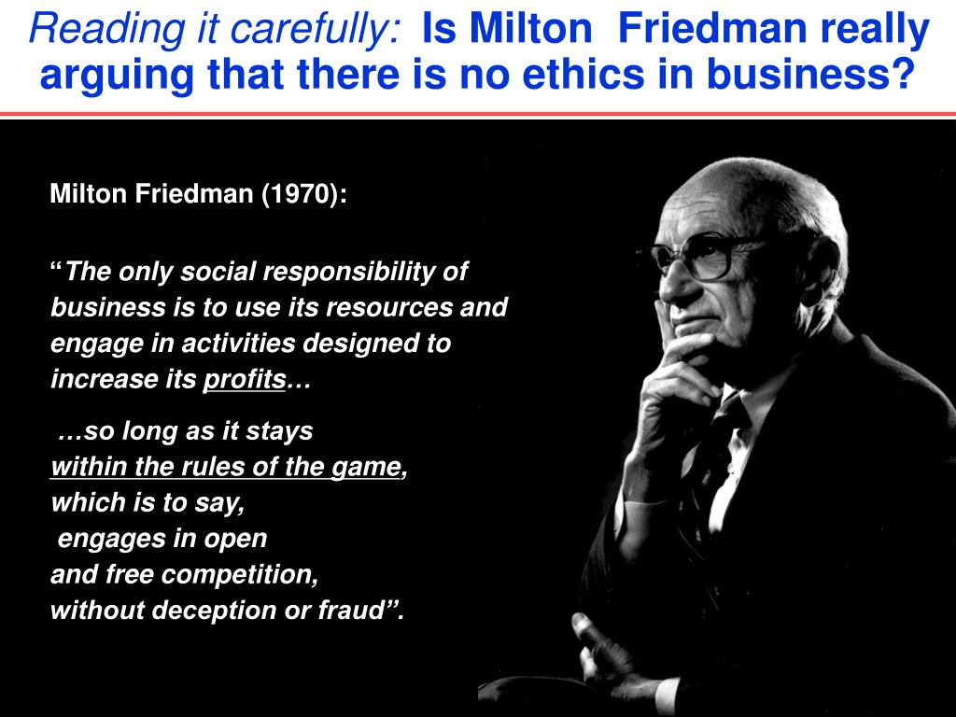

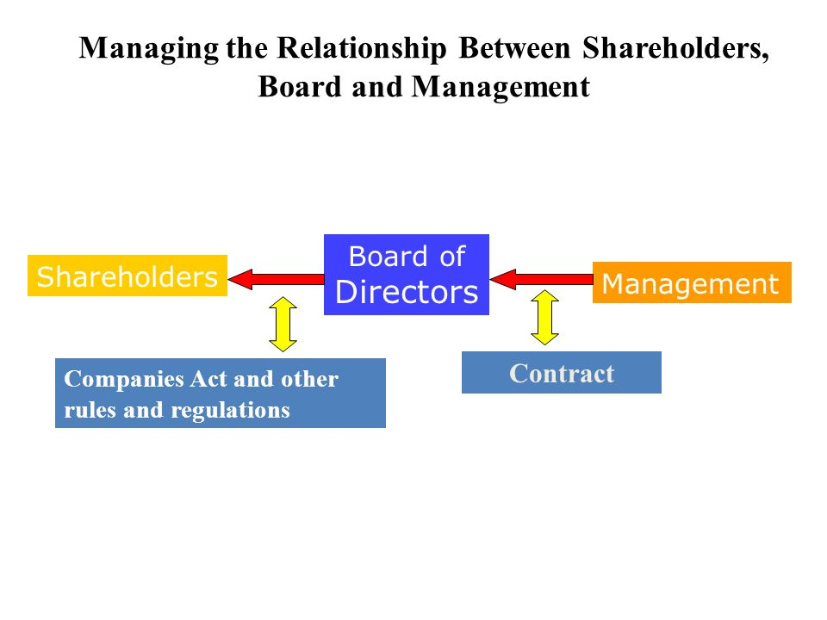
- Wide Stakeholder Theory
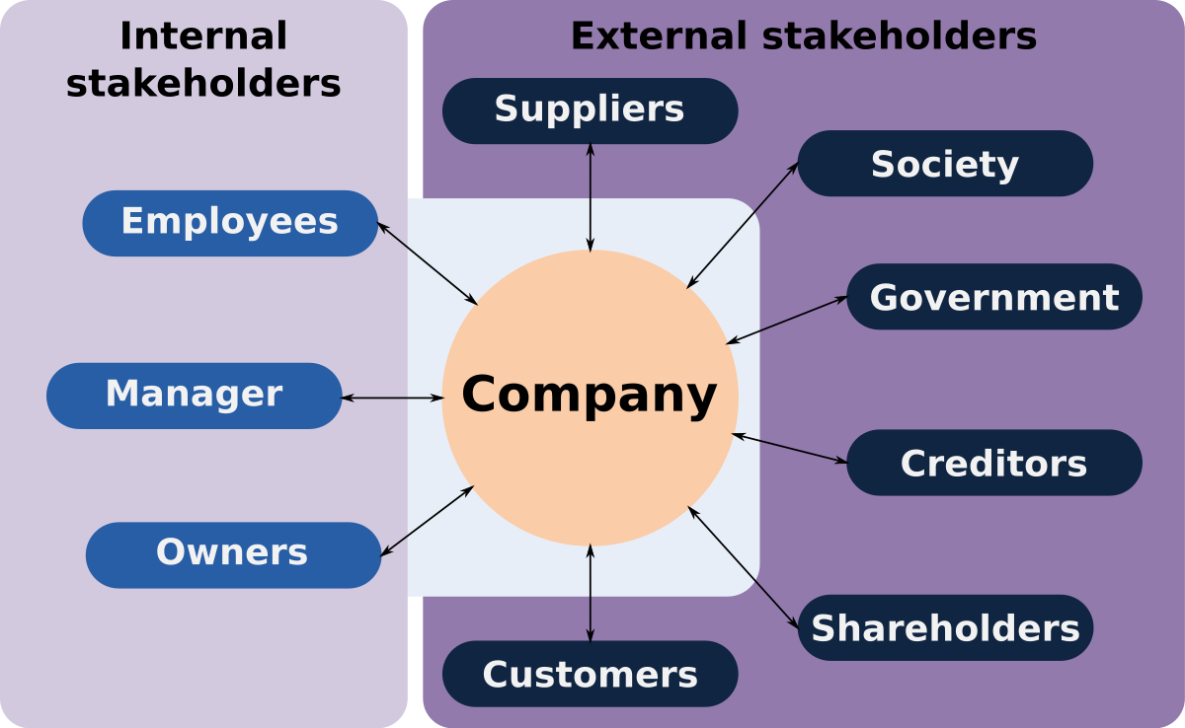

- Draw a stakeholder map for:

- A large joint stock company e.g. Starbucks
- A small business e.g. a local butcher
- A government service organisation e.g. a hospital or school
- A charity or voluntary organisation e.g. OXFAM
Who are the most important stakeholders?
- What is ‘agency loss? How might it affect the organisations you have mapped?
Source: https://www.investopedia.com/terms/a/agencytheory.asp (Accessed 01-12-19)
What Is Agency Theory?
Agency theory is a principle that is used to explain and resolve issues in the relationship between business principals and their agents. Most commonly, that relationship is the one between shareholders, as principals, and company executive, as agents.

How Agency Theory Works- An agency, in broad terms, is any relationship between two parties in which one, the agent, represents the other, the principal, in day-to-day transactions. The principal or principals have hired the agent to perform a service on their behalf.

Principals delegate decision-making authority to agents. Because many decisions that affect the principal financially are made by the agent, differences of opinion and even differences in priorities and interests can arise. This is sometimes referred to as the principal-agent problem.
By definition, an agent is using the resources of a principal. The principal has entrusted money but has little or no day-to-day input. The agent is the decision-maker but is incurring little or no risk because any losses will be borne by the principal.
To determine whether or not an agent acts in his or her principal’s best interest, the standard of “Agency Loss” has emerged as a commonly-used metric. Strictly defined, agency loss is the difference between the optimal results for the principal and the consequences of the agent’s behavior. For example, when an agent routinely performs with the principal’s best interest in mind, agency loss is zero. But the further an agent’s actions diverge from the principal’s best interests, the greater the agency loss becomes.
Agency loss drops when the following situations occur:
- The agent and principal both hold similar interests of achieving the identical income.
- The principal is mindful of the agent’s activities, so the principal has a keen knowledge of the level of service he is receiving.
If neither of these events occurs, agency loss is likely to climb. Therefore, the chief challenge involves persuading agents to prioritize their principal’s best interest while placing their self-interest second. If done correctly, the agent
- Is there a need for external regulation? Yes/No/Maybe/It depends…….

- Horsemeat scandal
- Why was this a scandal?
- How might you have dealt with the case if you had been a manager of a supermarket selling beef products which contained horsemeat?
- Can you use the Andersen (2000) model to develop an organisational approach to making an ethical policy?
- Will this retail/product scandal happen again?


