Qualification: Postgraduate Diploma in Strategic People Management

Module Name: Driving Performance (BMHR7016)
Assessment: Lunch and learn sessions

Student Name: Jessica Rainbow

Student Number: 1904613

CIPD Membership Number: 54071923

Word Count: 3259


Lunch and learn sessions for line managers

Duration: | 1 hour per session
Equipment: | Computer and projector
Materials: | Flip chart paper and pens
Session length: | 3 x 1-hour sessions


Session 1: Building Trust & Psychological Safety

Slide | Time (Minutes)
Overview of 3 sessions/Evaluation method | 5
Welcome/Introduction/Ice Breaker | 15
Line managers and their influence on high-performing teams | 5
The impact of effective line management on team productivity and morale | 5
Understanding trust and psychological safety | 10
“Manual of Me” activity | 15
Conclusions and further reading | 5
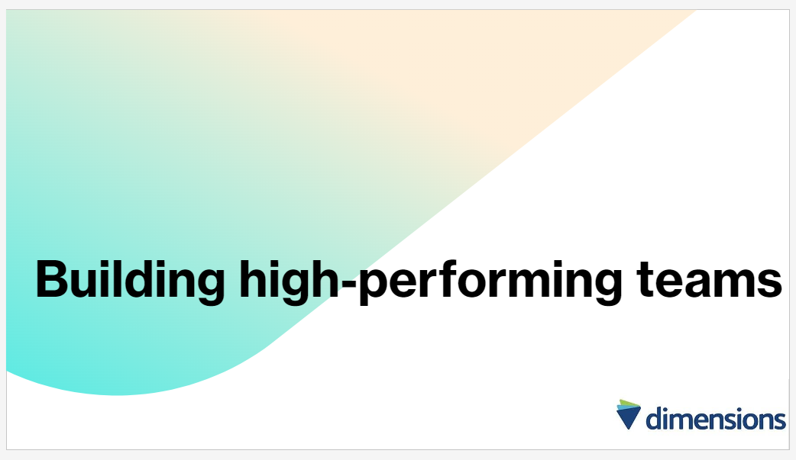
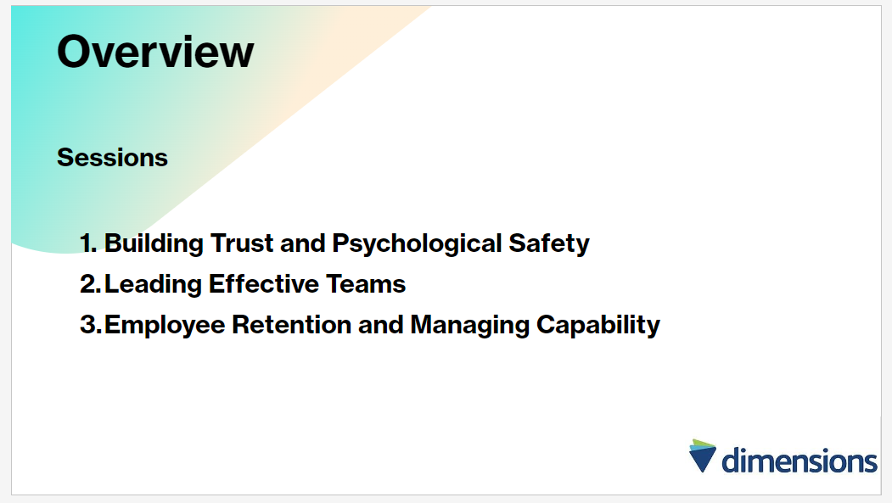

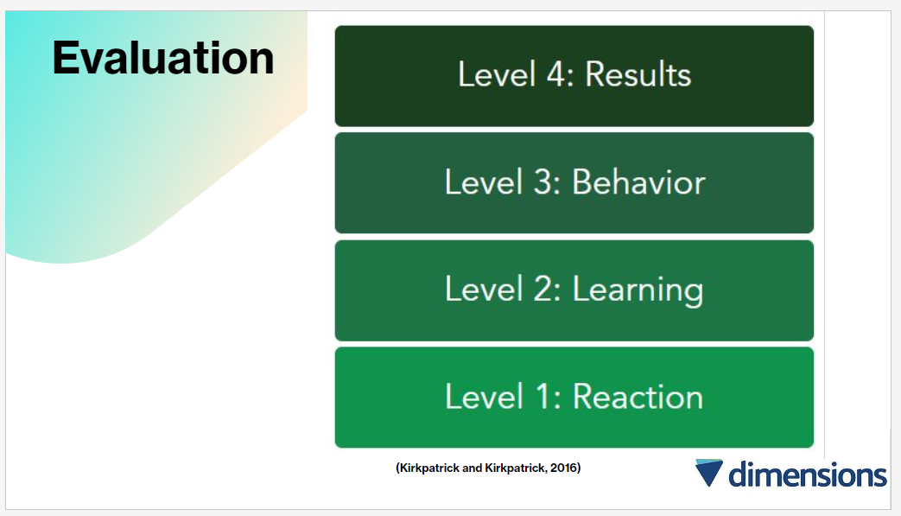
(5 mins)
Evaluation will be in line with the Kirkpatrick model, which is widely recognised as the gold standard for assessing investments in talent development involving four levels of assessment:
- Reaction: Evaluating participants immediate reactions and perceptions.
- Learning: Assessing the extent to which participants acquired new knowledge, skills, or attitudes.
- Behaviour: Examining changes in behaviour or performance as a result of the training.
- Results: Measuring the broader organisational outcomes or impact attributable to the training.
(Kirkpatrick & Kirkpatrick, 2016).
NB: Please see the training evaluation to be completed for each session in appendix (i), in line with level 1: reaction (Kirkpatrick & Kirkpatrick, 2016).

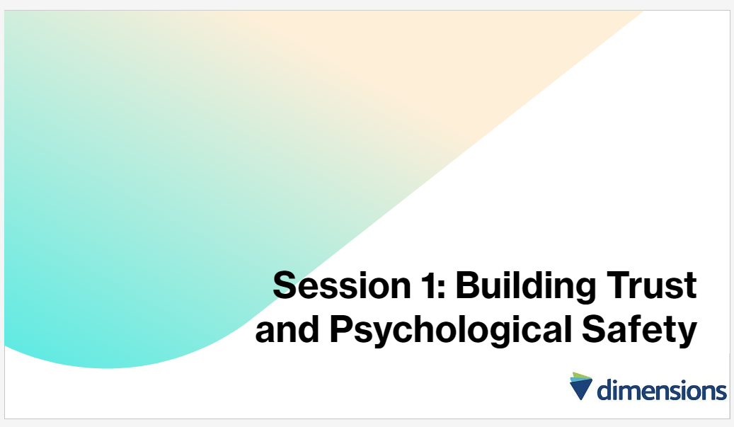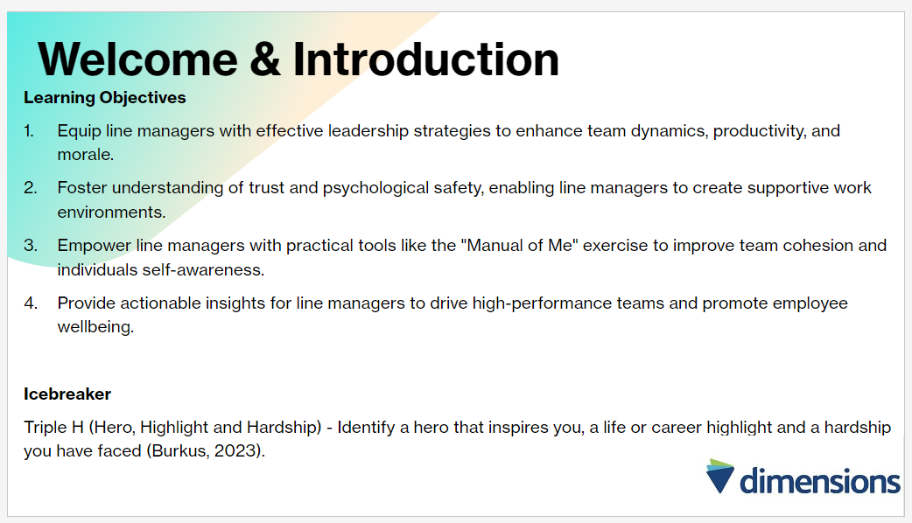
(15 mins)
This session will explore the crucial role of line managers in influencing team performance, understanding the impact of effective line management on productivity and morale, and fostering trust and psychological safety within teams (CIPD 2023; Chown, 2024). Through an interactive activity and insightful discussions, line managers will be equipped with the knowledge and tools to enhance team effectiveness and create a positive work environment.
NB: Ice Breaker: Encouraging team members to discuss personal preferences, values and experiences is with the view of identifying connections and strengthening bonds through shared moments, and ultimately leading to greater empathy, respect and collaboration (Burkus, 2023).

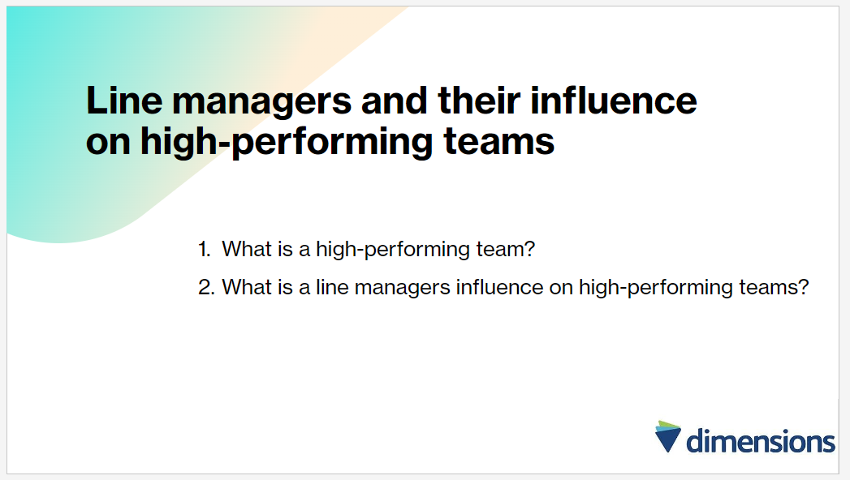
(5 mins)
- When individuals collaborate effectively towards shared objectives, they frequently exceed their designated tasks to accomplish remarkable outcomes, while ineffective teamwork can result in dysfunction and conflict (CIPD, 2023). A high-performing team exhibits mutual understanding, trust, a shared commitment to meaningful work, fostering an environment conducive to collaboration, innovation, and success (Burkus, 2023).
To develop high-performing teams, people leaders should prioritise:
- Team dynamics
- Team cohesion
- Shared thinking
- Information sharing
- Team reflection
- Well-planned interventions (CIPD, 2023).

- Steps to creating high-performing team involve initially defining the team’s purpose and objectives, aligning efforts toward a shared vision, and ensuring clear understanding of roles and responsibilities (Chown, 2024). Emphasising team collaboration, fostering a culture of trust and open communication, and facilitating regular’ meetings and “check ins” are essential components (Chown, 2024). Leadership plays a pivotal role in driving team performance by providing guidance, support, and resources, setting clear expectations, empowering team members, and offering feedback and recognition to foster motivation and commitment (Chown, 2024).
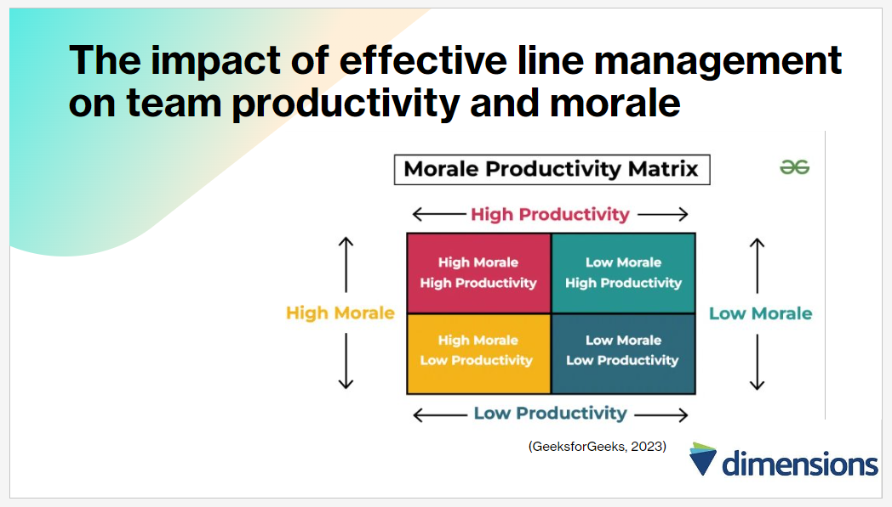
(5 mins)
- Highly effective teams achieve goals efficiently by leveraging co-operative collaboration among members, maximising productivity and financial success.
- Dedication to excellence and collaboration within high performing teams cultivates a positive workplace culture, enhancing employee engagement, satisfaction, and retention.
- Empowerment and autonomy in conducive environments drive high-performing teams to surpass expectations, fostering motivation and accountability for exceptional outcomes (CIPD, 2023; Chown, 2024).
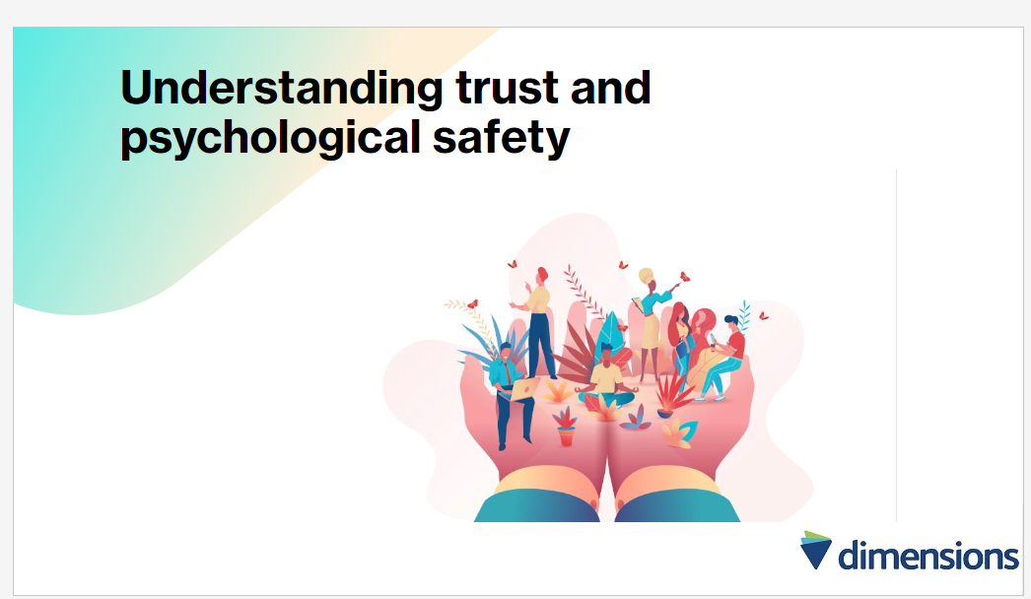
(10 min)
Understanding Trust
- When individuals from various groups collaborate on strategic endeavours, particularly if they haven't previously worked together, trust levels tend to be low initially (Hugander, 2022). Studies indicate that building interpersonal trust within organisations can be a time-consuming process (Hugander, 2022).
- However, teams cannot achieve peak productivity and effectiveness without a foundation of high levels of trust (Brownlee, 2019). Whilst this understanding may seem intuitive, there’s often a tendency in leadership circles to separate trust (often perceived as a warm and fuzzy concept) from concrete outcomes such as results and revenue, however it's important to recognise that trust and tangible results are deeply interconnected (Brownlee, 2019).
- Increased levels of trust among individuals and within groups have been linked to positive attitudes and performance outcomes, including the quality of decisions made by groups (Sapp et al., 2019)
- Building familiarity among team members is instrumental in cultivating trust, therefore, it’s unsurprising that research indicates high-quality team-building enhances team trust (CIPD, 2023). Conversely, one factor that can undermine team trust is the delivery of negative performance feedback (CIPD, 2023).

Psychological Safety
- Maslow’s renowned hierarchy suggests that humans require a certain level of needs to reach fulfilment and thrive (McKinsey & Company, 2023). Contemporary social scientists assert that psychological safety is among these fundamental needs, essential for individuals to perform optimally in various domains of life, including work (McKinsey & Company, 2023).
- Team psychological safety refers to a collective belief shared among team members that it is safe to take risks, voice ideas and concerns, ask questions, and acknowledge mistakes without facing adverse repercussions (Gallo, 2023).
- Line managers play a pivotal role in shaping a team’s psychological safety, with their actions setting the tone for whether team members feel secure (McKinsey & Company, 2023).
- McKinsey research identifies three leadership styles that can nurture psychological safety:
- Consultative leadership, where leaders seek input and considers team members’ views;
- Supportive leadership which shows care and support for individuals, fostering a positive team climate;
- Challenging leadership, which encourages team members to re-evaluate assumptions and strive for excellence, leading to increased creativity and motivation (McKinsey & Company, 2023).
- In addition, effective management practices can establish a psychologically safe environment including setting clear norms and expectations to create a sense of predictability and fairness, promoting open communication and actively listening to employees, ensuring team members feel supported, and demonstrating appreciation and humility when individuals speak up (Gallo, 2023).
- Lastly, psychological safety promotes better decision-making by encouraging diverse perspectives, and fosters continuous learning and improvement by enabling individuals to share and learn from mistakes (Gallo, 2023).

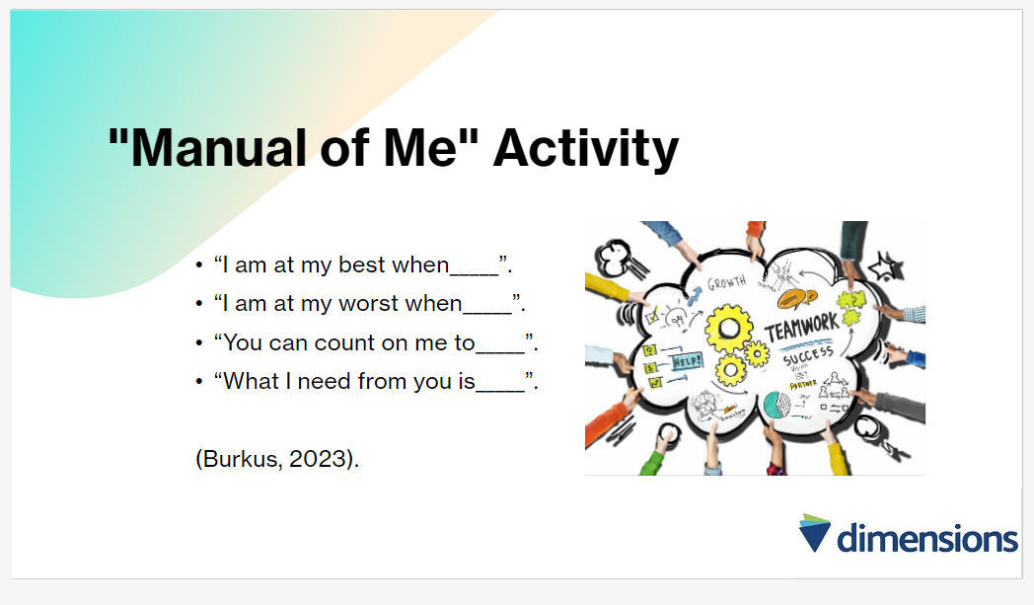
(15 mins)
Effective team building goes beyond mere understanding of team members; it requires insight into behaviours too (Burkus, 2024). Whilst personality tests are frequently enjoyed and are insightful team-building exercises (Jingfang, 2023), the “Manual of Me” activity stands out as a team building exercise, emphasising the sharing of individual work preferences rather than categorising team members (Burkus, 2024).
Encouraging self-awareness with the “Manual of Me” cultivates a personalised and supportive work atmosphere, allowing managers to adapt their leadership style to individual requirements (Chown, 2024). Whilst this will be carried out as a practical as a team, this template can be integrated into individual team building strategies to empower individuals to articulate their strengths, weaknesses and preferences, fostering a positive workplace and boosting team performance (Chown, 2024; Burkus, 2023).
NB: Participants to complete the activity followed by a group discussion on the benefits.
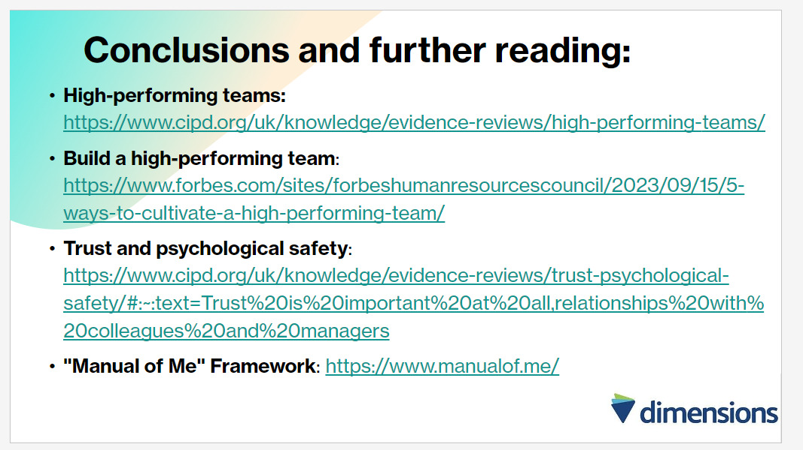
(5 mins)
In conclusion, this training session has highlighted the importance of effective line management in driving high performing teams. It has discussed how line managers can influence team dynamics, productivity, and morale, as well as the significance of trust and psychological safety in fostering a supportive work environment (CIPD, 2023; Chown 2024; Gallo, 2023). By implementing the strategies and practices covered in this session, line managers can be empowered to lead their teams effectively, maximise performance, and promote employee wellbeing. Prioritising effective line management practices to achieve organisational goals and continuing a culture of success (CIPD, 2023).

Session 2: Leading Effective Teams

Slide | Time (Minutes)
Welcome/Introduction/Ice Breaker | 20
Leadership styles | 5
Team Composition | 10
Measuring Team Effectiveness | 5
Coaching and Mentoring: The Basics | 5
Coaching at Dimensions | 10
Conclusions and Further Reading | 5

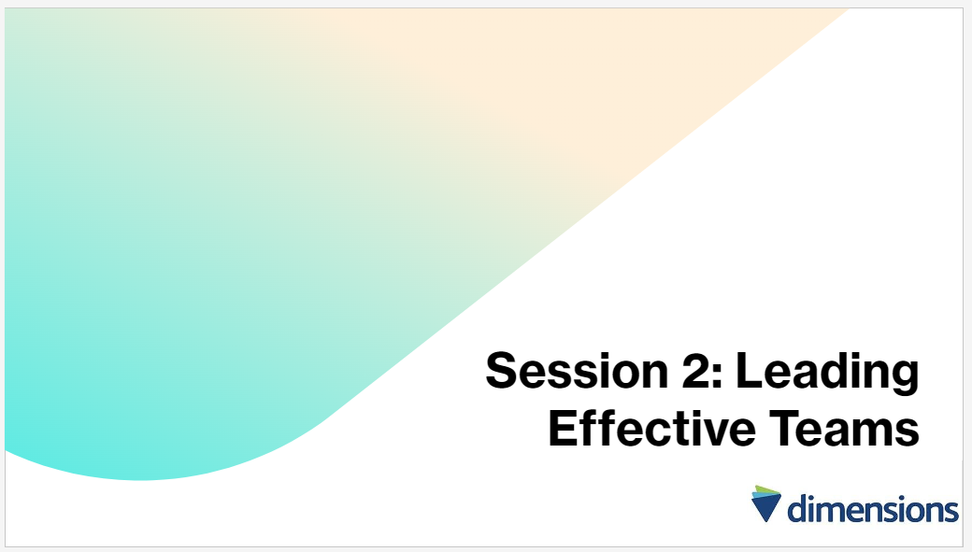

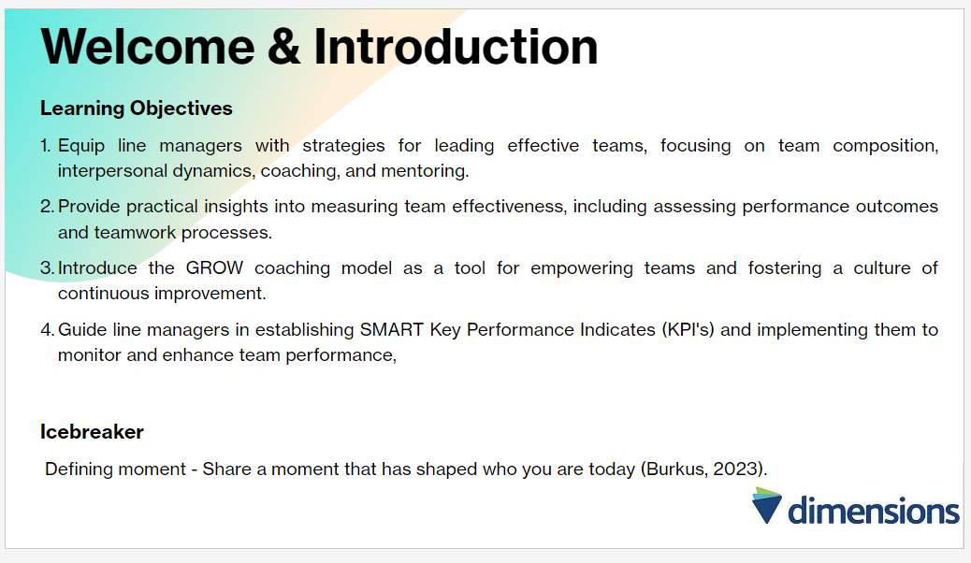
(20 mins)
This session will explore key factors influencing team effectiveness, including team composition, interpersonal dynamics, and measurement approaches (Cooke & Hilton, 2015; CIPD, 2023). It will delve into the significance of coaching and mentoring in fostering team development, utilising insights from recent research and practical models (Hayden, 2023). Through engaging discussions, the aim is to equip line managers with the knowledge and tools necessary to lead high-performing teams successfully.
NB: Ice Breaker - Encourage team members to disclose personally significant experiences to facilitate connections, allowing employees to reveal elements of their personality and beliefs which are not usually apparent professionally, with the view of enhancing mutual respect and understanding, and nurturing a more cohesive and effective team dynamic (Burkus, 2023).

Leadership styles
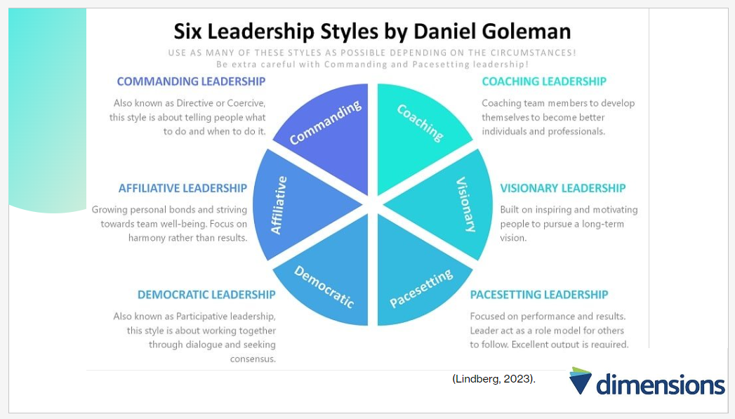
(5 mins)
Effective leadership involves using various styles to suit different situations, tasks, team members, and organisational contexts (Armstrong, 2021). Goleman identified six styles, each with its own contexts, however, it is important to note there is no universal ideal style; adaptability is key and leaders should communicate their approach clearly to avoid confusion as inconsistent or arbitrary styles changes can undermine leadership (Armstrong, 2021). Whilst good leaders demonstrate flexibility depending on their team members characteristics, it should be balanced with consistency to avoid confusion (Armstrong, 2021).
NB: Further reading on leadership styles can be found at the end of the session.

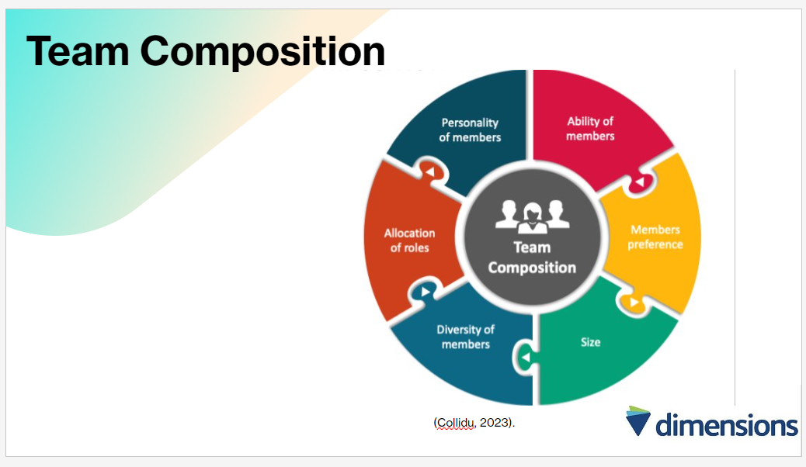
(10 mins)
Team composition entails selecting individuals with the appropriate expertise to achieve team goals and tasks while maximising overall effectiveness (Cooke & Hilton, 2015). Research suggests that whilst having the right skills and knowledge is important for team members, team composition in isolation has a limited impact on performance and must be balanced amongst other factors covered in the sessions (CIPD, 2023). Rather, team effectiveness is primarily influenced by management practices and team dynamics, with individual performance remaining crucial, underscoring the importance of talent selection and workforce diversity for organisational success (CIPD, 2023).
Discussions surrounding workplace diversity can be contentious, however, the data supports the value of diversity and inclusion, as companies committed to diversity consistently outperform those that are not (Carucci, 2024). Enhancing innovation, fostering inclusivity, retaining top talent, accelerating problem-solving, and boosting morale are just some of the benefits diversity brings to organisations (Carucci, 2024).
Meade (2021) recommends the following to navigate diverse workplaces effectively:
- Develop cultural competence: Acknowledge biases and commit to understanding diverse backgrounds.
- Practice active listening: Cultivate active listening skills to understand different perspectives.
- Ensure equity in retention and promotion: Promote true inclusion and hold leaders accountable for supporting diversity and equity.

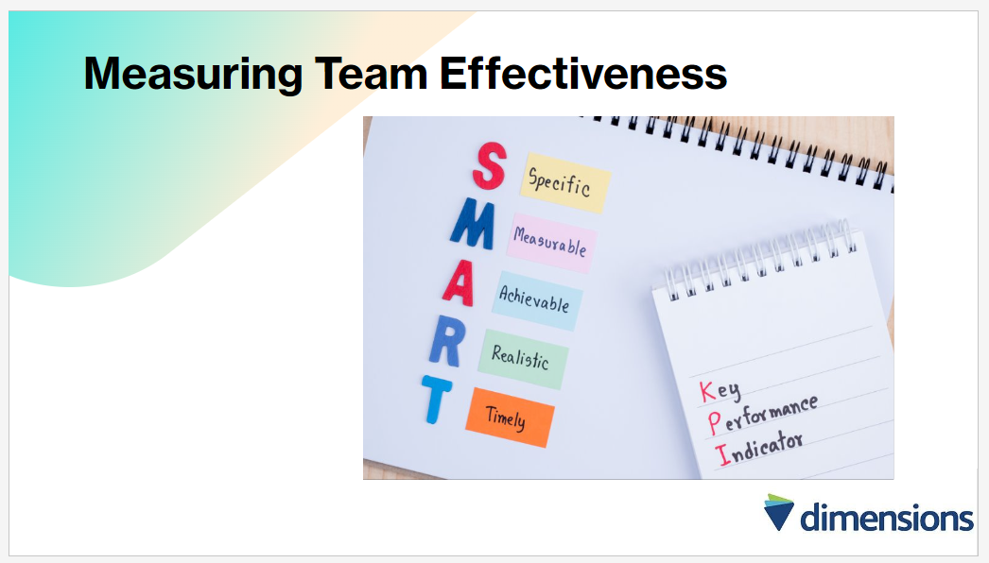(5mins)
Research provides substantial evidence on the effectiveness of measurable team level interventions in enhancing team performance, and measuring team effectiveness involves assessing various factors such as performance outcomes, teamwork processes, and individual contributions (Sales et al., 2008). According to Salas et al., (2008), a comprehensive approach to measuring team effectiveness includes evaluating team performance metrics, such as productivity, quality of output, and customer satisfaction, as well as considering team processes, such as communication, coordination, and cohesion. Additionally, Hackman and Wageman (2005) suggest assessing individual contributions within the team, such as role clarity, accountability, and task proficiency. Furthermore, Kozlowski and Ilgen (2006) emphasise the importance of evaluating team adaptation and learning, including the teams ability to innovate, problem-solve, and adapt to changing circumstances.
A specific measurement tool is Key Performance Indicators (KPIs); to ensure alignment with organisational goals and objectives, and facilitating focused efforts toward desired outcomes (Mind Tools, n.d). Mind Tools (n.d), continues that by quantifying performance metrics, teams can track progress and identify areas for improvement, ultimately enhancing productivity and efficiency. To maximise effectiveness, it’s crucial for line managers to:
- Establish SMART KPI’s
- Communicate KPI’s clearly
- Provide necessary support and resources for team members to achieve targets
Additionally, rewarding and recognising KPI achievement can further motivate teams to excel and drive organisational success (Mind Tools, n.d).
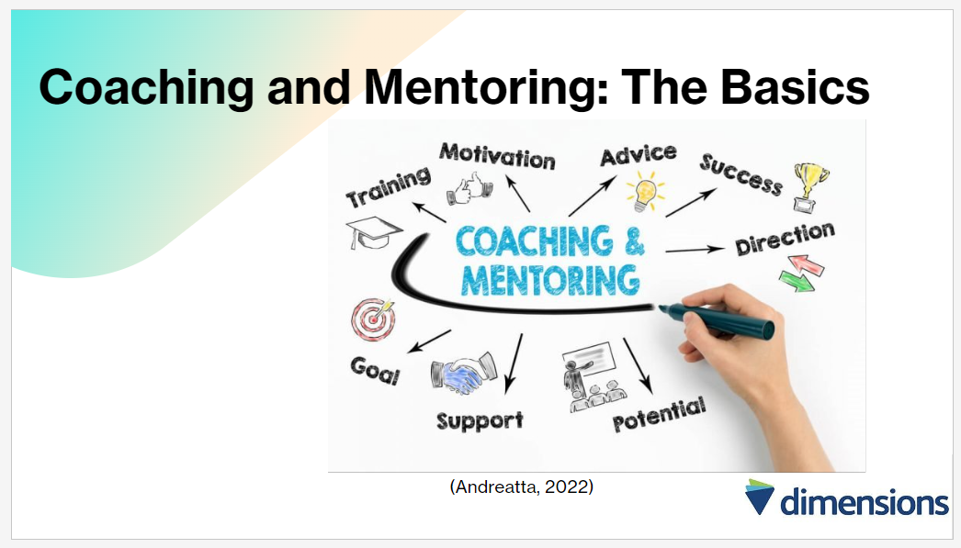
(5 mins)
What is mentoring?
Mentoring in the workplace involves an experienced professional sharing their knowledge and expertise with a less experienced individual to support their development (Hayden, 2023). Mentoring utilises specifically chosen and trained individuals to offer guidance, practical advice and ongoing support aimed at facilitating learning and development for the individuals assigned to them (Armstrong, 2012). Unlike coaching, mentoring relationships are typically long-term and involve mutual learning opportunities, moving beyond directive guidance to encourage joint sharing and learning (Hayden, 2023).
What is coaching?
Coaching in organisations is a developmental process aimed at enhancing performance and achieving specific goals, and is typically non-directive, focusing on improving work performance whilst considering personal attributes such as social interaction and confidence (Hayden, 2023). Coaching provides a personalised approach to skill and knowledge development, stemming from both formal and informal performance reviews, and daily work interactions (Armstrong, 2012). The practice involves both organisational and individual objectives, emphasising strengths and areas for development (Hayden, 2023).

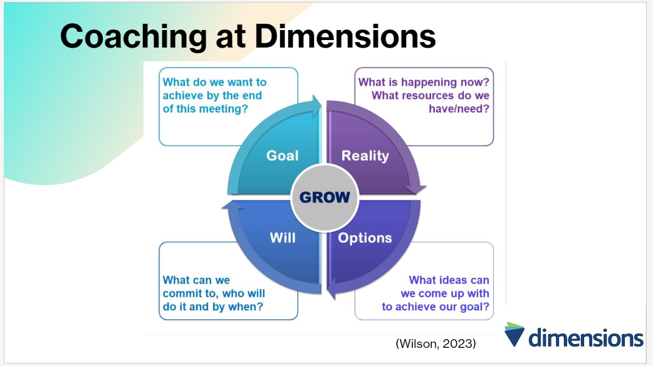
(10 mins)
A mentor shares personal experiences, which the mentee uses for development and learning, whereby coaching provides general advice derived from knowledge and training, focussing on skill development and identifying areas for improvement (Mundey, 2023). Due to the service requirements at Dimensions, employees are required to learn “on the job” via shadow shifts and peer learning (Dimensions, 2024). Therefore, at Dimensions, coaching, being more direct and objective-focussed, offers distinct benefits compared to mentoring, including:
- Offering specialised training and focussed sessions
- Rapidly improving skills and knowledge
- Enhancing employee engagement and loyalty
- Increasing employee retention
- Facilitating knowledge sharing (Munday, 2023).
Teaching coaching as a leadership and managerial skill can have transformative effects on an organisations and team performance, as coaching has evolved from its early days to become increasingly recognised for its value in driving business outcomes (Goldberg, 2023). Rather than solely relying on executive coaches, organisations are now adopting coaching as a leadership competency at all levels, fostering problem-solving, ideation, and initiative among employees, which leads to increased autonomy and contribution (Goldberg, 2023). Implementing a coaching culture can require overcoming challenges such as training time and expense (Goldberg, 2023). Equally, coaching within regular management practices can be easily introduced and involves:
- Raising awareness of individual performance levels e.g. asking questions to establish understanding
- Delegating responsibilities with oversight
- Using situational opportunities for learning
- Inspiring individuals to contemplate higher-level challenges and potential solutions (Armstrong, 2012).
Both cost and time investments pay off in enhanced effectiveness and retention throughout the organisation (Goldberg, 2023).
The GROW model of coaching, standing for Goal, Reality, Options, and Will/Way Forward, is a structured approach that helps individuals raise their awareness and take ownership of their actions and behaviours (Wilson, 2023).
- In the Goal stage, the coachee defines specific, positive outcomes
- Reality involves assessing the current situation
- Options encourage exploring various solutions
- Will/Way Forward focuses on selecting and implementing actions
The model emphasises asking open-ended questions tailored to each stage to guide the coaching process effectively (Wilson, 2023).
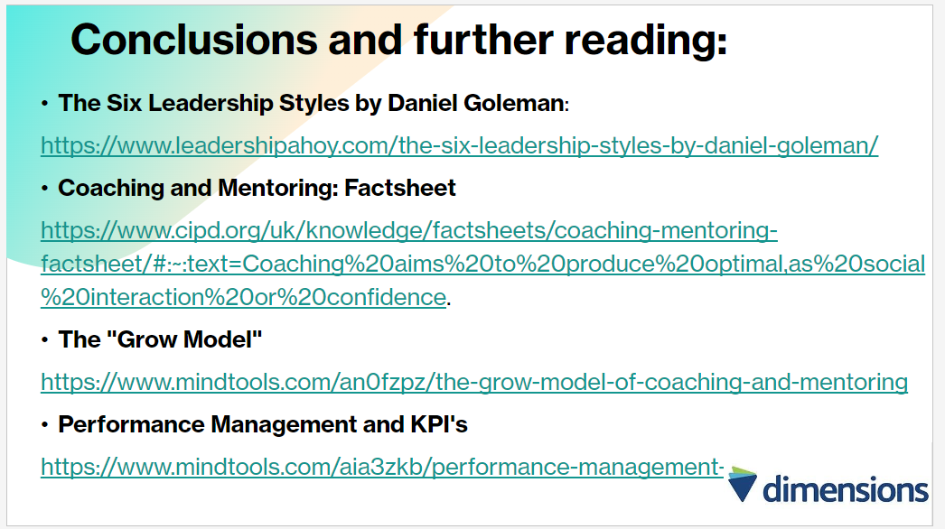
(5 mins)
This session has provided valuable insights into leading effective teams. It has discussed the importance of team composition, interpersonal dynamics, and measuring team effectiveness (Sales et al., 2008; Hackman & Wageman, 2005; Kozlowski & Ilgen, 2006). Additionally, the concepts of coaching and mentoring was explored and the role in driving team performance (Munday 2023; Goldberg, 2023). By leveraging evidence-based practices and practical frameworks like the GROW model (Goldberg, 2023), line managers can empower teams to achieve their full potential. Leaders must apply these principles to cultivate environments of trust, collaboration, and continuous improvement, ultimately driving organisational success.

Session 3: Employee Retention and Managing Capability

Slide | Time (Minutes)
Welcome/Introduction/Ice Breaker | 20
Strategies for Retaining Employees | 10
Managing Capability | 15
Coaching and Mentoring in Teams | 5
Conclusions and Further Reading | 10

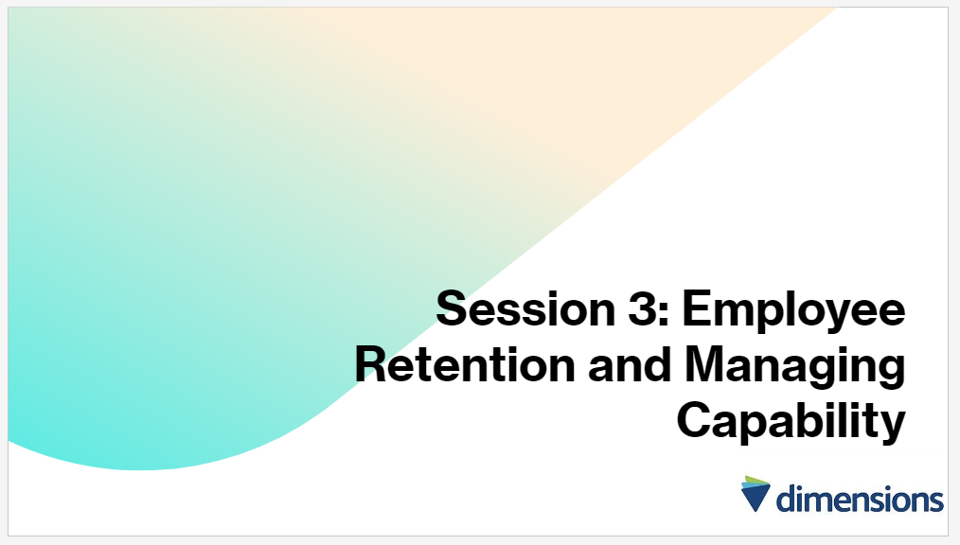

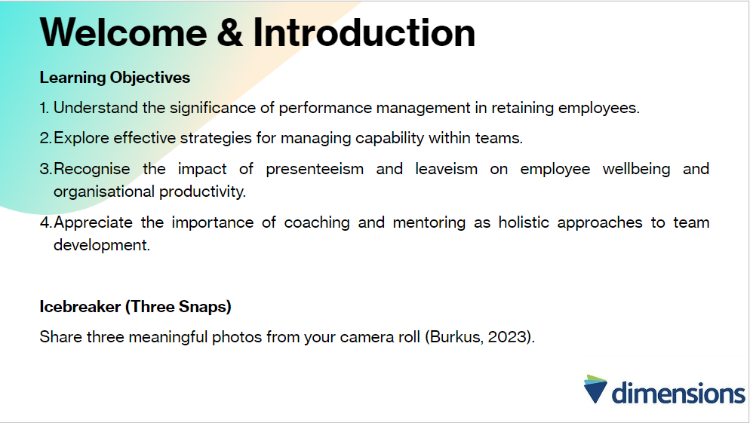
(20 mins)
In this session, essential strategies for retaining employees and effectively managing capability in teams will be explored. Through interactive discussions and insightful examples, the aim is to equip line managers with practical knowledge and tools to enhance employee retention, address performance issues, and foster a culture of continuous improvement within the organisation (Burkus, 2023; Plum, 2024; HRM Digest, 2017).
NB: Encouraging team members to share a glimpse into their personal lives can result in the discovery of commonalities and connections through shared experiences and interests, enhancing understanding and connection within the team and fostering a more collaborative environment (Burkus, 2023).

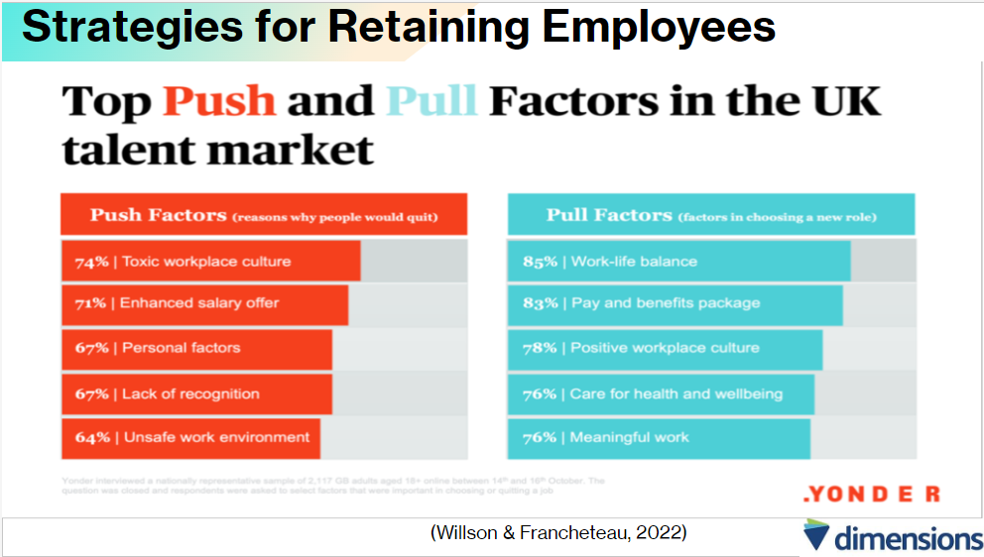
(10 mins)
Resignations can be influenced by a myriad of factors, with some individuals drawn to new opportunities or prospects outside their current employment (“pull” factors), while others feel compelled to seek alternatives due to dissatisfaction with their present job (“push” factors) (Peters, 2024). Peters (2024) continues that these “push” factors encompass a spectrum of issues, ranging from a lack of career advancement opportunities within their current organisation to significant changes within the company’s structure or culture. In certain instances, employees may find themselves motivated by a combination of both “pull” and “push” factors, promoting them to explore new avenues for their professional growth and fulfilment (Peters, 2024).
A recent review emphasises the significance of exit interviews in understanding turnover and identifying underlying reasons for dissatisfaction, highlighting the benefits of a well-planned exit interview process which involves establishing clear goals aligned with Dimensions objectives (HRM Digest, 2017). Additionally, the review presents a case study illustrating the effectiveness of exit interviews as a strategic tool in uncovering key factors influencing employee departures and providing actionable recommendations for improvement (HRM Digest, 2017).
Performance management serves as a vital mechanism for retaining employees by enabling organisations to monitor employee progress and accomplishments, identify issues promptly, offer feedback, and implement necessary enhancements (Plum, 2024). This process typically encompasses two primary types: goal-setting and rating/appraisal systems (Plum, 2024). Goal-setting systems entail establishing specific objectives for employees and monitoring their advancement, conversely, rating/appraisal systems involve evaluating employees and assigning ratings (Plum, 2024).
However, the traditional approach of annual reviews has faced growing scepticism in recent years, with many advocating for more frequent and ongoing conversations between managers and employees (Gifford, 2024). This shift aims to promote continuous feedback, agility and adaptation in response to evolving work dynamics and individual development needs (Gifford, 2024).

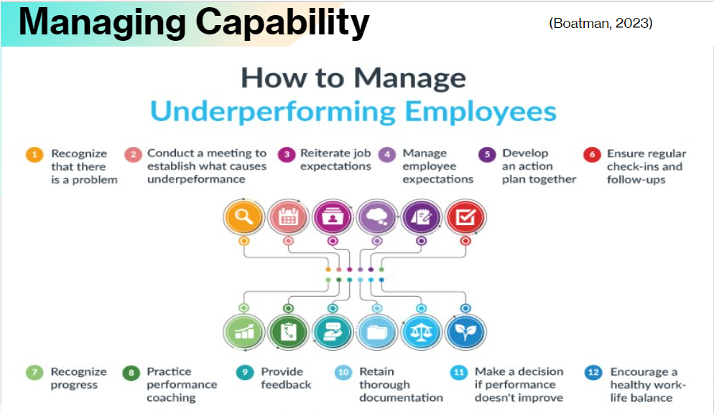
(15 mins)
In addition to supporting retention, performance management plays a pivotal role in fostering a high–performance culture within dimensions, by emphasising the message that achieving excellence is important (Armstrong & Taylor, 2017).
The management of underperforming staff i.e. performance capability is crucial for maintaining productivity and morale within a business, involving early identification of issues and proactive intervention in a supportive manner, balancing the need to address performance problems with fairness towards the individual (Horne, 2024).
To effectively manage underperformance, managers must:
- Establish clear targets and instructions from the outset to provide a framework for employees.
- Offer regular feedback and support to address issues early on and provide training if necessary.
- Keep records of performance indicators and discussions to maintain accountability.
- Follow internal policies and procedures consistently to ensure fairness and guard against claims of unfair treatment (Horne, 2024).
In essence, high-performance working resolves around enhancing performance through people, where high performance becomes ingrained as a fundamental aspect of organisational culture (Armstrong & Taylor, 2017).
The need to manage capability performance may also arise from ill-health or incapacity (Morris, 2021). Despite the surge in remote working brought about by the COVID-19 pandemic, a notable percentage of employers have reported instances of presenteeism and leaveism among their employees, both in remote and in-person work settings, with 77% observing presenteeism and 70% noting leaveism (Suff, 2021).
Whilst some organisations have taken steps to address these issues, a significant number have not, indicating the persistence of an ‘always on’ culture and blurred boundaries between work and personal life, underscoring the pivotal role of managers is supporting employee health and wellbeing by effectively managing workloads, setting clear expectations, and promoting healthy working practices (Suff, 2021).
Encouraging a supportive attendance culture, where genuine illness is accommodated while addressing non-genuine absences, is essential to maintaining accountability (Ayling and Suff, 2024). Line managers hold a crucial responsibility in overseeing absences, fostering an environment where employees feel comfortable addressing concerns early on, allowing for timely support interventions before situations worsen (Ayling and Suff, 2024).
A CIPD survey findings reveal widespread concern about the impact since COVID-19 of ongoing mental health issues, prompting line managers to implement measures such as increased focus on mental health and flexible working to support their employees (Suff, 2021).

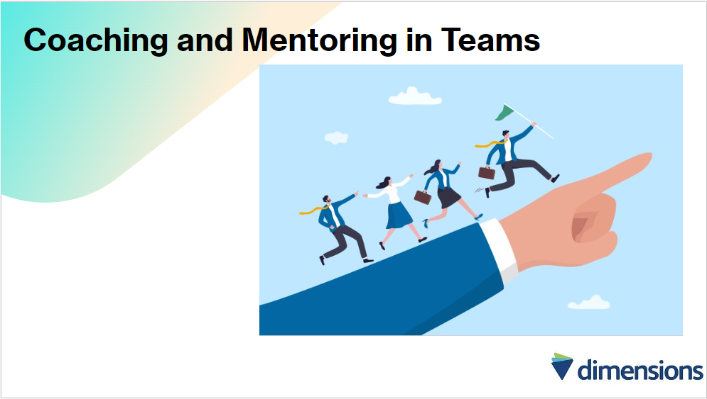
(5 mins)
Coaching and mentoring should not only focus on individual development but also aim to enhance team performance, ultimately contributing to the organisations strategic objectives and long-term success, however, unfortunately these practices are often viewed as quick fixes for individual problems rather than holistic approaches to improving overall performance management (Parsloe & Leedham, 2017).
Effective coaching and mentoring should be aligned with organisational strategy and designed to develop skills, behaviours, and mind-sets that support the organisations future resilience and growth (Parsloe & Leedham, 2017).
Ultimately, the goal is to build team capabilities and foster a culture of continuous learning and adaptation, ensuring the organisation remains agile and responsive in an ever-changing business landscape (Parsloe & Leedham, 2017).
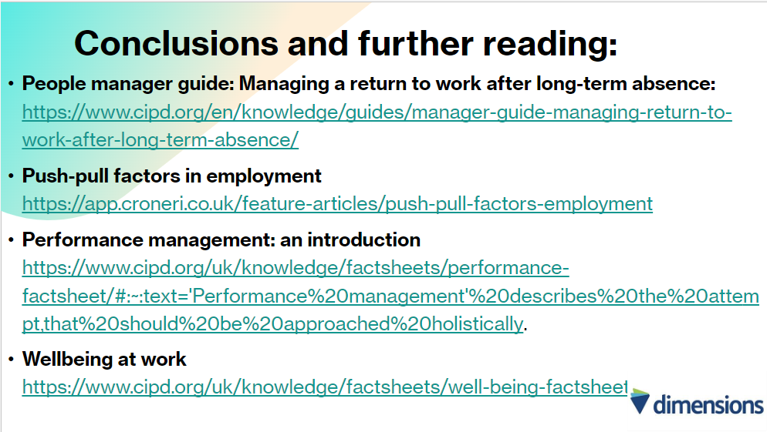
(10 mins)
This session has underscored the importance of proactive strategies for retaining employees and managing capability effectively. By implementing performance management practices, conducting meaningful exit interviews, and addressing presenteeism and leaveism, Dimensions can mitigate turnover and promote employee wellbeing (Snuff, 2021; Horne, 2024). Furthermore, embracing coaching and mentoring as holistic approaches to team development can foster resilience and drive organisational success (Parsloe & Leedham, 2017). By prioritising these strategies, Dimensions can cultivate a supportive and high-performing workplace culture conducive to long-term growth and success.

References
Andreatta, B. (2022) How to Use Coaching and Mentoring to Upskill Your Employees, Training. Available at: https://trainingmag.com/how-to-use-coaching-and-mentoring-to-upskill-your-employees/ (Accessed: 02 May 2024).
Morris, A. (2021) Capability Procedure for HR & Managers, DavidsonMorris. Available at: https://www.davidsonmorris.com/capability-procedure/ (Accessed: 03 May 2024).
Armstrong, M. (2012) Armstrong’s Handbook of Management and Leadership. 3rd edn. London: Kogan Page.
Ayling, L. and Suff, R. (2024) Absence Measurement and Management: Factsheets, CIPD. Available at: https://www.cipd.org/en/knowledge/factsheets/absence-factsheet/ (Accessed: 30 April 2024).
Boatman, A. (2023) 12 Actionable Tips for Managing Underperforming Employees, AIHR. Available at: https://www.aihr.com/blog/managing-underperforming-employees/ (Accessed: 03 May 2024).
Brownlee, D. (2019) 5 Reasons Why Trust Matters on Teams, Forbes. Available at: https://www.forbes.com/sites/danabrownlee/2019/10/20/5-reasons-why-trust-matters-on-teams/ (Accessed: 27 April 2024).
Burkus, D. (2023) Best Icebreakers for Team Meetings, LinkedIn. Available at: https://www.linkedin.com/pulse/best-icebreakers-team-meetings-dr-david-burkus-uci1e/ (Accessed: 25 April 2024).
Burkus, D. (2024) Why The ‘Manual of me’ is the Single Best Team Building Activity, David Burkus. Available at: https://davidburkus.com/2023/10/manual-of-me/#:~:text=They%20need%20to%20understand%20each,share%20their%20different%20work%20preferences. (Accessed: 27 April 2024).
Carucci, R. (2024) One more time: Why diversity leads to better team performance, Forbes. Available at: https://www.forbes.com/sites/roncarucci/2024/01/24/one-more-time-why-diversity-leads-to-better-team-performance/ (Accessed: 27 April 2024).
Chown, K. (2024) How to build a high-performing team, Institute of Directors. Available at: https://www.iod.com/resources/employment-and-skills/how-to-build-a-high-performing-team/ (Accessed: 25 April 2024).
CIPD (2023) High-Performing Teams: An Evidence Review, CIPD. Available at: https://www.cipd.org/uk/knowledge/evidence-reviews/high-performing-teams/ (Accessed: 25 April 2024).
Collidu (2023) Team composition, Collidu. Available at: https://www.collidu.com/presentation-team-composition (Accessed: 02 May 2024).
Cook, S. (2009) Coaching for High Performance How to Develop Exceptional Results Through Coaching. Cambridgeshire: IT Governance Publishing.
Cooke, N.J. and Hilton, M.L. (eds.) (2015) ‘Enhancing the Effectiveness of Team Science’, National Research Council [Preprint]. doi:10.17226/19007.

Dimensions (2024) Training for Social Care Careers, Dimensions. Available at: https://www.dimensionscareers.co.uk/basic-training (Accessed: 10 March 2024).

Goldberg, B. (2023) ‘Creating a Coaching Culture’, Arkansas Business, 40(36). Available at: https://www.proquest.com/docview/2862814956?accountid=130472&parentSessionId=ZxHickeSvayc1w6RcI%2BV3jh6AFJEoPvBNjvAnYeqmpI%3D&pq-origsite=primo&sourcetype=Trade%20Journals (Accessed: 27 April 2024).
Hackman, J.R. and Wageman, R. (2005) ‘A Theory of Team Coaching’, Academy of Management Review, 30(2), pp. 269–287. doi:10.5465/amr.2005.16387885.
Hayden, D. (2023) Coaching and Mentoring: Factsheets, CIPD. Available at: https://www.cipd.org/uk/knowledge/factsheets/coaching-mentoring-factsheet/#creating-a-coaching-culture (Accessed: 27 April 2024).
HRM Digest (2017) ‘Why Did They Leave?’, Human Resource Management International Digest, 25(5), pp. 21–24. doi:10.1108/hrmid-05-2017-0085.
Horne, A. (2024) The DOS and Don’ts of Managing Underperforming Staff, Home. Available at: https://www.peoplemanagement.co.uk/article/1864223/dos-donts-managing-underperforming-staff (Accessed: 28 April 2024).
Hugander, P. (2022) When trust takes away from effective collaboration, Harvard Business Review. Available at: https://hbr.org/2022/05/when-trust-takes-away-from-effective-collaboration (Accessed: 27 April 2024).
Jingfang, L. (2023) 7 Workplace Personality Tests That Can Help Improve Your Team, LinkedIn. Available at: https://www.linkedin.com/business/talent/blog/learning-and-development/workplace-personality-tests-that-can-improve-your-team (Accessed: 27 April 2024).
Kirkpatrick, D.L. and Kirkpatrick, J.D. (2016) Evaluating Training Programs. Oakland, CA: Berrett-Koehler.
Kozlowski, S.W.J. and Ilgen, D.R. (2006) ‘Enhancing the Effectiveness of Work Groups and Teams’, Psychological Science in the Public Interest, 7(3), pp. 77–124. doi:10.1111/j.1529-1006.2006.00030.x.
Lindberg, C. (2023) The Six Leadership Styles by Daniel Goleman, Leadership Ahoy! Available at: https://www.leadershipahoy.com/the-six-leadership-styles-by-daniel-goleman/ (Accessed: 01 May 2024).
Meade, J. (2021) Are You Prepared to Lead a Diverse Team?, Harvard Business Review. Available at: https://hbr.org/2021/12/are-you-prepared-to-lead-a-diverse-team (Accessed: 27 April 2024).
McKinsey & Company (2023) What is Psychological Safety?, McKinsey & Company. Available at: https://www.mckinsey.com/featured-insights/mckinsey-explainers/what-is-psychological-safety (Accessed: 27 April 2024).
Mind Tools (no date) Kirkpatrick’s Model, MindTools. Available at: https://www.mindtools.com/ak1yhhs/kirkpatricks-four-level-training-evaluation-model (Accessed: 03 May 2024).
Mind Tools (no date) Performance Management and KPIs, MindTools. Available at: https://www.mindtools.com/aia3zkb/performance-management-and-kpis (Accessed: 29 April 2024).
Mundey, M. (2023) Mentoring vs Coaching: The Key Differences and Benefits, Think Learning. Available at: https://www.think-learning.com/employee-engagement/mentoring-vs-coaching/#:~:text=A%20coach%20shares%20much%20more,to%20develop%20and%20learn%20from. (Accessed: 27 April 2024).
Parsloe, E. and Leedham, M. (2017) Coaching and Mentoring: Practical Techniques for Developing Learning and Performance. 3rd edn. Edited by D. Newell. London: KoganPage.
Peters, R. (2024) Employee Turnover and Retention: Factsheets, CIPD. Available at: https://www.cipd.org/uk/knowledge/factsheets/turnover-retention-factsheet/#:~:text=Sometimes%20it’s%20the%20attraction%20of,dissatisfied%20in%20their%20present%20job. (Accessed: 28 April 2024).
Plum (2024) How effective is performance management in retaining employees?, Plum. Available at: https://www.plumhq.com/blog/how-effective-is-performance-management-in-retaining-employees#:~:text=Performance%20management%20is%20an%20essential,setting%20and%20rating%2Fappraisal%20systems. (Accessed: 28 April 2024).
Salas, E. et al. (2008) ‘Does Team Training Improve Team Performance? A meta-analysis’, Human Factors: The Journal of the Human Factors and Ergonomics Society, 50(6), pp. 903–933. doi:10.1518/001872008x375009.
Sapp, J.E. et al. (2019) Trust in Group Decisions: A Scoping Review, National Library of Medicine. Available at: https://www.ncbi.nlm.nih.gov/pmc/articles/PMC6693175/ (Accessed: 27 April 2024).
Suff, R. (2021) Employers Urged to Address High Levels of People Working When Unwell, CIPD. Available at: https://www.cipd.org/uk/about/news/employers-urged-address-high-levels-presenteeism/ (Accessed: 28 April 2024).
Thinking Focus (2020) Is coaching all that?, Medium. Available at: https://thinkingfocus.medium.com/is-coaching-all-that-df37301db8aa (Accessed: 02 May 2024).
Wilson, C. (2023) The Grow Model, Culture at Work. Available at: https://www.coachingcultureatwork.com/the-grow-model/ (Accessed: 01 May 2024).

Appendix (i)
Training Evaluation Form

Date:

Trainer:

Please indicate your level of agreement or disagreement with the following statements:

 | Strongly Disagree | Somewhat Disagree | Neither Agree nor Disagree | Somewhat Agree | Strongly Agree
I was satisfied with the course overall. | 1 | 2 | 3 | 4 | 5
This course enhanced my knowledge of the subject matter. | 1 | 2 | 3 | 4 | 5
The course was relevant to what I might be expected to do to (prevent, prepare for, or respond to) an emergency. | 1 | 2 | 3 | 4 | 5
This course provided content that is relevant to my daily job. | 1 | 2 | 3 | 4 | 5
I would recommend this course to others. | 1 | 2 | 3 | 4 | 5
(Mind Tools, n.d).

