Katarzyna Kolowrocka (1805961)
27.03.2020
‘A critical perspective of Asda in relation to its CRM, Ethics, Sustainability and Quality Systems’


Understanding and engaging in the customer experience
BMSW5103

Executive Summary

The objective of this report is an analytical insight into ASDA and other British supermarkets and their best practice with regard to customers satisfaction, loyalty and retention.
This report is divided into sections. Each section commences with an explanation of the concepts, models and theories followed by examples of British supermarkets strategies and procedures. An overview of the UK’s retail market, including a brief background of three selected supermarkets, is an introduction to this paper. The main body commences with a brief description of the costumer’s experience in British supermarkets. Next section provides insights into effective Customer Relationship Management (CRM) undertaken by Asda and other retailing companies. This section provides a deeper understanding of the segmentation, targeting and positioning concepts. The third section of this report critically analysing practices undertaken by retailers based on their ethics, socially responsible behaviour and sustainability policies. The report contains a discussion of the changes that Asda has implemented to overcome ethical issues and gain customers’ trust back. The report also contains an aspect of quality. A final section concludes the report with a summary and recommendations on the changes that Asda should implement to sustain third position in the marketplace.

Table of Contents
Executive Summary 1
1.0 Introduction 3
1.1 An overview of the major British supermarkets. 3
1.1.1 Asda 3
1.1.2 Tesco 4
1.1.3 Whole Foods 4
1.2 Importance of customers engagement and shopping experience. 4
2.0 Main Findings 4
2.1 Customer Relationship Management (CRM) 4
2.2 Ethics and Sustainability 8
2.2.1 Ethics 9
2.2.2 Sustainability 12
2.3 Quality system 14
3.0 Conclusion 16
4.0 Recommendations 17
5.0 Appendix 21
6.0 References: 22

1.0 Introduction

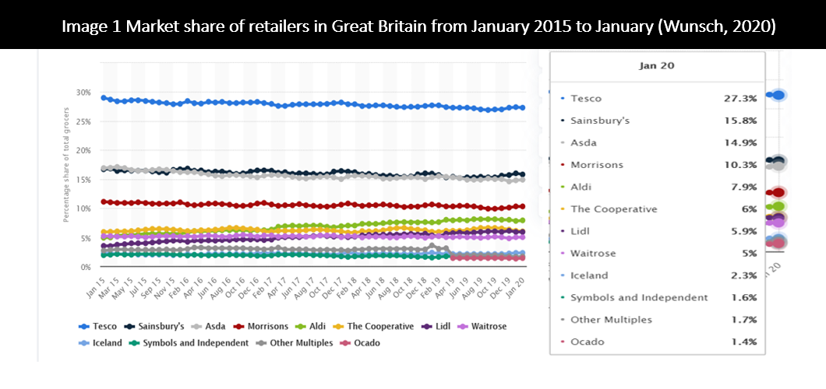
1.1 An overview of the major British supermarkets.

The UK supermarket sector is highly concentrated. The leading retailers together have 73% of the total market Wunsch (2020). Sainsbury's was a market leader until 1996, but the number one position was taken by Tesco with over 27% market share of the UK market.
Image 1, published by Nils-Gerrit Wunsch (2020), illustrates statistics of the market share of UK’s retailers from January 2015 to January 2020. Tesco and Sainsbury's have the largest share over the period.
The paragraphs below focus on the three British supermarkets: Tesco, Asda and Whole Foods describing their customers' relationship management, ethics, sustainability and quality approaches and how these approaches impact on customers experience.

1.1.1 Asda

Asda, the third-largest grocery in the UK (Bentham, 2018), owned by the American Walmart Company, was overtaken by Sainsbury’s, after disappointing sales. Wunsch’s statistics (2020) places ASDA’s market share at 14.9%.
‘Saving you money every day’ it is Asda’s core purpose (Alberto, 2020). Asda strives to make customers’ lives better by offering a wide range of products and services at reasonable prices. Asda is a multi-award-winning supermarket.

1.1.2 Tesco

Tesco is an international long-established retailer. The company was founded by Jack Cohen in 1919, whose mission was to ‘put affordable food in the reach of everybody’ (Clark and Chan, 2014). Tesco has maintained a number one position in the UK’s market through a well-targeted product range and innovation.

1.1.3 Whole Foods

Whole Foods (Cheretis and Mujtaba, 2014) has dominated the market of retailing highest quality organic products since 1980 and prides itself on promoting healthy living.

1.2 Importance of customers engagement and shopping experience.

Megicks et al (2012) proved that shopping experience is a functional activity, that has emotional and entertaining importance. According to Pearson et al (2011) customers search not only for best quality products and services but also for the best shopping experience. Whole foods (Cuenllas, 2013) differentiate the consumer's experience from competitors through a welcoming atmosphere, attractive displays, frequent food sampling, and available pleasant help.

2.0 Main Findings

2.1 Customer Relationship Management (CRM)

The highly competitive retail environment, where customer loyalty is shrinking and behaviour is changing (Chartered Institute of Management Accountants, 2017), resulted in supermarkets emphasis on customer’s needs. Today’s customers demand value and quality of products and services, (Buttle and Maklan, 2019), therefore today's retailer emphasis on building a strong relationship with customers.
According to Schneider (2019), there are several models for customer relationship management:
- IDIC Model
- QCI Model
- CRM Value Chain Model
The IDIC model (Peppers and Rogers, 2004), one of the most common CRM models, has been described in this report.
The first stage of this model is to Identify Customers (Schneider, 2019). Retailers accomplish this step by collecting as much data about customers as possible, to better understand their needs, expectations and behaviour (Siddiqi, et al, 2006).
EXAMPLE
Tesco (Keogh, 2016), collects information about customers through many touchpoints:
- Questionnaires, Feedbacks and customer complaints,
- Club Card shame,
- Home deliveries.
Tesco Clubcard (Keogh, 2016), allows identifying potential buyers and their needs.
Handley (2013) noted, that Asda does not have a data capture loyalty scheme like Tesco’s Clubcard. Asda’s Marketing Chief stated that not having a loyalty scheme is not a weakness. Asda collects data from other sources such as:
- Asda Price Guarantee,
- Online orders
- Click and collect.
Asda attracts customers on ‘Lower Prices Everyday’ strategy. Asda focuses on serving customers as fast and as convenient as possible. Collecting data comes second.

The second stage of this model is to Differentiate Customers (Schneider, 2019).
Organisations need to identify the most profitable segments, based on:
- Customers value to the organisation,
- Customers need from the organisation.
The retailer can prioritise efforts on the most profitable clients, through differentiate buyers according to their value (Schneider, 2019).
EXAMPLE
Kheogh (2016) noted, that EE uses data software to monitor segments and adapts its services and prices to valued customers. Most important consumers are recognised by call-centres and priority in the queuing system are provided. Contrary approach to the valuable customers can be seen in supermarkets, where separate tills are offered for clients with small baskets, allowing them to move quicker through the checkouts, than the buyers with loaded trolleys.
Asda (2020) customers are price sensitive and with its ‘SMART PRICE’ slogan attracts segments: good values for money, targeting benefit seekers, family focused. The business segmentation strategy helped Asda through recession years, however as economic conditions have improved, costumers increased their expectations. Today retailers strive to attract clients from the upper socio-economic profile (Rodrigo, 2014), by offering better quality and organic products and extraordinary shopping experience. Previously mentioned before Whole Foods is the most successful to meet customers’ expectations from that segment. Whole Foods (Cheretis, Mujtaba, 2014) attracts a healthier living society, quality, organic food and eco- friendly seekers.

To differentiate consumers in profitable ways based on their needs (Schneider, 2019), require knowledge about individual demands.
EXAMPLE
High health consciousness trends resulted that retailers aim to attract shoppers with “green” values. Asda, similar to Tesco and Whole Foods, emphasises on “eco-friendly seekers” customers with its “Organics”, “Good for You”, and “Asda Extra Special” brands label.
According to research (Peppers and Rogers, 2004), once customers are identified and categorised, the next step of this model is to develop interactions. The company adapts interactions to fit each segment for maximising profit.
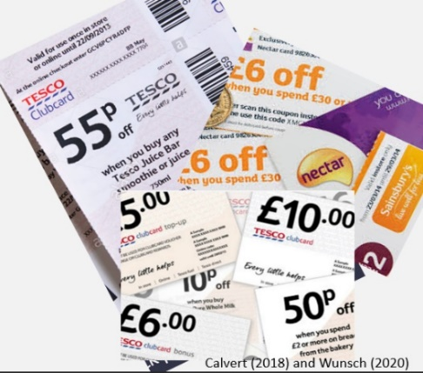
EXAMPLE
Tesco using Clubcard, as an interaction tool with customers. This data collection system (Lopez, et al, 2018) can be adjusted to individuals buying behaviour. Tesco and Sainsbury’s based on customers shopping history sending coupons on products or other vouchers to encourage customers to continued spending.
Image 2 Tesco and Sainsbury’s vouchers (Calvert, 2018 and Wunsch, 2020)
The last stage of the IDIC model is Customise (Peppers and Rogers, 2004), where organisations must customise products, offers and interactions, to best fit each segment for profitability, considering customers’ needs and values.
EXAMPLE
Customers have different needs (Clark and Chan, 2014), so Tesco adapts stores, services and products to provide more customised one-to-one service: from Value to Finest and from Express to Extra. For health-conscious customers, Tesco introduced better labelling system, diet guides, and organic ranges. For price-sensitive company have the “Step Change” programme and “Everyday Low Pricing”. A Tesco’s project “Every Little Helps” uses a questioner form. Retailer, based on the customer's feedback (complaints), can better understand buyers needs and can improve products and services. Customise this research has resulted in extra staff on checkouts, to reduce waiting times for customers in a hurry.
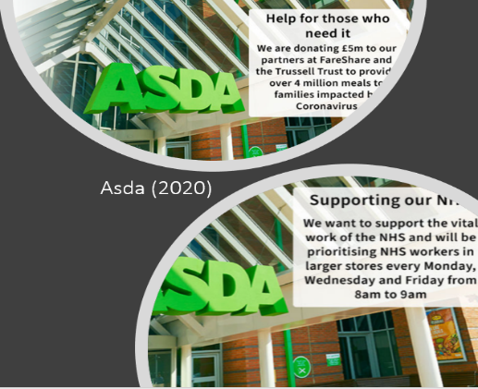
In this uncertain time of Coronavirus, majority of the supermarkets try to adapt to a new situation, not forgetting about elderly customers and NHS workers. Customising service procedures, ordering more stock of essential items, selecting time slots for vulnerable and NHS employees, closing counters with fresh meat to have extra staff to stock up shelves is the right thing to do during this pandemic. Sainsbury’s CEO communicated changes in procedures with customers via mail (Appendix 1). Asda (2020) communicate its support actions via website (Image 3). Supermarkets interact with customers to show their compassion and support.
Image 3 Example of Asda’s (2020) customer relationship management in pandemic times.

2.2 Ethics and Sustainability
According to Cheretis and Mujtaba (2014), ethical and sustainable behaviour encourage clients to buy products and helps build customers' loyalty to the business.

2.2.1 Ethics

Ethical Behaviour Elements (Browne et al, 2002):
- Fairtrade and competition,
- Social responsibility,
- Employees rights,
- Sustainable and environmentally safe natural resource management. (this topic will be described in section 2.2.2)

Regarding Fair Trade and Fair Competition
Asda has been involved in the price-fixing scandal estimated to have cost costumers £270m. The company has been fined more than £116m, after admitting that they fixed the price of dairy products (The Guardian, 2008).
Since stakeholders started to care about the environment, organic products, and suppliers’ human rights (Keogh, 2016), Asda strive to improve its image as a Fair Trader, through the Corporate Social Responsibility (CSR) and its sustainability reports.
Asda is changing towards Fairtrade products to ensure that suppliers are being fairly paid (Keogh, 2016). Asda also emphasises that fundamental principles and human rights are implemented by suppliers through its ethical code.
The company is determined to be a price leader on the market, to achieve this Asda disengaged with ethical behaviour on many occasions. (Keogh, 2016) The retailer has been involved in the price war with other supermarkets and has been accused of unfair competition practices in the past.
Another supermarket with Fair Competition issues is Whole Food. Despite the company operating in alignment with ethical standards when it comes to rivals Whole Foods strategy shows conflict with their organisational values (Cheretis, Mujtaba, 2014). Retailer buying out the competition, which drives a monopoly in the market. This tactic not only could be punished by the Federal Trade Commission but also brand reputation could be damaged. Whole Foods should concentrate on differentiating itself from the rivals, rather than continuing unethical processes which are against Fair Competition standards.
Regarding Social Responsibility
Asda is trying to improve its image and Corporate Social Responsibility through community involvement (Keogh, 2016). The retailer demonstrates activity in local charities (the Tickled Pink charity, BBC Children in Need, Orchid and Tommy’s charities). Asda supports the Change4Life campaign to promote healthier lifestyles, with a recipe section on its website educating customers on how to make meals healthier, especially with its Sugar Swaps Campaign (Keogh, 2016).
Paying taxes is a fundamental way in which organisations engage with society. Christensen and Murphy (2004), noted that Tax revenues are essential for physical infrastructure, which builds the market economy (Hutton, 2002). Asda’s engagement with society has been questioned, since 2012 company and US parent Walmart (Goldfingle, 2012), have been accused of a series of tax avoidances strategies such as transfer-pricing, re-invoicing, dubious charities activities. Asda comes under inspection over tax avoidance, after it was revealed that payments to Walmart, which reduced its UK tax bill by £250m. According to a study by Labour Heartlands (2019), Walmart hid $76bn of assets in tax havens across the world.
Asda’s aggressive tax-avoidance strategies are not aligned with Corporate Social Responsibility (CSR), which Asda trying to communicate to the broader society and potential customers.
Regarding employment and employees’ rights
Asda demand from its supplier chain (Keogh, 2016), to align with their ethical policies. Asda inspecting, if employees’ rights are protected, and hygienic working conditions are maintained. Asda does not tolerate child labour (Keogh, 2016) nor is inhumane treatment allowed. Asda ensures no discrimination is practised in any supply chain.
Paradoxically Asda has been involved in many scandals regarding unethical behaviours (Keogh, 2016). The company faced several accusations of employee discrimination and slavery cases in the Walmart prawn supply chain.

Asda faced legal action over equal pay for women (Ethical Consumer, 2020). Lawyers acting on behalf of 15,000 current and past employees against the company.
Asda has been also criticised for the treatment of employees in factories in Asia, supplying ‘George’ (Asda’s clothing brand). ActionAid (2012) investigations proved low wages, excessive hours and employees’ harassment. Asda responded to this criticism implementing Lean manufacturing model, which will be described in 2.3 section. Unfortunately, according to ActionAid (2012), Asda’s real motivations for lean production in Asian factories was maximising profit rather than focus on employees’ rights or healthier work conditions. Contrary to Asda, Whole Foods understands the importance of ethical behaviour. The retailer maximises the quality of living for people, rather than gaining profits that would only benefit a small group of stakeholders. The famous dictum of Milton Fridman (1970) states, ‘The only responsibility of business is to maximise a profit’ (Mühlbacher and Böbel, 2019). Companies that focus on profits and compete for a competitive advantage based on price and unethical actions, same as Asda, will not retain customers in the long term. Whole Foods educates customers to improve their health and standard of living with organic foods. For Example, removing products that threaten their ethical perception could reduce profits. Whole Foods dropped sea bass from sales as has been overfished (Cheretis and Mujtaba, 2014). Whole Foods ethical strategy could result in a short-term loss of profits. Rewarding employees with above-average salaries, supplying customers with quality, contributing to numerous charitable actions costs the company a generous amount of money that Asda are not willing to pay.

2.2.2 Sustainability

Reports published by the independent Food Ethics Council state that major food retailers applied sustainability strategies and have implemented many initiatives (Chartered Institute of Management Accountants, 2014). Ethics and sustainability (Prickett, 2010), are connected to the triple bottom line theory, that organisations should focus on social and environmental concerns the same as they focus on maximising profits. This model consists of three elements: economic, social, environmental. Table 1 introduced examples of supermarkets commitment to sustainability according to the triple bottom line theory.

Table 1. The triple bottom line model based on supermarkets examples.
Retailer & Action | Environmental | Social | Economic
ASDA  Pollution prevention  Vehicle initiatives  double deck lorries to increase capacity and lower journeys number  Transport initiatives – rail networks usage (Keogh, 2016)  E-shopping initiatives  fewer individual cars on the roads, (Parry et al, 2018), | Minimising harmful emissions from stores, depots and transport (Tidy et al, 2016), improve air and environment | Changing on transportation methods reduced congestion on the roads (Parry et al, 2018).  Lowering emission of harmful substances to the air reduces the risk of chronic health problems, heart and long dresses (Laumbach, et al 2015).  Home delivers are convenient for busy customers | Reduction of transportation distance and number of trips led to significant savings (Prickett, 2010)  Enhance or reduce the cost-efficiency of transport which includes, e.g., adequate vehicles, capacity utilization  Reduce the use of road infrastructure (e.g., trains versus trucks).  Seve customers time and petrol money
WHOLE FOODS  Create a win-win relationship with local suppliers | By using local suppliers the environment gets less polluted | Whole Foods gives low-interest loans to independent local farmers and suppliers to support their businesses. They can improve the products that customers enjoyed the fresh, tasty and nutritional value (Cheretis, Mujtaba, 2014) | Suppliers save money on transportation costs.  Farmers have more motivation to differentiate products, which help Whole Foods expand product choice and attract more customers. (Cheretis, Mujtaba, 2014)
TESCO  Cutting Waste and reducing packaging  According to Swaffield et al (2018) First supermarket, that recognised food waste problem and revealed information to the public | Tesco (2020) removed 6,500 t of plastic from its own-branded packaging. | Tesco resolved the food waste problem by donating any unsold food nearing its sell-by date to local charities and community groups (Hoad, 2017). | - By implementing better waste-management procedures Tesco saves money (Hoad, 2017).

Beside examples introduced in table 1, Asda (2020) implementing more sustainability strategies such as:
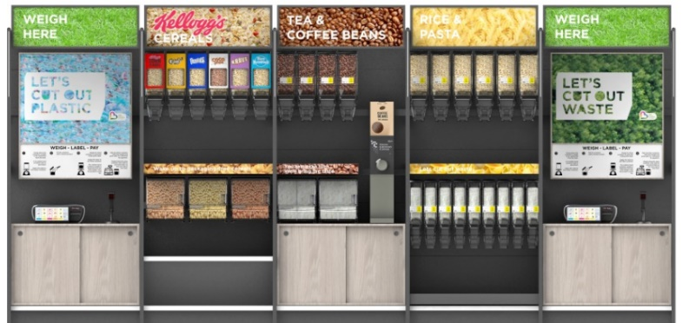
- reducing packaging on own-label products Asda (2020) planning to launch its first sustainability store to find ways to reduce plastic and encourage buyers to reuse plastic containers. Customers can fill up their containers with coffee, rice cereals and pasta. This invention will be connected with customers feedback allowing Asda to understand how these new ideas work in practice. Listening to customers feedback and acting on it, create stronger relationships. Moreover, Asda (2020) will install recycling facilities, for instance, reverse vending machine for plastic bottles, cans and hanger recycling. The savings obtained through the waste and packaging reduction, provide more sustainable products at the same or lower prices. The process will lead to significant savings for customers and Asda (2020).
Image 4 First in the UK sustainability store (Asda, 2020)
- Improving waste management practices - zero waste to landfill, (Keogh, 2016).
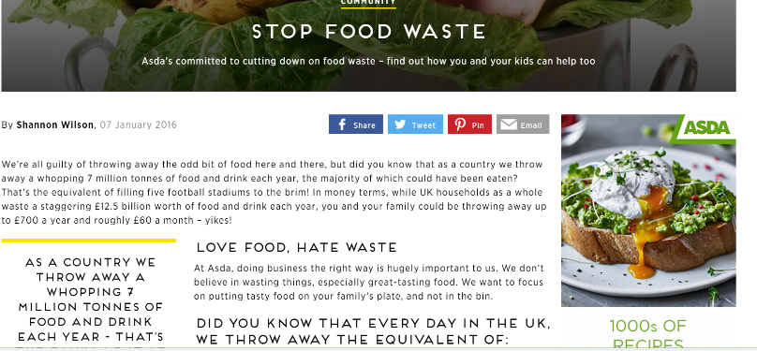
Asda working with the Food and Drink Federation and the Institute of Grocery Distribution to standardise portion sizes to reduce waste at consumers homes (Asda, 2020). Asda presented food waste reduction messages to its customers (Young et al, 2018) mainly through the company’s website (Image 5). This way retailer communicates its social responsibility involvement, concern for the environment and costumers finance.
Image 5 Asda’s ‘Love Food, Hate Waste’ campaign (Willson, 2016).

2.3 Quality system

There are many models which could be used to improve the quality of products and enhance services and CRM system, such as: Lean, Six Sigma, TQM. A characteristic of those models is a customer-centric approach.
The researcher compared two models: Lean and Six Sigma. Both models (ArunKumar, Dillibabu, 2016), work toward the same goal: how to eliminate waste and create an efficient system. The difference is how they view the causes of waste and how the improvement process is implemented. The Lean model focuses on waste reduction by eliminating imperfections and developing products quality. Lean strives to maximise value to the customer while reducing resources. Six Sigma looking for the perfect outcome while reducing costs to maximise customer satisfaction. Lean and Six Sigma demonstrate that it is possible to improve the quality of products and customer satisfaction by improving processes.
The researcher used Tesco as an example to explain Lean Model, despite Asda also implemented Lean manufacturing model in factories in Asia, after accusation of poor working conditions. Asda admitted (Actionaid, 2012), that by improving productivity and reducing waste, the lean strategies increased workers’ pay by 14%, reduced working hours and drove social improvements. Asda communicated work conditions improvements to the general public, stating: “By always doing the right thing, we guarantee our customers can shop at George with a clear conscience.” (ActionAid, 2012).
According to Womack and Jones (2007), Tesco successfully applied techniques and principles, primarily used in manufacturing sectors in the retail environment. Lean processes established Tesco at the lowest cost position among UK’s supermarkets (including Asda), while maximised profit.
The first stage of the Lean model is to specify the value from the consumer perspective. Tesco is an expert in understanding buyers needs through its Clubcard system (Lopez et al 2018) and market research.
Leaner thinking specifies eight types of waste (Lukic, 2012): Defect, Overproduction, Waiting, Non–Utilised Talent, Transportation, Inventory, Motion and Extra Processing.
Some of these waste technics are exemplified below.
Overproducing
Tesco Clubcard data collection (Lopez, et al, 2018) exactly show where customers value is allocated. Clubcard provides exact information what customers are buying. Tesco can produce items without guessing the amount required.
Waiting
Tesco implemented a system of continuous stock replenishment to reduce availability problems. This process increased up to 99% on-shelf availability.
Inventory
Implementing leaner structure in Tesco resulted (The guardian, 2019) reducing fresh food counters, to prevent food wasting while making space for more valued by customers products. Tesco CEO pointed out that shoppers have less time, therefore fresh food counters are no longer popular.
Making more changes towards leaner structure, Tesco (The guardian, 2019) eliminates variation from their product range and Asda (2018), helps the consumer save time, by becoming simpler.
Lean production methods are helpful in times of COVID-19 pandemic, where supermarkets limiting distribution of nonessential products. Supermarkets have closed cafes and counters with fresh food to increase warehouse and lorries capacity for products that customers really need, like toilet paper. Extra available staff can focus on keeping shelves well-stocked (The guardian, 2020).
Transportation and Motion
Lean managing is part of Tesco's and Asda’s approach to sustainability, and emphasis on waste reduction. Double-decker and aerodynamic lorries are being used to reduce fuel consumption and journeys. Service Centres are located next to the Distribution Centres, that creates an efficient recycling chain, reduces trips numbers and lowers pollution. (Keogh, 2016).

3.0 Conclusion

The objective of this report was to analyse Asda and other British supermarkets CRM best practice, ethical and sustainable challenges and quality system.
The report indicates that Asda focuses its marketing strategies and drives consumption through low prices. This strategy has disengaged the company with ethics and placed Asda into a market segment where competition getting stronger (Lidl, Aldi). To combat this, Asda could change its strategy and focus on the upper–socio-economic segment and modify its product range into a more ‘premium’.
The research highlights several ethical issues at Asda (Keogh, 2016), such as employees’ rights, supply chain unethical behaviour, aggressive competition, animal rights, anti-social finance, tax avoidance.

4.0 Recommendations

The main recommendations for ASDA are to re-position itself in the market, remove the constant focus on the price and maximise efforts on ethical issues, sustainability and improve quality.
Tactics to attract an upper socio-economic segment with “Organic” and “Local” initiatives could improve the Asda image. Good quality products are not enough. A passion for food, that Whole Foods communicate so well, is missing on many fronts at Asda. Through ‘Extra Special’ brand Asda is trying to show the passion, but at the moment that is just only words on the packet (Keogh, 2016). The management practices of Whole Foods offer many lessons on how to serve consumers to encourage frequent visits and long-term loyalty (Cheretis, Mujtaba, 2014).
Asda should focus on using local supply-chain, which distribute organic food and products. This may result in a higher price to customers, but it could improve brand image. However, the retailer should be aware that any change to prices may impact on its valued consumers and market share. However, this could be viewed as an opportunity.
Along with those above suggestions, Asda should revamp its CRM strategies.
Responding to customer needs and staying ahead of trends is only possible by knowing them. Wise CRM procedures helped Tesco to reach the number one position in the UK's grocery market. Tesco Clubcard (Lopez, et al, 2018) proved that is possible for a retailer to know customers individual preferences and establish a long-term relationship. To improve CRM Asda needs to implement a data collecting system, similar to Tesco Clubcard.
Whole Foods (Cheretis, Mujtaba, 2014) is promoting a culture that considers the ethical consequences of actions and that acts socially responsible to maximise good in the world. Asda can learn from Whole Foods that implementing ethical and sustainable practises leading to long term organisational success.
After numerous scandals and court cases, Asda should improve trustworthy and dependable connections with employees, by treating them fairly and offering them chances of development. When employees are satisfied, they will work harder and will positively impact on customer relations. That helps the supermarket maintain a high level of customer satisfaction (Cuenllas, 2013) and loyalty to the business (Titov and Urmanova, 2017).

5.0 Appendix
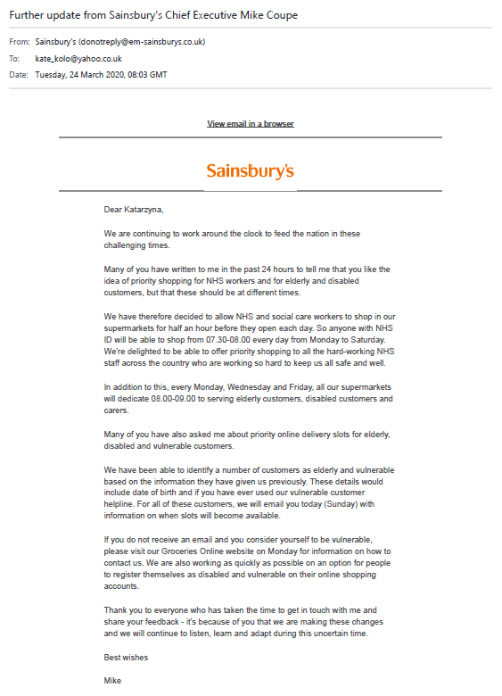

6.0 References:

ActionAid (2012), The real Asda price Poverty and abuse in George’s showcase factories [online]. Available at: https://www.actionaid.org.uk/sites/default/files/doc_lib/the_real_asda_price.pdf (accessed 23.03.2020)
Alberto (2020), Asda- case study, [online]. Available at: https://businesscasestudies.co.uk/asda/ (accessed 24.03.2020)
ASDA (2018), ‘Putting customers first in our communications’ [online]. Available at: https://corporate.asda.com/article/putting-customers-first-in-our-communications (accessed 03.02.2020)
Asda, (2020), Asda links up with big brands to launch the first sustainability trial store [online]. Available at https://corporate.asda.com/newsroom/2020/01/16/asda-links-up-with-big-brands-to-launch-first-sustainability-trial-store (accessed 24.03.2020]
Asda, (2020), ‘Asda groceries’ [online]. Available at: https://groceries.asda.com/ [accessed 25. 03.2020]
ArunKumar, G., Dillibabu, R., (2016), ‘Design and Application of New Quality Improvement Model: Kano Lean Six Sigma for Maintenance Project’, Vol.41, Iss.3 Arabian Journal for Science and Engineering
Bentham, J., (2018), ‘Business and Economics in the News – Sainsbury's and Asda - the decade's mega-merger’, Vol 22, Iss 3, Hassocks: Teaching Business & Economics pp. 11-12.
Browne, A.W., Harris, P.J., Hofny-Collins, A.H., Pasiecznik, N. and Wallace, R.R., (2000), ‘Organic production and ethical trade: definition, practice and links’, Vol. 25, Iss. 1, Food policy, 25(1), pp.69-89.
Buttle, F., Maklan, S., (2019), Customer Relationship Management: Concepts and Technologies, (4th edition), New York: Routledge.
Chartered Institute of Management Accountants, (2017), ‘Asda case studies: The role of the finance team in climate change projects’, London [online]. Available at: https://www.cimaglobal.com/Documents/Thought_leadership_docs/Sustainability%20and%20Climate%20Change/cid_execrep_asda_case_study_dec%2009.pdf (accessed 02.02.2020)
Cheretis, D., Mujtaba, B., (2014), ‘Maximising Long-Term Value and Conscious Capitalism at Whole Foods’, Vol. 79, Iss. 3, Corpus Christi: Society for the Advancement of Management
Christensen J., Murphy, R., (2004), ‘The Social Irresponsibility of Corporate Tax Avoidance: Taking CSR to the bottom line’, Vol. 47, Iss.3, Society for International Development
Clark, T., Chan, S.P., (2014), ‘A history of Tesco: The rise of Britain's biggest supermarket, Telegraph. Available at https://www.telegraph.co.uk/finance/markets/2788089/A-history-of-Tesco-The-rise-of-Britains-biggest-supermarket.html 2019/ [accessed 17.03.2020]
Cook, P., (2013), ‘The New Rules of Management: How to Revolutionise Productivity, Innovation and Engagement by Implementing Projects That Matter’, Melbourne: John Wiley & Sons
Cuenllas, A., (2013), ‘Whole Foods Case Study: A Benchmark of Management For Hospitality, Available at: https://www.hospitalitynet.org/opinion/4059396.html (Accessed: 07. 03. 2020)
Ethical consumer, (2020), ‘Asda Group Ltd’. Available at: https://www.ethicalconsumer.org/company-profile/asda-group-ltd [accessed: 02. 02. 2020]
Goldfingle, G., (2012), ‘Asda comes under scrutiny for tax avoidance’[online]. Available at: https://www.retail-week.com/asda/asda-comes-under-scrutiny-for-tax-avoidance/5042264.article?authent=1 [accessed 24.03.2020]
Handley, L., (2013), ‘Asda creating brand personality’, Marketing Week. Available at: https://www.marketingweek.com/asda-creating-brand-personality/ [accessed 20.02.2020]
Hoad, A. (2017), ‘Making Tesco great again’, Teddington: Cambridge University Press
Hutton, W., (2002), ‘The World We’re In’, London: Little, Brown
Keogh, C., (2016), ‘The CSR activities of UK Supermarkets and how they compare when evaluated using a framework based on ISO 26000’, Master’s thesis, University of Huddersfield
Khanmohammadi, E., Talaie, H., Salehzadeh, R., (2018), ‘Supplier evaluation and selection for sustainable supply chain management under uncertainty conditions’ Semantic scholar [online]. Available at: https://www.semanticscholar.org/paper/Supplier-evaluation-and-selection-for-sustainable-Khanmohammadi-Talaie/08a79ec191411b465f0b15ab28da968e1a9fa80a [accessed: 19.02.2020]
Labour Heartlands, (2019), ‘THE WALMART WEB: ASDA’S Tax dodging parent company’ [online]. Available at: https://labourheartlands.com/the-walmart-web-asdas-tax-dodging-parent-company/ (accessed 24.03.2019)
Laumbach, R., Meng, Q., Kipen, H., (2015), ‘What can individuals do to reduce personal health risks from air pollution?’, Vol. 7, Iss. 1, Journal of Thoracic Disease
Lopez, B., Francisca, M., Virto, N.R., San-Martín, S., (2018), ‘Local Food Shopping: Factors Affecting Users’ Behavioural E-Loyalty, Vol. 8, Iss. 3, Basel: Administrative Sciences
Lukic, R., (2012), ‘The effect of application the Lean concept in retail’. Vol. 15, Iss. 1, Economia: Seria Management
Marketing Week, (2006), ‘Assessing the Asda Brand’, [online]. Available at: https://www.marketingweek.com/assessing-the-asda-brand/ (accessed 01.02.2020)
Megicks, P., Memer, J., Angell, R., (2012), ‘Understanding local food shopping: Unpacking the ethical dimension’, Journal of Marketing Management.
Mühlbacher, H., Böbel, I., (2019), From zero-sum to win-win - Organisational conditions for successful shared value strategy implementation, Vol. 37, Iss. 3, European Management Journal.
Mujtaba, B. G., Cavico, F. J., (2013), ‘Corporate social responsibility and sustainability model for global firms’, Vol. 10, Iss.1, Journal of Leadership, Accountability and Ethics.
Mujtaba, B., G., (2014), ‘Managerial skills and practices for global leadership’. ILEAD Academy: Davie, FL.
Parry, J., Mitchell, K., Atkins, S., Parker, J., Waugh, J., Butterworth, G., Macbeth, I., Potter, S. (2018), ‘Climate Change and Sustainable Transport - the challenge for transport professionals’, The Institution of Highways and Transportation, Transport Policy Board
Pearson, (2017), Better decisions. Everyday. Everywhere. TalentLens [Online]. Available at: https://downloads.pearsonassessments.com/images/assets/talentlens/CriticalThinking-eBook.pdf (Accessed: 15. 02.2020).
Peppers, D., Rogers, M., (2004), ‘Managing customer relationships a strategic framework’. (6th edition), Hoboken, New Jersey: John Wiley & Sons.
Prickett, R., (2010), ‘THE BOTTOM LIME’. Financial Management, pp. 18-20
Rodrigo, P., (2017), ‘Asda Marketing Plan’. Available at: https://writepass.com/journal/2017/01/asda-marketing-plan/ [accessed: 27.02.2020]
Schneider D., (2019), ‘CRM Models’, Ninjaoutreach [online]. Available at: https://ninjaoutreach.com/crm-models/ (accessed: 25.02. 2020)
Seyfang, G., (2008), ‘Avoiding Asda? Exploring consumer motivations in local organic food networks’, Local Environment [online]. Available at: https://www.tandfonline.com/action/showCitFormats?doi=10.1080%2F1354983070166911 (accessed 03.03.2020)
Siddiqi, J., Akhgar, B., Wise, T., (2006), ‘A framework for the implementation of a Customer Relationship Management strategy in retail sector’. Sheffield: Hallam University
Sivapalan, A., Jebarajakirthy, C., (2017), ‘An application of retailing service quality practices influencing customer loyalty toward retailers’, Vol 35, Iss. 7, Bradford: Marketing Intelligence & Planning, 842-857.
Swaffield, J., Evans, D., Welch, D. (2018), ‘Profit, reputation and ‘doing the right thing: Convention theory and the problem of food waste in the UK retail sector’, Vol.89,Iss.2 Geoforum, Available at: https://doi.org/10.1016/j.geoforum.2018/ [accessed 17.03.2020]
The Guardian, (2008), ‘Supermarkets fined £116m for price fixing’. Available at: https://www.theguardian.com/business/2007/dec/08/supermarkets.asda (accessed:27.03.2020)
The Guardian, (2019), ‘Tesco confirms 9,000 jobs at risk as it axes fresh food counters.’ Available at: https://www.theguardian.com/business/2019/jan/28/tesco-jobs-fresh-food-counters-supermarket--staff (accessed: 27.03.2020)
Tidy, M., Wang, X., Hall, M., (2016), ‘The role of Supplier Relationship Management in reducing Greenhouse Gas emissions from food supply chains: supplier engagement in the UK supermarket sector’, Journal of Cleaner Production.
Titov E., Umarova, L., (2017), ‘Impact of Real and Propagated Values on Organisational Success’, Congruence of Personal and Organizational Values, Intech Open
Womack, J., Jones, D., (2007), ‘Lean Solutions: How Companies and Customers Can Create Value and Wealth Together’, London: Simon and Schuster UK Ltd.
Wunsch, N., (2020), ‘Grocery market share in Great Britain 2015-2020’, Statista [online]. Available at: https://www.statista.com/statistics/280208/grocery-market-share-in-the-united-kingdom-uk/ (accessed 17.03.2020)
Young, C.W., Russell, S.V., Robinson, C.A. and Chintakayala, P.K., (2018), ‘Sustainable retailing–influencing consumer behaviour on food waste’, Vol 27. Iss. 1, Business Strategy and the Environment, pp.1-15.
References for Images:
Calvert, W. (2018), ‘Coupon King’, The Sun. Available at: https://www.thesun.co.uk/money/6199412/sainsburys-coupons-money-off-nectar-points/ accessed on 25/03/2019
Willis, N. (2018), ‘Changes to Tesco Clubcard Vouchers’ https://skintdad.co.uk/tesco-clubcard-vouchers-changes-2018/ accessed 25.03.2020
Wunsch, N., (2020), Grocery market share in Great Britain 2015-2020, Statista https://www.statista.com/statistics/280208/grocery-market-share-in-the-united-kingdom-uk/ accessed 17/03

