Module: Financial Management for the Hotel Industry
Module code: BMIH5007
Lecturer: Tristan Hawkins
Assignment Title: Report Case Study: The City Hotel
Student: Maria-Monica Adam
Student ID: 2241338

AI ACKNOWLEDGMENT
I acknowledge using Grammarly (https://www.grammarly.com/) on 30 October 2024 to check spelling errors in my work. Grammarly did not require me to key in any prompt but only provided the document for spelling and grammar checks, and I chose what I wanted to change and what I tried to dismiss from change among the issues it highlighted. I confirm that I have not used any AI tools in the research and creation of this assignment. I confirm that I have not presented any AI-generated materials as my work. I confirm I have copies of my drafts, notes, and other resources I used, which I may be asked to provide in evidence.
Table of Contents
1. Introduction 3
2. Financial Performance Analysis 3
2.1 Table 1: Trends in Key Financial Metrics (2021-2023) 3
2.2 Table 2: Ratio Analysis (2021-2023) 4
3. Identification of Key Issues 4
4. Turnaround Strategy Proposal 7
4.1 Revenue Enhancement 8
4.2 Cost reduction, and efficiency improvements. 8
4.3 Customer Satisfaction and Service Improvements 9
4.4 Financial Restructuring 9
5. Implementation Plan 10
6. Conclusion 11
7. References 11

Introduction
An accommodation, dining and event facility, the City Hotel is a well-known urban hotel. But its downward financial performance has been ongoing for some time now, with lower revenue, lower occupancy rates, and lower customer satisfaction. These issues pose challenges, which have led people to question future hotel viability and have driven hotel owners to consider strategic intervention (Altin et al., 2023). The purpose of preparing this report is to evaluate if The City Hotel is financially healthy or if there are dimensions a declining financial health and, accordingly, to assess whether financial health is declining, the main financial metrics in the past three years have been assessed and the causes of the financial decline have been derived. Action-based recommendations will be provided in this report through an in-depth analysis of trends and factors that impact the profit of a hotel an it would restore the financial stability of the hotel, customer satisfaction will be improved and operational efficiency in the hotel can be achieved for sustainable growth in the environment.

Financial Performance Analysis
Financial Metric | 2021 | 2022 | 2023
Revenue | £5,248,290 | £5,307,480 | £2,325,440
Cost of Goods Sold (COGS) | £411,600 | £401,510 | £176,250
Employee Costs | £1,724,760 | £1,770,700 | £1,233,160
External Expenses | £1,894,720 | £1,675,410 | £1,071,030
Operating Income | £664,160 | £674,730 | £1,218,850
Net Income | £333,930 | £304,650 | £1,134,950

Identification of Key Issues
Several directly associated ones affecting a hotel's profitability are the decline in profitability of The City Hotel associated with various factors such as price, cost structure, and its overall market position. It can be observed that the sharpest drop is in revenue which plummeted from approx. £5.3 million in 2022 to £2.3 million in 2023. But the City Hotel has been adversely influenced due to external factors e.g. intensified competition, economic downfall, and variations in customers’ taste which would have resulted in a sharp decrease in revenue. Maybe some of what draws potential The City Hotel guests away is the growth of alternatives by way of vacation rentals. Additionally, not only because more people are willing to spend their time at their own homes, but also because the hotel business that experienced the recent economic challenge of inflation and the fact of increased rate of interest probably decreased demand for hotel services and that is leading to decrease the occupancy rate (Dabrowski et al., 2019).

It is also a cost structure problem, a profitability challenge. While revenue is declining, it is the expenditure of employee costs that is one of the largest ongoing liabilities. Due to slumping revenue in 2023, employee costs decreased very little from past years to a grand sum of £1.23 million. This imbalance suggests that The City Hotel has not adjusted its staffing costs and labor costs to the lower demand. Additionally, revenue less gracefully declined compared to external costs and this examinates turnover in controlling variable costs (Al-Wattar et al., 2019). There are also high fixed costs such as rent, utilities, and insurance, which makes it difficult to adjust to lowered costs in response to lower revenue (Patiar and Wang, 2016). The rigid cost structure of The City Hotel prevents it from increasing its margins and becoming profitable during any time of low occupancy.

Moreover, financial problems also indicate customer satisfaction, reputation and other problems. A lack of differentiation in the hotel’s offering, subpar quality of service, old facilities, or low occupancy rate may result. Such customers of lively urban markets will have a desire for an experience that provides more than basic lodging with modern amenities, personalized service or unique experience. Unless the trends of these expectations are met by the hotel, which unfortunately will also be losing customers to competitors who offer a better all-around experience, the City Hotel will not retain its customers. Not only would bad reviews from customers and word of mouth destroy the hotel's reputation and be hard to recruit new customers or hold existing ones. These customer satisfaction issues with revenue and therefore with profitability are directly impacted.

Yet, as with any hotel, no small part of the responsibility is borne by macroeconomic factors. Cost increases have come as a result of increased prices paid to utilities, supplies and food and beverage (in part as a result of inflationary pressures) within the broader economic climate. In a competitive market, the City Hotel may wait before raising prices because people might decide to go elsewhere instead and The City Hotel would lose money by not raising prices than by cutting costs. On top of higher borrowing costs, it is also getting harder and we will have to raise interest rates as we service and manage our debt deeper into the cycle, perhaps much deeper. It’s another financial burden that consumes shavings from what’s left for making investments or improvements to get customers better service and operational efficiency.
To sum up, these are the causes for The City Hotel’s profitability challenges: and a declining revenue, a rigid cost structure, a low customer satisfaction, and a difficult macroeconomic environment. Then to deal with these issues we need to be holistic, combining internal strategies like cost restructuring, improved service, or external tactics such as targeted marketing or a competitive strategy. The factors underscored the need for a powerful turnaround strategy to address financial, operational, and market-oriented issues to rehabilitate the hotel's financial health and competitiveness.

Turnaround Strategy Proposal
This requires a combination of a complete turnaround strategy based on leveraging revenue and thereby leveraging cost and customer satisfaction in a way that allows to also revitalize The City Hotel's financial health. The strategy will focus on long-term viability by increasing revenue streams, optimizing expenses, and improving guest experiences and financial challenges.
Budget Category | Description | Estimated Cost (£) | Timeline
Revenue Enhancement
Dynamic Pricing & Marketing | Digital Marketing | 50,000 | Short-term
Event & Corporate Packages | Promotion and engagement | 25,000 | Medium-term
Cost Reduction & Efficiency
Staffing Optimization | Training and Workshops | 10,000 | Short-term
Energy Efficiency Upgrades | Maintenance, Facility Management, HVAC | 75,000 | Medium-term
Supplier Negotiations | Bulk Discounts | 5,000 | Short-term
Customer Satisfaction
Facility Upgrades | Wifi, networking. | 100,000 | Short-term
Guest Experience Programs | Spa, wellness. | 30,000 | Medium-term
Financial Restructuring
Loan Refinancing | Debt restructuring | 15,000 | Long-term
Asset Liquidation | Selling non-essential assets | -50,000 (revenue) | Long-term
Contingency | Additional capital | 20,000 | Ongoing
Total Estimated Budget |  | £280,000

Revenue Enhancement
One of the best ways to increase revenue is to upgrade the menu and broaden the audience at The City Hotel. As a hotel it can be done by targeting corporate clients and event organizers with packaged deals for conferences, weddings, name it all, using the hotel’s already existing event facilities. Dynamic pricing may help resolve revenue problems in peak seasons and attract price-sensitive customers off-peak; more (Theodoulidis et al., 2017). By running a more comprehensive digital marketing strategy further the hotel can increase its visibility, have access to new segments of the market and may even be able to form partnerships with online travel agencies and then attract via targeted social media advertising (Franco et al., 2020). With the opportunity that the City Hotel has it can bring more customers that will help them to gain more revenue by positioning the pricing right.

Cost reduction, and efficiency improvements.
The theme is to lower operating costs while preserving the quality of the service to make a profit even better. Revenue should be drastically lowered without drastically high staff costs and staff can be optimized by careful massaging of the staff you do have through streamlining of roles, cross-training, and careful scheduling. The hotel can reduce labor costs without impairing guest experience by changing the staffing levels according to the seasonality of demand and minimizing the usage of external contractors for nonessential services. Upgrading lighting and HVAC and other energy efficiency improvements are ways of lowering utility expenses, as energy costs rise. Other attempts, such as renegotiating bulk discounts with suppliers, and finding local food and beverage providers to cut down the costs without any compromise on the quality, will also be made (Rotondo and Fadda, 2019). These measures effect change in the cost structure towards a more flexible environment that is more elastic concerning the size of the demand shock; at the same time a positive cash flow is produced for the hotel (Raguseo and Vitari, 2017).

Customer Satisfaction and Service Improvements
A major objective is to further increase occupancy rates and to increase repeat business by further increasing customer satisfaction. The common areas of the hotel, such as the hallway, the elevator and the lobby, can be altogether modernized with modern amenities such as high-speed Wi-Fi, smart TVs and comfortable furniture, which will attract both business travelers, and younger ones (Dai et al., 2015). The City Hotel will excel more than any of its competitors if succeeds in training its staff to deliver excellence in customer service and personalize the customer experience. Offering your guests curated local experiences or on-site experiences, such as culinary classes, wellness sessions, or even regular hobbies like cooking, can help the hotel differentiate itself from the competition and attract guests who want unique experiences (Turner et al., 2017). Prioritizing customer satisfaction will help the City Hotel to increase its market position by increasing the occupancy rate.

Financial Restructuring
Thus, an increase in The City Hotel’s debt and the company’s diminishing profitability meant a financial restructuring became part of the strategic turnaround. Some of these high loan repayments could be offset through refinancing available options for existing loans on the market to enable them to obtain lower interest rates in order to free up cash for essential improvement works. For instance, the flexibility of the firm in gaining improved cash flow volatility through reversing of leasing or consolidation of debts. So in one direct method, it could try to communicate with the stakeholders based on their identity, they are the lenders and investors that will help with the immediate short-term financing to fund operating changes or to meet payment liabilities (Nieves and Diaz-Meneses, 2016). Since it acts as a way that the hotel can address the liquidity situation, such a change would require the hotel to dispose of any non-revenue generating assets so that the hotel can concentrate more on revenue generation than on liquidity generation (Sardo et al., 2018). These will also reign In the debt level of The City Hotel and the resultant balance that will fund growth and the achievement of long-term goals.

Implementation Plan
Tasks | Month 1 | Month 2 | Month 3 | Month 4 | Month 5
Implement dynamic pricing strategies.
Targeted digital marketing campaigns
Optimized staffing schedules
Cross-training
Initiate room and facility upgrades (Wi-Fi, smart TVs)
Expand corporate and event packages.

Conclusion
In summary, the performance of The City Hotel is financially and operationally vulnerable with a decrease of income and a significant level of fixed costs, low customer satisfaction, and more obligations. Such measures that will be needed to restore profitability and viability in the future will have to come from huge enhancements in recent financial performance. This report presents a complex turnaround method that will seek to generate more income from different marketing approaches and new services; cut costs by raising efficiency; enhance customers’ satisfaction through building new facilities and additional value-added services; and reform the financial current condition to wipe out a massive amount of debts. This strategy can be implemented through short-term actions to stabilize the revenue (short term) and medium-term actions to differentiate the hotel and the long-term financial restructuring of the company (long term) based on the phased approach which will allow starting the gradual reestablishment of the hotel market position. With these strategic changes, it is well equipped to achieve financial sustainability, to increase occupancy and prospects for a growing market within a fiercely competitive urban hotel business.

Excel Presentation

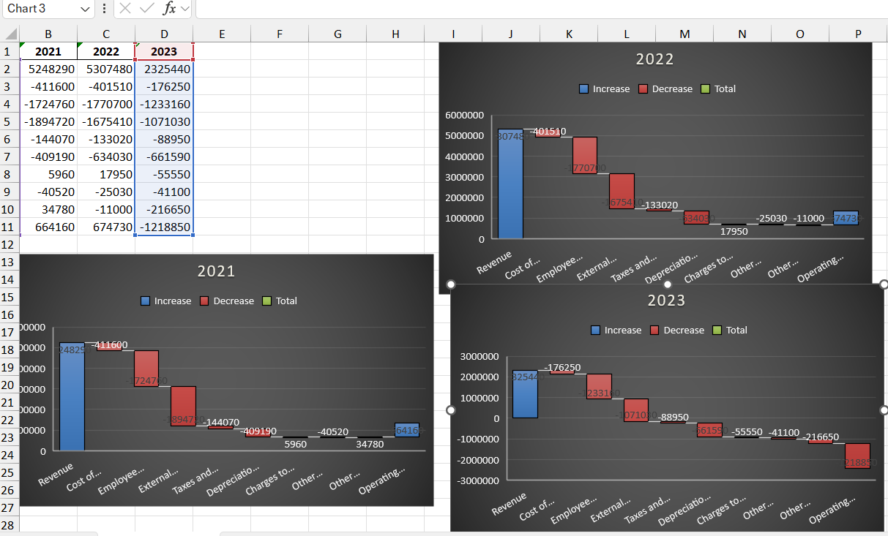
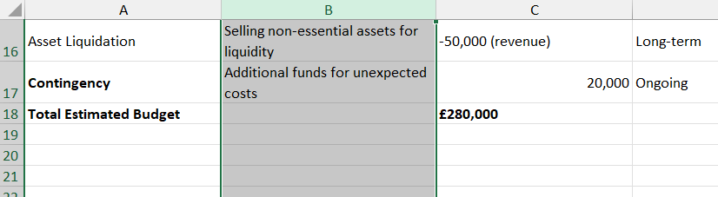
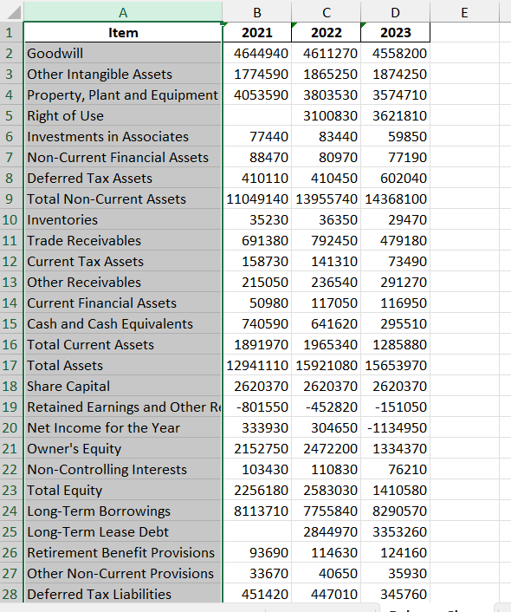

References
Altin, M., Chen, C.C., Riasi, A. and Schwartz, Z., 2023. Go moderate! How hotels' cancellation policies affect their financial performance. Tourism Economics, 29(8), pp.2165-2182.
Al-Wattar, Y.M.A., Almagtome, A.H. and Al-Shafeay, K.M., 2019. The role of integrating hotel sustainability reporting practices into an Accounting Information System to enhance Hotel Financial Performance: Evidence from Iraq. African Journal of Hospitality, Tourism and Leisure, 8(5), pp.1-16.
Dabrowski, D., Brzozowska-Woś, M., Gołąb-Andrzejak, E. and Firgolska, A., 2019. Market orientation and hotel performance: The mediating effect of creative marketing programs. Journal of Hospitality and Tourism Management, 41, pp.175-183.
Dai, W.D., Mao, Z.E., Zhao, X.R. and Mattila, A.S., 2015. How does social capital influence the hospitality firm's financial performance? The moderating role of entrepreneurial activities. International Journal of Hospitality Management, 51, pp.42-55
Franco, S., Caroli, M.G., Cappa, F. and Del Chiappa, G., 2020. Are you good enough? CSR, quality management and corporate financial performance in the hospitality industry. International Journal of Hospitality Management, 88, p.102395.
Nieves, J. and Diaz-Meneses, G., 2016. Antecedents and outcomes of marketing innovation: An empirical analysis in the hotel industry. International Journal of Contemporary Hospitality Management, 28(8), pp.1554-1576.
Patiar, A. and Wang, Y., 2016. The effects of transformational leadership and organizational commitment on hotel departmental performance. International Journal of Contemporary Hospitality Management, 28(3), pp.586-608.
Raguseo, E. and Vitari, C., 2017. The effect of brand on the impact of e-WOM on hotels’ financial performance. International Journal of Electronic Commerce, 21(2), pp.249-269.
Rotondo, F. and Fadda, N., 2019. The influence of being part of a tourist network on hotels’ financial performance. International Journal of Hospitality Management, 82, pp.335-344.
Sardo, F., Serrasqueiro, Z. and Alves, H., 2018. On the relationship between intellectual capital and financial performance: A panel data analysis on SME hotels. International Journal of Hospitality Management, 75, pp.67-74.
Theodoulidis, B., Diaz, D., Crotto, F. and Rancati, E., 2017. Exploring corporate social responsibility and financial performance through stakeholder theory in the tourism industries. Tourism Management, 62, pp.173-188.
Turner, M.J., Way, S.A., Hodari, D. and Witteman, W., 2017. Hotel property performance: The role of strategic management accounting. International Journal of Hospitality Management, 63, pp.33-43.
Uyar, A., Kilic, M., Koseoglu, M.A., Kuzey, C. and Karaman, A.S., 2020. The link among board characteristics, corporate social responsibility performance, and financial performance: Evidence from the hospitality and tourism industry. Tourism Management Perspectives, 35, p.100714.

