International Market Entry Strategy and Marketing Mix: A Comparative Analysis of Zara in India and the United Kingdom
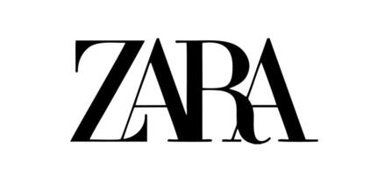
Programme: Master of Business Administration
Module Name: International Marketing: Principles and Practices
Module Code: LCMB7026

Student Name: Meet Malani
Student ID: 2504764

Table of Contents

SECTION 1: INTERNATIONAL MARKET ENTRY STRATEGY AND MARKETING MIX 4
1. Introduction 4
2. Company Overview and Internationalisation Context 5
3. Comparative Macro-Environmental Analysis (PESTEL) 5
3.1 Political and Legal Factors 6
3.2 Economic Factors 6
3.3 Social and Cultural Factors 7
3.4 Technological Factors 8
3.5 Environmental Factors 8
3.6 Legal Factors 9
4. Comparative STP Strategy in UK and India 9
4.1 Segmentation 9
4.2 Targeting 10
4.3 Positioning 11
5. Comparative International Marketing Mix: Application of 7Ps in the UK and India 12
5.1 Product Strategy 12
5.2 Price Strategy 13
5.3 Place (Distribution) Strategy 14
5.4 Promotion Strategy 15
5.5 People 15
5.6 Process 16
5.7 Physical Evidence 16
6. Directional Development Strategy in India: Application of the Ansoff Matrix 16
7. Ethical Issues in The UK and India 17
8. Strategic Recommendations for Zara 18
9. Conclusion 20
SECTION 2: REFLECTIVE ACCOUNT 21
1. Description 21
2. Feelings 21
3. Evaluation 22
4. Analysis 22
5. Conclusion 23
6. Action Plan 23
REFERENCE LIST 25

SECTION 1: INTERNATIONAL MARKET ENTRY STRATEGY AND MARKETING MIX

1. Introduction
The current report is a critical analysis of the international market entry strategy and marketing mix of Zara in two opposite markets of India and the United Kingdom. Being one of the leading brands of the Inditex, Zara is a part of the global fast fashion industry, with a short product cycle, vertical integration of supply chains and high sensitivity to the trends on the consumer side (Yang, 2025). In the rapidly globalised retailing context, global consistency must be matched with the local market sensitivity in an international success.
India and the UK are strategically different situations. UK is a mature and competitive market in fast fashion and very sustainable with good retail infrastructure. India on the contrary is a developing economy that is characterized by urban middle-class of rapid growth, cultural diversity and consumer behaviour change which reflects on India’s fast fashion market size (Figure 1).
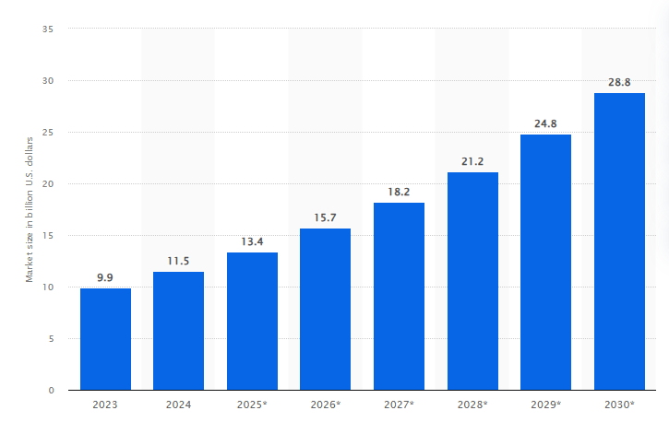
Figure 1: Size of Fast Fashion Market in India
(Source: statista.com, 2026)
This report introduces the internationalisation strategy of Zara and then a comparative study of its macro-environment is provided. It next compares STP plans and the 7Ps marketing mix in the two countries, then moral judgments, recommendations of the strategy and eventual findings.

2. Company Overview and Internationalisation Context
The flagship outlet of the Inditex, Zara, has established itself and developed its reputation internationally on a vertically integrated model of fast fashion that places a high emphasis on speed, flexibility and close control of its supply chain. Zara is able to rapidly react to new fashion trends and reduce inventory risk due to the close coordination of its design, production and distribution system uncommon among many of its competitors (Arimany Serrat, Arribas-Ibar and Erdoğan, 2025). This business structure fosters international homogeneity and fast locality.
The mode of entry used by Zara is different among markets. The brand in India has a joint venture with the Tata Group, which can be explained by regulatory barriers and the necessity to know the local market (More, 2024). Conversely, its business in the United Kingdom is conducted via a wholly owned subsidiary, which is in line with the stable and liberal retail environment in the United Kingdom. These options are in line with the Eclectic Paradigm (OLI) in which the decision to expand internationally is determined by ownership benefits, location-specific advantages, and internalisation benefits.
Theoretically, the slow nature of Zara in venturing into geographically and culturally diversified markets is an indicator of the Uppsala Model, especially experiential learning and reducing risks. Simultaneously, the brand demonstrates that there has been a persistent conflict between universal standardisation and domesticisation. Store formats and overall brand core are mostly standardised, but entry modes and product modifications chosen to reflect the institutional and cultural responsiveness.

3. Comparative Macro-Environmental Analysis (PESTEL)
An organized macro-environmental analysis points to the difference in the impact of external forces on strategic choices made by Zara in India and the United Kingdom. Despite the fact that both markets reinforce the fast fashion retail, institutional circumstances, economical abilities and socio-cultural anticipations generate different strategic pressures. These differences are important to understand when it comes to determining the balance between local responsiveness and global standardisation.

3.1 Political and Legal Factors
The history of the retail sector in India has been influenced by the limitation of foreign direct investment in the multi-brand retail (Sengupta et al., 2022). Policies have been liberalised over time, but the process of the regulation and compliance is rather complicated. The strategic reaction of Zara to political and institutional circumstances can be seen in the joint venture with the Tata Group, as it can help the brand avoid risks and capitalize on the local market experience. Operation decisions are also affected by political sensitivity regarding domestic sourcing and job creation.
The political environment in the United Kingdom is quite predictable and stable. Although the post-Brexit trade arrangements have brought cost aspects in the cross-border supply chains, the overall regulatory mechanism is clear. Accountability is further enhanced by political focus on sustainability and corporate responsibility. These variations reveal the impact of institutional stability and policy orientation on the structural and functional decisions of Zara in the markets.

3.2 Economic Factors
The economic difference between the UK and India is high. UK is characterized by a GDP per capita and comparatively good purchasing power although there are pressure and favourableness of inflation and problems in cost of life that have lately influenced discretionary purchasing (Bordo, Bush and Thomas, 2022). People are accustomed to the presence of fast fashion, so there is a strong rivalry in the price range and a high level of advertising campaigns.
India, being the low GDP per capita country, is being marked by the fast growth of urban middle classes and increased disposable incomes in urban areas. Generally, however, the prices are more sensitive than they are in the UK. Cost structures are also affected by import taxes and currency exchange rates, and in most cases, these aspects do place Zara in a high-end and aspirational brand in India. Contrary to this, in the UK Zara is more directly competing in a crowded fast fashion market. Such economic disparities define the pricing policies and value positioning in every market.

3.3 Social and Cultural Factors
The greatest difference between the two markets is the socio-cultural factors. Based on the cultural dimensions of Hofstede, UK is rated higher in the aspects of individualism in which self-expression and personal identity is very influential when it comes to fashion consumption. The UK scores higher on individuality, though India illustrates higher power distance (Figure 2). Fast fashion is part of the lifestyle culture and consumers have put more emphasis on convenience, being trend responsive and being able to access online (Del Olmo Arriaga, Pretel-Jiménez and Ruíz-Viñals, 2025). Also, its sustainability awareness is relatively great, and textile waste and ethical sourcing practices are increasingly questioned.
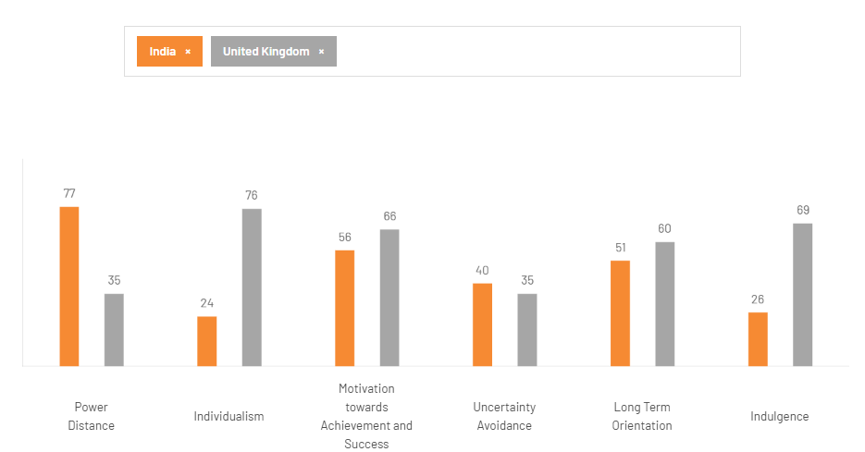
Figure 2: Hofstede’s Cultural Dimension Comparison
(Source: theculturefactor.com, 2026)
In India, purchasing behaviour is more collectivist in nature as family influence, social norms and cultural traditions play a larger role in shaping the purchasing behaviour. Consumption of fashion is usually related to festivals, weddings, and seasonal celebrations (Maduku and Phadziri, 2025). The standards of modesty and preference to the Indo-Western styles impact the demand trends and necessitate nuance in the garment’s construction, their length of sleeves, and the fabric types.
Retail interaction also varies in the consumer behaviour. Although the adoption of e-commerce in India is gaining pace, several customers still appreciate the experience of visiting a brick-and-mortar store and trying out products. Omnichannel retailing and online convenience has been well-established in the UK. In India, the price sensitivity is mostly intense, especially outside the Tier-1 cities, but the situation is different in the UK where consumers are more brand familiar and show a high level of comparison behaviour. Such cultural and behavioural differences have a great impact on product adaptation in Zara, tone of communication and market positioning.

3.4 Technological Factors
The UK has better infrastructure of retail technology, strong internet penetration and developed omnichannel systems (Wadud, Liang and Polkinghorne, 2025). Collecting at the counter services, mobile apps and a smooth process of making returns are norms.
India is digitally transforming at a very high rate, and this has been fueled by the usage of smart phones and digital payment systems. Nonetheless, the reliability of logistics and the variance of infrastructural aspects of the region calls upon Zara to strike a balance between the expansion of online and physical stores in crucial locations. The level of technological preparedness thus affects the distribution and customer experience policies of the two markets differently.

3.5 Environmental Factors
In the UK, the environmental pressures are stronger and fast fashion brands are heavily observed by the sustainability discourse, regulatory scrutiny and consumer activism. Sourcing and waste management is becoming more and more demanded as transparent.
Environmental awareness in India is increasingly growing but it is still at the backburner of many consumers who look at affordability and trendiness when it comes to purchasing. However, the expectations are also changing slowly, indicating that changes in strategies might be required in future.

3.6 Legal Factors
The UK has strict consumer protection laws, advertising provisions and newly introduced sustainability disclosure provisions (Kesidou and Palm, 2025). Reputational and financial consequences can be created due to legal non-compliance.
India also has consumer protection legislation as well as retail legislation, such as compliance related to sourcing and taxation. The level of enforcement and the complexity of regulations is however different. Such differences in law also affect the operational form and risk management policies of the two markets in Zara.

4. Comparative STP Strategy in UK and India
The segmentation of retailer Zara, its targeting and positioning strategies demonstrate the international consistency and the customization to the needs of the market to some extent (Moshood, 2025). Although the brand still has a single global identity based on the trend responsiveness and modern design, the implementation in India and the United Kingdom is different because of the differing income level, culture and market maturity.

4.1 Segmentation
Zara has a mixture of demographic, psychographic and behavioural segmentation in both markets. The core segment is demographically of young adults and working professionals aged around 18 to 40 with middle to high -income earners. Nevertheless, changes in the economic environment change the relative size and availability of this segment. This segment is a wide-ranging and mature consumer group in the UK that is conversant with the fast fashion consumption. The segment in India is more focused in the metropolitan centers and growing urban middle-class populations.
Zara keeps focusing on trendy and fashion-oriented people that attach importance to international style and quick turnover of products. UK buyers are also very concerned with convenience and becoming much more sustainability conscious when making a purchase (Babatunde, Oludoye and Hamzah, 2025). In their turn, the Indian customers of the target market of Zara often demand aspirational international brands which will imply status and modernity, but still within the cultural framework.
On the behavioural front, the UK customers have developed online purchasing behaviours and often repeat buying patterns. The Indian consumers, despite growing digital, could be visiting stores after doing online research. With these differences, it is meant that though the segmentation variables have the similarity of structure, the implications on the market are vastly different.

4.2 Targeting
Zara uses differentiated targeting strategy in the two markets. In the UK, the brand is directed towards a wide range of urban fashion-conscious markets in a highly competitive market (Zhang, 2024). The rivalry among brands like H&M and Primark requires value positioning and a quick change in assortment. Secondary data of market enhances high brand awareness and usage levels in the fashion retail industry of UK strong market penetration of Zara (Figure 3).
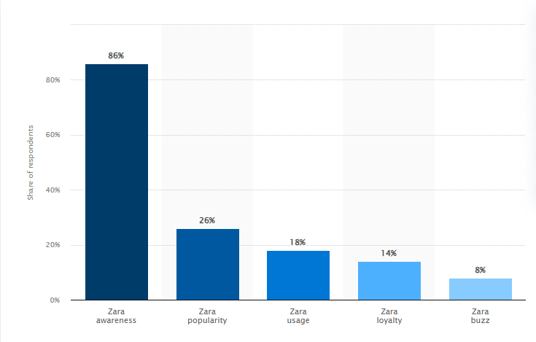
Figure 3: Brand Profile of Zara in UK (2022)
(Source: statista.com, 2026)
Targeting in India is more focused and selective in Tier-1 metropolitan cities. It is targeted at city youthful professionals and aspiring middle-income consumers whose disposable incomes get larger. The price point of Zara is nearer to a high-end low-end segment than in the UK and this limits its reach market base.

4.3 Positioning
The global positioning of Zara is based on the idea of providing the fashion of the runway at affordable prices and fast turnover. Positioning, however, is a subtle difference between markets. Zara is a competitive brand in the UK at fast fashion, where a number of established alternatives are available. It has a more premium and aspirational sense of perception in India because of higher comparison prices and a smaller store presence.
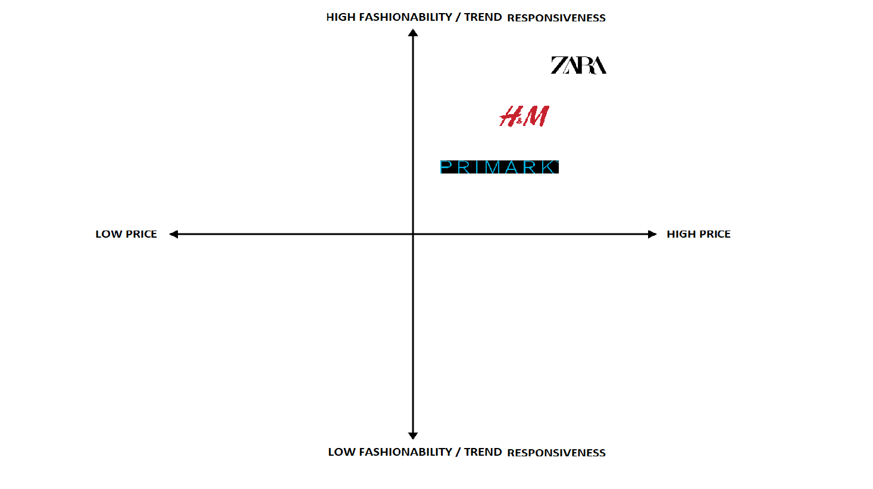
Figure 4: Fast Fashion Market Position of Zara in the UK
(Source: Self-created)
It is illustrated in figure 4, Zara is higher in price and fashionability than Primark and H&M. This is indicative of a rather premium image and high responsiveness to trends of Zara in the UK market.
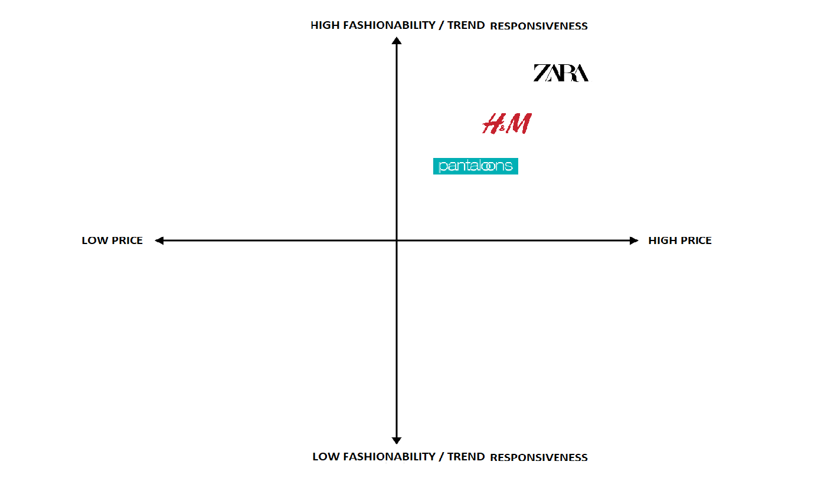
Figure 5: Fast Fashion Market Position of Zara in India
(Source: Self-created)
Figure 5 shows that Zara takes a superior price and fashionability status compared to that of Pantaloons and H&M in India. This brings out the premium and aspirational position of Zara in the Indian market.
On the whole, Zara exhibits partial standardisation of core brand identity and adjusts the intensity of its targeting and value perception to the local market conditions.

5. Comparative International Marketing Mix: Application of 7Ps in the UK and India

5.1 Product Strategy
The product strategy of Zara is based on the combination of the global and local requirements of product development. As mentioned by Liu and Bai, (2022), this can be stated as the glocalisation of the strategy for the overall development of the product category. Zara's product strategy strikes a balance between global standards and selective local adaptation to meet global consumer needs while managing pricing. The core design, sourcing and production decisions are being centralised, which is a way of vertical integration for the fast fashion model. However, the adaptation of localisation is clearly evident in India as the brand has incorporated higher necklines and 3/4 sleeves for reflecting preferences and cultural norms, which is specifically observed during the festive period like Diwali (More, 2024). The introduction of Western fusion elements, such as tunics and festive codes, demonstrates contextual responsiveness to the local market while maintaining a global brand identity.

5.2 Price Strategy
The pricing strategy of Zara depends on different aspects, such as high duty charges or regulatory environment, along with the nature of the market (Benavides, 2024). In the Indian market, the brand is perceived as premium, with an affordable premium pricing strategy. Compared with the local brand, it focuses on aspirational consumption among the urban middle class. The price is comparatively higher than in Europe due to the GST duties and other costs of logistics. The strategy helps address the requirements of the upper-middle-class demographic and also creates an international branding signal for the society's situation.
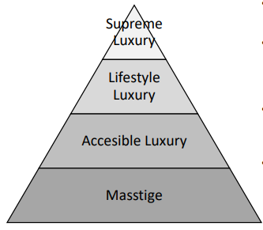
Figure 6: Different luxury fashion segments.
(Source: Gasamáns Gesto, 2023)
On the other hand, the strategy of pricing in the UK is competitive, with High Street pricing where they have strong competition from Primark and H&M (Jiang, 2022). In this market, pricing is competitive rather than having a premium yet affordable segment. Due to the availability of a high substitute environment, it focuses on the market and provides promotional discounts, which are strategically used during the seasonal sales to clear the inventory.
The primary driver of price volatility in India is currency fluctuations, which increase costs related to the euro and strain the supply chain (Diaz, Cunado and de Gracia, 2024). On the other hand, in the UK, the pricing benefits from established suppliers in the European market. The comparative analysis suggests that global price standardisation and the adoption of retail pricing in label-based purchase power can help increase competitive intensity.

5.3 Place (Distribution) Strategy
The location strategy of Zara is based on the nature of the market, maturity, and long-term target of the brand. For example, in the Indian market, Zara has adopted a joint-venture model with the Tata Group, which focuses on establishing flagship stores in metro cities such as Delhi, Mumbai, and Bengaluru, and most of these stores are located within premium malls like Palladium (Benavides, 2024). This kind of strategy targets the urban consumers. However, the expansion was cautious due to the infrastructural challenges and the cost of real estate. On the other hand, brands have a strong presence on the high street in the UK across regions such as Manchester, London, Birmingham, and other cities, which reflects market maturity.
The online business also represents differences where the UK consumer has a strong dependency on e-commerce support. People in India have not yet fully adopted the digital environment. However, as mentioned by Gupta and Mukherjee, (2022), digital shopping in India has started developing significantly in the post-pandemic era, which again demands acceleration of integration or an environment where it is possible to have better exposure

5.4 Promotion Strategy
With minimal traditional advertisement in the global market, Zara has a significant presence (Shen and Chen, 2024). Therefore, rather than depending on any prime retail location and store window, the majority of the promotions are controlled to create an exclusive image of the brand through the low-advertising model. Digital engagement, however, differs in the UK and Indian markets, as Zara leverages TikTok and Instagram in the UK, where the micro-influencer culture can shape purchase decisions. On the other hand, in India, the market is more strongly influenced by celebrity-affiliated styles and fashion bloggers, which represent a different pattern of consumption.
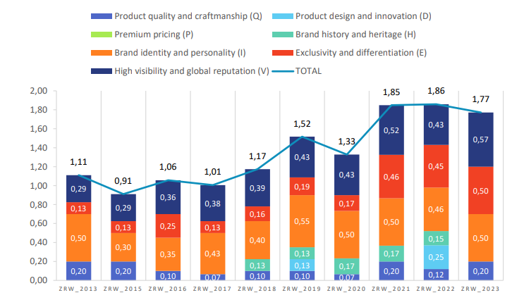
Figure 7: The Existence of the luxury characteristics in Zara's videos (2013-2023)
(Source: Gasamáns Gesto, 2023)

5.5 People
Cultural and lifestyle differences between the UK and India. The expectations are also culturally different. The consumers of the UK expect a low interaction service with individualistic preferences, whereas Indian customers, on the other hand, mainly expected assistance and personalised support (Sheth et al., 2022). With the proper HR training under the global protocol, Zara maintains both the approaches and adopts service styles through the recruitment of the local staff, which makes the brand culturally sensitive to communicate.

5.6 Process
The competitive advantage of the brand is primarily in its fast supply chain, which helps in designing the stores in around 2 to 4 weeks. In the UK the brand Zara has maintained a mature operation and its turnover is high, which minimises markdown risk. The management for the marking and stocking procedure occurs twice a week. This process is largely standardised across the majority of the markets, which demonstrates the global efficiency principle of the brand.
On the other hand, the Indian market presents logistical complexity. This alos maintains the centralised production for the maintenance of the variability across metropolitan cities. The tier 1 cities like Mumbai and Delhi also have a stronger “touch-and-feel” preference for the maintenance for the reverse logistics systems.

5.7 Physical Evidence
The physical evidence of the store layout, including Zara's minimalist aesthetics and lighting, helps maintain global consistency (Gasamáns Gestom, 2023). The logo of the brand also has minimal design designs and a clear font for catching the eye of the consumers. The evidence like the RFID based management and the Self-checkout systems have affected the retail environment in the UK.
However, the Indian stores majorly allocate greater space for festive display, which is a representation of cultural demand. Overall, the brand represents a core process and standardisation with technical adaptation.

6. Directional Development Strategy in India: Application of the Ansoff Matrix
The application of the Ansoff Matrix represents a significant growth opportunity in the Indian market. Currently, Zara is focusing on market development and product development for a hybrid strategy in emerging markets like India to capture the diet expansion and omnichannel market integration. As of 2025, the company is focusing on cities like Jaipur, Chandigarh, and Lucknow and focusing on market development for targeting the developing middle class in the Metro cities. ZHANG, (2024) Further stated that, with RFID technology deployed across all stores in India, Zara is focusing on developing the stock model and enabling online orders to fulfil individual requirements. The growth strategy theory, therefore, suggests that, as the Tier 1 market has saturated, the regional gap in Tier 2 cities yields the highest return on investment.
Market Development: From the perspective of market development, the expansion into cities like Jaipur and Lucknow represent a realistic opportunity for Zara (Benavides, 2024). The disposable income of individuals is increasing in this region along with the Shopping Mall infrastructure development, which can support the strategy.
Product Development: The exclusive fashion festive sector can strengthen the cultural adaptation in India (More, 2024). For example, a limited-edition collection can readily capture high-pending cycles, such as the wedding season.
Overall, from a growth strategy perspective, market development is correlated with this selective adoption of the product (Gasamáns Gesto, 2023). The younger demographic and retail expansion can be supported through investment, but the success is dependent on maintaining a balance between branding and affordability in developing markets like India.

7. Ethical Issues in The UK and India
The fashion industry is currently facing several ethical challenges due to the low cost, apparel production, and practises of business management (Abbate et al., 2024). Several accusations of environmental damage have also been raised against Zara, along with violations of labour rights, which are evident throughout the fashion industry's global supply and operations.
Challenges in the UK: The activist group operating in the UK has raised doubts about the textile waste problem, which is influenced by excessive production practices, despite reports on sustainability and carbon-neutral commitments. Again, in the UK, environmental issues are among the most critical concerns, as people increasingly protest and emphasise ESG (environmental, social, and governance) regulations to operate across the full breadth of sustainability (Jiang, 2022). The fashion industry has developed campaigns to reduce land waste, which have altered how people purchase products. Consumers in the UK are also claiming to have recycled fabric and demanding a reduction in greenwashing risk when companies do not provide complete information. The CSR framework also indicates that sustainable brand value creation requires companies to establish authentic sustainability programs. UK organisations demand enhanced ethical responsibility, as they require direct engagement with stakeholders and maintain active communication to responsibly address business requirements.
Challenges in India: Velluti, (2024) have further stated that the fashion industry also faced labour-related challenges, which are among its primary challenges. Organisations like Zara, which operate globally, have faced acquisition-related issues arising from non-compliance with business regulations in developing countries like India, particularly among suppliers. The environment of Zara is currently demanding an audit from the suppliers, as the international supply chain reputation can easily create a risk for remaining active in the operations. Additionally, the urban and developing middle class in India are increasingly concerned with ethical practices, while consumers are demanding ethical assessments (Kutaula et al., 2024). Real-life challenges, such as reports on labour conditions in material-sourcing hubs in regions like Turkey and Morocco, can have a severe impact on the supply chain. Currently, people perceive overconsumption as a failure of sustainable consumption, as it is treated as a form of consumer behaviour. Therefore, to retain the stakeholders, it is essential for Zara to protect the profit of the stakeholders while also fulfilling the responsibilities towards environmental issues (Baena, 2024). Therefore, balancing the profit of the shareholders with the NGO's ethical standards and the needs of environmentally conscious consumers is essential for further development.

8. Strategic Recommendations for Zara
The strategic recommendations for Zara to sustain in the market are based on its current situation and long-term objective to sustain in both locations (Zhou, 2025). For the developing market like India, a hyper localisation is needed, which demands launching a dedicated collection for major Indian festivals to deal with the local competition from the premium brands already existing in the market. Again, for the UK market, there is a requirement to maintain leadership in the circular economy to remain competitive in the fashion market (Metcalf and Hinske, 2022). The Zara pre-owned platform in the UK needs to include in-store and cycle-altering processes to address acquisitions related to greenwashing. A detailed recommendations for Zara are explained below.
Include tire-based expansion in India: Previously, brands like H&M have followed, such expansion procedure through a phased regional expansion procedure (Jiang, 2022). Also need to adopt a similar data-driven strategy for the expansion model to target the high-growth cities. This will also require highlighting the flagship stores and integrating the online fulfilment hubs for cycling and other related services to leverage urban economic growth.
Enhance transparency in the UK market: European and UK consumers are increasingly concerned about product sustainability and the accessibility of product origins. Therefore, this information needs to be easily accessible through a QR code, which is a similar initiative previously taken by premium European retailers (Ospital et al., 2023). This approach will also help maintain transparency in reporting, mitigate the risk of greenwashing in acquisitions, and strengthen these stakeholders' trust.
Invest in advanced technology and first strategy: The fashion brand needs to invest in personalisation through AI for seamless integration (Rathore, 2023). This can help in capturing the digitally capable consumers and strengthening the app-based engagement through click and collect services. This is also consistent with the market's penetration of digital payments, which will strengthen localisation without diluting brand identity.
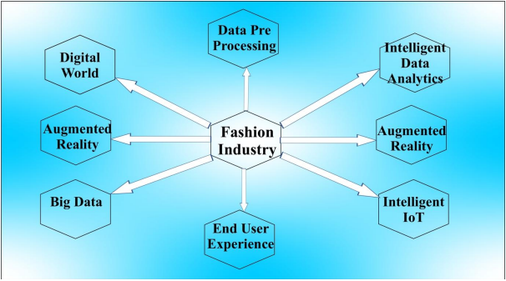
Figure 8: AI in the Fashion Industry
(Source: Rathore, 2023)

9. Conclusion
The comparative analysis of two completely different developing and developed economies for Zara emphasised understanding the global standardisation of the operation, which has already been adopted through Product assortment, pricing and better distribution. Considering both the emerging and cultural market of India and the mature and sustainability-driven environment of the UK. While the hydro potential market of India provides opportunities through business ventures, like joint ventures or its own model, these approaches also require understanding the capacity of the local people. On the other hand, the mature market of the UK demands ethical, transparency and comparative positioning. The strategic challenge is in sustainable global efficiency while also responding to the diverse pressures coming from the external aspect. The long-term success of the brand depends on the collaboration of sustainability and technical innovation, together with cultural sensitivity.

SECTION 2: REFLECTIVE ACCOUNT

1. Description
In completing this report, I have adhered to a research and analytical method to study the international marketing strategy of Zara in India and the United Kingdom. I started identifying the relevant scholarly theories regarding internationalisation, global marketing strategy and fast fashion business models (Wiśniewski, 2025). I have employed peer-reviewed journal articles, industry reports, corporate publications and market research databases to be academically credible. These readings assisted me in knowing theoretical ideas, as well as practical ones.
I subsequently gathered macro-environmental and country-specific information in each country, concentrating on economic and cultural attributes and infrastructures in the retail sector. To make the comparative analysis logically structured, I used analytical frameworks of PESTEL, STP and the 7Ps marketing mix. I also used the internationalisation theories, such as the Uppsala Model and the Eclectic Paradigm, to discuss the entry mode and globalisation strategy used by Zara.
In the process of writing, I also made sure that the analysis was comparative as opposed to being descriptive. I paid attention to connecting the theoretical assumptions and practical evidence on the market and kept in touch with the necessary framework.

2. Feelings
During the first phase of this task, I was confused about the complexity of trying to make comparisons between two structurally different markets. India and the UK are very dissimilar in the aspect of economic growth, consumerism, and the values of the culture which made it difficult to have a balanced analytic view (Apel and Bokhari, 2025). I was also worried in the beginning whether I was going to be able to combine the theoretical frameworks and also be able to back up my arguments with other credible data.
But with the course of the research, I slowly gained confidence in my analytical skills. The use of models like PESTEL and STP offered an evident framework, and the application of these models led me to simplify the complex information and divide it into easy-to-understand parts. What also gave me greater confidence is when I had a chance to relate theoretical models with practical strategic decisions made by Zara. This experience helped me to get a better insight on the way international marketing strategies work within various market environments.

3. Evaluation
A very useful application of analytical frameworks to frame the report was also one of the most positive aspects of this process. The use of PESTEL allowed me to connect the macro-environmental factors with the strategic decisions, whereas STP and the 7Ps allowed me to take a more critical look at the market positioning and marketing mix of Zara. This methodical process enhanced the logicality and the flow of my analysis.
Nonetheless, there existed difficulties too. To get uniform and similar information across the two countries, the choice of the sources had to be taken seriously, and certain information was more available to the UK than to India. Also, it was necessary to plan and revise the amount of words and retain the level of analysis. Nevertheless, the experience has helped me to develop my research skills, facilitate my capabilities to utilize theoretical concepts and sharpen my critical thinking in the study of international marketing.

4. Analysis
In the task, there are applications of the relevant and applicable theoretical frameworks cab easily help in the development of the capability for making the analysis appropriately (Luft et al., 2022). The application of PESTEL has been helpful for a systematic breakdown of challenges and micro-environmental forces, rather than for any unrealistic comparisons across regions. The inclusion of different cultural dimensions in this research has also helped explain differences in behaviour between the collectivist Indian consumer and the individualistic UK consumer, thereby enhancing the interpretive element. The discussion on developing the analysis approach to the current information on Zara's market situation, and on standardising and refining the approach, provided a conceptual framework for better analysis of the global market situation of Zara. The research has focused on the operational efficiency with the help of the globalisation theory and the contingency theory related to the market-specific adjustments.
Apart from that, the application of stakeholder evaluation in this research, along with the ethical analysis have also altered the concept of the discussion related to the corporate reputation for the maintenance of accountability frameworks in a broader way. This enhanced the critical analysis by placing Zara in the global ESG context for the maintenance of sustainability (Mehmeti, 2025). Overall, the theoretical application and analysis of different economies have been very helpful in converting raw market information into a comprehensive analysis, and the well-structured argument developed has been instrumental in this process. The procedure overall has created a better understanding and the capability for the evaluation and the analysis of the task.

5. Conclusion
This evaluation has taken a central role in the alteration of the perspective related to global branding, as I started perceiving the international marketing strategy for maintaining the balance between efficiency and environmental responsiveness. The comparison between the different regions of India and the UK has demonstrated that the concept of macro-environmental variation requires balancing the concept of adaptation, rather than focusing on the standardisation on an equal basis.
Overall, this project has improved my ability to convert the secondary information into comprehensive analytical information. The practical application of the frameworks has further highlighted the significance of theoretical frameworks at the postgraduate level. Additionally, the ethical evaluation has also highlighted that the marketing choices are not only focusing on the profitability but also on the administration of the sustainability and accountability to the stakeholders. This has enhanced my understanding of strategic marketing as shifting from a transactional exchange to value creation over the long term.

6. Action Plan
Specific | Measurable | Attainable | Relevant | Time-bound
Gather academic sources earlier | Minimum 15 peer-reviewed articles per assignment | Through the structured database search | Improves analytical depth | Within the first 2 weeks of task release
Strengthen data triangulation | Use at least 3 data types (academic, industry, governmental) | Yes | Enhances credibility | Every future assignment
Integrate theory more explicitly | Apply a minimum of 4 frameworks per major analysis | Achievable with planning | Supports Level 7 standards | Next semester onward
Improve time management | Draft completion 10 days before the deadline | Yes, with schedule planning | Reduces pressure | Immediate implementation.

REFERENCE LIST
Abbate, S., Centobelli, P., Cerchione, R., Nadeem, S.P. and Riccio, E., (2024). Sustainability trends and gaps in the textile, apparel and fashion industries: S. Abbate et al. Environment, development and sustainability, 26(2), pp.2837-2864. https://link.springer.com/content/pdf/10.1007/s10668-022-02887-2.pdf
Apel, L. and Bokhari, Z.F., (2025). Consumer Perception of Sustainable Fashion: A Cross-Cultural Comparison between South Asia and Europe. https://www.diva-portal.org/smash/get/diva2:1989189/FULLTEXT01.pdf
Arimany Serrat, N., Arribas-Ibar, M. and Erdoğan, G., (2025). Fast Fashion Sector: Business Models, Supply Chains, and European Sustainability Standards. Systems, 13(6), p.405. Available at: https://www.mdpi.com/2079-8954/13/6/405 (Accessed on 16th February 2026)
Babatunde, O., Oludoye, O. and Hamzah, T.A.A.T., (2025). Beyond fast fashion: consumer behavior, microfibre pollution, and sustainable fashion choices in the UK. Journal of Environmental Studies and Sciences, pp.1-16. Available at: https://link.springer.com/article/10.1007/s13412-025-01028-1 (Accessed on 16th February 2026)
Baena, V., (2024). The shift from fast fashion to socially and sustainable fast fashion: The pivotal role of ethical consideration of consumer intentions to purchase Zara. Corporate Social Responsibility and Environmental Management, 31(5), pp.4315-4328. https://onlinelibrary.wiley.com/doi/pdf/10.1002/csr.2803
Benavides, G.F., (2024). Evolution of INDITEX group’s internationalization strategy in Latin America. Cuadernos de Administración (Universidad del Valle), 40(79). http://www.scielo.org.co/scielo.php?pid=S0120-46452024000200008&script=sci_arttext&tlng=en
Bordo, M., Bush, O. and Thomas, R., (2022). “Muddling Through or Tunnelling Through?” UK monetary and fiscal exceptionalism during the Great Inflation. https://www.hoover.org/sites/default/files/2023-02/Muddling%20through%5B100%5D%5B2%5D.pdf
Del Olmo Arriaga, J.L., Pretel-Jiménez, M. and Ruíz-Viñals, C., (2025). From fast fashion to shared sustainability: The role of digital communication and policy in generation Z’s consumption Habits. Sustainability, 17(18), p.8382. Available at: https://www.mdpi.com/2071-1050/17/18/8382 (Accessed on 16th February 2026)
Diaz, E.M., Cunado, J. and de Gracia, F.P., (2024). Global drivers of inflation: The role of supply chain disruptions and commodity price shocks. Economic Modelling, 140, p.106860. https://www.sciencedirect.com/science/article/pii/S0264999324002177
Gasamáns Gesto, L., (2023). A change beyond fast fashion: An analysis of Zara’s positioning and communication. https://ruc.udc.es/bitstreams/04fa47fc-e148-402b-9d08-002f7cf0ab7a/download
Gupta, A.S. and Mukherjee, J., (2022). Long-term changes in consumers' shopping behavior post-pandemic: an exploratory study. International Journal of Retail & Distribution Management, 50(12), pp.1518-1534. https://www.emerald.com/ijrdm/article-pdf/50/12/1518/1073698/ijrdm-04-2022-0111.pdf
Jiang, B., (2022). How Consumers’ Response on CSR Affects Brand Competitiveness in the Fast Fashion Industry——Case Study of Zara (Inditex) and H&M. Academic Journal of Business & Management, 4(1), pp.100-110. https://www.francis-press.com/uploads/papers/aF896x2wBDrtm4geO9ghg15MGfULlKIX2eUi0txT.pdf
Kesidou, E. and Palm, C., (2025). Challenges of New Regulations and Strengths of Eco-Credential Standards in the UK’s Textile and Fashion Industry. https://eprints.whiterose.ac.uk/id/eprint/226876/1/Report2_Kesidou%20%26%20Palm.pdf
Kutaula, S., Gillani, A., Gregory-Smith, D. and Bartikowski, B., (2024). Ethical consumerism in emerging markets: opportunities and challenges. Journal of Business Ethics, 191(4), pp.651-673. https://link.springer.com/content/pdf/10.1007/s10551-024-05657-4.pdf
Liu, H. and Bai, H., (2022, September). Examining the Glocalised Marketing Strategies of Luxury Fashion Retailers in China. In Colloquium on European Research in Retailing Book of Proceedings (pp. 181-189). University of Zagreb. https://researchonline.ljmu.ac.uk/id/eprint/17605/7/Examining%20the%20Glocalised%20Marketing%20Strategies%20of%20Luxury%20Fashion%20Retailers%20in%20China.pdf
Luft, J.A., Jeong, S., Idsardi, R. and Gardner, G., (2022). Literature reviews, theoretical frameworks, and conceptual frameworks: An introduction for new biology education researchers. CBE—Life Sciences Education, 21(3), p.rm33. https://scholar.google.com/scholar?output=instlink&q=info:KRGReB9ts4gJ:scholar.google.com/&hl=en&as_sdt=0,5&as_ylo=2022&scillfp=14968634183623594886&oi=lle
Maduku, D.K. and Phadziri, F.R., (2025). Foreign firms’ cross-cultural competence and pro-domestic purchasing behaviours: How relevant are social norms?. Global Business Review, 26(3), pp.612-638. https://www.researchgate.net/profile/Daniel-Maduku/publication/353639534_Foreign_Firms%27_Cross-cultural_Competence_and_Pro-domestic_Purchasing_Behaviours_How_Relevant_Are_Social_Norms/links/612032061e95fe241ae73055/Foreign-Firms-Cross-cultural-Competence-and-Pro-domestic-Purchasing-Behaviours-How-Relevant-Are-Social-Norms.pdf
Mehmeti, A., (2025). Circular Economy in Fashion Industry, ESG Reporting of Case Study: Inditex Group. https://www.theseus.fi/bitstream/handle/10024/902898/MehmetiAlbine.pdf.pdf?sequence=2
Metcalf, M. and Hinske, C., (2022). Circular economy leadership: Leadership mindsets and behaviours–the unseen impossibility. In The Impossibilities of the Circular Economy (pp. 103-113). Routledge. https://api.taylorfrancis.com/content/chapters/oa-edit/download?identifierName=doi&identifierValue=10.4324/9781003244196-12&type=chapterpdf
More, A., (2024). Analysing the Application of Behavioural Economics Principles in Zara's Marketing Strategy in India. Available at SSRN 5741625. https://papers.ssrn.com/sol3/Delivery.cfm?abstractid=5741625
More, A., (2024). Analysing the Application of Behavioural Economics Principles in Zara's Marketing Strategy in India. Available at SSRN 5741625. https://papers.ssrn.com/sol3/Delivery.cfm?abstractid=5741625
Moshood, M., (2025). Assessing brand-driven supply chain customization and its role in enhancing operational efficiency and sustained market expansion for global enterprises. Int J Adv Res Publ Rev, 2(8), pp.32-50. https://www.researchgate.net/profile/Modinat-Moshood/publication/394406659_Assessing_Brand-Driven_Supply_Chain_Customization_and_its_Role_in_Enhancing_Operational_Efficiency_and_Sustained_Market_Expansion_for_Global_Enterprises/links/68962f5b37ccad61380433cb/Assessing-Brand-Driven-Supply-Chain-Customization-and-Its-Role-in-Enhancing-Operational-Efficiency-and-Sustained-Market-Expansion-for-Global-Enterprises.pdf
Ospital, P., Masson, D., Beler, C. and Legardeur, J., (2023). Toward product transparency: communicating traceability information to consumers. International Journal of Fashion Design, Technology and Education, 16(2), pp.186-197. https://www.researchgate.net/profile/Jeremy-Legardeur/publication/365894867_Toward_product_transparency_communicating_traceability_information_to_consumers/links/6841964b6b5a287c304970f1/Toward-product-transparency-communicating-traceability-information-to-consumers.pdf
Rathore, B., (2023). Integration of Artificial Intelligence& It’s Practices in Apparel Industry. International Journal of New Media Studies (IJNMS): Vol. ISSN. https://www.researchgate.net/profile/Bharati-Rathore-2/publication/368837157_Integration_of_Artificial_Intelligence_It's_Practices_in_Apparel_Industry/links/63fcae850cf1030a5657c5b8/Integration-of-Artificial-Intelligence-Its-Practices-in-Apparel-Industry.pdf
Sengupta, A., Wesley, S., Cavender, R. and Lee, M.Y., (2022). Global vs local: Analysis of the consumer-brand relationships in India. International Journal of Retail & Distribution Management, 50(3), pp.361-376. https://www.researchgate.net/profile/Rayecarol-Cavender/publication/357154862_Global_vs_local_analysis_of_the_consumer-brand_relationships_in_India/links/648370582cad460a1b0090fc/Global-vs-local-analysis-of-the-consumer-brand-relationships-in-India.pdf
Shen, Y. and Chen, Y., (2024). Research on Zara Digital Marketing Strategy. Academic Journal of Business & Management, 6(8), pp.101-108. https://www.francis-press.com/uploads/papers/GTCSf6yeoF5cvoHaB0wSVrEqID7P4vvu5dsnGnqi.pdf
Sheth, J.N., Jain, V., Roy, G. and Chakraborty, A., (2022). AI-driven banking services: the next frontier for a personalised experience in the emerging market. International Journal of Bank Marketing, 40(6), pp.1248-1271. https://scholar.google.com/scholar?output=instlink&q=info:DlBoKfxZRYIJ:scholar.google.com/&hl=en&as_sdt=0,5&as_ylo=2022&scillfp=10272023814677805427&oi=lle
Statista.com (2026). Size of fast fashion market in India for financial year 2023 and 2024, with estimates until 2030. Available at: https://www.statista.com/statistics/1557026/india-fast-fashion-market-size/ (Accessed on 16th February 2026)
Statista.com (2026). Zara brand awareness, usage, popularity, loyalty, and buzz among fashion store customers in the UK in 2022. Available at: https://www.statista.com/forecasts/1335667/zara-fashion-stores-brand-profile-in-the-uk/?srsltid=AfmBOopR0CjaZJIvSTmezOTXbgzikzCP3JqLlNg_TBx1aC0BkdyLbAuj (Accessed on 16th February 2026)
theculturefactor.com (2026). Country Comparison tool. Available at: https://www.theculturefactor.com/country-comparison-tool (Accessed on 16th February 2026)
Velluti, S., (2024). Labour standards in global garment supply chains and the proposed EU corporate sustainability due diligence directive. European Labour Law Journal, 15(4), pp.822-850. https://journals.sagepub.com/doi/pdf/10.1177/20319525241239283
Wadud, I., Liang, Y.D. and Polkinghorne, M., (2025). Digital Transformation in the UK Retail Sector. Encyclopedia, 5(3), p.142. Available at: https://www.mdpi.com/2673-8392/5/3/142 (Accessed on 16th February 2026)
Wiśniewski, A., (2025). Fast fashion business model: a review of innovation potential and environmental risks. Economics and Environment, 93(2), pp.944-944. https://ekonomiaisrodowisko.pl/journal/article/download/944/886
Yang, B., (2025), July. Analysis of Zara’s Fast Fashion Supply Chain Rapid Response Strategy. In 2025 11th International Conference on Humanities and Social Science Research (ICHSSR 2025) (pp. 1339-1352). Atlantis Press. https://www.atlantis-press.com/article/126013644.pdf
Zhang, E., (2024). Behind Zara’s success: An analysis of brand marketing and management in fast fashion. In SHS Web of Conferences (Vol. 199, p. 02005). EDP Sciences. https://www.shs-conferences.org/articles/shsconf/pdf/2024/19/shsconf_iclrc2024_02005.pdf
ZHANG, L., (2024). Maximizing Profits and Enhancing Efficiency in Fashion Supply Chain Management: An Analytical and Numerical Model Addressing RFID Technology. Omnichannel Strategies, and Environmental and Social Aspects. https://tsukuba.repo.nii.ac.jp/record/2012851/files/DA11058.pdf
Zhou, J., (2025). Marketing Strategy for a Fast Fashion Brand Based on SWOT: The Case of ZARA. Finance & Economics, 1(6). https://lseee.net/index.php/fe/article/download/1850/FE009412.pdf

