
BA (Hons) Business Management
Module: Principles of Human Resource Management
Module code: LCBB5012
Student name: Nicoleta Carp
Student ID: 2125547

Table of Contents
1.Introduction 3
2. External and Internal Environment (PESTLE Model) 3
2.1 Overview of PESTLE 3
2.2 PESTLE and HR functions 4
3. Organisation Application 5
3.1 Organisation Introduction 5
3.2 HR Practices in Jaguar Land Rover (JLR) 5
4. Application of Model (PESTLE in HR context) 6
4.1 Impact on organisation 6
4.2 Country Differences Cultural Differences: 7
5. Conclusion 8
5.1 Summary 8
5.2 Future Implications 8
References 10

1.Introduction
The role of a Human Resource (HR) manager in the organisation is crucial to its overall effectiveness as they deal with an organisation’s most critical resource, which are its people. The main areas covered by the HR function are selection and recruitment, training and development, performance appraisal and employee relations. Selection and recruitment is a key area, as only the most appropriate individual (with suitable skills and who would fit into the organisation’s culture) will improve productivity and the long-term success of the organisation. Training and development has the purpose of increasing individual competence, enabling employees to adapt to new technology and to keep competitive in changing times. Performance appraisal is concerned with linking individual performance with organisational objectives and employee relations is about developing and maintaining a positive employee environment in order to decrease the incidence of industrial action. However, the HR manager does not work in a vacuum; their actions are influenced by internal and external environmental factors (organisational culture, style of management, economy, legal and technological change (Bratton et al.,2021).

2. External and Internal Environment (PESTLE Model)

2.1 Overview of PESTLE
The PESTLE model allows an insight into the external macro-environment surrounding businesses. The model encompasses political, economic, social, technological, legal and environmental influences affecting the decisions that businesses make ((Zhang, 2026). Through HR managers this enables understanding of the external factors that may be affecting employee related decisions.
Usefulness of PESTLE: The PESTLE model can prove useful because of the structured and prospective nature of its framework. By using this model HR managers can anticipate and consequently plan ahead for certain environmental shifts. Political and legal influences, for example, have effects on the decisions around workforce related strategies and policies such as labor laws and employment policies, as do economic issues for workforce planning, wages and recruitment and social factors on training, engagement and so forth (Mesut, 2026).
Weaknesses of PESTLE: Despite being incredibly helpful the PESTLE model has some disadvantages. The model does not focus enough on the internal factors of a company; such as the attitude and behavior of staff members or internal leadership styles. Additionally the model produces broad predictions rather than direct solutions, so interpretations and conclusions drawn should only be considered a basis of planning and not applied directly by HR managers (Jahiu et al., 2025).
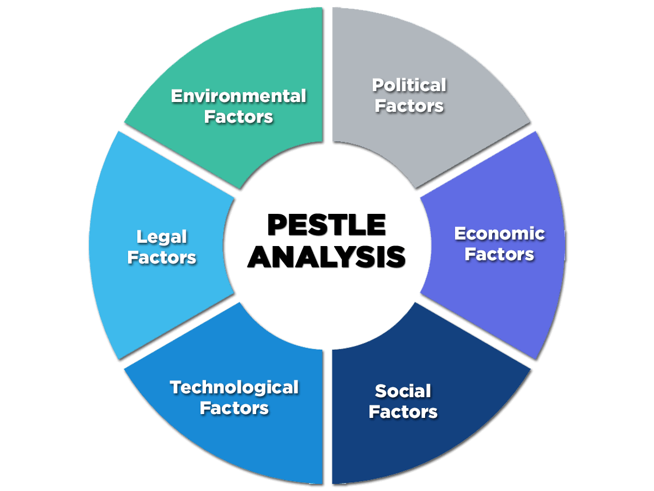
Figure 1: PESTLE MODEL
(Source: Self-created)

2.2 PESTLE and HR functions
The PEESTLE model can be directly related to some core HR functions. Political and legal factors are related to recruitment, and employee relations, where the company must comply with a myriad of labor laws and policies (Szőke and Lakosy, 2025).
Political Factors (Recruitment and Employee Relations): It is the HR managers' responsibility to ensure the organisation comply with diversity requirements, labor regulations, national policies, and other applicable employment policies and procedures and union rules and regulations. Political stability enables long term work-force planning and employees relation strategies (Fleming-Carroll, 2023).
Legal Factors (Compliance and Workplace Practices): HR functions are strongly influenced by the legal environment. These include working hours, labor wages, anti-discrimination, health and safety, labor laws the organisation has to adhere (Shan, 2025). All these laws have a significant impact on recruitment, employment contracts, performance management and disciplinary actions, and they must all be properly applied to avoid legal penalty and to guarantee a just workplace.
Economic Factors (Wages and Workforce Planning): The Gross domestic product for the United Kingdom was £2.8 trillion for 2025. This is higher compared to previous years as for 2024 the GDP of the UK was approximately £2.78 trillion (Statista, 2025). Workforce planning, job security and recruitment strategies depend heavily on economic factors. During periods of expansion firms hire more, and offer higher wages and during recessions, they reduce staff. Labor market competition and labor costs impact wages determination and the planning of human resources (Berger et al., 2026).
Social Factors (Diversity and Workforce Trends): Cultural aspects, population trends and the employees' wish shape the HR strategies (Nazir et al., 2026). HR managers have the responsibility to create a welcoming working place by developing suitable policies in the work environment that enable employee's wellbeing and a balance between work life and private life. Also job satisfaction and employee engagement practices are affected.
Training and Performance Management (Technological Factors): These include online training systems, digital recruitment system and performance management system, the evolution of HR processes due to technological advances are very important. New skills requirements by automation and AI need training in the work place, and the HR managers have to integrate changes due to technology. This increases the employee's productivity and efficiency (Udulu and Gorondutse, 2026).
Environmental Factors (Sustainability and CSR): Work place strategies are comply with environmental factors i.e. the Corporate Social Responsibility (CSR) and the sustainability. Organisations are encouraged to be on environmentally conscious and promote the environmentally friendly practices. HR plays the key role in promoting appropriate in green policies (Oyenuga, 2026).

3. Organisation Application

3.1 Organisation Introduction
Jaguar Land Rover (JLR) is a luxury motor car manufacturer headquartered in Coventry, United Kingdom. JLR is a subsidiary of Tata Motors and its operations spans in over 100 countries globally. It is a highly reputable company that produces premium motor cars under the Jaguars and Land Rover brands. JLR currently has operations in the United Kingdom, Slovakia, India and China (Jaguar Land Rover, 2026). Its international operations have greatly assisted the company to achieve its global presence. Operating on an international scale implies that JLR is involved in the management of a diverse multicultural workforce in diverse culture, law and economic conditions.

3.2 HR Practices in Jaguar Land Rover (JLR)
Recruitment: JLR uses an integrated approach for international recruitment and allows local customisation when needed. The organisation ensures a strong candidate pool is maintained by focusing on developing its employer brand, having comprehensive graduate programs, and working with academic institutions. The recruitment practices of JLR comply with local labour laws and also respond to labor market dynamics of specific nations.
Training and Development: JLR places emphasis on employee development. Through its technical training programs, leadership training, and e-learning opportunities, it provides development of skills that are crucial to employee development. These programs are adapted to international standards and also address specific local needs to equip employees with the necessary skills for technological advancement in the automobile industry (Obeng-Tuaah, 2025).
Performance Management: The organisation has set systematic performance management processes in place that ensures that individual performance contributes towards the overall organisation objectives. JLR uses periodic appraisals, continuous feedback, and performance based rewards as ways to promote productivity and accountability among its employees across various regions (Leavitt et al., 2025).
Employee Relations: Jaguar Land Rover's employees relations are driven by principles of communication, employee involvement, and equal treatment of all employees in the work place. While taking local cultural norms into consideration, the organisation addresses local legal regulations governing the workplace at various locations. It also collaborates with labor unions where appropriate to foster good industrial relations (Ganguly et al., 2025).

4. Application of Model (PESTLE in HR context)

4.1 Impact on organisation
Political and Legal factors: The model PESTLE influences the HR practices in the organisation like Jaguar Land Rover (JLR) which is a global car company functioning in many countries(Jahiu et al., 2025). Politics and laws impact the decisions related to HR to a large extent as JLR has to maintain standards and policies regarding working environment at all their functioning regions like UK, Europe, India and China by adhering to the varying rules of labor, acts and statutes imposed by each country's government. For example, stringent employment protection rules in the UK and the EU would be relevant for recruitment, employee contracts and termination procedures
Economic factors: The economical condition also plays a very crucial role in HR strategies followed by JLR. In a developed country like the UK or Europe where the cost of labor is high, HR managers are expected to optimise on efficiency and automation and attract talented professionals to continue working in the organisation, whereas in countries like India large scale recruitments and cost-effective workforce planning would be preferred. Economic slumps, recessions and consumer interest towards the brand also have an impact on recruitment decisions, wages paid to employees and restructuring of the workforce (Mujtaba and Vardarlier, 2025).
Social and Cultural factors: Differences in the social and cultural structure of the various countries would also influence the way human resources are managed at JLR. For instance, a more communal-centric culture as compared to that in India would highlight the importance of group work, respect to seniority and unity at the workplace. On the other hand a culture such as that in the UK would highlight individual performances, flexibility, autonomy and appraisal systems at work which the company would need to reflect in its management practices (Vuong and Nguyen, 2022).
Technological and Environmental factors: Technology will play a crucial role for a company like JLR in a way for their operations such as shifting towards electrical vehicles and smart technology to drive their business forward and digitally managed HR systems can be used in the areas of recruitment, training and performance management(Jaguar Land Rover, 2026). Environment too is of vital importance for a car company as the company should make its employees conscious about protecting the environment and working with zero emissions by adapting environmental policies.
Impact on internal organisation's practices on HR effectiveness
Internal factors at JLR such as the company's structure, leadership styles, and culture will also impact HR effectiveness at the organisation. Its strong engineering culture and emphasis on innovation at work would surely be instrumental in talent management and appraisal processes(Wang et al., 2022). It is to be kept in mind that having a work force at different parts of the world creates issues on maintaining global standards.
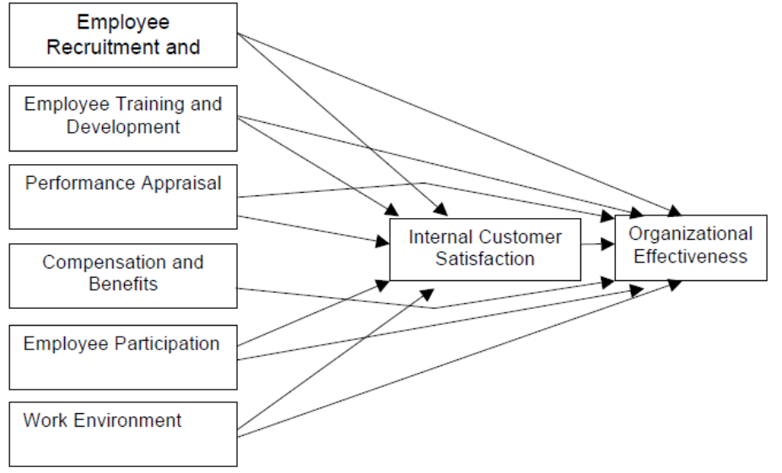
Figure 2: Practices on HR effectiveness
(Source: Self-created)

4.2 Country Differences Cultural Differences:
Cultural differences play a huge part in the comparison of HR management at Jaguar Land Rover in comparison to Toyota Motor Corporation. At Jaguar Land Rover in the UK, formal career progression, structured performance management and formal communication are key in the eyes of employees. At the other end of the world in India, HR strategies are centered on skill enhancement and management of an inclusive, multi-skilled workforce(Vuong and Nguyen, 2022) Conversely, within Toyota's culture of long-term employment, teamwork and consensual decision making within the company, the approach in Japan can be perceived as more collectivist and less focused on performance as compared to Jaguar Land Rover's more Western, performance driven ethos.
Legal Differences: Legal frameworks vary dramatically across countries and therefore have a significant impact on the way that HR operates. Jaguar Land Rover operates under stringent labor laws in the UK and Europe, covering employee rights and the like, with extensive involvement from trade unions and clear regulations governing redundancies and working hours, meaning that the HR system must be highly structured. Toyota also follows stringent regulations for labor laws in Japan; however this is considerably more flexible for its overseas operations (Toyota,2026).
Economic Differences: The economy itself plays a part in dictating the approach that HR must take at the national level. Both Toyota and Jaguar Land Rover strive to retain skilled workers and invest heavily in high technology and employee compensation in the developed economies such as the UK and Japan. Emerging economies like India, however see a focus on cost effectiveness and a rapid increase in the number of employees. Unemployment rates, inflation, as well as the state of the automotive industry contribute to a wide range of issues which dictate the need to change strategies regarding recruitment, compensation and restructuring (Venkat et al., 2023).

5. Conclusion

5.1 Summary
This report proves that the role of HR managers exists within a highly complex system impacted by internal as well as external forces. HR practices are affected greatly by internal factors such as structure, leadership and culture that directly impacts the ability to execute and be efficient. External forces impact the work that HR carries out based on its environment using the PESTLE model in the form of politics, economics, social factors, technology, law and the environment influencing recruitment, training, performance appraisal and the relationships that are maintained with staff. In terms of HR practices applied within the business world and more specifically within Jaguar Land Rover (JLR) it has been noted that HR practices will always need to be adaptable to each country and culture, law and economy of that country.

5.2 Future Implications
The global nature of future business will present HR managers with a rapidly evolving and complicated environment. Technology such as artificial intelligence, big data and various HR based platforms will revolutionise HR practices within recruitment, training and performance management. Greater global mobility and culture diversity within a workforce will require enhanced cross cultural understanding among HR managers and more fluid management styles. As global standards of sustainability and corporate social responsibility will grow to incorporate environmental practices into the workplace it will become necessary for HR managers to adopt a new approach towards managing. The role of future HR managers will be to continually analyse and react to changes within their external environment while still maintaining globally set HR standards within local circumstances to ensure business efficiency. Those organisations which provide their HR managers with adequate future-looking strategic knowledge and digital skills while fostering a cross-cultural aptitude will succeed in the competitive landscape while boosting employee performance and long term viability.

References
Berger, D., Herkenhoff, K. and Mongey, S., (2026). Labor Market Power: From Micro Evidence to Macro Consequences. Journal of Economic Perspectives, 40(1), pp.93-114.
Bratton, J., Gold, J., Bratton, A. and Steele, L., (2021). Human resource management. Bloomsbury Publishing.
Fleming-Carroll, B., (2023). Strategic Workforce Planning for Health Human Resources. Canadian Journal of Nursing Research.
Ganguly, A., Joseph, J.M., Dutta, S. and Dey, K., (2025). Exploring the employer–employee relationship: a management versus employee perspective of the vicissitudes in the virtual workplace. Global Business Review, 26(6), pp.1664-1693.
Jaguar Land Rover (2026) About Jaguar Land Rover. Available at: https://www.jlr.com/ (Accessed: 5 May 2026).
JAHIU, F., DANILOSKA, N., MIRCHEVSKA, T.P. and BOSHKOVSKA, D., (2025). IMPACT OF BUSINESS MACRO ENVIRONMENT ON THE SMALL BUSINESS MANAGEMENT IN THE REPUBLIC OF NORTH MACEDONIA–PEST ANALYSIS. Economic Development/Ekonomiski Razvoj, 27.
Leavitt, K., Barnes, C.M. and Shapiro, D.L., (2025). The role of human managers within algorithmic performance management systems: A process model of employee trust in managers through reflexivity. Academy of Management Review, 50(4), pp.745-767.
Mesut, C., (2026). Competitive Advantage Through Strategic. Bridging Traditional Theory and Emerging Corporate Strategies, 111.
Mujtaba, B.G. and Vardarlier, P.(2025). Recession Uncertainties and Socioeconomic Challenges for the Modern Workforce: Proactively Managing Real and Perceived Financial Depressions. SocioEconomic Challenges, 9(4), pp.38-61.
Nazir, M.A., Azam, I. and Zhu, X., (2026). Strategic HR in the digital era: synergising retention, inclusion and AI-driven practices for organisational performance in the IT industry. Journal of Organizational Effectiveness: People and Performance, pp.1-30.
Obeng-Tuaah, M., (202). Employees Training and Development to Enhance Organisational Performance: A Systematic Review: Employees Training and Development to Enhance Organisational Performance. International Journal of Multidisciplinary Studies and Innovative Research, 13(1), pp.1-15.
Oyenuga, M.O., (2026). Competitive Intelligence in Sustainability and Corporate Social Responsibility (CSR). In Competitive Intelligence in the Digital Age: Strategies for Business and Technology Leadership (pp. 65-102). IGI Global Scientific Publishing.
Shan, D.K., (2025). Legal foundations in business: Key factors influencing modern practices. OTS Canadian Journal, 4(1), pp.8-16.
Szőke, J. and Lakosy, D., (2025). Corporate Social Responsibility from the Aspect of Sustainability—Evidence from the Hungarian HR Sector. Administrative Sciences, 15(5), p.159.
Statsta, (2025), UK GDP, Available at:https://www.statista.com/statistics/281744/gdp-of-the-united-kingdom/ (Accessed: 5 May 2026).
Toyota (2026) About Toyota. Available at: https://www.toyota.co.uk/ (Accessed: 5 May 2026).
Udulu, U.F. and Gorondutse, A.H., (2026). Training Evaluation, Performance Management, and Environmental Analysis as Predictors of Organizational Growth in the Third FADAMA National Development Project. Journal of Institute of Africa Higher Education Research and Innovation (IAHERI), 2(1), pp.170-180.
Venkat, M.V.V., Khan, S.R.K., Gorkhe, M.D., Reddy, M.K.S. and Rao, S.P., (2023). Fostering talent stability: a study on evaluating the influence of competency management on employee retention in the automotive industry. Remittances Review, 8(4), pp.2300-2328.
Vuong, T.D.N. and Nguyen, L.T., (2022). The key strategies for measuring employee performance in companies: a systematic review. Sustainability, 14(21), p.14017.
Wang, L., Zhou, Y. and Zheng, G., (2022). Linking digital HRM practices with HRM effectiveness: The moderate role of HRM capability maturity from the adaptive structuration perspective. Sustainability, 14(2), p.1003.
Zhang, Q., (2026). External and Internal Analysis of Mid-sized Shipping Company.

