Market analysis and Product description of a Coffee Shop Business

Student: Mihai Tilea (2124071)
Lecturer: Alfred Mensah
University Of Wales Trinity Saint Davis
Module: BMSW4006_LON
Date: 09.02.2023

Introduction
This report is about the market analysis and product description of a coffee shop business. This report will provide an overview of the market opportunity and product details to help the business owner plan and grow their business. It will provide insights into the competitive landscape, target customer demographics, positioning strategy and pricing. It will also provide details about the products and services offered, including coffee selections, pastries, and sandwiches. Finally, the report will provide recommendations for marketing and promotional strategies to help the business succeed.

Market analysis
The coffee shop industry has become one of the most popular and profitable industries in recent years. Coffee shops have become a popular destination for people of all ages, offering a wide range of services and products. With the growth of the industry, the competition has become fierce. A thorough market analysis of a coffee shop business is essential for the success of any new or existing business. A market analysis of a coffee shop business requires an understanding of the industry and its current trends, as well as an understanding of the target market. By understanding the industry and the target market, a business can gain a better understanding of the competition and identify opportunities and threats in the market. This market analysis will provide an in-depth look at the coffee shop industry, the current trends, the target market, the competition, and the opportunities and threats in the market.
The coffee shop industry is one of the most popular and profitable industries in the United States. The industry has grown steadily in recent years and is expected to continue to grow over the next five years. According to Statista, the coffee shop industry in the US was estimated to be worth $45.3 billion in 2020 and is expected to grow to $54.8 billion by 2025. The industry is highly competitive and is dominated by a few large players. The top five players in the industry account for over 75% of the market, with Starbucks, Dunkin’ Donuts, and McDonald’s leading the way. Other players in the industry include Peet’s Coffee, Caribou Coffee, and Tim Hortons (TS, 2021).
Current Trends
Current Trends: Digital marketing has become an essential part of marketing for any business, including coffee shops. This includes marketing on social media platforms like Facebook, Instagram, and Twitter, as well as creating a website for your business and optimizing it for search engines.
Customer Segmentation: One of the most important aspects of marketing is to understand your customer base and segment them according to their interests and needs. This helps you tailor your marketing messages to their specific needs, which can result in higher conversion rates (Soedarsono et al., 2020).
Personalization: Personalizing your marketing messages is key to engaging with customers. This includes using customer data to tailor emails, ads, and other marketing messages to target customers with relevant content.
Data Analysis: Using data analysis to gain insights into customer behaviour and preferences is essential to understanding how customers interact with your business. This helps you optimize your marketing campaigns and improve your customer experience.
Content Marketing: Content marketing is a great way to engage with customers and build relationships. Creating content that provides value to your customers can help you set yourself apart from your competitors.
Target Market
The coffee shop industry is highly competitive, and it is essential for businesses to understand their target market in order to be successful. The target market for a coffee shop business consists of two main groups: millennials and Gen Z. Millennials, born between 1981 and 1996, are the largest consumer group in the United States, accounting for over one-third of all consumer spending. Gen Z, born between 1997 and 2012, is the next largest consumer group, accounting for 25% of consumer spending. Both millennials and Gen Z are highly engaged with the coffee shop industry, with millennials accounting for over 53% of all coffee shop visits, and Gen Z accounting for 28%. Both groups are also highly engaged with mobile ordering and delivery, with millennials accounting for 77% of all mobile orders, and Gen Z accounting for 51% (TS, 2021).
Competition
Competition in the marketing analysis of a coffee shop business is an important factor to consider when developing a business strategy. It is important to understand the competitive landscape in order to inform marketing decisions, such as pricing, product selection, and positioning. Competition can come from other coffee shops, as well as other food and beverage businesses such as restaurants, convenience stores, and fast food chains. It is important to understand how these competitors differentiate themselves, what their strengths and weaknesses are, and how they market themselves. Additionally, it is important to consider how their strategies might change or evolve over time. Understanding the competitive landscape can help inform decisions about pricing, product selection, and positioning. For example, if the competition is offering a higher-priced, premium product, a coffee shop might need to price its products differently in order to remain competitive (Jang and Lee, 2019). Additionally, if the competition is offering a wider selection of products, a coffee shop might need to consider expanding its own product selection to remain competitive. Finally, understanding the competition can help inform positioning decisions, such as whether to position a coffee shop as an upscale, speciality coffee shop or as a more casual, budget-friendly shop (TS, 2021).
Opportunities
- Growth of the Specialty Coffee Industry: The speciality coffee industry is growing rapidly, as more consumers become interested in higher-quality, speciality coffees. This presents an opportunity for a coffee shop business to capitalize on this trend and gain an edge in the market (MG, 2020).
- Expansion of Retail Locations: Coffee shop businesses have the opportunity to expand their retail locations, allowing them to capture a larger market share of the coffee industry. This will also allow them to reach more customers and expand their product offerings.
- Increasing Demand for Coffee Products: The demand for speciality coffee products is on the rise, as more and more consumers are looking for unique and high-quality products. This presents an opportunity for a coffee shop business to capitalize on this trend and differentiate its products from the competition (Erlina and Hermawan, 2021).
Threats
- Competition from Large Coffee Chains: Large coffee chains, such as Starbucks, present a major threat to independent coffee shops. These chains have the resources to offer a wide range of products and services, which can be difficult for smaller coffee shops to compete with.
- Increasing Coffee Prices: The cost of coffee beans is increasing due to a number of factors, including supply and demand. This can have a negative impact on a coffee shop business, as they may be forced to raise their prices to compensate for the increased cost of their product (MG, 2020).
- Changing Consumer Preferences: Consumer preferences can change quickly, and a coffee shop business must be able to stay ahead of the curve to remain competitive. If trends shift away from their current product offerings, they will need to adapt quickly or risk losing customers (Suhud et al., 2020).
The coffee shop industry is one of the most popular and profitable industries in the United States. As such, it is essential for businesses to understand the industry, the current trends, the target market, the competition, and the opportunities and threats in the market in order to be successful. A thorough market analysis of a coffee shop business is essential for the success of any new or existing business.

Product Description
A coffee shop business is a great way to bring people together in a relaxed and inviting atmosphere. Whether you're looking to open a small shop or a large chain, there are several factors to consider when planning your business. Here are some points to help you get started:
Location: Location is a critical factor in the success of a coffee shop business. The location should be in a high-traffic area with easy access for customers. It should also have an attractive storefront that will draw people in and provide ample parking for customers. Additionally, the coffee shop should be located within a vibrant neighbourhood where potential customers will congregate and be able to engage in conversation with others. The coffee shop should be easily visible from the street and have a convenient location for customers. Finally, the coffee shop should be easily accessible from public transportation and have a variety of food and beverage options to choose from (EH, 2021).
Menu: The menu in the product description of a coffee shop business would typically include a list of all the drinks and food items available. This could include coffee-based drinks like lattes, cappuccinos, and mochas, as well as hot and cold teas, iced drinks, smoothies, and other beverages. It might also include food items like pastries, bagels, sandwiches, salads, and other light snacks. Additionally, the menu could include any special items or seasonal offerings that the business has to offer (Sofia et al., 2020).
Equipment: Proper equipment is essential for a successful coffee shop. Depending on your budget, you may want to invest in professional-grade espresso machines, grinders, and other tools. Additionally, you'll need to purchase cups, saucers, spoons, and other supplies.
Staff: The staff in the product description of a coffee shop business are the people who will be working in the store. They should have a good knowledge of the products and services being offered, as well as excellent customer service skills. They should also be familiar with the store's policies and procedures, and be able to handle any complaints or questions customers may have. Depending on the size of the store, there may also be a need for baristas, cashiers, and other staff members to help with the day-to-day operations (Soedarsono et al., 2020).
Marketing: Marketing is essential for any business. Develop a plan to reach potential customers and let them know about your shop. Utilize social media, local advertising, and word of mouth to spread the word. Additionally, consider offering discounts or promotions to attract more customers.
Interior Design: Interior design in a coffee shop business is an important factor to consider when creating a successful business. It is the art of creating an inviting and comfortable atmosphere that will attract customers to your shop. This can be achieved through a variety of elements, such as colour schemes, lighting, furniture, artwork, and even the layout of the space. Interior design can also be used to create a unique and memorable experience for customers, which in turn can help to increase customer loyalty and sales. By creating an atmosphere that encourages conversation, encourages customers to stay longer, and creates a pleasant and inviting atmosphere, a coffee shop business can find success (Dharmayanti and Darma, 2020).
Customer Service: A great customer service experience is essential for any coffee shop. Customers should be greeted and served promptly, and the staff should be friendly and knowledgeable. Additionally, the shop should be kept clean and organized, with plenty of seating and comfortable spaces for customers to enjoy their drinks (STUDY, 2019).
Customer Loyalty: Building customer loyalty is key to the success of any business, and coffee shops are no exception. Offering loyalty programs, discounts, and rewards can help create a loyal customer base that will return time and time again. Additionally, coffee shops should look for ways to engage with their customers, such as hosting events or offering free samples (Rahardjo et al., 2019).
These are just a few of the points to consider when starting a coffee shop business. With careful planning and hard work, you can turn your vision into a successful business.

Conclusion
The coffee shop business is a viable business to venture into and can be a great source of income. This market analysis and product description report has provided an overview of the coffee shop industry, and the best practices to ensure success. With the right marketing, customer service, and product offering, a coffee shop business can be a great success. The key to success is to focus on creating a unique and enjoyable customer experience, as well as creating a product offering that caters to the local market. With the right blend of talent and dedication, a coffee shop business can be a great success.

Reference
Dharmayanti, P.D. and Darma, G.S., 2020. The use of Instagram in a coffee shops. International Research Journal of Management, IT and Social Sciences, 7(4), pp.48-56.
EH, 2021, “Coffee Shop Business Plan”, Available at https://www.experthub.info/launch/business-plans/sample-business-plans-link/coffee-shop-business-plan/ [Accessed on 3rd January 2023]
Erlina, E. and Hermawan, D., 2021. Marketing mix on customer loyalty at a coffee shop in Bandung. Artist Transactions on Management (ATM), 5(1), pp.89-96.
Jang, H.W. and Lee, S.B., 2019. Applying effective sensory marketing to sustainable coffee shop business management. Sustainability, 11(22), p.6430.
MG, 2020, “SWOT Analysis of a Coffee Shop Business”, Available at https://www.marketingtutor.net/swot-analysis-of-a-coffee-shop-business/ [Accessed on 2nd January 2023]
Rahardjo, B., Hasbullah, R. and Taqi, F.M., 2019. Coffee shop business model analysis. Integrated Journal of Business and Economics, 3(2), pp.140-152.
STUDY, 2019, “What is a Product Description”, Available at https://study.com/academy/lesson/product-description-definition-examples.html [Accessed on 2nd January 2023]
Soedarsono, D.K., Mohamad, B., Adamu, A.A. and Pradita, K.A., 2020. Managing Digital Marketing Communication of Coffee Shop Using Instagram. International Journal of Interactive Mobile Technologies, 14(5).
Soedarsono, D.K., Mohamad, B., Adamu, A.A. and Pradita, K.A., 2020. Managing Digital Marketing Communication of Coffee Shop Using Instagram. International Journal of Interactive Mobile Technologies, 14(5).
Sofia, A., Pangaribuan, C.H. and Sitinjak, M.F., 2020. Factors of coffee shop revisit intention and word-of-mouth mediated by customer satisfaction. Journal of Management and Business, 19(1).
Suhud, U., Allan, M., Wibowo, S.F., Sabrina, E. and Willson, G., 2020. Measuring customer satisfaction of a café and coffee shop colony at a traditional market. Journal of Foodservice Business Research, 23(1), pp.78-94.
TS, 2021, “A Market Analysis and Marketing Plan on Green Café Business”, Available at https://www.theseus.fi/bitstream/handle/10024/333903/Nong%2C%20Thi%20Nghi%20Phuong.pdf?sequence=3&isAllowed=y [Accessed on 3rd January 2023]
Appendix

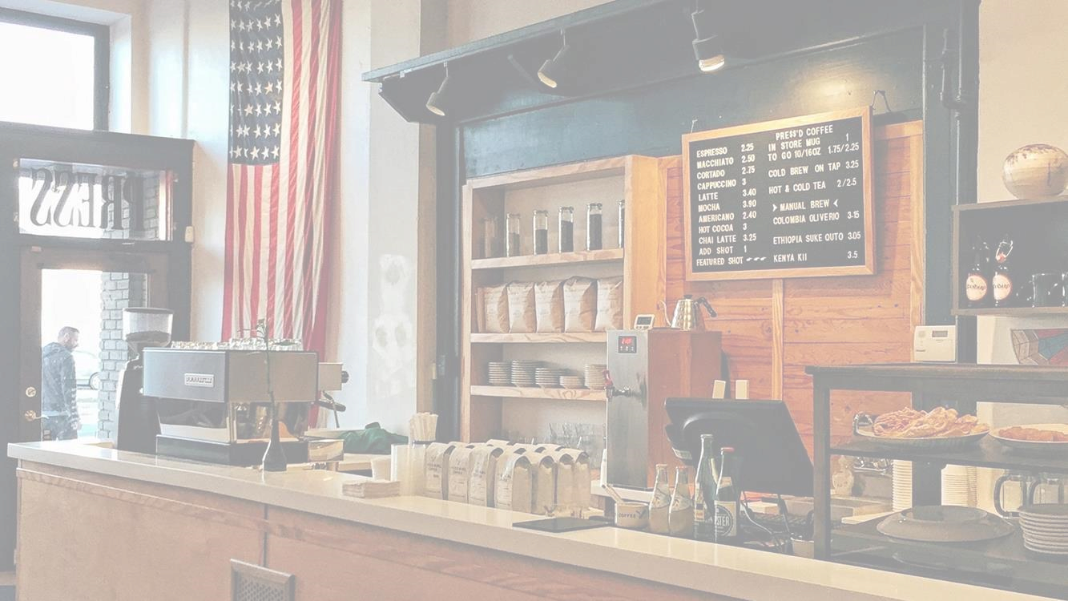
Market analysis and Product description
•
Coffee Shop Business

Market
analysis
•
Current Trends
•
Target Market
(
Erlina and Hermawan,
2021
)
•
Competition

Market
analysis
•
Opportunities
•
Threats
(
Sudiartini
et al
.,
2020
)

Product
Description
•
Location
•
Menu
•
Equipment
•
Marketing
•
Interior Design
•
Customer Service
(
Sofia
et al
.,
2020
)
•
Customer Loyalty

Reference
•
Erlina, E. and Hermawan, D.,
2021
. Marketing mix
on customer loyalty at coffee shop in bandung. Aptisi
Transactions on Management (ATM),
5
(
1
)
, pp.
89
-
96
.
•
Sofia, A., Pangaribuan, C.H. and Sitinjak, M.F.,
2020
. Factors of coffee shop revisit intention and
word
-
of
-
mouth mediated by customer satisfaction.
Journal of Management and Business,
19
(
1
).
•
Sudiartini
, N.W.A., Astari, A.A.E.,
Kardini
, N.L. and
Dhani, Y.R.,
2020
. The feasibility study of coffee
house business opportunity in the COVID
-
19

pandemic: a case study at
kulo
coffee shop began.
International Research Journal of Management, IT
and Social Sciences,
7
(
5
)
, pp.
38
-
45
.

