Experimental part:

1 Implementation of a man-in-the-middle attack

1.1 ARP disconnection attack

Scan the hosts in the local area network

Ping scan:

Scanning results:

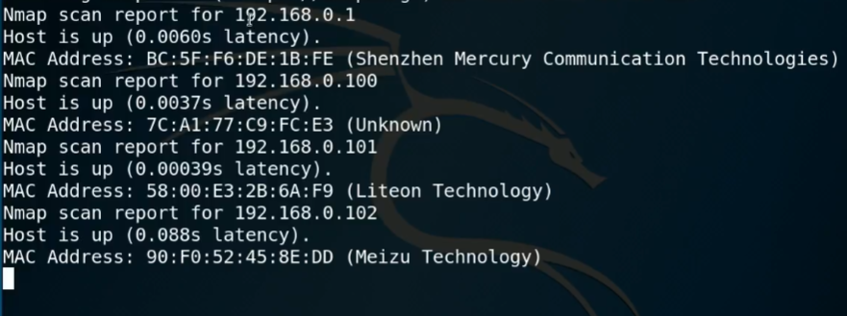

Take the physical host with the ip address of 192.168.0.101 as the target for network disconnection attacks

Physical machine state: 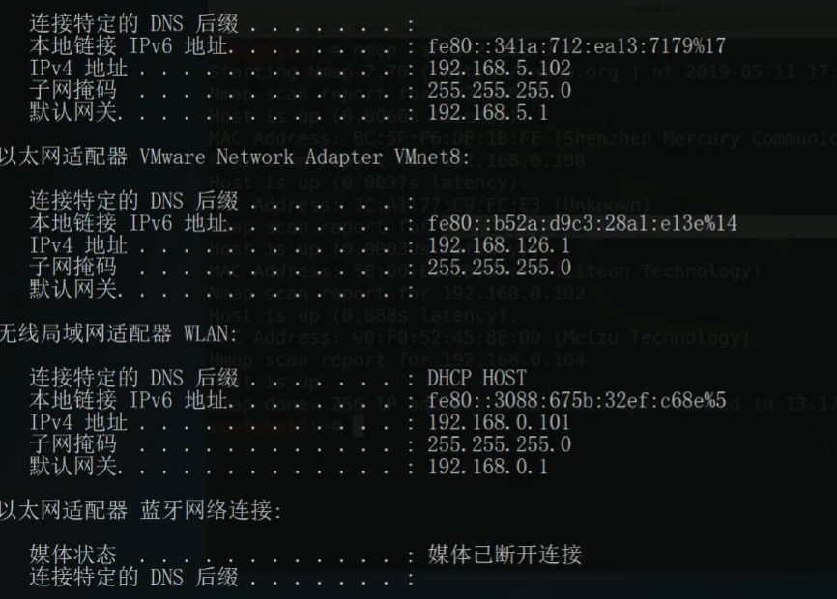
Before the network disconnection attack, the ping command of the physical machine is detected, and it can be connected to www.baidu.com.
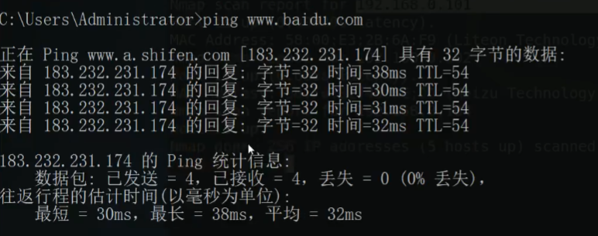

1.1.1 Use Arpspoof tool to realize arp disconnection attack

Determine the status of the network card:

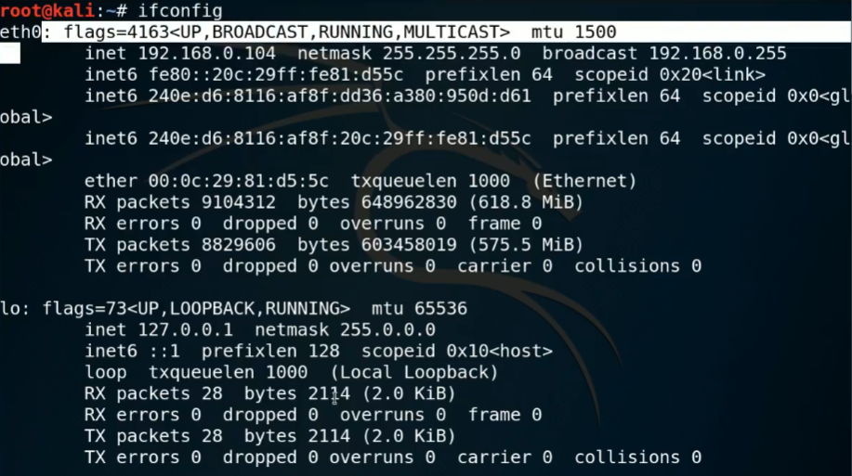

Select the object to be attacked on the network card eth0 connection

Start arp disconnection attack

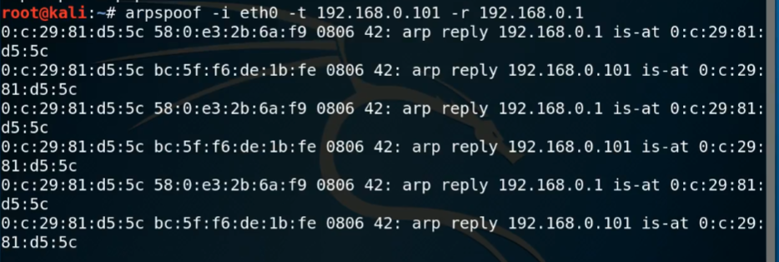

Ping command, the request timed out, and the arp disconnection attack was successful.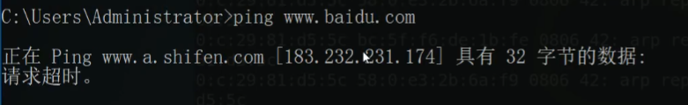

1.1.2 Using ettercap tool to realize arp network disconnection attack:

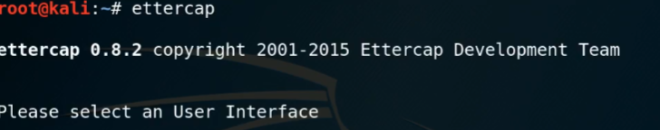

Help information of ettercap.

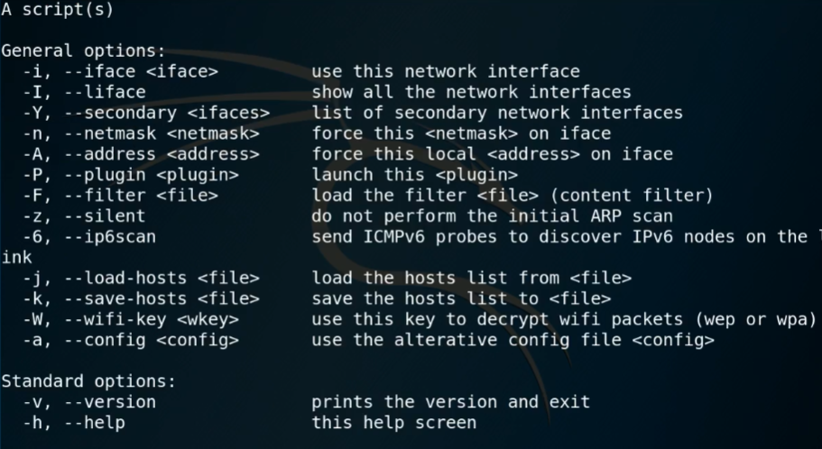

In ettercap, you can use the ettercap-G statement to open the graphical window:

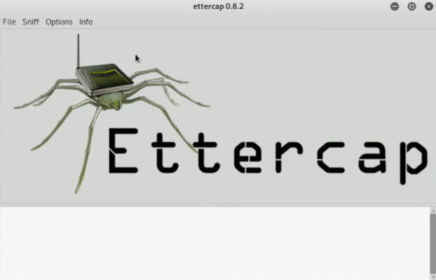

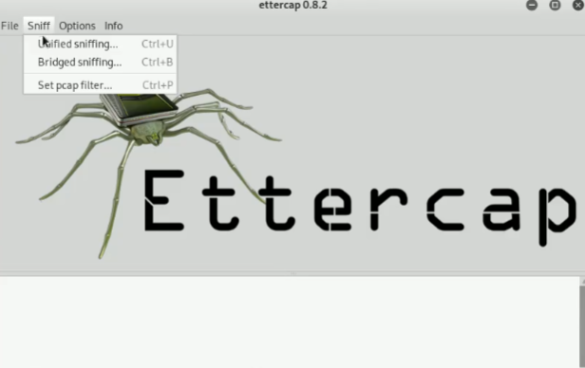

Select the network card to enter ettercap

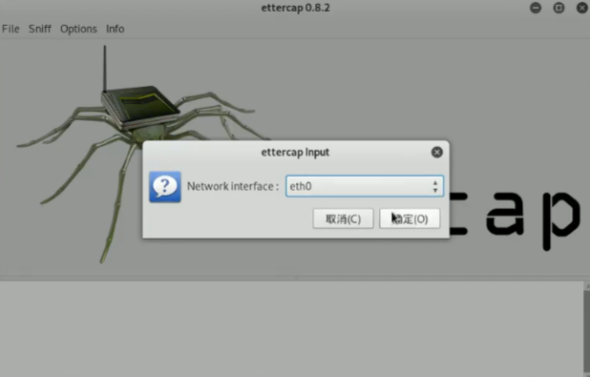

Scanned port

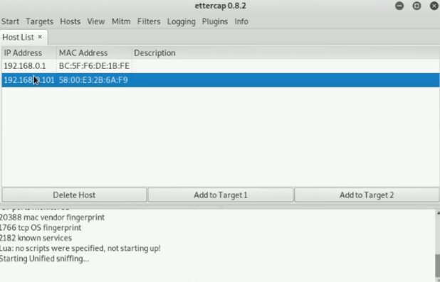
Start attack:

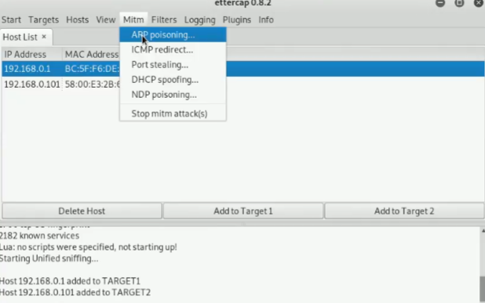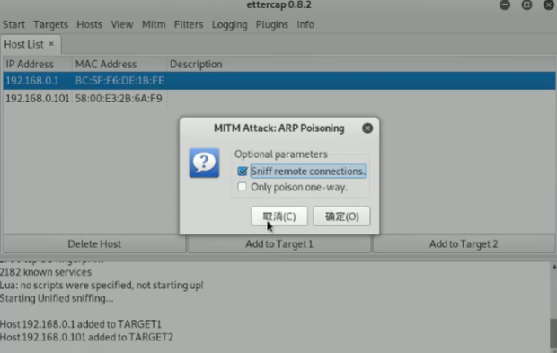
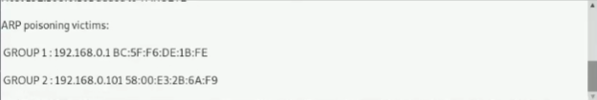

The drone request timed out and the arp attack was successful.

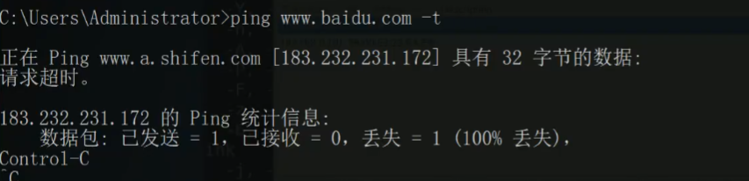

1.2 Obtain the image traffic of the target host in the LAN through ARP

Use the Arpspoof tool to monitor

When the attack is successful, the data traffic of the target IP flowing through the attack gateway will be spoofed and forwarded to the kali system.

The picture display tool driftnet can be used to display the acquired pictures

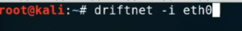

A pop-up window will pop up after driftnet is configured
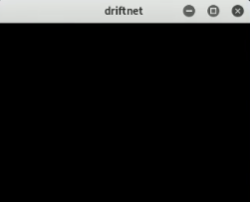

Get the picture successfully

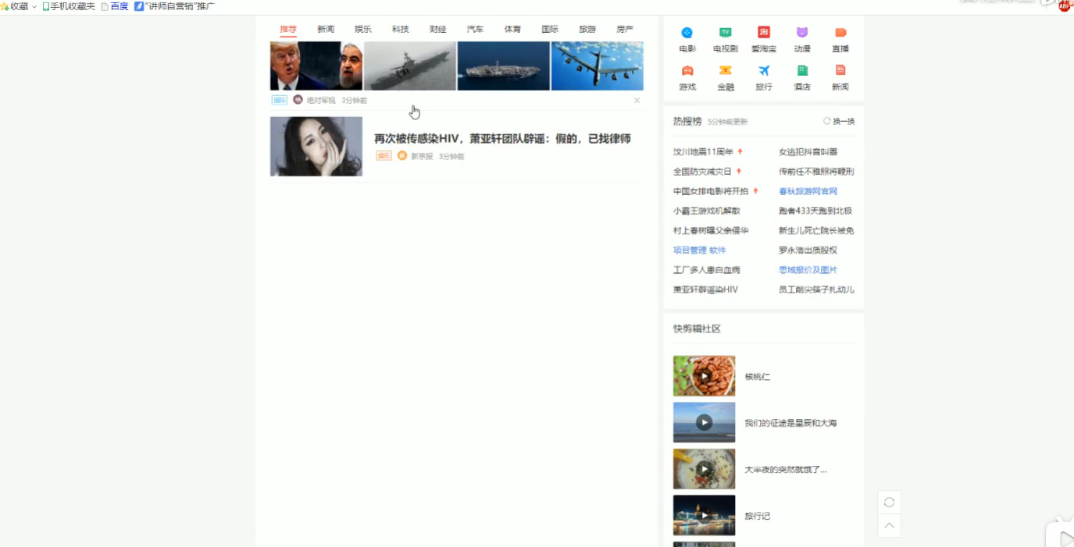

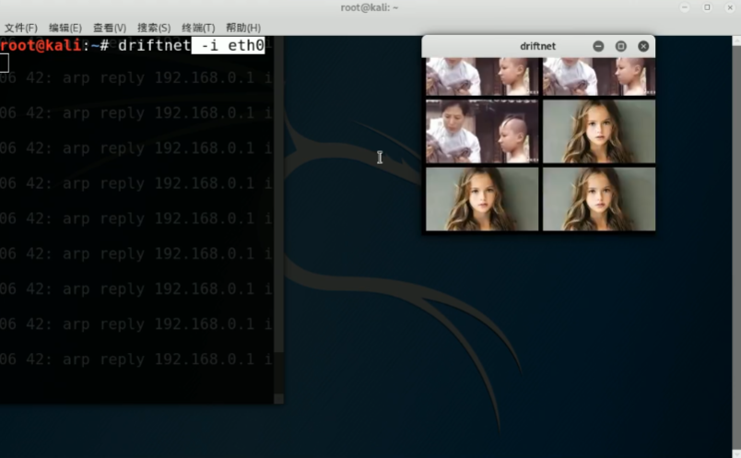

2 Metasploit penetration testing framework experiment

2.1.1 Introduction to Metasploit

Metasploit is a penetration testing platform that can find, exploit and verify vulnerabilities. The platform includes the Metasploit framework and its commercial counterparts, such as Metasploit Pro.
Metasploit is a free, downloadable framework that can easily attack computer software vulnerabilities. It comes with hundreds of professional vulnerability attack tools with known software vulnerabilities. When H.D. Moore released Metasploit in 2003, the computer security situation was permanently changed. It seems that anyone can become a hacker overnight, and everyone can use attack tools to attack those vulnerabilities that have not been patched or have just been patched.
Visit the official website: https://www.metasploit.com/
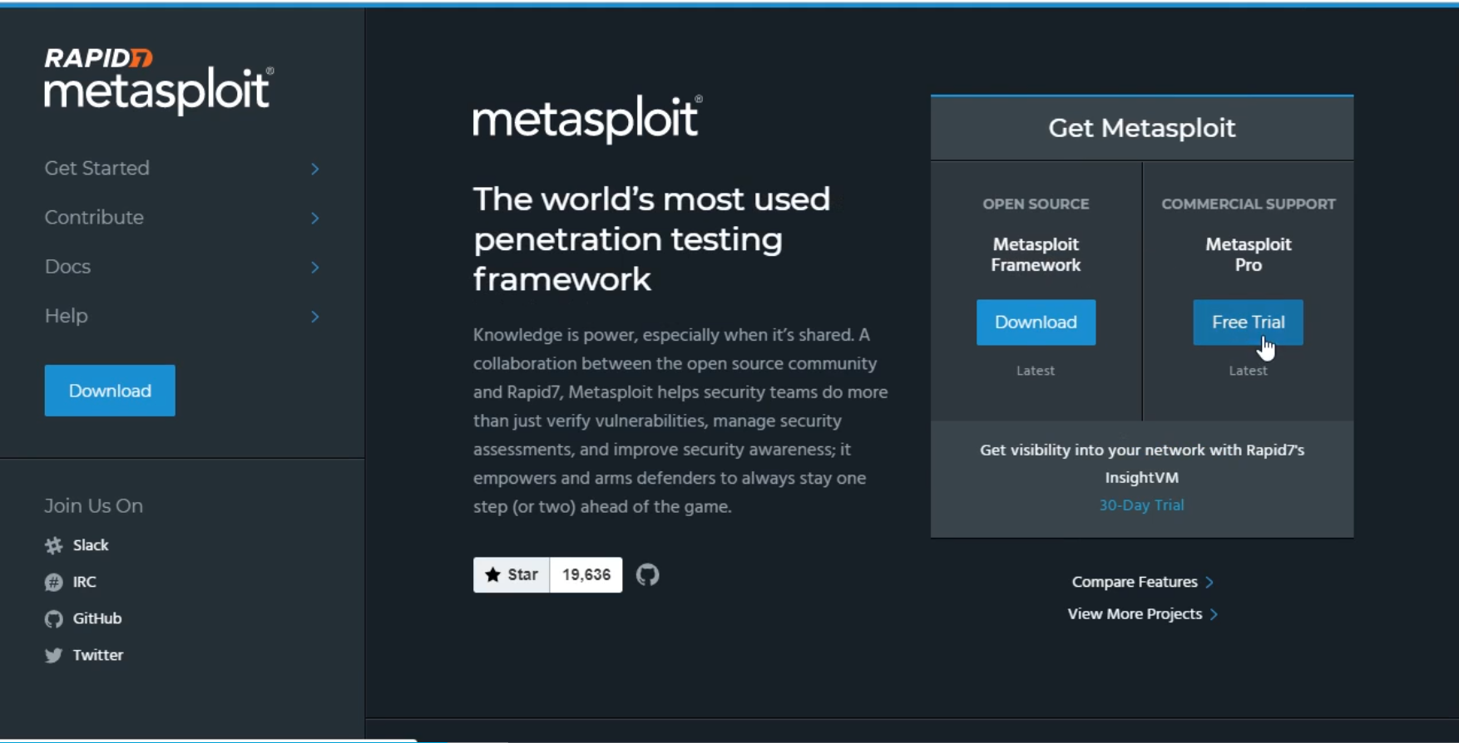

2.1.2 Metasploit system framework
1. Basic library: The metasploit basic library file is located in the libraries directory under the source root directory path, including Rex, framework-core and framework-base.
Rex is some of the most basic components that the entire framework depends on, such as packaged network sockets, network application protocol client and server implementation, logging subsystem, penetration attack support routines, PostgreSQL and MySQL database support, etc.;
The framework-core library is responsible for implementing all interactive interfaces with various types of upper-level modules and plug-ins; e
The framework-base library extends the framework-core, provides simpler packaging routines, and provides some functional classes for processing various aspects of the framework to support the user interface and function programs to call the framework's own functions and framework integration modules;
2. Modules: The module organization is divided into 6 types of modules (Modules) according to different purposes:
It is divided into auxiliary module (Aux), infiltration attack module (Exploits), post infiltration attack module (Post), attack payload module (payloads), encoder module (Encoders), and empty command module (Nops).
3. Plug-ins: Plug-ins can expand the functions of the framework, or assemble existing functions to form components with advanced features. The plug-in can integrate some existing external security tools, such as Nessus, OpenVAS vulnerability scanner, etc., to provide some new functions for the user interface.
4. Interface: including msfconsole control terminal, msfcli command line, msfgui graphical interface, armitage graphical interface and msfapi remote calling interface.
5. Functional programs: Metasploit also provides a series of functional programs that can be run directly to support penetration testers and security personnel to quickly use the internal capabilities of the metasploit framework to complete some specific tasks. For example, msfpayload, msfencode, and msfvenom can encapsulate the attack payload into executable files, C language, JavaScript language and other forms, and can perform various types of encoding.
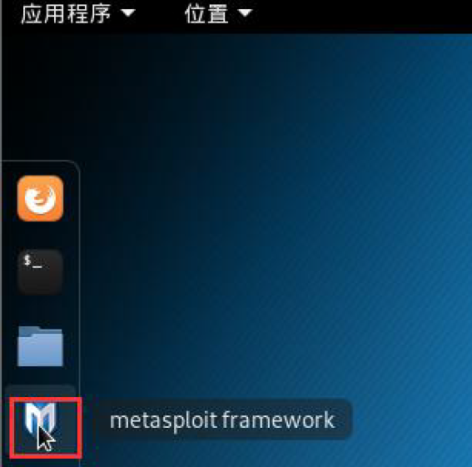

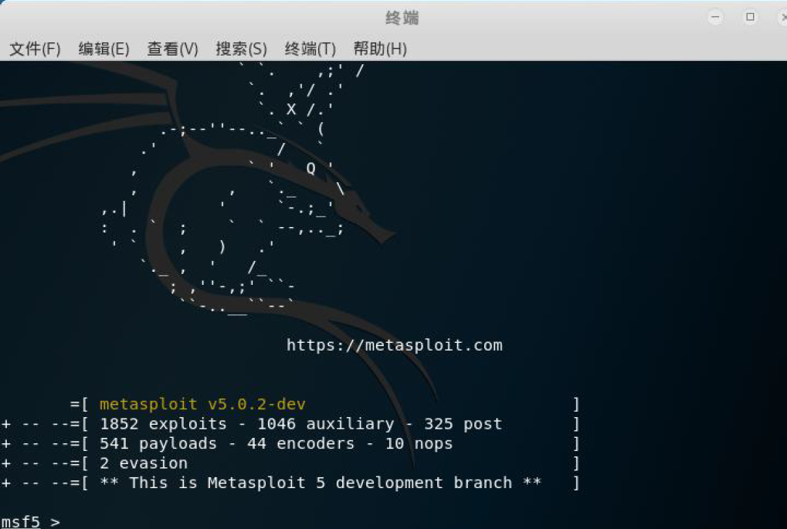

2.1.3 Metasploitable2-Linux Target System

and corresponding target
s and corresponding
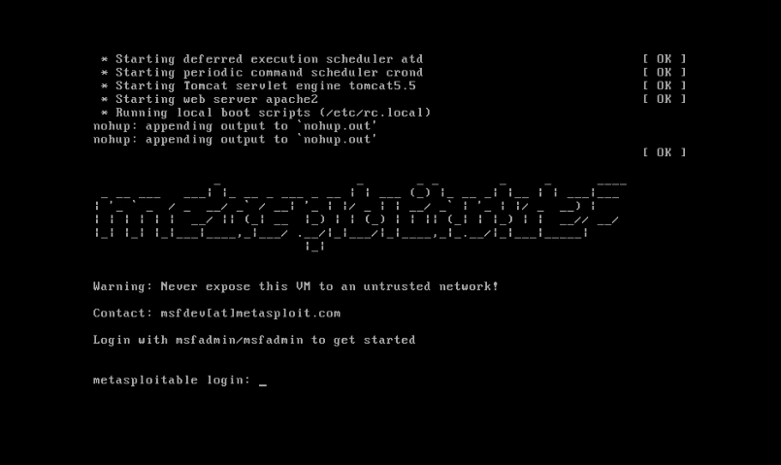
Target system creation

Create a snapshot to bring the virtual machine back to the same state after causing damage to the operating system in the future.

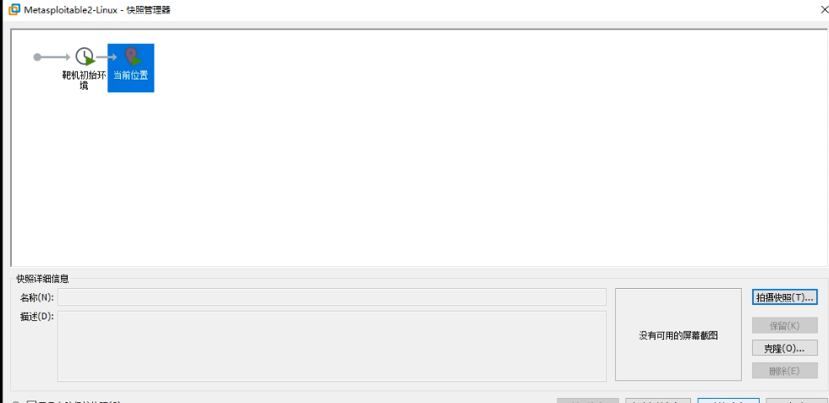
Snapshot window
7.4 Using msf to infiltrate the Win7 host and execute commands remotely

2.1.4 Eternal Blue

Eternal Blue is a hacking tool. On the evening of April 14, 2017, the hacker group Shadow Brokers announced a large number of network attack tools, including the "Eternal Blue" tool, which can be obtained by exploiting the SMB vulnerability of the Windows system. The highest authority of the system. On May 12th, criminals created the wannacry ransomware virus by transforming "Eternal Blue". In the United Kingdom, Russia, Europe and China, many college intranets, large corporate intranets, and government agencies’ private networks were recruited and ransomed for payment. A high ransom can be used to decrypt and restore files.
Microsoft's MS17-010 vulnerability link: https://docs.microsoft.com/zh-cn/security-updates/securitybulletins/2017/ms17-010=
Eternal Blue related viruses actually exploited Microsoft's MS17-010 vulnerability. MS17-010 is a vulnerability in the underlying service of the Windows system. The malicious code scans the Windows machines that open the 445 file sharing port without any user operation. As long as the Internet is turned on, criminals can implant ransomware and remote control in computers and servers. Malicious programs such as Trojan horses and virtual currency mining machines.

2.1.5 Metasploit use process
1)Known vulnerabilities
2)Find the module
3)Configuration
4)Exploit

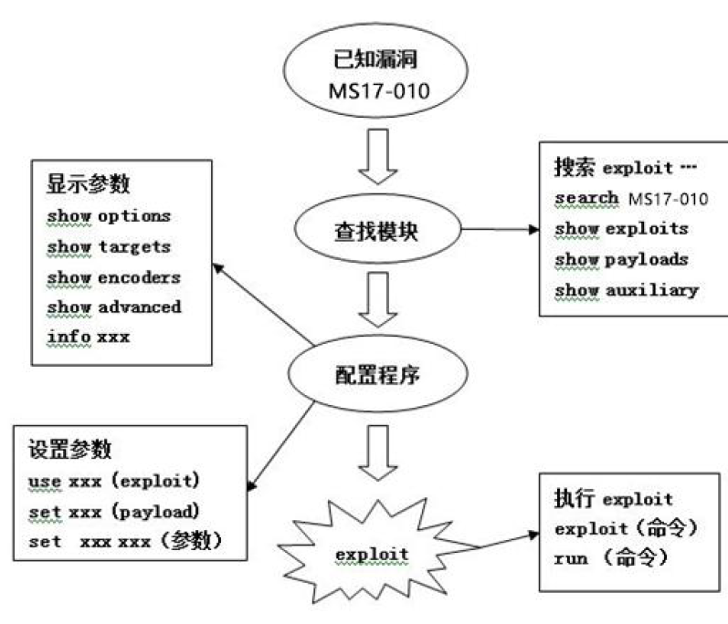

First scan the target for ms17-010 vulnerabilities

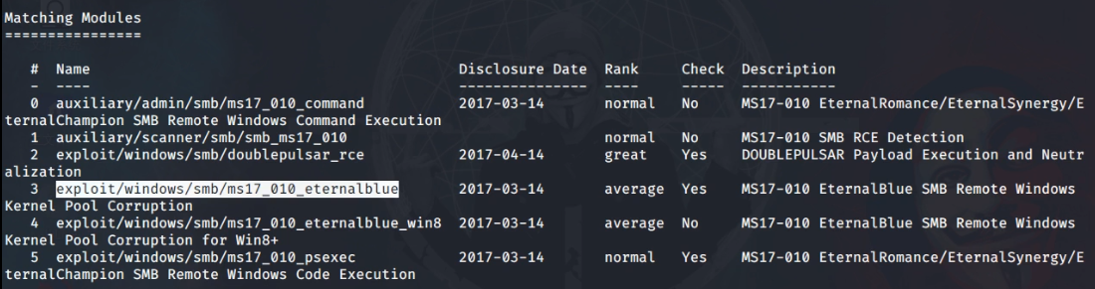
About ms17-010 vulnerability module (eternal blue)

View the information that the module needs to configure

msf5 auxiliary(scanner/smb/smb_ms17_010) > show options
The required configuration of the module is shown here

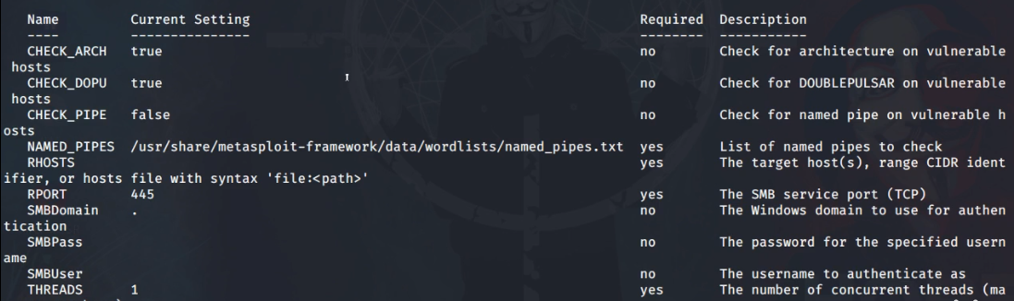

Set win7 target machine address

msf5 exploit(windows/smb/ms17_010_eternalblue) > show targets
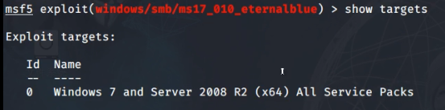
The ms17-010 vulnerability was found to target win7 system and Server 2008

Find a payload, get the shell remote connection permission, and execute the command remotely, import
msf5 exploit(windows/smb/ms17_010_eternalblue) > search windows/x64/shell
type:payload

The payload is mainly used to establish a stable connection between the target machine and the attacking machine. It can return to the shell or perform program injection.
Pick a payload for the reverse shell，如图所示.
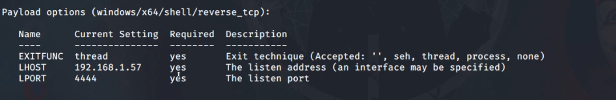
Payload set up

配置完毕，现在可以开始运行攻击程序，如图所示。

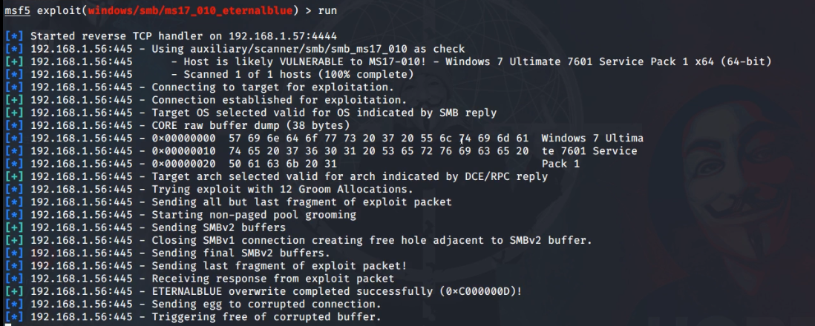

Successfully connected

At this time, the permission of the win7 system of the target machine has been obtained.

Create account in Win7 system
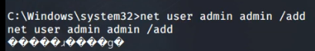
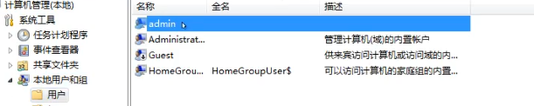
Created successfully.

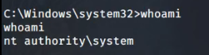
It is not difficult to find that the highest authority of the system has been obtained.

3 Using MSF to scan the empty password of the mysql service on the target machine
Some mysql services will set a blank password. These services can be scanned out through MSF to enter.

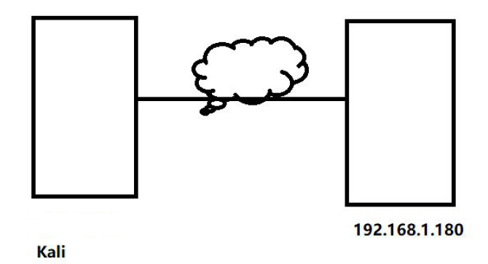

The vulnerability module of Mysql
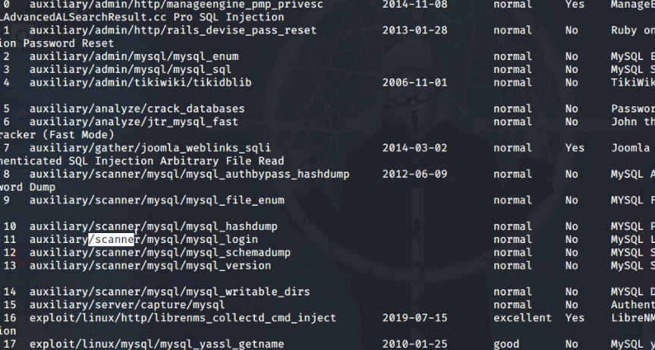

Load mysql login vulnerability module

Parameter requirements of the module
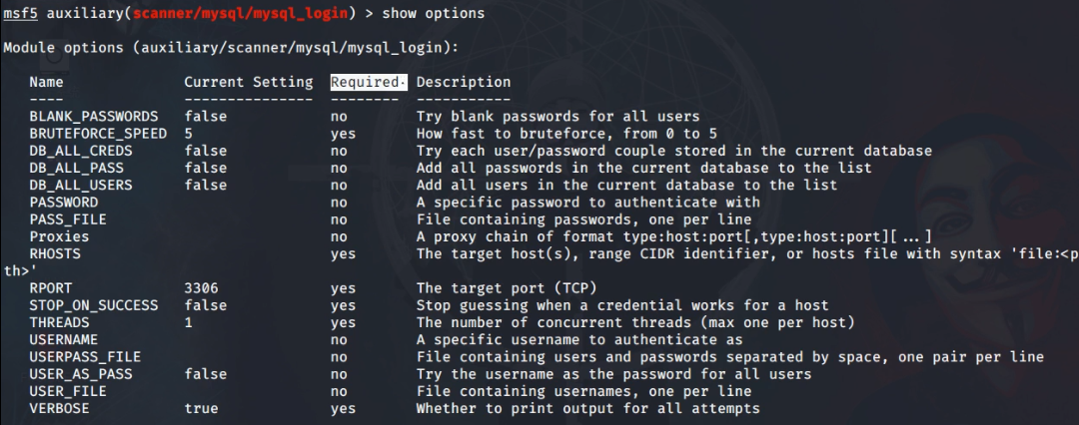

Set attack address

The query is successful. There is a Mysql service named'root' whose password is empty under this address.

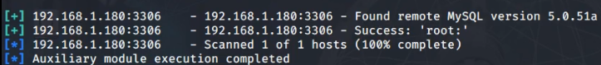
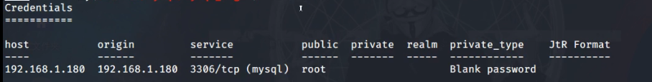

4 Methods of collecting host information

This section introduces the use of Metasploit to collect information on the target. This process includes some common ways and some more extreme ways to obtain information, such as obtaining server hardware information, system user information, process information, etc.

4.1 Collect host information based on TCP protocol
There is also NMAP tool in Metasploit

msfconsole
msf5 > db_nmap -sV 192.168.1.1
Nmap scan results:

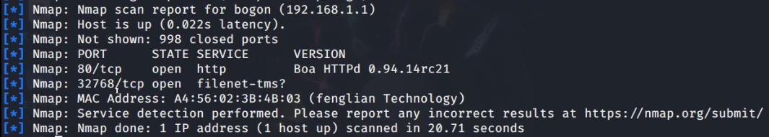

ARP scanning
msf5 > use auxiliary/scanner/discovery/arp_sweep

Check which parameters the module needs to be configured.

msf5 auxiliary(scanner/discovery/arp_sweep) > show options

arp scan result:

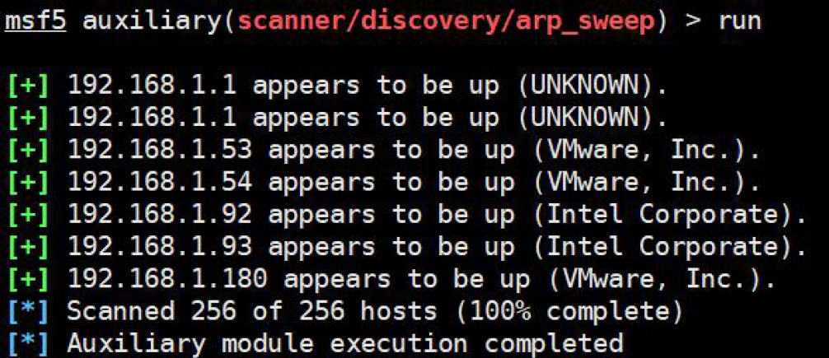

4.2 Collect host information based on SNMP protocol

The simple network management protocol is composed of a set of network management standards, including an application layer protocol, a database model, and a set of resource objects. This protocol can support a network management system to monitor whether the devices connected to the network have any management concerns.

Before using the SNMP protocol to collect information, the root user needs to go to the Metasploitable2-Linux host to modify the SNMP service, because the default service is not open to the outside world.

SNMP status of the target machine, found that it is only open to the local service

Modify SNMP service status

Use snmp_enum enumeration module to scan target information

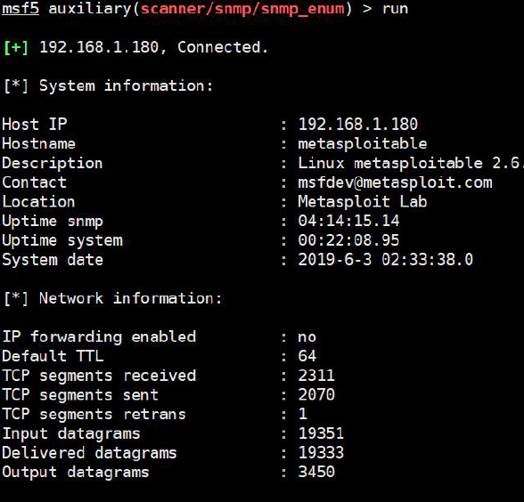

There is a lot of information detected through the snmp protocol. For example, the hardware information of the server and the processes currently running on the server are not obtained by other scanning methods.

4.3 Collect information based on SMB protocol

Server message block, also known as network file sharing system, is an application layer network transmission protocol developed by Microsoft. Its main function is to enable machines on the network to share resources such as computer files, printers, serial ports, and communications.

Use smb_version to scan the version number based on the SMB protocol
msf5 > use auxiliary/scanner/smb/smb_version

Set Target machine information

msf5 auxiliary(scanner/smb/smb_version) > set RHOSTS 192.168.1.56, 192.168.1.180

The version number of the system was successfully obtained.

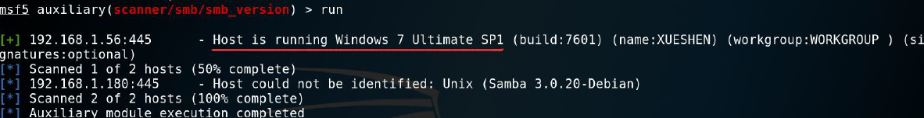

Use smb_enumshares to scan shared files based on the SMB protocol

In order to use the smb_enumshares module, the target machine needs to enable the sharing service.

Scan out shared folders
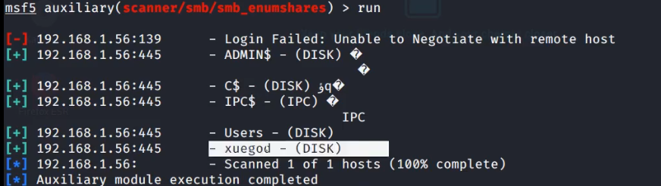

4.4 Collect information based on SSH protocol

msf5 > use auxiliary/scanner/ssh/ssh_version
msf5 auxiliary(scanner/ssh/ssh_version) > show options
msf5 auxiliary(scanner/ssh/ssh_version) > set RHOSTS 192.168.1.180
msf5 auxiliary(scanner/ssh/ssh_version) > run

Get the ssh version number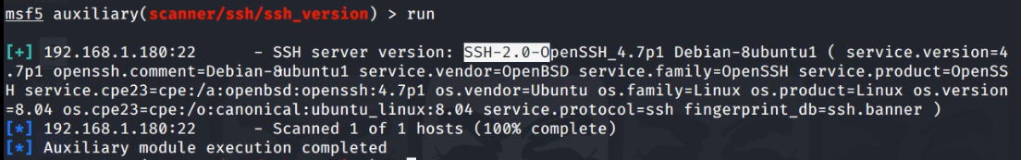

Brute force cracking on SSH

Set the default dictionary file for the dictionary file.

set USERPASS_FILE /usr/share/metasploit-framework/data/wordlists/root_userpass.txt

Because the dictionary file does not contain the user password information set by the target machine, it is necessary to manually add the password information of the target machine in order to show the effect.



